THE UNIVERSITY OF AZAD JAMMU & KASHMIR, MUZAFFARABAD


COURSE TITLE | DATABASE SYSTEMS
COURSE CODE | CS-2204
TITLE | LAB 01
STUDENT NAME | HASEEB SHEIKH
STUDENT ROLL NUMBER | 2024-SE-31
INSTRUCTOR NAME | ENGR. AWAIS RATHORE
SUBMISSION DATE | SEPTEMBER 20, 2026

DEPARTMENT OF SOFTWARE ENGINEERING
Database Systems
Lab 1
- Objective
To download, install, and configure XAMPP to run a local Apache web server and MySQL database environment.
- Downloading XAMPP
I navigated to the official Apache Friends website and downloaded the latest version of XAMPP for Windows.
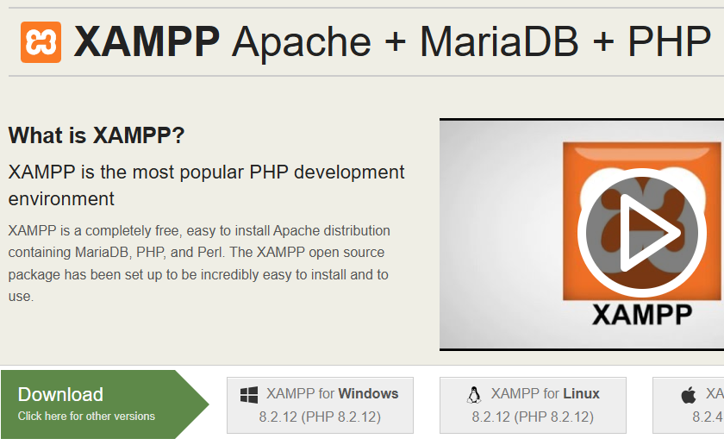

- Installation Process

During the installation, I ensured that the core components, specifically Apache and MySQL, were selected.
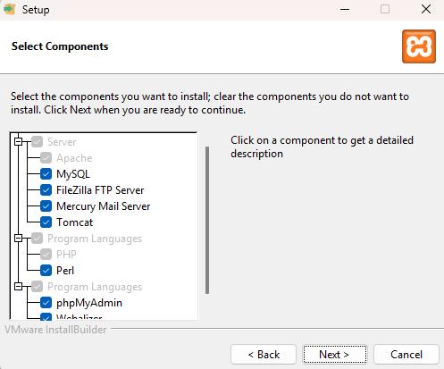
- Starting the Services
After installation, I opened the XAMPP Control Panel. I clicked the "Start" buttons for both Apache and MySQL. The module backgrounds turned green, indicating the services are running successfully on their default ports (Apache on 80/443, MySQL on 3306).
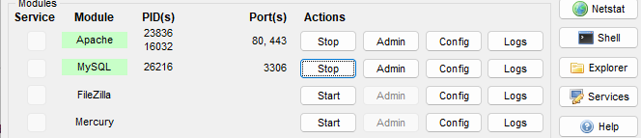

- Verification (phpMyAdmin)
To verify the database engine is working, I opened my web browser and navigated to http://localhost/phpmyadmin. The graphical interface for MySQL loaded successfully.
