L A B R E P O R T · 0 4
University of Azad Jammu and Kashmir
Department of Software Engineering

Digital Image Processing Lab
Lab Task #04
Geometric Transformations with Custom Inputs
Reusable transform function · Scaling · Cropping · Flipping · Translation · Rotation · Input validation
STUDENT NAME | Sheikh Haseeb-ur-Rehman
ROLL NUMBER | 2024-SE-31
INSTRUCTOR | Engr. Fahad Nisar
SEMESTER | Fifth
SESSION | 2024-28 (SE)
DATE | November 13, 2026

1 Project Setup and Image Loading
Objective: Set up the notebook, declare the limits and fixed choices that transform enforces, and load the input image with validation while keeping the original unchanged.

Libraries, Declared Limits, and Fixed Choices
Result
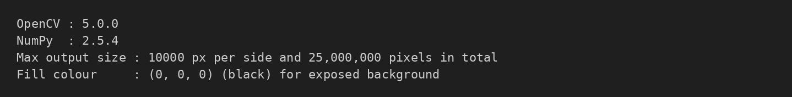
Figure 1 — Library versions and declared limits
Declared setting | Value
Maximum output side | 10,000 px (width or height)
Maximum output pixels | 25,000,000 (25 megapixels)
Background (fill) colour | (0, 0, 0), black, for areas exposed by translation and rotation
Operations | scale, crop, flip, translate, rotate
Interpolation names | nearest, bilinear, bicubic, lanczos (INTER_NEAREST, INTER_LINEAR, INTER_CUBIC, INTER_LANCZOS4)
Flip directions | horizontal, vertical, both
Resampling for translate / rotate | Bilinear (INTER_LINEAR)

Code
import os
import math
import hashlib
import numbers
import warnings

import cv2
import numpy as np
import pandas as pd
import matplotlib
import matplotlib.pyplot as plt

from matplotlib_inline.backend_inline import set_matplotlib_formats
set_matplotlib_formats("jpeg") # keeps the saved notebook small
plt.rcParams["figure.dpi"] = 80
pd.set_option("display.max_colwidth", 120)
pd.set_option("display.width", 200)

print("OpenCV :", cv2.__version__)
print("NumPy :", np.__version__)

# ---- paths -------------------------------------------------------------
IMAGE_PATH = "input_image.jpg" # input image lives next to this notebook
RESULTS_DIR = "results" # every transformed result is saved here
os.makedirs(RESULTS_DIR, exist_ok=True)

# ---- declared limits and fixed choices (enforced inside `transform`) ----
MAX_SIDE = 10_000 # maximum output width or height, in pixels
MAX_PIXELS = 25_000_000 # maximum output width * height (25 megapixels)
FILL_VALUE = (0, 0, 0) # background for areas exposed by translation / rotation (black)

SUPPORTED_OPERATIONS = ("scale", "crop", "flip", "translate", "rotate")

INTERPOLATIONS = { # user-facing name -> OpenCV flag
"nearest": cv2.INTER_NEAREST,
"bilinear": cv2.INTER_LINEAR,
"bicubic": cv2.INTER_CUBIC,
"lanczos": cv2.INTER_LANCZOS4,
}
FLIP_DIRECTIONS = ("horizontal", "vertical", "both")
ROTATION_INTERPOLATION = cv2.INTER_LINEAR # rotation / translation resampling (bilinear)

REQUIRED_PARAMS = { # exactly these keyword parameters are required, no hidden defaults
"scale": ("fx", "fy", "interpolation"),
"crop": ("left", "top", "right", "bottom"),
"flip": ("direction",),
"translate": ("tx", "ty"),
"rotate": ("angle", "expand"),
}

print(f"Max output size : {MAX_SIDE} px per side and {MAX_PIXELS:,} pixels in total")
print(f"Fill colour : {FILL_VALUE} (black) for exposed background")
Listing 1 — Imports, paths, declared limits, and fixed choices
The limits are declared once at the top of the notebook and are enforced inside transform, not in the prompt layer, so every caller is protected. An output larger than 10,000 pixels on a side or 25 megapixels is refused before any large array is allocated. The notebook ran on Python 3.14.6 with OpenCV 5.0.0 and NumPy 2.5.4.

Load and Validate the Image
Result
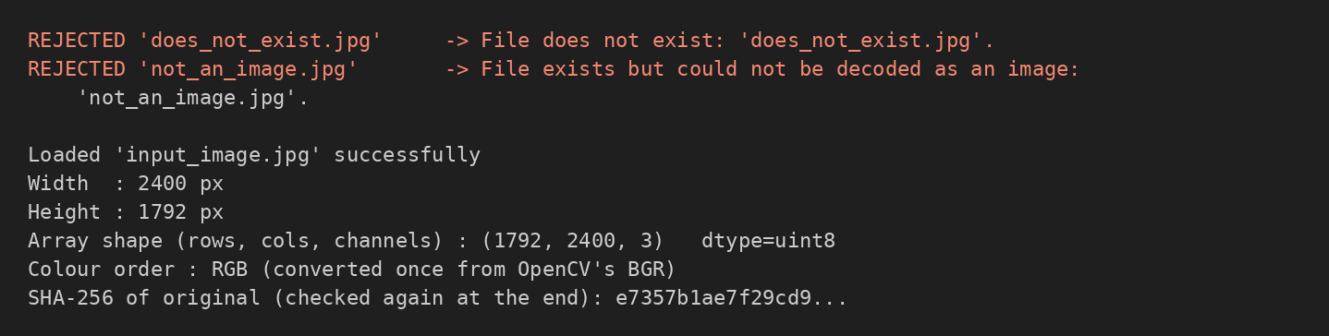
Figure 2 — Loader rejecting two bad inputs, then loading the real image
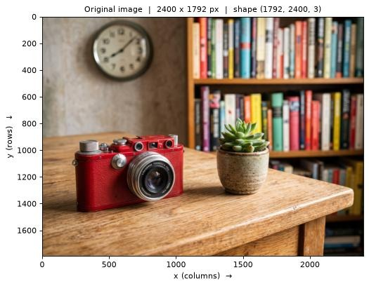
Figure 3 — Original image with its width, height, and array shape in the title
Property | Value
Width × Height | 2400 × 1792 px
Array shape (rows, columns, channels) | (1792, 2400, 3)
Data type | uint8
Colour order | RGB (converted once from OpenCV’s BGR)
Array writeable | False (original is read-only)

Code
class ImageLoadError(Exception):
'''Raised when the input image cannot be loaded or is unusable.'''

def load_image(path):
'''Load an image as an RGB uint8 array, validating file, decoding and size.'''
if not isinstance(path, (str, os.PathLike)):
raise ImageLoadError(f"Path must be a string, got {type(path).__name__}.")
if not os.path.isfile(path):
raise ImageLoadError(f"File does not exist: '{path}'.")
if os.path.getsize(path) == 0:
raise ImageLoadError(f"File is empty (0 bytes): '{path}'.")
bgr = cv2.imread(os.fspath(path), cv2.IMREAD_COLOR)
if bgr is None:
raise ImageLoadError(f"File exists but could not be decoded as an image: '{path}'.")
if bgr.ndim != 3 or bgr.shape[0] == 0 or bgr.shape[1] == 0:
raise ImageLoadError(f"Decoded image has invalid dimensions: {bgr.shape}.")
return cv2.cvtColor(bgr, cv2.COLOR_BGR2RGB) # BGR -> RGB (done once, here)

def save_image(path, rgb):
'''Save an RGB array to disk (converted back to BGR for OpenCV).'''
params = [cv2.IMWRITE_JPEG_QUALITY, 95] if path.lower().endswith((".jpg", ".jpeg")) else []
ok = cv2.imwrite(path, cv2.cvtColor(rgb, cv2.COLOR_RGB2BGR), params)
if not ok:
raise IOError(f"Could not write '{path}'.")
return path

# ---- demonstrate the loader on bad inputs first -------------------------
with open("not_an_image.jpg", "w") as f: # a file that exists but is not an image
f.write("this is plain text, not a JPEG")

for bad in ["does_not_exist.jpg", "not_an_image.jpg"]:
try:
load_image(bad)
print(f"{bad!r}: loaded (unexpected)")
except ImageLoadError as e:
print(f"REJECTED {bad!r:24} -> {e}")
os.remove("not_an_image.jpg") # clean up the temporary file

# ---- load the real image -------------------------------------------------
original = load_image(IMAGE_PATH)
original.flags.writeable = False # the original can no longer be modified
ORIGINAL_HASH = hashlib.sha256(original.tobytes()).hexdigest()

H0, W0 = original.shape[:2]
print(f"\nLoaded '{IMAGE_PATH}' successfully")
print(f"Width : {W0} px")
print(f"Height : {H0} px")
print(f"Array shape (rows, cols, channels) : {original.shape} dtype={original.dtype}")
print(f"Colour order : RGB (converted once from OpenCV's BGR)")
print(f"SHA-256 of original (checked again at the end): {ORIGINAL_HASH[:16]}...")
Listing 2 — Loading, saving, and protecting the original image
Validation: load_image checks that the file exists and is not empty, that cv2.imread decodes it (it returns None for a file that exists but is not an image), and that the decoded array has non-zero height and width. The two bad inputs in the figure, a missing file and a text file renamed to .jpg, are rejected with clear messages before the real image is loaded.
Consistent colour handling: OpenCV decodes to BGR, so the image is converted to RGB once at load time. All processing and Matplotlib display use RGB, and save_image converts back to BGR only when writing a file with cv2.imwrite.
Original kept unchanged: the array is made read-only (flags.writeable = False) and its SHA-256 hash is recorded. The hash is compared again at the end of the notebook (Section 10), which proves that no operation modified the original.

2 The Reusable transform Function
Objective: Build one entry point, transform(image, operation, **params), that validates the image, the operation name, and every parameter itself, and returns a new transformed image.

Operations, Parameters, and Validation Rules
Operation | Required parameters | Rules enforced
scale | fx, fy, interpolation | fx and fy finite and greater than 0; output size round(w·fx) × round(h·fy), both at least 1 px; interpolation in nearest, bilinear, bicubic, lanczos; maximum output size
crop | left, top, right, bottom | integers; 0 ≤ left < right ≤ width and 0 ≤ top < bottom ≤ height (right and bottom exclusive)
flip | direction | one of horizontal, vertical, both
translate | tx, ty | finite numbers (positive, negative, or zero); canvas size unchanged
rotate | angle, expand | angle finite (any value, including 0 and negative); expand is a real True or False; maximum output size when expanded

There are no hidden defaults: each operation requires exactly the parameters listed above. A missing, unexpected, or invalid parameter raises ValidationError with a clear message, and nothing is silently replaced by an unrelated value.

Validators
Code
class ValidationError(ValueError):
'''Raised for any invalid image, operation name or parameter.'''

# ------------------------------ validators --------------------------------
def _validate_image(image):
if not isinstance(image, np.ndarray):
raise ValidationError(f"image must be a NumPy array, got {type(image).__name__}.")
if image.dtype != np.uint8:
raise ValidationError(f"image dtype must be uint8, got {image.dtype}.")
if image.ndim not in (2, 3) or (image.ndim == 3 and image.shape[2] != 3):
raise ValidationError(f"image must have shape (H, W) or (H, W, 3), got {image.shape}.")
if image.shape[0] == 0 or image.shape[1] == 0:
raise ValidationError(f"image has zero size: {image.shape}.")

def _number(name, value):
'''Return `value` as a finite float. Rejects bool, text, None, NaN and +/- infinity.'''
if isinstance(value, (bool, np.bool_)) or not isinstance(value, numbers.Real):
raise ValidationError(f"'{name}' must be a number, got {value!r} ({type(value).__name__}).")
value = float(value)
if not math.isfinite(value):
raise ValidationError(f"'{name}' must be finite (not NaN or infinity), got {value}.")
return value

def _integer(name, value):
'''Return `value` as int. Only true integers are accepted (10.5 and "10" are rejected).'''
if isinstance(value, (bool, np.bool_)) or not isinstance(value, numbers.Integral):
raise ValidationError(f"'{name}' must be an integer, got {value!r} ({type(value).__name__}).")
return int(value)

def _check_output_size(w, h):
'''Reject empty or oversize outputs. Raises before any large array is allocated.'''
if w < 1 or h < 1:
raise ValidationError(f"output would be {w} x {h} px; both dimensions must be at least 1 pixel.")
if w > MAX_SIDE or h > MAX_SIDE:
raise ValidationError(f"output {w} x {h} px exceeds the maximum side length of {MAX_SIDE} px.")
if w * h > MAX_PIXELS:
raise ValidationError(f"output {w} x {h} = {w*h:,} px exceeds the maximum of {MAX_PIXELS:,} pixels.")

def _check_params(operation, params):
required = REQUIRED_PARAMS[operation]
missing = [p for p in required if p not in params]
if missing:
raise ValidationError(f"'{operation}' is missing required parameter(s): {', '.join(missing)}.")
unexpected = [p for p in params if p not in required]
if unexpected:
raise ValidationError(f"'{operation}' got unexpected parameter(s): {', '.join(unexpected)}. "
f"Allowed: {', '.join(required)}.")
Listing 3 — ValidationError and the shared validators
_number accepts only real, finite numbers (it rejects bool, text, None, NaN, and ±infinity), _integer accepts only true integers (10.5 and the string “10” are rejected), _check_output_size rejects empty or oversize outputs before any allocation, and _check_params rejects missing and unexpected parameters.

Affine Matrices
Code
# ------------------------- affine matrices (2 x 3) -------------------------
def translation_matrix(tx, ty):
'''2x3 affine matrix of a shift: x' = x + tx, y' = y + ty.'''
return np.float64([[1, 0, tx], [0, 1, ty]])

def rotation_matrix(w, h, angle, expand):
'''
2x3 affine matrix that rotates about the image centre, plus the output size (ow, oh).
Positive angle = counter-clockwise as displayed (OpenCV convention, y axis points down).
With expand=True the canvas grows to the bounding box and the matrix is shifted to fit it.
'''
angle = math.fmod(angle, 360.0) # same rotation, better numeric precision for huge angles
cx, cy = (w - 1) / 2.0, (h - 1) / 2.0 # image centre (pixel-centre convention)
M = cv2.getRotationMatrix2D((cx, cy), angle, 1.0)
ow, oh = w, h
if expand:
rad = math.radians(angle)
c, s = abs(math.cos(rad)), abs(math.sin(rad))
ow = int(math.ceil(round(w * c + h * s, 6))) # round() guards against 1e-13 noise at 90 degrees
oh = int(math.ceil(round(w * s + h * c, 6)))
_check_output_size(ow, oh)
M[0, 2] += (ow - 1) / 2.0 - cx # move the old centre to the new canvas centre
M[1, 2] += (oh - 1) / 2.0 - cy
return M, ow, oh
Listing 4 — The 2 × 3 matrices used by translation and rotation
Translation and rotation are built from explicit 2 × 3 affine matrices. Positive angles rotate counter-clockwise as displayed. With expand=True the canvas grows to the bounding box of the rotated rectangle and the matrix is shifted so that the old centre lands on the new centre.

The Five Operations
Code
# ------------------------------ operations --------------------------------
def _scale(image, fx, fy, interpolation):
fx, fy = _number("fx", fx), _number("fy", fy)
if fx <= 0 or fy <= 0:
raise ValidationError(f"scale factors must be greater than zero, got fx={fx}, fy={fy}.")
if not isinstance(interpolation, str) or interpolation.strip().lower() not in INTERPOLATIONS:
raise ValidationError(f"unsupported interpolation {interpolation!r}. "
f"Choose one of: {', '.join(INTERPOLATIONS)}.")
h, w = image.shape[:2]
ow_f, oh_f = w * fx, h * fy # float output size (can overflow to inf for huge factors)
if not (math.isfinite(ow_f) and math.isfinite(oh_f)):
raise ValidationError("scale factors are too large: output size is not representable.")
ow, oh = int(round(ow_f)), int(round(oh_f))
_check_output_size(ow, oh)
return cv2.resize(image, (ow, oh), interpolation=INTERPOLATIONS[interpolation.strip().lower()])

def _crop(image, left, top, right, bottom):
left, top = _integer("left", left), _integer("top", top)
right, bottom = _integer("right", right), _integer("bottom", bottom)
h, w = image.shape[:2]
if not (0 <= left < right <= w):
raise ValidationError(f"horizontal crop must satisfy 0 <= left < right <= {w}; "
f"got left={left}, right={right}.")
if not (0 <= top < bottom <= h):
raise ValidationError(f"vertical crop must satisfy 0 <= top < bottom <= {h}; "
f"got top={top}, bottom={bottom}.")
return image[top:bottom, left:right].copy() # right and bottom are exclusive

def _flip(image, direction):
if not isinstance(direction, str) or direction.strip().lower() not in FLIP_DIRECTIONS:
raise ValidationError(f"unsupported flip direction {direction!r}. "
f"Choose one of: {', '.join(FLIP_DIRECTIONS)}.")
d = direction.strip().lower()
code_ = {"horizontal": 1, "vertical": 0, "both": -1}[d]
return cv2.flip(image, code_)

def _translate(image, tx, ty):
tx, ty = _number("tx", tx), _number("ty", ty)
h, w = image.shape[:2]
fill = FILL_VALUE if image.ndim == 3 else FILL_VALUE[0]
if abs(tx) >= w or abs(ty) >= h: # shifted completely off the canvas
out = np.empty_like(image)
out[...] = fill
return out
M = translation_matrix(tx, ty) # x' = x + tx, y' = y + ty
return cv2.warpAffine(image, M, (w, h), flags=ROTATION_INTERPOLATION,
borderMode=cv2.BORDER_CONSTANT, borderValue=fill)

def _rotate(image, angle, expand):
angle = _number("angle", angle)
if not isinstance(expand, (bool, np.bool_)):
raise ValidationError(f"'expand' must be True or False, got {expand!r} ({type(expand).__name__}).")
h, w = image.shape[:2]
fill = FILL_VALUE if image.ndim == 3 else FILL_VALUE[0]
M, ow, oh = rotation_matrix(w, h, angle, expand)
return cv2.warpAffine(image, M, (ow, oh), flags=ROTATION_INTERPOLATION,
borderMode=cv2.BORDER_CONSTANT, borderValue=fill)
Listing 5 — Scaling, cropping, flipping, translation, and rotation

The Single Entry Point
Result
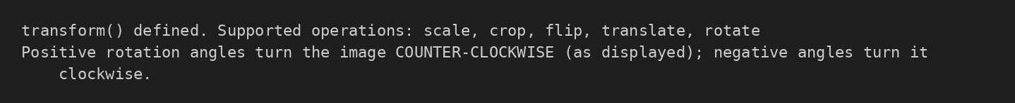
Figure 4 — transform defined and the rotation direction convention
Code
_DISPATCH = {"scale": _scale, "crop": _crop, "flip": _flip, "translate": _translate, "rotate": _rotate}

# ------------------------------ entry point --------------------------------
def transform(image, operation, **params):
'''
Single entry point for all geometric transformations.

image : uint8 RGB array (H, W, 3) (or grayscale (H, W)); never modified.
operation : 'scale' | 'crop' | 'flip' | 'translate' | 'rotate'
**params : the operation's custom parameters (see REQUIRED_PARAMS).

Returns a NEW image array. Raises ValidationError for any invalid input.
'''
_validate_image(image)
if not isinstance(operation, str):
raise ValidationError(f"operation must be a string, got {type(operation).__name__}.")
op = operation.strip().lower()
if op not in SUPPORTED_OPERATIONS:
raise ValidationError(f"unknown operation {operation!r}. Supported: {', '.join(SUPPORTED_OPERATIONS)}.")
_check_params(op, params)
return _DISPATCH[op](image, **params)

print("transform() defined. Supported operations:", ", ".join(SUPPORTED_OPERATIONS))
print("Positive rotation angles turn the image COUNTER-CLOCKWISE (as displayed); negative angles turn it clockwise.")
Listing 6 — Dispatch table and the transform entry point
transform validates the image first (NumPy uint8 array of shape (H, W) or (H, W, 3) with non-zero size), then the operation name (a string from the supported list), then the parameter names, and only then dispatches to the operation. It always returns a new array.

Display and Save Helpers
show_comparison draws the original beside the result. The result title carries the operation, its parameters, and the output dimensions, and both panels use real pixel axes so size changes are visible. run() calls transform, shows the comparison, and saves the result in the results folder (code in Section 3.1 of the notebook).

3 Prompt-Driven Input
Objective: Let the user select an operation and type its parameters, validate the typed text, and pass the values to transform instead of using fixed values inside it.

Prompt Layer
Code
# what to ask for each operation: (parameter name, prompt text, parser)
PROMPTS = {
"scale": [("fx", "Horizontal scale factor fx (> 0)", lambda t: parse_float("fx", t, positive=True)),
("fy", "Vertical scale factor fy (> 0)", lambda t: parse_float("fy", t, positive=True)),
("interpolation", f"Interpolation ({'/'.join(INTERPOLATIONS)})",
lambda t: parse_choice("interpolation", t, tuple(INTERPOLATIONS)))],
"crop": [("left", "Left x (integer, inclusive)", lambda t: parse_int("left", t)),
("top", "Top y (integer, inclusive)", lambda t: parse_int("top", t)),
("right", "Right x (integer, exclusive)", lambda t: parse_int("right", t)),
("bottom", "Bottom y (integer, exclusive)", lambda t: parse_int("bottom", t))],
"flip": [("direction", f"Direction ({'/'.join(FLIP_DIRECTIONS)})",
lambda t: parse_choice("direction", t, FLIP_DIRECTIONS))],
"translate": [("tx", "Horizontal offset tx in px (+ right, - left)", lambda t: parse_float("tx", t)),
("ty", "Vertical offset ty in px (+ down, - up)", lambda t: parse_float("ty", t))],
"rotate": [("angle", "Angle in degrees (+ counter-clockwise, - clockwise)", lambda t: parse_float("angle", t)),
("expand", "Expand canvas to fit the whole rotated image? (y/n)", lambda t: parse_bool("expand", t))],
}
Listing 7 — The PROMPTS table: parameter, prompt text, and parser for each operation
def ask(prompt, parser, input_fn):
'''Ask until the typed text parses; show a clear message on each mistake.'''
while True:
text = input_fn(f" {prompt}: ")
if text.strip().lower() == "q":
raise Cancelled()
try:
return parser(text)
except ValidationError as e:
print(f" ✗ Invalid input: {e} -> please try again.")

def prompt_for_transform(image, input_fn=input):
'''Select an operation, collect its parameters, call transform. Returns (operation, params, result).'''
ops = ", ".join(SUPPORTED_OPERATIONS)
operation = ask(f"Operation ({ops})", lambda t: parse_choice("operation", t, SUPPORTED_OPERATIONS), input_fn)
while True:
params = {name: ask(text, parser, input_fn) for name, text, parser in PROMPTS[operation]}
try:
return operation, params, transform(image, operation, **params) # values passed to transform
except ValidationError as e:
print(f" ✗ transform rejected these values: {e}\n -> please re-enter the {operation} parameters.")
Listing 8 — ask() repeats a prompt until the text is valid; prompt_for_transform() calls transform
PROMPTS lists, for each operation, the parameter name, the prompt text, and a parser. Small parser functions turn typed text into values and reject non-numeric text, NaN, and infinity; choices must be one of the supported names. ask() repeats a prompt until the text parses (typing q cancels), and prompt_for_transform() passes the collected values to transform. If transform itself rejects a combination, for example right ≤ left in a crop, the message is shown and that operation’s parameters are asked again. Nothing is replaced by a default.

Recorded Interactive Session
The recorded session feeds a fixed list of “typed” answers through the very same prompts, so the notebook runs from top to bottom without waiting for the keyboard. Each answer is echoed after its prompt. The answers deliberately include mistakes: an unknown operation, non-numeric text, zero, nan, inf, unsupported choices, a non-integer crop value, and a crop with right ≤ left, so every message and the correction loop can be seen. Every operation is then run once with valid custom values.
Result
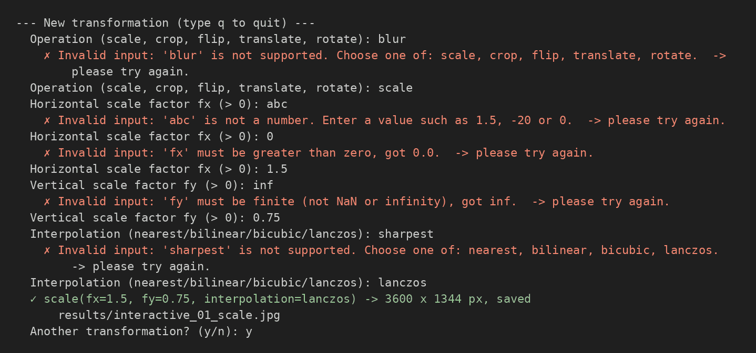
Figure 5 — Session 1 — scale: unknown operation, text, zero, and infinity rejected; then fx = 1.5, fy = 0.75, Lanczos
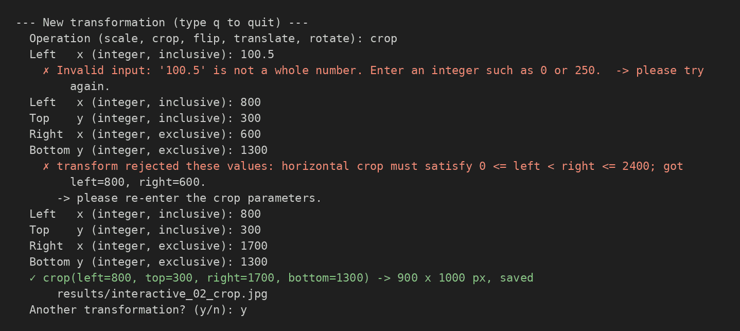
Figure 6 — Session 2 — crop: non-integer value and right ≤ left rejected; then a valid region
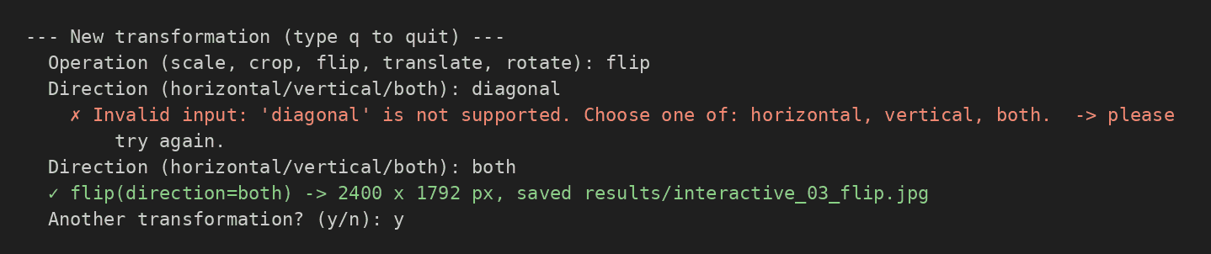
Figure 7 — Session 3 — flip: unsupported direction “diagonal” rejected; then both
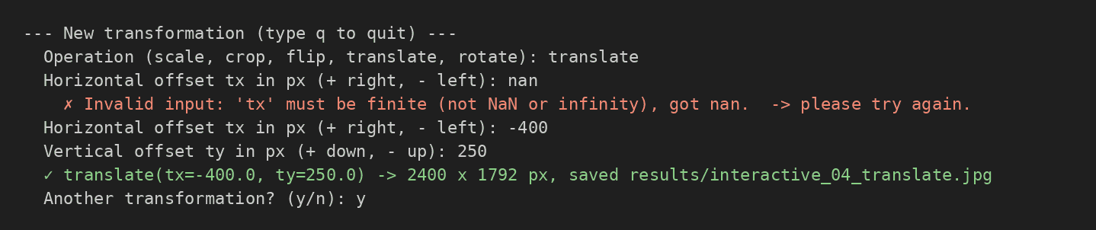
Figure 8 — Session 4 — translate: nan rejected; then tx = −400, ty = 250
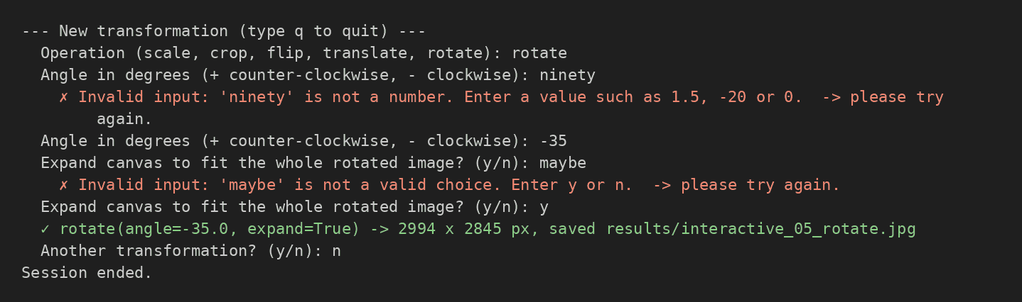
Figure 9 — Session 5 — rotate: non-numeric angle and invalid expand choice rejected; then −35° with expansion

Live Controls
For typing values live, the notebook provides two interfaces. Setting LIVE_INPUT = True runs the same prompts through the notebook’s input() box. The control panel below is built with ipywidgets: the operation is chosen from a drop-down, the parameters are typed into text boxes (numbers are typed as text on purpose, so non-numeric text, nan, and inf are caught and explained), and the Apply button parses the text with the same parsers and passes the values to transform. Each result is shown with its labels and saved as results/live_NN_<operation>.jpg. Errors are shown in the output area and the boxes keep their values so they can be corrected.
Code
try:
import ipywidgets as widgets
from IPython.display import display, clear_output
except ImportError:
widgets = None
print("ipywidgets is not installed -> run `pip install ipywidgets`, or use the input()-based session (LIVE_INPUT = True).")

def convert_typed_values(operation, raw_values):
'''Parse the typed/selected text with the same parsers as the prompts. Raises ValidationError.'''
params = {}
for name, _, parser in PROMPTS[operation]:
params[name] = parser(raw_values[name])
return params

if widgets is not None:
PLACEHOLDERS = {"fx": "e.g. 1.5", "fy": "e.g. 0.75", "left": "e.g. 0", "top": "e.g. 0",
"right": "e.g. 800", "bottom": "e.g. 600", "tx": "e.g. -120", "ty": "e.g. 80", "angle": "e.g. -30"}
live_state = {"count": 0}
op_menu = widgets.Dropdown(options=SUPPORTED_OPERATIONS, description="Operation:", layout=widgets.Layout(width="260px"))
param_box = widgets.VBox()
apply_btn = widgets.Button(description="Apply", button_style="primary", icon="check")
out = widgets.Output()
controls = {}

def build_param_widgets(*_):
controls.clear()
rows = []
for name, text, _parser in PROMPTS[op_menu.value]:
if name == "interpolation":
w = widgets.Dropdown(options=list(INTERPOLATIONS), value="bilinear")
elif name == "direction":
w = widgets.Dropdown(options=list(FLIP_DIRECTIONS), value="horizontal")
elif name == "expand":
w = widgets.Dropdown(options=["yes", "no"], value="no")
else:
w = widgets.Text(placeholder=PLACEHOLDERS.get(name, ""))
w.layout = widgets.Layout(width="420px")
w.description = name
controls[name] = w
rows.append(widgets.HBox([w, widgets.Label(text)]))
param_box.children = rows

def on_apply(_btn):
with out:
clear_output(wait=True)
operation = op_menu.value
try:
params = convert_typed_values(operation, {k: w.value for k, w in controls.items()})
result = transform(original, operation, **params) # typed values passed to transform
except ValidationError as e:
print(f"✗ {e}\n -> correct the value(s) above and press Apply again.")
return
live_state["count"] += 1
name = f"live_{live_state['count']:02d}_{operation}.jpg"
save_image(os.path.join(RESULTS_DIR, name), result)
show_comparison(original, result, operation, params)
print(f"✓ {operation}({fmt_params(params)}) -> {result.shape[1]} x {result.shape[0]} px, saved results/{name}")

op_menu.observe(build_param_widgets, names="value")
apply_btn.on_click(on_apply)
build_param_widgets()
display(widgets.VBox([op_menu, param_box, apply_btn, out]))
Listing 9 — Live control panel (drop-down, text boxes, Apply button)

4 Demonstration of Every Operation
Objective: Run each operation with custom values passed to transform, label every result with the operation, parameters, and output dimensions, and save the results in the results folder.

Scaling: Enlargement, Reduction, and Non-Proportional
Result
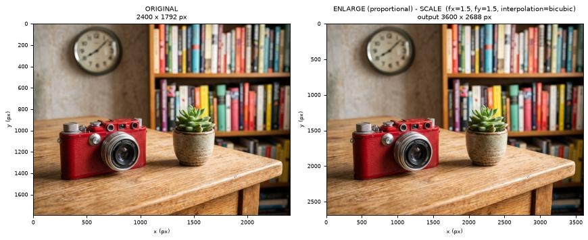
Figure 10 — Proportional enlargement, fx = fy = 1.5, bicubic
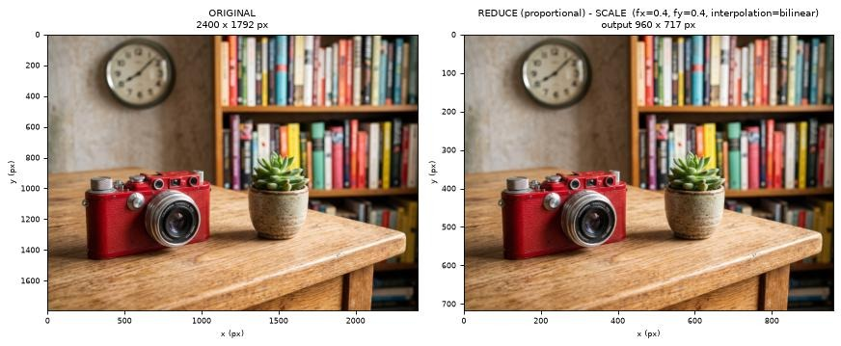
Figure 11 — Proportional reduction, fx = fy = 0.4, bilinear
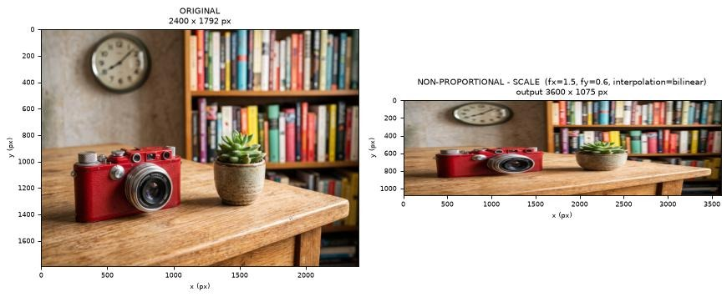
Figure 12 — Non-proportional scaling, fx = 1.5, fy = 0.6, bilinear
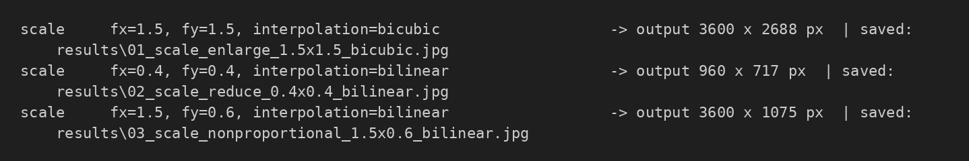
Figure 13 — Scaling output dimensions and saved files
Image | Width | Height | Aspect ratio (w/h)
original | 2400 | 1792 | 1.3393
enlarged 1.5 x 1.5 | 3600 | 2688 | 1.3393
reduced 0.4 x 0.4 | 960 | 717 | 1.3389
non-proportional 1.5 x 0.6 | 3600 | 1075 | 3.3488

Code
up = run(original, "scale", "01_scale_enlarge_1.5x1.5_bicubic.jpg", title_prefix="ENLARGE (proportional) - ",
fx=1.5, fy=1.5, interpolation="bicubic")
down = run(original, "scale", "02_scale_reduce_0.4x0.4_bilinear.jpg", title_prefix="REDUCE (proportional) - ",
fx=0.4, fy=0.4, interpolation="bilinear")
nonp = run(original, "scale", "03_scale_nonproportional_1.5x0.6_bilinear.jpg", title_prefix="NON-PROPORTIONAL - ",
fx=1.5, fy=0.6, interpolation="bilinear")

rows = []
for label, img in [("original", original), ("enlarged 1.5 x 1.5", up), ("reduced 0.4 x 0.4", down),
("non-proportional 1.5 x 0.6", nonp)]:
h, w = img.shape[:2]
rows.append({"image": label, "width": w, "height": h, "aspect ratio w/h": round(w / h, 4)})
display(pd.DataFrame(rows))
Listing 10 — Enlargement, reduction, and non-proportional scaling
Equal factors keep the width-to-height ratio at 1.339, so shapes keep their proportions. With fx ≠ fy the ratio changes by fx / fy (here 1.5 / 0.6 = 2.5, giving 3.349): the image is stretched along one axis only. Output dimensions are derived as integers with round(w·fx) and round(h·fy), which is why 0.4 × 1792 gives 717 pixels.

Cropping
Result
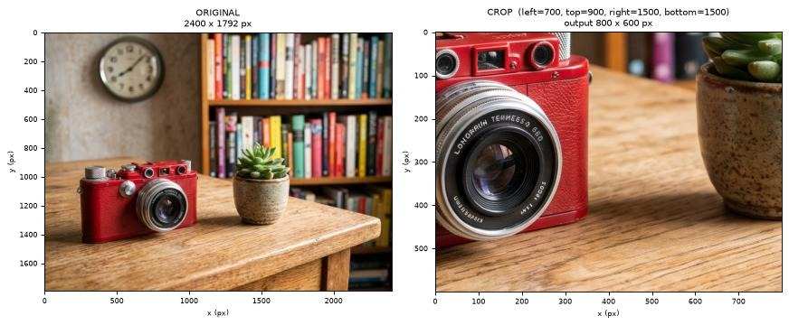
Figure 14 — Crop with left = 700, top = 900, right = 1500, bottom = 1500
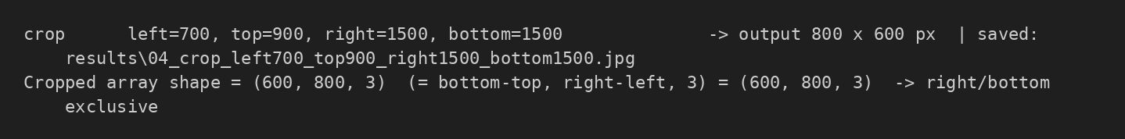
Figure 15 — Crop output dimensions and array shape
Code
cropped = run(original, "crop", "04_crop_left700_top900_right1500_bottom1500.jpg",
left=700, top=900, right=1500, bottom=1500)
print(f"Cropped array shape = {cropped.shape} (= bottom-top, right-left, 3) = ({1500-900}, {1500-700}, 3) -> right/bottom exclusive")
Listing 11 — Cropping with exclusive right and bottom
Right and bottom are exclusive, so the crop shape is (bottom − top, right − left) = (600, 800), and right = width or bottom = height is a valid choice.

Flipping: All Three Directions
Result
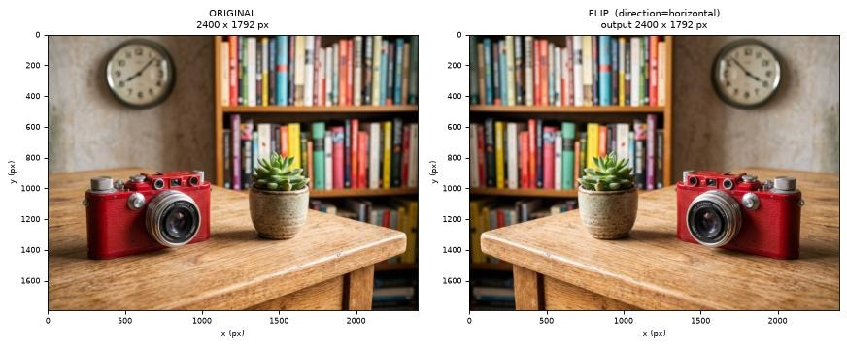
Figure 16 — Horizontal flip
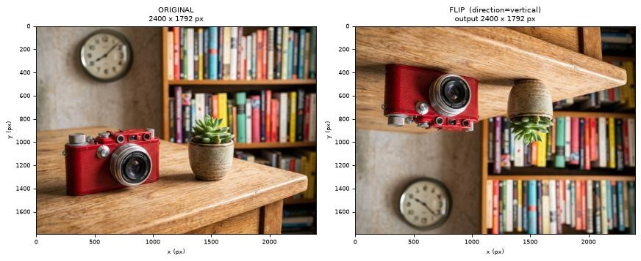
Figure 17 — Vertical flip
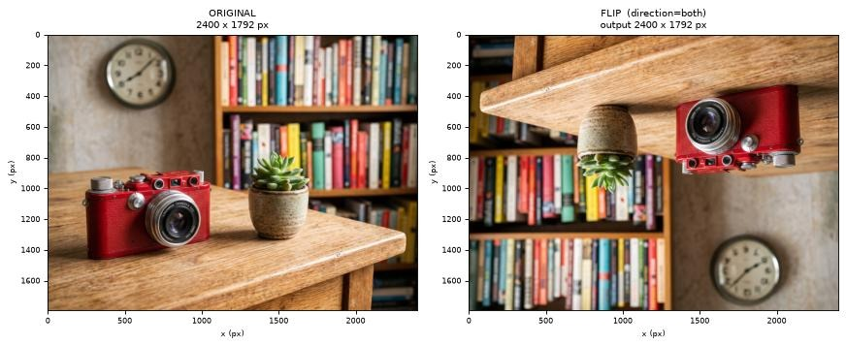
Figure 18 — Flip in both directions
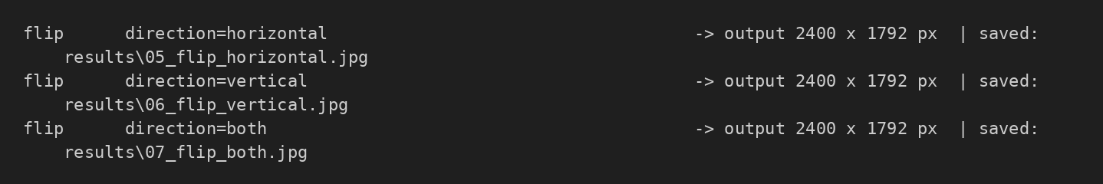
Figure 19 — Flip output dimensions (unchanged) and saved files
Code
flip_h = run(original, "flip", "05_flip_horizontal.jpg", direction="horizontal")
flip_v = run(original, "flip", "06_flip_vertical.jpg", direction="vertical")
flip_b = run(original, "flip", "07_flip_both.jpg", direction="both")
Listing 12 — Flipping horizontally, vertically, and both

Translation: Shifts in Opposite Directions
Result
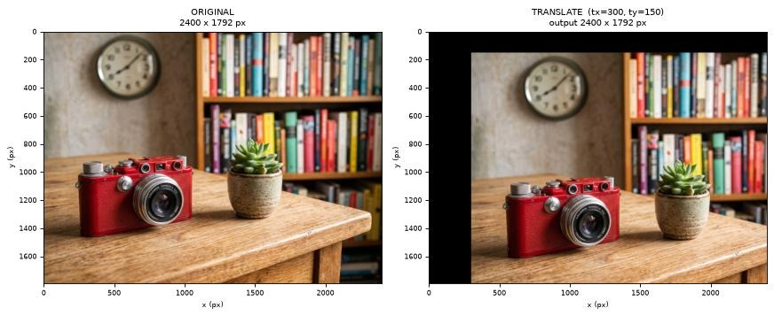
Figure 20 — Shift right and down, tx = +300, ty = +150
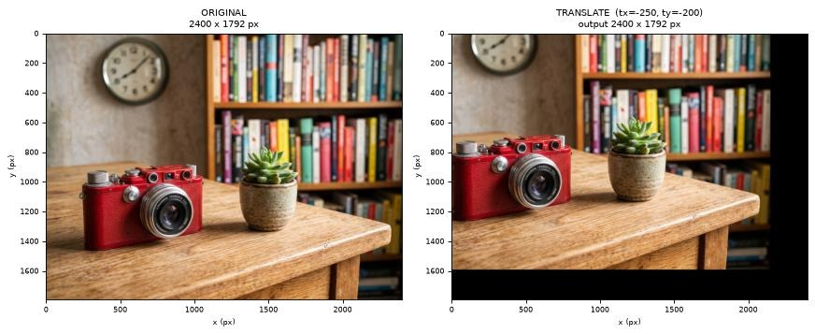
Figure 21 — Shift left and up, tx = −250, ty = −200
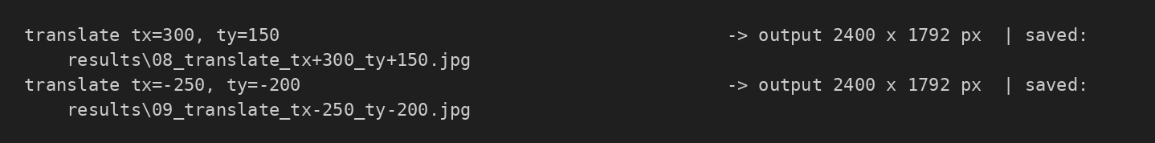
Figure 22 — Translation output dimensions (canvas unchanged)
tx | ty | Pixels kept | Kept % | Clipped % | Exposed black band
300 | 150 | 3448200 | 80.2 | 19.8 | 300 px wide (x) + 150 px tall (y)
-250 | -200 | 3422800 | 79.6 | 20.4 | 250 px wide (x) + 200 px tall (y)

Code
t1 = run(original, "translate", "08_translate_tx+300_ty+150.jpg", tx=300, ty=150) # right and down
t2 = run(original, "translate", "09_translate_tx-250_ty-200.jpg", tx=-250, ty=-200) # left and up

# quantify clipping for the two shifts
rows = []
for tx, ty in [(300, 150), (-250, -200)]:
kept = (W0 - abs(tx)) * (H0 - abs(ty))
rows.append({"tx": tx, "ty": ty,
"pixels kept": kept, "kept %": round(100 * kept / (W0 * H0), 1),
"clipped (lost) %": round(100 * (1 - kept / (W0 * H0)), 1),
"exposed black band": f"{abs(tx)} px wide (x) + {abs(ty)} px tall (y)"})
display(pd.DataFrame(rows))
Listing 13 — Two opposite shifts and the clipping table
The canvas keeps its original size. Pixels pushed past the canvas edge are clipped (permanently lost), and a band |tx| pixels wide and |ty| pixels tall is exposed on the opposite edges and filled with black (0, 0, 0). A positive tx moves the image right and a positive ty moves it down. For tx = 300, ty = 150 only 80.2% of the original pixels remain visible.

Rotation: Positive and Negative Angles
Result
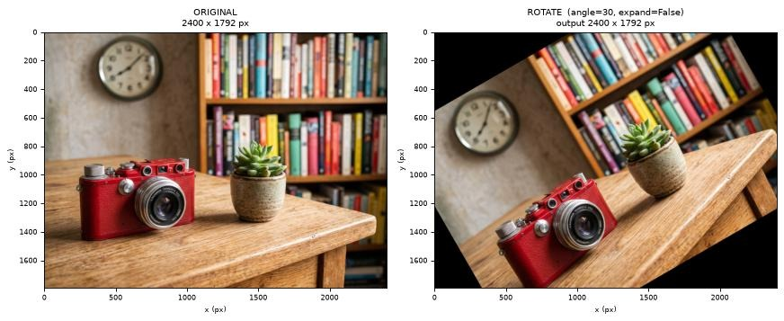
Figure 23 — Rotation +30°, canvas not expanded
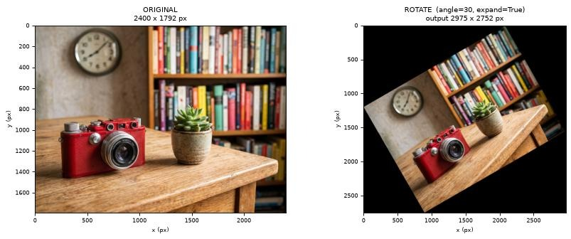
Figure 24 — Rotation +30°, canvas expanded
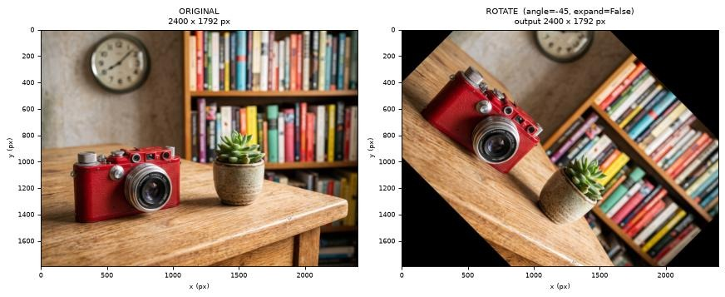
Figure 25 — Rotation −45°, canvas not expanded
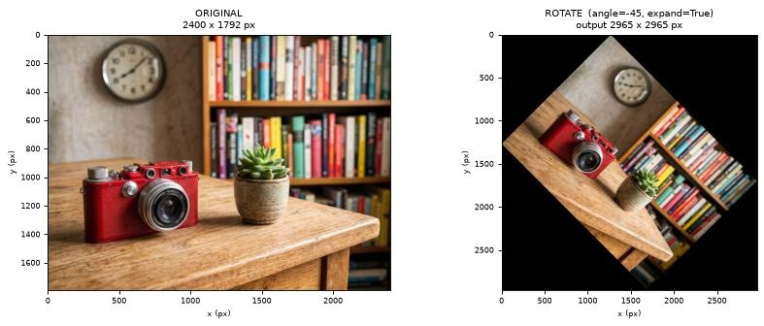
Figure 26 — Rotation −45°, canvas expanded
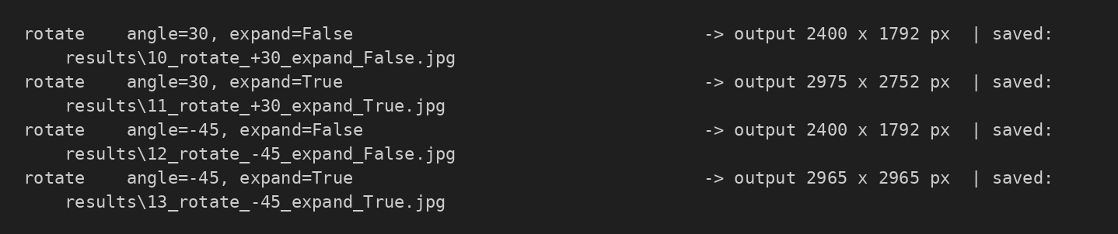
Figure 27 — Rotation output dimensions with and without expansion
Angle (°) | Formula w′ × h′ | Actual output | Match
30 | 2975 x 2752 | 2975 x 2752 | Yes
-45 | 2965 x 2965 | 2965 x 2965 | Yes

Code
r1 = run(original, "rotate", "10_rotate_+30_expand_False.jpg", angle=30, expand=False)
r2 = run(original, "rotate", "11_rotate_+30_expand_True.jpg", angle=30, expand=True)
r3 = run(original, "rotate", "12_rotate_-45_expand_False.jpg", angle=-45, expand=False)
r4 = run(original, "rotate", "13_rotate_-45_expand_True.jpg", angle=-45, expand=True)

# check the expanded sizes against the formula
rows = []
for ang, img in [(30, r2), (-45, r4)]:
t = math.radians(ang)
ew = math.ceil(round(W0 * abs(math.cos(t)) + H0 * abs(math.sin(t)), 6))
eh = math.ceil(round(W0 * abs(math.sin(t)) + H0 * abs(math.cos(t)), 6))
rows.append({"angle": ang, "formula w' x h'": f"{ew} x {eh}", "actual": f"{img.shape[1]} x {img.shape[0]}",
"match": (ew, eh) == (img.shape[1], img.shape[0])})
display(pd.DataFrame(rows))
Listing 14 — Positive and negative rotation with and without expansion
Rotation is about the image centre, and a positive angle rotates the image counter-clockwise as displayed (a negative angle rotates it clockwise). With expand = False the canvas keeps its size, the corners are clipped, and triangles of black background appear. With expand = True the canvas grows to w′ = w|cos θ| + h|sin θ| and h′ = w|sin θ| + h|cos θ| so that no pixel is lost. The table confirms that the actual output sizes equal the formula.

Affine Matrices Behind Translation and Rotation
Translation and rotation are affine transformations: each output position is a linear combination of the input position plus an offset, [x′, y′]ᵀ = A·[x, y]ᵀ + [tx, ty]ᵀ, stored as a 2 × 3 matrix M = [A | t] and applied with cv2.warpAffine. For a translation, A is the identity and t = (tx, ty). For a rotation by θ about the centre, A = [[cos θ, sin θ], [−sin θ, cos θ]] and t is chosen so that the image centre stays fixed (and is shifted again to the centre of the larger canvas when expand = True). The cell below prints the matrix of every translation and rotation demonstrated above and verifies that applying it directly with cv2.warpAffine reproduces the image returned by transform exactly.
Result
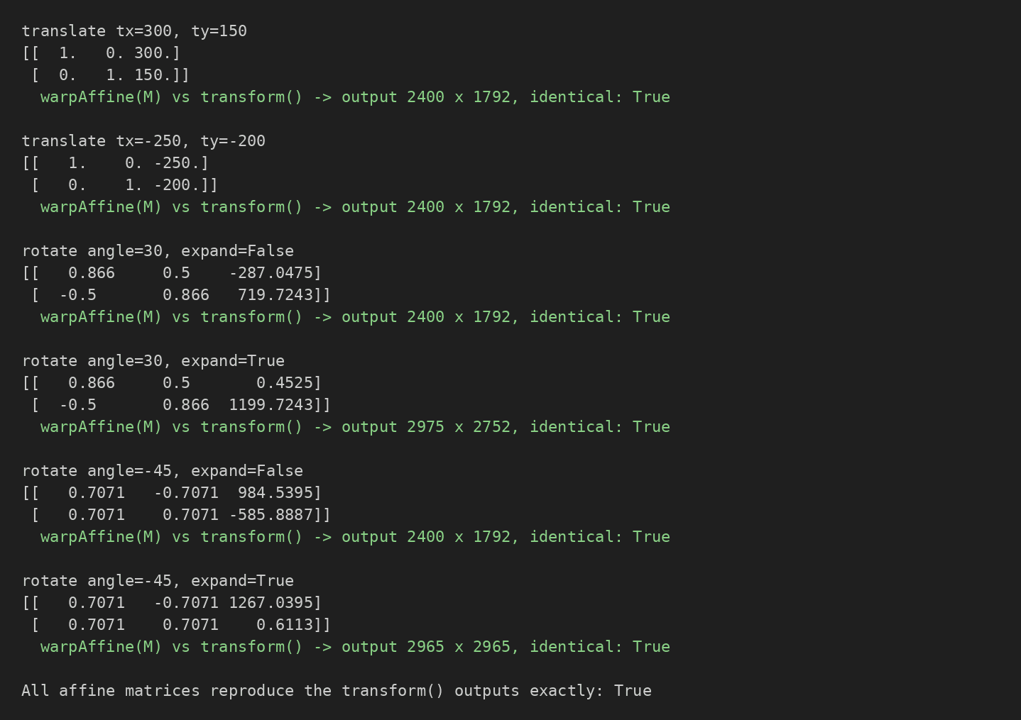
Figure 28 — Affine matrices and their verification against transform
Code
np.set_printoptions(precision=4, suppress=True)

def verify_affine(label, result, M, size):
direct = cv2.warpAffine(original, M, size, flags=ROTATION_INTERPOLATION,
borderMode=cv2.BORDER_CONSTANT, borderValue=FILL_VALUE)
same = direct.shape == result.shape and np.array_equal(direct, result)
print(f"{label}\n{M}\n warpAffine(M) vs transform() -> output {size[0]} x {size[1]}, "
f"identical: {same}\n")
return same

affine_ok = []
for (tx, ty), res in [((300, 150), t1), ((-250, -200), t2)]:
affine_ok.append(verify_affine(f"translate tx={tx}, ty={ty}", res, translation_matrix(tx, ty), (W0, H0)))

for (ang, exp), res in [((30, False), r1), ((30, True), r2), ((-45, False), r3), ((-45, True), r4)]:
M, ow, oh = rotation_matrix(W0, H0, ang, exp)
affine_ok.append(verify_affine(f"rotate angle={ang}, expand={exp}", res, M, (ow, oh)))

print("All affine matrices reproduce the transform() outputs exactly:", all(affine_ok))
Listing 15 — Printing and verifying the affine matrices

5 Interpolation Comparison
Objective: Compare nearest-neighbour, bilinear, bicubic, and Lanczos interpolation on the same enlarged image patch and describe the visible differences.

Same Patch Enlarged Six Times
A 160 × 100 patch showing a screw head and the edge of the silver lens ring is cropped with transform and then enlarged 6× to 960 × 600 pixels with each interpolation method through the same transform function. The patch is deliberately detailed, so differences are easy to see.
Result
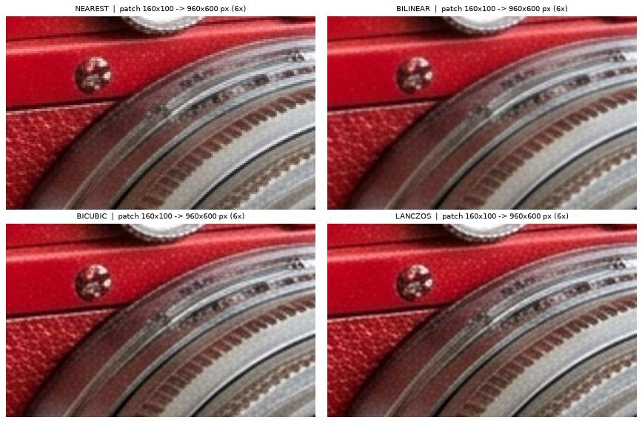
Figure 29 — The same patch enlarged 6× with each interpolation method
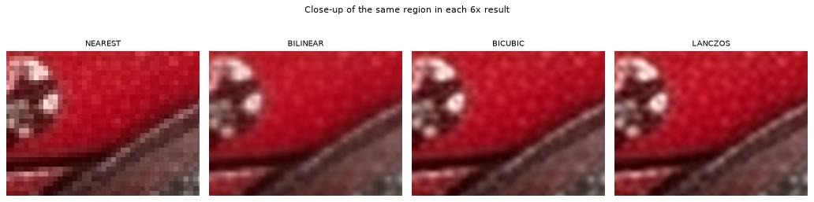
Figure 30 — Close-up of the same region in each 6× result
Method | Output size | Laplacian variance (edge strength)
nearest | 960 x 600 | 341.6
bilinear | 960 x 600 | 5.7
bicubic | 960 x 600 | 5.4
lanczos | 960 x 600 | 5.4

Method | Neighbourhood | Source pixels per output pixel | Best time (ms) | Visible character
nearest | 1 × 1 | 1 | 1.06 | Blocky, staircased edges
bilinear | 2 × 2 | 4 | 1.00 | Smooth, softest result
bicubic | 4 × 4 | 16 | 1.83 | Smooth, crisper edges
lanczos | 8 × 8 | 64 | 4.40 | Smooth, slightly more contrast

Code
patch = transform(original, "crop", left=640, top=1000, right=800, bottom=1100) # 160 x 100 px patch
save_image(os.path.join(RESULTS_DIR, "14_interp_patch_original.png"), patch)

enlarged = {}
for name in INTERPOLATIONS:
enlarged[name] = transform(patch, "scale", fx=6, fy=6, interpolation=name)
save_image(os.path.join(RESULTS_DIR, f"15_interp_patch_x6_{name}.png"), enlarged[name])

fig, axes = plt.subplots(2, 2, figsize=(11, 7.2))
for ax, (name, img) in zip(axes.ravel(), enlarged.items()):
ax.imshow(img)
ax.set_title(f"{name.upper()} | patch {patch.shape[1]}x{patch.shape[0]} -> {img.shape[1]}x{img.shape[0]} px (6x)", fontsize=9)
ax.axis("off")
plt.tight_layout(); plt.show()

def sharpness(img):
return cv2.Laplacian(cv2.cvtColor(img, cv2.COLOR_RGB2GRAY), cv2.CV_64F).var()

display(pd.DataFrame([{"method": n, "output size": f"{i.shape[1]} x {i.shape[0]}",
"Laplacian variance (edge strength)": round(sharpness(i), 1)} for n, i in enlarged.items()]))
Listing 16 — Enlarging the patch with each method and measuring edge strength
# Zoom further on a small region so pixel-level differences are clearly visible
fig, axes = plt.subplots(1, 4, figsize=(13, 3.6))
for ax, (name, img) in zip(axes, enlarged.items()):
zoom = img[120:300, 260:500]
ax.imshow(zoom); ax.set_title(name.upper(), fontsize=9); ax.axis("off")
plt.suptitle("Close-up of the same region in each 6x result", fontsize=10)
plt.tight_layout(); plt.show()
Listing 17 — Close-up of the same region in each result

Observations
Nearest-neighbour: copies the closest source pixel, so every source pixel becomes a visible 6 × 6 block. Edges are staircased and the screw head and the ridge of the lens ring look jagged and blocky. It invents no new colours and does the least arithmetic per pixel.
Bilinear: averages the 4 nearest pixels. The blockiness is gone and edges are smooth, but this is the softest result: the screw and the thin bright ridge look blurred.
Bicubic: uses a 4 × 4 neighbourhood. It is smooth like bilinear but keeps edges and the screw outline visibly crisper.
Lanczos: uses an 8 × 8 neighbourhood. It looks very close to bicubic; the difference is subtle, with slightly more contrast on the thin bright ridge and the screw highlights. Its larger kernel makes it the most expensive method per output pixel: the best of 30 timed runs was 4.40 ms for Lanczos, against 1.83 ms for bicubic and about 1.0 ms for nearest and bilinear (differences of a fraction of a millisecond between those two are timing noise).
About the table: the Laplacian variance of nearest (about 342) is far higher than the other three (about 5 to 6) only because the hard block boundaries are strong artificial edges, so the number must not be read as “more real detail”. Among the three smooth methods the metric cannot separate them (bilinear at 5.7 is even marginally above bicubic and Lanczos at 5.4), so visual inspection is used for those three; the visual comparison is the more reliable evidence here.

6 Input Validation
Objective: Show that invalid inputs are rejected with clear messages (at least one per operation), that valid boundary inputs are accepted, and that no case causes an unhandled crash or a silent default.

Rejected Inputs
expect_rejection calls transform with an invalid input and records the error message. A case passes only if ValidationError is raised. Several cases are shown for every operation, including an unsupported flip direction and a non-numeric, NaN, or infinite rotation angle, plus general failures (unknown operation, missing or extra parameters, bad image).
Result
Operation | Invalid input | Error message | Result
scale | fx = 0 | scale factors must be greater than zero, got fx=0.0, fy=1.0. | PASS
scale | fy = -2 (negative) | scale factors must be greater than zero, got fx=1.0, fy=-2.0. | PASS
scale | fx = NaN | 'fx' must be finite (not NaN or infinity), got nan. | PASS
scale | fy = infinity | 'fy' must be finite (not NaN or infinity), got inf. | PASS
scale | fx = 'abc' (non-numeric) | 'fx' must be a number, got 'abc' (str). | PASS
scale | unsupported interpolation 'sinc' | unsupported interpolation 'sinc'. Choose one of: nearest, bilinear, bicubic, lanczos. | PASS
scale | empty output (fx = 0.0001 -> width 0) | output would be 0 x 1792 px; both dimensions must be at least 1 pixel. | PASS
scale | output too large (fx = fy = 5) | output 12000 x 8960 px exceeds the maximum side length of 10000 px. | PASS
scale | missing parameter (no interpolation) | 'scale' is missing required parameter(s): interpolation. | PASS
crop | right <= left (600 <= 800) | horizontal crop must satisfy 0 <= left < right <= 2400; got left=800, right=600. | PASS
crop | right beyond width | horizontal crop must satisfy 0 <= left < right <= 2400; got left=0, right=2401. | PASS
crop | negative left | horizontal crop must satisfy 0 <= left < right <= 2400; got left=-1, right=100. | PASS
crop | bottom <= top (empty region) | vertical crop must satisfy 0 <= top < bottom <= 1792; got top=100, bottom=100. | PASS
crop | non-integer coordinate 10.5 | 'left' must be an integer, got 10.5 (float). | PASS
flip | unsupported direction 'diagonal' | unsupported flip direction 'diagonal'. Choose one of: horizontal, vertical, both. | PASS
flip | direction = None | unsupported flip direction None. Choose one of: horizontal, vertical, both. | PASS
translate | tx = NaN | 'tx' must be finite (not NaN or infinity), got nan. | PASS
translate | ty = -infinity | 'ty' must be finite (not NaN or infinity), got -inf. | PASS
translate | tx = 'ten' (non-numeric) | 'tx' must be a number, got 'ten' (str). | PASS
translate | missing ty | 'translate' is missing required parameter(s): ty. | PASS
rotate | angle = 'ninety' (non-numeric) | 'angle' must be a number, got 'ninety' (str). | PASS
rotate | angle = NaN | 'angle' must be finite (not NaN or infinity), got nan. | PASS
rotate | angle = infinity | 'angle' must be finite (not NaN or infinity), got inf. | PASS
rotate | expand = 'maybe' | 'expand' must be True or False, got 'maybe' (str). | PASS
rotate | missing expand | 'rotate' is missing required parameter(s): expand. | PASS
general | unknown operation 'blur' | unknown operation 'blur'. Supported: scale, crop, flip, translate, rotate. | PASS
general | operation = 5 (not a string) | operation must be a string, got int. | PASS
general | unexpected extra parameter | 'flip' got unexpected parameter(s): speed. Allowed: direction. | PASS
general | image is None | image must be a NumPy array, got NoneType. | PASS
general | empty image array | image has zero size: (0, 10, 3). | PASS

Figure 31 — Summary of the rejection test
Code
rejection_log = []

def expect_rejection(operation_label, case, image, operation, **params):
try:
transform(image, operation, **params)
rejection_log.append({"operation": operation_label, "invalid input": case,
"result": "NOT REJECTED (FAIL)", "message": ""})
except ValidationError as e:
rejection_log.append({"operation": operation_label, "invalid input": case,
"result": "Rejected (PASS)", "message": str(e)})

# ---------------- scaling
expect_rejection("scale", "fx = 0", original, "scale", fx=0, fy=1, interpolation="bilinear")
expect_rejection("scale", "fy = -2 (negative)", original, "scale", fx=1, fy=-2, interpolation="bilinear")
expect_rejection("scale", "fx = NaN", original, "scale", fx=float("nan"), fy=1, interpolation="bilinear")
expect_rejection("scale", "fy = infinity", original, "scale", fx=1, fy=float("inf"), interpolation="bilinear")
expect_rejection("scale", "fx = 'abc' (non-numeric)", original, "scale", fx="abc", fy=1, interpolation="bilinear")
expect_rejection("scale", "unsupported interpolation 'sinc'", original, "scale", fx=1, fy=1, interpolation="sinc")
expect_rejection("scale", "empty output (fx = 0.0001 -> width 0)", original, "scale", fx=0.0001, fy=1, interpolation="nearest")
expect_rejection("scale", "output too large (fx = fy = 5)", original, "scale", fx=5, fy=5, interpolation="nearest")
expect_rejection("scale", "missing parameter (no interpolation)", original, "scale", fx=1, fy=1)
# ---------------- cropping
expect_rejection("crop", "right <= left (600 <= 800)", original, "crop", left=800, top=0, right=600, bottom=500)
expect_rejection("crop", "right beyond width", original, "crop", left=0, top=0, right=W0 + 1, bottom=100)
expect_rejection("crop", "negative left", original, "crop", left=-1, top=0, right=100, bottom=100)
expect_rejection("crop", "bottom <= top (empty region)", original, "crop", left=0, top=100, right=100, bottom=100)
expect_rejection("crop", "non-integer coordinate 10.5", original, "crop", left=10.5, top=0, right=100, bottom=100)
# ---------------- flipping
expect_rejection("flip", "unsupported direction 'diagonal'", original, "flip", direction="diagonal")
expect_rejection("flip", "direction = None", original, "flip", direction=None)
# ---------------- translation
expect_rejection("translate", "tx = NaN", original, "translate", tx=float("nan"), ty=0)
expect_rejection("translate", "ty = -infinity", original, "translate", tx=0, ty=float("-inf"))
expect_rejection("translate", "tx = 'ten' (non-numeric)", original, "translate", tx="ten", ty=0)
expect_rejection("translate", "missing ty", original, "translate", tx=5)
# ---------------- rotation
expect_rejection("rotate", "angle = 'ninety' (non-numeric)", original, "rotate", angle="ninety", expand=True)
expect_rejection("rotate", "angle = NaN", original, "rotate", angle=float("nan"), expand=True)
expect_rejection("rotate", "angle = infinity", original, "rotate", angle=float("inf"), expand=False)
expect_rejection("rotate", "expand = 'maybe'", original, "rotate", angle=10, expand="maybe")
expect_rejection("rotate", "missing expand", original, "rotate", angle=10)
# ---------------- general
expect_rejection("general", "unknown operation 'blur'", original, "blur", radius=3)
expect_rejection("general", "operation = 5 (not a string)", original, 5)
expect_rejection("general", "unexpected extra parameter", original, "flip", direction="both", speed=3)
expect_rejection("general", "image is None", None, "flip", direction="both")
expect_rejection("general", "empty image array", np.zeros((0, 10, 3), np.uint8), "flip", direction="both")

rej = pd.DataFrame(rejection_log)
display(rej)
print(f"{(rej['result'] == 'Rejected (PASS)').sum()} of {len(rej)} invalid inputs were correctly rejected with a clear message "
f"(and no unhandled crash).")
Listing 18 — Thirty invalid inputs and the rejection log

Valid Boundary Inputs That Must Be Accepted
Valid zero values, negative values, and exact boundaries must not be rejected. Each row states the shape the output is expected to have and compares it with the actual shape.
Result
Valid boundary input | Expected shape | Actual shape | Result
crop the whole image (0, 0, W, H) | (1792, 2400, 3) | (1792, 2400, 3) | PASS
crop a single pixel | (1, 1, 3) | (1, 1, 3) | PASS
translate tx = 0, ty = 0 | (1792, 2400, 3) | (1792, 2400, 3) | PASS
translate negative tx = -50, ty = -50 | (1792, 2400, 3) | (1792, 2400, 3) | PASS
translate entirely off the canvas (tx = W) | (1792, 2400, 3) | (1792, 2400, 3) | PASS
rotate angle = 0 | (1792, 2400, 3) | (1792, 2400, 3) | PASS
rotate negative angle = -90, expand=False | (1792, 2400, 3) | (1792, 2400, 3) | PASS
rotate 90 degrees, expand=True (swaps W,H) | (2400, 1792, 3) | (2400, 1792, 3) | PASS
rotate huge finite angle 1e9 | (1792, 2400, 3) | (1792, 2400, 3) | PASS
scale to the smallest valid output (1 x 1) | (1, 1, 3) | (1, 1, 3) | PASS
scale 'BILINEAR ' (case/space tolerant) | (896, 1200, 3) | (896, 1200, 3) | PASS

7 Identity Checks
Objective: Verify that zero translation, scale factors of one, and zero rotation leave the image exactly unchanged, and record the expected behaviour, actual behaviour, and Pass or Fail.

Expected Versus Actual Behaviour
Result
Check | Expected behaviour | Actual behaviour | Pass / Fail
translate tx=0, ty=0 | Output identical to original (same shape, 0 differing values) | shape (1792, 2400, 3), 0 differing values | Pass
scale fx=1, fy=1 (nearest) | Output identical to original (same shape, 0 differing values) | shape (1792, 2400, 3), 0 differing values | Pass
scale fx=1, fy=1 (bilinear) | Output identical to original (same shape, 0 differing values) | shape (1792, 2400, 3), 0 differing values | Pass
scale fx=1, fy=1 (bicubic) | Output identical to original (same shape, 0 differing values) | shape (1792, 2400, 3), 0 differing values | Pass
scale fx=1, fy=1 (lanczos) | Output identical to original (same shape, 0 differing values) | shape (1792, 2400, 3), 0 differing values | Pass
rotate angle=0, expand=False | Output identical to original (same shape, 0 differing values) | shape (1792, 2400, 3), 0 differing values | Pass
rotate angle=0, expand=True | Output identical to original (same shape, 0 differing values) | shape (1792, 2400, 3), 0 differing values | Pass
rotate angle=360, expand=False | Output identical to original (same shape, 0 differing values) | shape (1792, 2400, 3), 0 differing values | Pass
crop whole image | Output identical to original (same shape, 0 differing values) | shape (1792, 2400, 3), 0 differing values | Pass
flip horizontal applied twice | Output identical to original (same shape, 0 differing values) | 0 differing values | Pass
rotate +90 then -90 (expand=True) | Same shape; values equal within +/-1 (resampling rounding) | shape (1792, 2400, 3), max abs difference 0 | Pass

Figure 32 — Summary of the identity checks
Code
checks = []

def identity_check(name, expected, **call):
out = transform(original, **call)
same_shape = out.shape == original.shape
diff = int(np.count_nonzero(out != original)) if same_shape else -1
ok = same_shape and diff == 0
actual = (f"shape {out.shape}, {diff} differing values" if same_shape else f"shape changed to {out.shape}")
checks.append({"check": name, "expected behaviour": expected, "actual behaviour": actual,
"Pass/Fail": "Pass" if ok else "Fail"})

expected_same = "Output identical to original (same shape, 0 differing values)"
identity_check("translate tx=0, ty=0", expected_same, operation="translate", tx=0, ty=0)
for m in INTERPOLATIONS:
identity_check(f"scale fx=1, fy=1 ({m})", expected_same, operation="scale", fx=1, fy=1, interpolation=m)
identity_check("rotate angle=0, expand=False", expected_same, operation="rotate", angle=0, expand=False)
identity_check("rotate angle=0, expand=True", expected_same, operation="rotate", angle=0, expand=True)
identity_check("rotate angle=360, expand=False", expected_same, operation="rotate", angle=360, expand=False)
identity_check("crop whole image", expected_same, operation="crop", left=0, top=0, right=W0, bottom=H0)

# flipping twice returns the original
twice = transform(transform(original, "flip", direction="horizontal"), "flip", direction="horizontal")
checks.append({"check": "flip horizontal applied twice", "expected behaviour": expected_same,
"actual behaviour": f"{int(np.count_nonzero(twice != original))} differing values",
"Pass/Fail": "Pass" if np.array_equal(twice, original) else "Fail"})

# rotate +90 then -90 (expand=True) returns the original
back = transform(transform(original, "rotate", angle=90, expand=True), "rotate", angle=-90, expand=True)
ok = back.shape == original.shape and int(np.abs(back.astype(int) - original.astype(int)).max()) <= 1
checks.append({"check": "rotate +90 then -90 (expand=True)", "expected behaviour": "Same shape; values equal within +/-1 (resampling rounding)",
"actual behaviour": f"shape {back.shape}, max abs difference {int(np.abs(back.astype(int) - original.astype(int)).max())}",
"Pass/Fail": "Pass" if ok else "Fail"})

check_df = pd.DataFrame(checks)
display(check_df)
print(f"{(check_df['Pass/Fail'] == 'Pass').sum()} of {len(check_df)} checks passed.")
Listing 19 — Identity and round-trip checks
Translation by (0, 0), scaling by 1 with every interpolation method, rotation by 0° (with and without expansion), rotation by 360°, and cropping the whole image all return an array with the same shape and zero differing values. Flipping twice returns the original exactly. Rotating by +90° and then −90° with expansion returns the same shape with values equal within ±1, which is the expected rounding of one resampling step.

8 Observations
Objective: Explain image coordinates versus array indexing, aspect-ratio distortion, rotation canvas expansion, and translation clipping, with measured evidence.

Image Coordinates Versus Array Indexing
Result
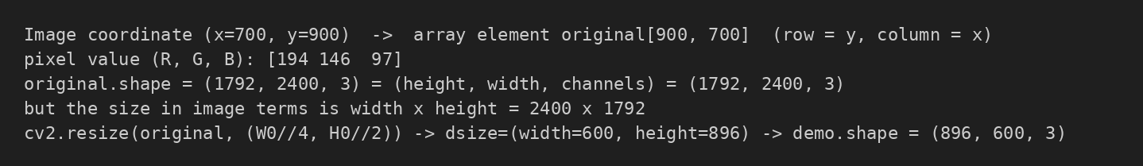
Figure 33 — A point in image coordinates and the matching array element
Code
x, y = 700, 900 # a point in IMAGE coordinates: x to the right, y downwards
print(f"Image coordinate (x={x}, y={y}) -> array element original[{y}, {x}] (row = y, column = x)")
print("pixel value (R, G, B):", original[y, x])
print(f"original.shape = {original.shape} = (height, width, channels) = ({H0}, {W0}, 3)")
print(f"but the size in image terms is width x height = {W0} x {H0}")

# demonstrate with cv2.resize, which takes (width, height), while shape gives (height, width)
demo = cv2.resize(original, (W0 // 4, H0 // 2))
print(f"cv2.resize(original, (W0//4, H0//2)) -> dsize=(width={W0//4}, height={H0//2}) -> demo.shape = {demo.shape}")
Listing 20 — Coordinates versus indexing
Image coordinates are written (x, y): x is the column counted from the left and y is the row counted downwards from the top, with the origin (0, 0) at the top-left pixel.
NumPy indexing is array[row, column] = array[y, x], so the order is swapped. array.shape is (height, width, channels), while sizes in OpenCV calls such as cv2.resize(img, (width, height)) and cv2.warpAffine(…, (width, height)) are given as (width, height).
Mixing the two orders is a classic bug. Cropping is img[top:bottom, left:right] (rows first), and because the y axis points down, a positive ty moves content down. Crop limits are half-open: right and bottom are exclusive, so the crop shape is (bottom − top, right − left).

Aspect-Ratio Distortion
Result
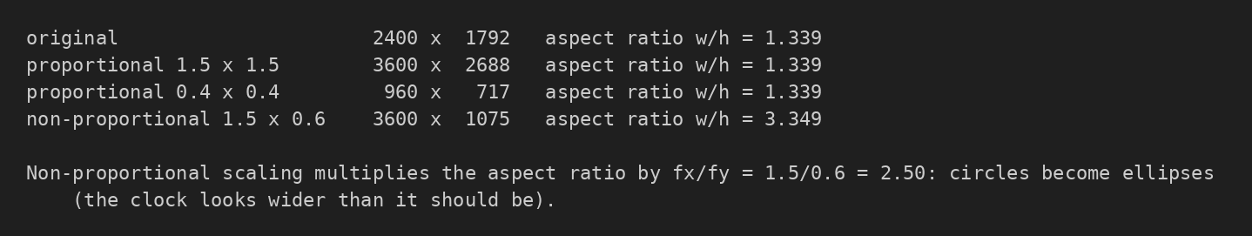
Figure 34 — Aspect ratios of proportional and non-proportional scaling
Code
for label, img in [("original", original), ("proportional 1.5 x 1.5", up), ("proportional 0.4 x 0.4", down),
("non-proportional 1.5 x 0.6", nonp)]:
h, w = img.shape[:2]
print(f"{label:28} {w:5d} x {h:5d} aspect ratio w/h = {w/h:.3f}")
print(f"\nNon-proportional scaling multiplies the aspect ratio by fx/fy = 1.5/0.6 = {1.5/0.6:.2f}: "
f"circles become ellipses (the clock looks wider than it should be).")
Listing 21 — Aspect ratio of each scaled image
Equal factors (fx = fy) preserve the width-to-height ratio, so shapes keep their proportions. When fx ≠ fy the ratio changes by fx / fy: the image is stretched along one axis only, so the round clock becomes an ellipse and the plant pot is distorted. That is correct behaviour for non-proportional scaling, but it should be used knowingly.

Rotation Canvas Expansion
Result
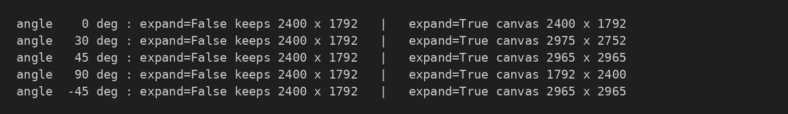
Figure 35 — Canvas size with and without expansion for several angles
Code
for ang in (0, 30, 45, 90, -45):
t = math.radians(ang)
ew = math.ceil(round(W0 * abs(math.cos(t)) + H0 * abs(math.sin(t)), 6))
eh = math.ceil(round(W0 * abs(math.sin(t)) + H0 * abs(math.cos(t)), 6))
print(f"angle {ang:4d} deg : expand=False keeps {W0} x {H0} | expand=True canvas {ew} x {eh}")
Listing 22 — Expanded canvas size for several angles
With expand = False the output keeps the original canvas size, so the rotated image’s corners fall outside the canvas and are clipped, while triangular regions of black background appear. With expand = True the canvas is enlarged to the bounding box of the rotated rectangle, so no pixel is lost, at the cost of a larger image and more black background. At exactly 90° the width and height are swapped, and at 0° the size is unchanged.

Translation Clipping
Result
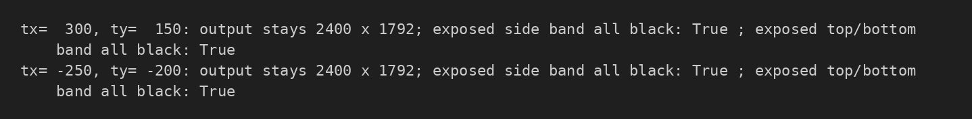
Figure 36 — Exposed bands after translation are entirely black
Code
for tx, ty in [(300, 150), (-250, -200)]:
out = transform(original, "translate", tx=tx, ty=ty)
black_cols = out[:, :abs(tx)] if tx > 0 else out[:, W0 - abs(tx):]
black_rows = out[:abs(ty), :] if ty > 0 else out[H0 - abs(ty):, :]
print(f"tx={tx:5d}, ty={ty:5d}: output stays {out.shape[1]} x {out.shape[0]}; "
f"exposed side band all black: {not black_cols.any()} ; exposed top/bottom band all black: {not black_rows.any()}")
Listing 23 — Checking the exposed bands
Translation keeps the original canvas size. Shifting by (tx, ty) pushes part of the image past the canvas edge and those pixels are clipped (permanently lost); shifting back later cannot restore them. On the opposite edges a band |tx| pixels wide and |ty| pixels tall is exposed and filled with black (0, 0, 0), the declared background. A shift that is at least as large as the width or height removes the whole image and leaves a black canvas.

9 Final Check and Submission
Objective: Confirm that the original image was never modified, list all saved results, and list the files that are submitted in the repository.

Final Integrity Check
Result
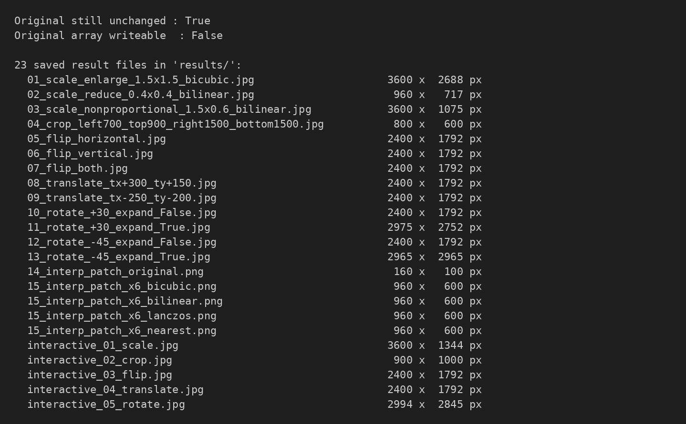
Figure 37 — Original unchanged and the 23 saved result files
Code
final_hash = hashlib.sha256(original.tobytes()).hexdigest()
print("Original still unchanged :", final_hash == ORIGINAL_HASH)
print("Original array writeable :", original.flags.writeable)
assert final_hash == ORIGINAL_HASH, "The original image was modified!"

files = sorted(os.listdir(RESULTS_DIR))
print(f"\n{len(files)} saved result files in '{RESULTS_DIR}/':")
for f in files:
im = cv2.imread(os.path.join(RESULTS_DIR, f))
print(f" {f:55} {im.shape[1]:5d} x {im.shape[0]:5d} px")
Listing 24 — Final integrity check and list of saved results
The SHA-256 hash of the original image is identical to the hash recorded at load time and the array is still read-only, so no operation modified it. All 23 result files exist in the results folder with the expected dimensions.

Submitted Files
File | Description
2024-SE-31-LAB04.ipynb | Completed notebook: transform, prompts, demonstrations, validation, checks, observations
input_image.jpg | Input image (2400 × 1792, colour)
results/ | Saved transformed images: 13 demonstrations, 5 interpolation patches, 5 interactive-session results
README.md | Repository description
requirements.txt | Python packages needed to run the notebook
.gitignore | Excludes the virtual environment and notebook caches
2024-SE-31-LAB04.docx | This report

The .venv folder and the .ipynb_checkpoints cache are not submitted.

