LAB REPORT · 01
University of Azad Jammu and Kashmir
Department of Software Engineering

Digital Image Processing Lab
Lab Task #01
Python Setup, Fundamentals, and Imports
Installation and setup · Python fundamentals · Package imports
STUDENT NAME | Sheikh Haseeb-ur-Rehman
ROLL NUMBER | 2024-SE-31
INSTRUCTOR | Engr. Fahad Nisar
SEMESTER | Fifth
SESSION | 2024-28 (SE)
DATE | October 22, 2026

1 Installation and Setup
Objective: Verify the installation of Python, the pip package manager, and the configuration of the Visual Studio Code environment.
■ Version Check Commands:
python --version
python -m pip --version
Listing 1 — Commands used to verify Python and pip
■ Python and Pip Versions:
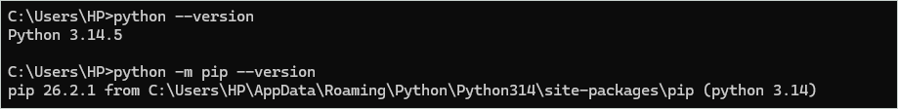
Figure 1 — Python and pip versions
■ VS Code Interpreter Selection:
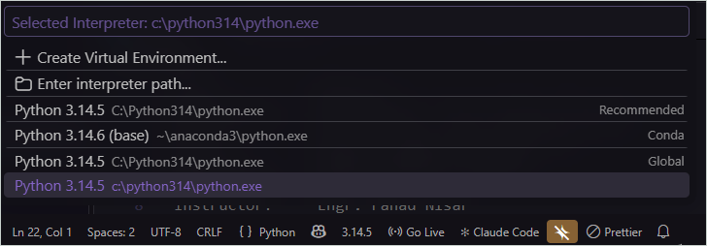
Figure 2 — VS Code interpreter selection
■ First Python Program (hello.py):
▸ Code
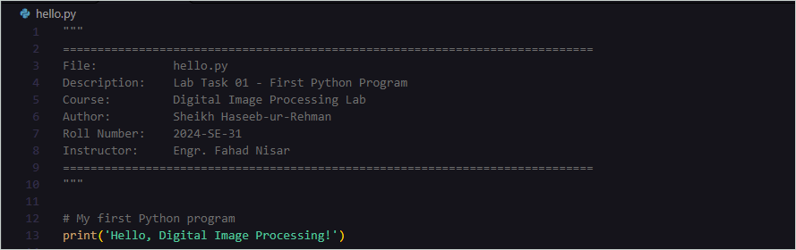
Figure 3 — hello.py code
▸ Output
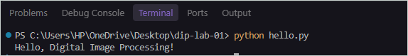
Figure 4 — hello.py terminal output
2 Python Fundamentals (basics.py)
Objective: Demonstrate proficiency in Python variables, data types, conditional statements, loops, functions, and collections.
Exercises 1 & 2: Variables, Data Types, and Conditions
■ Exercise 1
▸ Code
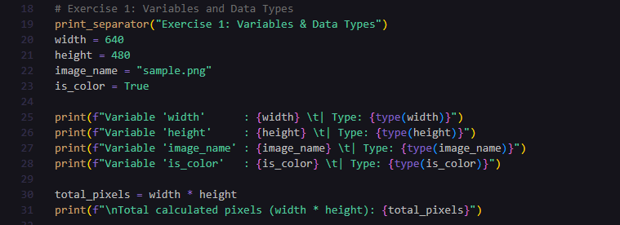
Figure 5 — Exercise 1 code
▸ Output
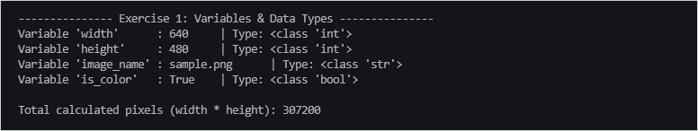
Figure 6 — Exercise 1 output
■ Exercise 2
▸ Code
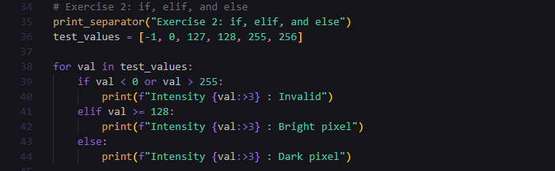
Figure 7 — Exercise 2 code
▸ Output
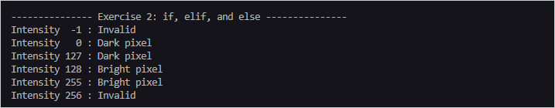
Figure 8 — Exercise 2 output
Exercises 3 & 4: Loops and Functions
■ Exercise 3
▸ Code
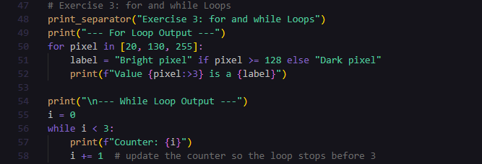
Figure 9 — Exercise 3 code
▸ Output
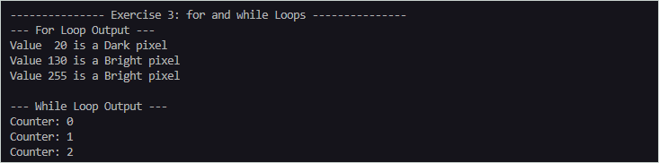
Figure 10 — Exercise 3 output
■ Exercise 4
▸ Code
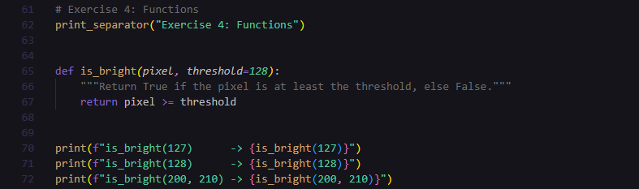
Figure 11 — Exercise 4 code
▸ Output
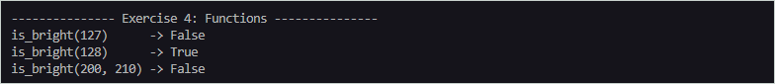
Figure 12 — Exercise 4 output
Exercises 5 & 6: Collections (Lists, Tuples, Dictionaries, Sets)
■ Exercise 5
▸ Code
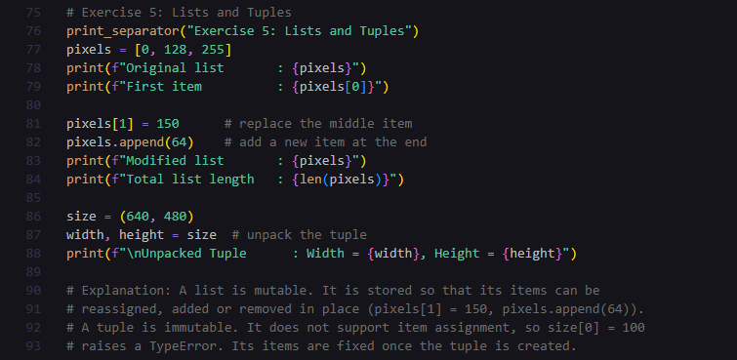
Figure 13 — Exercise 5 code
▸ Output
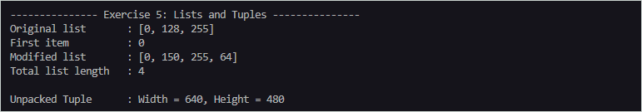
Figure 14 — Exercise 5 output
■ Exercise 6
▸ Code
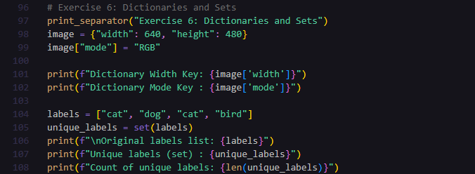
Figure 15 — Exercise 6 code
▸ Output
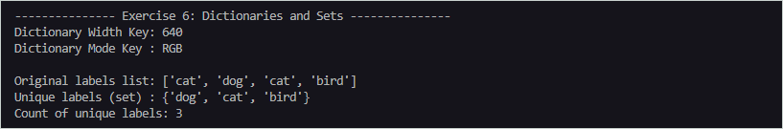
Figure 16 — Exercise 6 output
Understanding Mutability: As demonstrated in Exercise 5, a list is a mutable collection: its items can be reassigned, added or removed in place (for example pixels[1] = 150 and pixels.append(64)). A tuple is immutable: it does not support item assignment, so an attempt such as size[0] = 100 raises a TypeError, and its items stay fixed once the tuple is created.
3 Package Management and Imports
Objective: Install required external libraries for digital image processing and verify their successful import.
■ Installation Commands:
python -m pip install numpy pillow matplotlib
python -m pip show numpy pillow matplotlib
Listing 2 — Installing and inspecting the required packages
■ Installed Package Details:
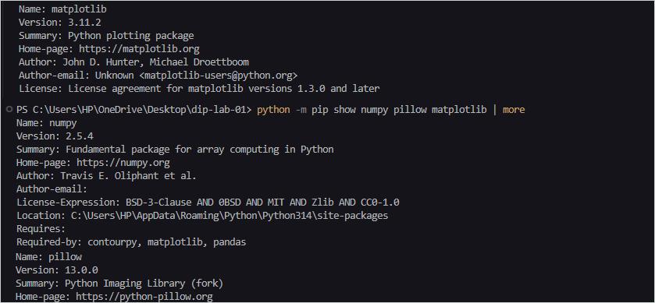
Figure 17 — pip show output for numpy, pillow, matplotlib
■ Import Verification (lab01_imports.py):
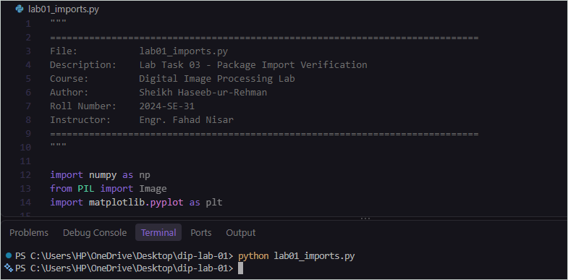
Figure 18 — lab01_imports.py code
4 Technical Summary
Python serves as the core runtime language that executes our programmatic logic, while pip functions as its dedicated package manager, enabling us to easily download and install external libraries like NumPy and Pillow. The import statements are then required to link these external libraries into our current working script, granting us access to their pre-built, specialized functions for tasks such as numerical computation, image manipulation, and data visualization.
■ Key Import Statements:
import numpy as np
from PIL import Image
import matplotlib.pyplot as plt
Listing 3 — Imports linking NumPy, Pillow, and Matplotlib into the script

