THE UNIVERSITY OF AZAD JAMMU AND KASHMIR
Department of Software Engineering
LAB REPORT 1
Use Case Diagrams
Modelling the online reservation system and credit card processing in UML
COURSE | Software Construction & Development (Lab)
COURSE CODE | SE-3102
SEMESTER | Fall 2026
INSTRUCTOR | Engr. Dr. Asma Javaid
TOOL USED | Visual Paradigm Community Edition
SUBMITTED BY | Sheikh Haseeb-ur-Rehman
ROLL NUMBER | 2024-SE-31
DATE | October, 26 2026

Table of Contents
1. Introduction 3
2. Task 1: Online Ticket Reservation System 4
2.1 Overview and Actor Identification 4
2.2 Solution Diagram 4
2.3 Key Use Case Specification 4
3. Task 2: Credit Card Processing System (Case Study) 5
3.1 Overview and Actor Identification 5
3.2 Solution Diagram 5
3.3 Key Use Case Specification 6
4. Summary and Conclusion 6

1. Introduction
This laboratory report documents the system modeling, actor identification, and use case specifications executed for Laboratory 01 of the Software Construction & Development course. The lab covers two software system domains: an Online Ticket Reservation System (Task 1) and a Point-of-Sale (POS) Credit Card Processing System (Task 2).
Table 1: Summary of lab tasks
Task | System | Interaction | Diagram
1 | Online Ticket Reservation System | Web user interface | UML use case diagram
2 | Credit Card Processing System | POS terminal hardware | UML use case diagram

2. Task 1: Online Ticket Reservation System

2.1 Overview and Actor Identification
- Customer (Primary Actor): Browses travel/event schedules, selects seats, and processes online payments.
- System Admin (Secondary Actor): Manages ticket cancellations and releases seat inventory.
- Core Use Cases: Search Ticket, Book Ticket, Process Payment, and Cancel Booking.

2.2 Solution Diagram
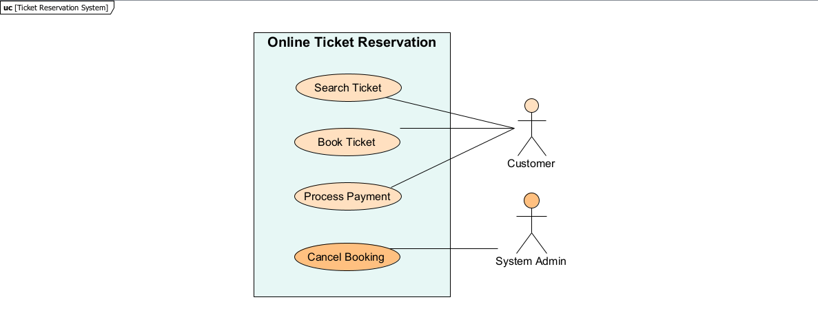
Figure 1: Use case diagram of the Online Ticket Reservation System

2.3 Key Use Case Specification
Table 2: UC-01 Book Ticket
Field | Details
Use Case Name | UC-01: Book Ticket
Primary Actor | Customer
Pre-Conditions | Customer has searched for tickets and selected a seat.
Main Flow | 1. Customer selects ticket and clicks 'Book Ticket'.  2. System locks seat inventory for 10 minutes.  3. Customer confirms payment details.
Post-Conditions | Booking record status set to 'Pending Payment'.
Exceptions | Selected seat concurrently booked: system prompts re-selection.

3. Task 2: Credit Card Processing System (Case Study)

3.1 Overview and Actor Identification
- Customer (Primary Actor): Selects items, swipes credit card, and signs physical purchase receipt.
- Vendor (Operational Actor): Generates purchase bill and hands printed balance statements to customer.
- Card Reader (Hardware Actor): Reads card data, communicates with bank server, and prints statements.
- Core Use Cases: Select Item, Swap Card, Generate Bill, Process Amount Transaction, Issue Balance Statement, Sign Receipt.

3.2 Solution Diagram
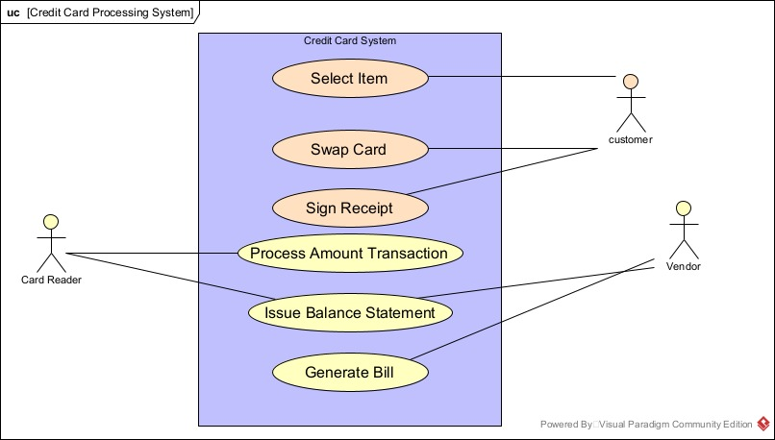
Figure 2: Use case diagram of the Credit Card Processing System

3.3 Key Use Case Specification
Table 3: UC-02 Process Amount Transaction
Field | Details
Use Case Name | UC-02: Process Amount Transaction
Primary Actors | Card Reader (Hardware), Vendor, Customer
Pre-Conditions | Card swiped in POS terminal; total bill calculated by Vendor.
Main Flow | 1. Card reader reads card data and sends bank authorization.  2. Bank validates limit and approves transaction amount.  3. Balance decremented and confirmation returned.
Post-Conditions | Transaction completed and merchant account credited.
Exceptions | Insufficient balance: card reader displays 'Declined'.

4. Summary and Conclusion
- System Differences: Task 1 relies on web UI user interaction, whereas Task 2 operates through physical POS terminal hardware interaction.
- Validation Model: Ticket booking uses temporary seat holds (asynchronous), whereas credit card processing requires real-time synchronous bank verification.
In this lab, UML Use Case diagrams were analyzed and documented for online ticketing and POS transaction systems. System boundaries were established, human and hardware actors were categorized, and core functional flows were documented into concise specifications.

