THE UNIVERSITY OF AZAD JAMMU AND KASHMIR
Department of Software Engineering
LAB REPORT 2
Activity and State Machine Diagrams
Modelling the foodPanda, Toaster and Elevator systems in UML

COURSE | Software Construction & Development (Lab)
COURSE CODE | SE-3102
SEMESTER | Fall 2026
INSTRUCTOR | Engr. Dr. Asma Javaid
TOOL USED | Visual Paradigm Community Edition
SUBMITTED BY | Sheikh Haseeb-ur-Rehman
ROLL NUMBER | 2024-SE-31
DATE | October, 26 2026

Table of Contents
1. Overview 3
2. Method: How Each Diagram Was Built 3
3. Task 1: foodPanda Activity Diagram (Swimlanes) 4
3.1 Steps to Build It 4
3.2 How to Read It 4
4. Task 2: Toaster State Machine 5
4.1 Steps to Build It 5
4.2 Activities Within Each State 5
4.3 Transitions: Triggered and Triggerless 6
5. Task 3: Elevator State Machine 7
5.1 Steps to Build It 7
5.2 How to Read It 8
6. Conclusion 8

1. Overview
This lab practises two UML behavioural diagrams: the activity diagram, which shows how work flows between people or systems, and the state machine diagram, which shows how one object changes state in response to events. Three diagrams were modelled.
Table 1: Summary of lab tasks
Task | System | Diagram Type | Key Idea
Q1 | foodPanda ordering | Activity diagram with swimlanes | Who does what, and in what order
Q2 | Toaster | State machine | Activities inside states, triggered and triggerless events
Q3 | Elevator / Lift | State machine | Movement, doors and safety states

2. Method: How Each Diagram Was Built
The same four-stage routine was followed for all three diagrams.
- Understand the system. Describe it in one sentence and list who or what is involved.
- Identify the building blocks. Pick out the actions (activity diagram) or the states and events (state machine).
- Draw in Visual Paradigm. Create a new diagram, add the initial node, place the elements, then connect them with labelled arrows.
- Check and refine. Every path must start at the initial node, every state must be reachable, and every arrow must have a clear label.

3. Task 1: foodPanda Activity Diagram (Swimlanes)
Goal: visualise the process of an online food-ordering app, showing which participant is responsible for each step.
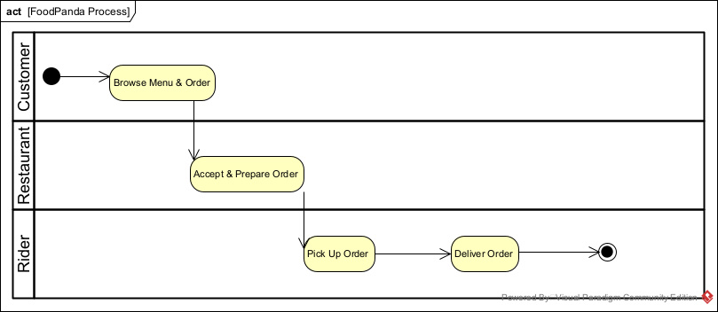
Figure 1: foodPanda activity diagram with Customer, Restaurant and Rider swimlanes

3.1 Steps to Build It
- Create an Activity Diagram and name it FoodPanda Process.
- Add three swimlanes, one per participant: Customer, Restaurant and Rider.
- Place the initial node in the Customer lane, because the customer starts the process.
- Add one action per step in the lane of whoever performs it.
- Connect the actions in order with control-flow arrows. An arrow that crosses a lane boundary is a hand-over.
- End the flow with a final node after delivery.

3.2 How to Read It
Table 2: foodPanda actions by lane
Lane | Action | What Happens
Customer | Browse Menu & Order | The customer picks items in the app and places the order
Restaurant | Accept & Prepare Order | The restaurant confirms the order and cooks it
Rider | Pick Up Order | The rider collects the food from the restaurant
Rider | Deliver Order | The rider hands the food to the customer, ending the process

The process is a simple straight line, and the swimlanes make the three hand-overs (Customer to Restaurant to Rider) easy to see at a glance.

4. Task 2: Toaster State Machine
Goal: model a toaster, list the activities inside each state, and identify triggered and triggerless events.
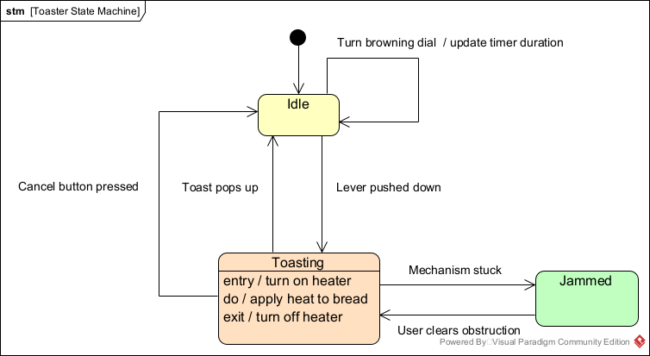
Figure 2: Toaster state machine with Idle, Toasting and Jammed states

4.1 Steps to Build It
- Create a State Machine Diagram named Toaster State Machine.
- Identify the states a toaster can be in: Idle, Toasting and Jammed.
- Add the initial node and point it to Idle, the resting state.
- Open the Toasting state and add its internal activities: entry, do and exit.
- Draw a transition for each thing that can happen, and label it event / action.
- Add the self-transition on Idle for adjusting the browning dial.

4.2 Activities Within Each State
Table 3: Entry, do and exit activities of the toaster
State | Entry | Do | Exit
Idle | None | Waits for user input | None
Toasting | Turn on heater | Apply heat to bread | Turn off heater
Jammed | None | Waits for the obstruction to be cleared | None

4.3 Transitions: Triggered and Triggerless
A triggered transition fires when an outside event occurs. A triggerless transition has no explicit event: it fires automatically when the state's own activity finishes.
Table 4: Toaster transitions
From | To | Label | Type
Idle | Idle | Turn browning dial / update timer duration | Triggered (event: dial turned, action: update timer)
Idle | Toasting | Lever pushed down | Triggered
Toasting | Idle | Toast pops up | Triggerless (fires when toasting completes)
Toasting | Idle | Cancel button pressed | Triggered
Toasting | Jammed | Mechanism stuck | Triggered
Jammed | Toasting | User clears obstruction | Triggered

Because Toasting has an exit action, the heater is switched off whenever the toaster leaves that state, whether the toast pops up, the user cancels, or the mechanism jams. This is the main benefit of entry and exit actions: the safety behaviour is written once and applies to every path.

5. Task 3: Elevator State Machine
Goal: model the behaviour of an elevator, including movement, door handling and the weight-limit safety check.
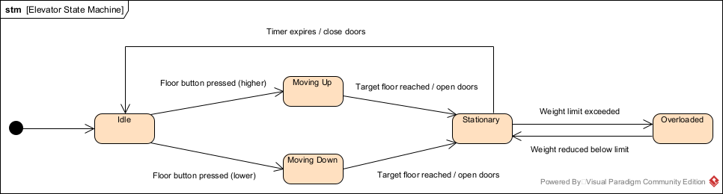
Figure 3: Elevator state machine with five states

5.1 Steps to Build It
- Create a State Machine Diagram named Elevator State Machine.
- List the states: Idle, Moving Up, Moving Down, Stationary (doors open at a floor) and Overloaded.
- Add the initial node and connect it to Idle.
- Add the movement transitions: a floor button pressed above or below the current floor.
- Add the arrival transitions, which open the doors in Stationary.
- Add the timer transition that closes the doors and returns the lift to Idle.
- Add the safety pair of transitions between Stationary and Overloaded.

5.2 How to Read It
Table 5: Elevator states
State | Meaning
Idle | Waiting at a floor with doors closed
Moving Up | Travelling to a higher floor
Moving Down | Travelling to a lower floor
Stationary | Arrived at the target floor with doors open
Overloaded | Weight limit exceeded, so the lift cannot leave

Table 6: Elevator transitions
From | To | Event / Action
Idle | Moving Up | Floor button pressed (higher)
Idle | Moving Down | Floor button pressed (lower)
Moving Up | Stationary | Target floor reached / open doors
Moving Down | Stationary | Target floor reached / open doors
Stationary | Idle | Timer expires / close doors
Stationary | Overloaded | Weight limit exceeded
Overloaded | Stationary | Weight reduced below limit

The lift can only enter Overloaded from Stationary, so it never starts moving while overweight. It returns to Stationary once people step out.

6. Conclusion
The activity diagram showed who does what in a process, while the two state machines showed how an object behaves over time. Swimlanes clarified responsibility in the foodPanda flow, entry/do/exit activities and the triggered versus triggerless distinction clarified the toaster, and the elevator showed how a safety condition becomes its own state.

