**CourierConnect – Map View**

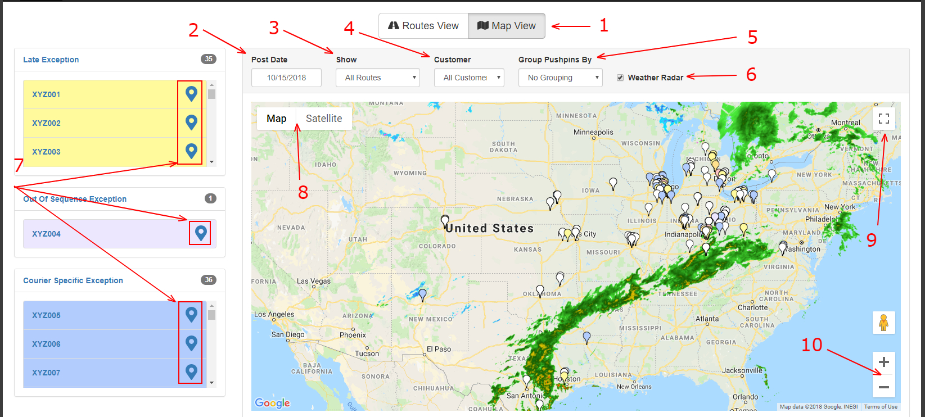

1. Switch between routes view and map view.
2. Routes’ postdate.
3. Display all routes, all exceptions or a specific exception type.
4. Display pushpins on the map for the selected customer.
5. You can currently group pushpins by state.
6. Show/Hide the weather radar.
7. Click on this to center the map on the selected route.
8. Switch between Map and Satellite view.
9. Enter full screen mode.
10. Zoom in and out of the map.