**CourierConnect – Transaction Logs Page**

**Filter Transaction Logs**

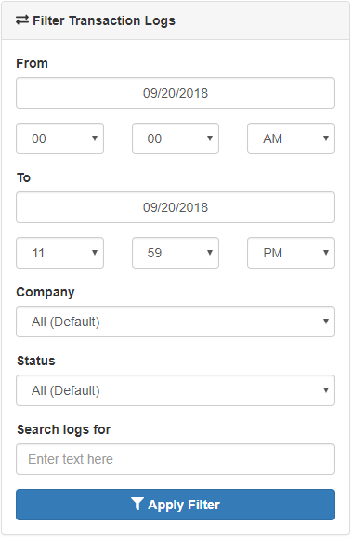

* **From**: The start date and time of the transaction log filter.
* **To**: The end date and time of the transaction log filter.
* **Company**: Choosing a company will only show logs for this company.
* **Status**: Filter logs by status.
* **Search logs for**: Use this if you need to look for a specific log file name or to find logs by stop’s reference number.

**Transaction Logs View**

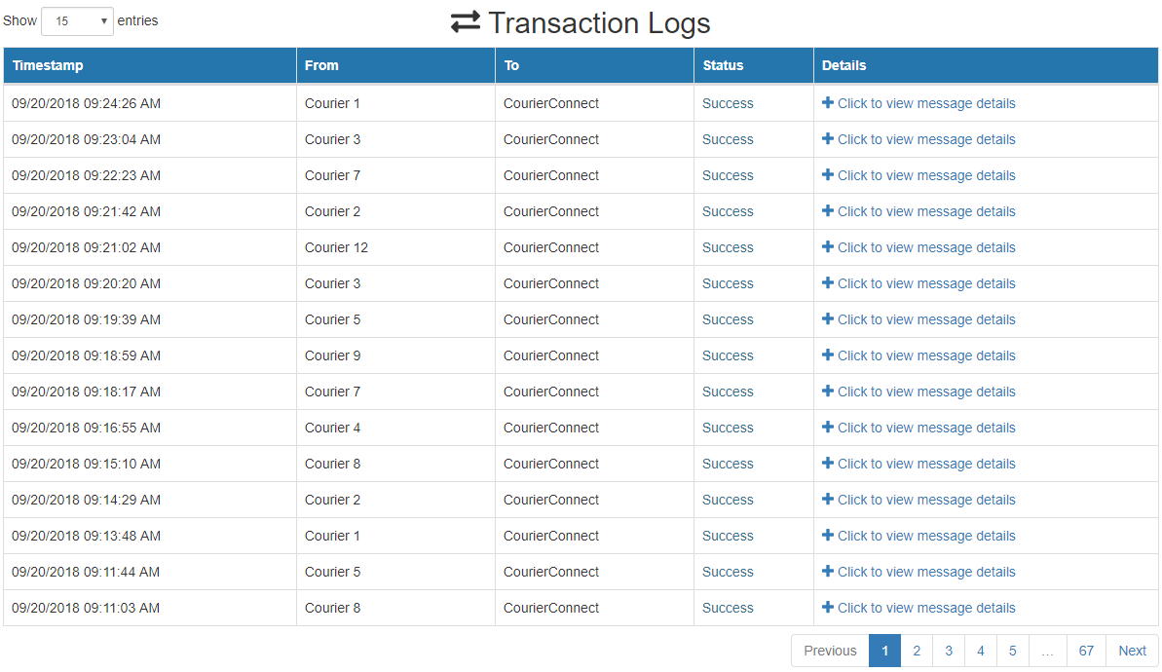

* This is the main view for transaction logs.
* You can show 15, 25, 50, 100 and 1000 records per page.
* Click on “Click to view message details” will open a pop-up window that contains more information about this log file.

**Transaction Log Details View**

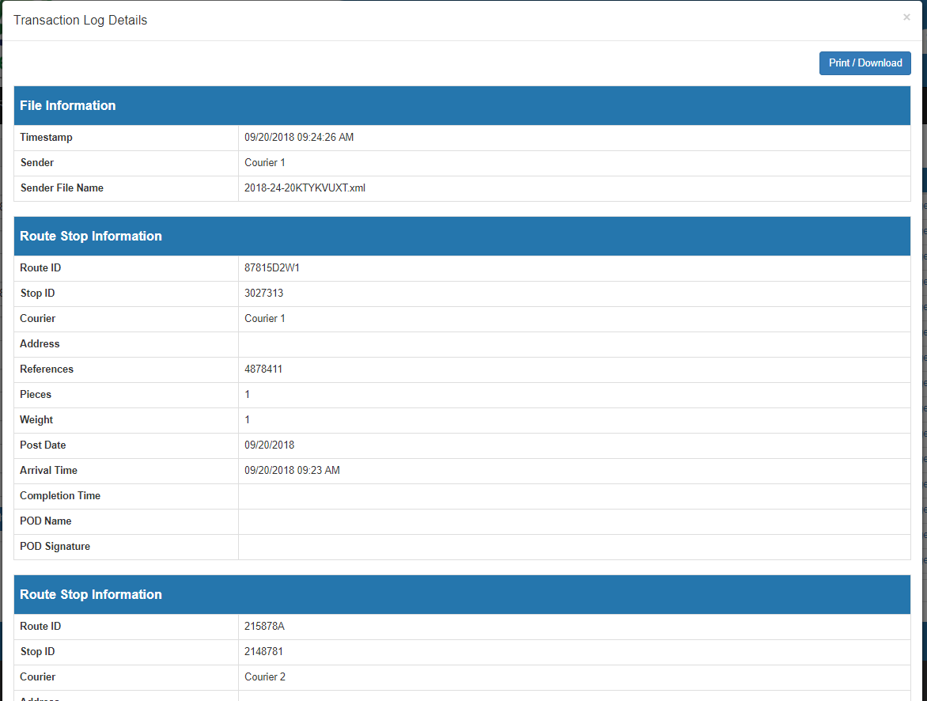

* **File Information**: Log file’s main information like Timestamp, name and file’s origin.
* **Route Stop Information**: Is an example of file’s content. In our example here, the log file shows that CourierConnect has received information about multiple route stops.