**CourierConnect – Track Shipments**

**Track Shipments Form**

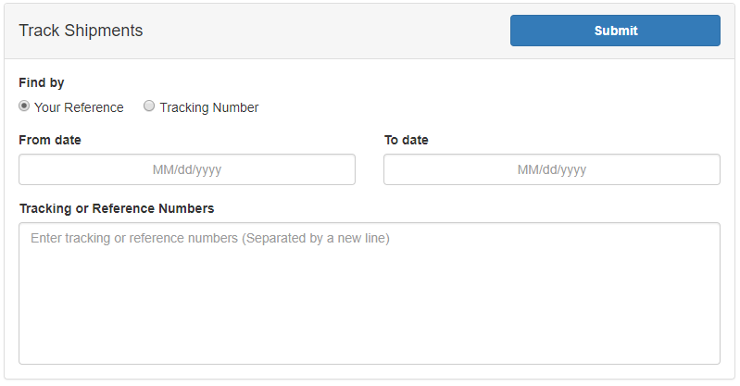

* **Find by**: Find shipments either by Reference Number or by Tracking Number.
* **From/To date**: Set a date range of which you would like find shipments.
* **Tracking or Reference Numbers**: Enter the Tracking or Reference numbers of the shipments you would like to track.

**Shipment(s) Details View**

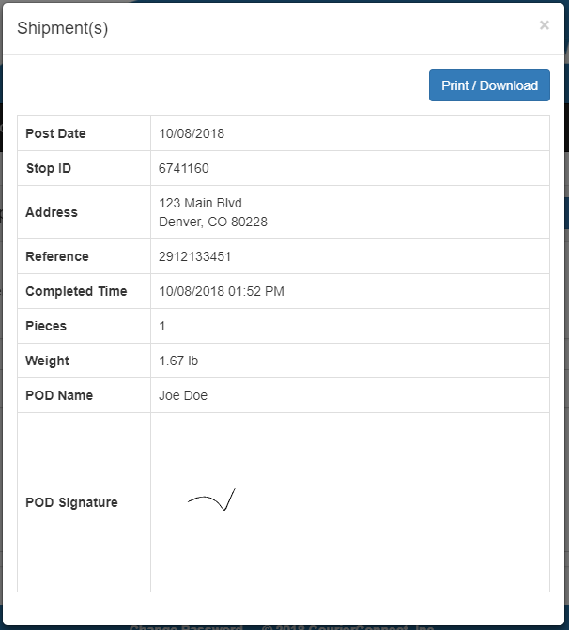

After submitting the form, this window will pop up showing route stop information.