**CourierConnect - Preferences**

**Portal Settings**

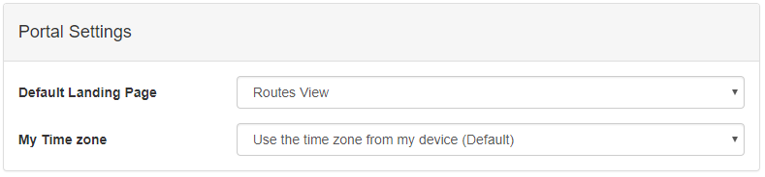

* **Default Landing Page**: Change the default landing page (**Home**).
* **My Time zone**: Choose your time zone or use the one set on your computer.

**Exception Time Thresholds**

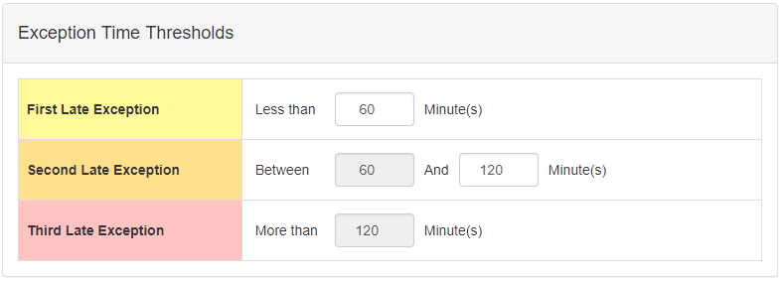

* In the above example
  + Any stop that is late for less than 60 Minutes will show up as Yellow.
  + Any stop that is late between 60 & 120 Minutes will show up as Orange.
  + Any stop that is late for more than 120 Minutes will show up as Red.

**On-time Trending**

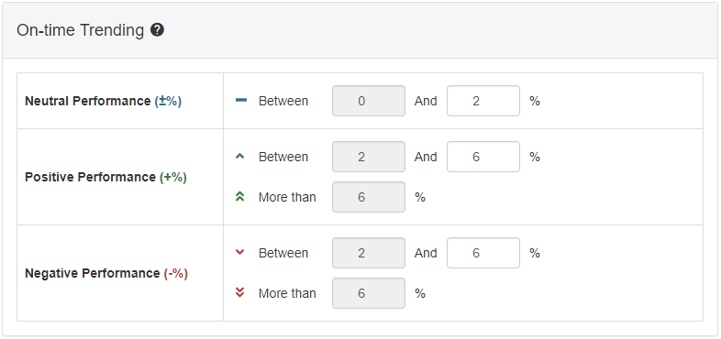

* On-Time Trending calculates the difference between Last 7 Days’ Performance and the Rolling 60 Day Average, then displays the result as Neutral, Positive or Negative Performance (Depends on the percentages set by the user).
* In the above example
  + Show Neutral Performance If the difference is less than or equal to 2%.
  + Show Positive Performance If the difference is more than 2% and less than or equal to 6%.
  + Also, show Positive Performance If the difference is more than 6%.
  + Show Negative Performance If the difference is more than 2% and less than or equal to 6%.
  + Also, show Negative Performance If the difference is more than 6%.

**Email Notification Settings**

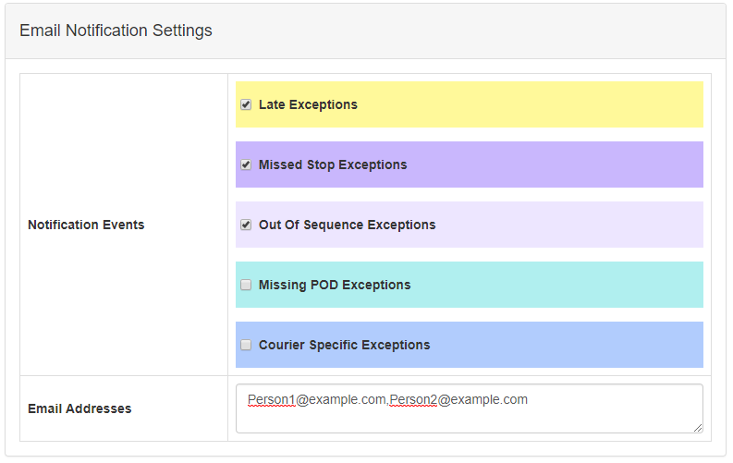

* Email Notification Settings allows you to
  + Subscribe to event-based alerts.
  + Un-Subscribe from emails at any time.
  + Change email addresses to
    - Add a new email address.
    - Remove an email address.
* In the above example
  + [Person1@example.com](mailto:Person1@example.com) and [Person2@example.com](mailto:Person2@example.com) are currently subscribed to receive email alerts when
    - A stop is Late.
    - A stop has been missed by driver.
    - A stop has been completed out of sequence.

**My Account Information**

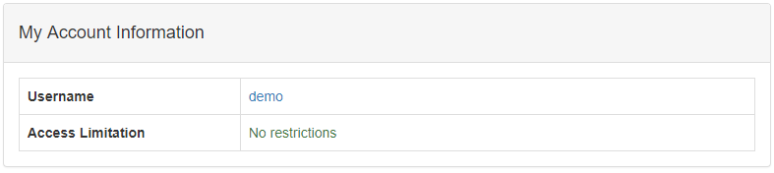

* My Account Information shows your current Username and Access Limitations
* In the above example
  + The username of this account is **demo**.
  + The account has no access limitations.