**CourierConnect – Routes View**

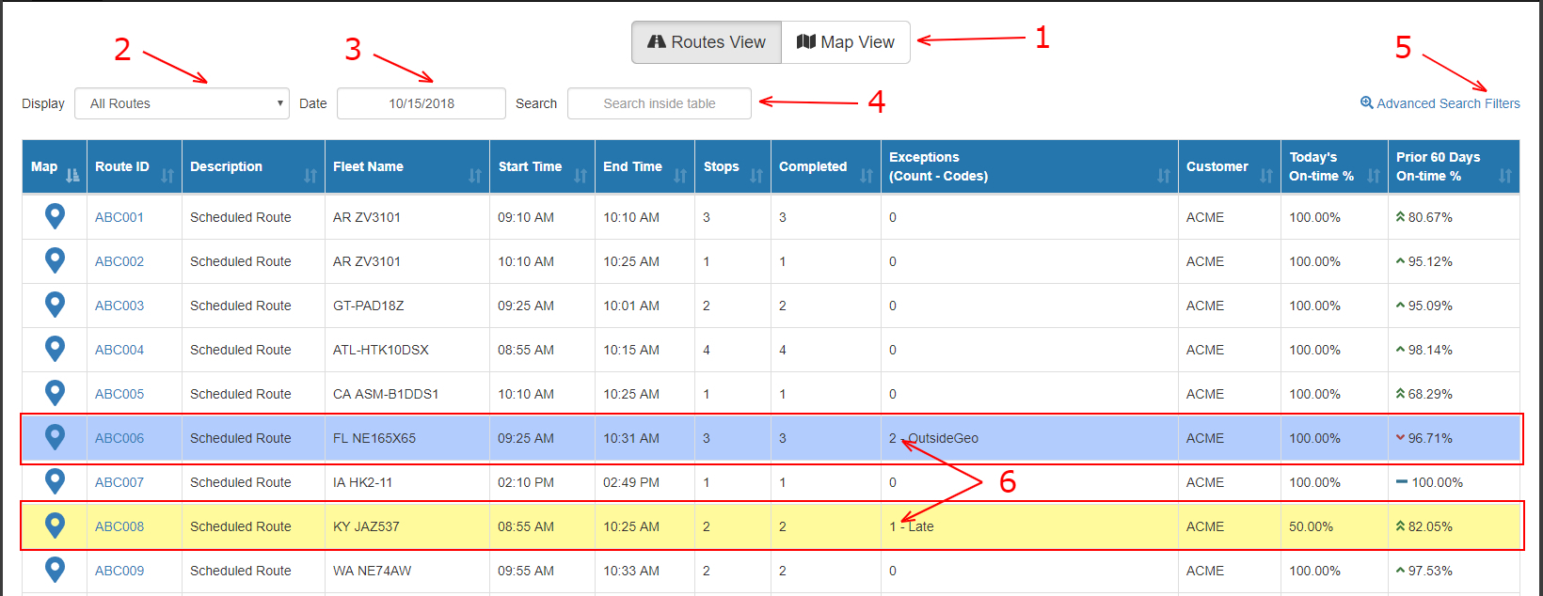

1. Switch between routes view and map view.
2. Display all routes, all exceptions or a specific exception type.
3. Routes’ postdate.
4. Type a keyword to narrow down results, for example if you type “AR ZV3101” in the box, it’ll show only all routes with fleet name “AR ZV3101”.
5. Clicking on that will open the advanced search filters pop up.  
   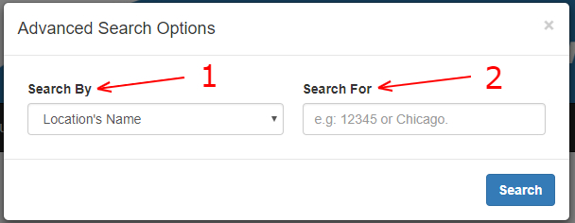
   1. Search by location’s name, address, city, etc.
   2. Type your search term.
6. Routes with exceptions.