**CourierConnect – Run Reports**

**Run Reports Form**

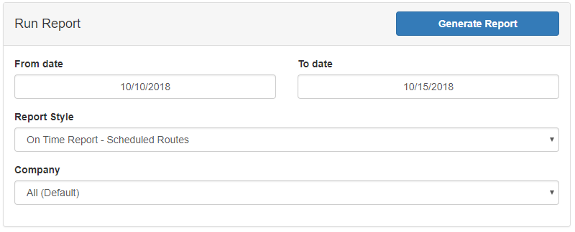

* **From/To date**: Set a date range for the report.
* **Report Style**: Choose the style of the report.
* **Company**: Choose a specific company to run the report against.

Once you click on Generate Report, we’ll generate your report in a Microsoft Excel format, and allow you to save it on your computer.