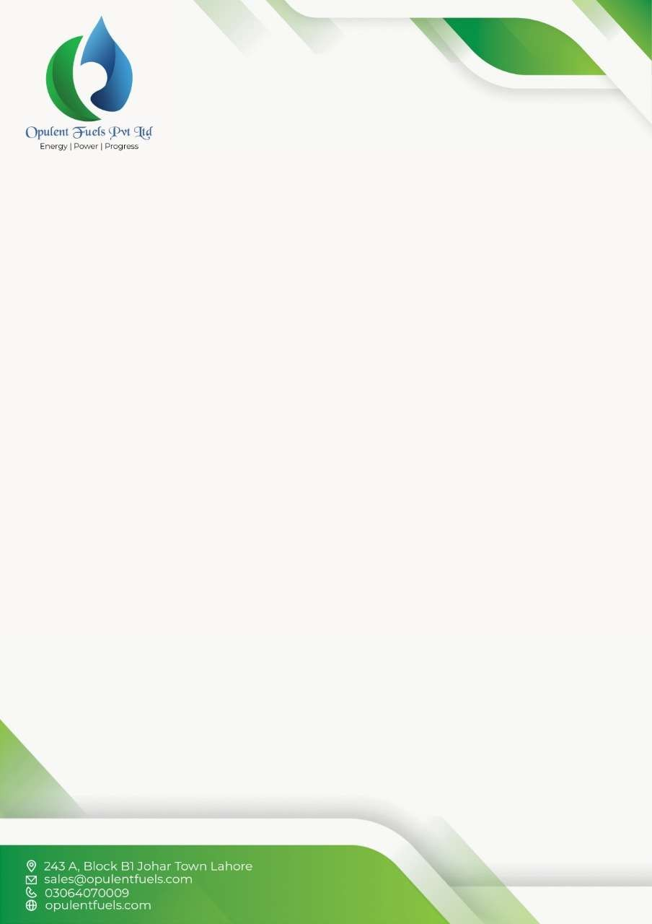

INVOICE

|  |  |
| --- | --- |
| Date | 2023-12-05T00:00:00.000Z |
| Invoice # | IDKLS |
| Buyer’s Name | John Doe |
| Address | 123 Main St, Cityville |
| Delivery Address | 456 Main St, Cityville |
| Sales Tax Reg # | ST123456 |
| NTN # | NTN123456 |
| Contact Number | +1 555-1234 |

|  |  |  |  |  |  |  |
| --- | --- | --- | --- | --- | --- | --- |
| **Item** | **Quantity** | **Unit (MTN/Liters)** | **Rate Unit/Ltr** | **Price Exclusive of Sales Tax** | **Sales Tax** | **Price**  **Inclusive of Sales Tax** |
| 2222 | 222 | 222 | 22 | 222 | 22 | 22 |
|  |  |  |  |  |  |  |
| TOTAL |  |  |  |  |  |  |