Project 1 Report: Sales Data Analysis

Objective
Analyze a retail sales dataset using Python to clean, explore, visualize, and derive business insights.

Tools & Technologies
Python, Pandas, NumPy, Matplotlib, Jupyter Notebook

Dataset
sales_data.csv containing sales transaction records.

Methodology
Loaded the dataset, cleaned missing values and duplicates, converted date columns, performed exploratory data analysis, analyzed monthly sales, top products, regional and category performance, created charts, and summarized insights.

Key Findings
Sales trends were identified, top-performing products and regions were analyzed, and category-wise performance was evaluated.

Business Recommendations
Focus on high-performing products, optimize inventory, strengthen low-performing regions, and use seasonal trends for planning.

Conclusion
The project demonstrates practical data analysis using Python and provides actionable business insights.

Screenshots:
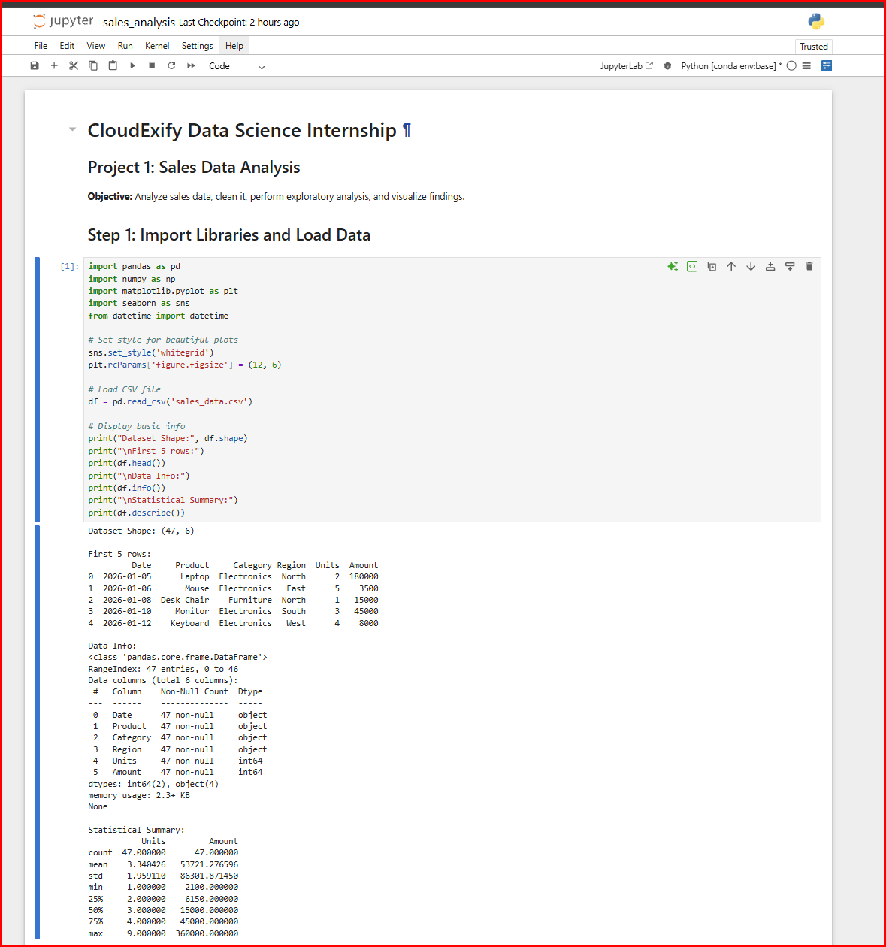
Step 2-3:
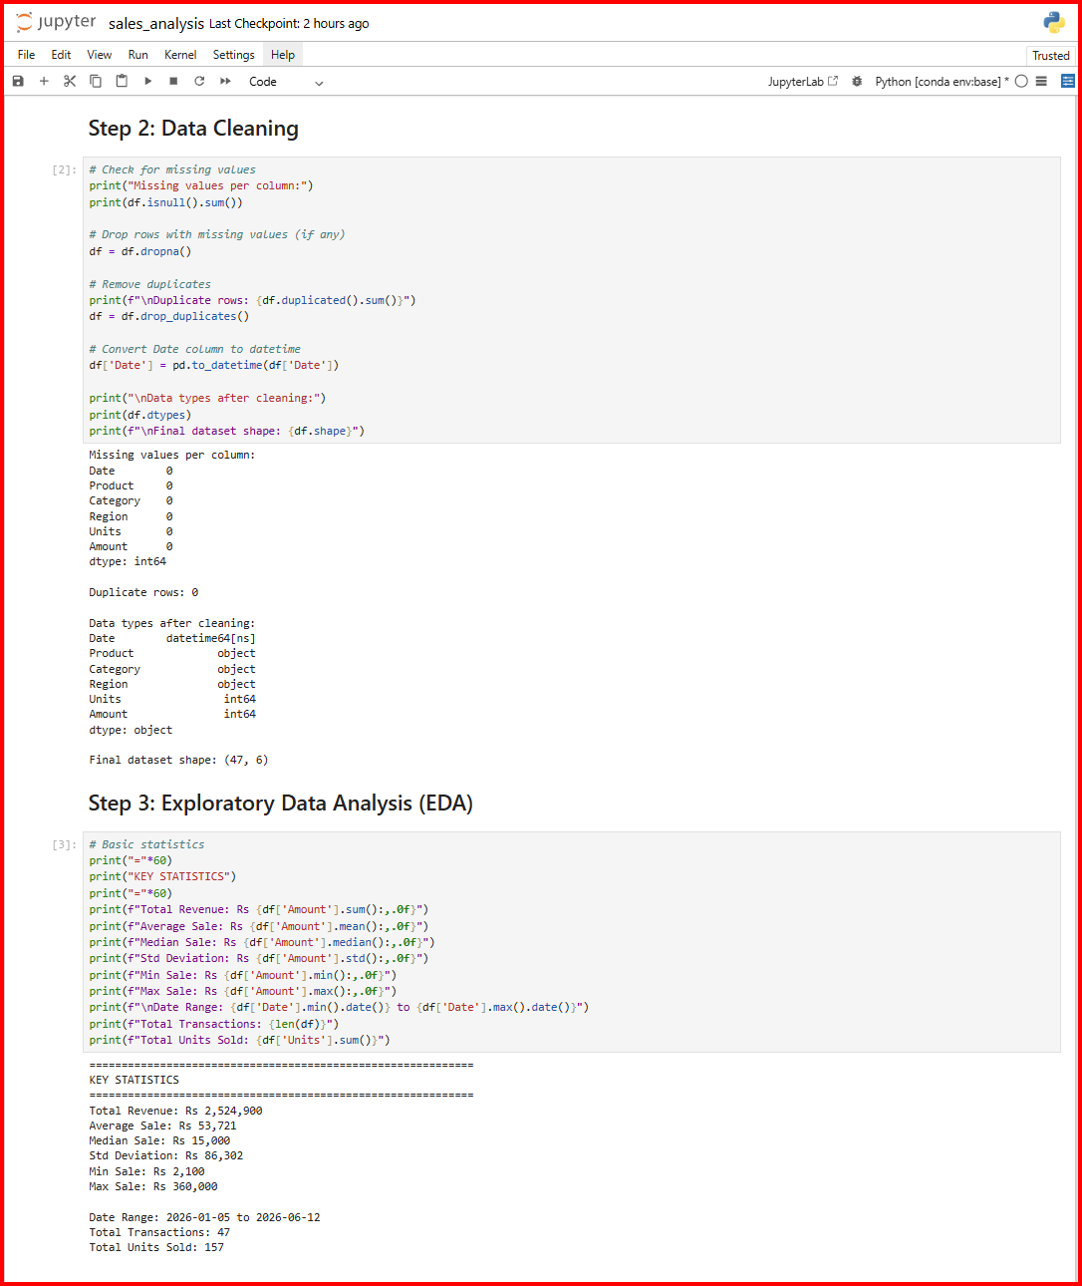

Step 4:
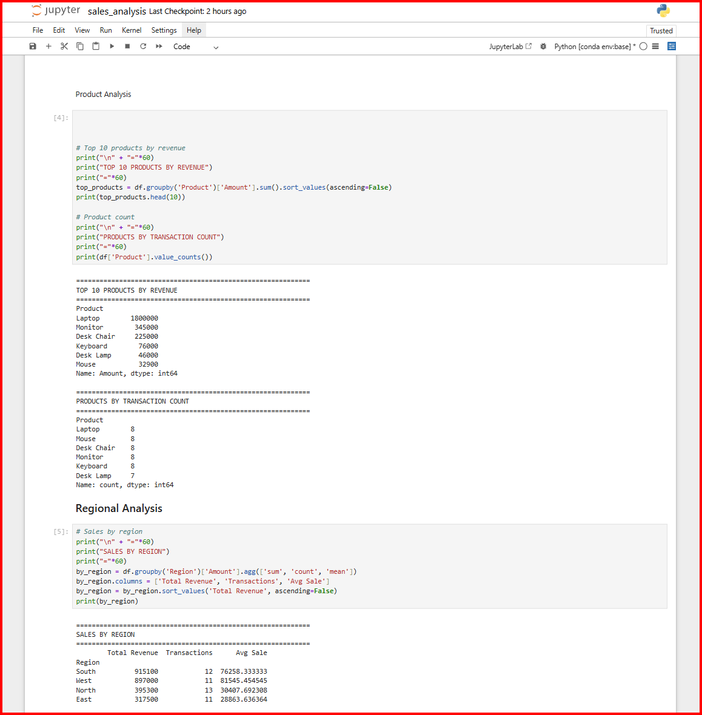
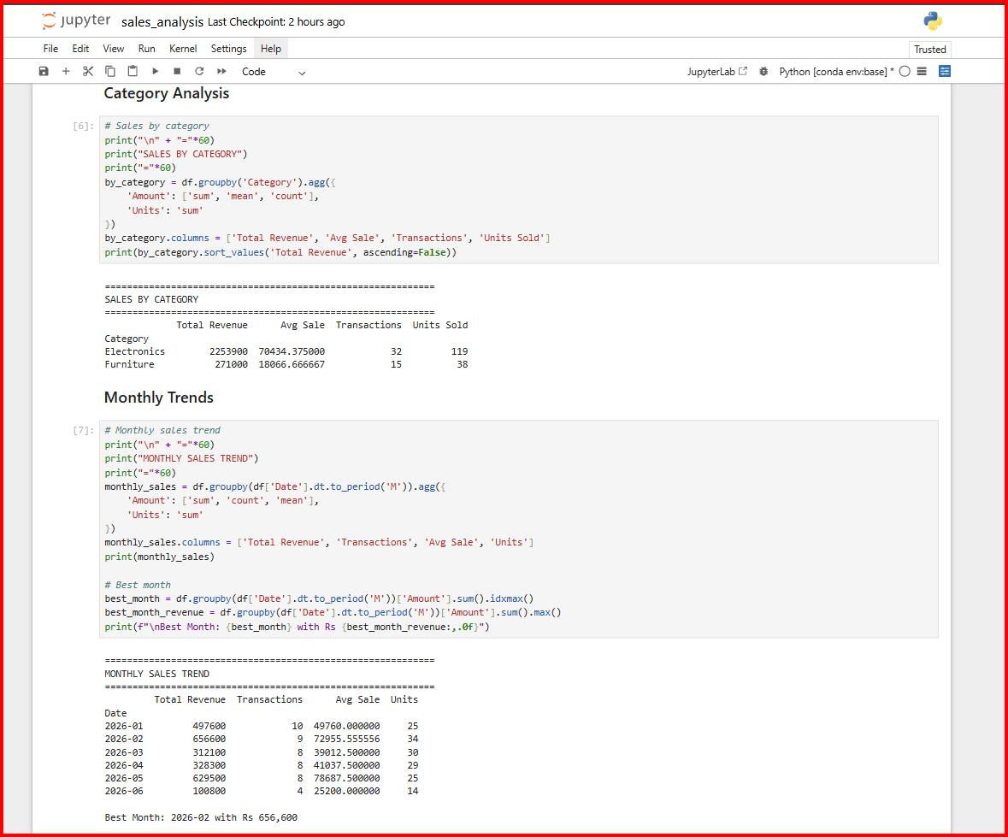

Step 4:
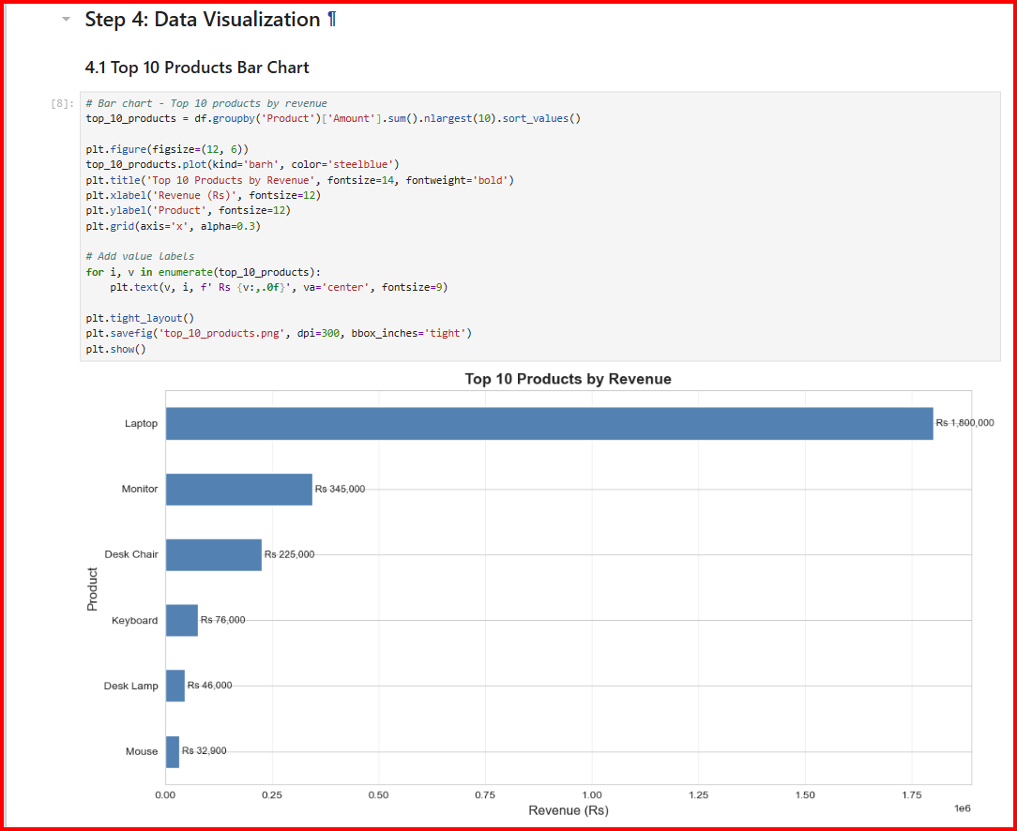
4.2:
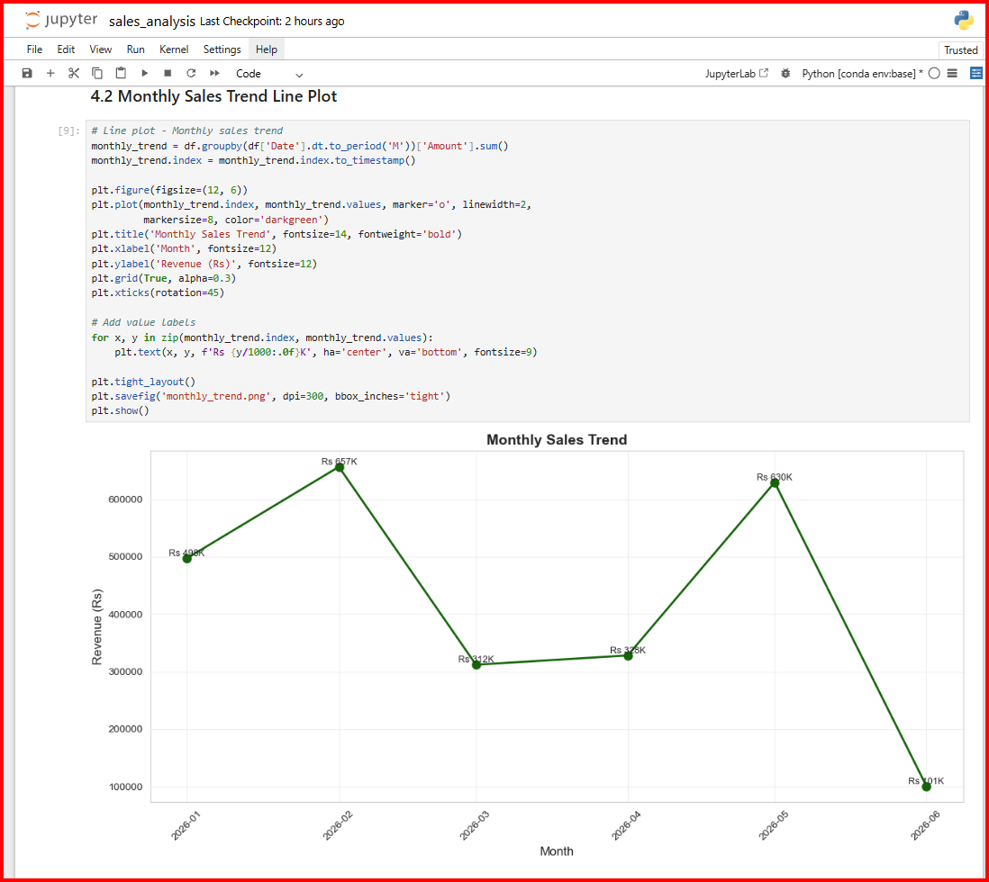
4.3:
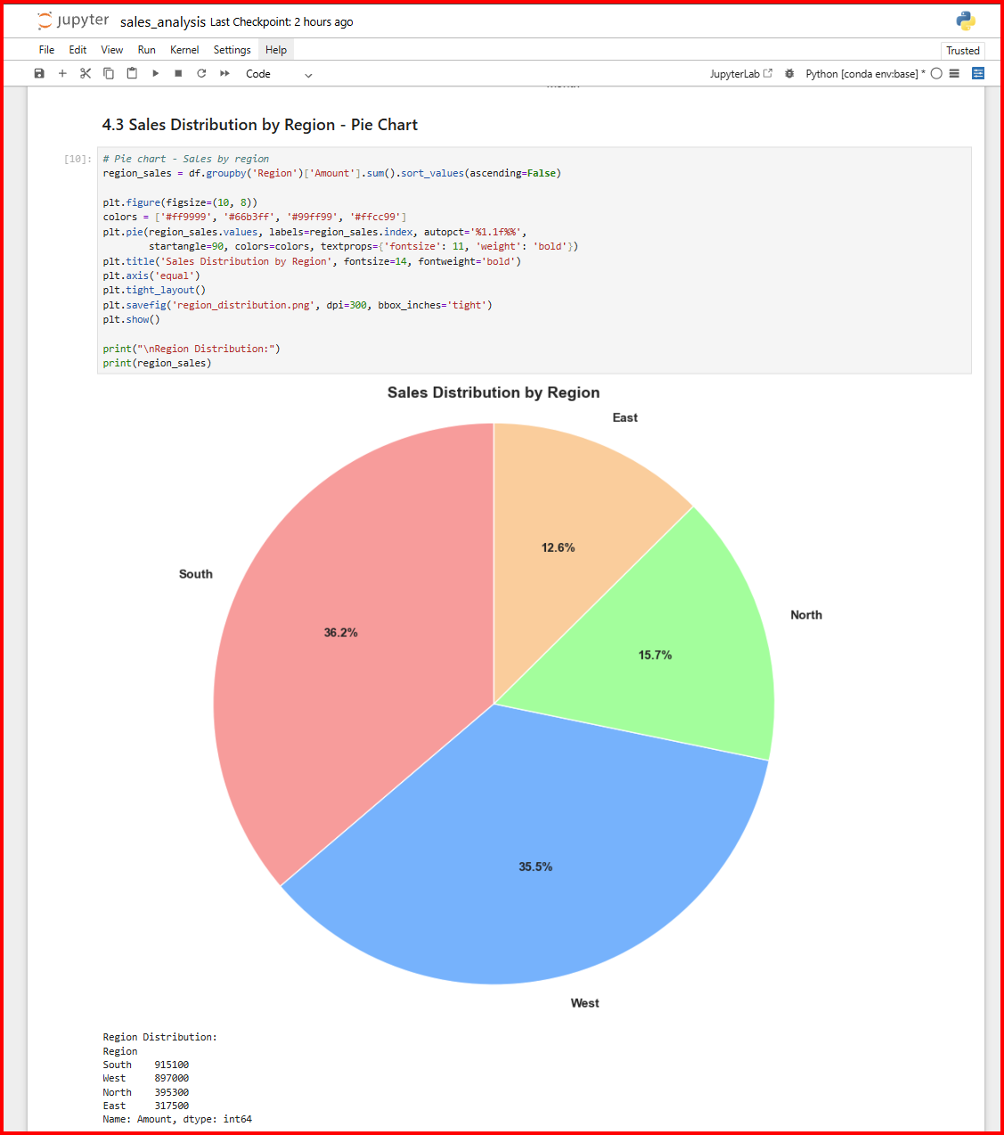
4.4: 4.5
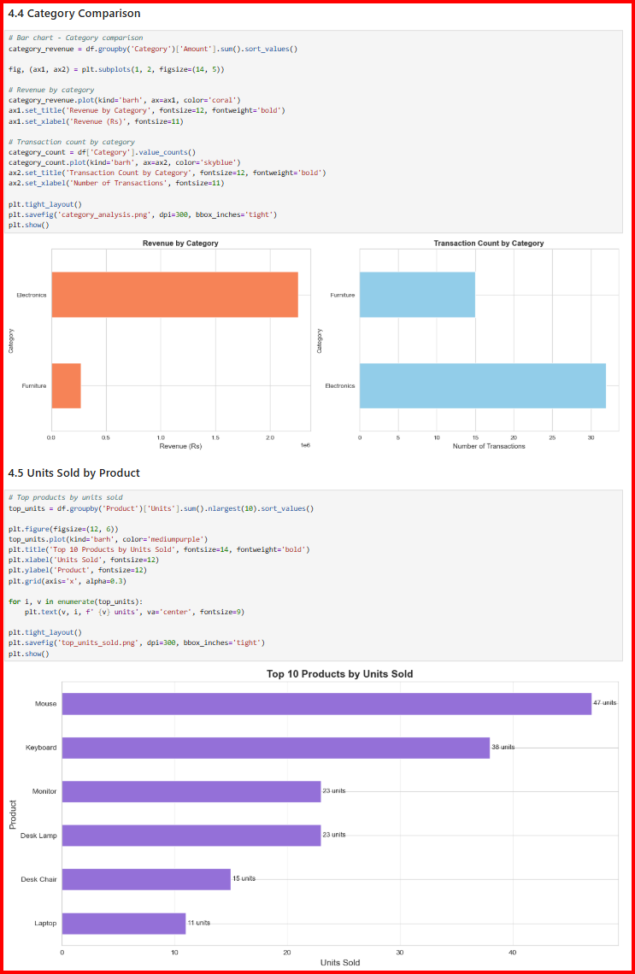
Step 5:
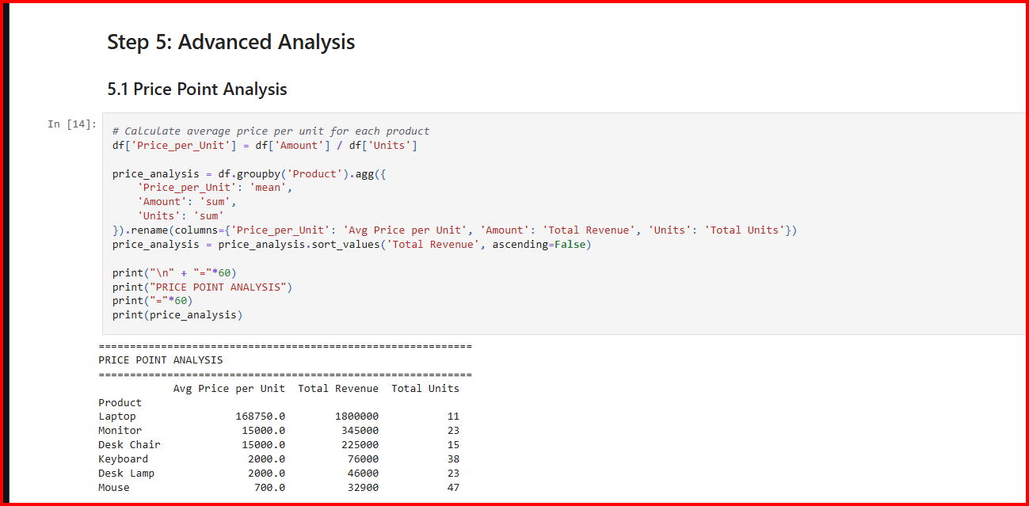
Step 6:
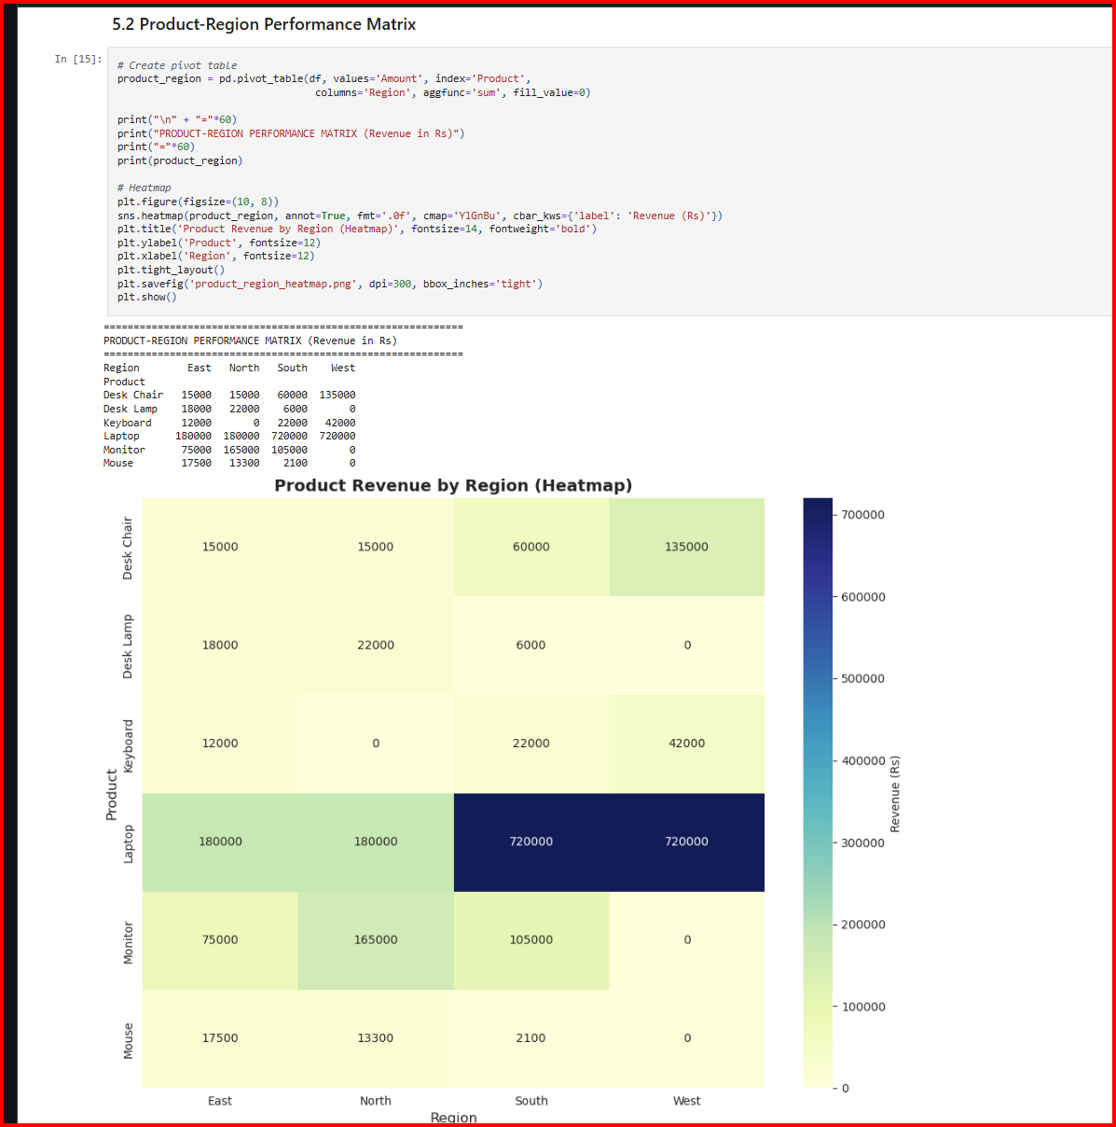
Report:
