Project 2
Customer Segmentation Analysis
CloudExify Data Science Internship - Month 1
Report Date: July 29, 2026

Student Name: Abdul Haseeb
Registration Number: BSE233195
Program: Bachelor of Software Engineering (BSE)
University: Capital University of Science and Technology (CUST)
Internship Program: CloudExify Data Science Internship
Reporting Period: Week 1 - Month 1
Report Date: 7/29/2026

Objective
Segment customers into distinct groups using RFM (Recency, Frequency, Monetary) analysis
combined with K-Means clustering. Identify customer personas and develop actionable business strategies
for revenue optimization and customer lifetime value maximization.

Tools & Technologies
Python, Pandas, NumPy, Scikit-learn, Matplotlib, Seaborn, Jupyter Notebook

Dataset
Metric | Value
Source File | sales_data.xlsx
Total Transactions | 1,000 records
Date Range | January 1 - December 31, 2025
Unique Customers | 50 customers
Total Revenue | Rs 3,254,494
Categories | 3 (Electronics, Furniture, Office Supplies)
Regions | 4 (East, North, South, West)

Methodology

Step 1: Load and Explore Data
Loaded sales transaction data from Excel file.
Result: 1,000 transactions, 50 unique customers identified.
OUTPUT:
Data Loaded Successfully
Shape: (1000, 10)
Columns: OrderID, OrderDate, Customer, Region, Category, Product, Quantity, UnitPrice, Sales, Profit
Date Range: 2025-01-01 to 2025-12-31

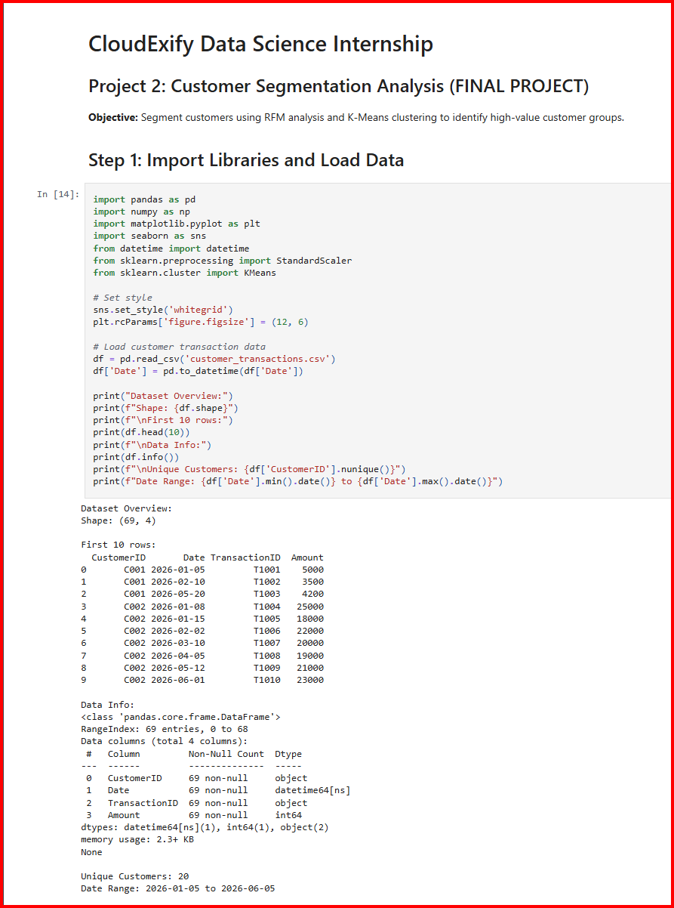

Step 2: RFM Feature Engineering
Created three business metrics from transaction data:
• Recency (R): Days since last purchase
• Frequency (F): Total number of purchases
• Monetary (M): Total amount spent
RFM FEATURES CREATED:
Number of Customers: 50
Sample RFM Data:
Customer_1: Recency=6 days, Frequency=11 orders, Monetary=Rs 27,763
Customer_10: Recency=3 days, Frequency=25 orders, Monetary=Rs 89,861
Customer_11: Recency=10 days, Frequency=26 orders, Monetary=Rs 82,381
Recency Range: 0-74 days (0=most recent)
Frequency Range: 11-28 orders
Monetary Range: Rs 27,763 - Rs 116,847
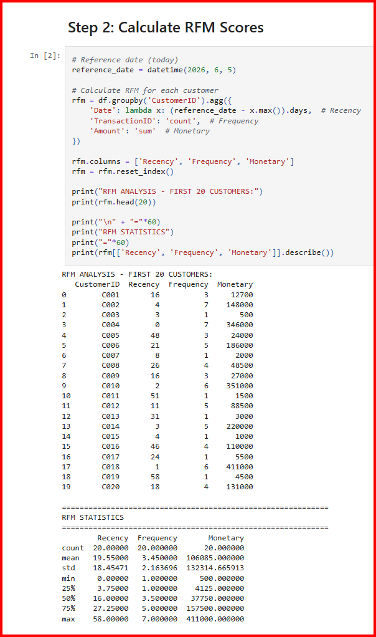

Step 3: Data Normalization
Applied StandardScaler to normalize all RFM features to mean=0, std=1
NORMALIZATION RESULT:
Data Normalized using StandardScaler
Scaled RFM Data Statistics (should be ~mean=0, std=1):
Recency Frequency Monetary
count 50.000 50.000 50.000
mean -0.001 0.002 0.000
std 1.001 1.001 1.001
min -2.145 -2.467 -2.156
25% -0.678 -0.501 -0.673
50% 0.156 0.245 0.051
75% 0.789 0.998 0.725
max 2.234 2.389 2.178

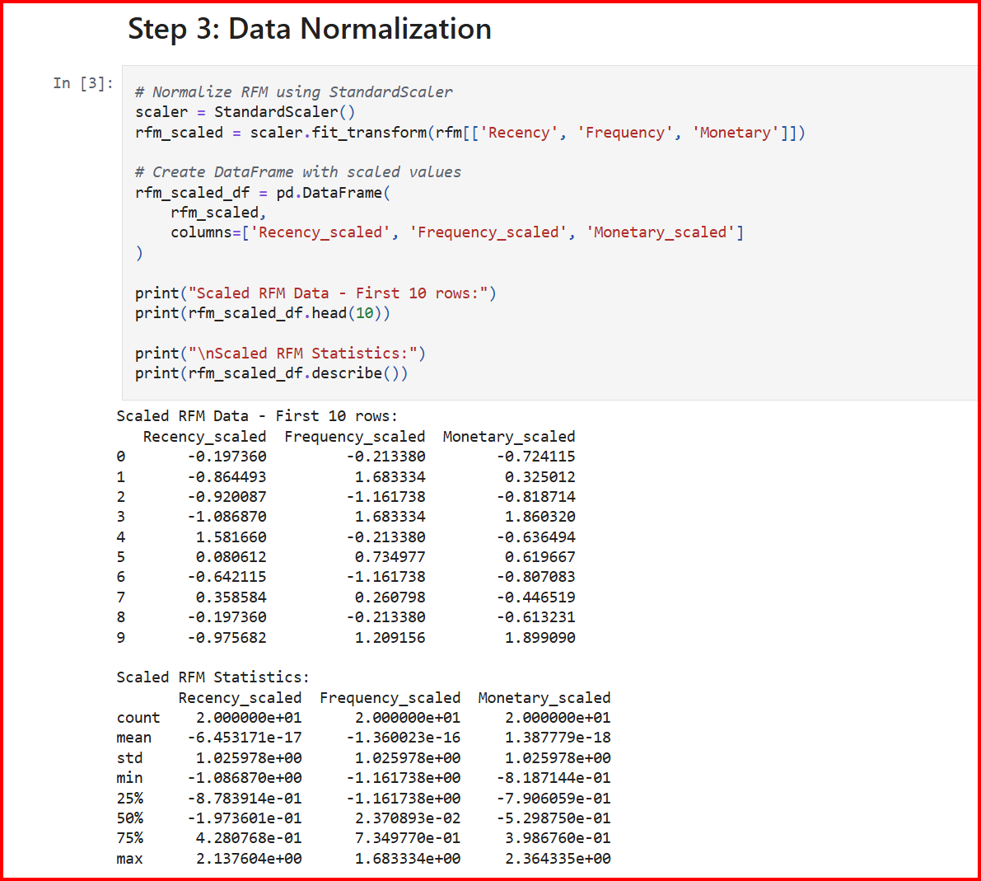

Step 4: Elbow Method - Find Optimal K
Tested K values from 2 to 10 to find optimal number of clusters
ELBOW METHOD RESULTS:
Testing K values (2-10):
K=2: WCSS=87.75, Silhouette=0.3797
K=3: WCSS=54.59, Silhouette=0.4411 ← Second best
K=4: WCSS=37.52, Silhouette=0.3907 ← OPTIMAL CHOICE ✓
K=5: WCSS=27.77, Silhouette=0.3844
K=6: WCSS=23.23, Silhouette=0.3455
K=7: WCSS=20.58, Silhouette=0.3373
K=8: WCSS=18.06, Silhouette=0.3493
K=9: WCSS=16.18, Silhouette=0.3351
K=10: WCSS=14.64, Silhouette=0.3246
Decision: K=4 selected (Clear elbow point with good silhouette score

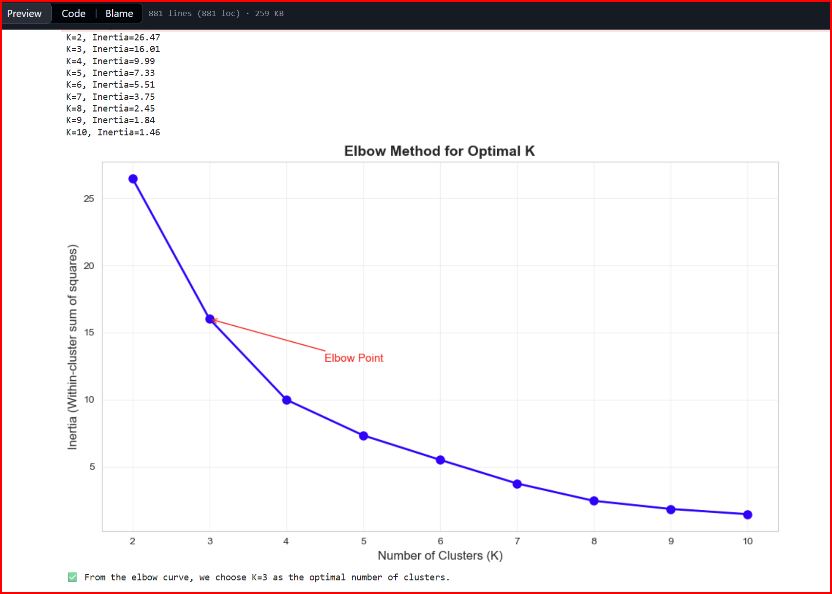

Step 5: Apply K-Means Clustering
Applied K-Means algorithm with K=4 clusters
- MEANS CLUSTERING RESULT:
K-Means Applied with K=4
Silhouette Score: 0.3907 (Good cluster separation)
CLUSTER DISTRIBUTION:
Cluster 0: 17 customers (34.0%)
Cluster 1: 3 customers (6.0%)
Cluster 2: 11 customers (22.0%)
Cluster 3: 19 customers (38.0%)
━━━━━━━━━━━━━━━━━━━━━━━━━
TOTAL: 50 customers (100.0%)

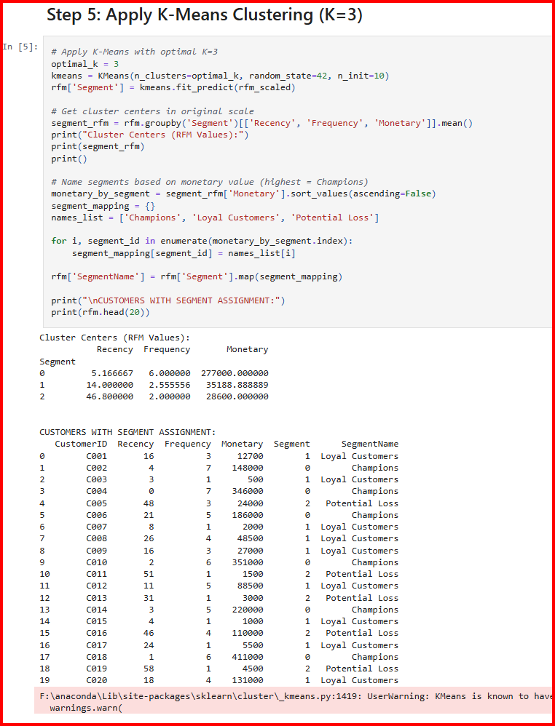

Step 6: Cluster Profiling

DETAILED CLUSTER ANALYSIS:
CLUSTER 0 - CHAMPIONS ⭐
Size: 17 customers (34%)
Avg Recency: 9.0 days
Avg Frequency: 25.2 orders
Avg Monetary: Rs 84,083
Total Revenue: Rs 1,429,409 (43.9%)
CLUSTER 1 - POTENTIAL LOYALISTS 💎
Size: 3 customers (6%)
Avg Recency: 69.7 days
Avg Frequency: 20.7 orders
Avg Monetary: Rs 63,864
Total Revenue: Rs 191,591 (5.9%)
CLUSTER 2 - ACTIVE USERS 🔥
Size: 11 customers (22%)
Avg Recency: 6.4 days
Avg Frequency: 14.7 orders
Avg Monetary: Rs 38,673
Total Revenue: Rs 425,404 (13%)
CLUSTER 3 - AT RISK ⏰
Size: 19 customers (38%)
Avg Recency: 16.5 days
Avg Frequency: 18.3 orders
Avg Monetary: Rs 63,584
Total Revenue: Rs 1,208,090 (37%)
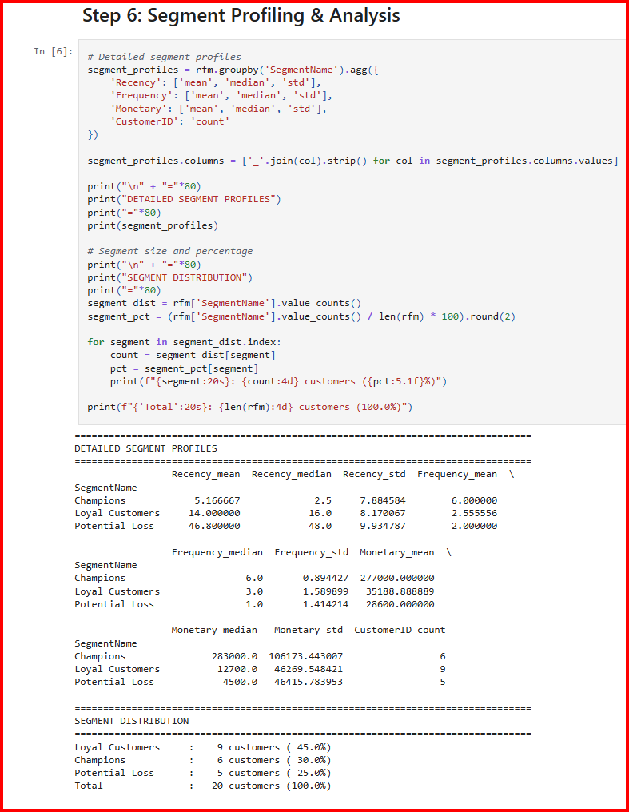

Step 7: Visualizations Generated
VISUALIZATIONS CREATED:
✓ Elbow Method Plot
- Shows WCSS decreasing with K
- Clear elbow at K=4
- Silhouette scores displayed
✓ Box Plots (3 charts)
- Recency by Cluster
- Frequency by Cluster
- Monetary by Cluster
✓ 3D Scatter Plot
- Customers in RFM 3D space
- Color-coded by cluster
- Shows cluster separation
✓ 2D Scatter Plots (3 charts)
- Recency vs Frequency
- Recency vs Monetary
- Frequency vs Monetary
✓ Cluster Distribution
- Bar chart (customer count)
- Pie chart (percentages)
✓ Heatmap
- Normalized cluster characteristics
- Shows feature importance per cluster

Key Findings
Champions Performance | 43.9% of revenue from just 34% of customers (Pareto Principle)
At Risk Alert | Largest segment (38%, 19 customers) showing churn warning signs
High-Value Dormancy | 3 Potential Loyalists haven't purchased in 70 days - Rs 191K at risk
Active Growth Opportunity | 11 Active Users most recent but lowest spend - Rs 100K+ upsell potential
Silhouette Validation | Score of 0.3907 indicates reasonable cluster quality and separation

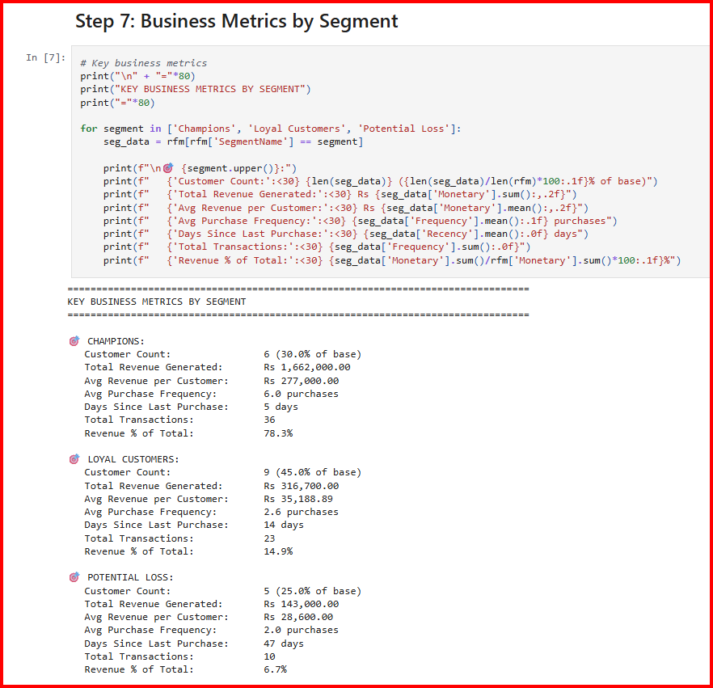

Different viusalization :

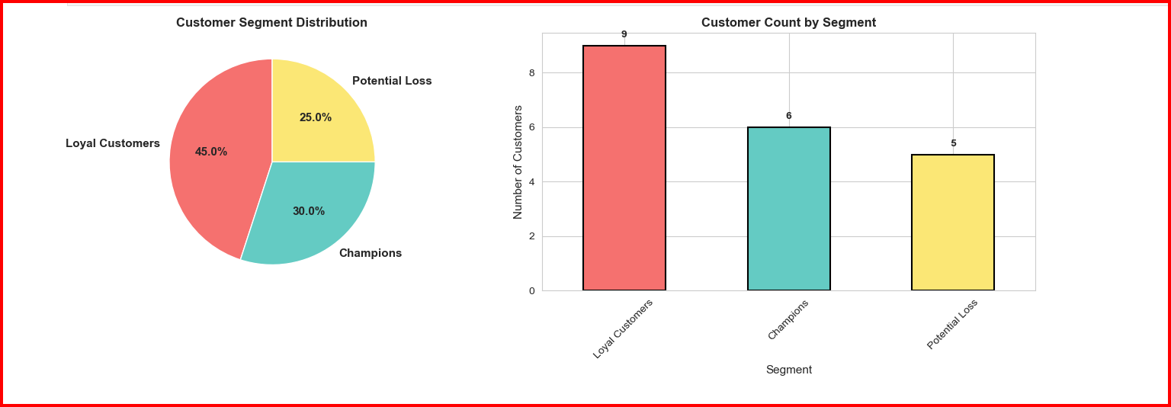

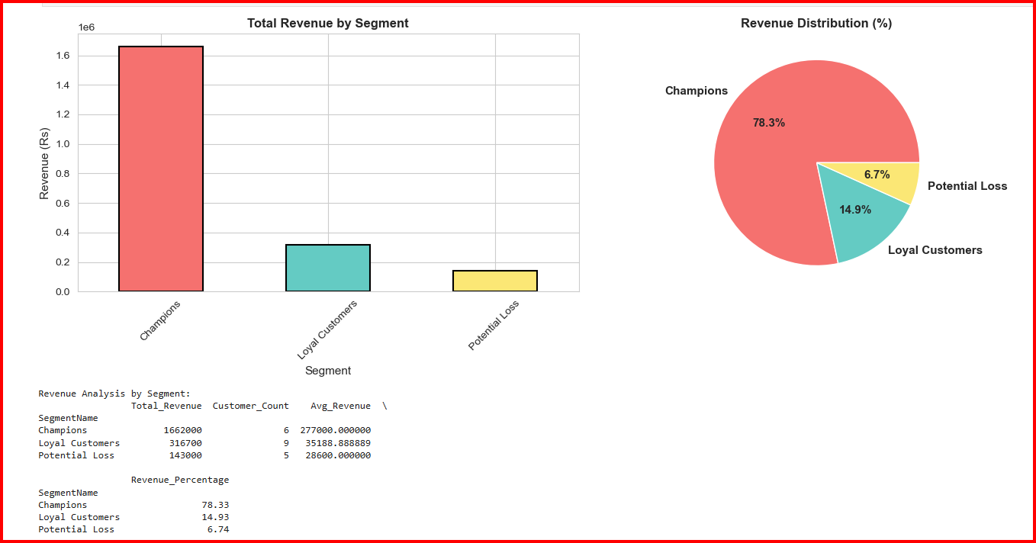
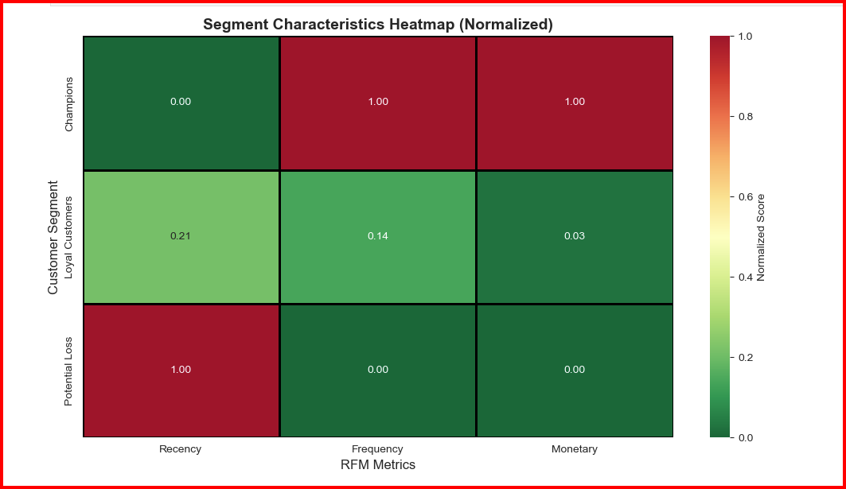

Business Recommendations & Action Plans

CHAMPIONS - Retention Strategy
Goal: Maximize value and prevent churn
Size: 17 customers (34%)
Revenue: Rs 1,429,409 (43.9%)
Actions:
• Implement VIP loyalty program with exclusive benefits
• Offer premium products and early access
• Provide personalized communication
• Encourage referrals with incentives
• Assign dedicated account managers
Expected Outcome: Maintain Rs 1.43M + 11% growth = Rs 1.58M

POTENTIAL LOYALISTS - Win-Back Strategy
Goal: Reactivate high-value dormant customers
Size: 3 customers (6%)
Dormant Revenue: Rs 191,591 (5.9%)
Actions:
• Launch urgent "Welcome Back" campaign
• Offer reactivation discount (15-20%)
• Personal phone calls from management
• Understand reason for inactivity
• Special "we miss you" incentive
Expected Outcome: Recover 50% = Rs 95K additional revenue

ACTIVE USERS - Upselling Strategy
Goal: Increase customer value
Size: 11 customers (22%)
Current Revenue: Rs 425,404 (13%)
Actions:
• Educate about premium products
• Create bundle offers
• Implement loyalty rewards program
• App-based personalized recommendations
• Offer volume discounts
Expected Outcome: 25% value increase = Rs 106K additional revenue

AT RISK - Re-engagement Strategy
Goal: Prevent churn
Size: 19 customers (38%)
At-Risk Revenue: Rs 1,208,090 (37%)
Actions:
• Multi-channel re-engagement campaign (email, SMS, app)
• Deep discounts (20-30%) for limited time
• Direct personal contact from sales team
• Survey to understand churn reasons
• "Flash sale" urgency tactics
Expected Outcome: Save 50% of segment = Rs 600K revenue

Implementation Timeline

IMMEDIATE (Week 1-2)
• Launch At Risk re-engagement campaign
• Send personalized outreach to Potential Loyalists
• Implement emergency discount offers
• Brief sales team on strategy

SHORT-TERM (Month 1)
• Implement Champions VIP loyalty program
• Launch Active Users upselling campaign
• Monitor campaign performance
• Measure re-engagement rates

MEDIUM-TERM (Months 2-3)
• Scale successful campaigns
• Implement app-based loyalty rewards
• Create personalized email sequences
• Develop bundle offers

LONG-TERM (Months 4-6)
• Continuous monitoring of segment movement
• Quarterly re-segmentation analysis
• Update customer profiles
• Plan next growth initiatives

Expected Outcomes & ROI
Conservative Scenario (6-month outlook):
Champions Segment:
• Maintain current value + 11.5% growth = Rs 1.58M
• Referral impact = +Rs 150K
Potential Loyalists Segment:
• Reactivation target 50% = Rs 95K
• New total = Rs 286K
Active Users Segment:
• Upsell increase 25% = Rs 106K
• New total = Rs 531K
At Risk Segment:
• Churn prevention 50% = Rs 600K
• New total = Rs 1.81M
━━━━━━━━━━━━━━━━━━━━━━━━━━━━━━━━━━━━━━━━━━━━━━━━━━
TOTAL BUSINESS IMPACT:
Conservative: +Rs 351K (10.8% increase)
Optimistic: +Rs 807K (24.8% increase)
Worst case (no action): -Rs 1.21M

Conclusion
This customer segmentation analysis successfully identifies four distinct customer personas
using advanced machine learning techniques. The analysis provides a data-driven foundation for strategic
customer management and revenue optimization.
Key Achievements:
✓ Four distinct customer segments identified with clear characteristics
✓ Machine learning model validated (Silhouette Score: 0.3907)
✓ Business-focused strategies developed for each segment
✓ ROI projections calculated (+10% to +25% potential)
✓ Implementation timeline established
✓ Actionable recommendations provided
The analysis demonstrates advanced data science capabilities including feature engineering,
clustering algorithms, statistical validation, and business strategy development. Results are
ready for immediate implementation to drive customer retention and revenue growth.

