


{DOCTITLE}

[[TIMEFRAME]]

[[TimeFrame]]

[[Timeframe]]

[[timeframe]]

{CLIENT_CONTACT}
{CUSTOMER_NAME}
Date: DD/MM/YYYY
Quote No: QXXXX-XXX-X
Our Telephone: +44 (0)1642 762 151
Our Email: info@mjrpower.com
Subject: {DOCTITLE}

Dear {CUSTOMER_NAME},

Thank you for inviting MJR Power & Automation to respond to your RFP for Professional Engineering Services.
I hope this correspondence finds you well. We appreciate the opportunity to respond to your Request for Proposal (RFP) for [Type of Services].
We are pleased to present our proposal for [Brief Project Description]. The scope of work offered encompasses:
- {NAMES}
Please be aware that [Specific Exclusions] are currently excluded from the lump sum scope of supply. The estimated cost for the entire project is {TOTAL_2}, and we anticipate completing the job within [Timeframe].
Our team is committed to ensuring the success of this project and meeting all specified requirements. We are confident that our expertise and commitment to excellence align with your project goals.
Should you have any questions or require further clarification, please do not hesitate to contact us
Regards,


Paul Cairns
Managing Director

TABLE OF CONTENTS

1. COMPANY INTRODUCTION 4

2. TECHNICAL PROPOSAL 5

2.1 CLIENT SUPPLIED INFORMATION 5

2.2 SCOPE OF SUPPLY 6

2.2.1 EQUIPMENT 7

2.2.2 ENGINEERING & DOCUMENTATION 10

2.2.3 CONSTRUCTION & TESTING 11

2.2.4 INSTALLATION ON BOARD 11

2.2.5 COMMISSIONING, HARBOUR ACCEPTANCE TRIAL (HAT) & SEA TRIAL ACCEPTANCE TESTS (SAT) 11

2.2.6 AS BUILT DOCUMENTATION 12

2.2.7 CLASSIFICATION SOCIETY APPROVAL & CERTIFICATION 12

2.2.8 SPARE PARTS 12

2.2.9 SERVICE & SUPPORT 12

3. COMMERCIAL PROPOSAL 13

3.1 PRICING SUMMARY 13

3.2 MILESTONES 15

4. TERMS AND CONDITIONS 16

4.1 PAYMENT TERMS AND CONDITIONS 16

4.2 DELIVERY 16

4.3 WARRANTY 16

4.4 VALIDITY 16

4.5 GENERAL ASSUMPTIONS & EXCLUSIONS 16

5. SYSTEM INFORMATION 18

5.1 PORTABLE OPERATOR STATIONS 20

5.2 PRINTERS 20

5.3 EXTENDED ALARM SYSTEM, ENGINEER CALLING, BNWAS & DEAD MAN 21

5.4 UPS 23

5.5 FIELD PROCESSING DEVICES (OUTSTATIONS) 23

5.6 IAS FUNCTIONS 25

5.7 REMOTE ACCESS 26

6. APPENDICES 27

- COMPANY INTRODUCTION
MJR Power & Automation provides electrical power and automation engineering, construction, installation and after sales support services to the commercial marine and offshore energy industries. Our customers include ship owners and operators, offshore and port infrastructure developers, offshore installation contractors and equipment manufacturers. For over 25 years MJR Power & Automation has successfully delivered projects to Customers in the Marine industry, Oil and Gas industry, Offshore Wind/Renewable Energy industry and Marine Telecommunications industry.

Our highly skilled engineering, integration, installation, and service teams have a broad range of experience, ranging from development of complex control systems and equipment to the supply of complete marine power generation, propulsion, and distribution packages for vessels and offshore and subsea mobile and fixed assets. Services range from providing independent engineering consultancy, through to the design and build of bespoke marine, offshore, deck and subsea mission equipment to full installation and integration into Customer vessels and assets.

In addition, MJR Power & Automation are Authorised Value Partners with ABB, Siemens, and Danfoss for Marine & Offshore Power Conversion & Automation Systems, Skeleton Technologies for Marine Energy Storage (battery and supercapacitor), and a support and service centre for Hyundai Heavy Industries and Samsung Heavy Industries, supporting their Marine & Offshore Integrated Automation Platforms on vessels worldwide.

With a strong track record and comprehensive reference list in both new build and retrofit/upgrade projects, MJR is your partner of choice for marine and offshore electrical power and automation.

- TECHNICAL PROPOSAL
  - CLIENT SUPPLIED INFORMATION
REFERENCES
Ref No | Title | Number | Revision | Author/Vendor

  - SCOPE OF SUPPLY
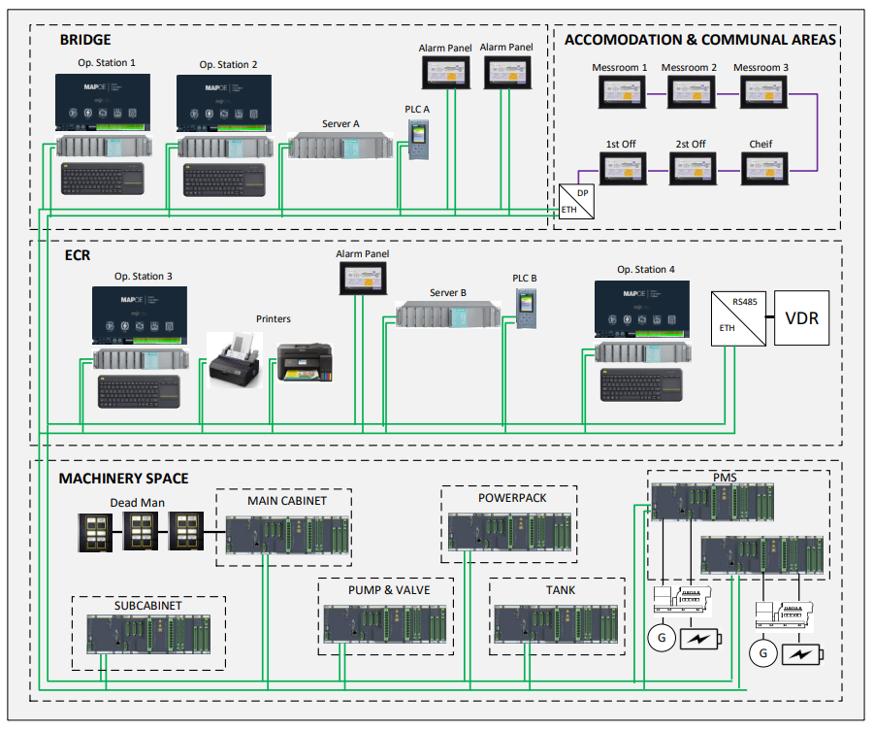

    - EQUIPMENT
Part No | Qty | Item | Notes | Item Price | Total Cost
{Q.part_no} | {Q.a} | {Q.b} | {Q.c} | {Q.d} | £{Q.total}.00
Total Cost (All prices exclusive of VAT) | £{GRAND_TOTAL}

      - I/O CONFIGURATIONS & DISTRIBUTION
For budgetary purposes the number of required channels has been estimated as follows:
- 672 Total number of I/O Channels

These are divided into Hardware Channels (signals via hardwired connection) and Software Channels (signals via serial interface connections) as follows:

- 672 Total number of hardware channels (see below for details)
- 100 Total number of software channels (see below for details)

Detailed Hardware Channels below with 15% Spare channels
Digital inputs | 0 | Digital inputs include wire break supervision | 0
Digital outputs | 0 | Digital outputs include wire break supervision | 0
High Speed Digital  counter Inputs | 0 | Analogue outputs | 0
Analogue inputs 0- 20mA, 4–20mA, 0– 10V | 0 | Analogue inputs PT 100 / resistors max. 2k | 0

 |  | Receive | Sends
Voyage Data Recorder | Nema 0183 | No | 0
Valve Control | RS-485 or RS-422 | Yes | 8
Power Management | Profinet | Yes | 32

Serial interfaces of external systems, which shall be connected to the alarm and monitoring system The MAP-OETM must meet the following basic requirements:
- Speed Between 150 to 57600 baud
- Serial Communication Protocol RS485, RS422, RS232 or Profibus/Modbus

The Alarm system is Inputs and outputs are installed in the following locations:
- MAP900 -Umas Alarm system main cabinet
- MAP940-Umas Pump and valve control cabinet
- MAP950 Power Pack local control cabinet
- MAP980 Tank Sounding main cabinet.

      - PRESENTATION SCREENS & MIMIC DIAGRAMS
On each Operator Station the general alarm list, event list and suppressed channel list are available as standard. The following presentation screens will be provided for supervision.
- Alpha numeric alarm lists- defined by alarm group.
- User Defined Journals -for periodic print out of user defined channels
- Trends -A maximum of 16 user defined analogue channels per screen.
- Standard mimic showing main engine with bar graphs for exhaust gas temperatures and including deviation temperatures.
The following additional custom-made mimic diagrams will be provided for supervision and control purposes:
Number | Location

    - ENGINEERING & DOCUMENTATION
Installation documentation supplied will comprise a full set of bespoke drawings covering all relevant equipment dimensions, mounting, cabling and connection details, plus written cable schedules in both hard copy (one set) and .pdf format.
An initial set of drawings for Shipyard/Owner system approval will be provided within six weeks of order placement and a final set (‘as built’ drawings), within six weeks of completion of all sea trials. Harbour and Sea Trials documentation (if required) will consist of a full set of bespoke documents supplied in .pdf format. Operator’s documentation will consist of one set of the manufacturer’s standard manuals in both hard copy and .pdf format.
The following list of documentation will generally be supplied:
• GA & Layout Drawings
• Electrical Schematic Diagrams
• Loop Diagrams
• Cable Schedules
• Equipment Data Sheets
• I/O List
• Alarm List
• Inspection & Test Plan
• Factory Acceptance Test (FAT) Procedure
• Harbour Acceptance Test (HAT) Procedure
• Sea Trial Acceptance Test (SAT) Procedure
• Operation & Maintenance Manual
• Spare Parts List
• Revision of all documentation to ‘As Built’ status
• 3 sets of hardcopy ‘As Built’ documentation plus all documentation in electronic (pdf) format.

    - CONSTRUCTION & TESTING
The system will be fully constructed, assembled and hooked up at MJR’s Facilities in preparation for Customer and Class FAT prior to installation on the Vessel. A detailed FAT procedure will be prepared and submitted for Customer and Class for review, comment and/or approval and FAT will not commence without prior approval of FAT. MJR Engineers will carry out full internal FAT prior to Customer and Class FAT, which will follow the same procedure as the Customer and Class FAT.
Once the FAT has been successfully passed, the system will be disassembled, unhooked, packed and be made available for Ex works Delivery.

    - INSTALLATION ON BOARD
Installation labour, materials and expenses are not included in this proposal but can be offered against MJR Standard Schedule of Rates with an estimated Budget cost or quoted subject to survey.
Shipyard/Owner is responsible for:
- Ensuring that all equipment is mounted and that all required cabling is properly installed, marked, terminated and tested.
- Where the system is being retrofitted to an existing vessel, that:
  - All existing sensors, transducers and other input devices that are to be reused are in a serviceable condition and calibrated as required.
  - All existing devices that are being interfaced to, and controlled by the system are in a serviceable and safe condition.
  - All existing cables that are to be reused are in a serviceable condition and have sufficient insulation resistance.
  - All existing cabinets and locations that the equipment is being installed into have the necessary environmental conditions required by the equipment (cooling, ventilation etc.)
Remedial work, repair, recalibrating or overhauling of defective equipment that is to be reused is not included in the scope of supply.

    - COMMISSIONING, HARBOUR ACCEPTANCE TRIAL (HAT) & SEA TRIAL ACCEPTANCE TESTS (SAT)
Commissioning, Harbour Acceptance and Sea Trial are not included in this proposal but can be offered against MJR Standard Schedule of Rates with an estimated Budget cost provided subject to survey.

    - AS BUILT DOCUMENTATION
After successful completion of SAT ‘as built’ documentation will be prepared and submitted to the Customer.

    - CLASSIFICATION SOCIETY APPROVAL & CERTIFICATION
Allowance for <> approval has been included based on a previous costs for similar systems. This covers plan approval and FAT at MJR but excludes any onboard survey at harbour or sea trial which will be to owner’s account.
In the event that the classification society chosen is not <> and the price from the chosen society is more than the allowance, the company reserves the right to charge extra to cover the additional cost.

    - SPARE PARTS
Spare Parts are currently excluded from the scope of supply but can be offered upon request.

    - SERVICE & SUPPORT
MJR operates as a single point of contact for all service and support requirements. As part of our product support commitment MJR will ensure that the customer is advised of any software updates on the equipment supplied that may improve functionality or performance.
The system includes a remote access function allowing MJR’s service department to monitor the system, allowing for remote fault diagnostics and reprogramming.

- COMMERCIAL PROPOSAL
  - PRICING SUMMARY
Line | Description | Notes | Qty | Unit | Item Price | Total
{S.a} | {S.b} | {S.c} | {S.d} | {S.e} | £{S.f} | £{S.g}
All prices exclusive of VAT | Total | £{TOTAL_2}

  - MILESTONES
Milestones | Amount Due | Notes
Milestone 1 | 10% | At the point of placing an order
Milestone 2 | 10% | On the submission of basic design
Milestone 3 | 10% | On the submission of detailed design
Milestone 4 | 10% | When ordering long lead items
Milestone 5 | 20% | On the completion of construction
Milestone 6 | 10% | On the completion of FAT and equipment being available for delivery
Milestone 7 | 15% | On the completion of installation
Milestone 8 | 10% | On the completion of SAT
Milestone 9 | 5% | On the submission of final documentation

- TERMS AND CONDITIONS
  - PAYMENT TERMS AND CONDITIONS
Credit Account - Payment terms strictly 30 days net (unless otherwise agreed) According to MJR Standard Conditions of Sale

  - DELIVERY
Delivery is Ex Works, currently 40 working weeks from order. Delivery time to be confirmed at the time of order placement and is dependent on equipment lead times and capacity remaining unsold at the time of order.

  - WARRANTY
18 months from the date of equipment being available for Ex Works Delivery or 12 months from commissioning whichever is the sooner.

  - VALIDITY
Validity 30 days from date of quotation unless otherwise stated.

  - GENERAL ASSUMPTIONS & EXCLUSIONS
- All engineering work will be carried out at MJR locations in UK.
- This offer is based on unrestricted access at all times.
- All documentation will be submitted to the customer for review and comment and one review cycle only is allowed for. Comments shall be returned within a 14-day period from submission. If no comments are received within this period, it is considered that the customer does not have any comments and that the documentation is accepted and approved by him.
- Any later requests (after the review period and/or design/document freeze) for changes may, at MJR discretion, be subject to a Change or Variation Order Request if material changes are required. Such changes will be offered against a separate quotation indicating cost and schedule impact. No work will begin until a Variation Order Request is submitted and accepted and a Variation Order is provided.
- If milestones cannot be delivered due to circumstances outside of MJR control, milestone payments shall be due not later than 60 days after originally agreed milestone delivery schedule.
- Class approval (if applicable) fees are excluded.
- Where required by the marine classification society, all hardware offered as part of this proposal is marine type approved.
- MJR reserves the right to substitute materials or equipment where supply chain delays result in the original equipment not being available to meet the project timescales.
- Any mileage incurred in carrying out business for the Client outside of the lump sum contract will be charged at 0.75p/mile.
- MJR reserves the right exclude Client changes or modifications if there is a reasonable belief that such changes will compromise the function, integrity or safety of the system.
- Allowance is made within the lump sum for one weekly Technical and/ or Progress Meeting with the Client at either MJR Offices or via Conference Call.
- A weekly progress report can be provided on request.
- Testing and acceptance, (FAT) will be against pre-agreed acceptance criteria.
- Contract base location will be at MJR Teesside Facilities.
- Any time, assistance, travelling, accommodation and general out of pocket expenses outside of the lump sum contract, unless otherwise agreed will be according to MJR Standard Schedule of Rates, recorded on a weekly time & expense claim sheet and signed/approved by an authorised Client representative. Expenses will be charged at cost + 10% by MJR to the Customer.
- Where assistance on site is required from the Customer or third parties, this is assumed to be provided to MJR on a cost free basis.
- The following are services/activities are the responsibility of others and are to be supplied on a cost-free basis:
− Hot work such as cutting and welding.
− Mounting Brackets and plinths.
− Access for working at height.
− Working at height safety equipment.
− Rigging and lifting.
− Cranage.
− Insulation/lagging removal and replacement.
− Deck head and bulkhead panels removal, replacement, modification.
− Pipe work.
− Hydraulics & Pneumatics
− Confined space safety equipment.
− Safety barriers and signage.
− Temporary power supplies.
− Temporary lighting.
− Additional ventilation.
− Secure site storage.
− Welfare facilities.
− Working close to water safety equipment.
− Crew transfer safety equipment.
- SYSTEM INFORMATION
MAP-OE is a modular, flexible and scalable marine automation platform developed based on over 30 years of MJR experience in vessel maintenance, retrofit, life extension, conversion and newbuild projects. It is particularly well suited to retrofit projects where adaptability and flexibility are critical and the ability to make changes during commissioning and setting to work is essential.

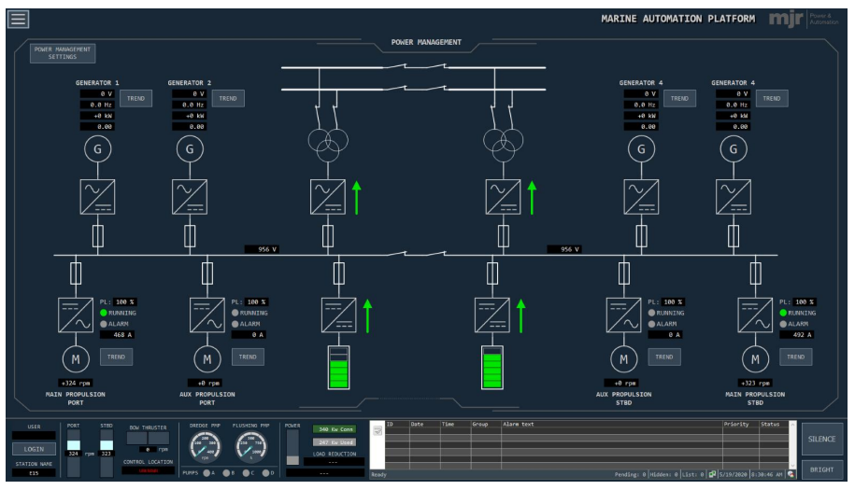

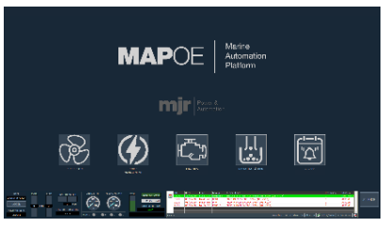
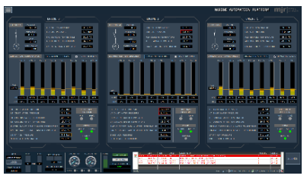
MAP-OE is based on commercial off the shelf ‘COTS’ hardware and is built using the same PLC/SCADA/DCS architectural foundations as the most critical industrial automation systems. Multiple distributed redundant operator stations allow crew access to all critical on-board system information with robust security groups to ensure that only crew members authorised to control particular equipment and machinery have control rights.

High levels of system redundancy are provided at all levels ensuring that the system meets all of the major
classification society rules allowing the system to be deployed in the most demanding and mission critical
applications, for example DP3 offshore/subsea construction vessels. Extensive diagnostics are provided together
with sophisticated datalogging, audit trail and historian functions to assist crew with identifying and resolving issue
quickly and safely. The system is also equipped with the necessary power and energy management functions to
cater for hybrid power system installations with energy storage and shore/offshore power and charging.

  - PORTABLE OPERATOR STATIONS
A laptop is installed with the same software as the main stations and can be connected to the system at any of the outstations or workstation locations. In addition, the laptop can connect at any remote IO stations.

  - PRINTERS
The system includes three printers, an alarm printer and two inkjet office printers providing various data including:
- Alarm/Event Log detailing changed alarm / event status, error messages, changed suppression status, password input, information on duty officers/engineers and Unattended WS, as well as changes in system date and time.
- Alarm List covering the contents of the Alarm List, i.e. all present and unacknowledged alarms in the alarm system at the moment when the report is triggered.
- Suppression List covering the contents of the Suppression List, i.e. all channels which have the automatic or manual Suppression status.
- Data log detailing channel data. For analogue channels the current value is output. For binary channels and event channels, the respective status is output.
- Command List printout prints the maneuver log.
- Journals, reports etc.

  - EXTENDED ALARM SYSTEM, ENGINEER CALLING, BNWAS & DEAD MAN
The extended alarm system consists of a number of duty alarm panels (DAP) from where all alarms can be viewed and acknowledged. This meets the unmanned machinery space (UMS) requirement as the panel is used for transfer of watch between the engine control room, cargo rooms and the bridge where other DAPs are installed. Change‐over procedure from attended to unattended engine room and vice versa is realised through these panels. The extended alarm system is based on a touch screen HMI, Exor 710.
The engineer calling system is an integrated part of the IAS. From any DAP panel individual or general call of all engineers is possible. The system also integrates the Bridge Navigation Watch Alarm (BNWAS) and engineer’s Dead Man function with the bridge DAP2200 being used for both functions. Both of these are timer based functions. The BNWAS includes two reset buttons on the bridge and can accept a reset from the navigation equipment. The engineer’s dead man system includes two start panels at the engine room entrances and five reset panels.
For the crew cabins and communal areas the Accommodation Alarm Panel is included. The unit provides visual indication of ten group alarms plus separate fire and on call indication. The unit can be programmed to operate as part of the engineers alarm system, BNWAS, or both functions.

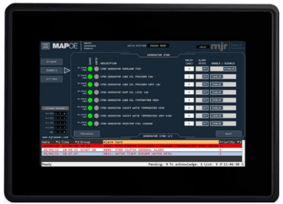
The dead man alarm system is an integrated part of the alarm and monitoring system. The dead man timer is password protected and adjusted through the duty alarm panels usually installed in the engine control room (ECR). Reset of the dead man timer can be done via the duty alarm panels and push buttons distributed in engine room spaces.
Initiation (start-up) of the dead man function can be done from the duty alarm panels, push buttons located at the entry of the engine room spaces or automatically when an alarm occurs in “unmanned engine room“ mode. All connected push buttons will glow in steady light to indicate the system is active. A pre-warning will be given before the dead man alarm is released, indicated by flashing of connected push buttons in engine room spaces. If the alarm is not acknowledged within the predefined time the dead man alarm will be released.
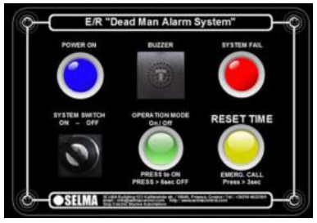

  - UPS
All workstations are supplied with a UPS to ensure uninterrupted operation in the event of a blackout.

  - FIELD PROCESSING DEVICES (OUTSTATIONS)
The I/O channels will be distributed throughout the Alarm System Installation Cabinets. Each location will have a minimum of one Remote Alarm Management Unit (RAMU) fitted. The RAMU comprises of an independent network header and various I/O modules dependent on the type of signals at that location. Each RAMU is connected to a fully redundant Siemens PLC CPU1515-2-PN, both CPU are located in two separate compartments as required by the classification societies and manage the alarm system communication traffic and the redundant control logic functions of the IAMCS system. Both redundant servers are also connected to each redundant PLC and each RAMU via a redundant ethernet network. Figure below shows a simplistic representation of the above explained.
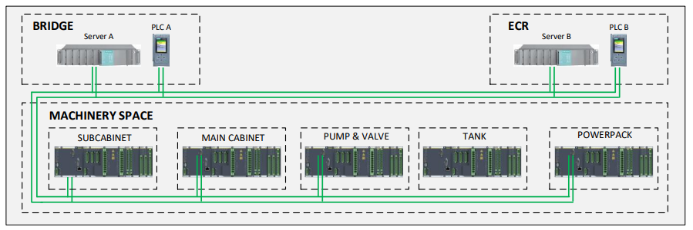

  - IAS FUNCTIONS
Icon | Part No | Description
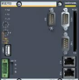 | MX207/213 CPU | The CPU provides independent processing of all signals for the RAMU and provides Profinet communication to the IAMCS.
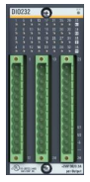 | DIO 232 | The digital input / output module DIO216 or 232 can be used to operate receivers of digital control devices such as contactors, relays, pneumatic and hydraulic valves as well as for reading signals from digitally operating sources such as sensors, photocells or switches.  ✓ 16 channels can be configured as input or output  ✓ Configurable interrupt inputs  ✓ 8 x fast Counter Inputs.  ✓ Status display for each channel via LED  ✓ Supply voltage 18 to 34 VDC
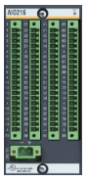 | AIO216 | The AIO216 modules enable the measuring or output of all standard analog signals. The AIO216 offers 16 channels compactly in a single module. The standard signal types for current (0 to 20 mA and 4 to 20 mA) and voltage ranges (±10 V to ±10 mV) allow the connection of a wide range of sensors and actuators. A minimum 14-bit resolution makes it possible to also measure signals that do not fully utilize the measuring range (e.g. 0 to 5 V) with a sufficiently high resolution. These modules support Pt100/Pt1000 in 2, 3 and 4- wire measuring circuits, as well as all standard thermocouples.
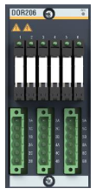 | DOR206 | The output module’s direct pluggable relays drastically reduce wiring work, save valuable control cabinet space, and facilitate troubleshooting. The locking mechanism keeps the relay in place even when subjected to shocks and vibrations. The relays offer maximum flexibility for implementation in control cabinets thanks to possibilities offered by standard relay types with a voltage range from 24 V/48 VDC or 230 VAC, a broad power range and the selection of valuable electromechanical relays or solid state for high make-and-break cycles.
The IAMCS functions can include (but are not limited to) the possibility to control and/or monitor the following equipment/functions. Please note that the functions provided in the list below are provided as an illustration of system capability only and are dependent upon the vessel. The exact project specific functions provided may be different to this list.
✓ Power management system including generator sets and emergency generator set.
✓ Propulsion system
✓ Emergency shutdown monitoring and control
✓ Motor control for pumps and fans
✓ One speed duty/standby motor
✓ Valve control
✓ PID type control loops
✓ Hour counters
✓ Exhaust systems monitoring
✓ Bow thrusters monitoring
✓ Bilge system
✓ Fire‐fighting system monitoring
✓ Seawater cooling system monitoring
✓ Fresh water cooling systems monitoring
✓ Fuel oil systems monitoring
✓ Lube oil systems monitoring
✓ Fresh water system monitoring
✓ Black and grey water systems monitoring
✓ Automatic start/stop of Diesel Engines
✓ DDGG standby program
✓ Automatic Generator’s breakers synchronization on network and connection
✓ Shore to Ship and vice versa seamless transfer management
✓ Load sharing
✓ Load dependent DDGG start/stop program
✓ DDGG Minimum Number setting (by Operator)
✓ Hydraulic systems monitoring
✓ Compressed air system monitoring
✓ HVAC system monitoring
✓ Refrigeration plant monitoring
✓ Cold and freezer rooms temperature reading and lock in/panic alarm monitoring
✓ Tank levels system
✓ Technical water/deck wash system monitoring ✓ Fire dampers monitoring
✓ Watertight and fire doors and hatches
✓ Electrical systems
✓ Fire detection and alarm system monitoring
✓ General alarm/public address system monitoring
✓ Gas detection system monitoring
✓ Surveillance systems monitoring
✓ Burglar alarm system monitoring
✓ Navigation lights monitoring
✓ UPS and battery systems monitoring
✓ DDGG Start sequence setting (by Operator)
✓ Automatic generator substitution for pre warning
✓ Blackout Condition detection
✓ Automatic Power Restoration sequence
✓ Heavy load program to control large consumers
✓ Load shedding
✓ Emergency generator monitoring
✓ PMS Control mode program
  - REMOTE ACCESS
MJR can optionally offer remote access and service for the system. This may be used for MJR service engineers to provide cost effective and fast remote fault finding and support of the system and is only activated by onboard crew giving explicit access permission. It is also possible for the system to serve data to MJR remote cloud-based server infrastructure to enable the owner to be provided with full vessel data.
This is particularly useful as part of a wider vessel remote monitoring and analytics platform for services such as vessel performance monitoring and electronic fuel management system (EFMS). The system is connected via an MJR supplied and configured integrated services router with inbuilt VPN tunnel and firewall to encrypt communication and prevent unauthorised access. The connection can be via any satellite system with broadband capability.
- APPENDICES

Here are the questions and answers:

{QATable}

