ROUTE 53:-

R53- Route 53- Where as the 53 stands for port number.

- Purchase one Domain from Godaddy.
haseebteach.co.in
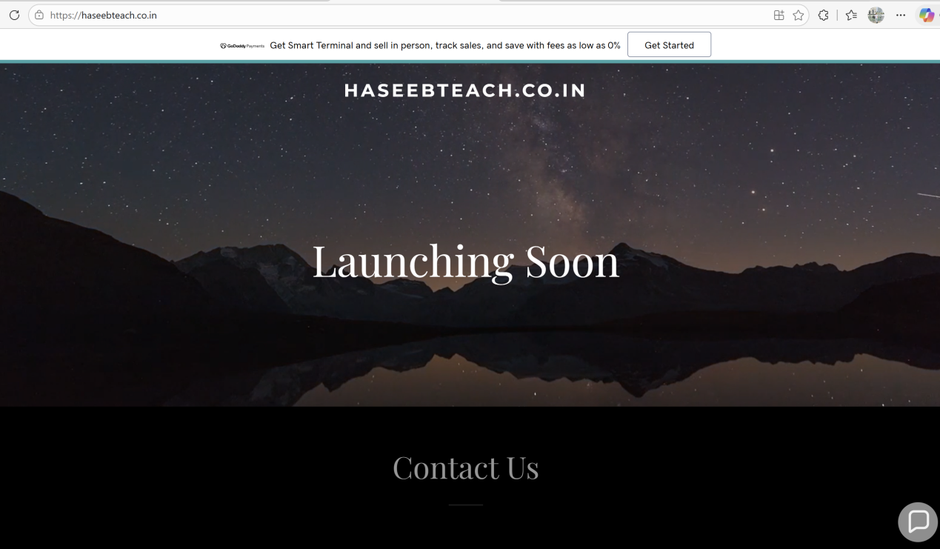

2) Deploy a Static Website in S3.
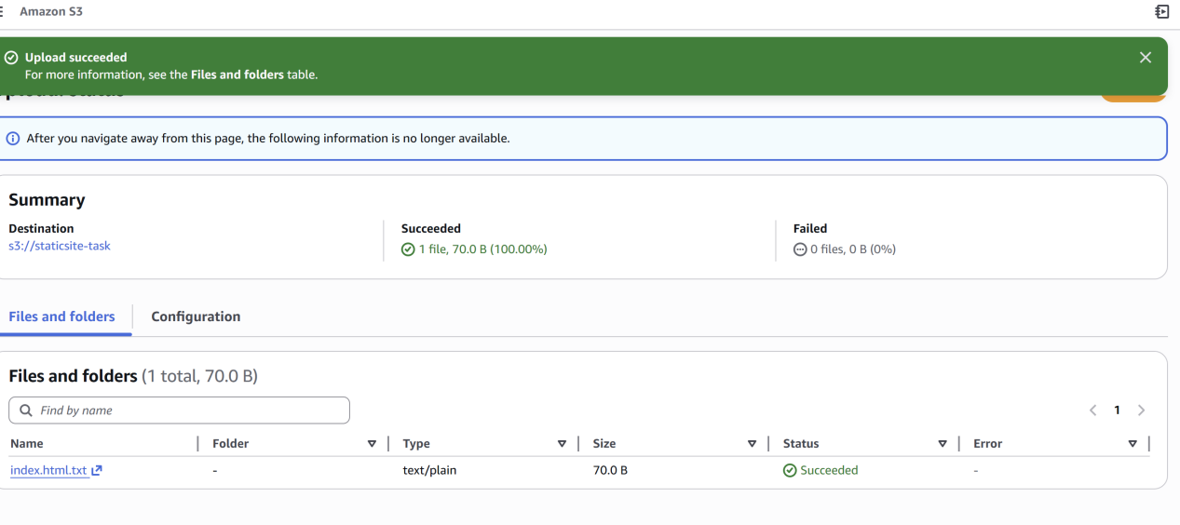
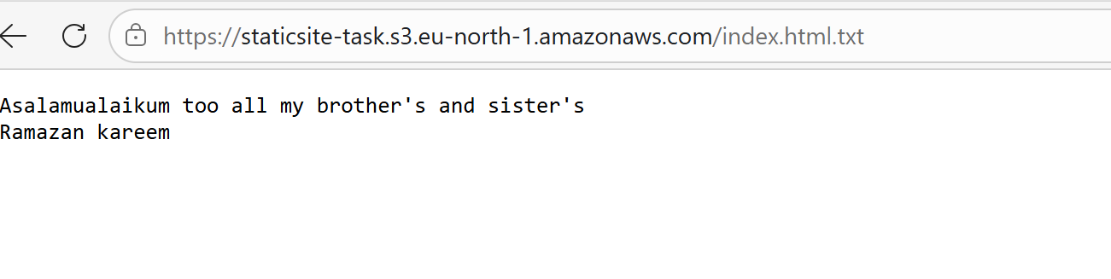

Q)Create a CDN and attach a SSL Certificate.
A) First create a s3 bucket with the same domain name and upload index.hml file in order to create a static website. Then open cloudfront and create distribution as mentioned below.

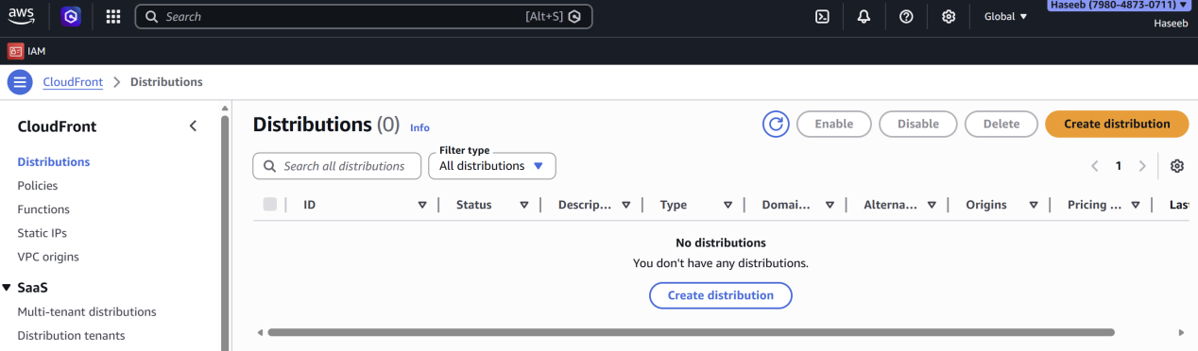
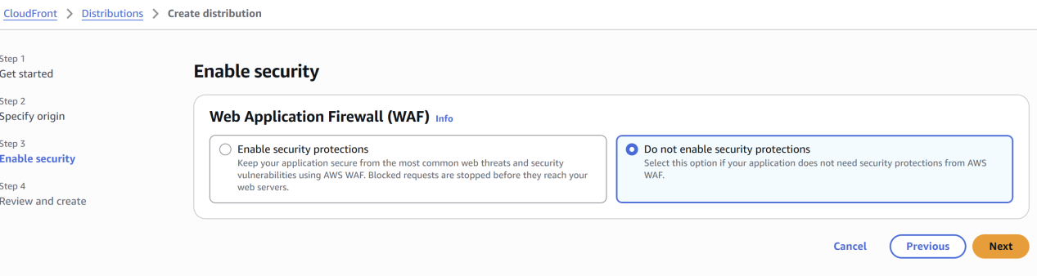
Click on create distribution…
As the cloudfront distribution has been created now connect it with Route53 by creating a record..
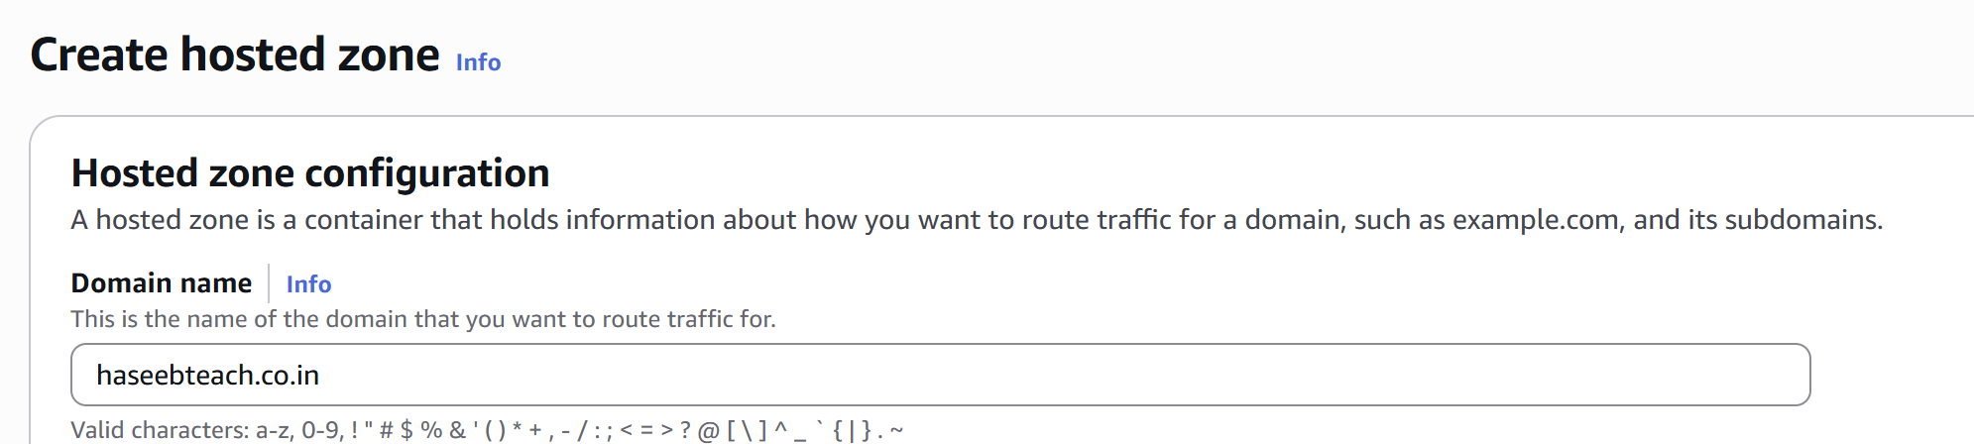

Then go to godaddy (The source from where the domain was created) and select the domain --> DNS --> Name servers.
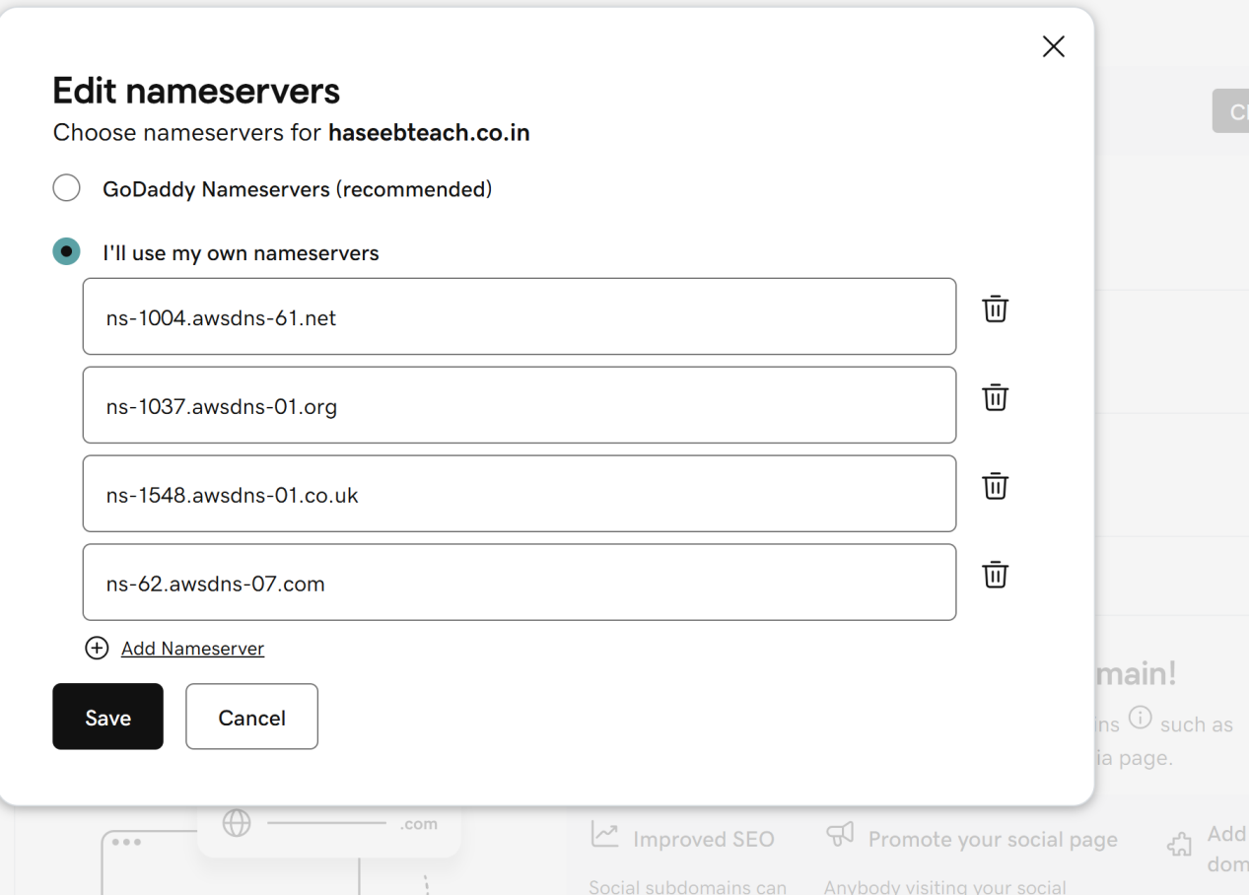

Click on Add domain and you can follow the steps…
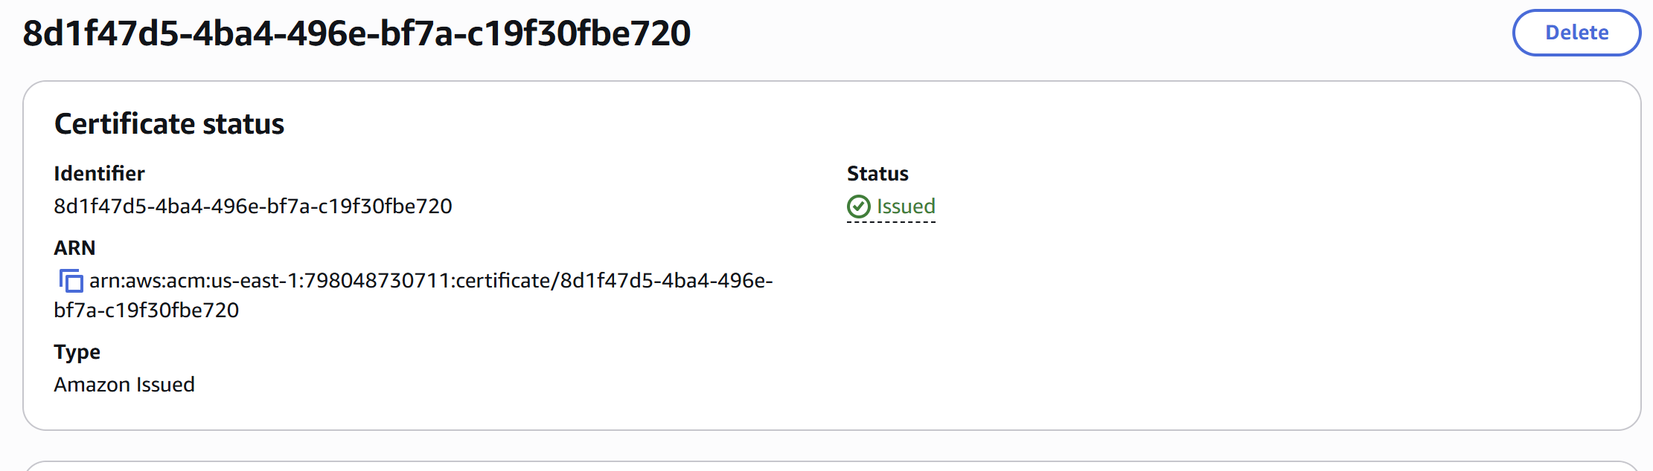

Create a Route 53 hosted zone and map the domain with the CDN.
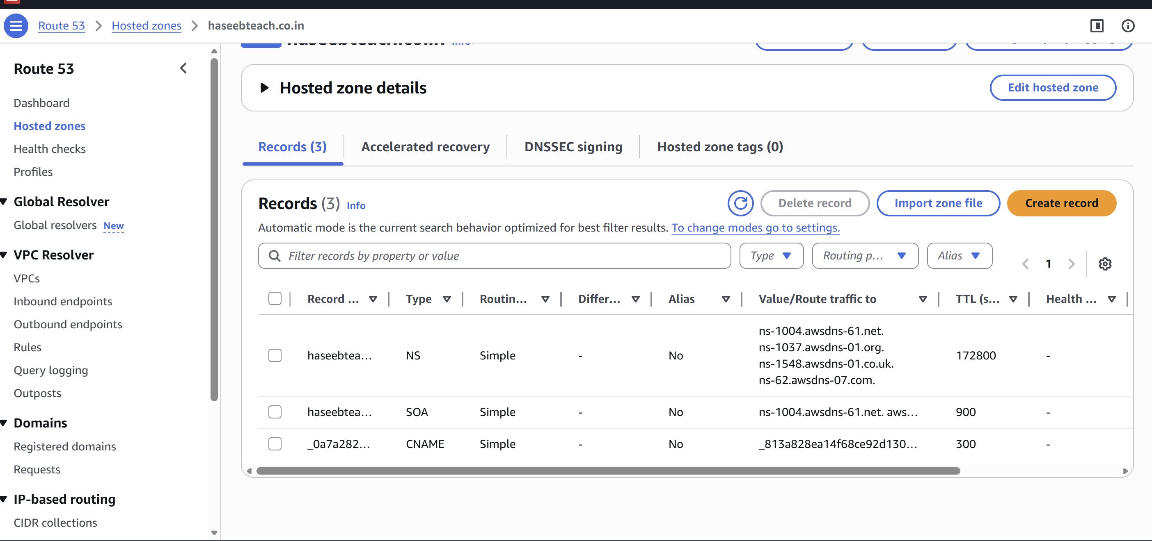

Update the index.html in the S3 bucket and ensure the updated file is accessible using the domain name
