EC2 -Task
- Launch one EC2 using Amazon Linux 2 image and add a script in user data to install Apache.
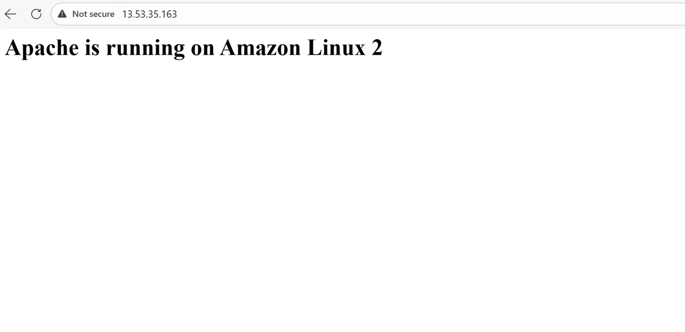
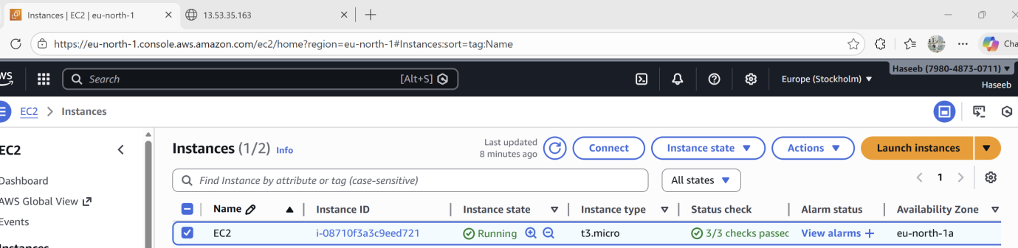

- Launch one EC2 using Ubuntu image and add a script in user data to install Nginx.

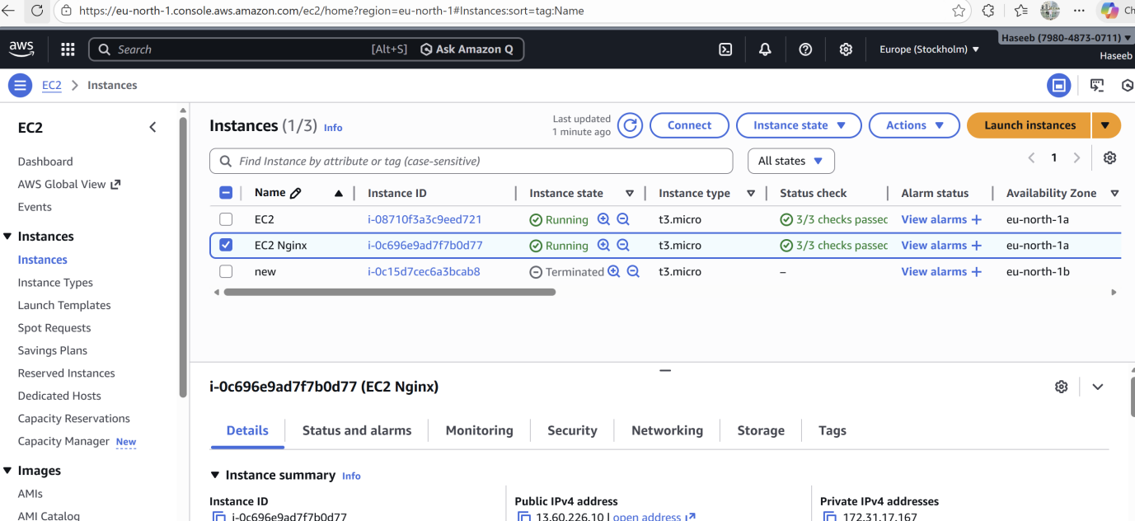

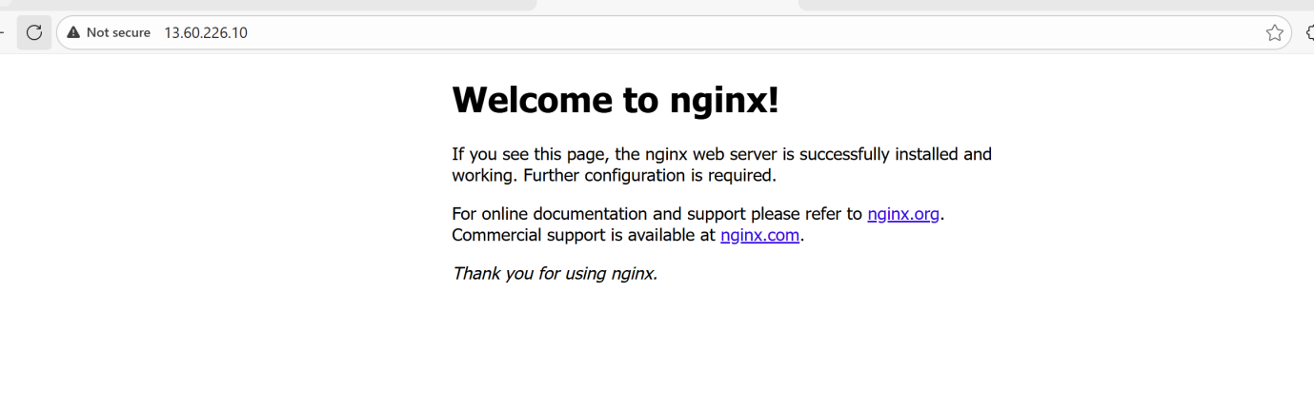

- Launch one Windows server and install Tomcat on Windows.
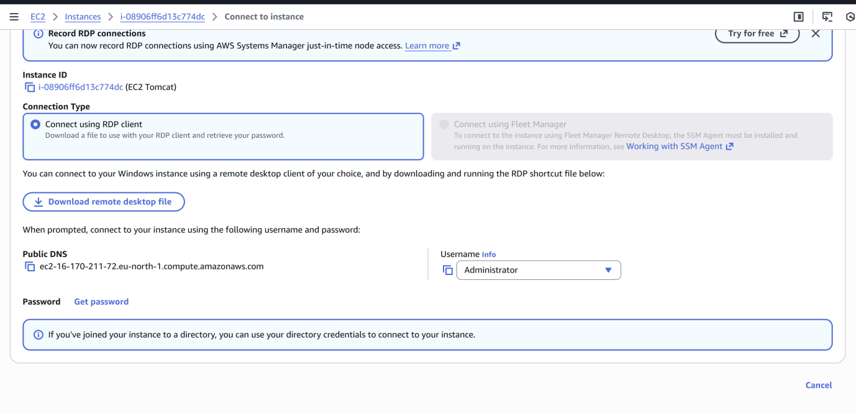
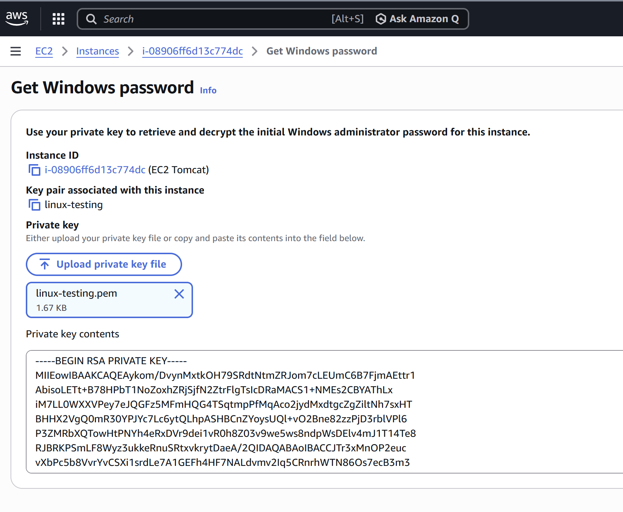

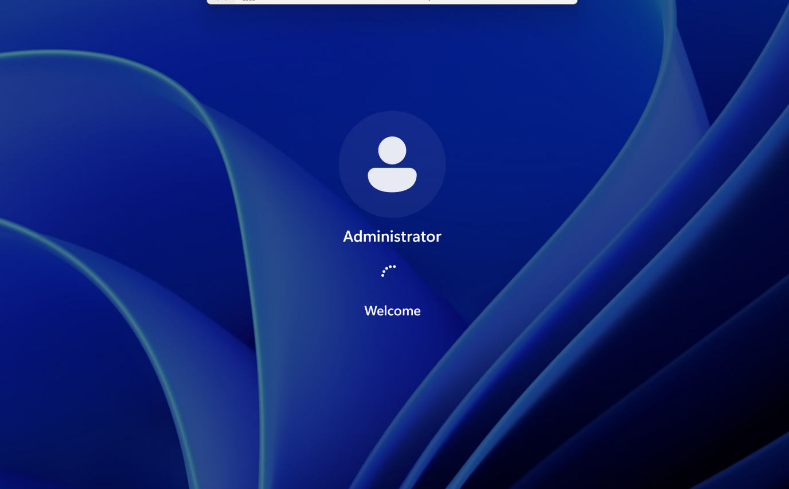
After this step the machine runs real slow…
- Take a snapshot of the instance created in Task 1.
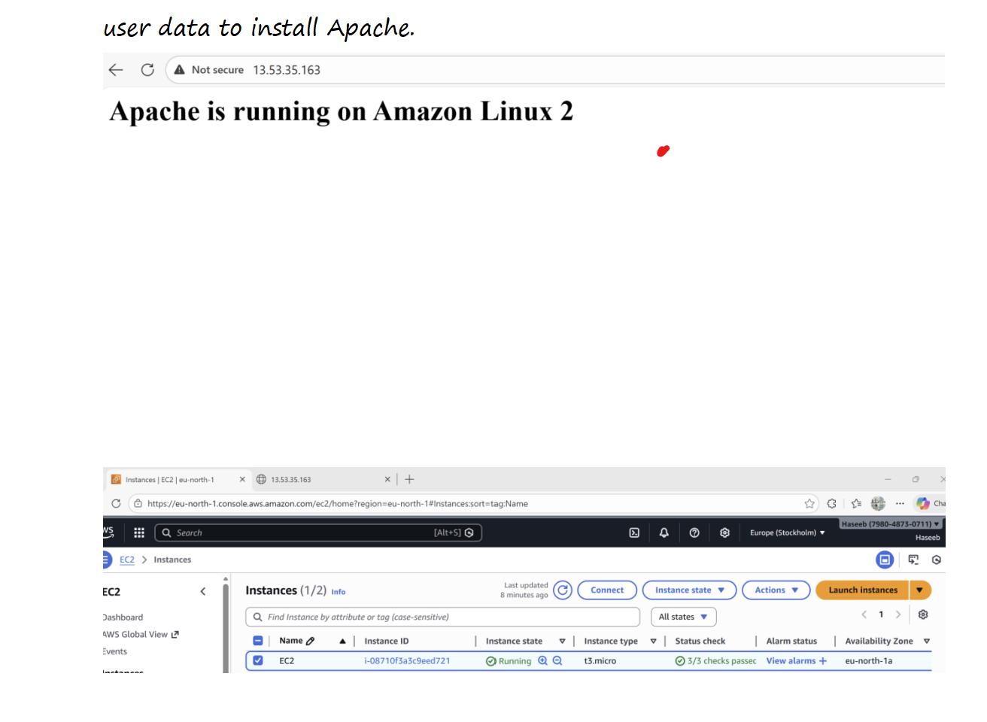
- Assign passwordless authentication for the EC2 created in Task 2.

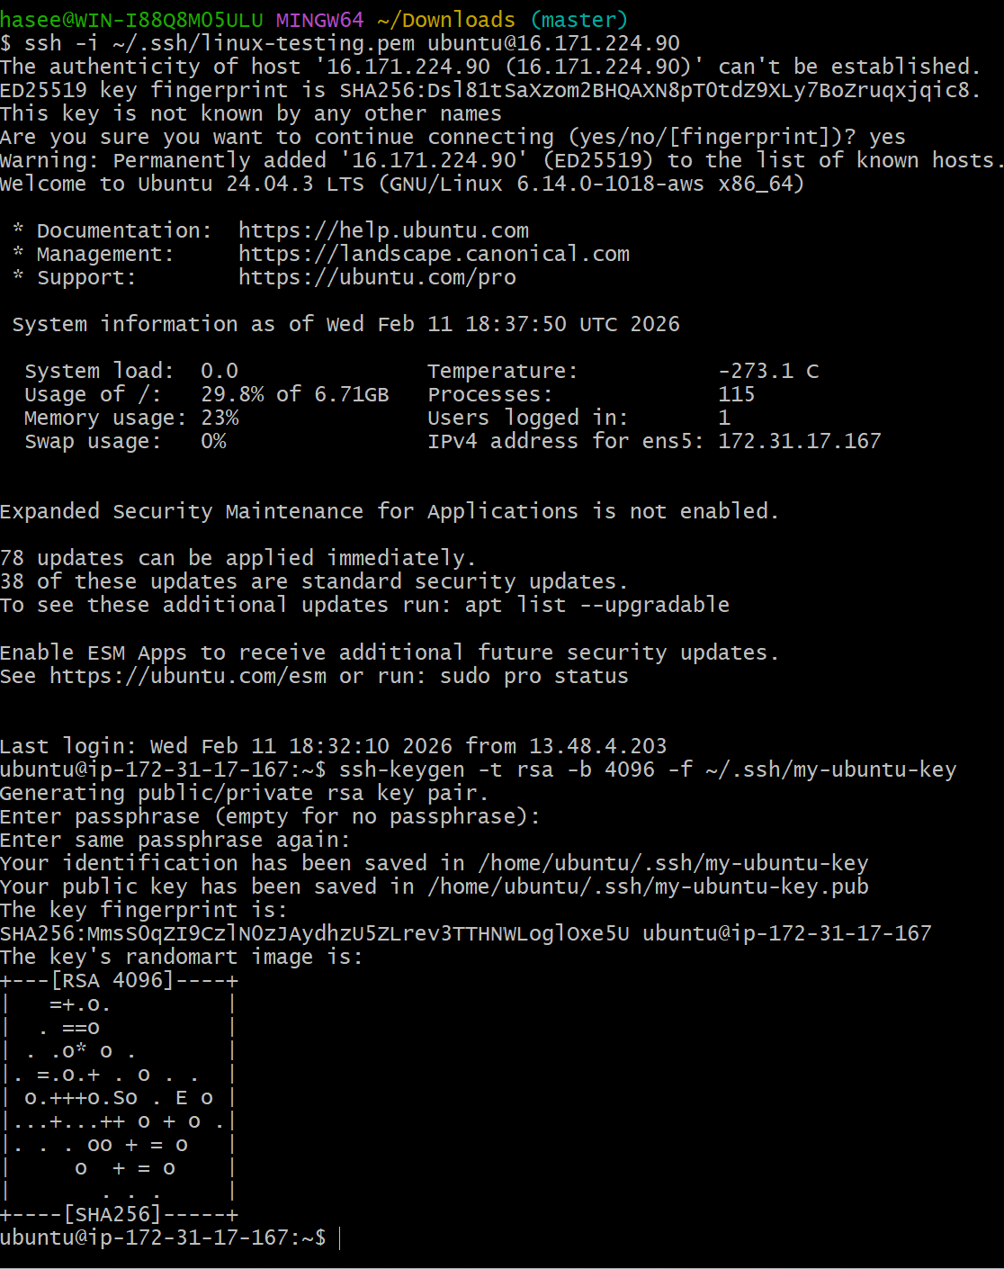

- Launch any EC2 using the spot purchasing option.
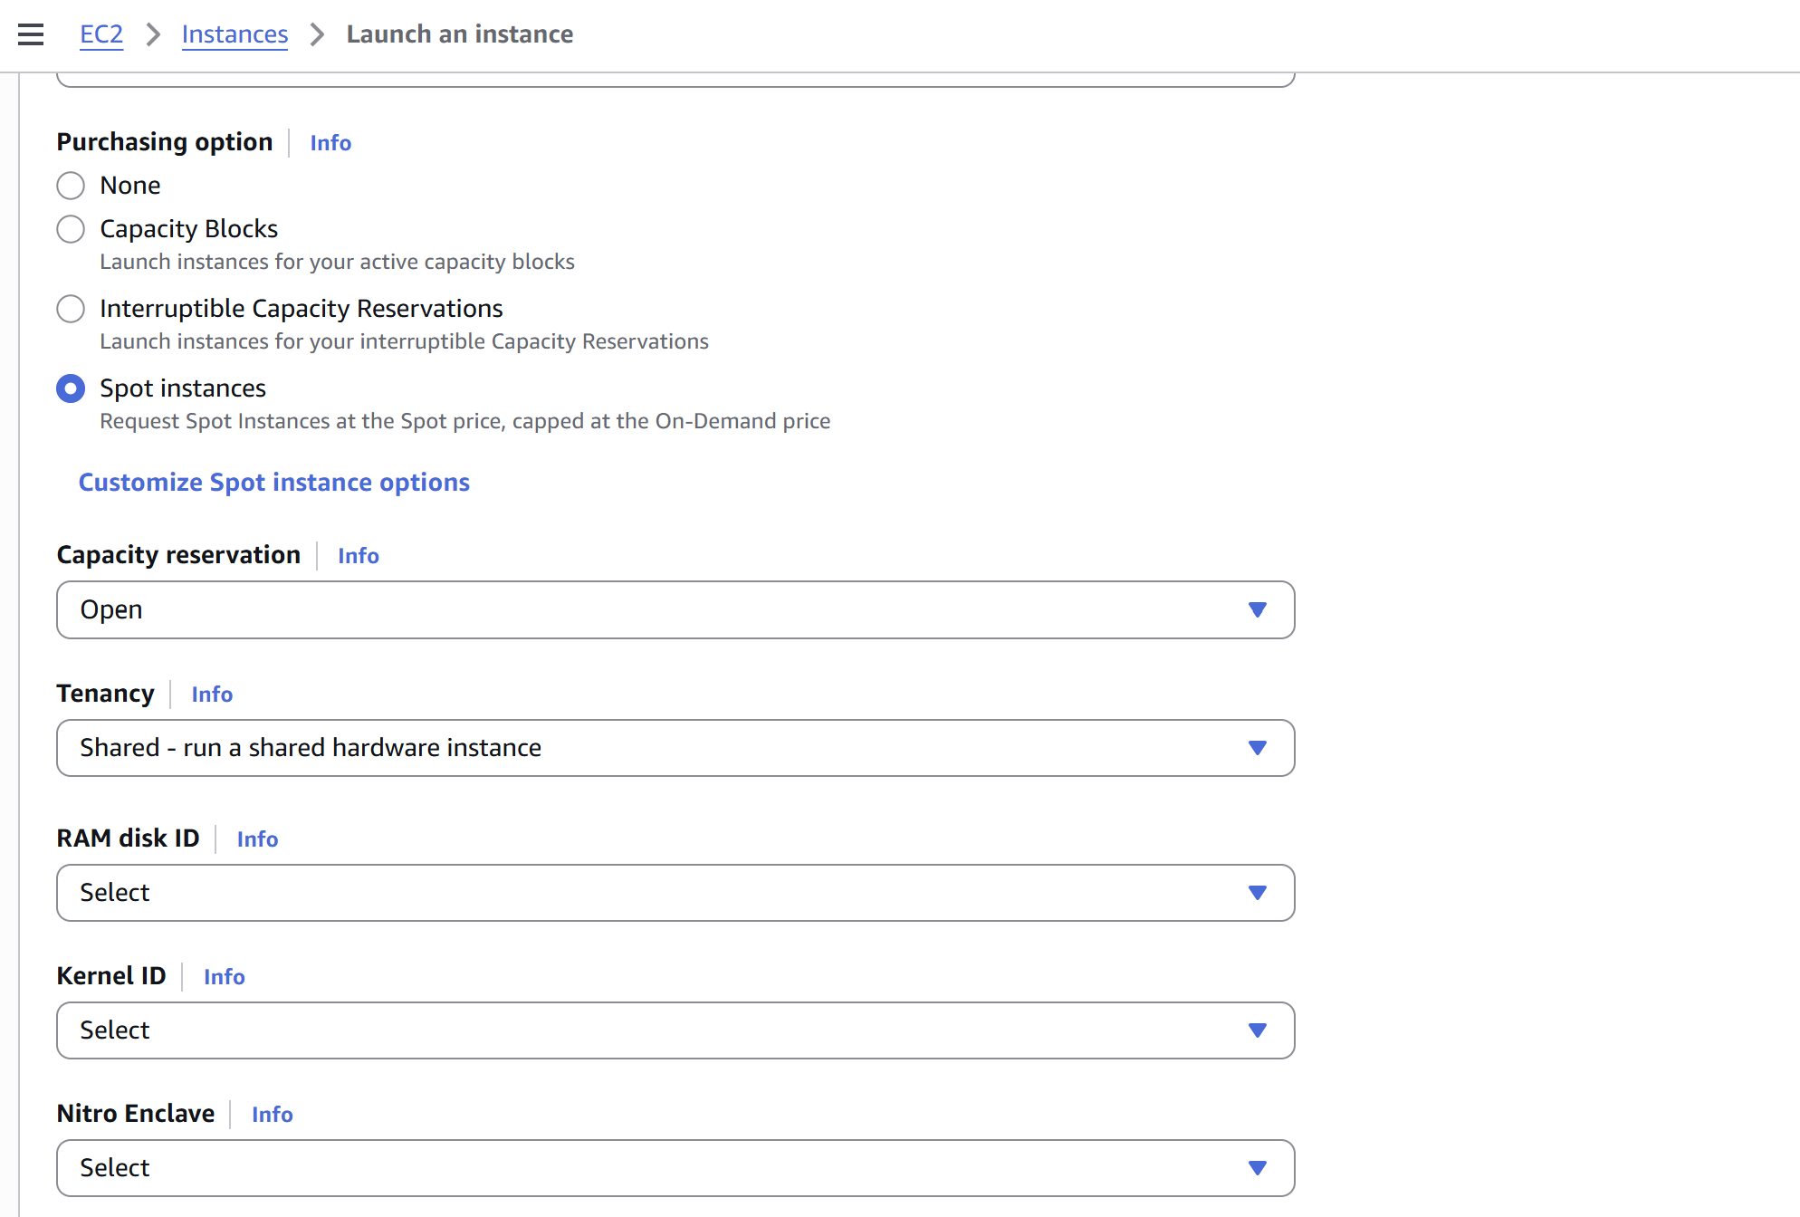
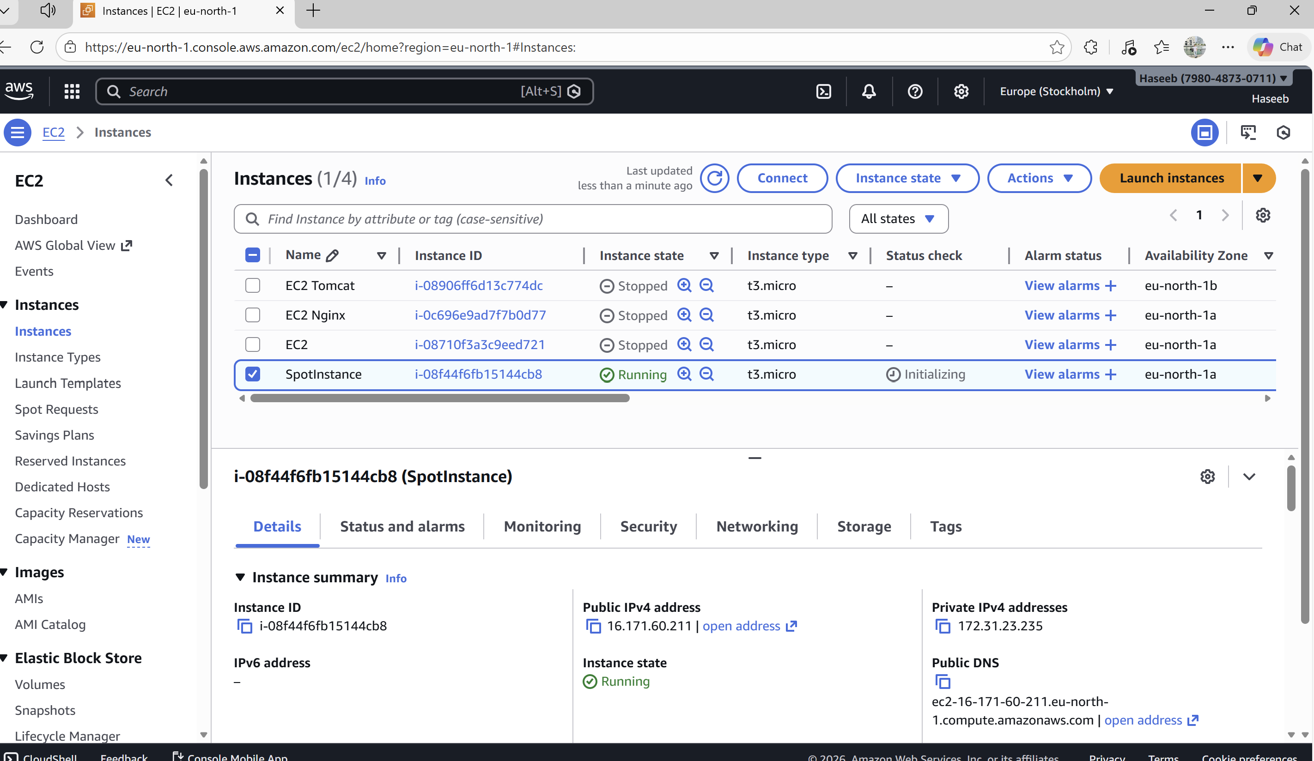

- : Enable Termination Protection (Task 2 Instance)
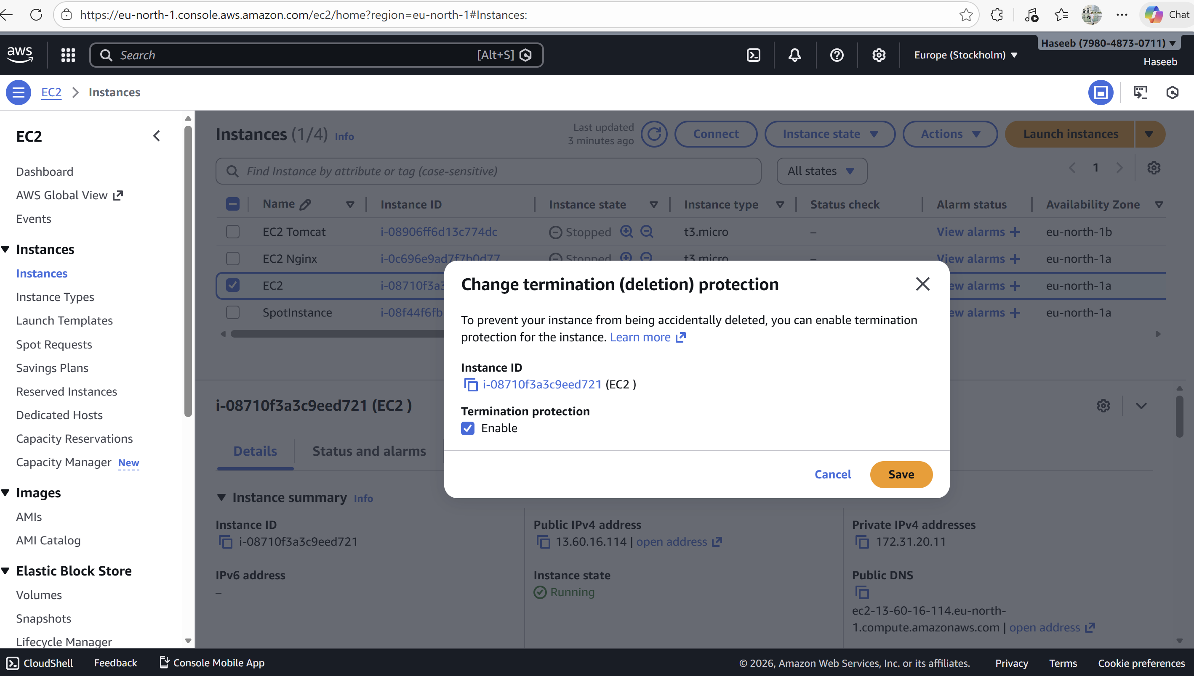

- Launch EC2 using AWS CLI

