- Create an S3 bucket and upload some objects to S3.
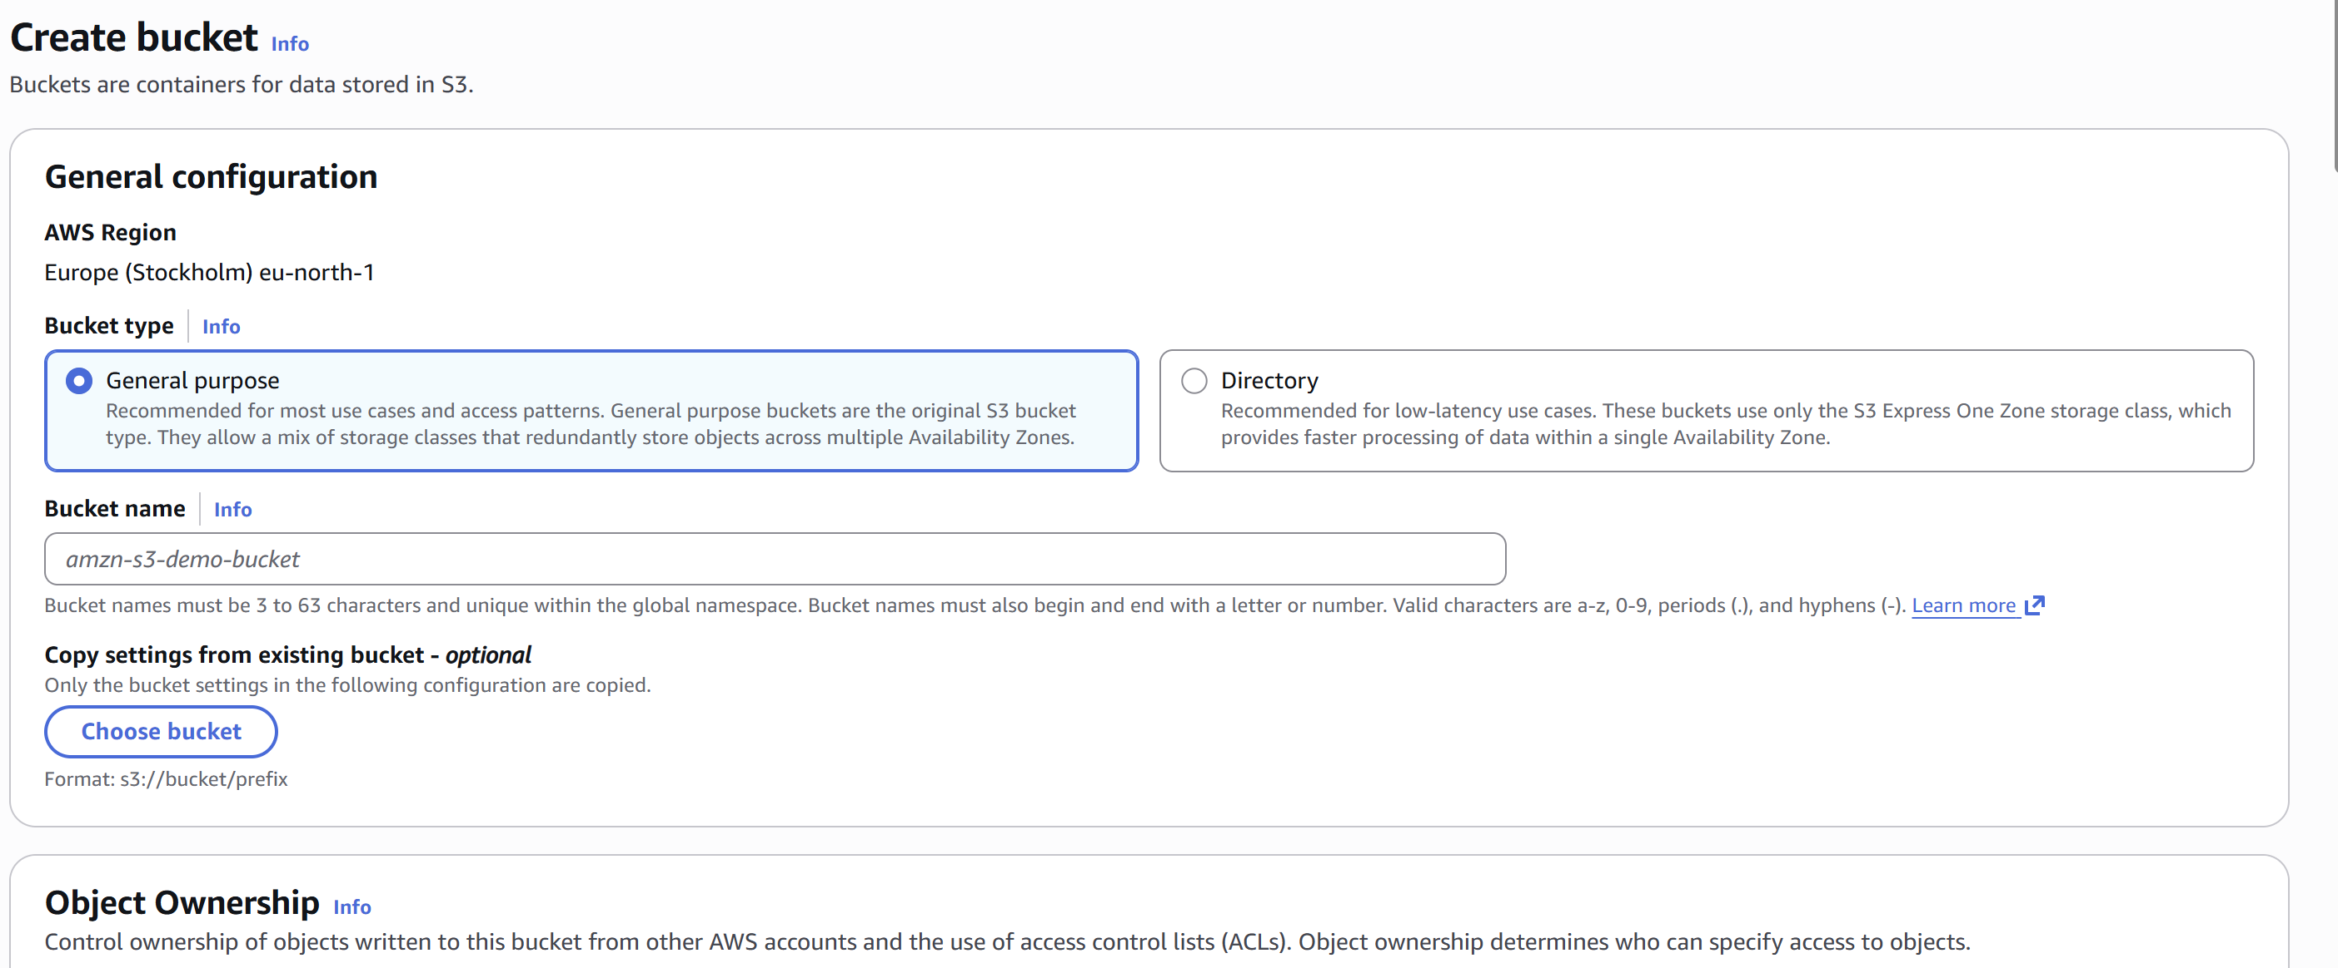
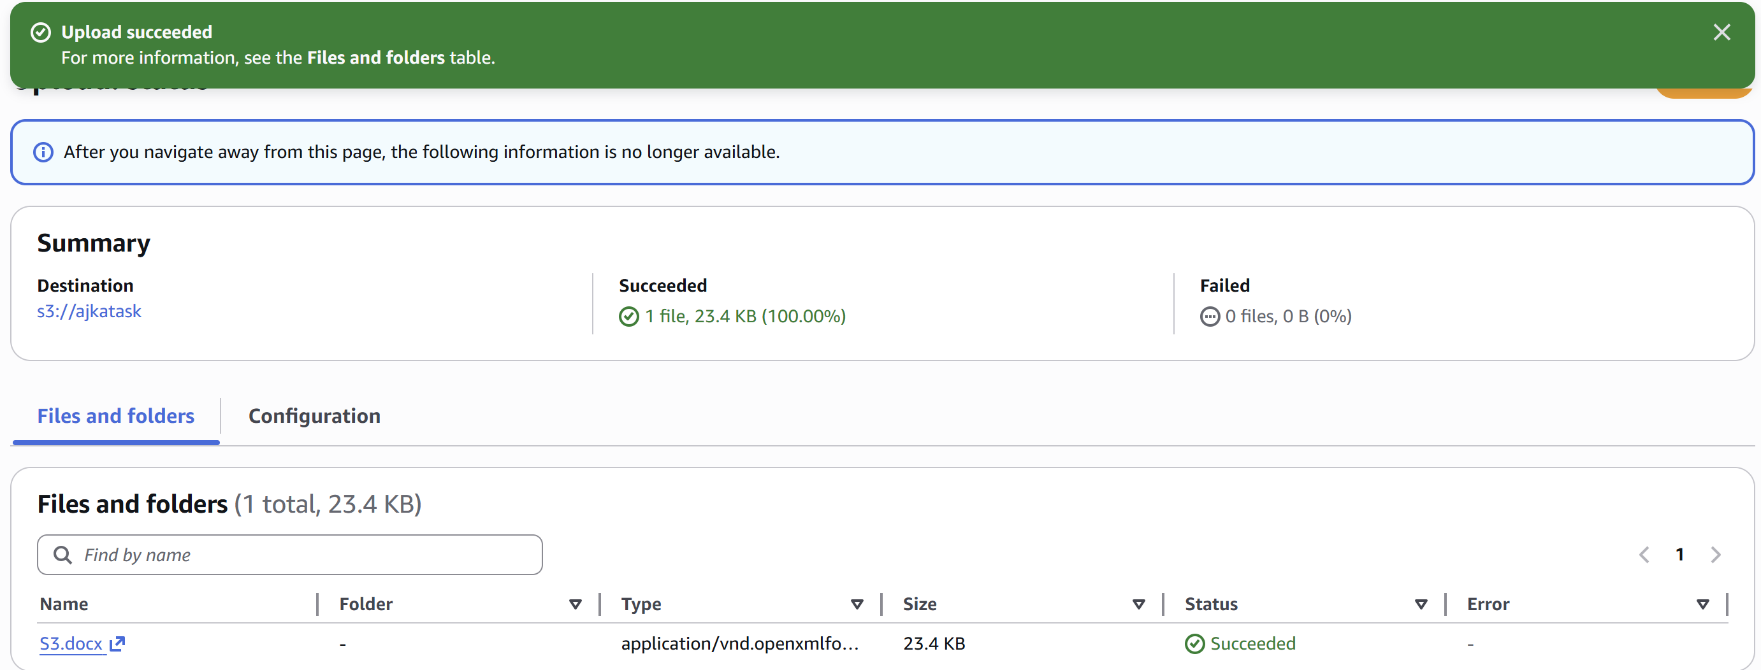

- Deploy a static website in the S3 bucket.
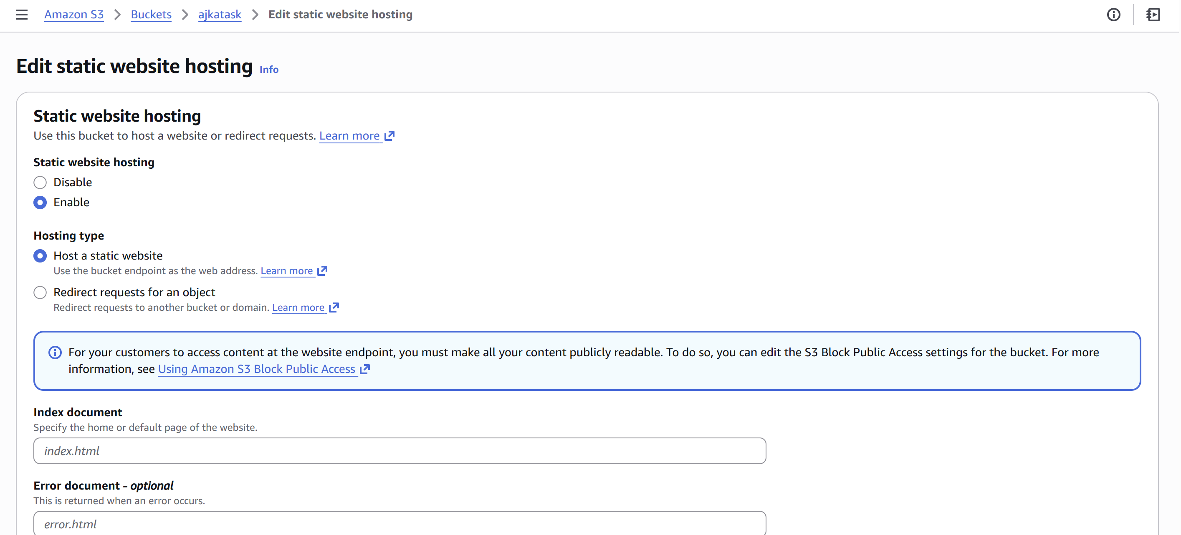
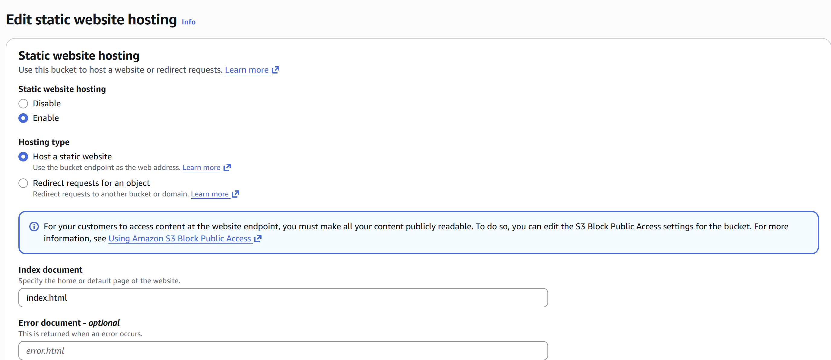
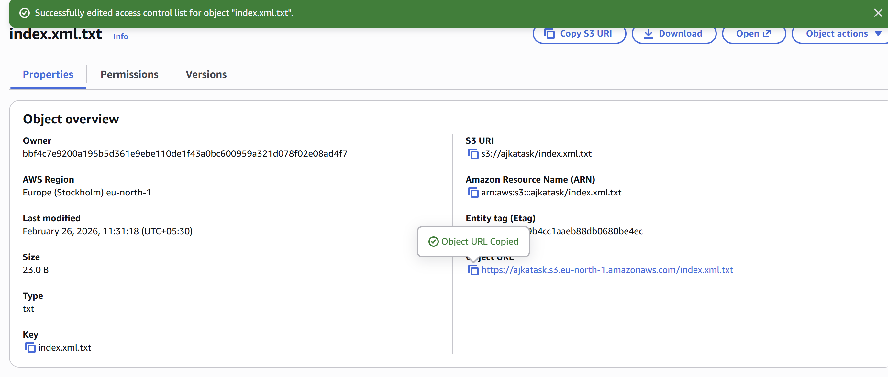
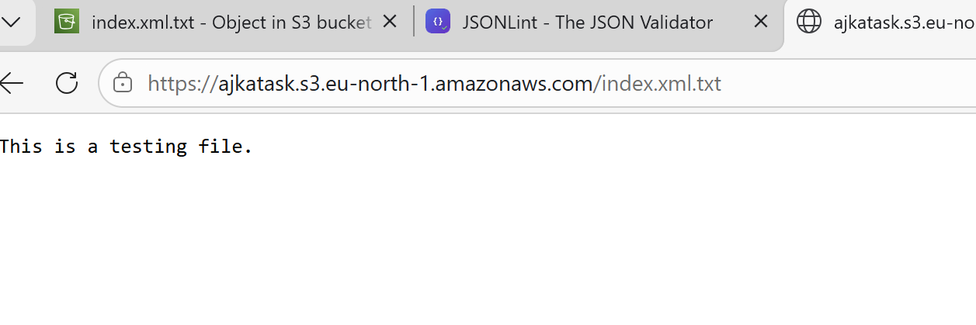

- Enable Cross-Region replication on S3 Bucket.

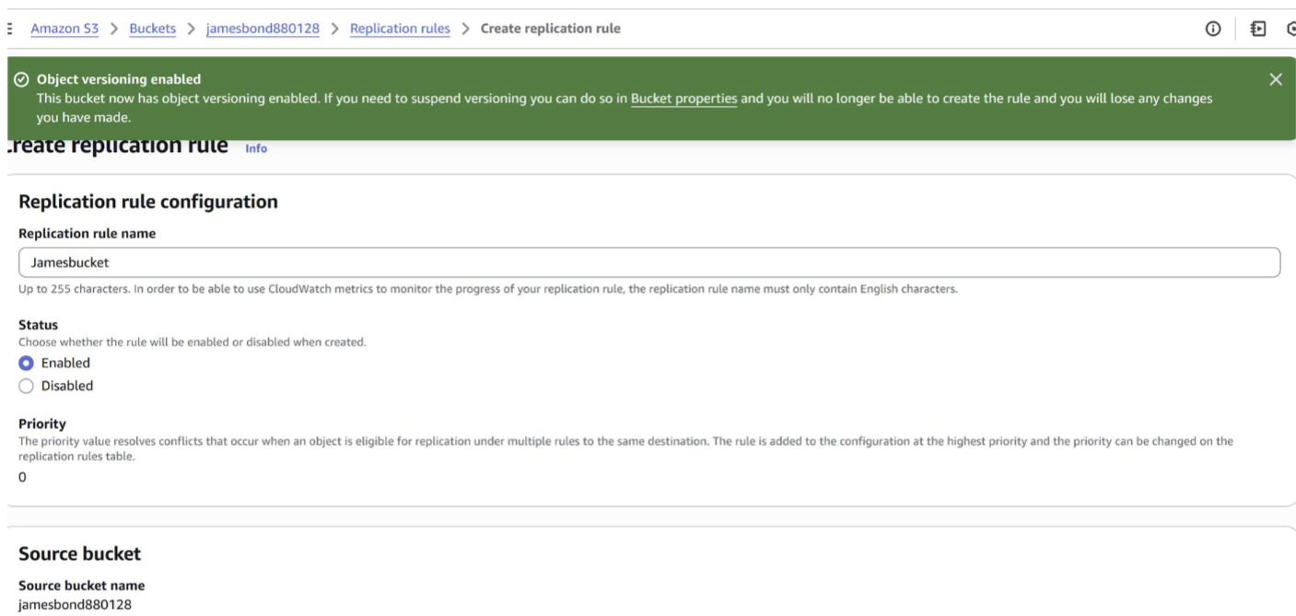

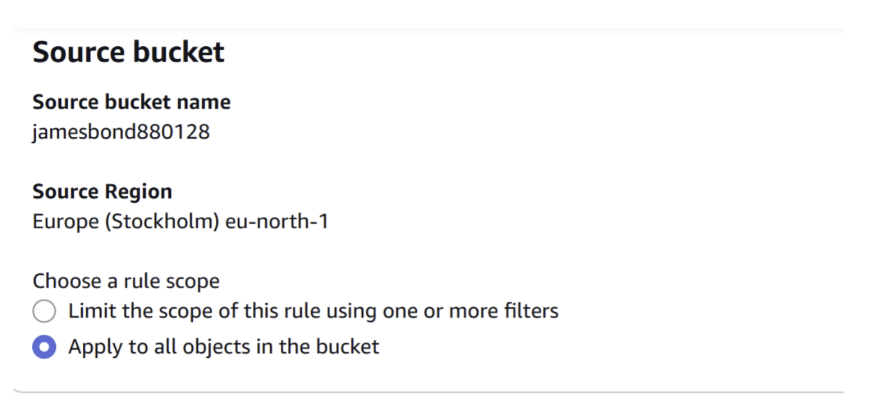
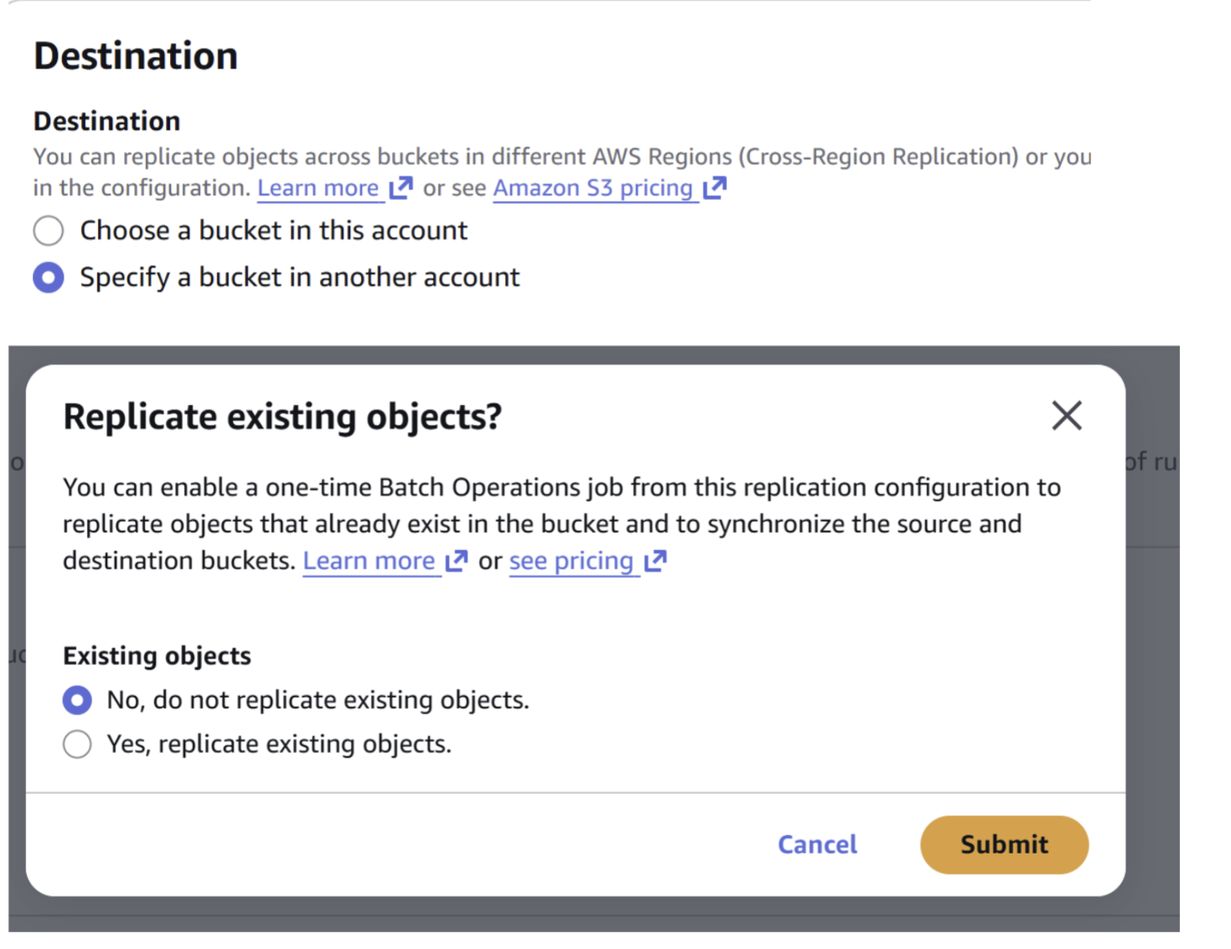
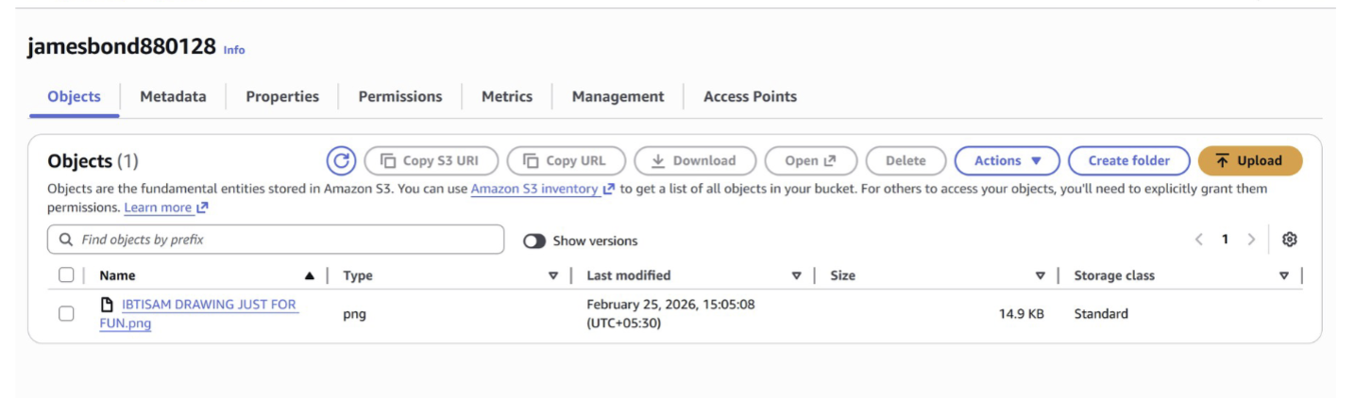

- Configure a bucket policy so only the Admin user can see the objects of the S3 bucket.

Create a S3 bucket and create an IAM user too
Note down the arn link
Go to bucket ---> Permission tab ---> Edit Bucket Policy
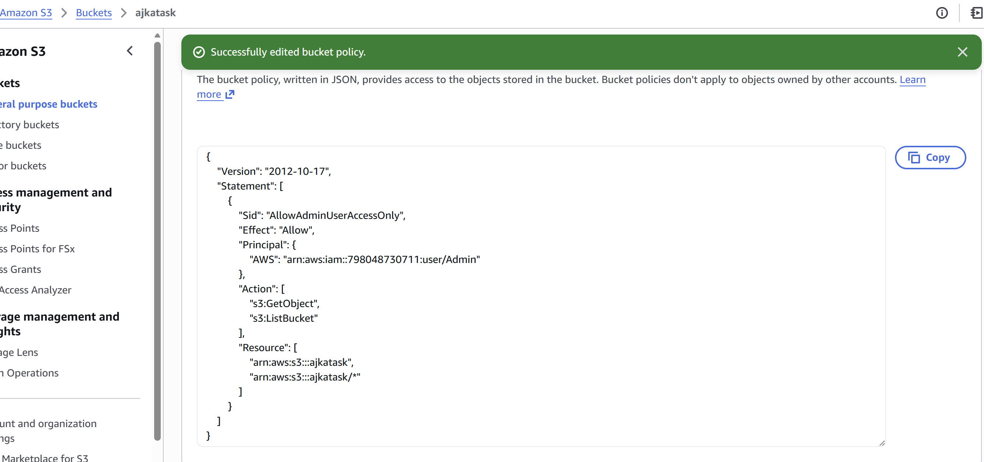
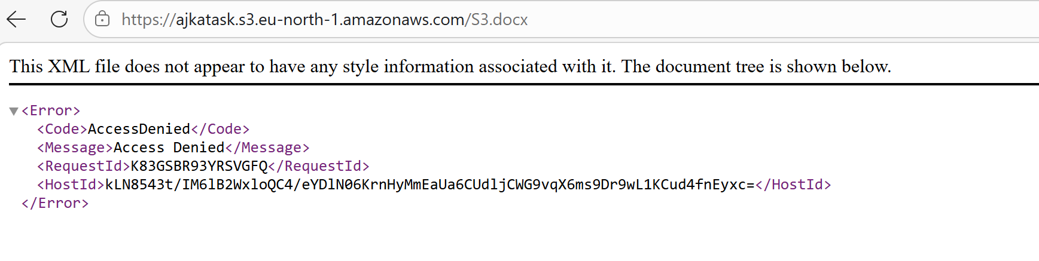

- Set up lifecycle policies to automatically transition or delete objects based on specific criteria.

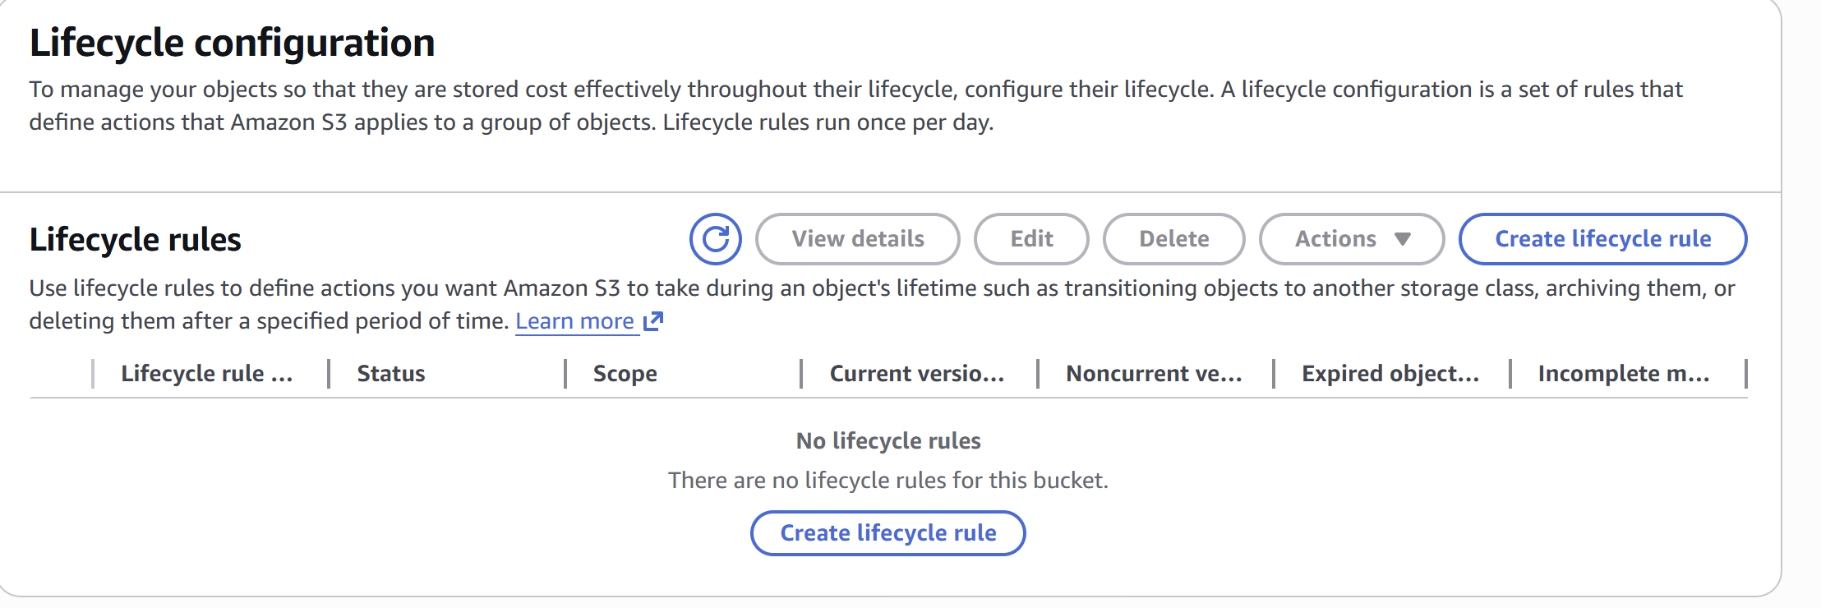
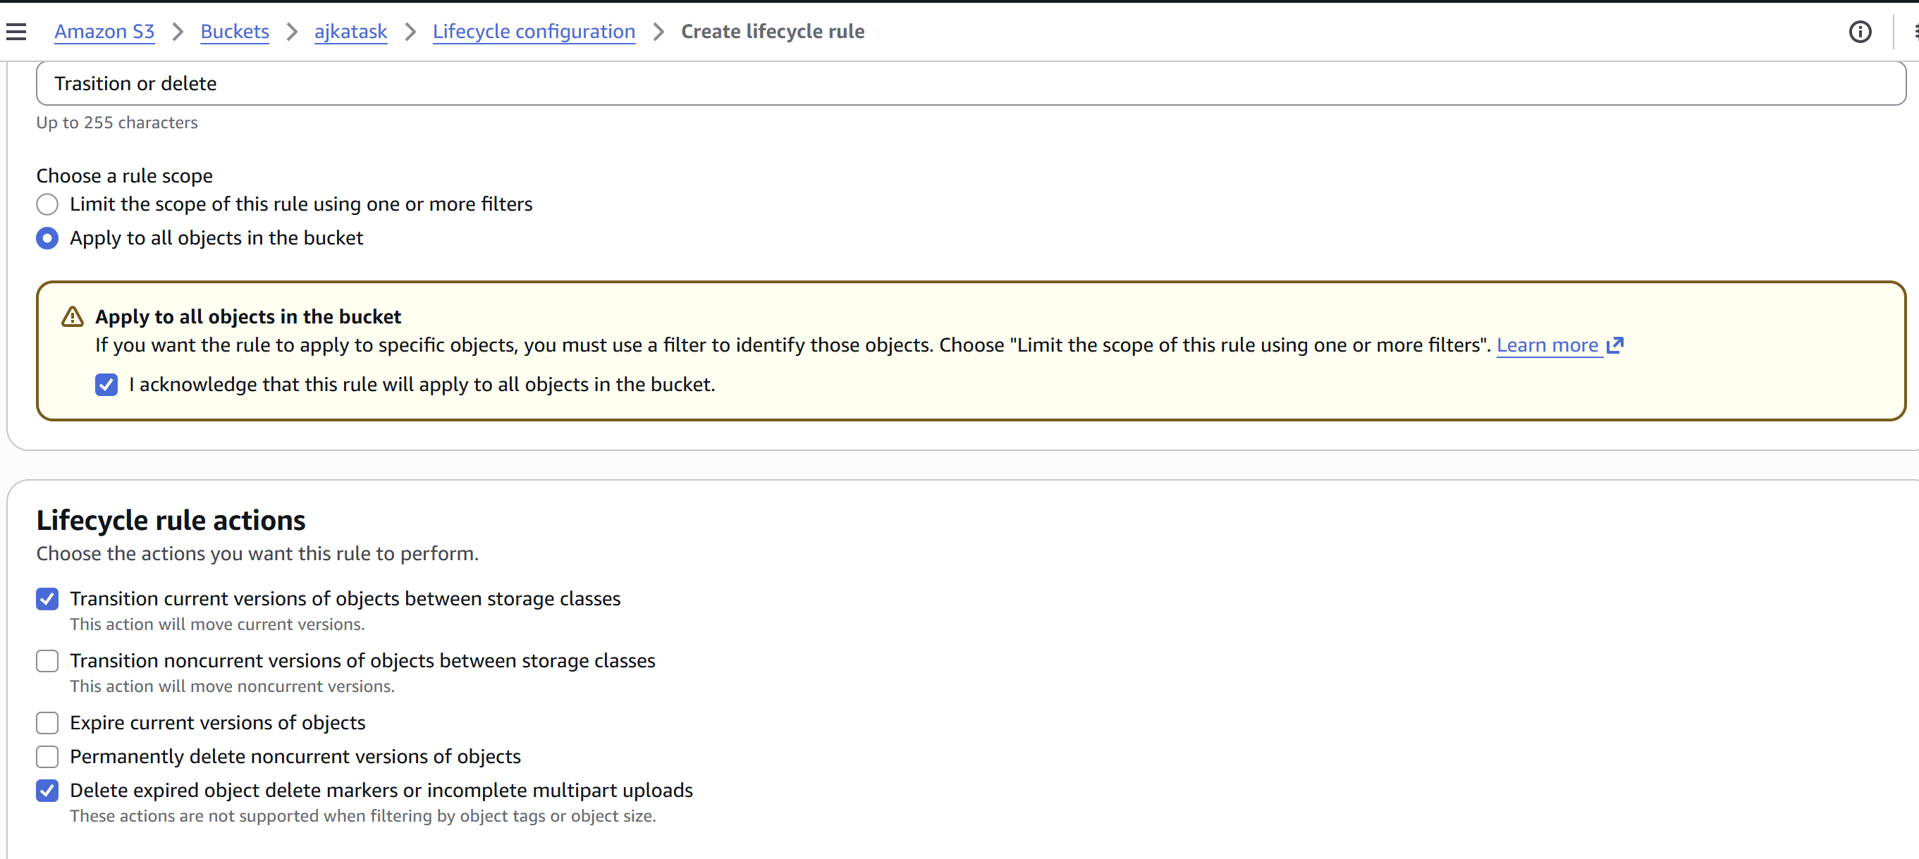
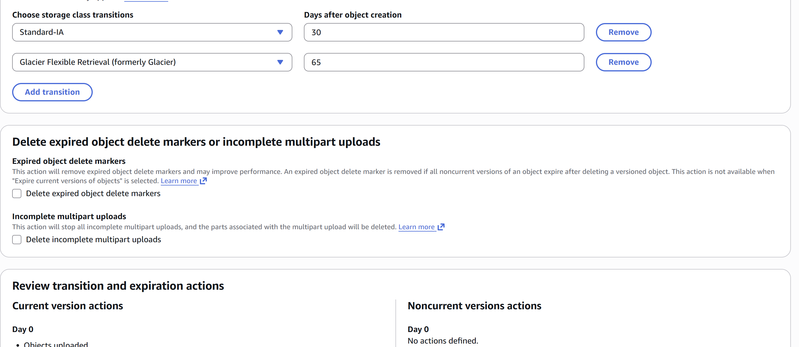
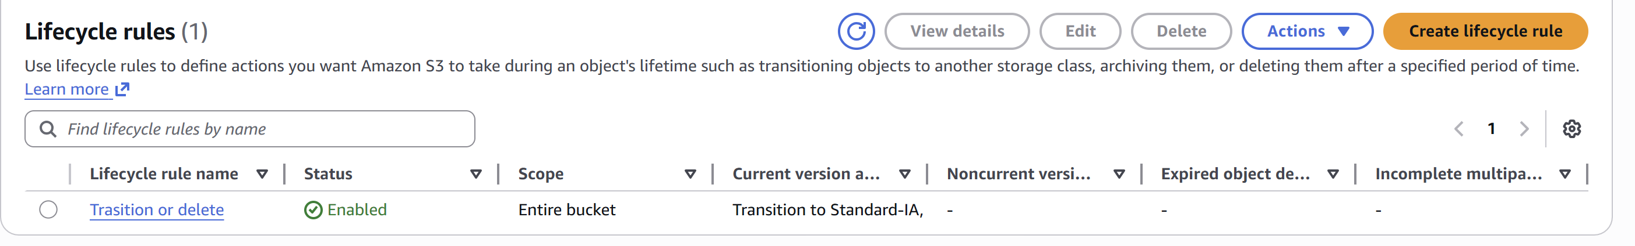

- Push some objects to S3 using the AWS CLI.
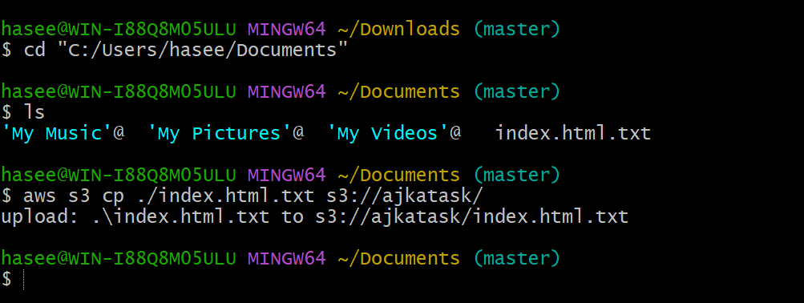

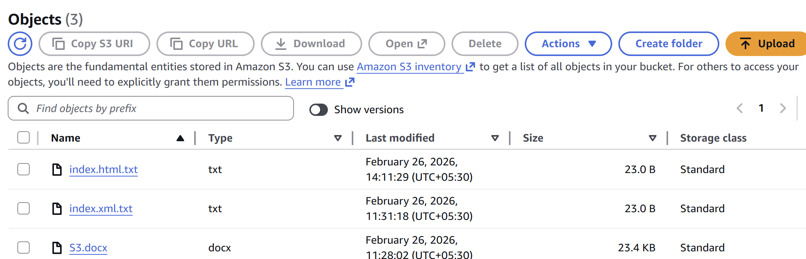

- Write a Bash script to create an S3 bucket.
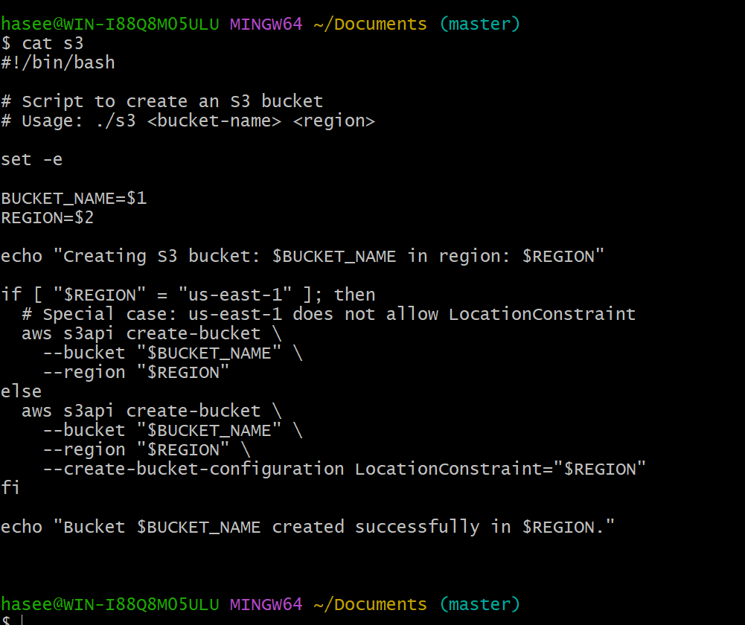

- Upload a 1 GB file to S3 using the CLI.

Create a file first and then upload in s3 using the mentioned command

