IAM :- Identity Access Management.
- Create one IAM user and assign EC2 and S3 full access roles.
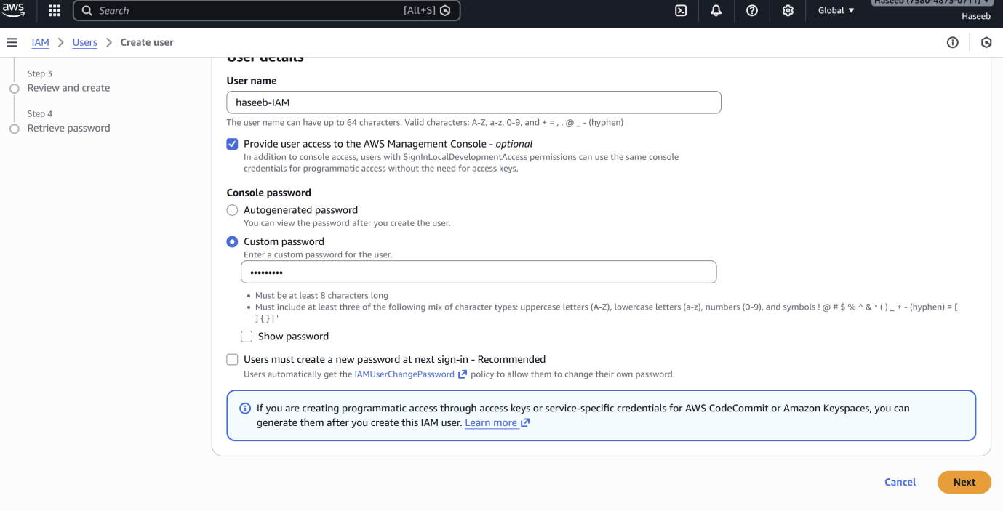
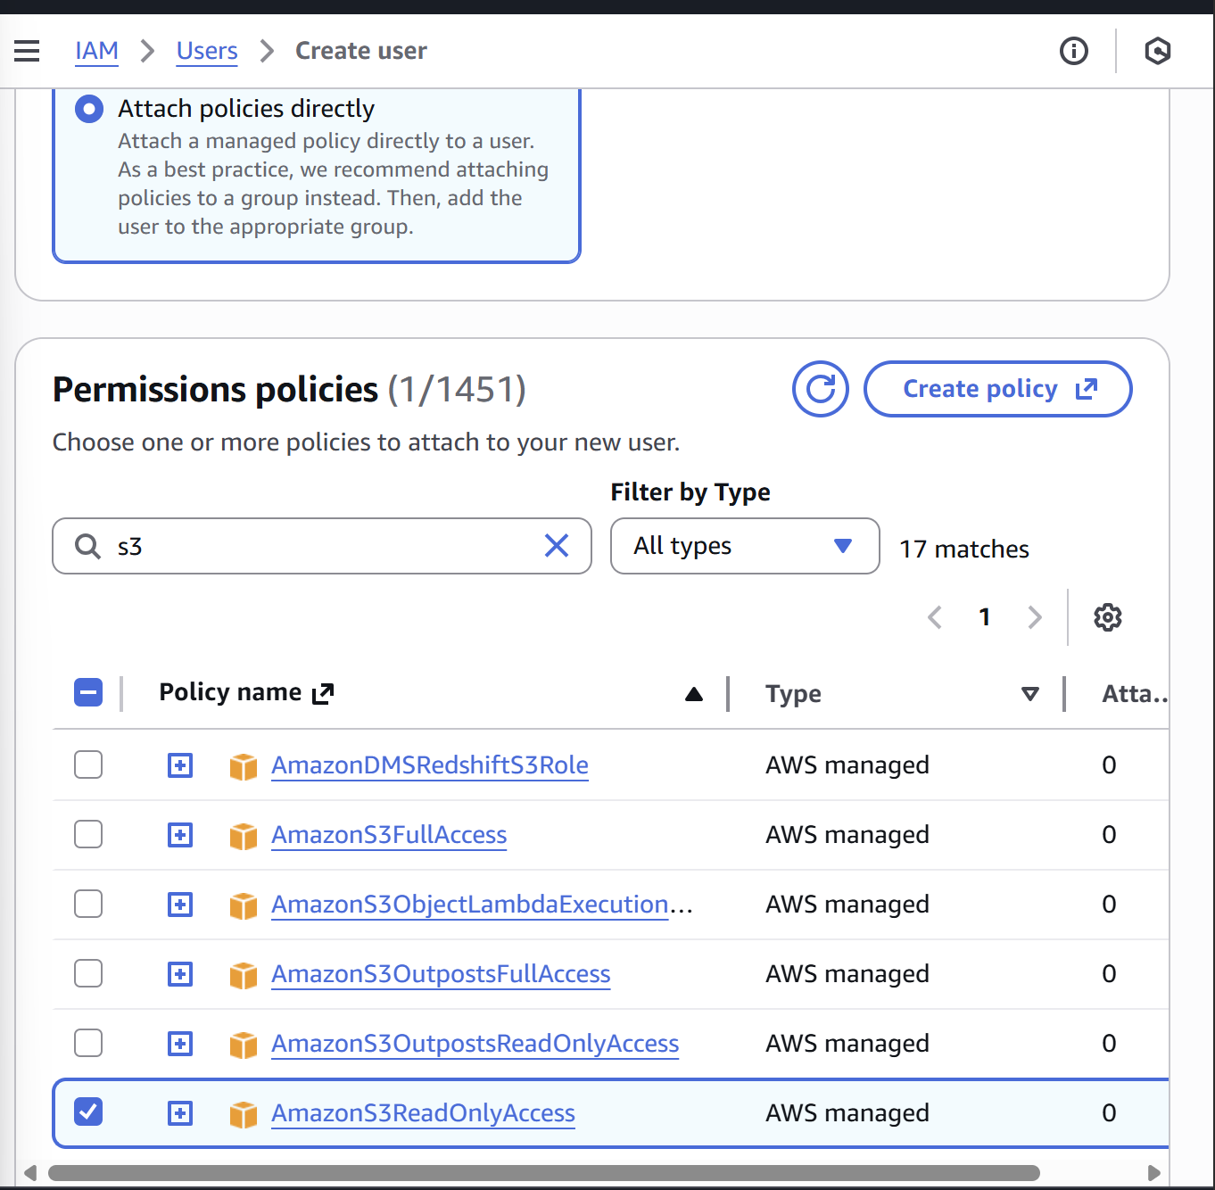

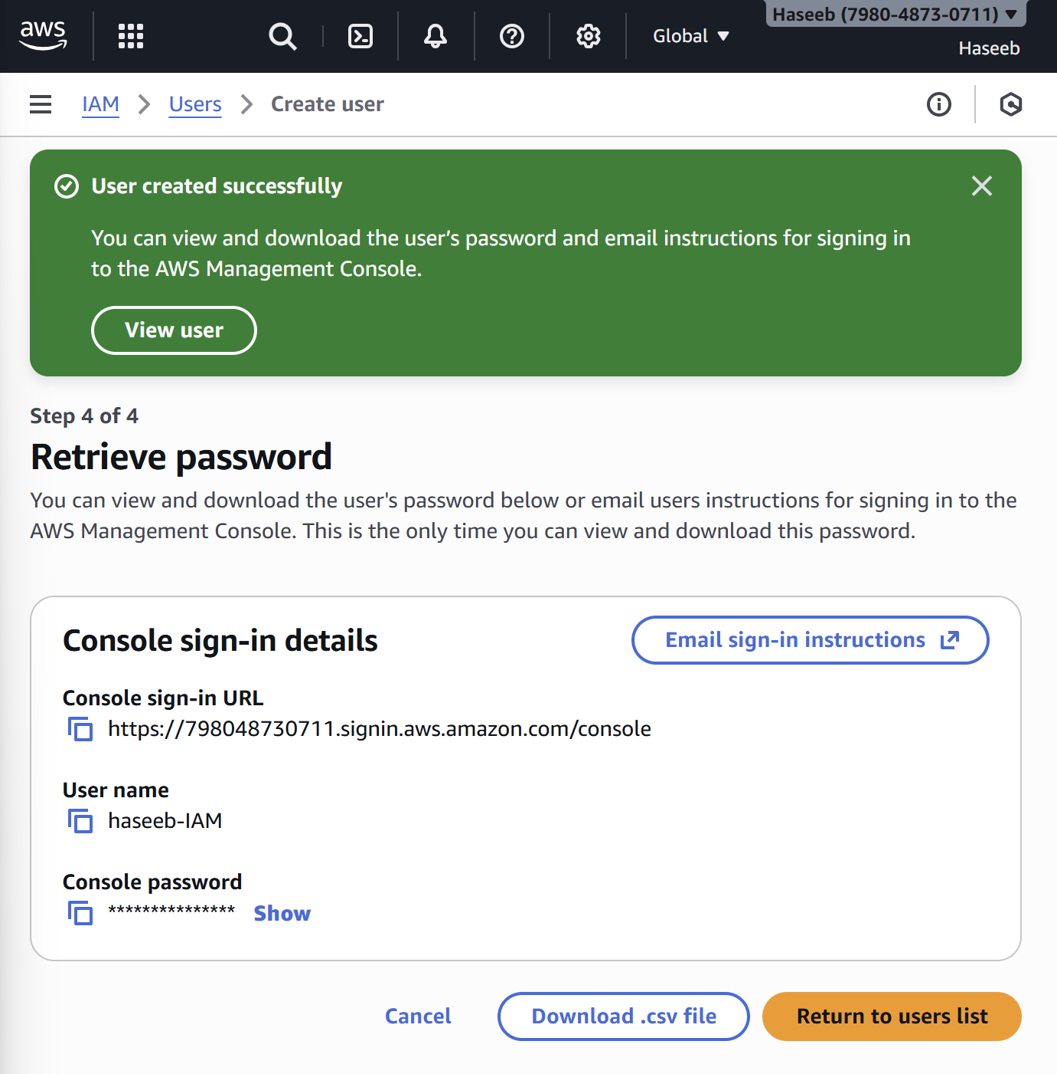
As we have created IAM user, now try loggin in…
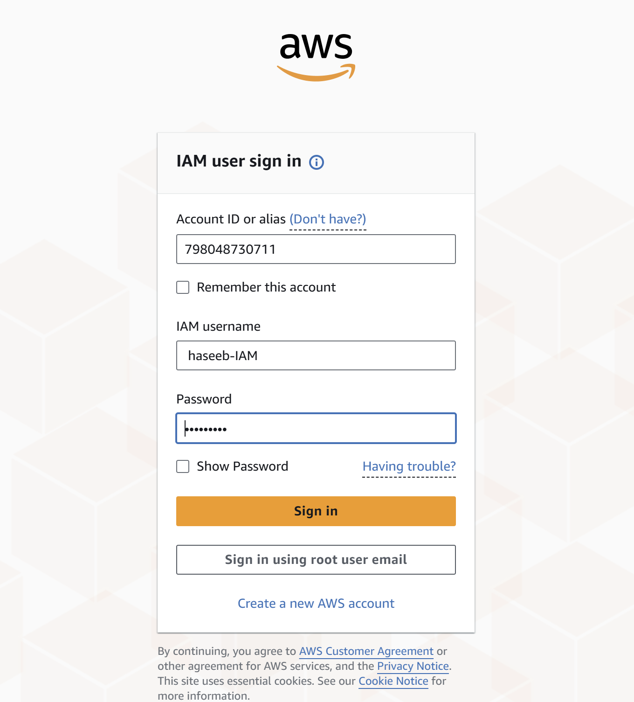
As we have created S3 bucket, search S3 bucket and create a bucket.
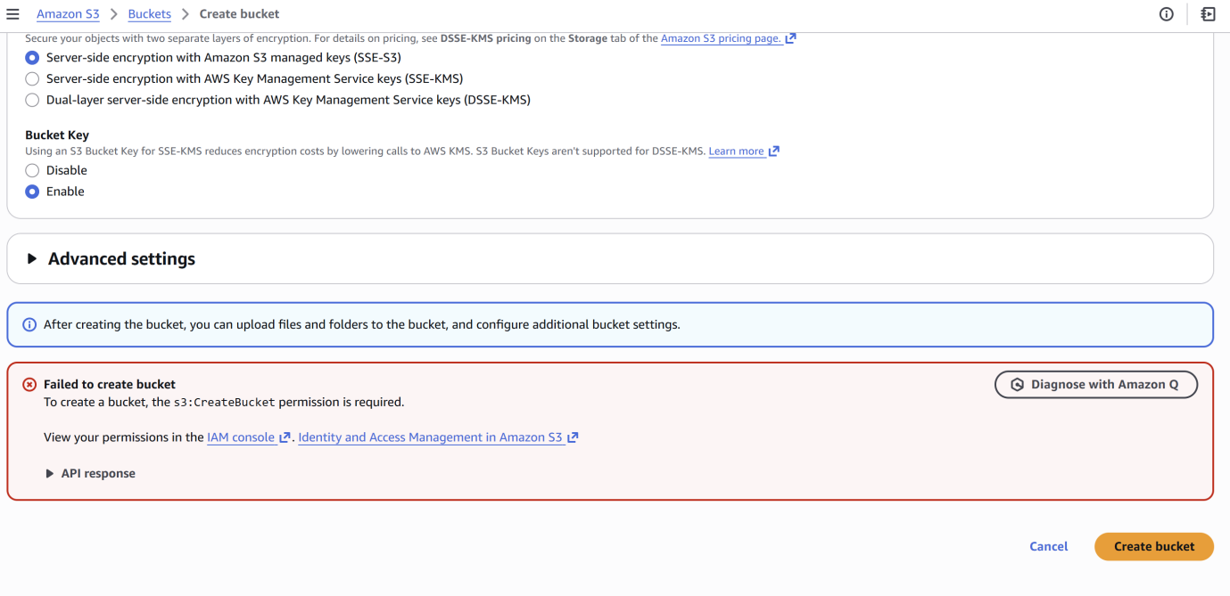
Unable to create a user as we haven’t provide user the permissions.
Login to root user in order to give permissions in IAM A/C.
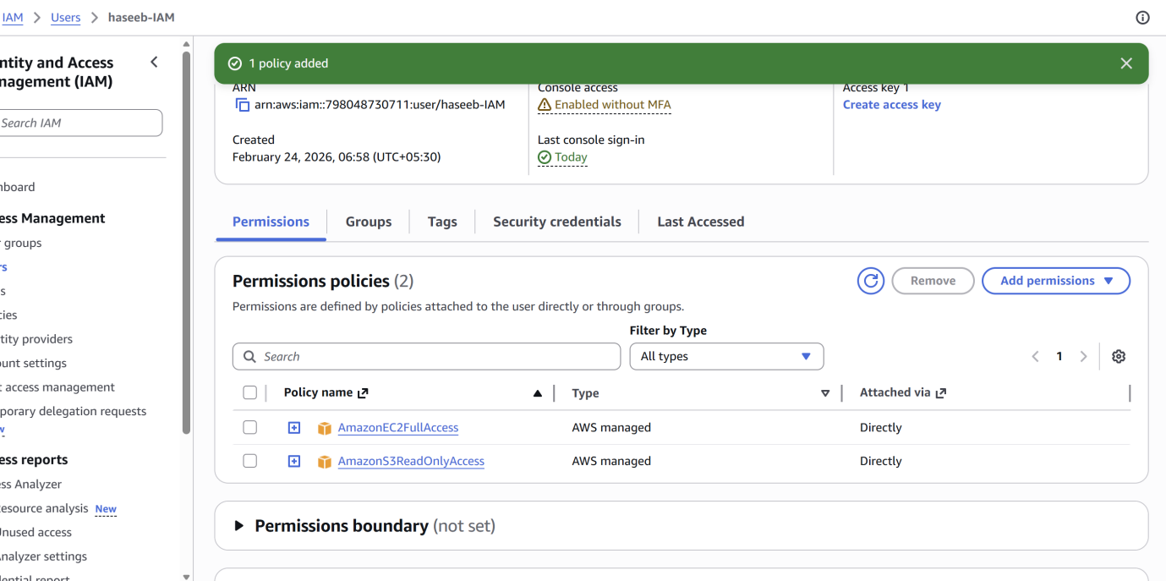
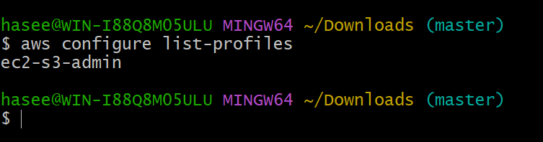

- Create one group in IAM and assign read access for EC2.
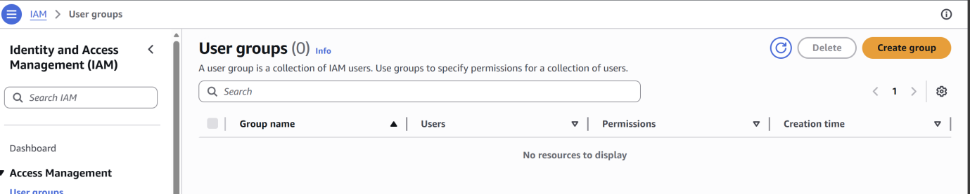
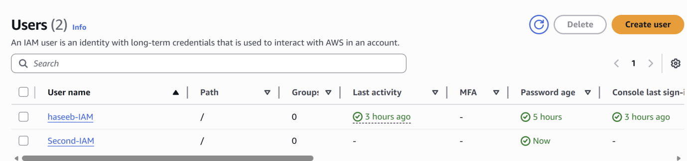

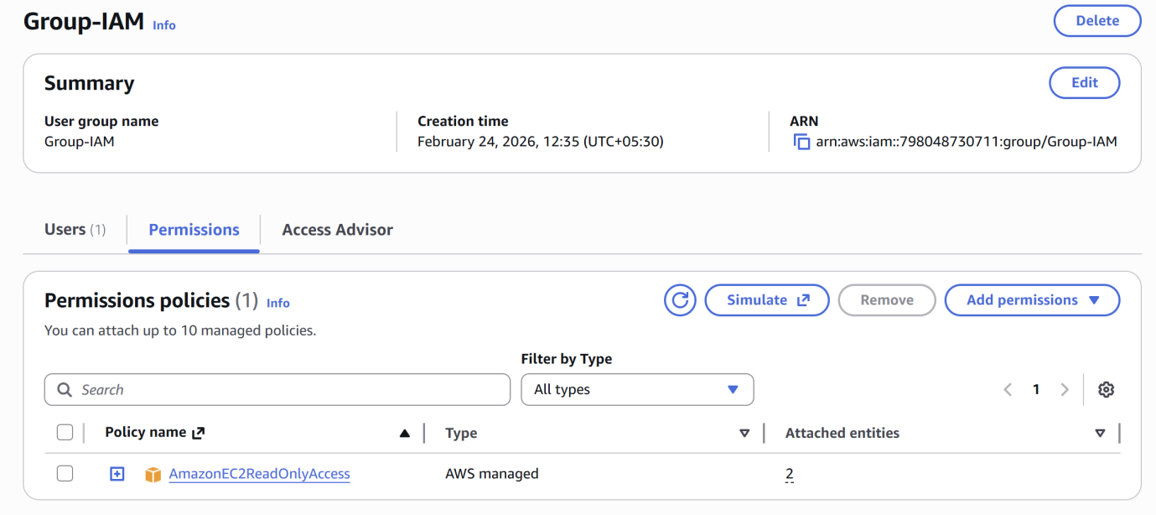

- Create a new user named "Devops" and add to the group created in task 2.
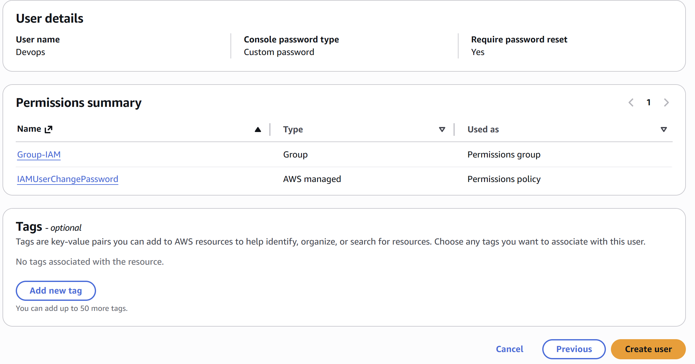
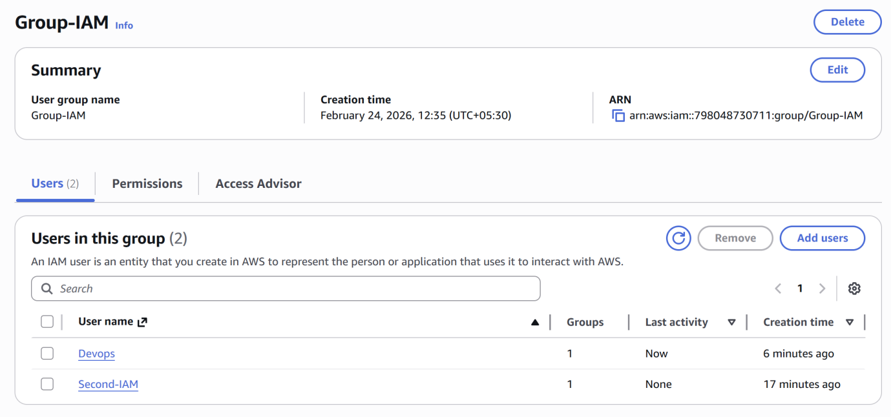

- Write a bash script to create an IAM user with VPC full access.
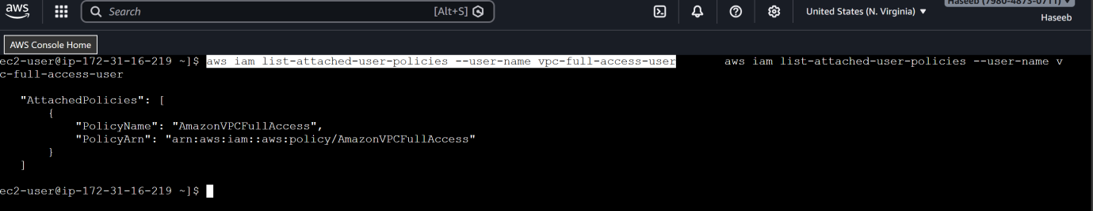
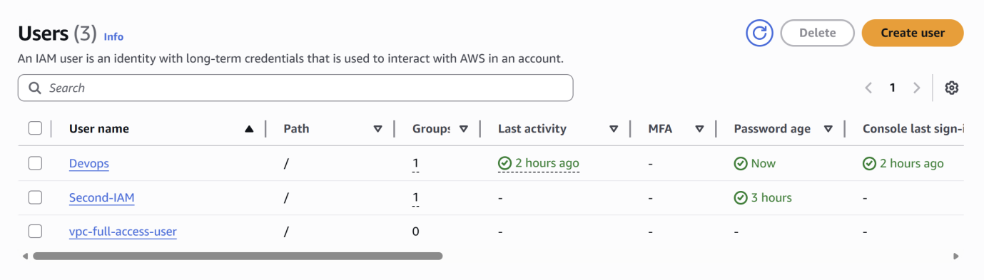

5. Create an IAM policy to allow EC2 access for a specific user in specific regions only.
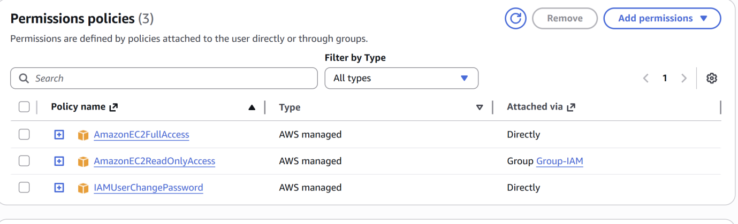

- We have two accounts: Account A and Account B. Account A user should access an S3 bucket in Account B.

Youtube Source link (Automating S3 Data Replication Between AWS Accounts).

Create a bucket and then create replication by clicking on management option.

