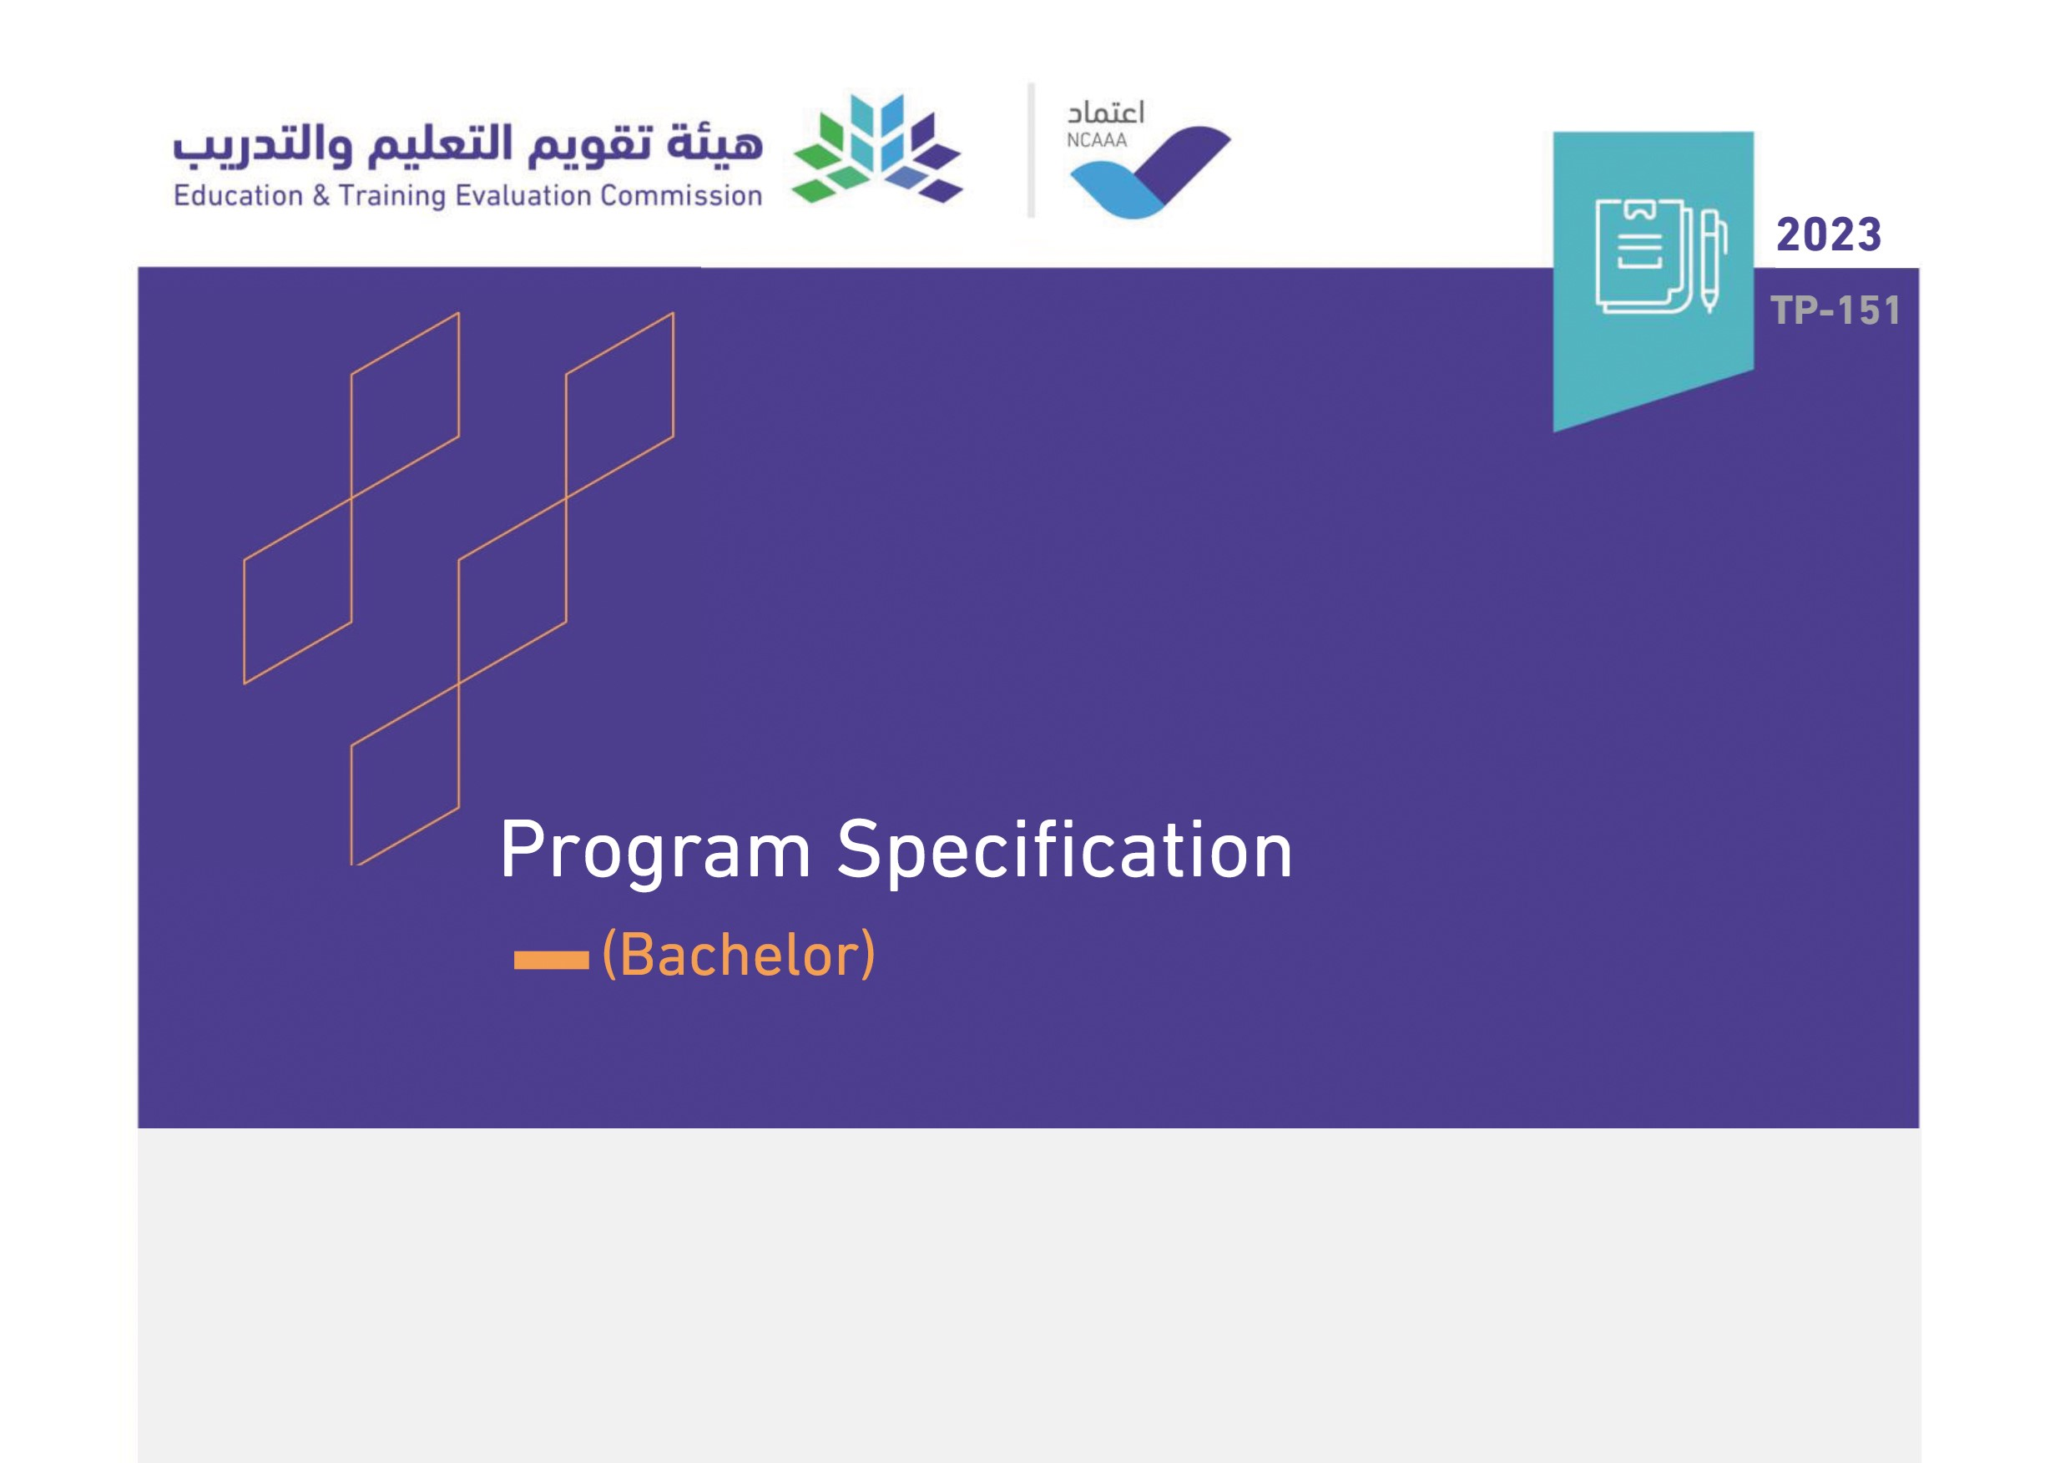

Program:

|  |
| --- |
| Program: |

Program:

|  |
| --- |
| Program: |

Program:

|  |  |  |  |  |
| --- | --- | --- | --- | --- |
| Program: |  |  |  |  |
| Program: | New | |  | | --- | |  | | Updated* | |  | | --- | |  | |

|  |
| --- |
| Program: |

*Attach the previous version of the program specification