MULTIPLE GROUP COMPARISON

Create new .dat-file
- Create a .dat-file from the ess3atdech.sav with the variables ipmodst imptrad ipfrule ipbhprp ipeqopt ipudrst impenv imsmetn imdfetn impcntr gndr yrbrn eduyrs cntry and name it ess3atdech_TRACO_UNIV_ATT_SEM.dat.

Testing factorial equivalence among groups
Data file: ess3atdech_TRACO_UNIV_ATT_SEM.dat
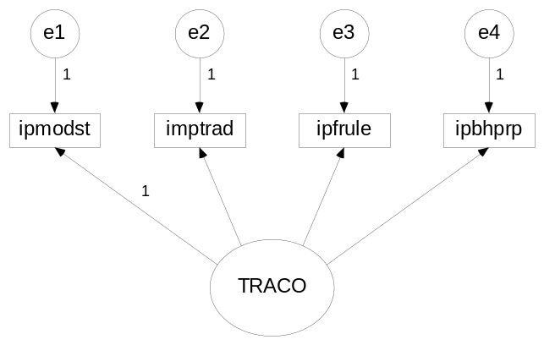 Figure 1

  - Add the option >GROUPING IS CNTRY (1=AT 2=DE 3=CH);< at the End of the >VARIABLE< command.
We do not want to estimate means and intercepts (default): Add >MODEL=NOMEANSTRUCTURE; >INFORMATION=EXPECTED;< to the >ANALYSIS< command.
  - Run the model and try to figure out the default constraints of Mplus for multigroup comparisons: Which parameters differ between the groups and which parameters are constrained to be equal across groups? Where will you look for these specifications?
Do the default constraints make sense from a methodological point of view?
  - The model under the >Model< command always applies to the first group (in our case AT). If you want to modify the default cross-group-constraints, add an option in MODEL >Model DE<: All parameters you specify in the subcommand will be estimated independently from the other groups (same procedure for every additional group, in our case >Model CH<). Try to set up a model with no cross-group-constraints on the constraint paramters.
Notice: One factor loading per latent variable (default: the first one) has to be set to 1 in all groups to set the metric. Omit this variable in the subsequent >Model DE< and >Model CH< commands.
  - Can we accept the Mplus default model? (Do we want to?)

Multiple Group Comparison with latent Means and Intercepts
Build on exercise before.
Delete >MODEL=NOMEANSTRUCTURE;< and >INFORMATION=EXPECTED;< from the analysis command.
  - Let the default settings of plus do the rest and run the model.
  - Try to figure out the default constraints of Mplus for multigroup comparisons: Which parameters differ between the groups and which parameters are constrained to be equal across groups?
  - What about the latent mean values? Do the countries differ? Try to give a substantive interpretation.
  - Try to estimate a model with no cross-group constraints on the intercepts.
Hint: To identify the model you have to set the latent mean to 0 in all groups.

