Distributed CNN Training
Implementation Design Report

Group Members:
Haseeb Ul Hassan (MSCS25003)
Haris Alam (MSCS25010)

1. Abstract
This report details a distributed training system designed to execute a Convolutional Neural Network (CNN) across multiple processors. Rather than distributing data, the system partitions the network architecture itself. This design allows for model parallelism where different layers of a custom neural network reside on separate worker nodes, coordinated by a central master process.

2. System Architecture
The implementation utilizes three distinct roles operating within a Gloo message-passing environment:
- Master (Rank 0): Acts as the orchestrator. It manages mini-batch loading from the CIFAR-10 dataset, issues control signals (START, NEXT, STOP), and monitors the operational status of workers.
- Worker 1 (Rank 1): Responsible for Stage A of the model. This consists of the first two convolutional blocks.
- Worker 2 (Rank 2): Responsible for Stage B of the model. This includes the final convolutional blocks, the classifier, and the loss function computation.

3. Design Strategy: Model Partitioning
The core objective is to split a neural network of moderate depth into sequential stages through pipeline parallelism.

3.1 Forward Pass
The Master sends a batch to Worker 1. Worker 1 computes the initial features and transmits these intermediate tensors to Worker 2. Worker 2 completes the pass to generate predictions and calculate cross-entropy loss.

3.2 Backward Pass
Worker 2 computes local gradients and the gradient with respect to the input it received from Worker 1. These gradients are sent back to Worker 1, allowing both workers to update their respective layers simultaneously via the optimizer.

4. Architecture Diagram

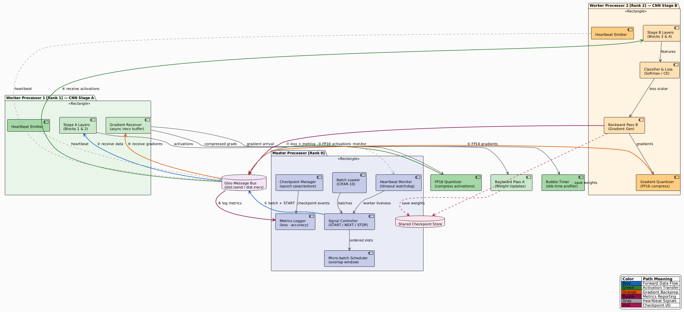
This section illustrates the communication flow (Gloo Bus) between the Master node and the Worker nodes, highlighting the forward and backward paths.

5. Technical Implementation & Optimizations
- Non-Blocking IPC: The system uses dist.isend and dist.irecv (asynchronous communication) to prevent the CPU from idling during data transfer.
- Precision Quantization: Tensors are cast to FP16 before network transmission to minimize bandwidth consumption.
- Micro-batch Scheduling: To minimize 'pipeline bubbles', the Master initiates the next batch transfer as soon as Worker 1 completes its forward pass.
- Heartbeat Monitoring: A dedicated thread sends 'alive' signals to the Master for fault detection.
- Checkpointing: Periodic saves of model states enable recovery from the last successful epoch.

6. Operational Limitations
- Master process is a single point of failure.
- Static Partitioning: The boundary between Stage A and Stage B is fixed.
- CPU Backend: Optimized for multi-core CPU execution using Gloo.

