**2nd Assignment**

Haseeb Raza

Ot7dee

[ot7dee@inf.elte.hu](mailto:ot7dee@inf.elte.hu)

Group 3

**Task**

In the hydrological cycle of the Earth, various areas affect the weather as well as areas are also affected by various weathers. Areas involved in the simulation: plain, grassland, lakes region. Each area has a name, and the amount of water stored in the certain area is also given in km3 . The humidity of the air over the areas is also given in percentage. The possible types of weather are the following: sunny, cloudy, rainy, depending on the humidity of the air. In case the humidity exceeds 70%, the weather gets rainy and the humidity decreases to 30%. In case the humidity is between 40-70%, the calculation of the chance of rainy weather is: (humidity-40) *3,3%, otherwise the weather is cloudy. Humidity below 40% leads to sunny weather. In the following, we declare how the certain areas respond to the different type of weathers. First the amount of water stored by the area varies then the weather will be affected. There is no type of areas with negative amount of water stored. In case the type is plain, if the weather is sunny, the amount of water will be decreased by 3 km3 ; if cloudy, it will be decreased by 1 km3 ; for rainy weather it will be increased by 20 km3 . The humidity of the air is increased by 5%. If the amount of the stored water is greater than 15 km3 , the plain area changes into grassland. In case of type grassland: in sunny weather, the amount of water is decreased by 6 km3 , for cloudy it will be decreased by 2 km3 , but and for rainy, it will be increased by 15 km3 . The humidity of the air is increased by 10%. The area becomes lakes region obtaining amount of water over 50 km3 , whereas in case the amount of stored water goes below 16 km3 , the area changes to plain. In case of type lakes region: in sunny weather, the amount of water is decreased by 10 km3 , for cloudy it will be decreased by 3 km3 , for rainy it will be increased by 20 km3 . The humidity will be increased by 15%. Beyond an amount of water of 51 km3 the area changes into grassland. The program reads data from a text file. The first line of the file contains a single integer N indicating the number of areas. Each of the following N lines contains the attributes of an area separated by spaces: the owner of the area, the type of the area, and the amount of water stored by the area. In the last line, the humidity of the air is given in percentage. The type is identified by a character: P – plain, G – grassland, L – lakes region. After 10 simulation rounds, determine the owner of the area which is storing the greatest amount of water. The amount of water is also required to be determined. The program should print all attributes of the certain areas by simulation rounds!

**Analysis**

Depending on the type of weather the different areas are affected. The amount of water in the area will be affected.

|  |  |  |  |
| --- | --- | --- | --- |
| Areas | Sunny | Cloudy | Rainy |
| Plain | -3 | -1 | +20 |
| Grassland | -6 | -2 | +15 |
| LakesRegion | -10 | -3 | +20 |

The humidity is affected by the type of area and depending on the amount of water stored in an area, the type of area also changes.

|  |  |  |
| --- | --- | --- |
|  | Humidity | Area |
| Plain | +5% | If water > 15 -> grassland |
| Grassland | +10% | If water > 50 -> lakes region, if water < 16 -> plain |
| Lakes region | +15% | If water < 51 -> grassland |

The weather is affected by the humidity in the following ways:

|  |  |
| --- | --- |
| Humidity | Weather |
| Humidity >= 70% | Rainy and humidity is set to 30% |
| 40% <= Humidity <= 70% | Calculate the chance of rain = (humidity - 40) * 3.3%. If the calculated chance is bigger than a random number then rainy else sunny |
| Humidity <= 40% | Sunny |

Method weather_affect_area() takes weather as an attribute and modifies the amount of water in that area, finally it returns the modified weather.

All the classes of the weather are realized based on the Singleton design pattern, as it is enough to create one object for each class.

The humidity is affected by the type of area.

A = humidity *: humidity, areas: ${areas}^{n}$*

Pre = humidity = humidity’ Λ areas = areas’

Post = i[1..n]: areas[i].modifyHumidity()

Analogy:

|  |  |
| --- | --- |
| enor(E) | i = 1..n |
| f(e) | areas[i].modifyHumidity() |
| s | humidity |

Finding the landlord with most water after 10 simulations is the maximum search.

A = *areas: ${areas}^{n}$, humidity : humidity, weather : weather,* , max*LandLord*: *String, maxWaterStored:Integer*

Pre *=* humidity = humidity’ Λ areas = areas’ Λ weather = weather’

Post = i[1..n]: areas[i].modifyHumidity() Λ areas[i].weather_affect_area(weather) Λ

areas[i] = areas[i].modifyArea() Λ print(areas[i])

*(maxLandLord,maxWaterStoreds) = MAXi=1..N(area[i].getwater())*

|  |  |
| --- | --- |
| enor(E) | I = 1..n |
| f(e) | Area[i].getwater() |
| H, < | Z , < |
|  |  |
|  |  |

The solution for modify humidity is:

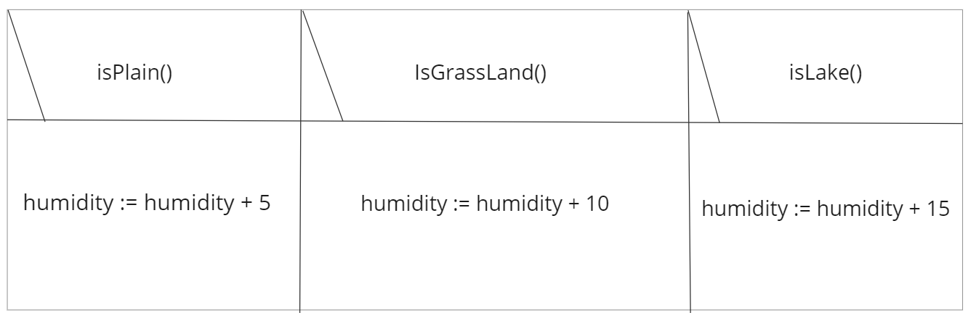

Since area affects the weather, area affects humidity and humidity affects the weather we must call all the functions in the main program. The simulation is continued until the 10-simulation loop and at the end we get the landlord with the most amount of water stored.

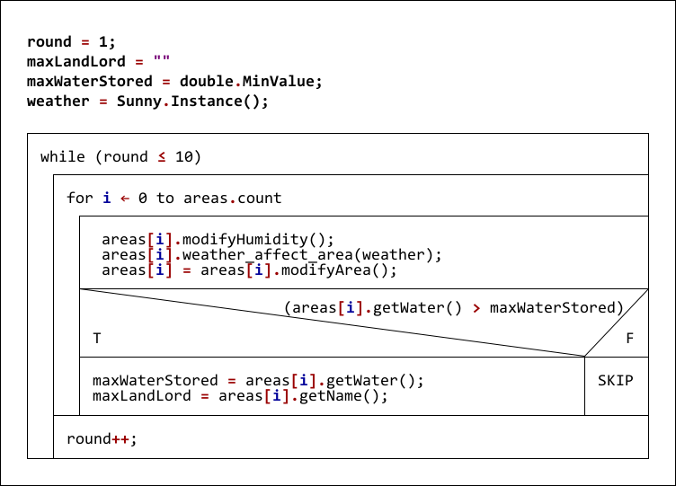

Testing:

1. ModifyHumidity:

* Plain p has humidity and check
* Check how grassland affects humidity
* How lakes affect humidity

1. modifyArea

* Plain with different amounts of water and check if the area is modified
* Grassland with different amounts of water and check if the area is modified
* Lakes with different amounts of water and check if the area is modified

1. updateWeather

* Giving values for humidity and checking if the weather is correct

Examination of function weather_affect_area()

Nine different cases depending on the creature and the ground.