**Task1**

1. A=matrix(AirPassengers,nrow = 12,ncol = 12,byrow = TRUE)
2. dimnames(A)=list(c(1949:1960),c("Jan","Feb","March","April","May","June","July","Aug","Sep","Oct","Nov","Dec"))
3. ap=which(A==max(A),arr.ind = TRUE)
4. sprintf("Most profitabale month in 12 years:%s year:%s flights %s ",ap[1,2],year,max(A))
5. plot(AirPassengers,col="red",ylab="Number of Passengers",xlab="Year")
6. max(rowSums(A))

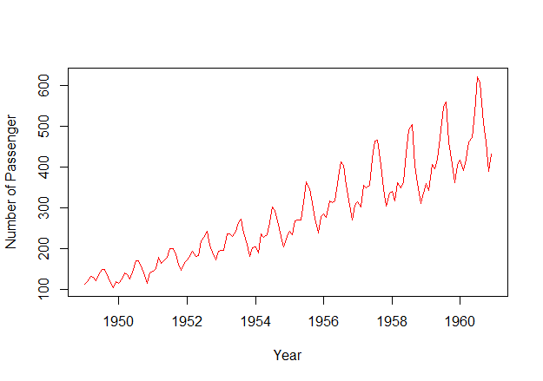

Task2:

Task3:

GitHub: **https://github.com/haseebsahmad/finding_trends**