

***Name : Shaik Haseeb Ur Rahman***

***Regd. No. : 18BCE0646***

***Course : Image Processing***

***Slot : G2 + TG2***

***Title : “ Detection of Early Stage Breast Cancer through Image Processing Enhancement and Segmentation Techniques “.***

***Application : Medical Imaging***

***Methodology :***

In this assignment, the tool used is ***MATLAB***, configured with ***Image Processing Toolbox*** so that all the image processing functions can be applied on the image.

First, a grayscale image of possibly affected breast is read, then ***thresholding*** is applied with 0.1 value, in the next step the breast part is extract is through ***Background Subtraction***, then this background subtracted image is multiplied ***(Multiplication of images)*** with the original image to get a image with only the breast part without background.

Then in the second assignment, ***Seed based Region growing Segmentation*** will be applied on the image to segment the pectoral muscle and then the output will be reached by applying ***Wiener Filter*** and ***CLAHE*** to the segmented image and hence at last ***Watershed Segmentation*** will be applied to get the output. After getting the output, we will be clearly able to tell if the breast is at an early stage of breast cancer. I will update the methodology in second assignment, if any extra segmentation is required in the image.

***Input Image :***

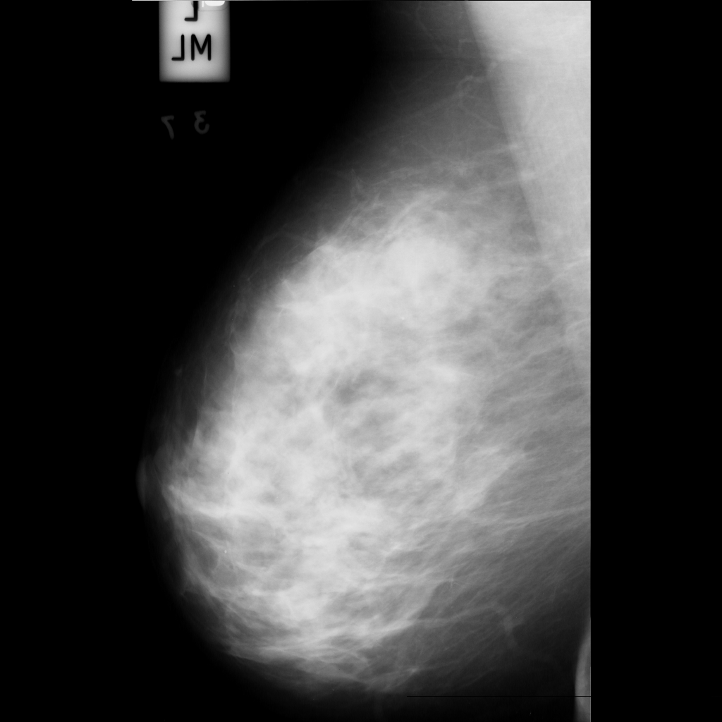

***Flowchart :***

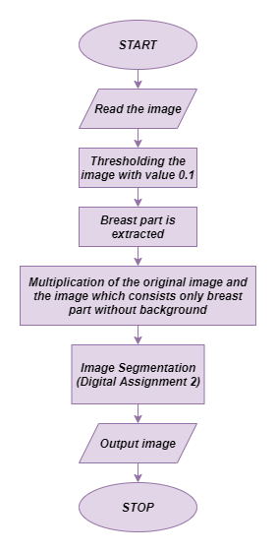

***Enhancement techniques chosen :***

***1) Thresholding***

***2) Background Subtraction***

***3) Multiplication of images***

***Read the image :***

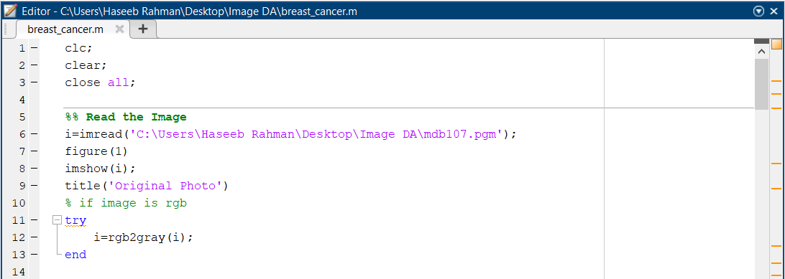

***Output :***

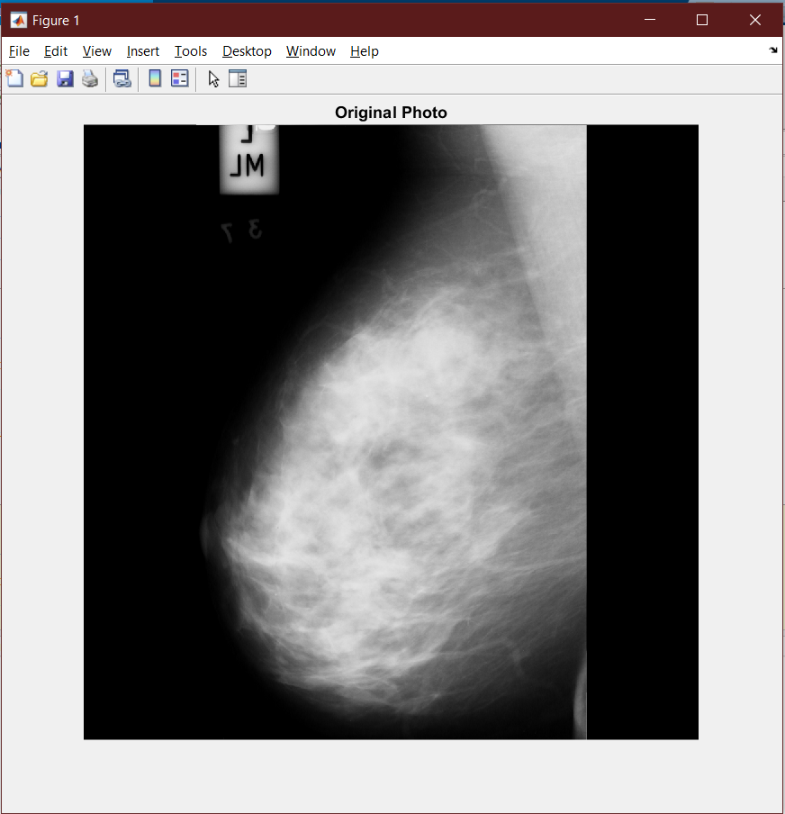

***Threshold the image at 0.1 :***

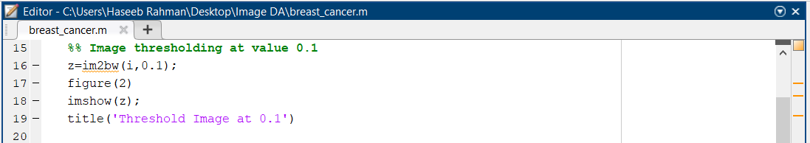

***Output :***

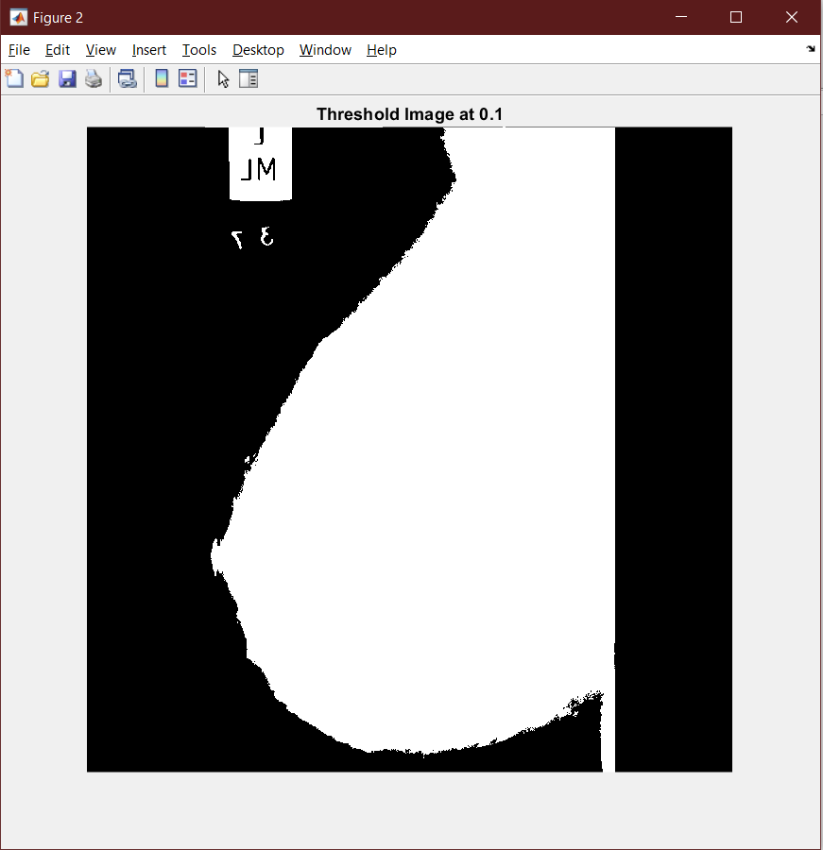

***Background Subtraction and Multiplication with original Image***

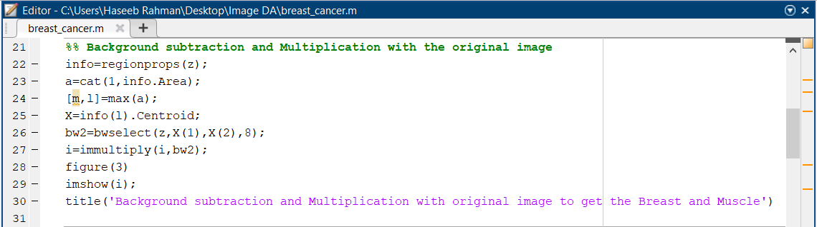

***Output :***

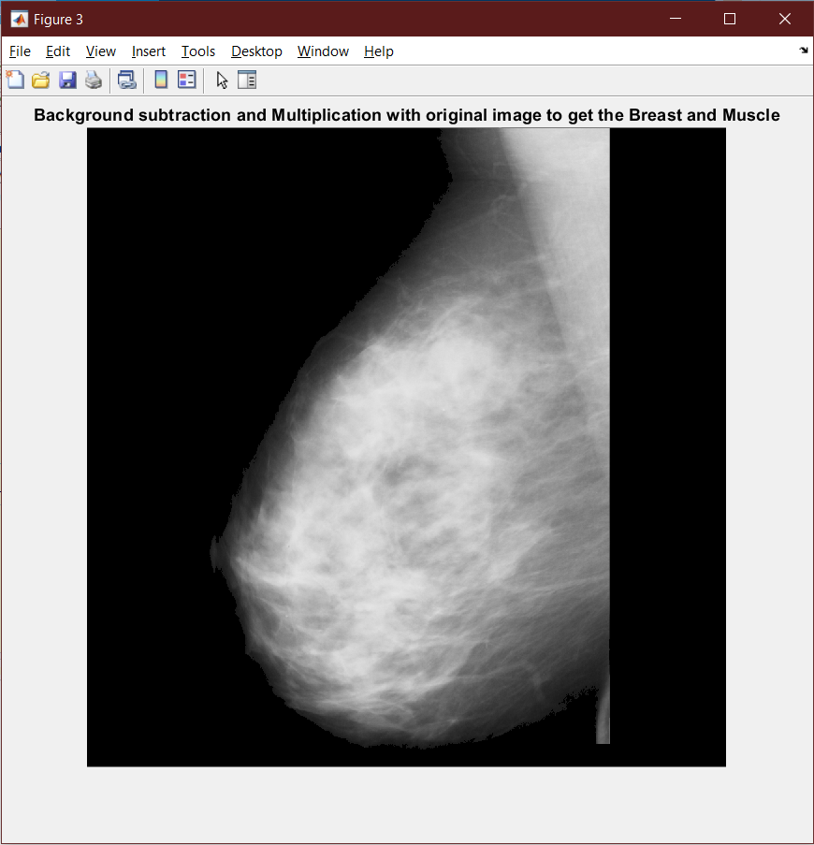

***Conclusion :***

Hence, after applying the 3 operations (Thresholding, Background Subtraction and Multiplication with original Image) we get the final image (figure 3) which is the image of just the breast and muscle after the background subtraction from the original image. Later in Assignment-2, this image will be segmented through Seed based Region growing Segmentation, Wiener Filter will be applied on the image and CLAHE will be performed on it. Then at last Watershed Segmentation will be applied on the image to find out from the output whether the breast is affected with an early stage of cancer or not.

***Dataset Link :***

* [***https://drive.google.com/drive/folders/1QuwJSTQpKCWfbRwMsa20xmvFZhi3GnxV?usp=sharing***](https://drive.google.com/drive/folders/1QuwJSTQpKCWfbRwMsa20xmvFZhi3GnxV?usp=sharing)

***Reference Papers [Citations] :***

* ***C. Varma and O. Sawant, "An Alternative Approach to Detect Breast Cancer Using Digital Image Processing Techniques," 2018 International Conference on Communication and Signal Processing (ICCSP), Chennai, India, 2018, pp. 0134-0137, doi: 10.1109/ICCSP.2018.8524576.***
* ***Aziz Makandar and Bhagirathi Halalli. Article: A Review on Preprocessing Techniques for Digital Mammography Images. IJCA Proceedings on National conference on Digital Image and Signal Processing DISP 2015(1):23-27, April 2015***

***References :***

* [***https://timesofindia.indiatimes.com/city/indore/37-pros-face-risk-of-cancer-Survey/articleshow/29830667.cms***](https://timesofindia.indiatimes.com/city/indore/37-pros-face-risk-of-cancer-Survey/articleshow/29830667.cms)
* [***https://ieeexplore.ieee.org/document/5742205***](https://ieeexplore.ieee.org/document/5742205)
* [***https://www.researchgate.net/publication/260368549_A_Preprocessing_Algorithm_for_the_CAD_System_of_Mammograms_Using_the_Active_Contour_Method/fulltext/57aa4d8308ae7a6420bceecf/A-Preprocessing-Algorithm-for-the-CAD-System-of-Mammograms-Using-the-Active-Contour-Method.pdf***](https://www.researchgate.net/publication/260368549_A_Preprocessing_Algorithm_for_the_CAD_System_of_Mammograms_Using_the_Active_Contour_Method/fulltext/57aa4d8308ae7a6420bceecf/A-Preprocessing-Algorithm-for-the-CAD-System-of-Mammograms-Using-the-Active-Contour-Method.pdf)