

***Name : Shaik Haseeb Ur Rahman***

***Regd. No. : 18BCE0646***

***Course : Image Processing***

***Slot : G2 + TG2***

***Title : “ Detection of Early Stage Breast Cancer through Image Processing Enhancement and Segmentation Techniques “.***

***Application : Medical Imaging***

***Methodology :***

In this assignment, the tool used is ***MATLAB***, configured with ***Image Processing Toolbox*** so that all the image processing functions can be applied on the image.

First, a grayscale image of possibly affected breast is read, then ***thresholding*** is applied with 0.1 value, in the next step the breast part is extract is through ***Background Subtraction***, then this background subtracted image is multiplied ***(Multiplication of images)*** with the original image to get an image with only the breast part without background. This is what I did in the first digital assignment.

Now, in the second assignment, ***Seed based Region growing Segmentation*** will be applied on the image to segment the pectoral muscle and then the output will be reached by applying ***Wiener Filter*** and ***CLAHE*** to the segmented image. Then binarization will be applied followed by opening to the image. Hence, we will get our required output. After getting the output, we will be clearly able to tell if the breast is at an early stage of breast cancer or not and also the parts which are affected with cancer.

***Image after the three operations from Digital Assignment -1 :  
(Output image of DA -1 (OR) Input image for DA -2) :***

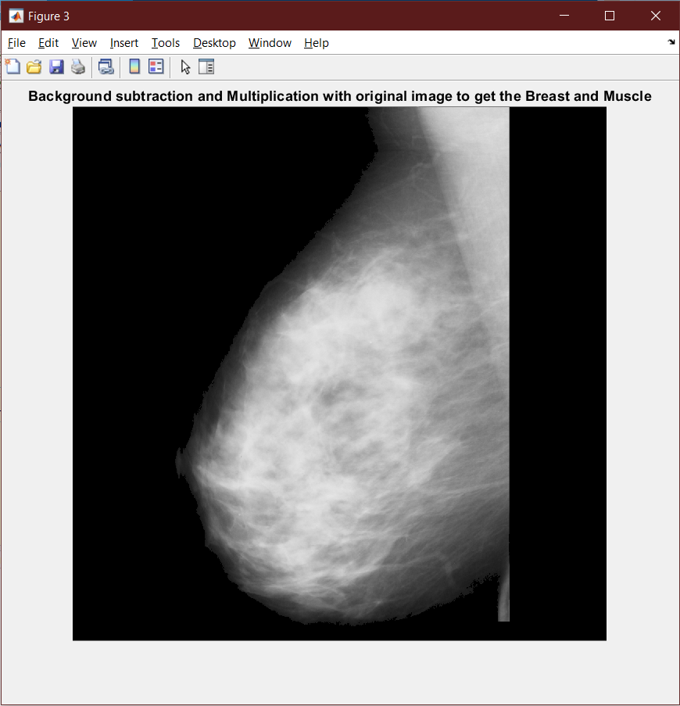

***Deleting the background prior, the Segmentation :***

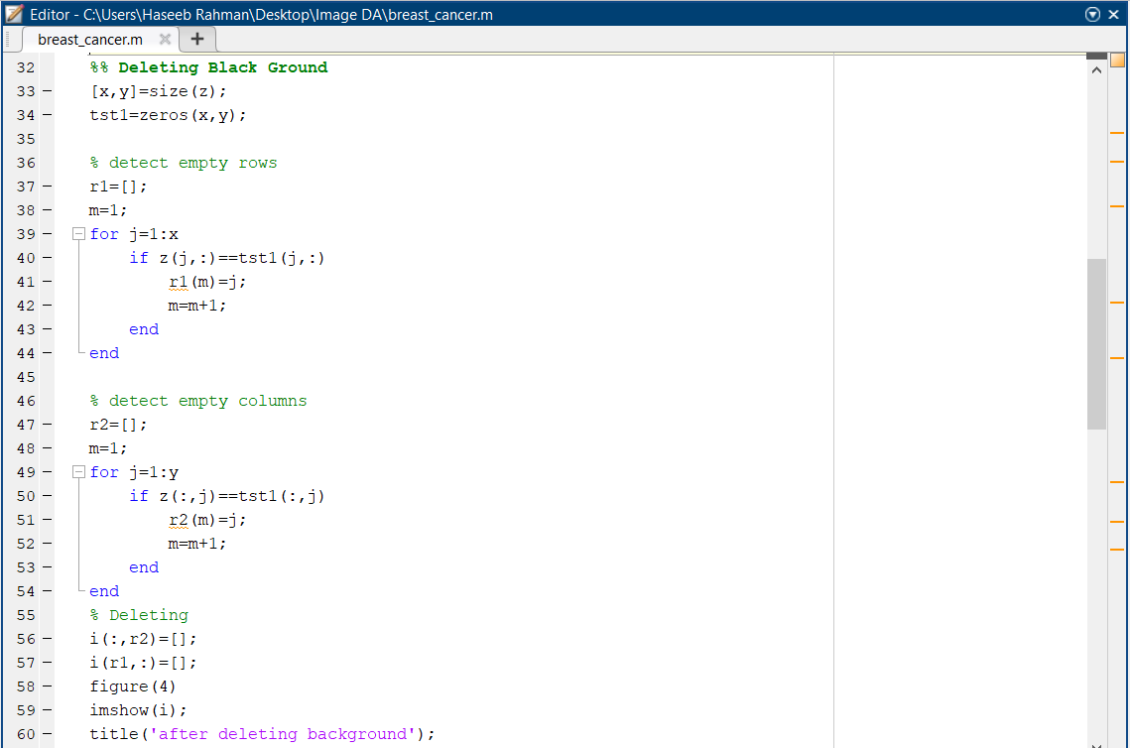

***Output :***

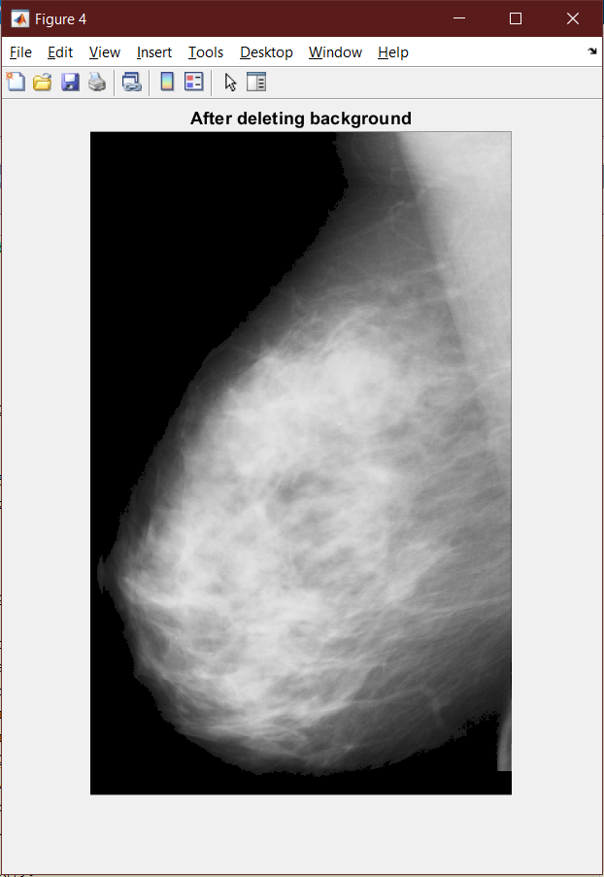

***Segment the pectoral muscle through Seed based Region Growing Segmentation :***

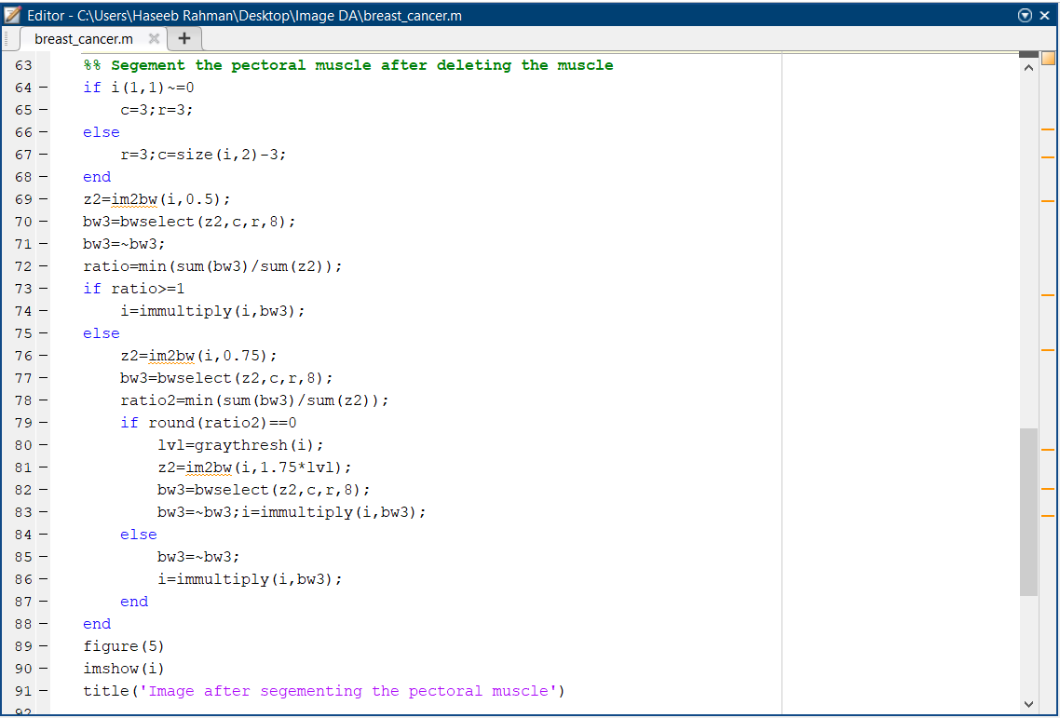

***Output :***

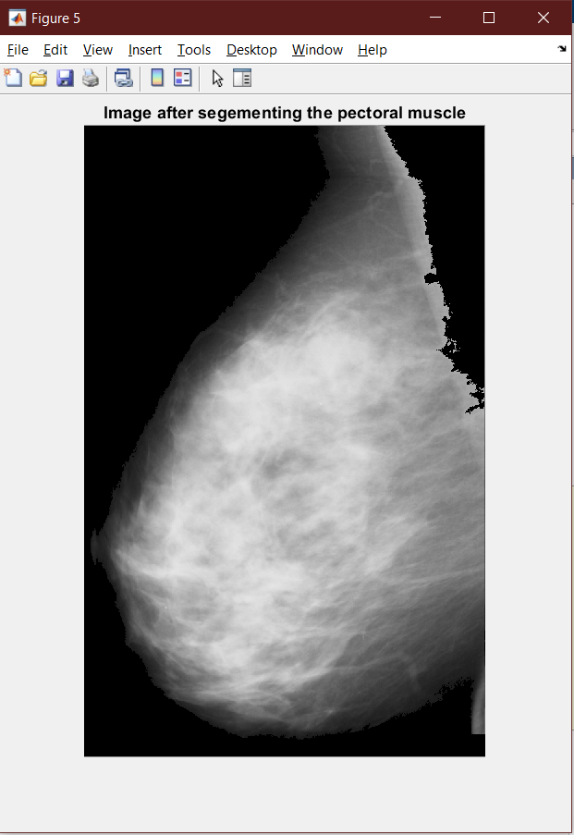

***Applying the Weiner filter :***

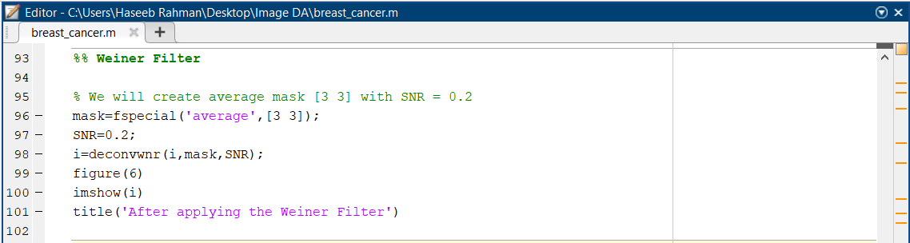

***Output :***

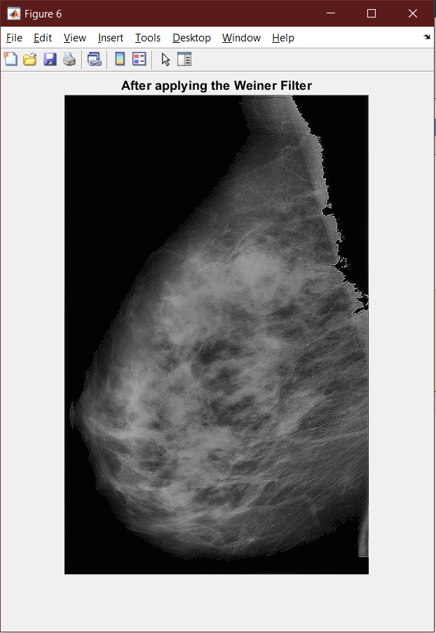

***Applying the CLAHE filter :***

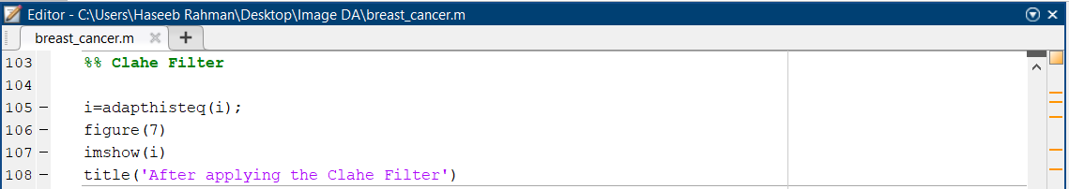

***Output :***

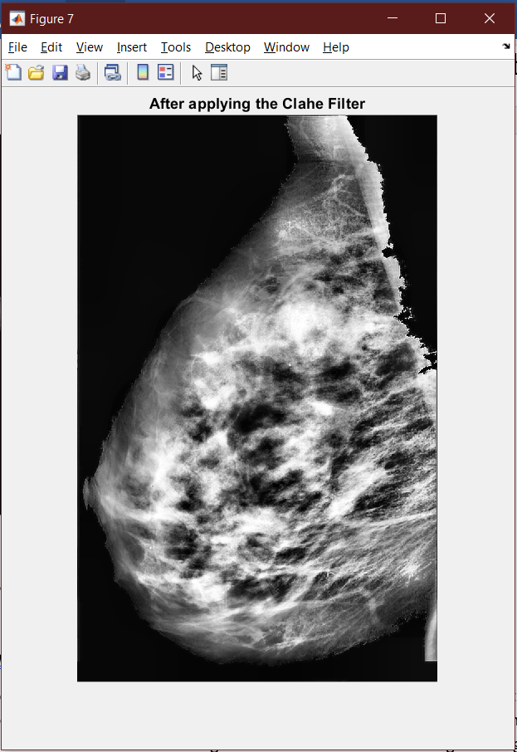

***Binarizing the image at 0.7 :***

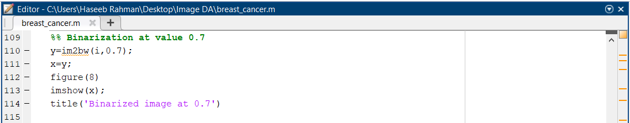

***Output :***

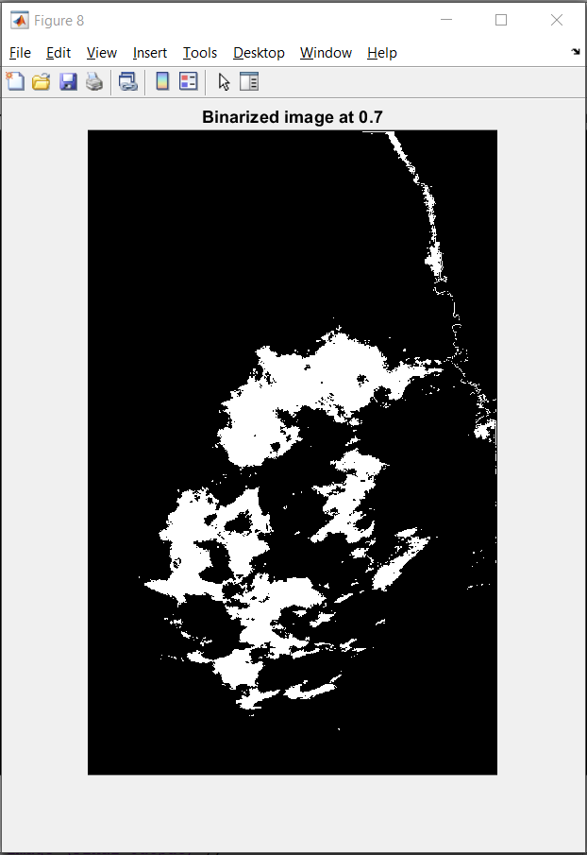

***Applying Opening on the image :***

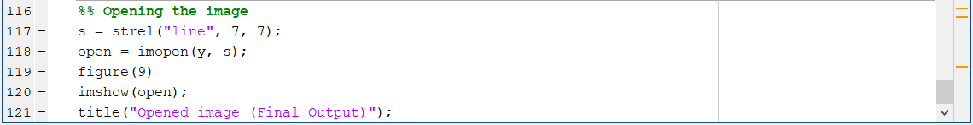

***Output :***

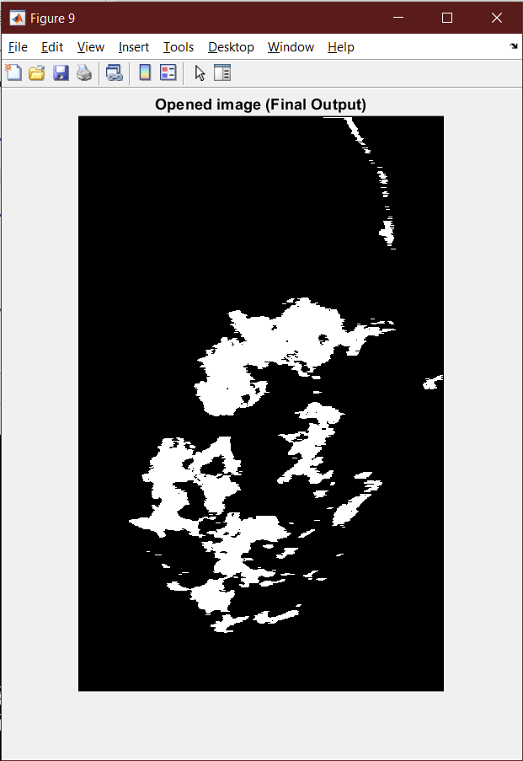

***Conclusion :***

After applying the 3 operations (Thresholding, Background Subtraction and Multiplication with original Image) we get the final image (figure 3) which is the image of just the breast and muscle after the background subtraction from the original image. This was done in Digital Assignment-1.

In this assignment, the image’s background is deleted and then it is segmented through Seed based Region growing Segmentation, Wiener Filter is applied on the image and then CLAHE is performed on it. At last, the image is binarized with a value of 0.7 and opening is applied on it. Hence, we will get our output image (Figure-9) and the prominent white part which we can see is the affected part of the breast from early stage of cancer. Hence, through these step by step processes, we can know whether a breast is affected with an early stage of cancer or not.

***Dataset Link :***

* [***https://drive.google.com/drive/folders/1QuwJSTQpKCWfbRwMsa20xmvFZhi3GnxV?usp=sharing***](https://drive.google.com/drive/folders/1QuwJSTQpKCWfbRwMsa20xmvFZhi3GnxV?usp=sharing)

***Reference Papers [Citations] :***

* ***C. Varma and O. Sawant, "An Alternative Approach to Detect Breast Cancer Using Digital Image Processing Techniques," 2018 International Conference on Communication and Signal Processing (ICCSP), Chennai, India, 2018, pp. 0134-0137, doi: 10.1109/ICCSP.2018.8524576***
* ***Aziz Makandar and Bhagirathi Halalli. Article: A Review on Preprocessing Techniques for Digital Mammography Images. IJCA Proceedings on National conference on Digital Image and Signal Processing DISP 2015(1):23-27, April 2015***
* ***Abbas, Amel & Kareem, Aryan & y kamil, Mohammed. (2015). BREAST CANCER IMAGE SEGMENTATION USING MORPHOLOGICAL OPERATIONS. international journal of electronics and communication engineering and technology. 6. 8-14***
* ***S. Punitha, A. Amuthan, K. Suresh Joseph, Benign and malignant breast cancer segmentation using optimized region growing technique, Future Computing and Informatics Journal, Volume 3, Issue 2, 2018, Pages 348-358, ISSN 2314-7288, https://doi.org/10.1016/j.fcij.2018.10.005***

***References :***

* [***https://timesofindia.indiatimes.com/city/indore/37-pros-face-risk-of-cancer-Survey/articleshow/29830667.cms***](https://timesofindia.indiatimes.com/city/indore/37-pros-face-risk-of-cancer-Survey/articleshow/29830667.cms)
* [***https://ieeexplore.ieee.org/document/5742205***](https://ieeexplore.ieee.org/document/5742205)
* [***https://www.researchgate.net/publication/260368549_A_Preprocessing_Algorithm_for_the_CAD_System_of_Mammograms_Using_the_Active_Contour_Method/fulltext/57aa4d8308ae7a6420bceecf/A-Preprocessing-Algorithm-for-the-CAD-System-of-Mammograms-Using-the-Active-Contour-Method.pdf***](https://www.researchgate.net/publication/260368549_A_Preprocessing_Algorithm_for_the_CAD_System_of_Mammograms_Using_the_Active_Contour_Method/fulltext/57aa4d8308ae7a6420bceecf/A-Preprocessing-Algorithm-for-the-CAD-System-of-Mammograms-Using-the-Active-Contour-Method.pdf)
* [***https://www.geeksforgeeks.org/morphological-operations-in-matlab/***](https://www.geeksforgeeks.org/morphological-operations-in-matlab/)
* [***https://www.mathworks.com/help/images/morphological-dilation-and-erosion.html#:~:text=Morphological%20operations%20apply%20a%20structuring,input%20image%20with%20its%20neighbors.***](https://www.mathworks.com/help/images/morphological-dilation-and-erosion.html#:~:text=Morphological%20operations%20apply%20a%20structuring,input%20image%20with%20its%20neighbors.)