# Kubernetes cluster on premise

## 1.1 Pre-requirement

*Machine mini-Requirements are given below:*

1. Master: 2 cpu, 2 GB ram and 20 GB memory
2. Worker: 1 cpu, 2 GB ram and 20 GB memory
3. Turn off the swap memory (kubernetes does not support)
4. Turn off the firewall/ add required port in firewall

## 1.2 Set the host name

***hostnamectl set-hostname master***

***hostnamectl set-hostname worker-1***

Add the host name with IP in both machine

Add in etc/hosts file and then try to ping through hostname

Now, we have swapped memory off from the machine and go into etc/fstab

Run the following command on master and worker:

cat <<EOF | sudo tee /etc/sysctl.d/k8s.conf

net.bridge.bridge-nf-call-ip6tables = 1

net.bridge.bridge-nf-call-iptables = 1

EOF

sudo sysctl --system

*Now, we have opened following* ***ports on Master*** *that are mention in given below:*

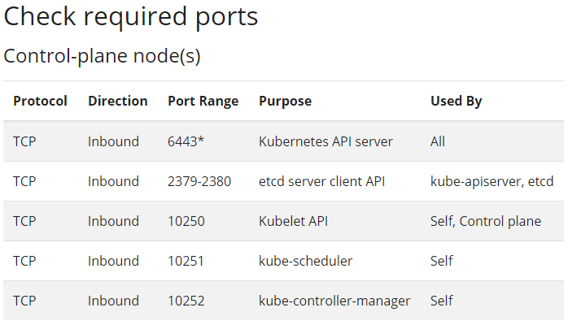

*Similarly, we have opened the following* ***ports on Worker*** *that are mention in given below:*

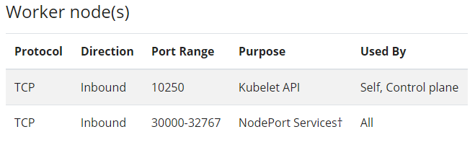

**Install** **docker** by following command on master and worker

sudo yum-config-manager \

--add-repo \

<https://download.docker.com/linux/centos/docker-ce.repo>

sudo yum install docker-ce docker-ce-cli containerd.io -y

systemctl enable docker

systemctl start docker

*Run the following command on* ***master and worker-1***

cat <<EOF | sudo tee /etc/yum.repos.d/kubernetes.repo

[kubernetes]

name=Kubernetes

baseurl=https://packages.cloud.google.com/yum/repos/kubernetes-el7-\$basearch

enabled=1

gpgcheck=1

repo_gpgcheck=1

gpgkey=https://packages.cloud.google.com/yum/doc/yum-key.gpg https://packages.cloud.google.com/yum/doc/rpm-package-key.gpg

exclude=kubelet kubeadm kubectl

EOF

sudo setenforce 0

sudo sed -i 's/^SELINUX=enforcing$/SELINUX=permissive/' /etc/selinux/config

sudo yum install -y kubelet kubeadm kubectl --disableexcludes=kubernetes

sudo systemctl enable --now kubelet

*Now, we have executed command on* ***“master to make master”*** *that are given below:*

kubeadm init

mkdir -p $HOME/.kube

sudo cp -i /etc/kubernetes/admin.conf $HOME/.kube/config

sudo chown $(id -u):$(id -g) $HOME/.kube/config

* 1. **Installing a Pod network add-on master**

kubectl apply -f <https://docs.projectcalico.org/v3.14/manifests/calico.yaml>

*Now, we have executed the commands given by “****master on the worker to add worker”*** *in the cluster, like that*

*kubeadm join 172.31.66.232:6443 --token zwijtx.0suhg87zu2scryfh --discovery-token-ca-cert-hash sha256:6ba0a6dc3d07a01e28a04f8ef88fbd8d2ed529c8955dcbe327156542fbaf9136*