SUBMITTED BY:

NAME | ABDUL HASEEB
ROLL NO | CSE25001
YEAR / SEM / SECTION | 2 / 3 / CSE-A
CREDITS | 5

SUBMITTED TO:

NAME | Dr.B.RAJ KUMAR
DEPARTMENT | SCHOOL OF COMPUTING
DESIGNATION | ASST. PROFFESOR (SI grade)

S NO: | TITLE | DATE | PAGE
1 | WEEK 1:  1a: Recursive countdown from n.  1b: Recursive calculation of compound growth factor.  1c: Recursive search for emo id in list.  1d: Recursive factorial calculation.  1e: Recursive fibonacci series. | 23-07-26 | 5-9
2 | WEEK 2:  2a: Write a program to perform linear search on a given input.  2b: Write a Python program to perform binary search on the given input. Verify by taking sorted array & unsorted array as input. | 30-07-26 | 10-12
3 | WEEK 3:  3a: write a python program to sort the elements using a bubble sort technique. Take an input elements from the user.  3b: Insertion sort.  3c: selection sort.  3d: Merge sort.  3e: Quick sort. | 06-08-26 | 13-19
4 | WEEK 4:  4a: Write a python program to implement a single linked list which would perform the below operations, by taking an input from the user.  a. Create a linked list.  b. Insert at beginning.  c. Insert at end.  d. Insert at a specific index.  e. Delete by value.  f. Delete 1st node.  g. Delete last node.  h. Count no. of nodes.  i. Display.  j. Exit.  4b: Doubly linked list  4c: Circular linked list | 13-08-26 | 20-41
5 | WEEK 5:  5a: Write a python program to implement stack operations using array which would perform the below operations, by taking an input from the user.  a. Push.  b. Pop.  c. Peek.  d. Exit.  5b: Implement stack using linked list | 27-08-26 | 42-46
6 | WEEK 6:  6a: Write a python program to implement queue operations using array which would perform the below operations, by taking an input from the user.  a. Enqueue.  b. Dequeue.  c. Peek.  d. Exit.  6b: Implement queue using linked list  6c: Implement circular queue using arrays  6d: Implement circular queue using linked list | 03-09-26 | 47-59
7 | WEEK 7:  7a: Write a python program to implement binary tree using an array which would perform the below operations, by taking an input from the user.  a. Insertion  b. Deletion  c. Searching  d. Traversal  7b: Implement binary tree using linked list | 24-09-26 | 60-65
8 | WEEK 8:  8a: Write a Python program to implement a Binary Search Tree (BST) which would perform the below operations, by taking an input from the user.  a. Insertion  b. Deletion  c. Searching  d. Traversal  8b: Implement a Binary Search Tree using a linked list. | 08-10-26 | 66-74
9 | WEEK 9:  9a: Write a Python program to implement a AVL Tree which would perform the following operations by taking input from the user.  a. Insertion  b. Deletion  c. Searching  d. Traversal  9b: Implement a AVL Tree using a linked structure and display its elements using traversal. | 22-10-26 | 75-84
10 | 10a: Write a Python program to implement Hashing using Separate Chaining which would perform the following operations by taking input from the user.  a. Insertion  b. Searching  c. Displaying  10b: Write a Python program to implement Hashing using Linear Probing.  10c: Write a Python program to implement Hashing using Quadratic Probing | 29-10-26 | 85-92
  WEEK 10:

LAB 1

1A)

AIM: A rocket launch system displays a countdown. Use no loops. Write a Python program to display the countdown from n to 1, followed by “Launch”.

PROGRAM:

def countdown(n):

if n==0:

print("Launch")

return

print(n)

countdown(n-1)

n=int(input("Enter n: "))

countdown(n)

OUTPUT:

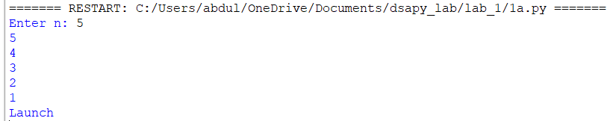

EXPLANATION:

- Defines a recursive countdown() function that prints numbers in decreasing order.
- Prints the current value of n before making the recursive call.
- When n becomes 0, the recursion stops.
- Otherwise, the function calls itself with n-1.
- Takes the starting number as input and displays the countdown.

ERROR TABLE:

S.No | Error Obtained | Rectification
1 | Countdown does not stop | Check the condition when n reaches 0
2 | Program stops for a very large number | Use a loop instead of recursion
3 | Negative numbers are printed unexpectedly | Allow only non negative starting values

1B)

AIM: Banks calculate the growth of an investment using compound interest. The formula requires calculating powers, which can be implemented recursively. Write a recursive program to calculate pⁿ (power), where p = principal growth factor and n = number of years.

PROGRAM:

def power(p,n):
if n==0:
return 1
return p*power(p,n-1)
p=int(input("Enter p: "))
n=int(input("Enter n: "))
print(power(p,n))

OUTPUT:

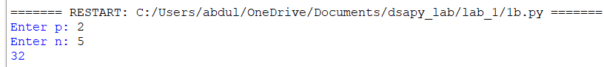

EXPLANATION:

- Defines a recursive power() function to calculate \(p^n\).
- Returns 1 when n <= 0, which is the base case.
- Otherwise, multiplies p by power(p, n-1) repeatedly.
- Takes the base (p) and exponent (n) as input.
- Calls the function and prints the calculated power.

ERROR TABLE:

S.No | Error Obtained | Rectification
1 | Incorrect result for negative exponent | Add separate handling for negative exponents
2 | Program becomes slow for large exponent | Use an efficient power calculation method
3 | Wrong result for exponent zero | Make sure the base case returns 1

1C)

AIM:An HR department stores employee IDs in a list. Develop a recursive program to search for a given employee ID. Write a recursive function to search for an employee ID in a list.

PROGRAM:

def search(arr,id,n):
if n==len(arr):
return -1
if arr[n]==id:
return n
return search(arr,id,n+1)
arr=[101,102,103,104,105]
id=int(input("Enter employee ID: "))
result=search(arr,id,0)
if result==-1:
print("Employee ID not found")
else:
print("Employee ID found at index",result)

OUTPUT:

EXPLANATION:

- Defines a recursive search() function to find the target element in the list.
- Checks each element starting from index 0 using recursion.
- If the target is found, its index is returned.
- If the end of the list is reached, -1 is returned.
- Takes the target value as input and displays the search result.

ERROR TABLE:

S.No | Error Obtained | Rectification
1 | Target element is not found | Check whether the target exists in the list
2 | Recursion stops before checking all elements | Verify the index increment in the recursive call
3 | Program stops for a large list | Use an iterative search method

1D)

AIM:In a logistics company, the number of possible ways to arrange n different parcels is calculated using the factorial formula (n!). Develop a recursive program to calculate the factorial of a given number.

PROGRAM:

def factorial(n):
if n==0:
return 1
return n*factorial(n-1)
n=int(input("Enter number: "))
print("Factorial =",factorial(n))

OUTPUT:

EXPLANATION:

- Defines a recursive factorial() function to calculate the factorial of a number.
- Returns 1 when n <= 0, which also handles 0!.
- Otherwise, multiplies n by factorial(n-1) until reaching the base case.
- Takes a number as input from the user.
- Calls the function and prints the factorial result.

ERROR TABLE:
S.No | Error Obtained | Rectification
1 | Incorrect factorial for negative input | Restrict the input to non negative numbers
2 | Program stops for a large number | Use an iterative approach
3 | Wrong factorial result | Check the recursive multiplication and base condition

1E)

AIM:Write a recursive Python program to print the first n terms of the Fibonacci series.

PROGRAM:

def fibonacci(n):
if n<=1:
return n
return fibonacci(n-1)+fibonacci(n-2)
n=int(input("Enter n: "))
for i in range(n):
print(fibonacci(i),end=" ")

OUTPUT:

EXPLANATION:

- Defines a recursive fibonacci() function to calculate Fibonacci numbers.
- Returns 0 for n <= 0 and 1 for n == 1.
- For other values, it recursively adds the previous two Fibonacci numbers.
- Takes the number of terms from the user.
- Uses a loop to generate and print each Fibonacci term.
- The sequence starts as 0, 1, 1, 2, 3, 5, ....

ERROR TABLE:

S.No | Error Obtained | Rectification
1 | Program runs very slowly | Use an iterative or optimized approach
2 | Incorrect sequence is displayed | Check the base conditions for 0 and 1
3 | Program stops for large input | Avoid excessive recursive calls

LAB 2

2A)

AIM: Write a program to perform linear search on a given input.

PROGRAM:

def linear_search(arr,x):
for i in range(len(arr)):
if arr[i]==x:
return i
return -1
arr=[]
n=int(input("Enter number of elements: "))
for i in range(n):
arr.append(int(input("Enter element: ")))
x=int(input("Enter element to search: "))
result=linear_search(arr,x)
if result==-1:
print("Element not found")
else:
print("Element found at index",result)

OUTPUT:

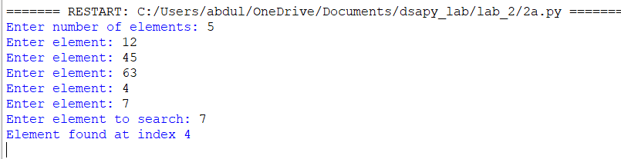

EXPLANATION:

- Takes the number of elements and stores them in a list.
- Takes the target element to be searched.
- linearSearch() checks each element one by one.
- If the target is found, its index is returned.
- If not found, -1 is returned.
- The result is displayed using print().

ERROR TABLE:

S.No | Error Obtained | Rectification
1 | Element is not found | Check whether the required element is present in the list
2 | Wrong index is displayed | Check the list indexing starting from 0
3 | Search stops unexpectedly | Verify the range used in the for loop

2B)

AIM:Write a Python program to perform binary search on the given input. Verify by taking sorted array & unsorted array as input.

PROGRAM:

def binary_search(arr,x):
low=0
high=len(arr)-1
while low<=high:
mid=(low+high)//2
if arr[mid]==x:
return mid
elif arr[mid]<x:
low=mid+1
else:
high=mid-1
return -1
arr=[]
n=int(input("Enter number of elements: "))
for i in range(n):
arr.append(int(input("Enter element: ")))
arr.sort()
x=int(input("Enter element to search: "))
result=binary_search(arr,x)
if result==-1:
print("Element not found")
else:
print("Element found at index",result)

OUTPUT:

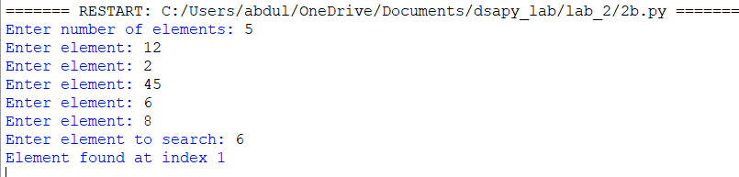

EXPLANATION:

- Takes the number of elements and stores them in a list.
- Sorts the list using a.sort() because binary search requires sorted data.
- Calculates the middle element and compares it with the target.
- If the target is smaller or larger, searches only the appropriate half.
- Returns the index if found; otherwise returns -1.
- Displays whether the element is found or not.

ERROR TABLE:

S.No | Error Obtained | Rectification
1 | Wrong element is returned | Make sure the list is sorted before searching
2 | Search gives incorrect index | Check the calculation of the middle index
3 | Element is not found | Verify the low and high boundaries

LAB 3

3A)

AIM: Write a python programme to sort the elements using a bubble sort technique. Take an input elements from the users.

PROGRAM:

def bubble_sort(a, n):
for i in range(n):
for j in range(n - i - 1):
if a[j] > a[j + 1]:
a[j], a[j + 1] = a[j + 1], a[j]
return a
n = int(input("Enter number of elements: "))
a = []
for i in range(n):
x = int(input("Enter element: "))
a.append(x)
print("Sorted array:", bubble_sort(a, n))

OUTPUT:

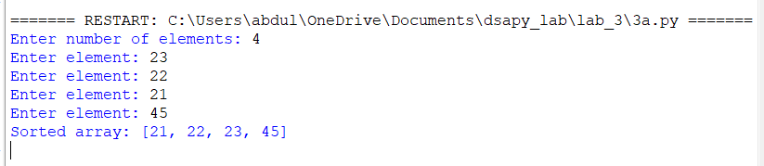

EXPLANATION:

Defines the bubble_sort function and finds the number of elements in the list.
Compares adjacent elements using two nested loops.
Swaps the elements if they are in the wrong order.
Repeats the process until all elements are arranged in ascending order.
Takes the elements as input from the user and stores them in a list.
Calls bubble_sort and displays the sorted array.

ERROR TABLE:

S.No | Error Obtained | Rectification
1 | IndexErrorwhile comparing elements | Check the loop range and array size
2 | Elements are not sorted correctly | Check the swapping condition
3 | Incorrect number of elements processed | Make sure the entered count matches the elements

3B)

AIM: Write a python programme to sort the elements using a insertion sort technique. Take an input elements from the users.

PROGRAM:

def insertion_sort(a, n):
for i in range(1, n):
key = a[i]
for j in range(i - 1, -1, -1):
if a[j] > key:
a[j + 1] = a[j]
else:
break
a[j + 1] = key
return a
n = int(input("Enter number of elements: "))
a = []
for i in range(n):
x = int(input("Enter element: "))
a.append(x)
print("Sorted array:", insertion_sort(a, n))

OUTPUT:

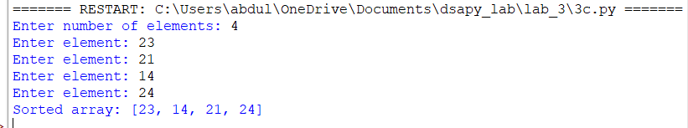

EXPLANATION:

Defines the insertion_sort function and starts from the second element of the list.
Stores the current element in key and compares it with the previous elements.
Moves larger elements one position to the right.
Places key in its correct position in the sorted portion of the list.
Displays the original and sorted arrays.

ERROR TABLE:

S.No | Error Obtained | Rectification
1 | Elements are not sorted correctly | Check the position where key is inserted
2 | IndexErrorwhile shifting elements | Check the condition j >= 0
3 | Someelementsare overwritten | Place key after completing the shifting process

3C)

AIM: Write a python programme to sort the elements using a selection sort technique. Take an input elements from the users.

PROGRAM:

def selection_sort(a, n):
for i in range(n):
min_index = i
for j in range(i + 1, n):
if a[j] < a[min_index]:
min_index = j
a[i], a[min_index] = a[min_index], a[i]
return a
n = int(input("Enter number of elements: "))
a = []
for i in range(n):
x = int(input("Enter element: "))
a.append(x)
print("Sorted array:", selection_sort(a, n))

OUTPUT:

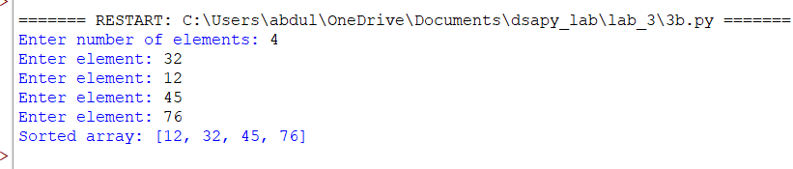

EXPLANATION:

Defines the selection_sort function and assumes the first unsorted element as the minimum.
Compares it with the remaining elements to find the smallest element.
Stores the position of the smallest element in min_index.
Swaps the smallest element with the element at the current position.
Repeats the process until the entire list is sorted.
Takes input elements and displays the sorted array.

ERROR TABLE:

S.No | Error Obtained | Rectification
1 | Incorrect sorting of elements | Perform the swap after finding the minimum element
2 | Elements are swapped multiple times | Move the swap statement outside the inner loop
3 | Minimum element is selected incorrectly | Check the min_index update condition

3D)

AIM: Write a python programme to sort the elements using a merge sort technique. Take an input elements from the users.

PROGRAM:

def merge_sort(a):
if len(a) <= 1:
return a
mid = len(a)
left = merge_sort(a[:mid])
right = merge_sort(a[mid:])
result = []
i = 0
j = 0
for k in range(len(left) + len(right)):
if i < len(left) and j < len(right):
if left[i] <= right[j]:
result.append(left[i])
i += 1
else:
result.append(right[j])
j += 1
elif i < len(left):
result.append(left[i])
i += 1
else:
result.append(right[j])
j += 1
return result
n = int(input("Enter number of elements: "))
a = []
for i in range(n):
x = int(input("Enter element: "))
a.append(x)
a = merge_sort(a)
print("Sorted array:", a)

OUTPUT:

EXPLANATION:

Defines the merge_sort function and divides the array into two halves.
Recursively divides each half until single elements remain.
Compares elements from the left and right halves.
Merges the elements back into the array in ascending order.
Continues merging until the complete array is sorted
Takes input elements and displays the original and sorted arrays.

ERROR TABLE:

S.No | Error Obtained | Rectification
1 | Elements are not merged correctly | Check the comparison between left and right arrays
2 | Some elements are missing after merging | Check the remaining element loops
3 | Incorrect sorted output | Verify the values of i, j and k during merging

3E)

AIM: Write a python programme to sort the elements using a quick sort technique. Take an input elements from the users.

PROGRAM:

def quick_sort(a):
if len(a) <= 1:
return a
pivot = a[-1]
left = []
right = []
for i in range(len(a) - 1):
if a[i] <= pivot:
left.append(a[i])
else:
right.append(a[i])
return quick_sort(left) + [pivot] + quick_sort(right)
n = int(input("Enter number of elements: "))
a = []
for i in range(n):
x = int(input("Enter element: "))
a.append(x)
a = quick_sort(a)
print("Sorted array:", a)

OUTPUT:

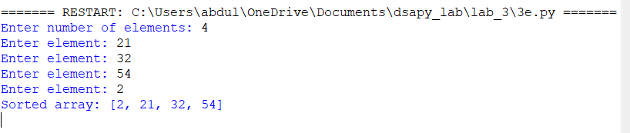

EXPLANATION:

Defines a recursive Quick Sort function and selects the first element as the pivot.
Uses two pointers, i and j, to compare and arrange elements around the pivot.
Swaps elements when they are on the wrong side of the pivot.
Places the pivot in its correct position after partitioning.
Recursively sorts the elements before and after the pivot.
Takes the elements as input and performs the sorting operation.

ERROR TABLE:

S.No | Error Obtained | Rectification
1 | UnboundLocalError for i or j | Keep the partitioning code inside the if block
2 | RecursionError for large input | Check the recursive calls and pivot position
3 | Sorted array is displayed as None | Print the list after calling quicksort

\

LAB 4

4A)

AIM: Write a python programme to implement single linked list. Take an input elements from the users .

PROGRAM:

class Node:
def __init__(self, data):
self.data = data
self.next = None

class SLL:
def __init__(self):
self.head = None

# 1. Create a linked list
def create(self):
n = int(input("Enter number of nodes: "))

for i in range(n):
data = int(input("Enter data: "))
new_node = Node(data)

if self.head is None:
self.head = new_node
else:
temp = self.head

while temp.next is not None:
temp = temp.next

temp.next = new_node

print("Linked List created successfully")

# 2. Insert at Beginning
def insert_beginning(self):
data = int(input("Enter data: "))

new_node = Node(data)
new_node.next = self.head
self.head = new_node

print(f"Inserted {data} at the beginning.")

# 3. Insert at End
def insert_end(self):
data = int(input("Enter data: "))

new_node = Node(data)

if self.head is None:
self.head = new_node
return

temp = self.head

while temp.next is not None:
temp = temp.next

temp.next = new_node

print(f"Inserted {data} at the end.")

# 4. Insert at Index
def insert_at_index(self):
data = int(input("Enter data: "))
index = int(input("Enter index: "))

if index < 0:
print("Invalid index")
return

if index == 0:
new_node = Node(data)
new_node.next = self.head
self.head = new_node
return

temp = self.head

for i in range(index - 1):
if temp is None:
print("Index out of range")
return
temp = temp.next

if temp is None:
print("Index out of range")
return

new_node = Node(data)
new_node.next = temp.next
temp.next = new_node

print(f"Inserted {data} at index {index}.")

# 5. Delete from Beginning
def delete_beginning(self):
if self.head is None:
print("List is empty")
return

self.head = self.head.next
print("Deleted beginning node.")

# 6. Delete from End
def delete_end(self):
if self.head is None:
print("List is empty")
return

if self.head.next is None:
self.head = None
return

temp = self.head

while temp.next.next is not None:
temp = temp.next

temp.next = None

print("Deleted last node.")

# 7. Delete from Index
def delete_at_index(self):
index = int(input("Enter index: "))

if self.head is None:
print("List is empty")
return

if index < 0:
print("Invalid index")
return

if index == 0:
self.head = self.head.next
return

temp = self.head

for i in range(index - 1):
if temp.next is None:
print("Index out of range")
return
temp = temp.next

if temp.next is None:
print("Index out of range")
return

temp.next = temp.next.next

print("Deleted node value.")

# 8. Count Nodes
def count_nodes(self):
count = 0
temp = self.head

while temp is not None:
count += 1
temp = temp.next

print("Number of nodes:", count)

# 9. Display
def display(self):
if self.head is None:
print("List is empty")
return

temp = self.head

while temp is not None:
print(temp.data, end=" -> ")
temp = temp.next

print("None")

# Main Program
sll = SLL()

while True:
print("\n----- SINGLY LINKED LIST -----")
print("1. Create Linked List")
print("2. Insert at Beginning")
print("3. Insert at End")
print("4. Insert at Index")
print("5. Delete from Beginning")
print("6. Delete from End")
print("7. Delete from Index")
print("8. Count number of nodes")
print("9. Display")
print("10. Exit")

choice = int(input("Enter your choice: "))

if choice == 1:
sll.create()

elif choice == 2:
sll.insert_beginning()

elif choice == 3:
sll.insert_end()

elif choice == 4:
sll.insert_at_index()

elif choice == 5:
sll.delete_beginning()

elif choice == 6:
sll.delete_end()

elif choice == 7:
sll.delete_at_index()

elif choice == 8:
sll.count_nodes()

elif choice == 9:
sll.display()

elif choice == 10:
print("Exiting from the program...")
break

else:
print("Invalid choice")

OUTPUT:

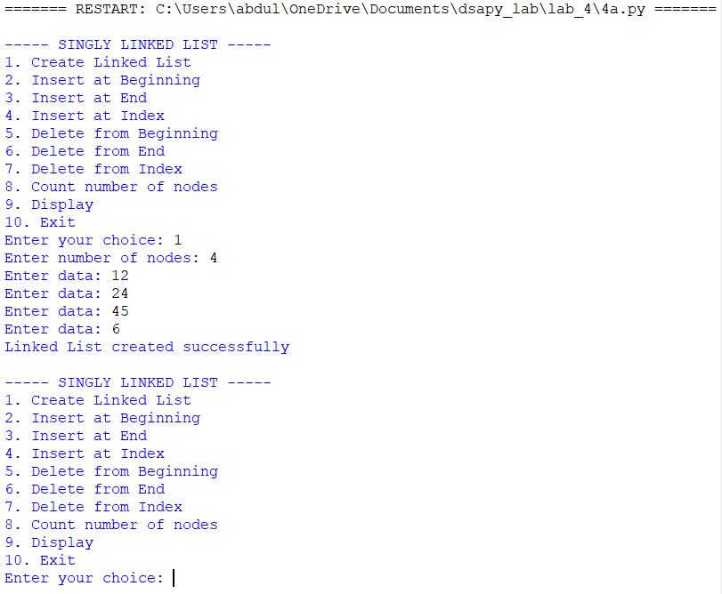

EXPLANATION:

Defines a node containing data and a pointer to the next node.
Creates a singly linked list by dynamically allocating memory for each node.
Stores the address of the next node in the next pointer.
The last node points to NULL, indicating the end of the list.
Performs operations such as insertion, deletion, and traversal.
Traverses the list from the first node until NULL is reached.
Takes the required elements as input and performs the linked list operations.

ERROR TABLE:

S.No | Error Obtained | Rectification
1 | New node is not inserted correctly | Update the next pointer of the previous node
2 | List traversal stops incorrectly | Make sure the last node points to NULL
3 | First node is lost after insertion | Update the head pointer correctly

4B)

AIM: Write a python programme to implement double linked list. Take an input elements from the users.

PROGRAM:

class Node:
def __init__(self, data):
self.data = data
self.prev = None
self.next = None

class DLL:
def __init__(self):
self.head = None

# 1. Create Linked List
def create(self):
n = int(input("Enter number of nodes: "))

for i in range(n):
data = int(input("Enter data: "))
new_node = Node(data)

if self.head is None:
self.head = new_node
else:
temp = self.head

while temp.next is not None:
temp = temp.next

temp.next = new_node
new_node.prev = temp

print("Linked List created successfully")

# 2. Insert at Beginning
def insert_beginning(self):
data = int(input("Enter data: "))

new_node = Node(data)

new_node.next = self.head

if self.head is not None:
self.head.prev = new_node

self.head = new_node

print(f"Inserted {data} at the beginning.")

# 3. Insert at End
def insert_end(self):
data = int(input("Enter data: "))

new_node = Node(data)

if self.head is None:
self.head = new_node
print(f"Inserted {data} at the end.")
return

temp = self.head

while temp.next is not None:
temp = temp.next

temp.next = new_node
new_node.prev = temp

print(f"Inserted {data} at the end.")

# 4. Insert at Index
def insert_at_index(self):
data = int(input("Enter data: "))
index = int(input("Enter index: "))

if index < 0:
print("Invalid index")
return

if index == 0:
new_node = Node(data)
new_node.next = self.head

if self.head is not None:
self.head.prev = new_node

self.head = new_node
return

temp = self.head

for i in range(index - 1):
if temp is None:
print("Index out of range")
return

temp = temp.next

if temp is None:
print("Index out of range")
return

new_node = Node(data)

new_node.next = temp.next
new_node.prev = temp

if temp.next is not None:
temp.next.prev = new_node

temp.next = new_node

print(f"Inserted {data} at index {index}.")

# 5. Delete from Beginning
def delete_beginning(self):
if self.head is None:
print("List is empty")
return

self.head = self.head.next

if self.head is not None:
self.head.prev = None

print("Deleted beginning node.")

# 6. Delete from End
def delete_end(self):
if self.head is None:
print("List is empty")
return

if self.head.next is None:
self.head = None
print("Deleted last node.")
return

temp = self.head

while temp.next is not None:
temp = temp.next

temp.prev.next = None

print("Deleted last node.")

# 7. Delete from Index
def delete_at_index(self):
index = int(input("Enter index: "))

if self.head is None:
print("List is empty")
return

if index < 0:
print("Invalid index")
return

if index == 0:
self.head = self.head.next

if self.head is not None:
self.head.prev = None

print("Deleted node value.")
return

temp = self.head

for i in range(index):
if temp is None:
print("Index out of range")
return

temp = temp.next

if temp is None:
print("Index out of range")
return

if temp.next is not None:
temp.next.prev = temp.prev

if temp.prev is not None:
temp.prev.next = temp.next

print("Deleted node value.")

# 8. Count Nodes
def count_nodes(self):
count = 0
temp = self.head

while temp is not None:
count += 1
temp = temp.next

print("Number of nodes:", count)

# 9. Display
def display(self):
if self.head is None:
print("List is empty")
return

temp = self.head

while temp is not None:
print(temp.data, end=" <-> ")
temp = temp.next

print("None")

# Main Program
dll = DLL()

while True:
print("\n----- DOUBLY LINKED LIST -----")
print("1. Create Linked List")
print("2. Insert at Beginning")
print("3. Insert at End")
print("4. Insert at Index")
print("5. Delete from Beginning")
print("6. Delete from End")
print("7. Delete from Index")
print("8. Count number of nodes")
print("9. Display")
print("10. Exit")

choice = int(input("Enter your choice: "))

if choice == 1:
dll.create()

elif choice == 2:
dll.insert_beginning()

elif choice == 3:
dll.insert_end()

elif choice == 4:
dll.insert_at_index()

elif choice == 5:
dll.delete_beginning()

elif choice == 6:
dll.delete_end()

elif choice == 7:
dll.delete_at_index()

elif choice == 8:
dll.count_nodes()

elif choice == 9:
dll.display()

elif choice == 10:
print("Exiting from the program...")
break

else:
print("Invalid choice")

OUTPUT:

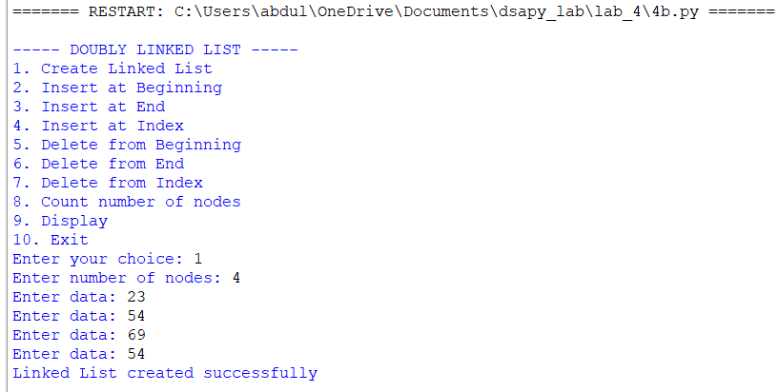

EXPLANATION:

Defines a node containing data, a pointer to the previous node, pointer to next.
Creates a doubly linked list by dynamically allocating memory for each node.
Maintains both prev and next pointers for every node.
The first node has prev as NULL.
The last node has next as NULL.
Performs operations such as insertion, deletion, forward traversal and back.
Updates both prev and next pointers whenever a node is inserted or deleted.
Takes the required elements as input and performs the linked list operations.

ERROR TABLE:

S.No | Error Obtained | Rectification
1 | Segmentation fault while accessing prev or next | Check whether the node is NULL before accessing it
2 | Forward traversal works but backward traversal fails | Update the prev pointer correctly
3 | Node is inserted but links are incorrect | Update both prev and next pointers

4C)

AIM: Write a python programme to implement circular linked list. Take an input elements from the users.

PROGRAM:

class Node:
def __init__(self, data):
self.data = data
self.next = None

class CLL:
def __init__(self):
self.head = None

# 1. Create Linked List
def create(self):
n = int(input("Enter number of nodes: "))

for i in range(n):
data = int(input("Enter data: "))
new_node = Node(data)

if self.head is None:
self.head = new_node
new_node.next = self.head
else:
temp = self.head

while temp.next != self.head:
temp = temp.next

temp.next = new_node
new_node.next = self.head

print("Linked List created successfully")

# 2. Insert at Beginning
def insert_beginning(self):
data = int(input("Enter data: "))

new_node = Node(data)

if self.head is None:
self.head = new_node
new_node.next = self.head
print(f"Inserted {data} at the beginning.")
return

temp = self.head

while temp.next != self.head:
temp = temp.next

new_node.next = self.head
self.head = new_node
temp.next = self.head

print(f"Inserted {data} at the beginning.")

# 3. Insert at End
def insert_end(self):
data = int(input("Enter data: "))

new_node = Node(data)

if self.head is None:
self.head = new_node
new_node.next = self.head
print(f"Inserted {data} at the end.")
return

temp = self.head

while temp.next != self.head:
temp = temp.next

temp.next = new_node
new_node.next = self.head

print(f"Inserted {data} at the end.")

# 4. Insert at Index
def insert_at_index(self):
data = int(input("Enter data: "))
index = int(input("Enter index: "))

if index < 0:
print("Invalid index")
return

if index == 0:
new_node = Node(data)

if self.head is None:
self.head = new_node
new_node.next = self.head
else:
temp = self.head

while temp.next != self.head:
temp = temp.next

new_node.next = self.head
self.head = new_node
temp.next = self.head

print(f"Inserted {data} at index {index}.")
return

if self.head is None:
print("Index out of range")
return

temp = self.head

for i in range(index - 1):
temp = temp.next

if temp == self.head:
print("Index out of range")
return

new_node = Node(data)

new_node.next = temp.next
temp.next = new_node

print(f"Inserted {data} at index {index}.")

# 5. Delete from Beginning
def delete_beginning(self):
if self.head is None:
print("List is empty")
return

if self.head.next == self.head:
self.head = None
print("Deleted beginning node.")
return

temp = self.head

while temp.next != self.head:
temp = temp.next

self.head = self.head.next
temp.next = self.head

print("Deleted beginning node.")

# 6. Delete from End
def delete_end(self):
if self.head is None:
print("List is empty")
return

if self.head.next == self.head:
self.head = None
print("Deleted last node.")
return

temp = self.head

while temp.next.next != self.head:
temp = temp.next

temp.next = self.head

print("Deleted last node.")

# 7. Delete from Index
def delete_at_index(self):
index = int(input("Enter index: "))

if self.head is None:
print("List is empty")
return

if index < 0:
print("Invalid index")
return

if index == 0:
self.delete_beginning()
return

temp = self.head

for i in range(index - 1):
temp = temp.next

if temp == self.head:
print("Index out of range")
return

if temp.next == self.head:
print("Index out of range")
return

temp.next = temp.next.next

print("Deleted node value.")

# 8. Count Nodes
def count_nodes(self):
if self.head is None:
print("Number of nodes: 0")
return

count = 0
temp = self.head

while True:
count += 1
temp = temp.next

if temp == self.head:
break

print("Number of nodes:", count)

# 9. Display
def display(self):
if self.head is None:
print("List is empty")
return

temp = self.head

while True:
print(temp.data, end=" -> ")
temp = temp.next

if temp == self.head:
break

print("(HEAD)")

# Main Program
cll = CLL()

while True:
print("\n----- CIRCULAR LINKED LIST -----")
print("1. Create Linked List")
print("2. Insert at Beginning")
print("3. Insert at End")
print("4. Insert at Index")
print("5. Delete from Beginning")
print("6. Delete from End")
print("7. Delete from Index")
print("8. Count number of nodes")
print("9. Display")
print("10. Exit")

choice = int(input("Enter your choice: "))

if choice == 1:
cll.create()

elif choice == 2:
cll.insert_beginning()

elif choice == 3:
cll.insert_end()

elif choice == 4:
cll.insert_at_index()

elif choice == 5:
cll.delete_beginning()

elif choice == 6:
cll.delete_end()

elif choice == 7:
cll.delete_at_index()

elif choice == 8:
cll.count_nodes()

elif choice == 9:
cll.display()

elif choice == 10:
print("Exiting from the program...")
break

else:
print("Invalid choice")

OUTPUT:

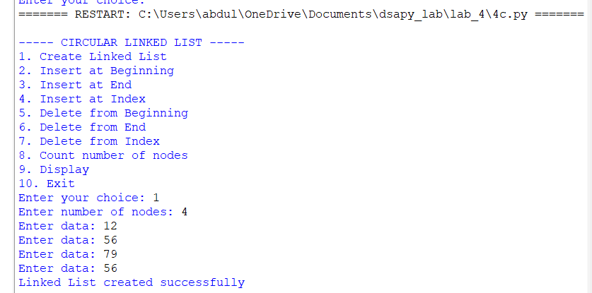

EXPLANATION:

Defines a node containing data and a pointer to the next node.
Creates a circular linked list by dynamically allocating memory for each node.
The last node points back to the first node instead of NULL.
Traverses the list starting from the first node.
Stops traversal when the current node reaches the starting node again.
Performs operations such as insertion, deletion, and traversal.
Maintains the circular connection after every insertion or deletion
Takes the required elements as input and performs the circular linked list.

ERROR TABLE:

S.No | Error Obtained | Rectification
1 | Infinite loop during traversal | Stop when the current node becomes the starting node again
2 | Last node does not point to the first node | Set the last node's next pointer to head
3 | Segmentation fault while accessing a node | Check whether the list is empty before accessing nodes

LAB 5

5A)

AIM: Write a python programme to implement stack operations using arrays. Take an input elements from the users.

PROGRAM:

class StackEx:
def __init__(self, size):
self.size = size
self.stack = [None] * size
self.top = -1

def push(self, item):
if self.top == self.size - 1:
print("Stack Overflow")
else:
self.top += 1
self.stack[self.top] = item
print(item, "pushed into the stack")

def pop(self):
if self.top == -1:
print("Stack Underflow")
else:
item = self.stack[self.top]
self.stack[self.top] = None
self.top -= 1
print(item, "popped from the stack")

def peek(self):
if self.top == -1:
print("Stack is empty")
else:
print("Top element:", self.stack[self.top])

def display(self):
if self.top == -1:
print("Stack is empty")
else:
print("The elements of the stack are:")
for i in range(self.top, -1, -1):
print(self.stack[i])

size = int(input("Enter the size of the stack: "))
s = StackEx(size)

while True:
print("\n----- STACK MENU -----")
print("1. Push")
print("2. Pop")
print("3. Peek")
print("4. Display")
print("5. Exit")

choice = int(input("Enter your choice: "))

if choice == 1:
item = int(input("Enter the element to push: "))
s.push(item)
elif choice == 2:
s.pop()
elif choice == 3:
s.peek()
elif choice == 4:
s.display()
elif choice == 5:
print("Program terminated.")
break
else:
print("Invalid choice")

OUTPUT:

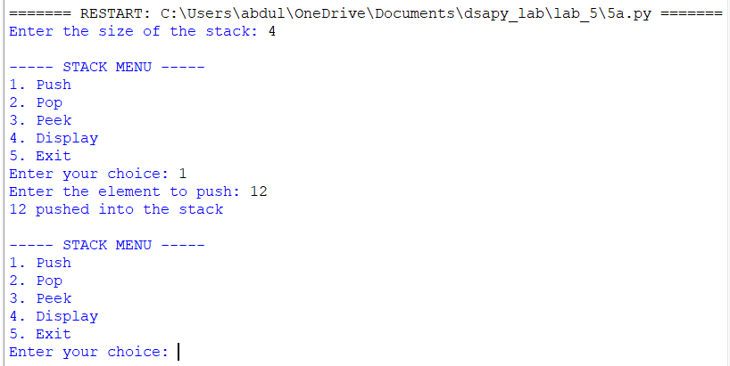

EXPLANATION:

Defines the stack array and initializes the top variable to -1.
Checks whether the stack is full before performing the push operation.
Adds elements to the top of the stack using the push operation.
Checks whether the stack is empty before performing the pop operation.
Removes the top element using the pop operation and decreases top.
Displays the top element using the peek operation.

ERROR TABLE:

S.No | Error Obtained | Rectification
1 | Stack Overflow | Check whether top == MAX-1 before pushing
2 | Stack Underflow | Check whether top == -1 before popping
3 | Incorrect top position | Check the increment and decrement of top

5B)

AIM: Write a python programme to implement stack operations using linked list. Take an input elements from the users.

PROGRAM:

class Node:
def __init__(self, data):
self.data = data
self.next = None

class Stack:
def __init__(self):
self.top = None

def push(self, data):
new = Node(data)
new.next = self.top
self.top = new
print(data, "pushed into stack")

def pop(self):
if self.top is None:
print("Stack Underflow")
else:
temp = self.top
print(temp.data, "popped from stack")
self.top = self.top.next

def peek(self):
if self.top is None:
print("Stack is empty")
else:
print("Top element:", self.top.data)

def display(self):
if self.top is None:
print("Stack is empty")
else:
temp = self.top
print("Stack elements:")
while temp is not None:
print(temp.data)
temp = temp.next

s = Stack()

while True:
print("\n--- STACK USING LINKED LIST ---")
print("1. Push")
print("2. Pop")
print("3. Peek")
print("4. Display")
print("5. Exit")

choice = int(input("Enter your choice: "))

if choice == 1:
data = int(input("Enter the element: "))
s.push(data)
elif choice == 2:
s.pop()
elif choice == 3:
s.peek()
elif choice == 4:
s.display()
elif choice == 5:
print("Program terminated")
break
else:
print("Invalid choice")

OUTPUT:

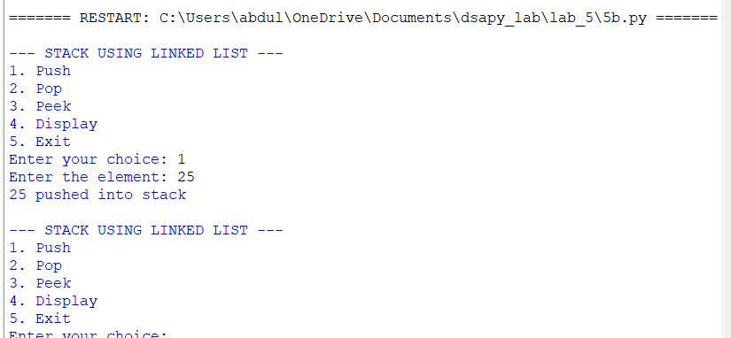

EXPLANATION:

Defines the node structure containing data and a pointer to the next node.
Creates a new node and inserts it at the top during the push operation.
Checks whether the stack is empty before performing the pop operation.
Removes the top node and updates the top pointer.
Frees the deleted node and displays the stack elements.

ERROR TABLE:

S.No | Error Obtained | Rectification
1 | IndexErrorwhile comparing elements | Check the loop range and array size
2 | Elements are not sorted correctly | Check the swapping condition
3 | Incorrect number of elements processed | Make sure the entered count matches the elements

LAB 6

6A)

AIM: Write a python programme to implement queue operations using arrays. Take an input elements from the users.

PROGRAM:

class QueueEx:
def __init__(self, size):
self.size = size
self.queue = [None] * size
self.front = -1
self.rear = -1

def enqueue(self, item):
if self.rear == self.size - 1:
print("Queue Overflow")
else:
if self.front == -1:
self.front = 0

self.rear += 1
self.queue[self.rear] = item
print(item, "enqueued into the queue")

def dequeue(self):
if self.front == -1 or self.front > self.rear:
print("Queue Underflow")
else:
item = self.queue[self.front]
self.queue[self.front] = None
self.front += 1

if self.front > self.rear:
self.front = -1
self.rear = -1

print(item, "dequeued from the queue")

def peek(self):
if self.front == -1:
print("Queue is empty")
else:
print("Front element:", self.queue[self.front])

def display(self):
if self.front == -1:
print("Queue is empty")
else:
print("The elements of the queue are:")
for i in range(self.front, self.rear + 1):
print(self.queue[i])

size = int(input("Enter the size of the queue: "))
q = QueueEx(size)

while True:
print("\n----- QUEUE MENU -----")
print("1. Enqueue")
print("2. Dequeue")
print("3. Peek")
print("4. Display")
print("5. Exit")

choice = int(input("Enter your choice: "))

if choice == 1:
item = int(input("Enter the element to enqueue: "))
q.enqueue(item)

elif choice == 2:
q.dequeue()

elif choice == 3:
q.peek()

elif choice == 4:
q.display()

elif choice == 5:
print("Program terminated.")
break

else:
print("Invalid choice")

OUTPUT:

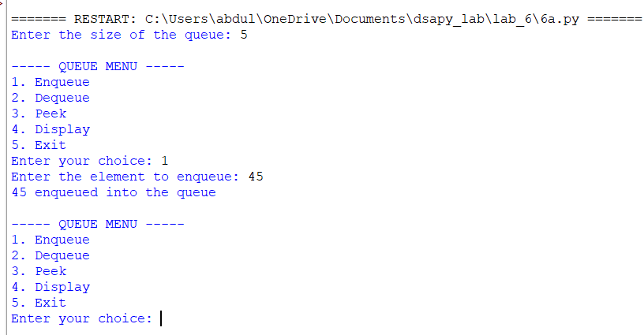

EXPLANATION:

Defines the queue array and initializes the front and rear variables.
Checks whether the queue is full before performing the enqueue operation.
Adds elements at the rear of the queue using the enqueue operation.
Checks whether the queue is empty before performing the dequeue operation.
Removes elements from the front of the queue using the dequeue operation.
Displays the elements of the queue from front to rear.

ERROR TABLE:

S.No | Error Obtained | Rectification
1 | Queue Overflow | Check whether rear == MAX-1 before enqueue
2 | Queue Underflow | Check whether front == -1 or front > rear before dequeue
3 | Incorrect front or rear position | Check the increment and update of front and rear

6B)

AIM: Write a python programme to implement queue operations using linked list. Take an input elements from the users.

PROGRAM:

class Node:
def __init__(self, data):
self.data = data
self.next = None

class QueueEx:
def __init__(self):
self.front = None
self.rear = None

def enqueue(self, item):
new_node = Node(item)

if self.front is None:
self.front = new_node
self.rear = new_node
else:
self.rear.next = new_node
self.rear = new_node

print(item, "enqueued into the queue")

def dequeue(self):
if self.front is None:
print("Queue Underflow")
else:
item = self.front.data
self.front = self.front.next

if self.front is None:
self.rear = None

print(item, "dequeued from the queue")

def peek(self):
if self.front is None:
print("Queue is empty")
else:
print("Front element:", self.front.data)

def display(self):
if self.front is None:
print("Queue is empty")
else:
print("The elements of the queue are:")

temp = self.front

while temp is not None:
print(temp.data)
temp = temp.next

q = QueueEx()

while True:
print("\n----- QUEUE USING LINKED LIST -----")
print("1. Enqueue")
print("2. Dequeue")
print("3. Peek")
print("4. Display")
print("5. Exit")

choice = int(input("Enter your choice: "))

if choice == 1:
item = int(input("Enter the element to enqueue: "))
q.enqueue(item)

elif choice == 2:
q.dequeue()

elif choice == 3:
q.peek()

elif choice == 4:
q.display()

elif choice == 5:
print("Program terminated.")
break

else:
print("Invalid choice")

OUTPUT:

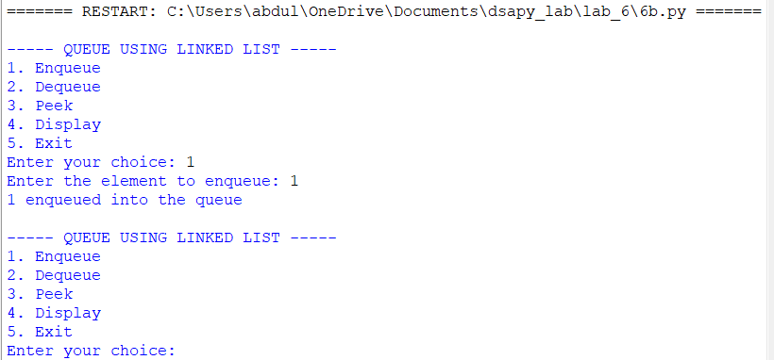

EXPLANATION:

Defines the node structure containing data and a pointer to the next node.
Initializes the front and rear pointers to NULL.
Creates a new node and inserts it at the rear during the enqueue operation.
Checks whether the queue is empty before performing the dequeue operation.
Removes the node from the front and updates the front pointer.
Updates the rear pointer when the last element is removed.

ERROR TABLE:

S.No | Error Obtained | Rectification
1 | Queue Underflow | Check whether front == NULL before dequeue
2 | Memory allocation error | Check whether the new node is successfully allocated
3 | Incorrect front or rear pointer | Check the updating of front and rear

6C)

AIM: Write a python programme to implement circular queue operations using arrays. Take an input elements from the users.

PROGRAM:

class CircularQueueEx:
def __init__(self, size):
self.size = size
self.queue = [None] * size
self.front = -1
self.rear = -1

def enqueue(self, item):
if (self.rear + 1) % self.size == self.front:
print("Queue Overflow")
else:
if self.front == -1:
self.front = 0
self.rear = 0
else:
self.rear = (self.rear + 1) % self.size

self.queue[self.rear] = item
print(item, "enqueued into the circular queue")

def dequeue(self):
if self.front == -1:
print("Queue Underflow")
else:
item = self.queue[self.front]
self.queue[self.front] = None

if self.front == self.rear:
self.front = -1
self.rear = -1
else:
self.front = (self.front + 1) % self.size

print(item, "dequeued from the circular queue")

def peek(self):
if self.front == -1:
print("Queue is empty")
else:
print("Front element:", self.queue[self.front])

def display(self):
if self.front == -1:
print("Queue is empty")
else:
print("The elements of the circular queue are:")

i = self.front

while True:
print(self.queue[i])

if i == self.rear:
break

i = (i + 1) % self.size

size = int(input("Enter the size of the circular queue: "))
q = CircularQueueEx(size)

while True:
print("\n----- CIRCULAR QUEUE MENU -----")
print("1. Enqueue")
print("2. Dequeue")
print("3. Peek")
print("4. Display")
print("5. Exit")

choice = int(input("Enter your choice: "))

if choice == 1:
item = int(input("Enter the element to enqueue: "))
q.enqueue(item)

elif choice == 2:
q.dequeue()

elif choice == 3:
q.peek()

elif choice == 4:
q.display()

elif choice == 5:
print("Program terminated.")
break

else:
print("Invalid choice")

OUTPUT:

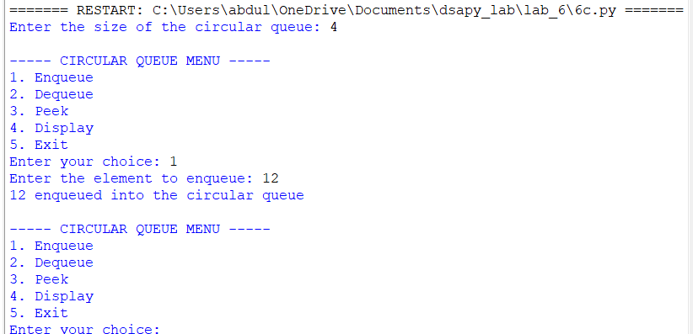

EXPLANATION:

Defines the circular queue array and initializes front and rear.
Checks whether the circular queue is full before performing the enqueue operation.
Adds elements at the rear and uses modulo operation to wrap around the array.
Checks whether the queue is empty before performing the dequeue operation.
Removes elements from the front and updates the position using modulo operation.
Allows the unused spaces at the beginning of the array to be reuse.

ERROR TABLE:

S.No | Error Obtained | Rectification
1 | CircularQueue Overflow | Check whether (rear + 1) % MAX == front
2 | CircularQueue Underflow | Check whether front == -1
3 | Incorrectcircular movement | Use modulo operation correctly

6D)

AIM: Write a python programme to implement circular queue operations using arrays. Take an input elements from the users.

PROGRAM:

class Node:
def __init__(self, data):
self.data = data
self.next = None

class CircularQueueEx:
def __init__(self):
self.front = None
self.rear = None

def enqueue(self, item):
new_node = Node(item)

if self.front is None:
self.front = new_node
self.rear = new_node
self.rear.next = self.front
else:
new_node.next = self.front
self.rear.next = new_node
self.rear = new_node

print(item, "enqueued into the circular queue")

def dequeue(self):
if self.front is None:
print("Queue Underflow")
else:
item = self.front.data

if self.front == self.rear:
self.front = None
self.rear = None
else:
self.front = self.front.next
self.rear.next = self.front

print(item, "dequeued from the circular queue")

def peek(self):
if self.front is None:
print("Queue is empty")
else:
print("Front element:", self.front.data)

def display(self):
if self.front is None:
print("Queue is empty")
else:
print("The elements of the circular queue are:")

temp = self.front

while True:
print(temp.data)

if temp == self.rear:
break

temp = temp.next

q = CircularQueueEx()

while True:
print("\n----- CIRCULAR QUEUE USING LINKED LIST -----")
print("1. Enqueue")
print("2. Dequeue")
print("3. Peek")
print("4. Display")
print("5. Exit")

choice = int(input("Enter your choice: "))

if choice == 1:
item = int(input("Enter the element to enqueue: "))
q.enqueue(item)

elif choice == 2:
q.dequeue()

elif choice == 3:
q.peek()

elif choice == 4:
q.display()

elif choice == 5:
print("Program terminated.")
break

else:
print("Invalid choice")

OUTPUT:

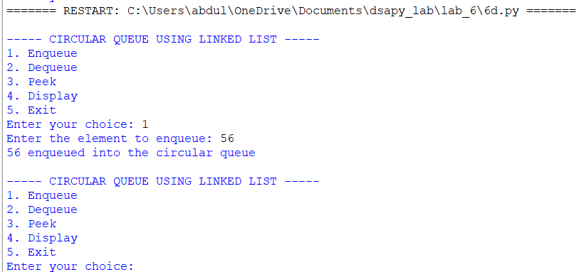

EXPLANATION:

Defines the node structure containing data and a pointer to the next node.
Initializes the front and rear pointers to NULL.
Creates a new node and inserts it at the rear of the circular queue.
Connects the last node back to the first node to maintain the circular structure.
Removes elements from the front during the dequeue operation.

ERROR TABLE:

S.No | Error Obtained | Rectification
1 | Queue Underflow | Check whether front == NULL before dequeue
2 | Memory allocation error | Check whether the new node is successfully allocated
3 | Incorrect circular link | Ensure rear->next points to front

LAB 7

7A)

AIM: Write a python program to implement binary tree using an array

PROGRAM:

class BinaryTreeArray:
def __init__(self,size):
self.tree=[None]*size
self.size=size

def set_root(self,data):
self.tree[0]=data

def set_left(self,parent_index,data):
child_index=2*parent_index+1
if child_index<self.size:
self.tree[child_index]=data
else:
print("Index out of range!")

def set_right(self,parent_index,data):
child_index=2*parent_index+2
if child_index<self.size:
self.tree[child_index]=data
else:
print("Index out of range!")

def preorder(self,index=0):
if index>=self.size or self.tree[index] is None:
return
print(self.tree[index],end=" ")
self.preorder(2*index+1)
self.preorder(2*index+2)

def inorder(self,index=0):
if index>=self.size or self.tree[index] is None:
return
self.inorder(2*index+1)
print(self.tree[index],end=" ")
self.inorder(2*index+2)

def postorder(self,index=0):
if index>=self.size or self.tree[index] is None:
return
self.postorder(2*index+1)
self.postorder(2*index+2)
print(self.tree[index],end=" ")

def level_order(self):
for value in self.tree:
if value is not None:
print(value,end=" ")

def display(self):
print("\nArray Representation:")
for i in range(self.size):
print(f"Index {i}: {self.tree[i]}")

tree=BinaryTreeArray(7)
tree.set_root('A')
tree.set_left(0,'B')
tree.set_right(0,'C')
tree.set_left(1,'D')
tree.set_right(1,'E')
tree.set_right(2,'F')
tree.display()
print("\nPreorder: ",end="")
tree.preorder()
print("\nInorder: ",end="")
tree.inorder()
print("\nPostorder: ",end="")
tree.postorder()
print("\nLevel-order: ",end="")
tree.level_order()

OUTPUT:

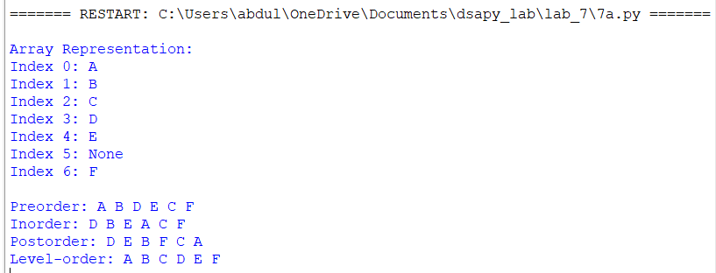

EXPLANATION:

Defines a binary tree using an array to store the elements.

The root node is stored at index 0.

For a node at index i, the left child is at index 2*i + 1.

The right child is at index 2*i + 2.

The parent of a node at index i is at index (i-1)/2.

Takes array elements as input and displays the binary tree elements.

ERROR TABLE:

S.No | Error Obtained | Rectification
1 | Array index out of bounds | Check the array size before accessing elements.
2 | Incorrect left or right child | Use the correct formulas: 2*i + 1 and 2*i + 2.
3 | Missing child nodes | Use -1 or another marker to represent empty nodes.

7B)

AIM: Write a python program to implement binary tree using an linked list

PROGRAM:

class Node:
def __init__(self, data):
self.data = data
self.left = None
self.right = None

class BinaryTree:
def __init__(self):
self.root = None

def create_tree(self):
self.root = Node('A')
self.root.left = Node('B')
self.root.right = Node('C')
self.root.left.left = Node('D')
self.root.left.right = Node('E')
self.root.right.right = Node('F')
print("Binary tree created successfully!")

def preorder(self, node):
if node is None:
return
print(node.data, end=" ")
self.preorder(node.left)
self.preorder(node.right)

def inorder(self, node):
if node is None:
return
self.inorder(node.left)
print(node.data, end=" ")
self.inorder(node.right)

def postorder(self, node):
if node is None:
return
self.postorder(node.left)
self.postorder(node.right)
print(node.data, end=" ")

def level_order(self):
if self.root is None:
print("Tree is empty!")
return

queue = [self.root]

while queue:
node = queue.pop(0)
print(node.data, end=" ")

if node.left is not None:
queue.append(node.left)

if node.right is not None:
queue.append(node.right)

tree = BinaryTree()

while True:
print("\n\n--- BINARY TREE USING LINKED NODES ---")
print("1. Create Tree")
print("2. Preorder Traversal")
print("3. Inorder Traversal")
print("4. Postorder Traversal")
print("5. Level-order Traversal")
print("0. Exit")

while True:
choice = int(input("Enter your choice: "))

if choice == 1:
tree.create_tree()

elif choice == 2:
if tree.root is None:
print("Create the tree first!")
else:
print("Preorder: ", end="")
tree.preorder(tree.root)
print()

elif choice == 3:
if tree.root is None:
print("Create the tree first!")
else:
print("Inorder: ", end="")
tree.inorder(tree.root)
print()

elif choice == 4:
if tree.root is None:
print("Create the tree first!")
else:
print("Postorder: ", end="")
tree.postorder(tree.root)
print()

elif choice == 5:
print("Level-order: ", end="")
tree.level_order()
print()

elif choice == 0:
print("Exiting program...")
break

else:
print("Invalid choice! Try again.")

OUTPUT:

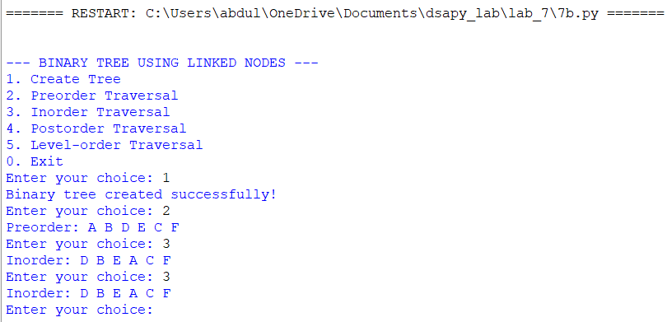

EXPLANATION:

Defines a binary tree using a linked list to store the elements.

Each node contains three fields: data, left pointer, and right pointer.

The root node represents the starting node of the binary tree.

The left pointer stores the address of the left child node.

The right pointer stores the address of the right child node.

Takes node values as input and displays the binary tree elements.

ERROR TABLE:

S.No | Error Obtained | Rectification
1 | Null pointer error | Check whether the node pointer is NULL before accessing it.
2 | Incorrect left or right child | Assign the new node to the correct left or right pointer.
3 | Memory allocation failure | Check whether malloc() returns NULL.

LAB 8

8A)

AIM: Write a Python program to implement a Binary Search Tree (BST)

PROGRAM:

tree = []
def insert(value, i=0):
global tree

if i >= len(tree):
tree.extend([None] * (i - len(tree) + 1))

if tree[i] is None:
tree[i] = value
elif value < tree[i]:
insert(value, 2 * i + 1)
elif value > tree[i]:
insert(value, 2 * i + 2)
else:
print("Duplicate values are not allowed.")

def search(value, i=0):
if i >= len(tree) or tree[i] is None:
return False

if tree[i] == value:
return True
elif value < tree[i]:
return search(value, 2 * i + 1)
else:
return search(value, 2 * i + 2)

def minimum(i):
while 2 * i + 1 < len(tree) and tree[2 * i + 1] is not None:
i = 2 * i + 1
return i

def delete(value, i=0):
if i >= len(tree) or tree[i] is None:
return

if value < tree[i]:
delete(value, 2 * i + 1)
elif value > tree[i]:
delete(value, 2 * i + 2)
else:
left = 2 * i + 1
right = 2 * i + 2

has_left = left < len(tree) and tree[left] is not None
has_right = right < len(tree) and tree[right] is not None

if not has_left and not has_right:
tree[i] = None

elif not has_left:
tree[i] = tree[right]
delete_subtree(right, i)

elif not has_right:
tree[i] = tree[left]
delete_subtree(left, i)

else:
j = minimum(right)
tree[i] = tree[j]
delete(tree[j], right)

def delete_subtree(child, parent):
if child >= len(tree) or tree[child] is None:
return

value = tree[child]
delete(value, child)

remaining = collect_subtree(child)
for v in remaining:
insert(v)

def collect_subtree(i):
if i >= len(tree) or tree[i] is None:
return []
value = tree[i]
left = collect_subtree(2 * i + 1)
right = collect_subtree(2 * i + 2)
tree[i] = None
return left + [value] + right

def inorder(i=0):
if i < len(tree) and tree[i] is not None:
inorder(2 * i + 1)
print(tree[i], end=" ")
inorder(2 * i + 2)

def preorder(i=0):
if i < len(tree) and tree[i] is not None:
print(tree[i], end=" ")
preorder(2 * i + 1)
preorder(2 * i + 2)

def postorder(i=0):
if i < len(tree) and tree[i] is not None:
postorder(2 * i + 1)
postorder(2 * i + 2)
print(tree[i], end=" ")

while True:
print("\n\n1. Insert")
print("2. Delete")
print("3. Search")
print("4. Inorder Traversal")
print("5. Preorder Traversal")
print("6. Postorder Traversal")
print("7. Display Array")
print("8. Exit")

choice = int(input("Enter your choice: "))

if choice == 1:
value = int(input("Enter value: "))
insert(value)

elif choice == 2:
value = int(input("Enter value to delete: "))
if search(value):
delete(value)
print("Value deleted.")
else:
print("Value not found.")

elif choice == 3:
value = int(input("Enter value to search: "))
print("Found" if search(value) else "Not found")

elif choice == 4:
inorder()
print()

elif choice == 5:
preorder()
print()

elif choice == 6:
postorder()
print()

elif choice == 7:
print(tree)

elif choice == 8:
break

else:
print("Invalid choice.")

OUTPUT:

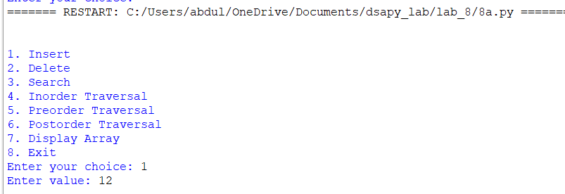

EXPLANATION:

Defines a Binary Search Tree (BST) using an array to store the elements.

Inserts elements according to the BST property: smaller values go to the left, and larger values go to the right.

Uses index 0 to store the root node.

For a node at index i, the left child is at index 2*i + 1 and the right child is at index 2*i + 2.

Performs insertion, deletion, searching, and traversal using a menu-driven program.

Displays the elements using inorder, preorder, and postorder traversal.

ERROR TABLE:

S.No | Error Obtained | Rectification
1 | Array index out of bounds | Extend the array when a required index exceeds its size.
2 | Incorrect insertion position | Compare values and use the correct left and right child indices.
3 | Element not found during deletion | Search for the element before deleting it.

8B)

AIM: Write a Python program to implement a Binary Search Tree (BST) use Ll

PROGRAM:

class Node:
def __init__(self, data):
self.data = data
self.left = None
self.right = None

def insert(root, value):
if root is None:
return Node(value)

if value < root.data:
root.left = insert(root.left, value)
elif value > root.data:
root.right = insert(root.right, value)
else:print("Duplicate values are not allowed.")

return root

def search(root, value):
if root is None:
return False

if root.data == value:
return True
elif value < root.data:
return search(root.left, value)
else:
return search(root.right, value)

def find_min(root):
while root.left is not None:
root = root.left
return root

def delete(root, value):
if root is None:
return None

if value < root.data:
root.left = delete(root.left, value)

elif value > root.data:
root.right = delete(root.right, value)

else:
# No left child
if root.left is None:
return root.right

# No right child
if root.right is None:
return root.left

# Two children
temp = find_min(root.right)
root.data = temp.data
root.right = delete(root.right, temp.data)

return root

def inorder(root):
if root:
inorder(root.left)
print(root.data, end=" ")
inorder(root.right)

def preorder(root):
if root:
print(root.data, end=" ")
preorder(root.left)
preorder(root.right)

def postorder(root):
if root:
postorder(root.left)
postorder(root.right)
print(root.data, end=" ")

root = None

while True:
print("\n\n1. Insert")
print("2. Delete")
print("3. Search")
print("4. Inorder Traversal")
print("5. Preorder Traversal")
print("6. Postorder Traversal")
print("7. Exit")

choice = int(input("Enter your choice: "))

if choice == 1:
value = int(input("Enter value: "))
root = insert(root, value)

elif choice == 2:
value = int(input("Enter value to delete: "))
if search(root, value):
root = delete(root, value)
print("Value deleted.")
else:
print("Value not found.")

elif choice == 3:
value = int(input("Enter value to search: "))
if search(root, value):
print("Value found.")
else:
print("Value not found.")

elif choice == 4:
inorder(root)
print()

elif choice == 5:
preorder(root)
print()

elif choice == 6:
postorder(root)
print()

elif choice == 7:
break

else:
print("Invalid choice.")

OUTPUT:

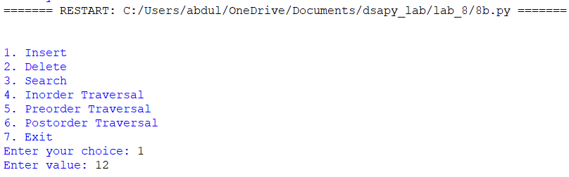

EXPLANATION:

Defines a Binary Search Tree (BST) using a linked list structure.

Each node contains three fields: data, left, and right.

Inserts smaller values into the left subtree and larger values into the right subtree.

Uses a root pointer to represent the starting node of the tree.

Performs insertion, deletion, searching, and traversal using a menu-driven program.

Displays the elements using inorder, preorder, and postorder traversal.

ERROR TABLE:

S.No | Error Obtained | Rectification
1 | Null pointer error | Check whether the node is None before accessing its data.
2 | Incorrect insertion position | Compare the value with the current node and follow the correct pointer.
3 | Incorrect deletion of a node | Handle leaf nodes, nodes with one child, and nodes with two children separately.

LAB 9

9A)

AIM: Write a Python program to implement a AVL tree using arrasy

PROGRAM:

keys = []
left = []
right = []
heights = []
root = -1

def new_node(key):
i = len(keys)
keys.append(key)
left.append(-1)
right.append(-1)
heights.append(1)
return i

def height(i):
return 0 if i == -1 else heights[i]

def update(i):
heights[i] = 1 + max(height(left[i]), height(right[i]))

def balance(i):
return 0 if i == -1 else height(left[i]) - height(right[i])

def rotate_right(y):
x = left[y]
t = right[x]

right[x] = y
left[y] = t

update(y)
update(x)
return x

def rotate_left(x):
y = right[x]
t = left[y]

left[y] = x
right[x] = t

update(x)
update(y)
return y

def insert(node, key):
if node == -1:
return new_node(key)

if key < keys[node]:
left[node] = insert(left[node], key)
elif key > keys[node]:
right[node] = insert(right[node], key)
else:
return node

update(node)
bf = balance(node)

if bf > 1 and key < keys[left[node]]:
return rotate_right(node)

if bf < -1 and key > keys[right[node]]:
return rotate_left(node)

if bf > 1 and key > keys[left[node]]:
left[node] = rotate_left(left[node])
return rotate_right(node)

if bf < -1 and key < keys[right[node]]:
right[node] = rotate_right(right[node])
return rotate_left(node)

return node

def min_node(node):
while left[node] != -1:
node = left[node]
return node

def delete(node, key):
if node == -1:
return -1

if key < keys[node]:
left[node] = delete(left[node], key)
elif key > keys[node]:
right[node] = delete(right[node], key)
else:
if left[node] == -1:
return right[node]
if right[node] == -1:
return left[node]

temp = min_node(right[node])
keys[node] = keys[temp]
right[node] = delete(right[node], keys[temp])

update(node)
bf = balance(node)

if bf > 1 and balance(left[node]) >= 0:
return rotate_right(node)

if bf > 1 and balance(left[node]) < 0:
left[node] = rotate_left(left[node])
return rotate_right(node)

if bf < -1 and balance(right[node]) <= 0:
return rotate_left(node)

if bf < -1 and balance(right[node]) > 0:
right[node] = rotate_right(right[node])
return rotate_left(node)

return node

def search(node, key):
while node != -1:
if keys[node] == key:
return True
if key < keys[node]:
node = left[node]
else:
node = right[node]
return False

def inorder(node):
if node != -1:
inorder(left[node])
print(keys[node], end=" ")
inorder(right[node])

def preorder(node):
if node != -1:
print(keys[node], end=" ")
preorder(left[node])
preorder(right[node])

def postorder(node):
if node != -1:
postorder(left[node])
postorder(right[node])
print(keys[node], end=" ")

while True:
print("\n\n--- AVL TREE USING ARRAYS ---")
print("1. Insert")
print("2. Delete")
print("3. Search")
print("4. Inorder")
print("5. Preorder")
print("6. Postorder")
print("7. Exit")

choice = input("Enter choice: ")

if choice == '1':
key = int(input("Enter value: "))
root = insert(root, key)
print("Node inserted.")

elif choice == '2':
key = int(input("Enter value: "))
if search(root, key):
root = delete(root, key)
print("Node deleted.")
else:
print("Value not found.")

elif choice == '3':
key = int(input("Enter value: "))
print("Value found." if search(root, key)
else "Value not found.")

elif choice == '4':
inorder(root)
print()

elif choice == '5':
preorder(root)
print()

elif choice == '6':
postorder(root)
print()

elif choice == '7':
break

else:
print("Invalid choice.")

OUTPUT:

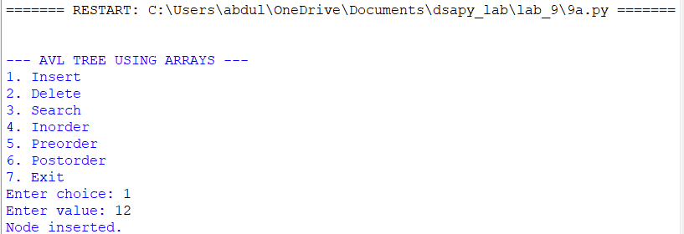

EXPLANATION:

Creates arrays to store node values, left-child indices, right-child indices, and node heights.

Inserts elements according to Binary Search Tree (BST) properties.

Calculates the height and balance factor of each node.

Performs LL, RR, LR, and RL rotations to maintain AVL tree balance.

Deletes nodes and rebalances the tree whenever necessary.

Searches for an element and displays whether it is found or not.

Performs inorder, preorder, and postorder traversals.

ERROR TABLE:

S.No | Error Obtained | Rectification
1 | Incorrect child index | Verify left and right child indices are updated correctly during rotations.
2 | Tree becomes unbalanced | Calculate the balance factor and apply the appropriate rotation.
3 | Incorrect height calculation | Update node heights after insertion, deletion, and rotations.

9B)

AIM: Write a Python program to implement a AVL tree using linked list

PROGRAM:

class Node:
def __init__(self, key):
self.key = key
self.left = None
self.right = None
self.height = 1

def height(root):
return 0 if root is None else root.height

def balance(root):
if root is None:
return 0
return height(root.left) - height(root.right)

def update(root):
root.height = 1 + max(height(root.left), height(root.right))

def rotate_right(y):
x = y.left
t = x.right

x.right = y
y.left = t

update(y)
update(x)
return x

def rotate_left(x):
y = x.right
t = y.left

y.left = x
x.right = t

update(x)
update(y)
return y

def insert(root, key):
if root is None:
return Node(key)

if key < root.key:
root.left = insert(root.left, key)
elif key > root.key:
root.right = insert(root.right, key)
else:
return root

update(root)
bf = balance(root)

if bf > 1 and key < root.left.key:
return rotate_right(root)

if bf < -1 and key > root.right.key:
return rotate_left(root)

if bf > 1 and key > root.left.key:
root.left = rotate_left(root.left)
return rotate_right(root)

if bf < -1 and key < root.right.key:
root.right = rotate_right(root.right)
return rotate_left(root)

return root

def min_node(root):
while root.left is not None:
root = root.left
return root

def delete(root, key):
if root is None:
return None

if key < root.key:
root.left = delete(root.left, key)
elif key > root.key:
root.right = delete(root.right, key)
else:
if root.left is None:
return root.right
elif root.right is None:
return root.left

temp = min_node(root.right)
root.key = temp.key
root.right = delete(root.right, temp.key)

update(root)
bf = balance(root)

if bf > 1 and balance(root.left) >= 0:
return rotate_right(root)

if bf > 1 and balance(root.left) < 0:
root.left = rotate_left(root.left)
return rotate_right(root)

if bf < -1 and balance(root.right) <= 0:
return rotate_left(root)

if bf < -1 and balance(root.right) > 0:
root.right = rotate_right(root.right)
return rotate_left(root)

return root

def search(root, key):
if root is None or root.key == key:
return root

if key < root.key:
return search(root.left, key)

return search(root.right, key)

def inorder(root):
if root:
inorder(root.left)
print(root.key, end=" ")
inorder(root.right)

def preorder(root):
if root:
print(root.key, end=" ")
preorder(root.left)
preorder(root.right)

def postorder(root):
if root:
postorder(root.left)
postorder(root.right)
print(root.key, end=" ")

root = None

while True:
print("\n\n--- AVL TREE USING LINKED LIST ---")
print("1. Insert")
print("2. Delete")
print("3. Search")
print("4. Inorder")
print("5. Preorder")
print("6. Postorder")
print("7. Exit")

choice = input("Enter choice: ")

if choice == '1':
key = int(input("Enter value: "))
root = insert(root, key)
print("Node inserted.")

elif choice == '2':
key = int(input("Enter value: "))
if search(root, key):
root = delete(root, key)
print("Node deleted.")
else:
print("Value not found.")

elif choice == '3':
key = int(input("Enter value: "))
if search(root, key):
print("Value found.")
else:
print("Value not found.")

elif choice == '4':
inorder(root)
print()

elif choice == '5':
preorder(root)
print()

elif choice == '6':
postorder(root)
print()

elif choice == '7':
print("Exiting program.")
break

else:
print("Invalid choice.")

OUTPUT:

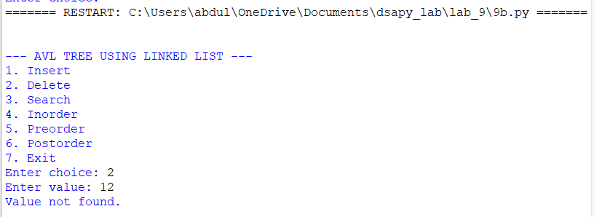

EXPLANATION:

Creates nodes containing a key, left-child reference, right-child reference, and height.
Inserts elements according to Binary Search Tree (BST) properties.
Calculates the height and balance factor of each node.
Performs LL, RR, LR, and RL rotations to maintain AVL tree balance.
Deletes nodes and restores balance using rotations.
Searches for an element by comparing the target with each node's key.
Performs inorder, preorder, and postorder traversals.
Displays whether the searched element is found or not.

ERROR TABLE:

S.No | Error Obtained | Rectification
1 | AttributeError while accessing a node | Check whether the node is None before accessing its attributes.
2 | Tree becomes unbalanced | Calculate the balance factor and apply the correct rotation.
3 | Incorrect height calculation | Update the heights of affected nodes after every rotation.

LAB 10

10A)

AIM: Write a Python program to implement Hashing using Separate Chaining

PROGRAM:

SIZE = 10
table = [[] for _ in range(SIZE)]

def insert(key):
index = key % SIZE
table[index].append(key)
print("Inserted successfully")

def search(key):
index = key % SIZE

if key in table[index]:
print("Element found")
else:
print("Element not found")

def display():
for i in range(SIZE):
print(i, ":", table[i])

while True:
print("\n1.Insert 2.Search 3.Display 4.Exit")
ch = int(input("Enter choice: "))

if ch == 1:
key = int(input("Enter key: "))
insert(key)

elif ch == 2:
key = int(input("Enter key: "))
search(key)

elif ch == 3:
display()

elif ch == 4:
break

else:
print("Invalid choice")

OUTPUT:

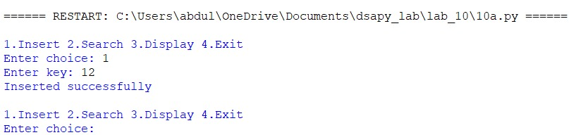

EXPLANATION:

Creates a hash table using an array of lists to store elements.
Calculates the hash index using the hash function key % SIZE.
Inserts elements into the corresponding index of the hash table.
Handles collisions by storing multiple elements in the same list.
Searches for an element in the corresponding list and displays whether it is found or not.
Displays all hash table indices and their stored elements.

ERROR TABLE:

S.No | Error Obtained | Rectification
1 | Incorrect hash index | Calculate the index using key % SIZE.
2 | Element not inserted properly | Use append() to insert elements into the corresponding list.
3 | Element not found during searching | Search within the correct index list.

10B)

AIM: Write a Python program to implement Hashing using Linear Probing

PROGRAM:

SIZE = 10
table = [-1] * SIZE

def insert(key):
index = key % SIZE

for i in range(SIZE):
pos = (index + i) % SIZE

if table[pos] == -1:
table[pos] = key
print("Inserted successfully")
return

print("Hash table is full")

def search(key):
index = key % SIZE

for i in range(SIZE):
pos = (index + i) % SIZE

if table[pos] == -1:
break

if table[pos] == key:
print("Element found at index", pos)
return

print("Element not found")

def display():
for i in range(SIZE):
print(i, ":", table[i])

while True:
print("\n1.Insert 2.Search 3.Display 4.Exit")
ch = int(input("Enter choice: "))

if ch == 1:
key = int(input("Enter key: "))
insert(key)

elif ch == 2:
key = int(input("Enter key: "))
search(key)

elif ch == 3:
display()

elif ch == 4:
break

else:
print("Invalid choice")

OUTPUT:

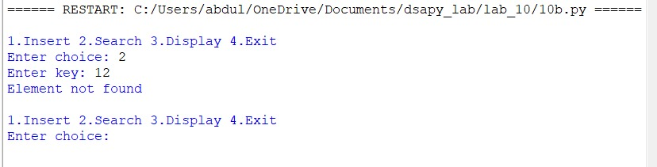

EXPLANATION:

Creates an array to store elements in the hash table and initializes all positions with -1.
Calculates the hash index using the hash function key % SIZE.
Inserts elements according to the linear probing technique.
Handles collisions by checking the next consecutive position using (index + i) % SIZE.
Searches for an element using the same probing sequence and displays whether it is found or not.
Displays all hash table indices and their stored elements.

ERROR TABLE:

S.No | Error Obtained | Rectification
1 | Incorrect hash index | Calculate the index using key % SIZE.
2 | Collision not handled properly | Check the next available position using linear probing.
3 | Element not found during searching | Use the same probing sequence used during insertion.

10C)

AIM: Write a Python program to implement Hashing using Quadratic Probing

PROGRAM:

SIZE = 10
table = [-1] * SIZE

def insert(key):
index = key % SIZE

for i in range(SIZE):
pos = (index + i * i) % SIZE

if table[pos] == -1:
table[pos] = key
print("Inserted successfully")
return

print("Insertion failed")

def search(key):
index = key % SIZE

for i in range(SIZE):
pos = (index + i * i) % SIZE

if table[pos] == -1:
break

if table[pos] == key:
print("Element found at index", pos)
return

print("Element not found")

def display():
for i in range(SIZE):
print(i, ":", table[i])

while True:
print("\n1.Insert 2.Search 3.Display 4.Exit")
ch = int(input("Enter choice: "))

if ch == 1:
key = int(input("Enter key: "))
insert(key)

elif ch == 2:
key = int(input("Enter key: "))
search(key)

elif ch == 3:
display()

elif ch == 4:
break

else:
print("Invalid choice")

OUTPUT:

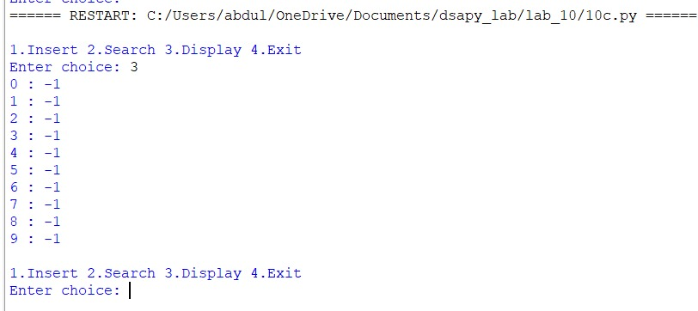

EXPLANATION:

Creates an array to store elements in the hash table and initializes all positions with -1.

Calculates the hash index using the hash function key % SIZE.

Inserts elements according to the quadratic probing technique.

Handles collisions by checking positions using the formula (index + i*i) % SIZE.

Searches for an element using the same quadratic probing sequence and displays whether it is found or not.

Displays all hash table indices and their stored elements.

ERROR TABLE:

S.No | Error Obtained | Rectification
1 | Incorrect child index | Calculate the index using key % SIZE..
2 | Collision not resolved properly | Apply quadratic probing using index + i*i.
3 | Element not found during searching | Use the same quadratic probing sequence used during insertion.

