**Guide: Uploading Code to nRF52840 and Using nRF Connect BLE App**

Section 1: Uploading Code to nRF52840

**Requirements**

1. **nRF52840 Development Board**
2. **USB Cable** (to connect the board to your computer)
3. **nRF Connect for Desktop** (installed on your computer)

**Step 1: Install nRF Connect and Programmer Tool**

1. **Download and install** nRF Connect for Desktop from the link above.
2. **Open** nRF Connect for Desktop.
3. Click on the **"Programmer"** option to install it if it’s not already installed.

**Step 2: Connect the nRF52840 Board**

1. Plug the nRF52840 board into your computer using the USB cable.
2. The board should appear under **"Select Device"** in the Programmer tool.

**Step 3: Upload the Firmware**

1. Click on the **"Select Device"** dropdown and select your connected board (Img: 1).
2. Click **"Add file"** and select the following: (Img: 2)
   * **Hex file** (.hex): The compiled firmware file you want to upload.
3. Click on the **"Erase & write"** button to flash the firmware onto the board.
4. Wait for the process to complete. You should see a **"Success"** message once done.

**Step 4: Verify the Upload**

1. Once the upload is complete, check the **log output** at the bottom for any errors.
2. If there are no errors, the code has been successfully uploaded to the nRF52840.

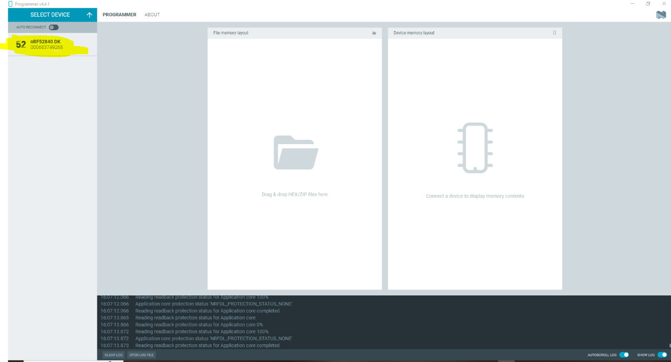

Img: 1

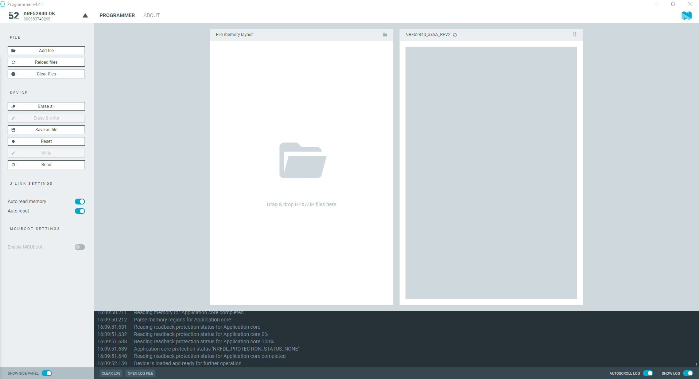

Img: 2

## **Section 2: Connecting to the nRF52840 with nRF Connect BLE App**

### ****Requirements****

1. **nRF Connect for Mobile** (available on Android and iOS)
   * Download for Android
   * [Download for iOS](https://apps.apple.com/us/app/nrf-connect/id1054362403)

### ****Step 1: Install the nRF Connect BLE App****

1. Download and install the nRF Connect BLE app from the App Store or Google Play.

### ****Step 2: Power On the nRF52840 Board****

1. Make sure your nRF52840 board is powered on and running the recently uploaded firmware.

### ****Step 3: Scan for BLE Devices (Img: 3, Img: 4)****

1. Open the **nRF Connect** app on your mobile device.
2. Tap on the **"Scan"** button to start scanning for nearby BLE devices.
3. Look for a device named **"Smart_Lock"** (this will be defined in your firmware).
4. Tap on the device to connect to it.

### ****Step 4: Explore BLE Services (Img: 5, Img: 6)****

1. Once connected, you will see a list of **BLE services** offered by the nRF52840.
   * The code provided has two services:
     + **Notification Service**: Sends updates automatically.
     + **Write Service**: Allows you to send data to the device.
2. To receive notifications:
   * Click on the **Notification characteristic** and enable notifications.
   * You'll start receiving data from the nRF52840 device.
3. To send data:
   * Find the **Write characteristic**, enter your data, and tap **Send**.

4. Img 7 shows when data is sent and received. First characteristic receives the data and last one sends the data

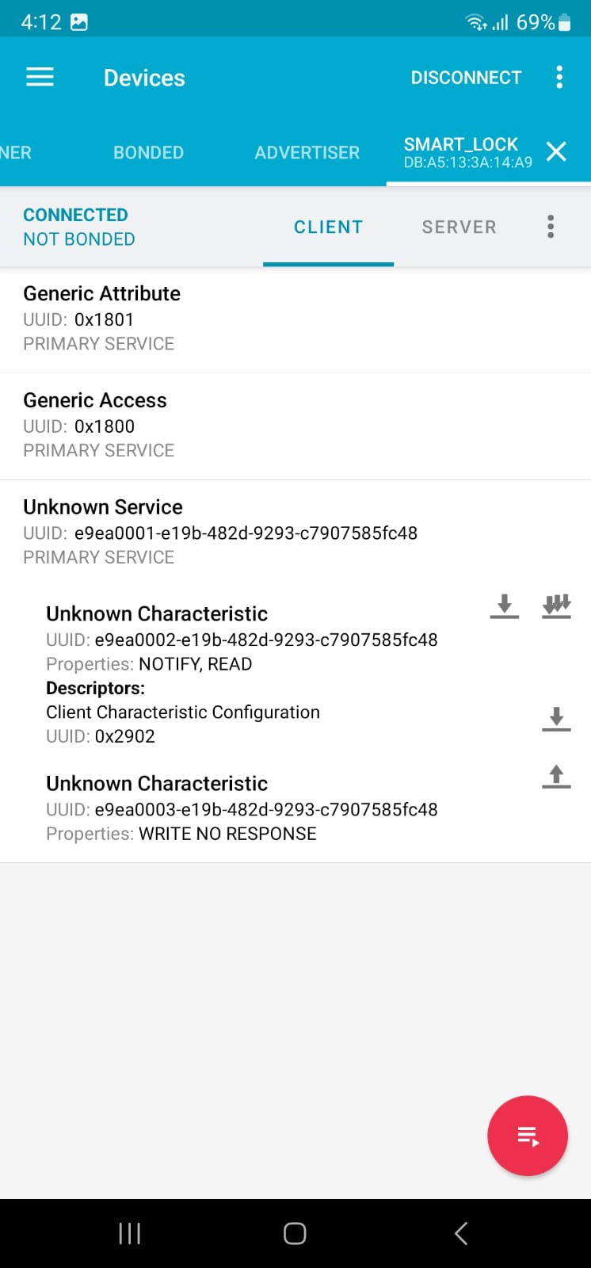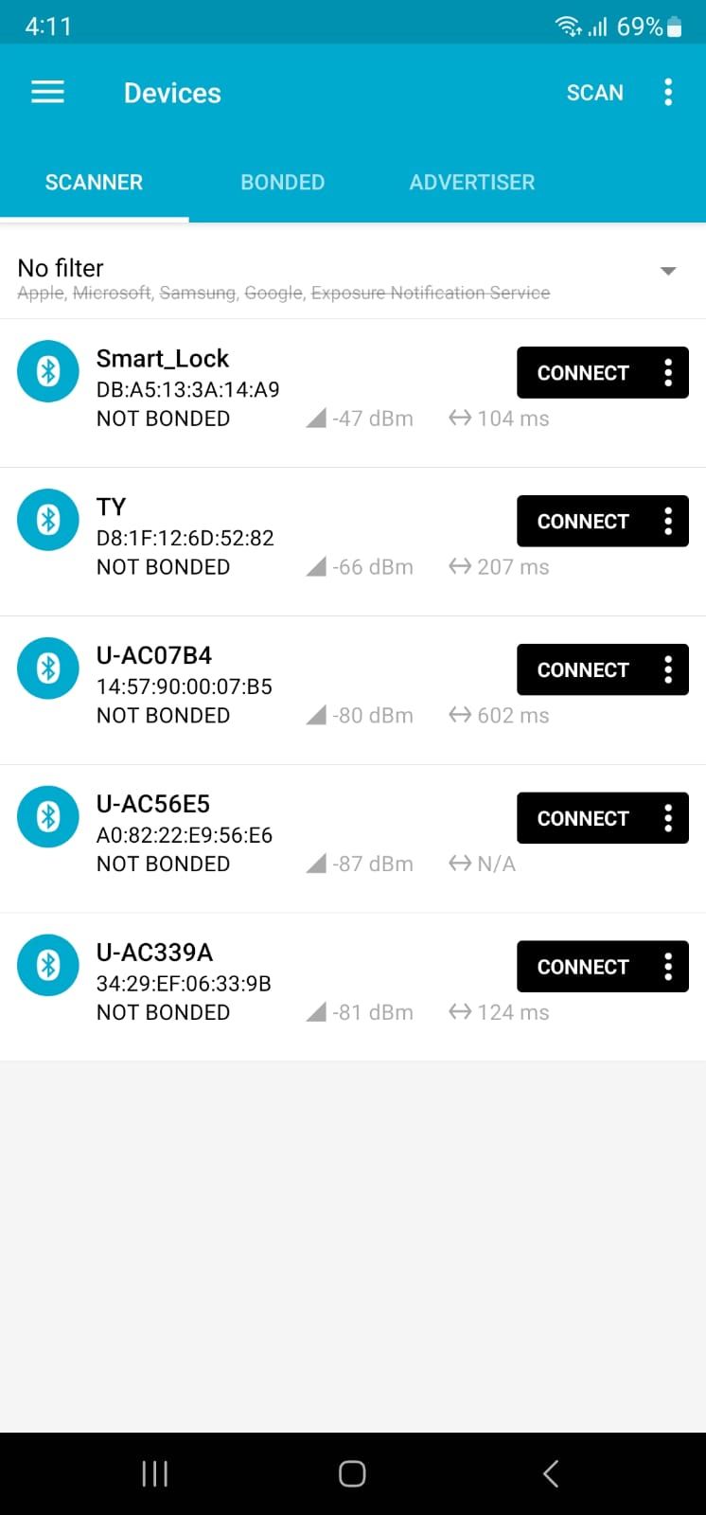

Img: 3 Img: 4

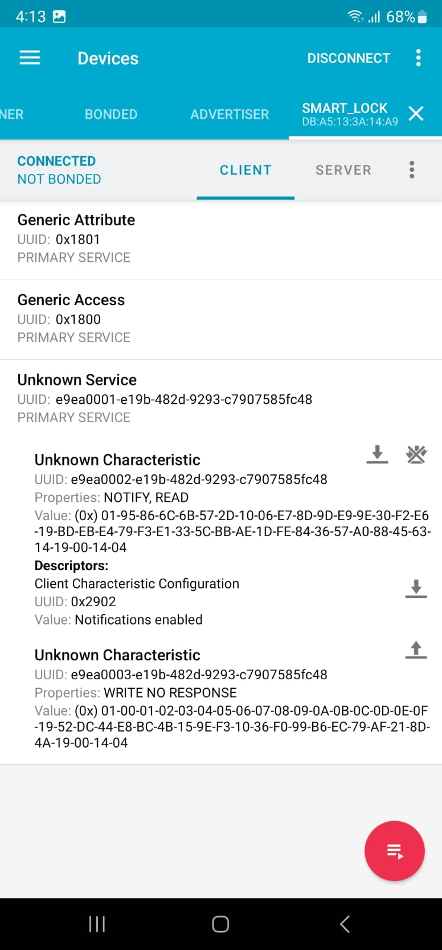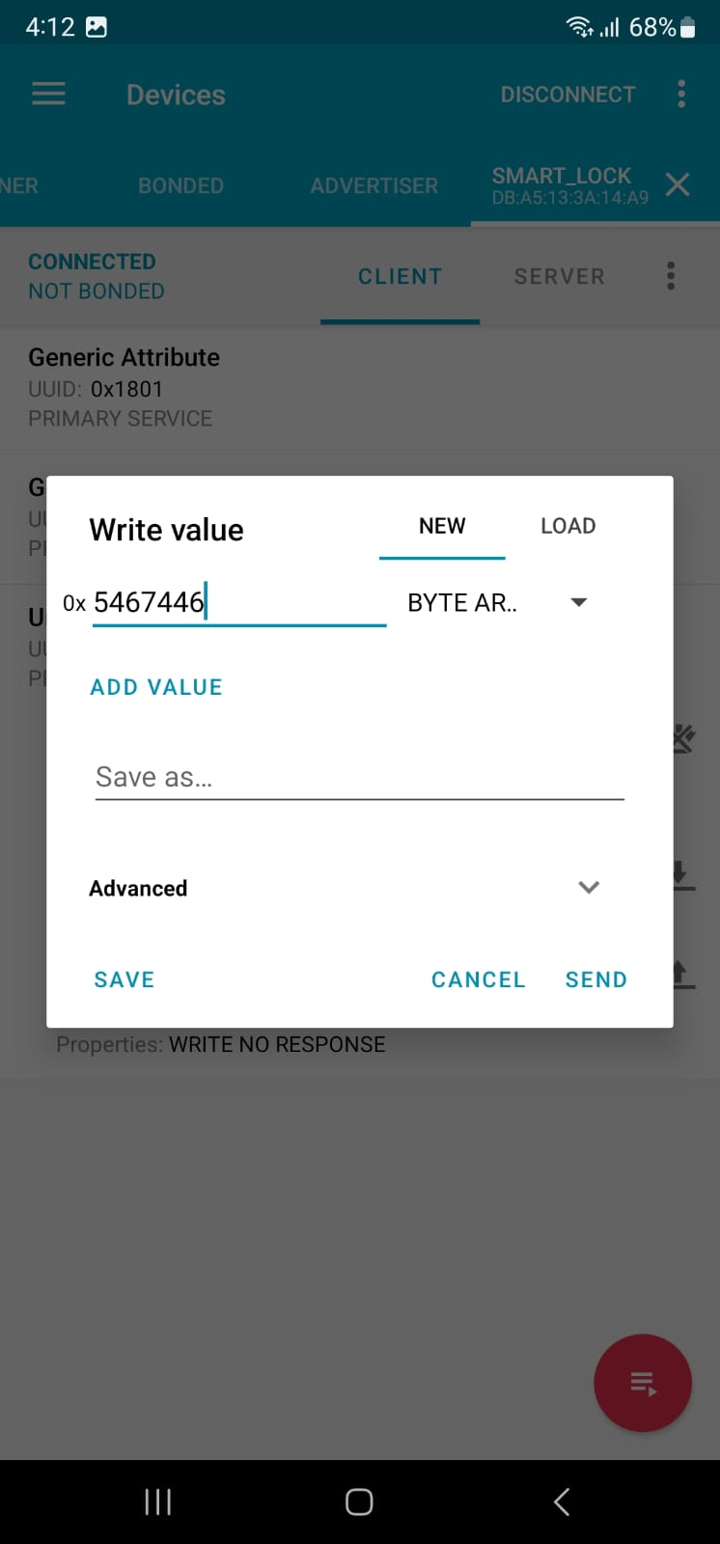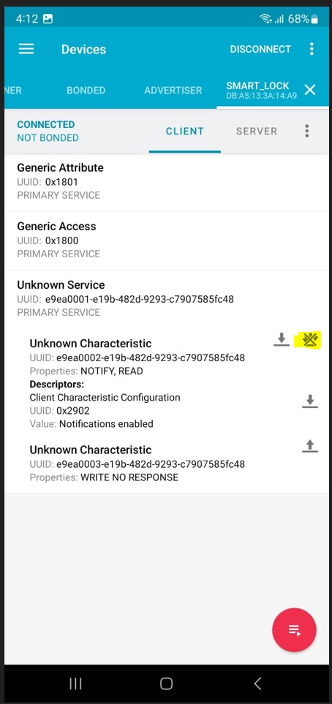

Img: 5 Img: 6 Img: 7