Lab manual 4

Name: Haseem Farooq

Section: ME:15 C

CMS ID: 467020

1. Write a program in C++ that prints the numbers from 1 to 150 except the multiples of 10. Make use of the continue statement.

Input:

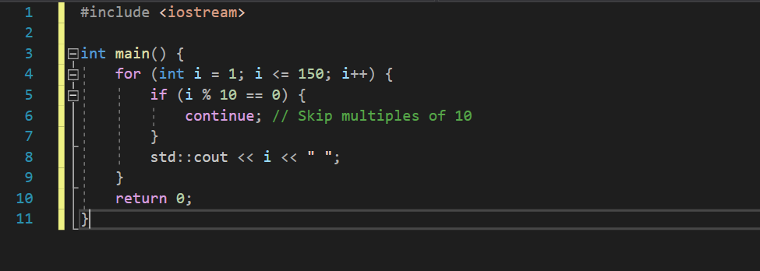

Output:

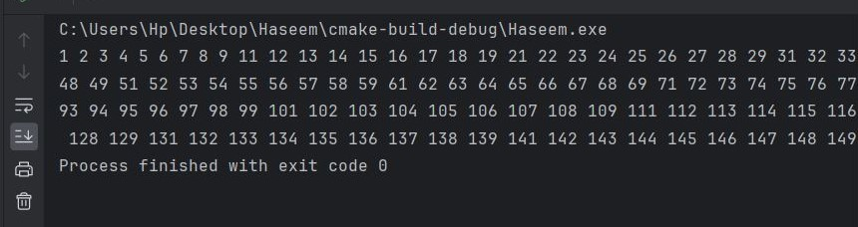

1. Write a C++ program to find the sum of digits of a number. The sum of digits means adding all the digits of any number, for example, we take any number like 358. Its sum of all digits is 3+5+8=16.

Input:

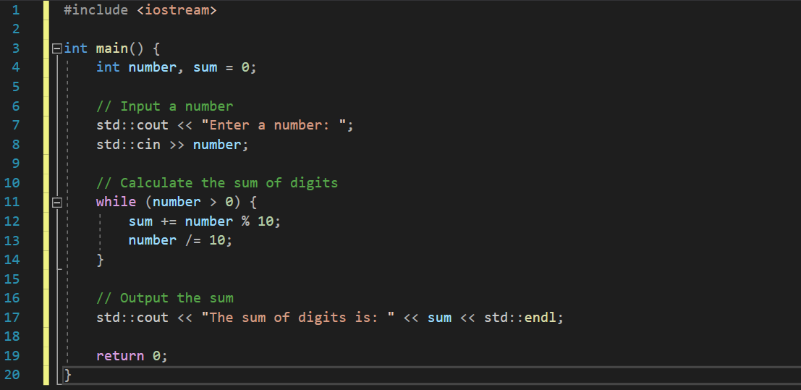

Output:

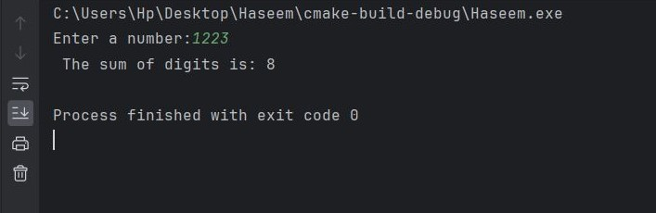

1. Write a program in C++ to check whether a number is prime or not.

Input:

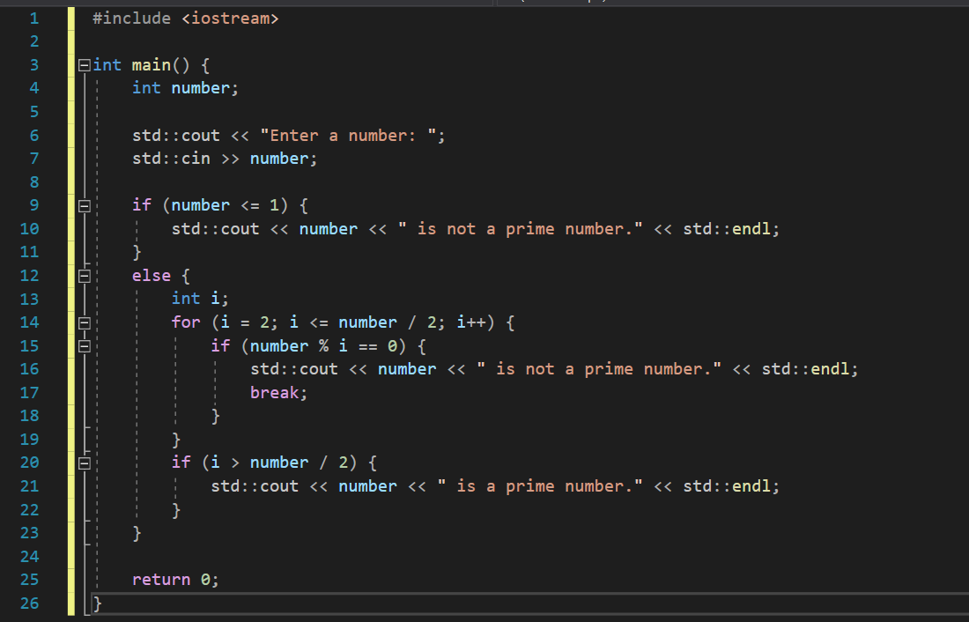

Output:

