STUDENT TASK MANAGER
PROJECT REPORT
Submitted by: ______________________________
Roll Number: ______________________________
Department: _______________________________
College: __________________________________
Academic Year: ____________________________

1. AIM
To develop a simple Student Task Manager web application that helps students add, view, complete, filter, and delete their academic tasks using a React frontend and a Node.js/Express backend.

2. PROJECT EXPLANATION
The Student Task Manager is a web application for organizing academic work such as assignments, records, and study tasks. The user enters a task and clicks Add Task. The task appears in the list. The user can mark it as completed using the checkbox, view All, Pending, or Completed tasks, and delete a task.
The frontend is developed using React and Vite. The backend is developed using Node.js and Express. The frontend sends HTTP requests to the backend API to read and change task data. The current version stores tasks temporarily in server memory; tasks are cleared when the backend server restarts.

Main Features
- Add a new task.
- View all tasks.
- Mark a task as completed or pending.
- Filter tasks by All, Pending, and Completed.
- Delete a task.
- Connect the React frontend to the Express backend using API requests.

3. SOURCE CODE
The following is a reference implementation of the main frontend and backend logic. The project folders are named fronted and backend in the current laptop setup.

3.1 Backend — backend/server.js
const express = require("express");
const cors = require("cors");
const app = express();
const PORT = 5000;
app.use(cors());
app.use(express.json());
let tasks = [];
let nextId = 1;
app.get("/", (req, res) => {
res.send("Student Task Manager Server is Running!");
});
app.get("/api/tasks", (req, res) => {
res.json(tasks);
});
app.post("/api/tasks", (req, res) => {
const title = (req.body.title || "").trim();
if (!title) {
return res.status(400).json({ message: "Task title is required" });
}
const task = {
id: nextId++,
title,
completed: false
};
tasks.push(task);
res.status(201).json(task);
});
app.patch("/api/tasks/:id", (req, res) => {
const id = Number(req.params.id);
const task = tasks.find((item) => item.id === id);
if (!task) {
return res.status(404).json({ message: "Task not found" });
}
task.completed = Boolean(req.body.completed);
res.json(task);
});
app.delete("/api/tasks/:id", (req, res) => {
const id = Number(req.params.id);
const oldLength = tasks.length;
tasks = tasks.filter((item) => item.id !== id);
if (tasks.length === oldLength) {
return res.status(404).json({ message: "Task not found" });
}
res.json({ message: "Task deleted successfully" });
});
app.listen(PORT, () => {
console.log(`Server running at http://localhost:${PORT}`);
});

3.2 Frontend — fronted/src/App.jsx
import { useEffect, useState } from "react";
import "./App.css";
const API_URL = "http://localhost:5000/api/tasks";
export default function App() {
const [tasks, setTasks] = useState([]);
const [title, setTitle] = useState("");
const [filter, setFilter] = useState("All");
async function loadTasks() {
const response = await fetch(API_URL);
const data = await response.json();
setTasks(data);
}
useEffect(() => {
loadTasks().catch(console.error);
}, []);
async function addTask(event) {
event.preventDefault();
if (!title.trim()) return;
const response = await fetch(API_URL, {
method: "POST",
headers: { "Content-Type": "application/json" },
body: JSON.stringify({ title })
});
if (response.ok) {
setTitle("");
await loadTasks();
}
}
async function toggleTask(task) {
await fetch(`${API_URL}/${task.id}`, {
method: "PATCH",
headers: { "Content-Type": "application/json" },
body: JSON.stringify({ completed: !task.completed })
});
await loadTasks();
}
async function deleteTask(id) {
await fetch(`${API_URL}/${id}`, { method: "DELETE" });
await loadTasks();
}
const visibleTasks = tasks.filter((task) => {
if (filter === "Pending") return !task.completed;
if (filter === "Completed") return task.completed;
return true;
});
return (
<main className="app">
<h1>Student Task Manager</h1>
<form onSubmit={addTask}>
<input
value={title}
onChange={(event) => setTitle(event.target.value)}
placeholder="Enter a task"
/>
<button type="submit">Add Task</button>
</form>
<nav className="filters">
{["All", "Pending", "Completed"].map((name) => (
<button key={name} onClick={() => setFilter(name)}>
{name}
</button>
))}
</nav>
<ul>
{visibleTasks.map((task) => (
<li key={task.id}>
<label>
<input
type="checkbox"
checked={task.completed}
onChange={() => toggleTask(task)}
/>
<span className={task.completed ? "completed" : ""}>
{task.title}
</span>
</label>
<button onClick={() => deleteTask(task.id)}>Delete</button>
</li>
))}
</ul>
</main>
);
}

3.3 CSS — fronted/src/App.css
.app {
max-width: 700px;
margin: 40px auto;
padding: 24px;
font-family: Arial, sans-serif;
}
form, .filters, li {
display: flex;
gap: 10px;
margin-bottom: 14px;
}
input:not([type="checkbox"]) {
flex: 1;
padding: 10px;
}
button {
padding: 9px 14px;
cursor: pointer;
}
ul {
padding: 0;
list-style: none;
}
li {
justify-content: space-between;
align-items: center;
padding: 10px;
border: 1px solid #ddd;
border-radius: 6px;
}
.completed {
text-decoration: line-through;
color: #666;
}
Important: This source code section is a reference version. Keep the code in this report aligned with the actual App.jsx and server.js files on your laptop if your current code has additional styling or different field names.

4. EXPECTED OUTPUT
When the application is started successfully, the browser should display:
- A heading named Student Task Manager.
- A text box to enter a task and an Add Task button.
- Filter buttons named All, Pending, and Completed.
- A list of tasks with checkboxes and Delete buttons.
- Completed tasks shown with a line through the task text (depending on the CSS used).

5. OUTPUT
The application was tested in the browser at http://localhost:5173/ while the backend was running at http://localhost:5000. A task such as “Complete Assignment” can be added to the list. Selecting its checkbox marks it completed, and the Completed filter displays it. The Pending filter hides completed tasks. Unchecking the task makes it pending again. The Delete button removes the selected task from the list.
Paste or insert your own screenshot of the running application here if your lecturer requires an output image.
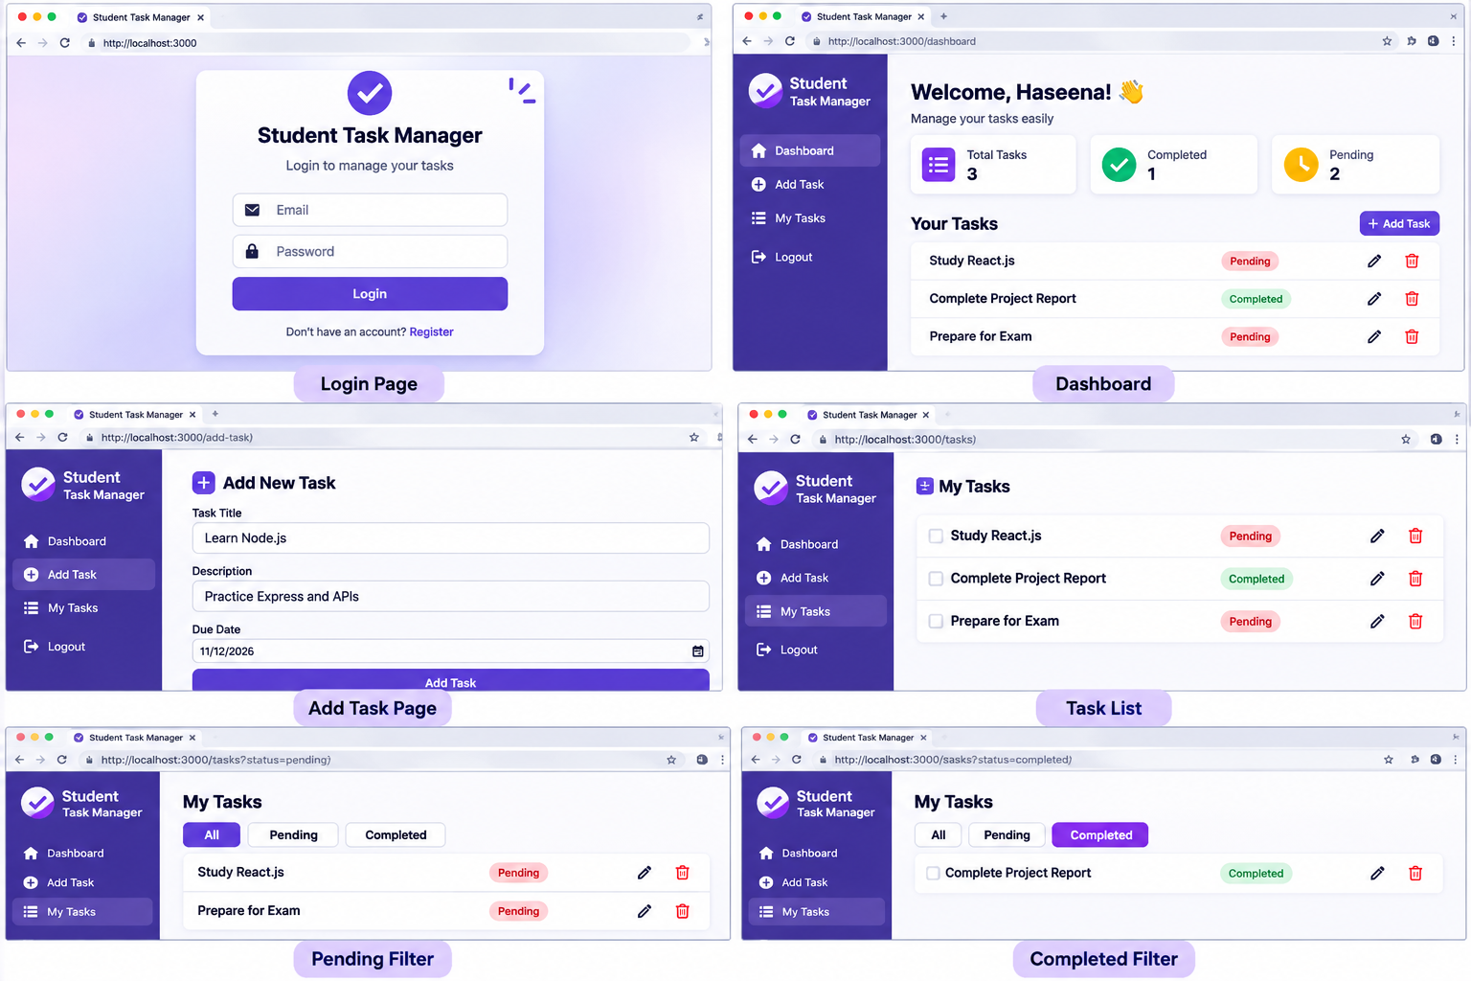
Output screenshots (illustrative UI examples):

6. RESULT
The Student Task Manager web application was developed and tested successfully. It supports adding tasks, viewing tasks, changing completion status, filtering tasks, and deleting tasks. The project demonstrates basic React frontend development, Node.js/Express backend development, and API communication. Permanent database storage can be added as a future enhancement.

