Hi,
The delivery has some bugs and missing features, which I will list below:
The new version is not responsive. The alignment doesn’t seem to be right on small screen, phone, etc.
Original  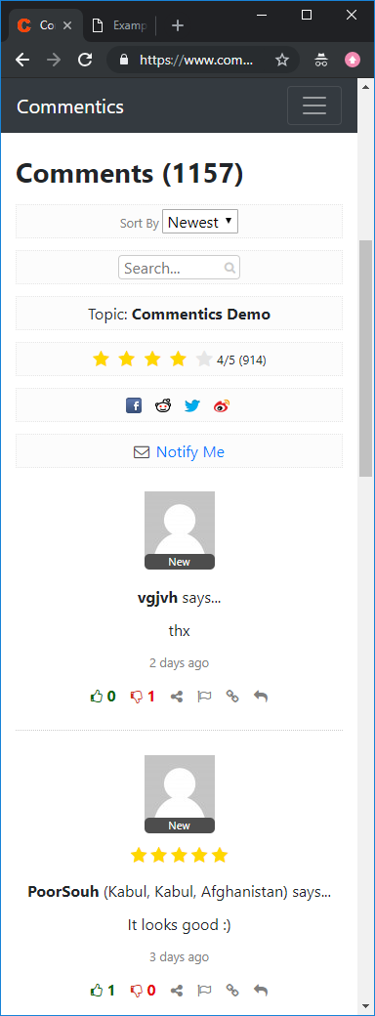 | Your version  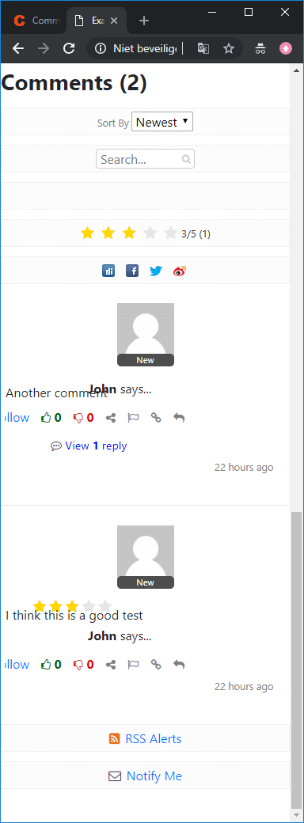

Replies are not shown expanded
I asked that if there is a reply it should be expanded by default. This does not happen.
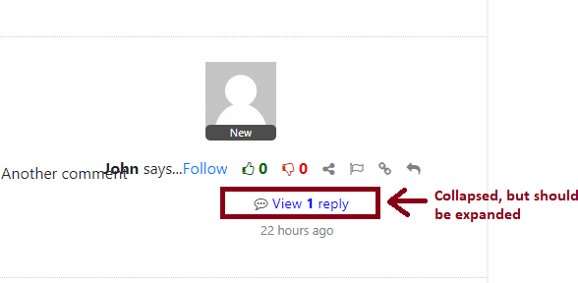
When you click on View reply, you expect to see the reply, but then the whole thing disappears.

Reply function not working properly
When I click to reply, a dialog appears that does not work. I can click reply 1000 times but nothing happens.
It is asking me to enter a name and email address, whilst I am logged in already. It should only show the text inputfiled for the reply. Not prompt for my name and email again. How can I reply as 2 persons. Pls think of how it works on Facebook for example. When you are logged in, you cant post a reply as another person and the system doesn’t prompt for it.
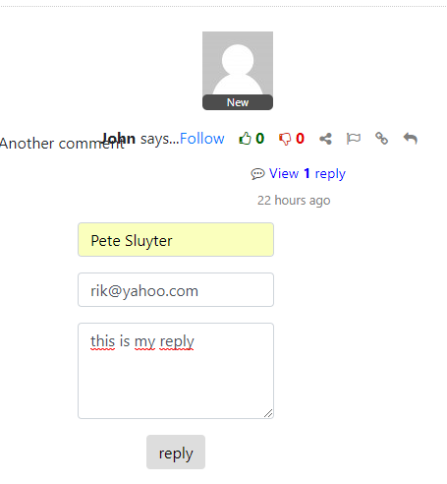

Also I wanted the editor inputfield with styling features. The same that is present on top of the form. Not a plain text input field.
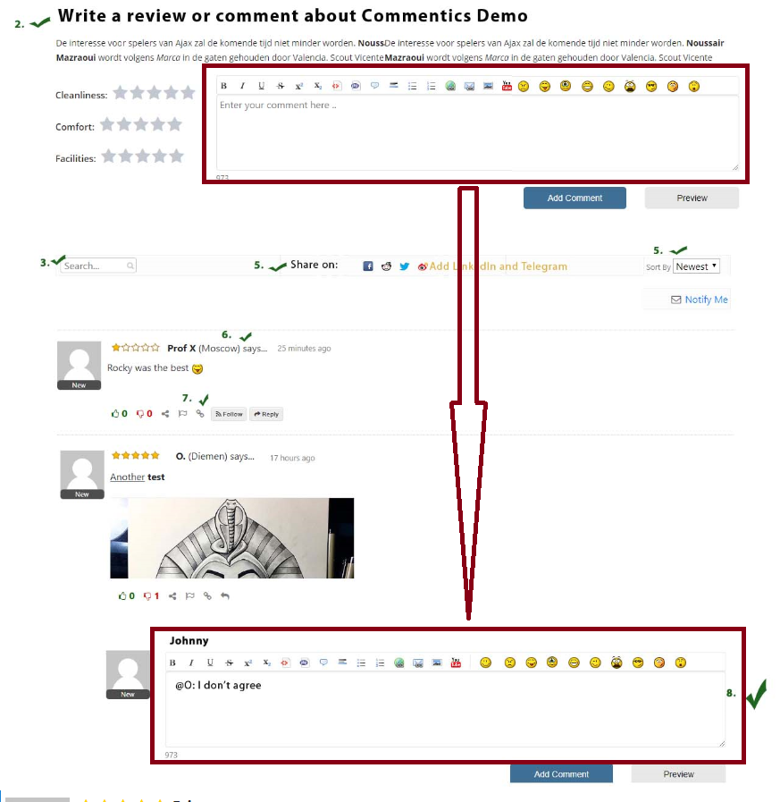

I can click Following even if I am not logged in as a user
This is not logical. I should only be able to click on following a user if I am logged in and then in the DB should be set User A is following User B. Now “user unknown” is following User B. How will this work?

Top summary doesn’t work
I placed some ratings and reviews, but nothing happens at the top summary.
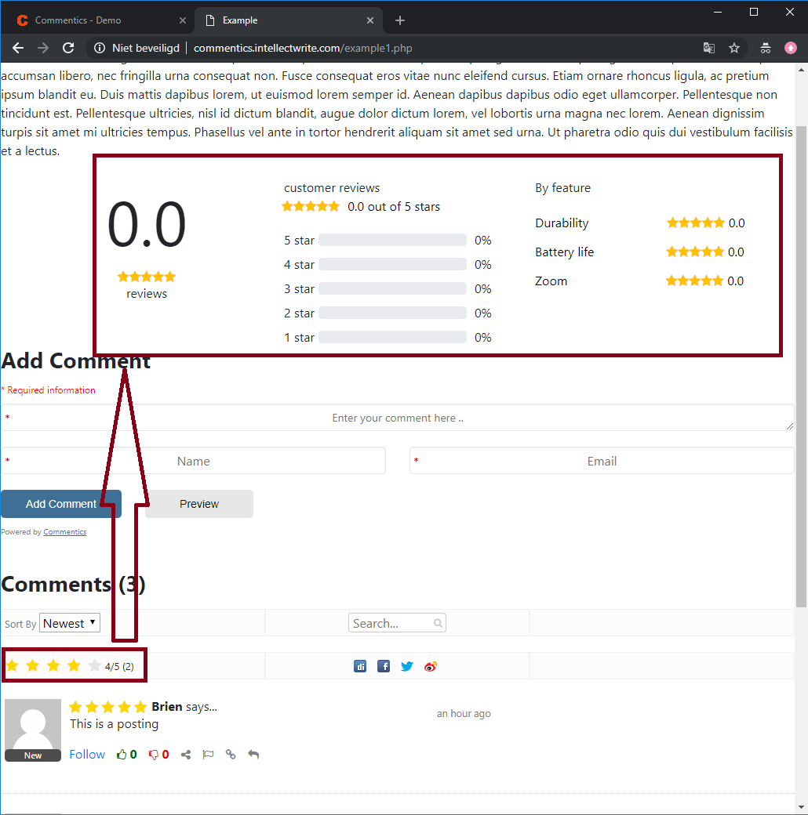

Missing features
Pls look at the project doc [Commentics - Query 1 - 15-03-2019.doc]you send, the desired result image I send and hold it against what you have delivered and you will see the work has omissions.

