1. We are have few master like village and farmer and product verity and product
2. We will make a Contract with Farmer were farmer will commit some Qty to Supply our plant

For Exmaple

Farmer “**Ramesh”**

from Village **“Village 1”**

will be supply **“Qty 100 KG”** of”

**p1 verity”** or “**product 1” and**

**p2 verity of “product 1”**

1. **(During the farming our Technical team will guide farmers to do perfect output but this is not a part of our Porgramme)**
2. **Above Contract We will make a contract and enter in Software**

Remember Supply may be Split in **Various Interval**

For Example if Farmer Give us

**40 KG on Date 10 Mar 2020**

it may be he give an next part of

**20 KG on 20 Mar 2020 and so on**

1. **Once Product is Ready for supply Farmer Inform our Technician to Keep ready Bag**

**Ramesh Ask Technician to keep a 3 Bag**

**(2 Bag Red for Verity 1 or Product 1)**

**(1 Bag Red for Verity 2 or Product 1)**

1. **Now entry will call as a “Performa Entries” and it Creat a BARCODE and QRCODE and all next process Refer from “BAR CODE or QRCODE” same as “Ref No”**

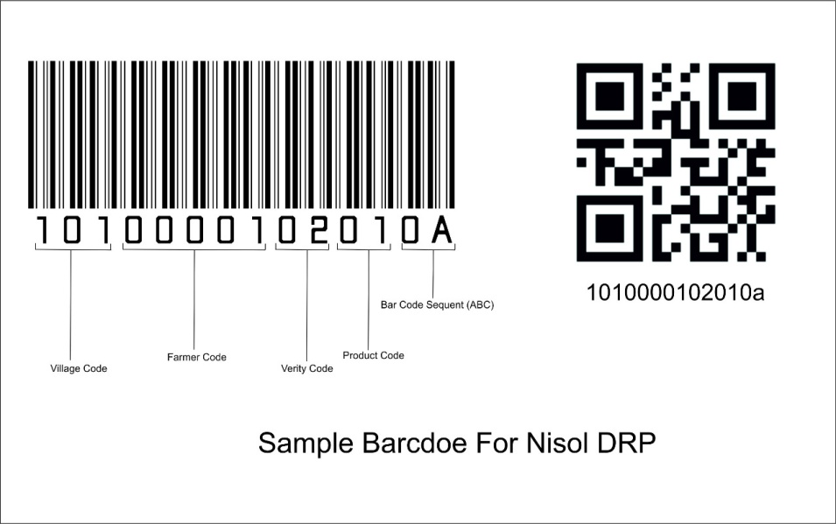

This Barcode Print as Different Bag Qty Ask By Farmer

Here we Mentioning That Barcode Generate in this Way

1 Village Code 3 No

2. Farmer Code 5 No

3. Virty Code 2 No

4. Product Code 2 No

5 0A 0B 0C as a Slab Supply

06 There is new Add 2 digit like 00 and 01 after 0a

Like this

*10 100001 02 01 0A 00*

Last 00 Mean it is initial bar code

7 Bag Sequence Number Optional) We we Setup in System Setting

Barcode and QRCODE wil be print on Barcode Printer

After **Sticking Barcode** on **Bag** Technician Will Give Bag to **Farmer** and Farmer Fill the Material in Appropirat Color Bag

(There is Bag may in Different Colour so we need inventory on Bag Issue Which Colour and How many Bag Given to Which Technican for Which Farmer)

Now As Per Below Flow Chart Farmer Keep Bag and Go to Buying Station

1. There is Farmer handover the bag to Buying Station Supervisor and Supervisor Check and Basic Quality of Material and Take a Bag on Weighing Machine and Scan Barcode of Bag and take weight as a Inward on Buying Station

(BAG WISE ENTY NEED For Example

Bag 1 have 18.5 KG it enter same 18.1 KG and

BAG 2 have 17.5 KG it enter same 18.1 KG

So what ever item whom to belong and how much it is goes to one table for futhre report and payment process

So above example there is 2 Bag of 20 KG but farmer given 18.5 and 17.5 i.e. total 36 KG so in this case on due to date of first supply will be issue payment of 36 KG not for 40 KG

(Due date or day or payment will be taken from farmer contact paper) if not what ever we define as default in setting it will take

When material recived it put a SMS to Admin / Factory Incharge / Supervisior / Technician and Farmer it self as a recipt of material

If need there may be Receipt can be print

1. While Selection we need to make a one Check box (Inward at FACTORY) so it mean inward taken on Factory (Not Outside Factory)

After Material taken at buying station it goes in Stack at Factory Inward Station and Inspect Again as well qualify for milling processing there will be we generate a new barcode and qrcode with same pattern just sequence will be 0B

Like this

*10 100001 02 01 0A 01*

Last 00 Mean it is initial bar code

Last 01 Mean it is final bar code

It will go to **GODOWN in STACK**

REMEMBER WE NEED BARCODE SIZE AS DEFINE IN “SETTING SECTION”

REMEBER WE NEED BARCODE AND QRCODE SAME AS SOME TIME WE NEED TO SCAN BY MOBILE

**There is one main feature we want as Urgent there is one consignment on way from china we want seprate menu called “Import Material”**

**Were we can Create both Kind of Barcode**

1 County Code 3 No

2. Company Code 5 No

3. Virty Code 2 No

4. Product Code 2 No

5 0A 0B 0C as a Slab Supply

06 There is new Add 2 digit like 00 and 01 after 0a

Like this

*10 100001 02 01 0A 00*

Last 00 Mean it is initial bar code

7 Bag Sequence Number Optional) We we Setup in System Setting

**So in sort Material From Import and From Farmer will Be different**

Rejected

Accepted

End

Product sent to NISOL

Process report generated.

After milling, material packed in bags and Final barcode label attached

Process order generated, Material sent for Milling process,

Material accepted and Initial barcode label attached

Material rejected, farmer will take back.

Material Inspection

Farmers bring material at Buying station

Start