EduGlobe CRM Modifications:

Enquiry > Enquiries list ( need to add Country from frontend enquiry under courses lists and courses profiles . **---Done---**

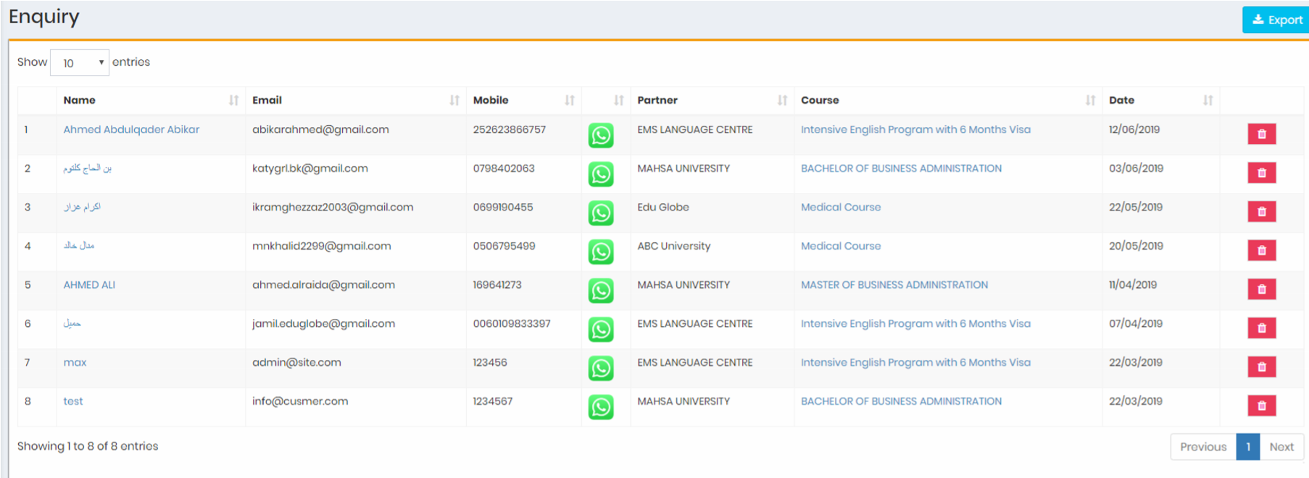

Students Table > Resource ( here we have only students who added by staff and added by students themselves BUT there is students added by agents and Co-Partners.(this users) so we will have resources like Staff, Agents, Co-Partner and website. (current only Staff and website) **---Done---**

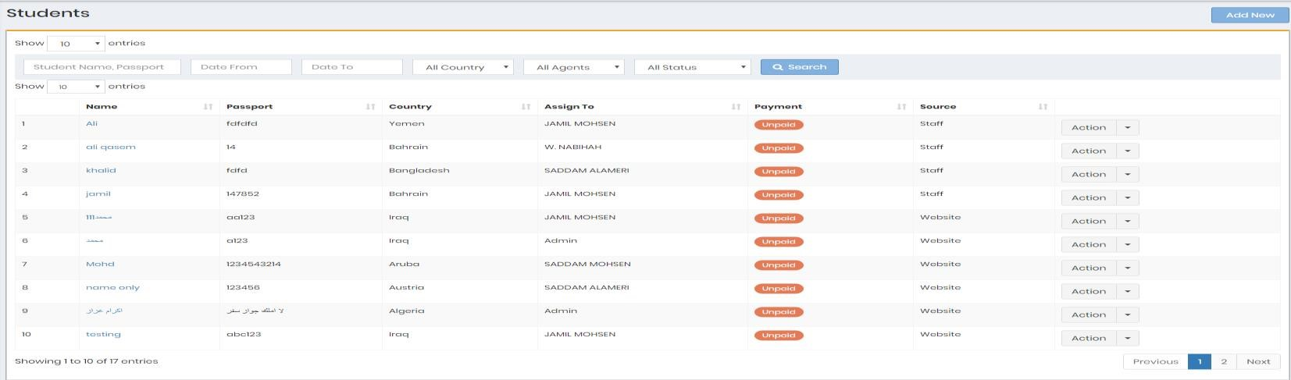

Student List > profile > add student Photo by Admin or by student login page he can upload his photo 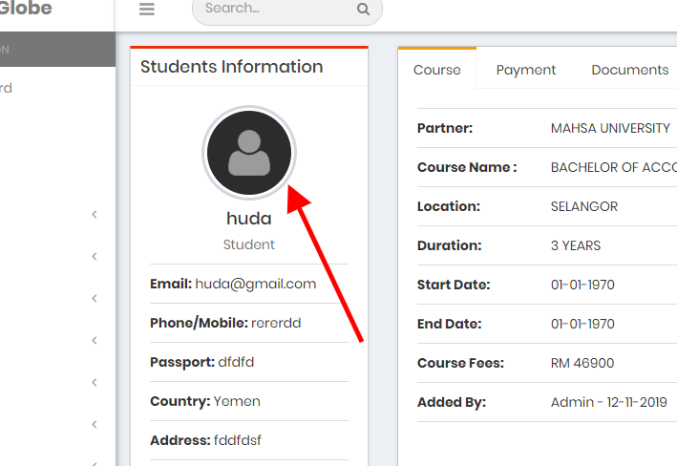

**---Done---**

Student > profile > add tasks which related to this specific student, the completed tasks show Green in the table of tasks and the uncompleted show red DOT. Also show ticket Date in this table **---Done---**

AND ADD COMISSION TAB WILL HAVE ADD NEW COMISSION AND FILL WITH AMOUNT AND ATTACHMENT AND DATE, ALSO THIS COMISSION NEED TO BE CONVERT TO INVOICE AND SEND TO PARTNERS. **---Done---**

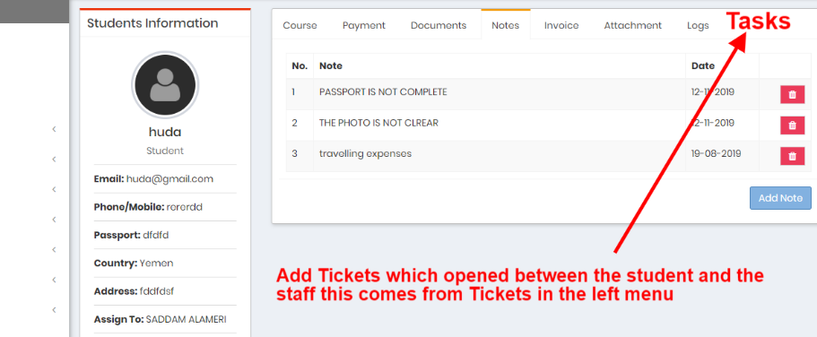

**---Done---**

Also Add Attachments to payment so when click payment and select the payment from the popup form there will have attachment button after save show the clickable attachment to the table

**---Done---**

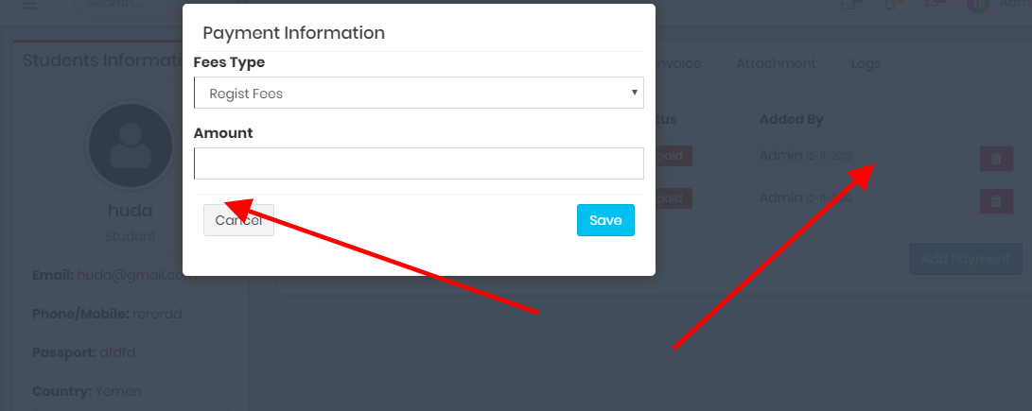

**---Done---**

Add more Fees types like :

1. Uni Application Fee
2. EMGS Visa Fee
3. Office Charge
4. Others

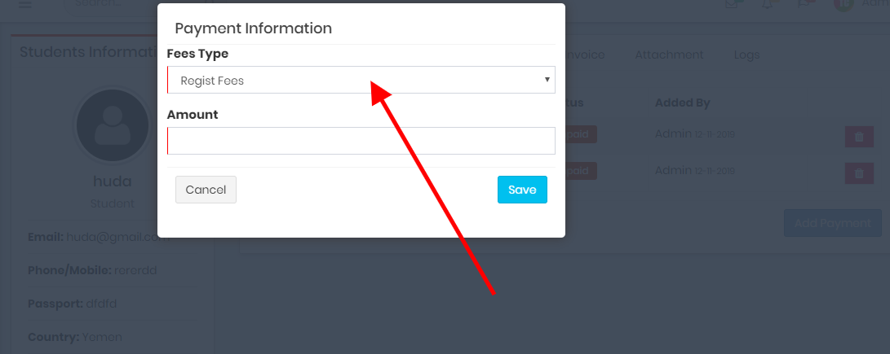

**---Done---**

Invoice > invoice and quotations need to select bill to auto low students, or agents, partners and co partners .

Also need to add Email the invoice to Action of invoices list **---Done---**

And need to double check email sending function.

Add more currencies in setting and show on invoices and quotations **---Done---**

Remove GST field (TAX Field) **---Done---**

Payment need to auto show company payment details (EduGlobe payment details) from setting

**---Done---**

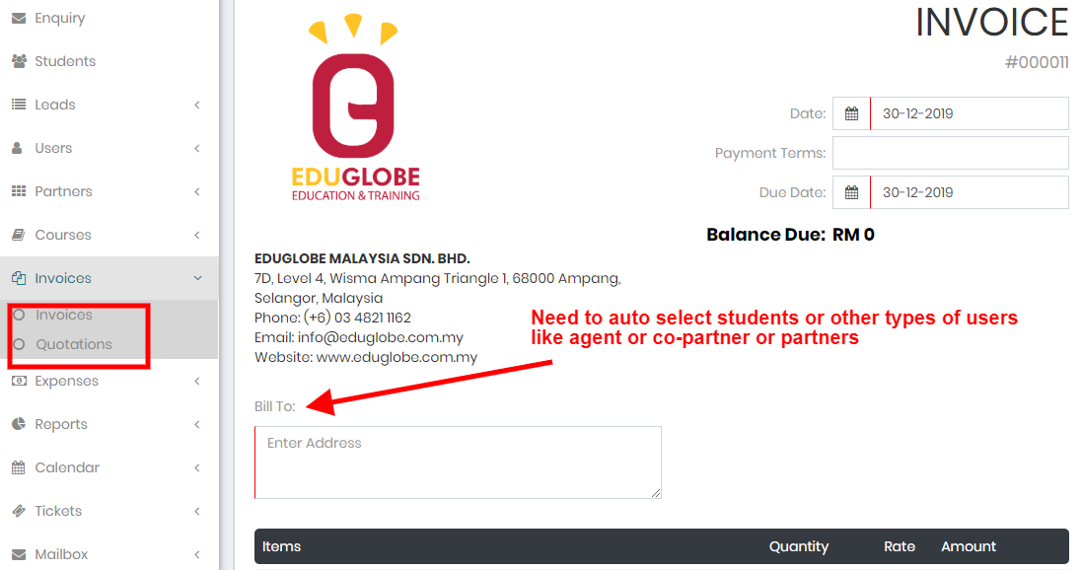

**---Done---**

Leads > Add passport number as second column beside the name, also hide commission from student panel.

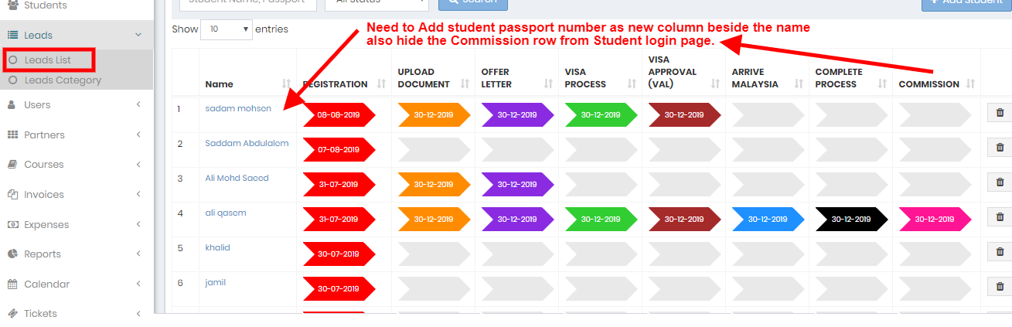

**---Done---**

Agent > add attachment when add new payment and show on the payment table. **---Done---**

