Class05 Intro to plots

Harpreet Setia

January 24th, 2019

# Class 5 R graphics intro  
  
# My first box plot  
x <- rnorm(1000,0)  
boxplot(x)

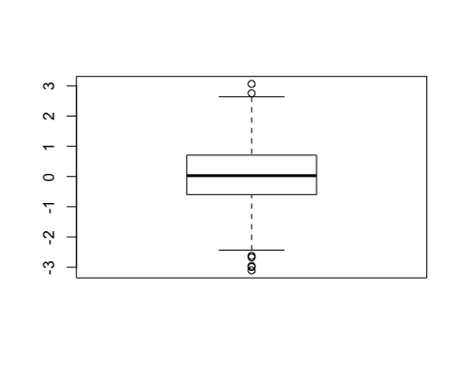

summary(x)

## Min. 1st Qu. Median Mean 3rd Qu. Max.   
## -3.10605 -0.59761 0.02824 0.03540 0.70364 3.06238

hist(x)

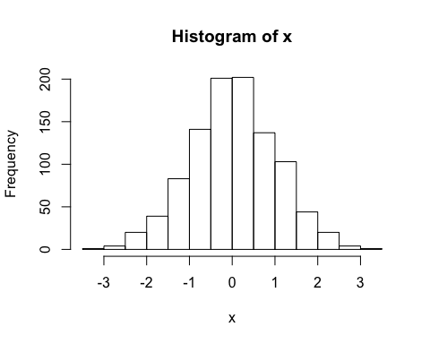

boxplot(x, horizontal = TRUE)

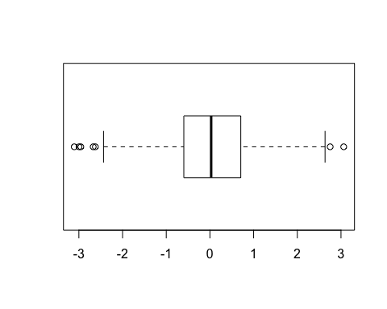

# Hands on session 2  
?read.table()  
getwd()

## [1] "/Users/harpreetsetia/Desktop/BIMM 143/class05"

list.files()

## [1] "bimm143_05_rstats" "class05.html" "class05.R"   
## [4] "class05.Rproj" "class05.spin.R" "class05.spin.Rmd"   
## [7] "class05.tex"

weight <- read.table("bimm143_05_rstats/weight_chart.txt", header = TRUE)  
weight

## Age Weight  
## 1 0 3.6  
## 2 1 4.4  
## 3 2 5.2  
## 4 3 6.0  
## 5 4 6.6  
## 6 5 7.2  
## 7 6 7.8  
## 8 7 8.4  
## 9 8 8.8  
## 10 9 9.2

plot(weight, typ = "o", pch = 15, cex = 1.5, lwd = 2, ylim = c(2,10), xlab = "Age (months)", ylab = "Weight (kg)", main = "Some title")

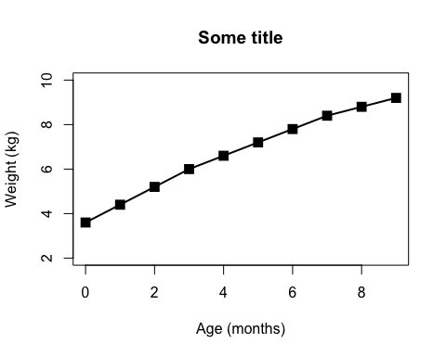

?plot  
feature_counts <- read.table("bimm143_05_rstats/feature_counts.txt", sep = "\t", header = TRUE)  
#margin parameters are usually figured out by guess and check, have no set way of making that ez  
par( mar = c (3.1, 11.1, 4.1, 2))  
barplot(feature_counts$Count, horiz = TRUE,   
 ylab = "", names.arg = feature_counts$Feature,   
 las = 1, main = "Features of stuff", xlim = c(0,80000))

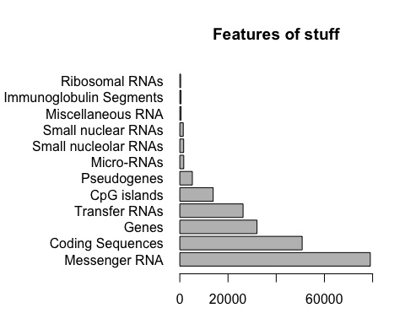

x <- c(rnorm(10000), rnorm(10000)+4)  
hist( x, breaks = 80, col = rainbow(11))

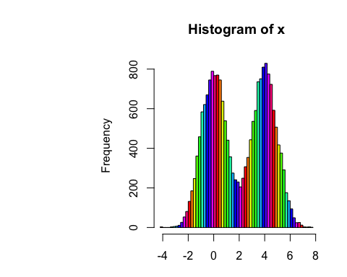

par( mar = c (3.1, 11.1, 4.1, 2))  
gender <- read.delim("bimm143_05_rstats/male_female_counts.txt", header = TRUE)  
barplot(gender$Count,names.arg = gender$Sample, las = 2, col = c("red", "blue"))

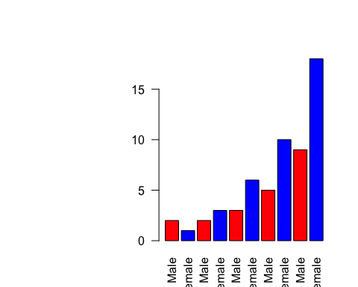

#expression data  
e <- read.table("bimm143_05_rstats/up_down_expression.txt", header = TRUE)  
  
#how many genes  
nrow(e)

## [1] 5196

#how many up, how many down and all around?  
table(e$State)

##   
## down unchanging up   
## 72 4997 127

plot(e$Condition1, e$Condition2, col = e$State)

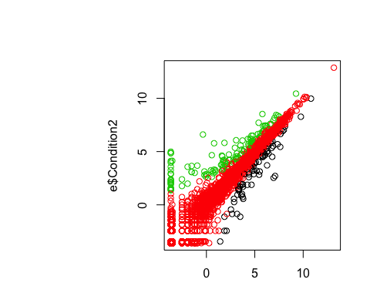

#play  
palette(c("red", "lightgray","blue"))  
plot(e$Condition1, e$Condition2, col = e$State)

