FEDERAL BUREAU OF INTELLIGENCE & ART RECLAMATION

OFFICIAL CASE DOSSIER: #DV-992-Gourd
Date: March 21, 2026
Security Clearance: TOP SECRET // ORCON
Subject: Recovery of the "Lucania" Da Vinci (The Amber Veil)
Location: Rome, Italy / Alexandria, VA

1. OPERATIONAL SUMMARY
The objective of Operation: Vermilion Whisker was the extraction of a lost 16th-century panel painting by Leonardo da Vinci. The artifact was confirmed to be in the possession of Count Alessandro Valerius at his private residence. The operation utilized unconventional camouflage—a chemically stabilized Atlantic Giant pumpkin—to bypass traditional thermal and X-ray scanning.

2. PERSONNEL & CONTACT DATA
Role | Name | Identification / Contact
Lead Field Agent | Elias Thorne | Badge #7742-ET
Mission Director | Sarah Vance | +1-202-555-0198 (Secure Line)
Extraction Lead | Marcus "The Ghost" Reed | m.reed.secure@protonmail.ch
Primary Target | Count A. Valerius | 142 Via della Lungaretta, Rome, IT
Emergency Contact | Valerius Security | +39-06-555-4321

3. FIELD LOG: MARCH 18-19, 2026

Phase I: Infiltration (01:45 AM)
Agent Thorne successfully breached the perimeter of the Valerius Estate. Environmental factors were suboptimal due to heavy precipitation. A local feline asset, designated Subject: BARNABY, was identified as a potential security variable. The subject exhibited territorial behavior but did not immediately compromise the agent's stealth profile.

Phase II: The "Gourdian" Containment (02:15 AM)
Thorne entered the secondary storage facility (the "Shed"). The artifact was housed within a synthetic organic vessel (a preserved pumpkin).
- Technical Note: The vessel used a special resin-bonding agent to prevent the degradation of the organic rind while shielding the internal titanium tube from moisture and standard infrared detection.

Phase III: Technical Extraction (02:40 AM)
Using a high-frequency laser cutter, Thorne breached the vessel. The Da Vinci panel was confirmed authentic via a portable micro-spectroscopy scan. During extraction, Subject BARNABY triggered a Class-3 laser tripwire, alerting the Valerius security detail stationed at 88 Piazza Santa Maria.
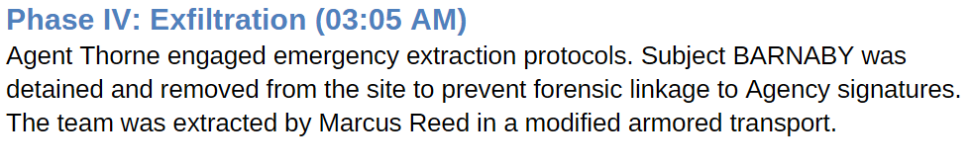

4. ASSET DISPOSITION
- The Artifact: Currently held at the Alexandria Preservation Facility (7210 Oakhaven Lane, VA). Initial carbon dating and brushstroke analysis confirm the work is 100% authentic Leonardo da Vinci, circa 1502.
- The Feline: Subject BARNABY has been processed and is currently residing at the Headquarters Annex. He has been assigned a level 1 clearance for pest control.
- The Pumpkin: Incinerated per biohazard protocols to remove trace evidence of Agency-grade resin.

5. RECOMMENDATIONS
- Surveillance: Maintain a 24-month watch on Count Valerius’s communications (+39-06-555-4321) for signs of retaliation.
- Protocol Update: Amend field manuals to include "unconventional organic camouflage" as a high-probability storage method for high-value assets.
- Logistics: Approve the food and veterinary stipend for Subject BARNABY.
Approved by: Director Sarah Vance Department of Extralegal Recovery

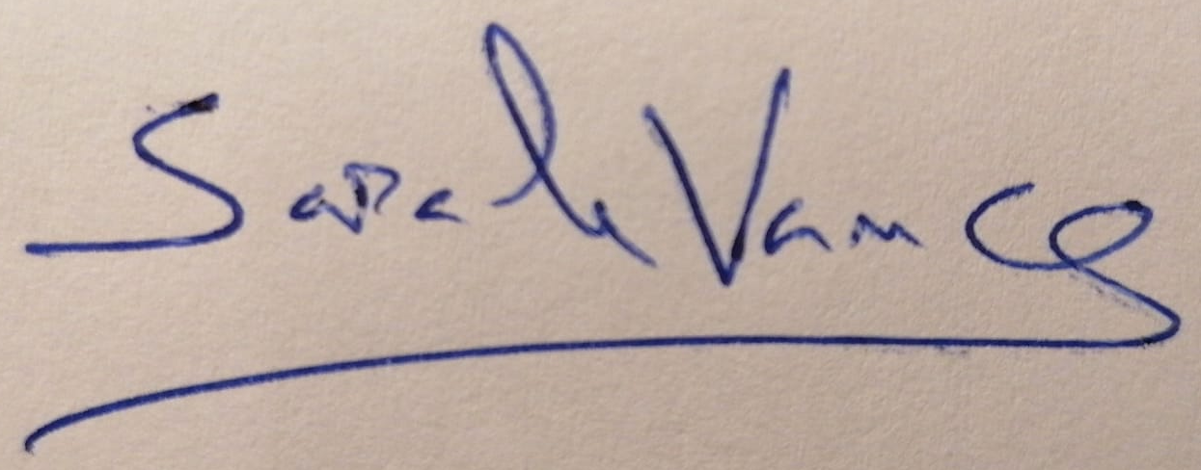
_________________________________________________________
(sign here)

