**CONTENTS**

**S.No. Heading Page No.**

1 Description of ISS 5

2 Used Technologies 10

3 Networking/Security 18

4 Computer-Vision (AI / ML) 21

5 Hardware Control 23

6 Internet of Things 26

7 Applications 28

8 References 29

**Introduction to ISS (Intelligent Surveillance System)**

 ISS is an IoT and ML based project. It is an intelligent surveillance and security system which works on facial recognition and IoT techniques.

This Project is divided into 2 stages.   
**STAGE 1**- This involves implementation of facial recognition algorithm &cloud computing for the verification of visitors with pre-stored collection of faces. It also involves alerts & streaming of live camera feed which can be accessed from anywhere.

It involves the setup of Raspberry pi with the local servers running with check.js and verify.js nodes.

**Check.js**

It is the script that will be running on the raspberry pi that get user input from the push button as trigger to initialize the face capture. The captured image is then uploaded to the amazon s3 bucket for then face detected within the image are extracted and then this face is used as search parameter in the collection of faces .If searched face is found in the collection then json object is returned with face matched index and similarity percentage. AWS also gives option to set the similarity threshold such that only faces above that threshold will be recognized and returned true in search.

The node is also responsible for the Control of the I/O pins of Raspberry-pi which in return controls GPIO’s of Arduino.

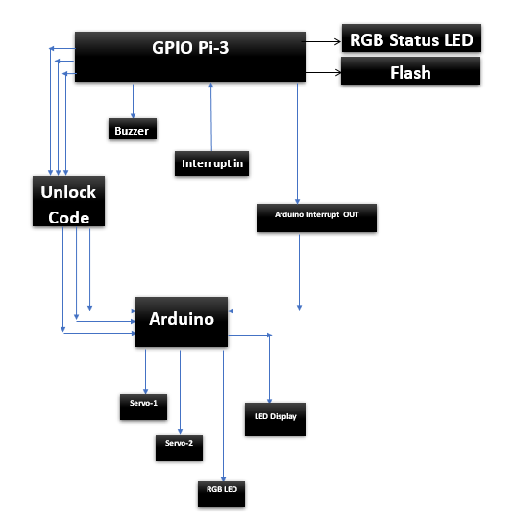

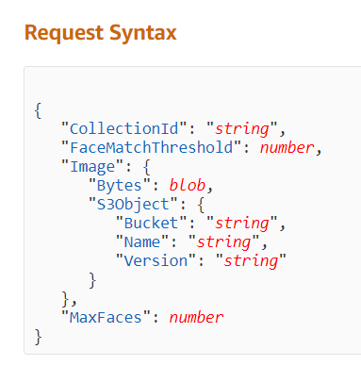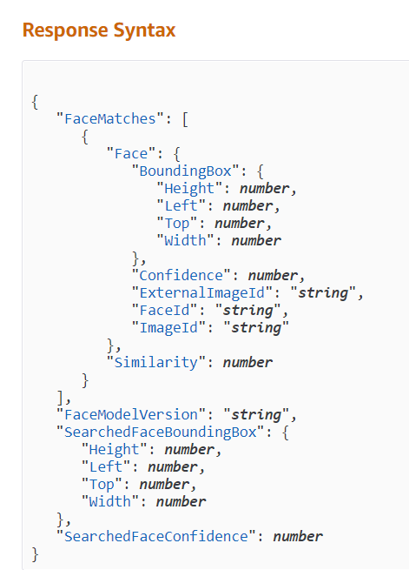

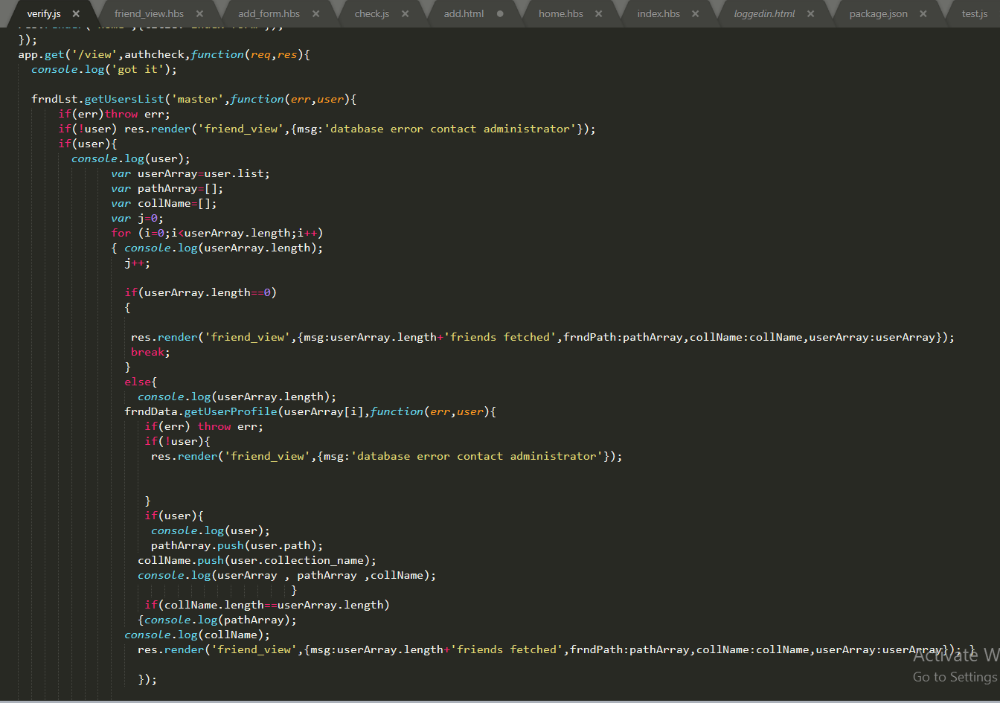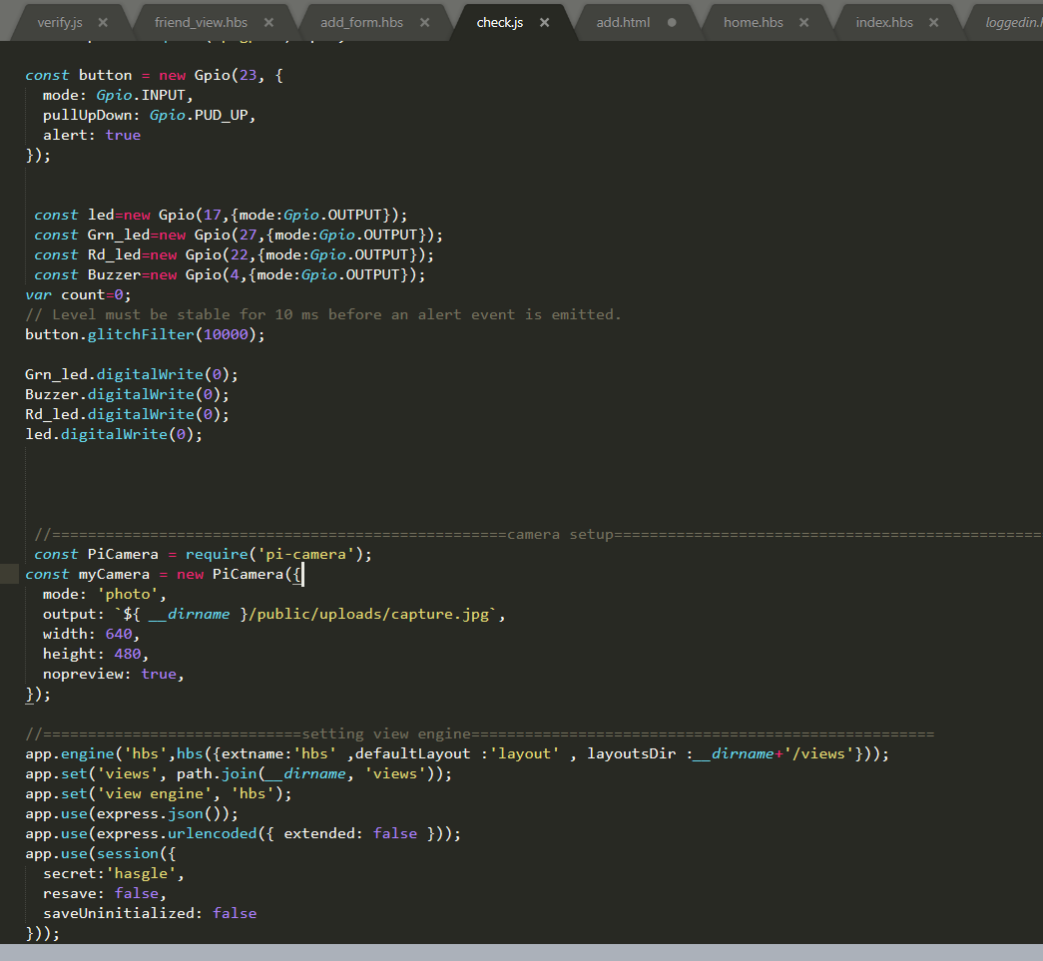

1. Check.js

b. Verify.js

**Verify.js**

This script is the general webserver script which acts as user-interface for the user to control the monitor the ISS.

This script gives user to option to Login in to his account using custom credentials .Once Logged-In an user can view all the members or friends who has been granted access and can add more or remove existing friends to or from the list.

This is the general UI of the ISS.This can only be accessed from machines (PCs and Mobile) which are on local network only i.e. connected to home router.

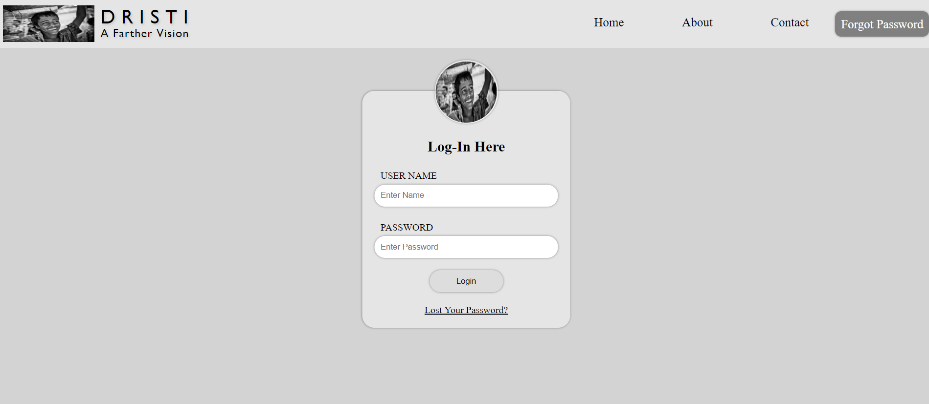

STAGE 2- This involves implementation of secure IoT nodes(TLS 1.2) for home automation and remote monitoring. It facilitates-   
1) Remote control of home appliances   
2) Remote monitoring of conditions of different part of home.   
3) Automated daily tasks

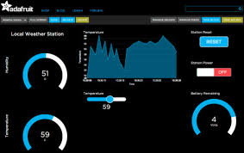

This gives user to remotely monitor the status of all parameters of his house from anywhere all around the world. All data id reflected in from of gauges and status bars.

This all gives user to control his home appliances from anywhere on globe with internet connection. User is provided with buttons and sliders to control the home appliances.

**Technologies Used**

* Programming Languages
* Hardware Peripherals
* Data Processing (Cloud Computing)

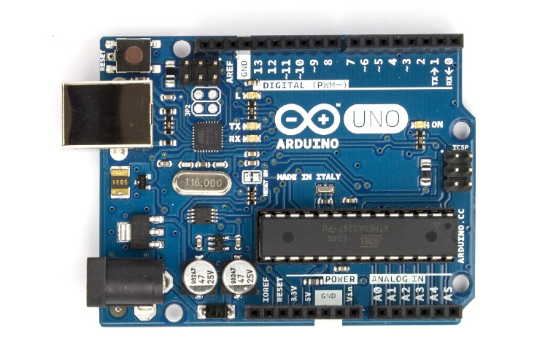 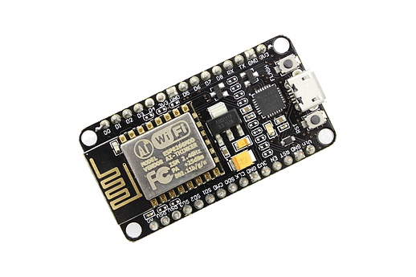

ESP 8266

Arduino Uno

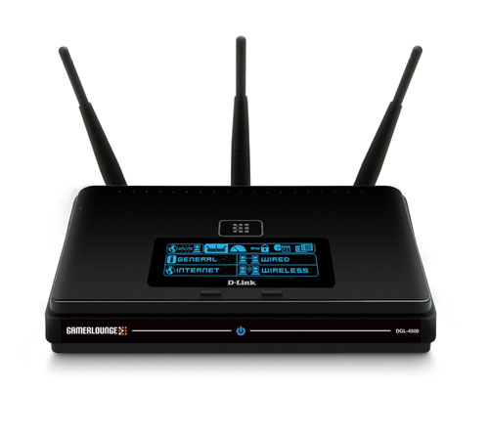 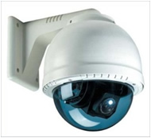

Camera

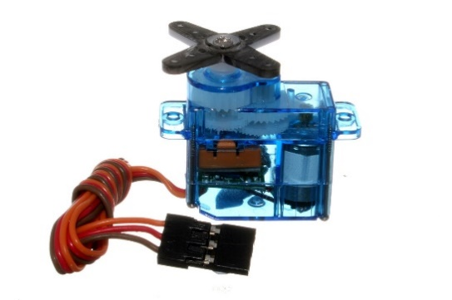

Routers

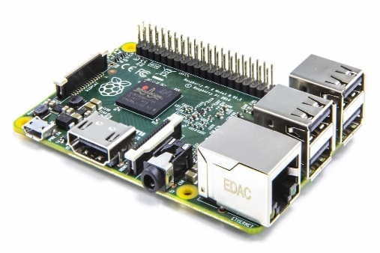

Raspberry Pi

Servo Motor

**Programming Languages Used**

• Shell Script

• Python

• JavaScript

• HTML/CSS

**Shell Script**

A shell script is a computer program designed to be run by the Unix/Linux shell which could be one of the following:

• The Bourne Shell

• The C Shell

• The Korn Shell

• The GNU Bourne-Again Shell

A shell is a command-line interpreter and typical operations performed by shell scripts include file manipulation, program execution, and printing text.

**Python**

Python is a popular programming language. It was created in 1991 by Guido van Rossum.

It is used for:

• web development (server-side),

• software development,

• mathematics,

• system scripting.

What can Python do?

• Python can be used on a server to create web applications.

• Python can be used alongside software to create workflows.

• Python can connect to database systems. It can also read and modify files.

• Python can be used to handle big data and perform complex mathematics.

• Python can be used for rapid prototyping, or for production-ready software development.

•

**JavaScript**

JavaScript (JS) is a lightweight interpreted or JIT-compiled programming language with first-class functions. While it is most well-known as the scripting language for Web pages, many non-browser environments also use it, such as Node.js, Apache CouchDB and Adobe Acrobat. JavaScript is a prototype-based, multi-paradigm, dynamic language, supporting object-oriented, imperative, and declarative (e.g. functional programming) styles. Read more about JavaScript.

This section is dedicated to the JavaScript language itself, and not the parts that are specific to Web pages or other host environments. For information about APIs specific to Web pages, please see Web APIs and DOM.

**HTML/CSS**

HTML is the standard markup language for creating Web pages.

• HTML stands for Hyper Text Markup Language

• HTML describes the structure of Web pages using markup

• HTML elements are the building blocks of HTML pages

• HTML elements are represented by tags

• HTML tags label pieces of content such as "heading", "paragraph", "table", and so on

• Browsers do not display the HTML tags, but use them to render the content of the page

What is CSS?

• CSS stands for Cascading Style Sheets

• CSS describes how HTML elements are to be displayed on screen, paper, or in other media

• CSS saves a lot of work. It can control the layout of multiple web pages all at once

• External stylesheets are stored in CSS files

**Hardware Peripherals**

**Raspberry pi**

• Raspberry Pi 3 is tiny single board computer, introduced by Raspberry Pi Foundation, that comes with CPU, GPU, USB ports and i/o pins and capable of doing some simple functions like regular computer.

• This tiny computer was developed with the purpose of making computer learning process easy so an average student can get benefit and anticipate what an advanced computer can do.

• Raspberry Pi 1(first generation Model B) came into play in 2012, and soon got a renowned reputation in terms of ease of use and availability. Similarly, Raspberry Pi 2 was introduced in Feb,2015 will little improvement in design with added RAM than its previous version.

• Introduced in 2016, Raspberry Pi 3 Model B comes with a quad core processor that shows robust performance which is 10 times more than Raspberry Pi 1. And speed exhibits by Raspberry Pi 3 is 80% more than Raspberry Pi 2.

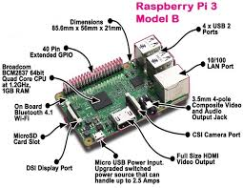

**ESP8266-wifi module**

ESP8266 is a wifi SOC (system on a chip) produced by Espressif Systems . It is an highly integrated chip designed to provide full internet connectivity in a small package.

Technical Features

• 802.11 b / g / n

• Wi-Fi Direct (P2P), soft-AP

• Built-in TCP / IP protocol stack

• Built-in TR switch, balun, LNA, power amplifier and matching network

• Built-in PLL, voltage regulator and power management components

• 802.11b mode + 19.5dBm output power

• Built-in temperature sensor

• Support antenna diversity

• off leakage current is less than 10uA

• Built-in low-power 32-bit CPU: can double as an application processor

• SDIO 2.0, SPI, UART

• STBC, 1×1 MIMO, 2×1 MIMO

• A-MPDU, A-MSDU aggregation and the 0.4 Within wake

• 2ms, connect and transfer data packets

• standby power consumption of less than 1.0mW (DTIM3)

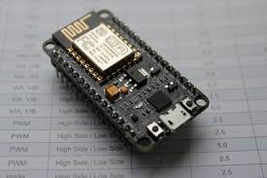

**Arduino**

Arduino is an open-source electronics platform based on easy-to-use hardware and software. Arduino boards are able to read inputs - light on a sensor, a finger on a button, or a Twitter message - and turn it into an output - activating a motor, turning on an LED, publishing something online. You can tell your board what to do by sending a set of instructions to the microcontroller on the board. To do so you use the Arduino programming language (based on Wiring), and the Arduino Software (IDE), based on Processing.

**Data Processing**

**Introduction to AWS**

What is AWS? – Amazon Web Services(AWS) is a cloud service from Amazon, which provides services in the form of building blocks, these building blocks can be used to create and deploy any type of application in the cloud.

These services or building blocks are designed to work with each other, and result in applications which are sophisticated and highly scalable.

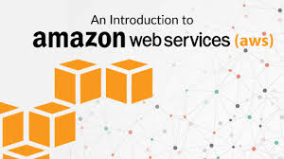

Each type of service in this “What is AWS” blog, is categorized under a domain, the few domains which are widely used are:

• Compute

• Storage

• Database

• Migration

• Network and Content Delivery

• Management Tools

• Security & Identity Compliance

• Messaging

**Cloud Computing**

Cloud computing makes computer system resources, especially storage and computing power, available on demand without direct active management by the user. The term is generally used to describe data centers available to many users over the Internet. Large clouds, predominant today, often have functions distributed over multiple locations from central servers. If the connection to the user is relatively close, it may be designated an Edge server.

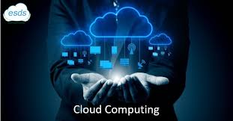

**AWS Rekognition**

Amazon Rekognition makes it easy to add image and video analysis to your applications. You just provide an image or video to the Rekognition API, and the service can identify the objects, people, text, scenes, and activities, as well as detect any inappropriate content. Amazon Rekognition also provides highly accurate facial analysis and facial recognition on images and video that you provide. You can detect, analyze, and compare faces for a wide variety of user verification, people counting, and public safety use cases.



Amazon Rekognition is based on the same proven, highly scalable, deep learning technology developed by Amazon’s computer vision scientists to analyze billions of images and videos daily, and requires no machine learning expertise to use. Amazon Rekognition is a simple and easy to use API that can quickly analyze any image or video file stored in Amazon S3. Amazon Rekognition is always learning from new data, and we are continually adding new labels and facial recognition features to the service.

**Networking Concepts/Security issues**

A network is the interconnection of several devices with each other.Their are different types of networks classified according to the size of networks.

• LAN ( Local Area Network )

• WAN (Wide Area Network )

• MAN (Metropolitan Area Network)

In ISS we use LAN for the connection of router to our Raspberry-pi with the router.

All devices only on LAN can only access the resources of raspberry pi .Devices Outside LAN can’t access these resources. The Security of the system ( ISS ) depends on the security of the LAN.

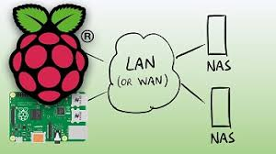

**local area network (LAN)**

A local area network (LAN) is a group of computers and associated devices that share a common communications line or wireless link to a server. Typically, a LAN encompasses computers and peripherals connected to a server within a distinct geographic area such as an office or a commercial establishment. Computers and other mobile devices use a LAN connection to share resources such as a printer or network storage.

A local area network may serve as few as two or three users (for example, in a small-office network) or several hundred users in a larger office. LAN networking comprises cables, switches, routers and other components that let users connect to internal servers, websites and other LANs via wide area networks.

Ethernet and Wi-Fi are the two primary ways to enable LAN connections. Ethernet is a specification that enables computers to communicate with each other. Wi-Fi uses radio waves to connect computers to the LAN. Other LAN technologies, including Token Ring, Fiber Distributed Data Interface and ARCNET, have lost favor as Ethernet and Wi-Fi speeds have increased. The rise of virtualization has fueled the development of virtual LANs, which allows network administrators to logically group network nodes and partition their networks without the need for major infrastructure changes.

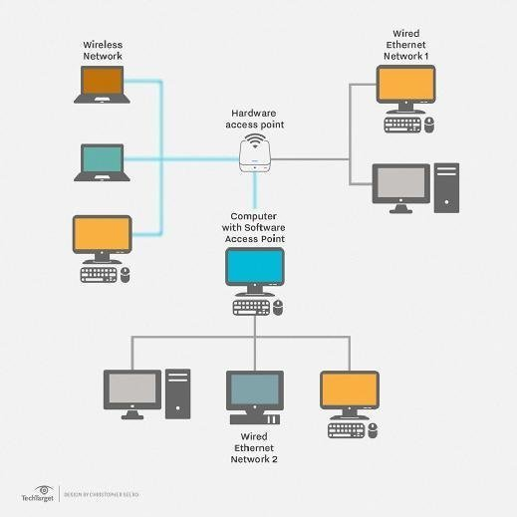

Typically, a suite of application programs can be kept on the LAN server. Users who need an application frequently can download it once and then run it from their local device. Users can order printing and other services as needed through applications run on the LAN server. A user can share files with others stored on the LAN server; read and write access is maintained by a network administrator. A LAN server may also be used as a web server if safeguards are taken to secure internal applications and data from outside access.

In some situations, a wireless LAN, or Wi-Fi, may be preferable to a wired LAN connection because of its flexibility and cost. Companies are assessing WLANs as primary means of connectivity as the number of smartphones, tablets and other mobile devices proliferates.

**Router (computing)**

A router[a] is a networking device that forwards data packets between computer networks. Routers perform the traffic directing functions on the Internet. Data sent through the internet, such as a web page or email, is in the form of data packets. A packet is typically forwarded from one router to another router through the networks that constitute an internetwork until it reaches its destination node.[2]

A router is connected to two or more data lines from different networks.[b] When a data packet comes in on one of the lines, the router reads the network address information in the packet to determine the ultimate destination. Then, using information in its routing table or routing policy, it directs the packet to the next network on its journey.

The most familiar type of routers are home and small office routers that simply forward IP packets between the home computers and the Internet. An example of a router would be the owner's cable or DSL router, which connects to the Internet through an Internet service provider (ISP). More sophisticated routers, such as enterprise routers, connect large business or ISP networks up to the powerful core routers that forward data at high speed along the optical fiber lines of the Internet backbone. Though routers are typically dedicated hardware devices, software-based routers also.

**Network Address Translation (NAT)**

Network address translation (NAT) is a method of remapping one IP address space into another by modifying network address information in the IP header of packets while they are in transit across a traffic routing device.The technique was originally used as a shortcut to avoid the need to readdress every host when a network was moved. It has become a popular and essential tool in conserving global address space in the face of IPv4 address exhaustion. One Internet-routable IP address of a NAT gateway can be used for an entire private network.

**Computer Vision/AI/ML**

**Introduction**

A human eye has between six and seven million cone cells, containing one of three colour-sensitive proteins known as opsins. When photons of light hit these opsins, they change shape, triggering a cascade that produces electrical signals, which in turn transmit the messages to the brain for interpretation.

This whole process is a very complex phenomenon and making a machine to interpret this at a human level has always been a challenge. The motivation behind the modern-day machine vision system lies at the core of emulating human vision for recognising patterns, faces and rendering 2D imagery from a 3D world into 3D.

There is a lot of overlap between image processing and computer vision at the conceptual level and the jargon, often misunderstood, is being used interchangeably. Here we give a brief overview of the techniques and explain how they are different at the fundamental level.

**Image Processing**

Digital image processing was pioneered at NASA’s Jet Propulsion Laboratory in the late 1960s, to convert analogue signals from the Ranger spacecraft to digital images with computer enhancement. Now, digital imaging has a wide range of applications, with particular emphasis on medicine. Well-known uses for it include Computed Aided Tomography (CAT) scanning and ultrasounds.

Image Processing is mostly related to the usage and application of mathematical functions and transformations over images regardless of any intelligent inference being done over the image itself. It simply means that an algorithm does some transformations on the image such as smoothing, sharpening, contrasting, stretching on the image.

For a computer, an image is a two-dimensional signal, made up of rows and columns of pixels. An input of one form can sometimes be transformed into another. For instance, Magnetic Resonance Imaging (MRI), records the excitation of ions and transforms it into a visual image.

Here’s an example of smoothing images with Python:

As for one-dimensional signals, images also can be filtered with various low-pass filters (LPF), high-pass filters (HPF), etc. An LPF helps in removing noise or blurring the image. An HPF filter helps in finding edges in an image.

Via OpenCV documentation

These type of transformations using matrices are quite prevalent in machine learning algorithms like convolution neural network. Where a filter is convolved over an image(another matrix of pixel values) to detect edges or colour intensities.

Some techniques which are used in digital image processing include:

Hidden Markov models

Image editing and restoration

Linear filtering and Bilateral filtering

Neural networks

Hence, Image processing is a subset of computer vision. A computer vision system uses the image processing algorithms to try and perform emulation of vision at human scale. For example, if the goal is to enhance the image for later use, then this may be called image processing. And if the goal is to recognise objects, defect for automatic driving, then it can be called computer vision.

The first three are hierarchical; AI is the largest, overarching category. Machine Learning (ML) is a subset of AI and Deep Learning (DL) a subset of ML.

**Artificial intelligence** — A computer system able to perform tasks that normally require human intelligence, such as visual perception, speech recognition, decision-making, and translation between languages.

**Machine learning** — Arthur Samuel said “Machine Learning is the ability to learn without being explicitly programmed.”

**Deep learning** — From MIT News: Modelled loosely on the human brain, a neural net consists of thousands or even millions of simple processing nodes that are densely interconnected. This is similar to synaptic connections of axons and dendrites.

**Hardware Control**

**Embedded**

An embedded system is a controller programmed and controlled by a real-time operating system (RTOS) with a dedicated function within a larger mechanical or electrical system, often with real-time computing constraints. It is embedded as part of a complete device often including hardware and mechanical parts. Embedded systems control many devices in common use today. Ninety-eight percent of all microprocessors manufactured are used in embedded systems.

Examples of properties of typical embedded computers when compared with general-purpose counterparts are low power consumption, small size, rugged operating ranges, and low per-unit cost. This comes at the price of limited processing resources, which make them significantly more difficult to program and to interact with. However, by building intelligence mechanisms on top of the hardware, taking advantage of possible existing sensors and the existence of a network of embedded units, one can both optimally manage available resources at the unit and network levels as well as provide augmented functions, well beyond those available. For example, intelligent techniques can be designed to manage power consumption of embedded systems.

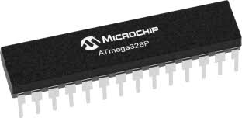

**Arduino**

Arduino is an open-source electronics platform based on easy-to-use hardware and software. Arduino boards are able to read inputs - light on a sensor, a finger on a button, or a Twitter message - and turn it into an output - activating a motor, turning on an LED, publishing something online. You can tell your board what to do by sending a set of instructions to the microcontroller on the board. To do so you use the Arduino programming language (based on Wiring), and the Arduino Software (IDE), based on Processing.

Over the years Arduino has been the brain of thousands of projects, from everyday objects to complex scientific instruments. A worldwide community of makers - students, hobbyists, artists, programmers, and professionals - has gathered around this open-source platform, their contributions have added up to an incredible amount of accessible knowledge that can be of great help to novices and experts alike.

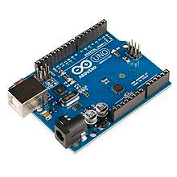

Arduino was born at the Ivrea Interaction Design Institute as an easy tool for fast prototyping, aimed at students without a background in electronics and programming. As soon as it reached a wider community, the Arduino board started changing to adapt to new needs and challenges, differentiating its offer from simple 8-bit boards to products for IoT applications, wearable, 3D printing, and embedded environments. All Arduino boards are completely open-source, empowering users to build them independently and eventually adapt them to their particular needs. The software, too, is open-source, and it is growing through the contributions of users worldwide.

**Internet of Things**

**What is Internet of Things?**

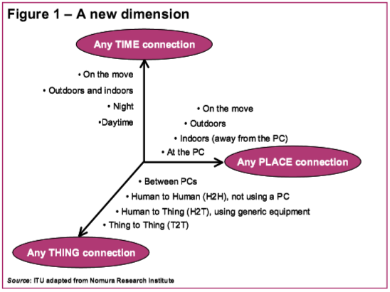We are standing on the brink of a new ubiquitous computing and communication era, one that will radically transform our corporate, community, and personal spheres. Over a decade ago, the late Mark Weiser developed a seminal vision of future technological ubiquity – one in which the increasing “availability” of processing power would be accompanied by its decreasing “visibility”. As he observed, “the most profound technologies are those that disappear…they weave themselves into the fabric of everyday life until they are indistinguishable from it”. Early forms of ubiquitous information and communication networks are evident in the widespread use of mobile phones: the number of mobile phones worldwide surpassed 2 billion in mid-2005. These little gadgets have become an integral and intimate part of everyday life for many millions of people, even more so than the internet. Today, developments are rapidly under way to take this phenomenon an important step further, by embedding short-range mobile transceivers into a wide array of additional gadgets and everyday items, enabling new forms of communication between people and things, and between things themselves. A new dimension has been added to the world of information and communication technologies (ICTs): from anytime, anyplace connectivity for anyone, we will now have connectivity for anything (Figure 1). Connections will multiply and create an entirely new dynamic network of networks – an Internet of Things. The Internet of Things is neither science fiction nor industry hype, but is based on solid technological advances and visions of network ubiquity that are zealously being realized.

**Technologies for the Internet of Things**

The Internet of Things is a technological revolution that represents the future of computing and communications, and its development depends on dynamic technical innovation in a number of important fields, from wireless sensors to nanotechnology. First, in order to connect everyday objects and devices to large databases and networks – and indeed to the network of networks (the internet) – a simple, unobtrusive and cost-effective system of item identification is crucial. Only then can data about things be collected and processed. Radio-frequency identification (RFID) offers this functionality. Second, data collection will benefit from the ability to detect changes in the physical status of things, using sensor technologies. Embedded intelligence in the things themselves can further enhance the power of the network by devolving information processing capabilities to the edges of the network. Finally, advances in miniaturization and nanotechnology mean that smaller and smaller things will have the ability to interact and connect (Figure 2). A combination of all of these developments will create an Internet of Things that connects the world’s objects in both a sensory and an intelligent manner. Indeed, with the benefit of integrated information processing, industrial products and everyday objects will take on smart characteristics and capabilities. They may also take on electronic identities that can be queried remotely, or be 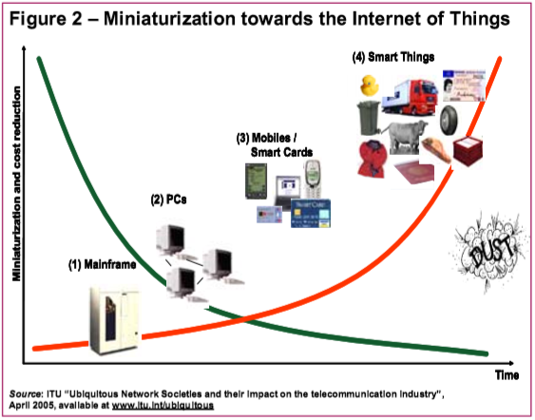equipped with sensors for detecting physical changes around them. Eventually, even particles as small as dust might be tagged and networked. Such developments will turn the merely static objects of today into newly dynamic things, embedding intelligence in our environment, and stimulating the creation of innovative products and entirely new services. RFID technology, which uses radio waves to identify items, is seen as one of the pivotal enablers of the Internet of Things. Although it has sometimes been labelled as the next-generation of bar codes, RFID systems offer much more in that they can track items in real-time to yield important information about their location and status. Early applications of RFID include automatic highway toll collection, supply-chain management (for large retailers), pharmaceuticals (for the prevention of counterfeiting) and e-health (for patient monitoring). More recent applications range from sports and leisure (ski passes) to personal security (tagging children at schools). RFID tags are even being implanted under human skin for medical purposes, but also for VIP access to bars like the Baja Beach Club in Barcelona. E-government applications such as RFID in drivers’ licences, passports or cash are under consideration. RFID readers are now being embedded in mobile phones. Nokia, for instance, released its RFID-enabled phones for businesses with workforces in the field in mid-2004 and plans to launch consumer 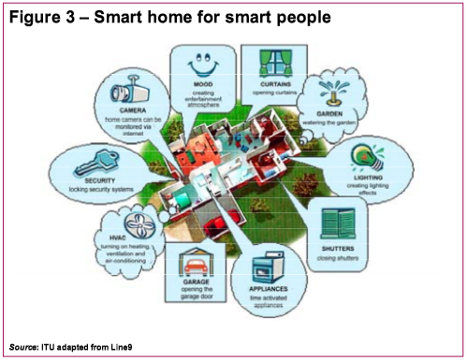handsets by 2006. In addition to RFID, the ability to detect changes in the physical status of things is also essential for recording changes in the environment. In this regard, sensors play a pivotal role in bridging the gap between the physical and virtual worlds, and enabling things to respond to changes in their physical environment. Sensors collect data from their environment, generating information and raising awareness about context. For example, sensors in an electronic jacket can collect information about changes in external temperature and the parameters of the jacket can be adjusted accordingly. Embedded intelligence in things themselves will distribute processing power to the edges of the network, offering greater possibilities for data processing and increasing the resilience of the network. This will also empower things and devices at the edges of the network to take independent decisions. “Smart things” are difficult to define, but imply a certain processing power and reaction to external stimuli. Advances in smart homes, smart vehicles and personal robotics are some of the leading areas. Research on wearable computing (including wearable mobility vehicles) is swiftly progressing. Scientists are using their imagination to develop new devices and appliances, such as intelligent ovens that can be controlled through phones or the internet, online refrigerators and networked blinds (Figure 3). The Internet of Things will draw on the functionality offered by all of these technologies to realize the vision of a fully interactive and responsive network environment.

**Applications of ISS**

* Home security

For restricting access to only know peoples to house. They can be authenticated using face-id.

* Industrial site security

more sophisticated way of automatic authentication at busy places in industrial sites. Face-id type recognition can be crucial and time saving.

* Restricted access within facilities

For securing Sensitive places within organisations.

* Military Applications for Face-ID based access

Face-id type security can be beneficial even in military where security is most important and as organisation has several different levels of roles. Using face-id different levels of access and services can easily be managed.

**And anywhere where security is needed!!!**

**References**

1. https://www.raspberrypi.org
2. https://www.arduino.cc
3. https://www.wikipedia.org
4. https://nodejs.org/en/
5. https://www.w3schools.com
6. https://docs.aws.amazon.com/index.html
7. https://aws.amazon.com/rekognition/