Major Project (Phase 3)

PSW

(Tentative-name)

Photoshop + JavaScript

Mentored By:

Prof. Sanjay Goel

Submitted By:

Harsh Bhatia

# Index

1. Introduction
2. Implementation and Testing
   1. Overall description of the project
   2. Modified Design
   3. Implementation Details and Issues
      1. Description of Modules with respect to design
   4. Testing
      1. Testing Plan
      2. Component decomposition and type of testing required
      3. Test Cases performed
      4. Error and Exception Handling
      5. Limitations of the solution
   5. Risk Analysis and Mitigation Plan

**Appendix**

1. References

Introduction

PS2WEB is a Photoshop Script plugin to convert a Photoshop Document (PSD) into a html and CSS code used for standard static web page.

A Photoshop Script is an approach to automate Photoshop using its JavaScript object model. Photoshop Application Programming Index (API) allows user to use Photoshop object model to automate filters, functionalities and effects or convert a document into various format. PS2WEB, once called, extracts all the information from the PSD file and converts the possible effect into its HTML and CSS code and lately combine it all to complete a static webpage design.

By PS2WEB our goal is to remove the gap of functionalities between a graphic template designer and a web developer for better web-design.

# Implementation and Testing

Overall Description of the Project

PS2WEB is a Photoshop Script plugin to convert a Photoshop Document (PSD) into a html and CSS code used for standard static web page.

A Photoshop Script is an approach to automate Photoshop using its JavaScript object model. Photoshop Application Programming Index (API) allows user to use Photoshop object model to automate filters, functionalities and effects or convert a document into various format. PS2WEB, once called, extracts all the information from the PSD file and converts the possible effect into its HTML and CSS code and lately combine it all to complete a static webpage design.

PS2WEB is an open-source, which let users to use it for free and modify it as per their own requirement or designing pattern.

Relevant and current solutions

Currently available software’s for converting PSD to HTML or CSS contain either of one format or strip down total document as image and attach in web page in an inappropriate way. Old method doesn’t satisfy the responsive behavior various html tags and complete CSS effects. An old script doesn’t create a single page markup for webpage or relate different html tags with latest web features like header or footer.

Problem Statement

Graphic Designers generally complains about the proposed markup by them and the final design developed by the developer differ by various reason as various filters / effects available in PS are not available in web or the ratio of document to web page attributes if different. PS2WEB gives PSD designers freedom to design in the web friendly environment and convert it into responsive web page design while filling the gap between a developer and designer.

Modified Design

In Last Design, PSD had very few features implemented in it. The current design and working of PSD contains Image downloading and complete text feature extraction for web conversion. The new design has following bullets feature addition:

* Complete Text Feature Extraction with shadow effect conversion.
* Images Downloading into particular folders
* 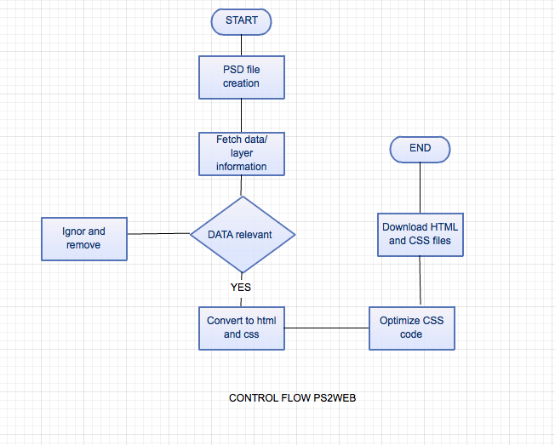Creation of separate well connected files of HTML and CSS.
* Removal of empty layer and layerset for better performance.

Implementation Details and Issues

* **Details**:

PS2WEB will provide HTML code with CSS for particular Document in Photoshop, and download them in the same folder as PSD file. PS2WEB will be beneficial in the following ways:

1. Converting PSD into CSS with absolute positioning and size ratio to adjust the responsive behavior.
2. Creating respective HTML files for better compatibility
3. Using classes fir CSS, leaving ids for JavaScript functioning.

Optimization of CSS for minimal code.

* **Issues**:

While Implementing PSW I faced a lot of Issues dealing with vary small support of features of web as compared to available in Adobe Photoshop. The File accessing library of photoshop doesn’t support all operating systems in one way. Although I have chose javascript for multiple os compatibility yet the features are not supported in all platform due to file handling issues.

Conversion of Shadow and Blending effects in Photoshop can not be converted directly into web due to its incompatibility.

1. font-size and font family function do not respond for multiple size in same paragraph or multiple font in same text filed.
2. Shadow function only available with length, color and few parameters.
3. Similar layers name/ numerical naming causes effect to non-functional in css.
4. Outer layer not in layer set does not get included in html.

Description of Modules with respect of design:

* **Fetching Text-Effect:** It extracts all features of text of both types i.e. single line or paragraph text. It extracts font, size, length & width of text box, text-shadow and all effects, convert it into web compatible format.
* **File and Folder Creation:** Currently this contains script, which creates HTML, and CSS file format in same folder as the photoshop document. Creating well-structured folder format of a web project with all files in its place ready to host on a domain.
* **Shadow (Text / Box):**  This Supports the text and box shadow functionality of a tex field or a image or an object. It converts the spread, size , opacity and color into h-length, v-length, v spread and color of text shadow in css compatible format.
* **Image and Division property:** This converts properties of layerset and image into particular html element.

Testing

## Testing Plan:

|  |  |  |  |  |
| --- | --- | --- | --- | --- |
| **Sr. No.** | **Types of Test** | **Will test be performed?** | **Comments/Explanations** | **Software Component** |
| 1. | Requirement Testing | Yes | All appropriate API’s are installed. | To be tested on OS. |
| 2. | Unit Testing | Yes | Software units tested on multi platforms. | To be tested on the user side. |
| 3. | Integration | Yes | Successful software integration on Windows and mac operating systems. | The client script tested on different devices. |
| 4. | Performance | Yes | Server responds to any conversion in minimal time. | To be tested on the software side. |
| 5. | Stress | Yes | Able to convert all tags | To be tested on Adobe PS. |
| 6. | Compliance | Yes | In compliance with the existing competition needs. | Suite to be tested and compared with existing technologies. |
| 7. | Security | No | - | - |
| 8. | Load | No | Software allows multiple users to request at same time. | To be tested on user’s threading component. |
| 9. | Space | Yes | Results for all the layers on PS are processed. | On Photoshop. |
| 10. | Interface | No | - | - |

Testing schedule:

|  |  |  |  |  |
| --- | --- | --- | --- | --- |
| Activity | Start Date | Completion Date | Hours | Comments |
| File Creation and code writing. | 2/Jan/14 | 15/Feb/14 | 50 hrs. | Initial script was not working on file handling as isssues of mac with file ahndling and permission to photshop. |
| Json extration | 10/Apr/14 | 12/Apr/14 | 8 hrs. | Json Extraction of styel properties to convert into smart object. |
| Performance | 12/March/14 | Till date | -- hrs | Relevance of result are still tested on various varieties of Documents. |

Test environment:

Component Decomposition and Identification of Tests required:

|  |  |  |
| --- | --- | --- |
| List of Various  Components | Type of Testing Required | Technique for writing test  Cases |
| CSS Code | Unit | Black box |
| File Creation | Unit | Black box |
| Feature extraction | Requirement | Converting to code as per the requirements |
| Web design | Performance | Black box |
| Shadow conversion | Requirement | Extraction JSON of photshop document. |
| Shadow conversion | Unit | White box |

Error and Exception Handling:

Debugging

|  |  |  |
| --- | --- | --- |
| Test Case ID | Test Case | Debugging Technique |
| 4 | File and folder creation permission error. | Added Try Catch to control error outcome and inform user. |
| 5 | Layer Style Compatibility | All Styles have not been lifted only few are extracted and converted into the Css code. |
| 7 | Multiple layered structure. | Special div control with layer functionaliry is added. |

Limitations of the Solution:

PSW various limitation in the implementation as:

* Shadow property is converted into web format but the limitation of web format doesn’t allow all shadow ad blending options to be converted into web.
* Only PSD approved by Photoshop etiquettes can pass several tests and get converted into relevant code.
* The Script only runs on the Photoshop CS5 + version otherwise various functionalities are not converted into final product.
* File and folder permission to Photoshop are in the folder of PSD, hence custom location of final product is not variable.

Risk Analysis and Mitigation Plan

|  |  |  |  |  |  |  |
| --- | --- | --- | --- | --- | --- | --- |
| ID | Description | Area | Probability | Impact | Risk Selected | Contingency Plan |
| 1 | Fixed size document | Design | Good | Impact on final design to be responsive, scrolling or one page | Final output design would be | Assumption of fixed document size. |
| 2 | Similar layer names | Extraction | Max | On id assignment and division for CSS. |  | Assigning a number set to similar id or class definition. |
| 3 | Unconvertible PS effect | Design | High | Overall css design would be different than proposed |  | Assuming the nearest possible css effect to particular object. |

## FUTURE WORK

* Use of all HTML tags (currently very few).
* Optimizing CSS and renaming layer with specific class name for less code
* Importing external libraries for special effect
* Beautifying html code.
* Border effect possibility
* Final code tips for better performance.

**REFERENCES**

1. Smashing magazine article on how to make first adobe script,25th july 2013

“<http://www.smashingmagazine.com/2013/07/25/introduction-to-photoshop-scripting/>”

1. Official Adobe photoshop scripting Guide,  
   “<http://wwwimages.adobe.com/www.adobe.com/content/dam/Adobe/en/products/photoshop/pdfs/cs6/Photoshop-CS6-Scripting-Guide.pdf> ”
2. Official Adobe JavaScript reference,  
   “<http://wwwimages.adobe.com/www.adobe.com/content/dam/Adobe/en/products/photoshop/pdfs/cs6/Photoshop-CS6-JavaScript-Ref.pdf>”
3. Article on adobe photoshop scripting by Creative droplets,12th December 2012,  
   “<http://creativedroplets.com/tutorial-write-your-first-photoshop-script/>”
4. JavaScript reference by W3schools,“<http://www.w3schools.com/js/>”
5. JavaScript reference by Mozilla,“<https://developer.mozilla.org/en-US/docs/Web/JavaScript/Reference>”