MAJOR PROJECT (2013-14)

REPORT

PHOTOSHOP TO WEB CONVERTER

Photoshop Plugin

By

HARSH BHATIA

(10103487)

INDEX

**1.** Introduction

**2.** Literature Survey

**3.** Results of Literature Survey

**4.** Analysis, Design and Modeling

**4.1** Overall description of the project

**4.2** Functional requirements and Non Functional requirements

**4.3** Overall architecture with component description and dependency details

**4.4** ProposedAlgorithm

**4.5** Risk Analysis and Mitigation Plan

**4.6** Implementation

**Appendix**

A. Project Plan as Gantt chart (current version)

B. Details of practice with new tool

C. References

INTRODUCTION

A Photoshop Plugin is an add-on to Adobe Photoshop to support users to create its own scripts/ functions and use product in a different way. Plugins are created using Apple script, JavaScript or VBscript; which runs on MAC OSX, MACOSX n WINDOWS and WINDOWS operating systems respectively.

Photoshop to Web converter is a Photoshop plugin design to convert PSD files / design into respective HTML and CSS code files. PSD2WEB is totally scripted in JavaScript to insure cross – platform compatibility. It extracts information from currently active Photoshop document and converts it into HTML and CSS3 scripts.

The Main purpose of this plugin is to reduce the gap between a graphic designer and a web developer while integrating digital art with information technology.

Literature Survey and results

1. ART in Information age by EA Shanken (paper)

Summary : This paper Suggest the method and ways evolved in the field of art due to information and technology. A new trend of Digital world has been form and a domain of digital art has been developing. Effect of non-paper art and effect of social media in its expansion has been a boom to art.

Link address: -

[https://www.google.co.in/url?sa=t&rct=j&q=&esrc=s&source=web&cd=1&cad=rja&ved=0CCoQFjAA&url=http%3A%2F%2Finfodate.nctu.edu.tw%2Fteaching%2Fpa..%2Flessons%2Fweek14%2F10art%2520in%2520the%2520information%2520age.pdf&ei=-0SBUtq-LIiSrgeEl4CoBQ&usg=AFQjCNHDsmT3x-4EFE5j23t3NpoGVj29CA&sig2=O5aStYIMCXHnTVtXGlCUkA&bvm=bv.56146854,d.bmk](https://www.google.co.in/url?sa=t&rct=j&q=&esrc=s&source=web&cd=1&cad=rja&ved=0CCoQFjAA&url=http%3A%2F%2Finfodate.nctu.edu.tw%2Fteaching%2Fpa..%2Flessons%2Fweek14%2F10art%2520in%2520the%2520information%2520age.pdf&ei=-0SBUtq-LIiSrgeEl4CoBQ&usg=AFQjCNHDsmT3)

1. Information technology and art concepts by SU Ahmed  
   Summary :

Similar to previous page this paper also explain the importance of IT in Art and its expansion

Link address: - [https://www.google.co.in/url?sa=t&rct=j&q=&esrc=s&source=web&cd=4&cad=rja&ved=0CEkQFjAD&url=http%3A%2F%2Fciteseerx.ist.psu.edu%2Fviewdoc%2Fdownload%3Fdoi%3D10.1.1.159.3379%26rep%3Drep1%26type%3Dpdf&ei=-0SBUtq-LIiSrgeEl4CoBQ&usg=AFQjCNEYpyjkLhnNKISBvnw-eS21_7kMcA&sig2=fsqM4PRgA1nqoe6cax67Ow&bvm=bv.56146854,d.bmk\](https://www.google.co.in/url?sa=t&rct=j&q=&esrc=s&source=web&cd=4&cad=rja&ved=0CEkQFjAD&url=http%3A%2F%2Fciteseerx.ist.psu.edu%2Fviewdoc%2Fdownload%3Fdoi%3D10.1.1.159.3379%26rep%3Drep1%26type%3Dpdf&ei=-0SBUtq-LIiSrgeEl4CoBQ&usg=AFQjCNEYpyjkLhnNKISBvnw-eS21)

1. Wikipedia article on Digital Art

Summary:

Digital art is a general term for a range of artistic works and practices that use [digital technology](http://en.wikipedia.org/wiki/Digital_technology) as an essential part of the creative and/or presentation process. Since the 1970s, various names have been used to describe the process including [computer art](http://en.wikipedia.org/wiki/Computer_art) and [multimedia art](http://en.wikipedia.org/wiki/Multimedia_art), and digital art is itself placed under the larger umbrella term [new media art](http://en.wikipedia.org/wiki/New_media_art)

Web link :

http://en.wikipedia.org/wiki/Digital_art

1. **css3**ps.com/‎

A css3 to photoshop converter creates web design into static photohop file for presentation and UI improvement.

1. **psd**2**css**online.com/

This online application uploads a PSD files and convert into css by dividing the psd file image into multiple sector of image and arranging them one below another

1. **psd**2html**converter**.com

This online application uploads a PSD files and convert into html, using the layer tree graph of photoshop

Above all lead to the idea of generating an open source plugin to convert photohop into csss and html without using image partition and editable code.

Analysis, Design n Modeling

Description

PSD - 2 - WEB converter is a Photoshop plugin scripted in JavaScript to convert a PSD design into respective HTML n CSS code. Using the Inbuilt Adobe Photoshop API of JavaScript whole tree structure of Photoshop layers and their properties are extracted and converted into similar effect formation code of CSS.

Functional requirements

Tree structure information extraction from adobe Photoshop

Conversion into CSS

Non-Functional requirements

Adobe Photoshop CS6

MAC OSX or WINDOWS Operating system.

Architecture

Scripting Language and Operating system

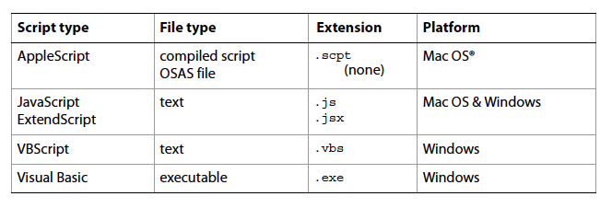

This script requires Adobe Photoshop to run as an application in the background. They do not act as and individual separate file format over an operating system.

Photoshop layer/ tree architecture

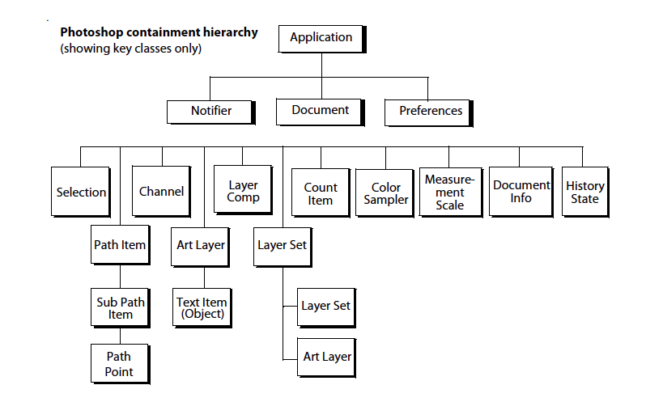

Risk Analysis

|  |  |  |  |  |  |  |
| --- | --- | --- | --- | --- | --- | --- |
| ID | Description | Area | Probability | Impact | Risk Selected | Contingency Plan |
| 1 | Fixed size document | Design | Good | Impact on final design to be responsive, scrolling or one page | Final output design would be | Assumption of fixed document size. |
| 2 | Similar layer names | Extraction | Max | On id assignment and division for CSS. |  | Assigning a number set to similar id or class definition. |
| 3 | Unconvertible PS effect | Design | High | Overall css design would be different than proposed |  | Assuming the nearest possible css effect to particular object. |

Implementation  
File named Mark_phase1.jsx has been added into the attachment within the folder of report contains implementation of extraction of properties of Document , ArtLayer, Layer tree,  
Channels, LayerSet, Application and TextItem.

GANTT CHART

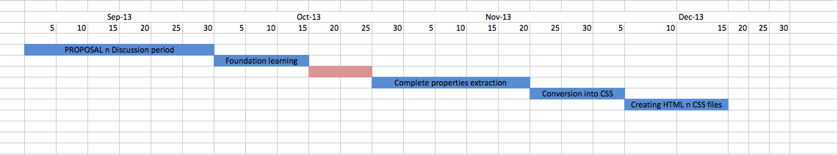

Gantt Chart explained:

1. Idea proposal and discussion (Sept 1 - Sept 30)
2. Basic idea implementation (Oct 1- Oct 15)
3. Complete Properties extraction from Photoshop file (Oct 25 - Nov 25)
4. Conversion of properties into respective CSS values (Nov 25 – Dec 5)
5. Creating HTML and CSS files (Dec 5 – Dec 15)

REFERENCES

1. Smashing magazine article on how to make first adobe script

<http://www.smashingmagazine.com/2013/07/25/introduction-to-photoshop-scripting/>

1. Official Adobe photoshop scripting Guide  
   <http://wwwimages.adobe.com/www.adobe.com/content/dam/Adobe/en/products/photoshop/pdfs/cs6/Photoshop-CS6-Scripting-Guide.pdf>
2. Official Adobe JavaScript reference  
   <http://wwwimages.adobe.com/www.adobe.com/content/dam/Adobe/en/products/photoshop/pdfs/cs6/Photoshop-CS6-JavaScript-Ref.pdf>
3. Article on adobe photoshop scripting by Creative droplets  
   <http://creativedroplets.com/tutorial-write-your-first-photoshop-script/>
4. JavaScript reference by W3schools  
   <http://www.w3schools.com/js/>
5. JavaScript reference by Mozilla  
   <https://developer.mozilla.org/en-US/docs/Web/JavaScript/Reference>