INTRODUCTION

1. GENERAL INSTRUCTION

PS2WEB is a Photoshop Script plugin to convert a Photoshop Document (PSD) into a html and CSS code used for standard static web page.

A Photoshop Script is an approach to automate Photoshop using its JavaScript object model. Photoshop Application Programming Index (API) allows user to use Photoshop object model to automate filters, functionalities and effects or convert a document into various format. PS2WEB, once called, extracts all the information from the PSD file and converts the possible effect into its HTML and CSS code and lately combine it all to complete a static webpage design.

PS2WEB is an open-source, which let users to use it for free and modify it as per their own requirement or designing pattern.

1. RELEVANT, CURRENT AND OPEN PROBLEMS

Currently available softwares for converting PSD to HTML or CSS contain either of one format or strip down total document as image and attach in web page in an inappropriate way. Old method doesn’t satisfy the responsive behavior various html tags and complete CSS effects. An old script doesn’t create a single page markup for webpage or relate different html tags with latest web features like header or footer.

1. PROBLEM STATEMENT

Graphic Designers generally complains about the proposed markup by them and the final design developed by the developer differ by various reason as various filters / effects available in PS are not available in web or the ratio of document to web page attributes if different. PS2WEB gives PSD designers freedom to design in the web friendly environment and convert it into responsive web page design while filling the gap between a developer and designer.

4. OVERVIEW OF PROPOSEDSOLUTION, APPROACH AND BENEFITS

PS2WEB will provide HTML code with CSS for particular Document in Photoshop, and download them in the same folder as PSD file. PS2WEB will be beneficial in the following ways:

1. Converting PSD into CSS with absolute positioning and size ratio to adjust the responsive behavior.
2. Creating respective HTML files for better compatibility
3. Using classes fir CSS, leaving ids for JavaScript functioning.
4. Optimization of CSS for minimal code.

**BACKGROUND STUDY**

* 1. LITERATURE SURVEY

2.1.1 SUMMARY OF TOOLS STUDIED

1. Photoshop Scripting API

Summary: Photoshop scripting API is Photoshop object model representation and function declaration guide. Completely written and very badly designed guide for API makes it very difficult to read and extract information.

1. Photoshop Scripting Reference

Summary: Photoshop scripting reference is guide for making plugin attached on the top layer of Photoshop to permit access to the document and its content.  
designed in Apple script for Mac, Visual Basic for Windows and JavaScript for cross platform.

Link: http://www.adobe.com/devnet/photoshop/scripting.html

1. ART in Information age by EA Shanken (paper)

Summary: This paper Suggest the method and ways evolved in the field of art due to information and technology. A new trend of Digital world has been form and a domain of digital art has been developing. Effect of non-paper art and effect of social media in its expansion has been a boom to art.

Link address: -

[https://www.google.co.in/url?sa=t&rct=j&q=&esrc=s&source=web&cd=1&cad=rja&ved=0CCoQFjAA&url=http%3A%2F%2Finfodate.nctu.edu.tw%2Fteaching%2Fpa..%2Flessons%2Fweek14%2F10art%2520in%2520the%2520information%2520age.pdf&ei=-0SBUtq-LIiSrgeEl4CoBQ&usg=AFQjCNHDsmT3x-4EFE5j23t3NpoGVj29CA&sig2=O5aStYIMCXHnTVtXGlCUkA&bvm=bv.56146854,d.bmk](https://www.google.co.in/url?sa=t&rct=j&q=&esrc=s&source=web&cd=1&cad=rja&ved=0CCoQFjAA&url=http%3A%2F%2Finfodate.nctu.edu.tw%2Fteaching%2Fpa..%2Flessons%2Fweek14%2F10art%2520in%2520the%2520information%2520age.pdf&ei=-0SBUtq-LIiSrgeEl4CoBQ&usg=AFQjCNHDsmT3)

1. Information technology and art concepts by SU Ahmed

Summary: Similar to previous page this paper also explain the importance of IT in Art and its expansion

Link address: - [https://www.google.co.in/url?sa=t&rct=j&q=&esrc=s&source=web&cd=4&cad=rja&ved=0CEkQFjAD&url=http%3A%2F%2Fciteseerx.ist.psu.edu%2Fviewdoc%2Fdownload%3Fdoi%3D10.1.1.159.3379%26rep%3Drep1%26type%3Dpdf&ei=-0SBUtq-LIiSrgeEl4CoBQ&usg=AFQjCNEYpyjkLhnNKISBvnw-eS21_7kMcA&sig2=fsqM4PRgA1nqoe6cax67Ow&bvm=bv.56146854,d.bmk\](https://www.google.co.in/url?sa=t&rct=j&q=&esrc=s&source=web&cd=4&cad=rja&ved=0CEkQFjAD&url=http%3A%2F%2Fciteseerx.ist.psu.edu%2Fviewdoc%2Fdownload%3Fdoi%3D10.1.1.159.3379%26rep%3Drep1%26type%3Dpdf&ei=-0SBUtq-LIiSrgeEl4CoBQ&usg=AFQjCNEYpyjkLhnNKISBvnw-eS21)

1. Wikipedia article on Digital Art

Summary: Digital art is a general term for a range of artistic works and practices that use [digital technology](http://en.wikipedia.org/wiki/Digital_technology) as an essential part of the creative and/or presentation process. Since the 1970s, various names have been used t o describe the process including [computer art](http://en.wikipedia.org/wiki/Computer_art) and multimedia art, and digital art is itself placed under the larger umbrella term [new media art](http://en.wikipedia.org/wiki/New_media_art)

Web link: <http://en.wikipedia.org/wiki/Digital_art>

2.1.2 INTEGRATED SUMMARY OF LITERATURE STUDIED

The basic aim of the tools and literary work was to gain the knowledge of importance of Gap of execution between a designer and a web developer and need of a tool to remove it. The Photoshop API and reference makes it much easier to understand the working of Photoshop and modify or automate its functionality for better productivity.   
While the research papers and all the literature above gives importance of digital media for better content on web and bringing the artwork to digital world. Conversion into CSS required a deep knowledge of CSS and HTML and was supported through various known and unknown sources like stack Overflow question answers, W3schools and other web tutorial.

2.1.3 COMPARISION WITH EXISTING APPROACHES

|  |  |  |
| --- | --- | --- |
| **PS2WEB** | **CSS3PS** | **CSSHAT** |
| Complete HTML and CSS code | Only CSS code | Only CSS |
| Complete document conversion | Complete document conversion | Only selected layers are converted into css |
| Responsive behavior with code in html and CSS mutually connected file | CSS code to be carried out at the clipboard | CSS code copied to clipboard |
| CSS code generated with class and connected with html | No class declaration | Class declaration |
| Code optimization | No optimization | No |
| Open Source | Costly with one free trial | No free trial and costly |

**3. ANALYSIS, DESIGN AND MODELLING**

**3.1 REQUIREMENTS SPECIFICATIONS**

❖ **Hardware Requirements:**

▪ Personal Computer/Laptop.

▪ Internet

❖ **Software Requirements:**

▪ WINDOWS/ IOS operating system

▪ ADOBE PHOTOSHOP CS5+

**3.2 FUNCTIONAL AND NON-FUNCTIONAL REQUIREMENTS**

1_**Functional Requirements:**

* Effects Created by user must be available in CSS for conversion into CSS
* Classes are defined as the name of layers so it should not contain special character or individual numbers.
* Layer effects must not contain element non-described or irrelevant to the format of web.

2 _**Non-Functional Requirements:**

* Error Handling: Product handles expected and non-expected errors such as irrelevant and inappropriate nomenclature by providing alternatives for them.
* Performance Requirements:

o Response Time: The processing of the results i.e. fetching and converting should be done very fast.

o Workload: single File /document is converted once with limited processing speed.

o Scalability: It is a software based service so can be used at windows/ iOS platform with standard supporting latest Adobe Photoshop CS.

* Better hardware for fast processing.

**3.3 OVERALL ARCHITECTURE WITH COMPONENT DESCRIPTION AND DEPENDENCY DETAILS**

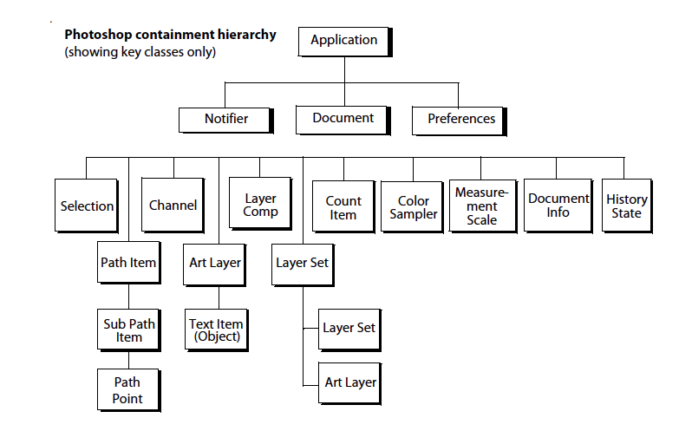

**3.4 DESIGN DOCUMENTATION**

* + 1. **USE CASE DIAGRAM**

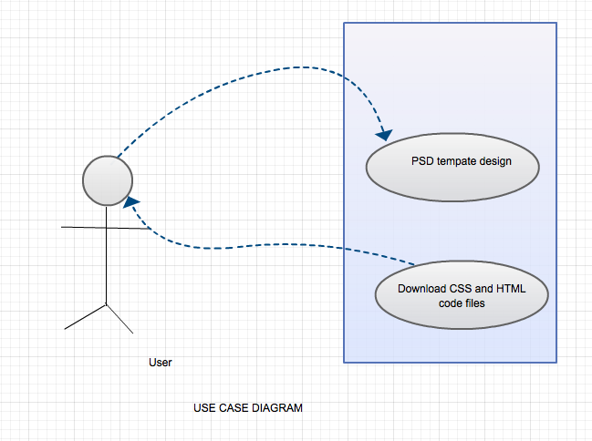

* + 1. 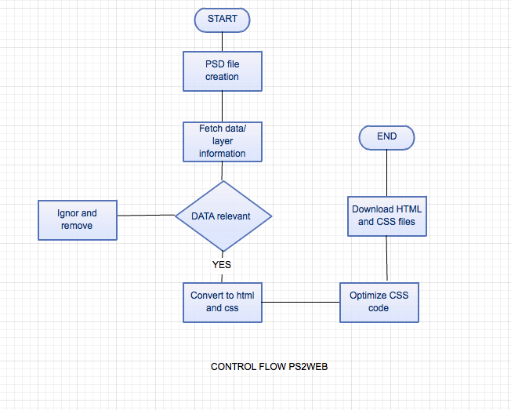**CONTROL FLOW DIAGRAM**
    2. **ACTIVITY DIAGRAMS**

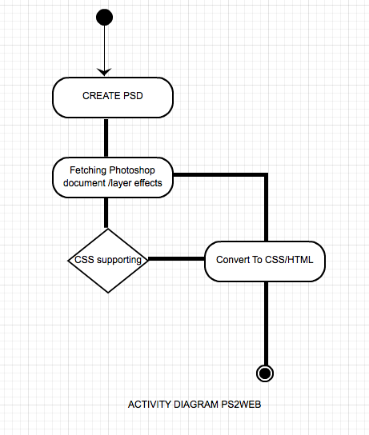

**3.5 RISK ANALYSIS AND MITIGATION PLAN**

|  |  |  |  |  |  |  |
| --- | --- | --- | --- | --- | --- | --- |
| ID | Description | Area | Probability | Impact | Risk Selected | Contingency Plan |
| 1 | Fixed size document | Design | Good | Impact on final design to be responsive, scrolling or one page | Final output design would be | Assumption of fixed document size. |
| 2 | Similar layer names | Extraction | Max | On id assignment and division for CSS. |  | Assigning a number set to similar id or class definition. |
| 3 | Unconvertible PS effect | Design | High | Overall css design would be different than proposed |  | Assuming the nearest possible css effect to particular object. |

**4.IMPLEMENTATION AND TESTING**

**4.1 IMPLEMENTATION DETAILS AND ISSUES**

1. Fetching:

1. Fetching Application layer information
2. Fetching document information
3. Fetching layer types and respective effects

2. converting to HTML

1. text is converted to <p> tag and other as shown in the table below

|  |  |
| --- | --- |
| TAG | COVERTED to |
| Text | <p> |
| Image | <img> |
| Rectangle | <div> |
| Solidfill | <div> |
| Document name | <title> |
| Layername | Class name |

3. Converting to CSS

1. Converting following information into css syntax

* Font-size
* Font family
* Position
* Width of div
* Height of div
* Orientation
* Border
* Line height
* Font color
* Opacity

**ISSUES:**

1. font-size and font family function do not respond for multiple size in same paragraph or multiple font in same text filed.
2. Shadow function only available with length, color and few parameters.
3. Similar layers name/ numerical naming causes effect to non-functional in css.
4. Outer layer not in layer set does not get included in html.

**4.1.1 PROPOSED SOLUTIONS**

1. Keep same font family and size while designing in psd
2. Keep nomenclature to be in context of class name i.e non numerical and space free.
3. Keep all layer in layerset.

**4.2TESTING**

**4.2.1 TESTING PLAN**

|  |  |  |  |  |
| --- | --- | --- | --- | --- |
| **Sr. No.** | **Types of Test** | **Will test be performed?** | **Comments/Explanations** | **Software Component** |
| 1. | Requirement Testing | Yes | All appropriate API’s are installed. | To be tested on OS. |
| 2. | Unit Testing | Yes | Software units tested on multi platforms. | To be tested on the user side. |
| 3. | Integration | Yes | Successful software integration on Windows and mac operating systems. | The client script tested on different devices. |
| 4. | Performance | Yes | Server responds to any conversion in minimal time. | To be tested on the software side. |
| 5. | Stress | Yes | Able to convert all tags | To be tested on Adobe PS. |
| 6. | Compliance | Yes | In compliance with the existing competition needs. | Suite to be tested and compared with existing technologies. |
| 7. | Security | No | - | - |
| 8. | Load | No | Software allows multiple users to request at same time. | To be tested on user’s threading component. |
| 9. | Space | Yes | Results for all the layers on PS are processed. | On Photoshop. |
| 10. | Interface | No | - | - |

**TEST TEAM DETAILS**

|  |  |  |
| --- | --- | --- |
| **Role** | **Name** | **Specific Responsibilities/Comments** |
| Fetching layer information | Harsh Bhatia | Test fetching all components of PSD. |
| converting | Harsh Bhatia | Test converting every effect. |

**TEST ENVIRONMENT Software Items:**

1) Operating systems used:

Mac operating system( iOS-lion10.8.1)

**Hardware Items:**

The only hardware is computer systems.

1. 2 GB or higher RAM
2. Graphic Card with 1GB internal memory
3. Processor 1.9 GHz or higher.

**4.2.2 COMPONENT DECOMPOSITION &TYPE OF TESTING REQUIRED**

|  |  |  |  |
| --- | --- | --- | --- |
| **Sr. No** | **Components**  **(modules) that require**  **Testing** | **Type of Testing Required** | **Technique for writing test cases** |
| 1. | Plugin inclusion API testing | Requirement Testing, Compliance | Black Box |
| 2. | Application, Layer and Document effect fetching | Performance, Stress, Load and Space Testing | Black Box |
| 3. | Conversion into css and HTML | Performance, Load, and Space Testing | Black Box |
| 4. | Correctness of Results | Unit Testing, compliance | Black Box |

Table 5:- Component Decomposition and Type of Testing Required

**4.2.3 TEST CASES**

1. Only Text layer in one document

|  |  |  |  |  |  |  |  |
| --- | --- | --- | --- | --- | --- | --- | --- |
| |  | | --- | | **Test Case ID** | | |  | | --- | | **Input** | | |  | | --- | | **Expected Output** | | |  | | --- | | **Status** | |
| 1. | Fetching text effect and function | Successful run | Pass |
| 2. | Conversion and display | Successful run | Pass |

1. Only Image in one Document.

|  |  |  |  |  |  |  |  |
| --- | --- | --- | --- | --- | --- | --- | --- |
| |  | | --- | | **Test Case ID** | | |  | | --- | | **Input** | | |  | | --- | | **Expected Output** | | |  | | --- | | **Status** | |
| 1. | Fetching image effect and function | Successful run | Pass |
| 2. | Conversion and display | Successful run | Pass |

1. Large file with simple combinations of text and image

|  |  |  |  |  |  |  |  |
| --- | --- | --- | --- | --- | --- | --- | --- |
| |  | | --- | | **Test Case ID** | | |  | | --- | | **Input** | | |  | | --- | | **Expected Output** | | |  | | --- | | **Status** | |
| 1. | Fetching text and image effect and function | Successful run | Pass |
| 2. | Conversion and display | Successful run | Pass |

1. Only rectangle/shape in file

|  |  |  |  |  |  |  |  |
| --- | --- | --- | --- | --- | --- | --- | --- |
| |  | | --- | | **Test Case ID** | | |  | | --- | | **Input** | | |  | | --- | | **Expected Output** | | |  | | --- | | **Status** | |
| 1. | Fetching div effect and function | Successful run | Pass |
| 2. | Conversion and display | Successful run | Pass |

5. Table for Irregular Inputs/Queries

|  |  |  |  |  |  |  |  |
| --- | --- | --- | --- | --- | --- | --- | --- |
| |  | | --- | | **Test Case ID** | | |  | | --- | | **Input** | | |  | | --- | | **Expected Output** | | |  | | --- | | **Status** | |
| 1. | Multiple text –size and font value | Fetching of font size and element | Fail |
| 2. | Conversion into css and html | Conversion after fetching | Fail |

Table:-Table for Correctness of Results

|  |  |  |  |  |  |  |  |
| --- | --- | --- | --- | --- | --- | --- | --- |
| |  | | --- | | **Test Case ID** | | |  | | --- | | **Input** | | |  | | --- | | **Expected Output** | | |  | | --- | | **Status** | |
| 1. | Multiple text –size and font value | Fetching of font size and element | 1. case failed for multiple entries 2. Working well on single output |
| 2. | Conversion into css and html | Conversion after fetching | Successfully converting single value function. |

1. **FINDINGS AND CONCLUSION**
   1. **FINDINGS**

* We can not convert all the Photoshop effect to web as Photoshop has a very rich designing library designed for itself. Web needs to improve further to get all the features into html and css.
* We Cannot add other js libraries to Photoshop to convert a new software or application
* Photoshop has several layers type n that has to be converted into div or section tag of html and hence limiting the functionality.
* Apple script and Visual Basic cannot work on both operating system while js single file without any changes in function runs perfectly on both.
* Photoshop library is rich and can be converted for automated for better use in web using various plugins or scripts.
  1. **CONCLUSION**

PS2WEB is an excellent script and can be used for removing the gap between a graphic designer and a developer. It can be used to increase productivity by minimizing the time to code and making developer friendly design.PS2WEB can be use to create single buttons or text format or shadow design and its css code can be used to add into existing code of a website. Pre-design conversion and possible effect into css and html of a PSD file, can be found out using this script.

**5.3 FUTURE WORK**

* Converting Shadow functionalities to css with limited effects.
* Removing limitation of code by layerset to free layer extraction
* Use of all HTML tags (currently very few) for positioning
* Optimizing CSS and renaming layer with specific class name for less code
* Importing external libraries for special effect
* Adding hover in layer effect for css animation and transition.

**REFERENCES**

1. Smashing magazine article on how to make first adobe script,25th july 2013

“<http://www.smashingmagazine.com/2013/07/25/introduction-to-photoshop-scripting/>”

1. Official Adobe photoshop scripting Guide,  
   “<http://wwwimages.adobe.com/www.adobe.com/content/dam/Adobe/en/products/photoshop/pdfs/cs6/Photoshop-CS6-Scripting-Guide.pdf> ”
2. Official Adobe JavaScript reference,  
   “<http://wwwimages.adobe.com/www.adobe.com/content/dam/Adobe/en/products/photoshop/pdfs/cs6/Photoshop-CS6-JavaScript-Ref.pdf>”
3. Article on adobe photoshop scripting by Creative droplets,12th December 2012,  
   “<http://creativedroplets.com/tutorial-write-your-first-photoshop-script/>”
4. JavaScript reference by W3schools,“<http://www.w3schools.com/js/>”
5. JavaScript reference by Mozilla,“<https://developer.mozilla.org/en-US/docs/Web/JavaScript/Reference>”

**APPENDICES**

1. **GANTT CHART**

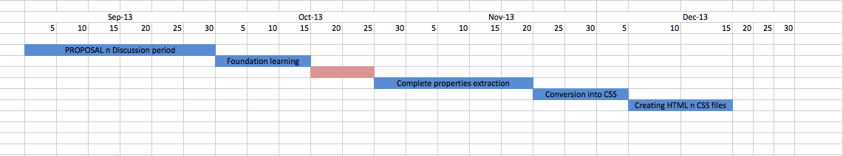

Gantt Chart explained:

1. Idea proposal and discussion (Sept 1 - Sept 30)
2. Basic idea implementation (Oct 1- Oct 15)
3. Complete Properties extraction from Photoshop file (Oct 25 - Nov 25)
4. Conversion of properties into respective CSS values (Nov 25 – Dec 5)
5. Creating HTML and CSS files (Dec 5 – Dec 15)

**BRIEF RESUME**

**HARSH BHATIA**

**Near Ankur Nursing Home, Sneh nagar, Takiya ward, Bhandara (MH)- 441904 harshbhatia296@gmail.com   
slashharsh@hotmail.com**

**OBJECTIVE :**

By enhancing my inherent features and acquired skills through team effort, continuous learning, sheer hard work, I want to achieve professional excellence for the upliftment of my organization.

**EDUCATION :**

***2006-2007 Maharishi Vidya Mandir, Bhandara(Maharashtra)***

Passed AISSCE 10th Board with 87%

***2008-2009 Central Academy, Kota(Rajasthan)***

Passed AISSCE 12th Board with 81%

***2010-Present Jaypee Institute of Information Technology, Noida(U.P.)***

Currently pursuing 4th year(7th sem) B-Tech degree Computer Science Engineering at Jaypee Institute of Information Technology, Noida (U.P.) with CGPA 7.0.  
Expected graduation date May-2014.

**INDUSTRIAL TRAINING :**

Internship cum training in The Fingo (thefingo.com), for duration of 6 weeks on Django website development and Testing. Creation of a continuous integration build-bot for test-driven-development.

**PROJECTS UNDERTAKEN :**

* [**Www.harshbhatia.net**](http://Www.harshbhatia.net)

Personal website design for sketch display and portfolio display.

* **Sharpy:**

A File sharing application for users on local connected network in python.

Users can control on access of contents and notified of changes in particular file.

* **Color Mouse**

An OpenCV based application uses webcam to detect red and blue color to control mouse cursor. The application also performs primary mouse task of right and left click.

* **Click Pic**

An application using OpenCV library to edit live stream into various format and filters. This app allows user to click and save pictures in all of filters.

* **Mélange : Static Website Builder**

A static webpage builder designed in html, Jquery, Object oriented JavaScript, equipped with latest css3 and html5 effects. The website allows user to create webpage by simple drag and drop element and gives a freedom to download the source code into their local storage**.**

* **Image Razor:**

An Image editing tool in JAVA language with simplest graphical-user-interface. This software allows user to convert an image into different types using 25 various image-filters.

* **Sickliness Reference Data Labs**

A medical database website(on local server) under database management for doctors on various diseases using PHP, Html and fully functional css3. This website serves as a data reference to doctors to answer different queries related to diseases, their symptoms, cure etc.

* **Sudoku Solver**

A user friendly Sudoku solver in C( intermediate level) using data structures and graphics.

* **Writing-pad**

A Google-chrome-extension for saving notes, links and passwords etc.  
No sign up is required as this project uses latest HTML5 function of local storage to store the data into users computer, the data stays in the writing pad even after the session completion or shutdown.

* **TIC-TAC-TOE**

A Two player traditional tic-tac-toe(cross-O) game in C language.

**ACHIEVEMENTS :**

* Volunteered in International Conference of Contemporary Computing -2012 held at Jaypee Institute of Information Technology, Noida.
* Participated in the "The Noble Conclave:Apoogee-2012" at BITS Pilani.
* Organized "Roopantar" : Artwork Exhibition of Personal Pencil sketches in collaboration with other artist at the annual fest in College.
* Awarded for highest marks and cent-percent in math subject in school in 10th class.
* Student Member of Creative society of college.
* Awarded various prizes in Drawing at district level.

**SKILLS And HOBBIES**  :

* C/C++,Python,HTML,CSS3, JavaScript
* Pencil sketching with different graphite pencils.

(Face-book fan page : " https://www.facebook.com/Harsh.BhatiaOfficial")

* Badminton and lawn Tennis
* Paper engineering and creative artwork