Disaster Response Tweet Triage
AI-Based Crisis Informatics Using Natural Language Processing
Project Progress Report
Submitted by
Krrish Chanchal (23CSB0B06)
Shashank Dixit (23CSB0B07)
Shubh Gupta (23CSB0F33)
5 October 2026

Contents

1. Summary
This report describes the progress of our project on automatically sorting disaster-related tweets into categories that are useful to emergency responders. It is written so that it can be read without any earlier knowledge of the project; technical terms are explained where they first appear and again in the glossary at the end.
What we set out to do. Build a system that reads a tweet posted during a disaster and assigns it to one of ten humanitarian categories, such as infrastructure damage, urgent requests, or injured people.
What was asked of us. After the proposal presentation we were given two directions: (1) the project should contain something new and should not stop at fine-tuning BERT or a Twitter-specific BERT, and (2) the model should understand context, so that it can tell "the bridge collapsed in the flood" apart from "the bridge is closed for construction work".
What we have done so far.
- Set up the full working environment: a shared code repository on GitHub and GPU training on Kaggle, with live monitoring of every training run.
- Downloaded and analysed the HumAID dataset (76,484 labelled tweets from 19 disasters).
- Trained and evaluated three reference models (baselines): TF-IDF with Logistic Regression, BERT, and Twitter-RoBERTa.
- Measured how the simplest baseline behaves on a disaster type it has never seen.
- Built a small first test of the "bridge" problem and ran all three baselines on it.
Main findings so far.
- The best baseline (BERT) reaches a macro-F1 score of 0.766 on the standard test set. Twitter-RoBERTa is effectively equal at 0.761, and the simple TF-IDF model reaches 0.730.
- On our ten-sentence context test, none of the three baselines handles routine construction and maintenance messages reliably. BERT and Twitter-RoBERTa label three of the four routine sentences as infrastructure damage. This supports the concern raised about context, and shows it is not solved by using a stronger standard model.
- We believe the reason is in the data and not the model: the dataset contains only tweets collected during real disasters, so a model trained on it never sees ordinary construction or maintenance messages.
What comes next. We will build a dedicated "confounder" test set of sentence pairs that share words but differ in meaning, and a model designed to separate them. The approach is described in Section 4 and the plan in Section 10. This part is planned and has not been built yet.

2. Background and motivation
When an earthquake, flood, hurricane or wildfire strikes, people post very large numbers of messages on social media. Some of these messages contain information that responders can act on: a road that is blocked, people who are trapped, a shelter that needs water. Many others are prayers, news commentary, jokes or unrelated chatter. No emergency team can read all of them by hand while the disaster is unfolding.
"Triage" is a term from emergency medicine: sorting patients by how urgently they need attention. Tweet triage applies the same idea to messages. A computer program reads each tweet and assigns it to a category, so that a responder interested in, say, infrastructure damage sees only the tweets about infrastructure damage.
This is a task in Natural Language Processing (NLP), the field of making computers work with human language. More precisely it is a text classification task: the input is a piece of text and the output is one label chosen from a fixed list.
Three things make this task difficult:
- Noisy text. Tweets contain spelling mistakes, abbreviations, hashtags, links and informal language.
- Class imbalance. Some categories have very many examples and others very few. A model can score well overall while ignoring the rare categories, which are often the most urgent.
- Domain shift. The vocabulary of a flood is different from that of a wildfire. A model trained on some disasters may do worse on a new kind.
To these we add a fourth, which came from faculty feedback and has become the centre of our project:
- Context confusion. Everyday messages about construction, repair or maintenance use the same words as disaster reports ("bridge", "closed", "blocked", "power lines", "collapsed"). A triage system that raises an alarm for routine roadworks is of little use.

3. Problem statement and feedback received

3.1 Problem statement
Given the text of a single tweet, assign it to exactly one of ten humanitarian categories. This is called multi-class classification because there are more than two possible answers. The ten categories are fixed by the dataset and are listed below with a plain-language description.
Category | What it covers | Tweets
Rescue, volunteering or donation effort | Rescue operations, volunteers, fundraising and donations | 21,278
Other relevant information | Related to the disaster but fitting no other category | 12,144
Sympathy and support | Prayers, condolences and emotional support | 8,931
Infrastructure and utility damage | Damaged buildings, roads, bridges, power or water supply | 8,163
Injured or dead people | Reports of casualties | 7,303
Not humanitarian | Not useful for humanitarian response | 6,296
Caution and advice | Warnings, alerts and safety tips | 5,394
Displaced people and evacuations | People leaving or being moved from their homes | 3,999
Requests or urgent needs | Requests for food, water, shelter, medical help | 2,618
Missing or found people | Reports of people who are missing or have been found | 358
Table 1. The ten categories and the number of tweets in each (whole dataset).
Correction to our proposal slides. The slides listed 11 categories, including "Don’t know / can’t judge". The released dataset contains 10; that eleventh label does not appear in it. We will correct the slides.

3.2 Feedback from the proposal presentation
Our original proposal was to compare three models: TF-IDF with Logistic Regression, BERT, and a Twitter-specific transformer. Two points were raised:
- Novelty. Fine-tuning BERT or Twitter-BERT is standard practice and is not a contribution by itself. The project should go beyond it with something more advanced or new.
- Context discrimination. The model should be able to differentiate between a message such as "construction is going on and the bridge is not functional" and a message reporting that a disaster has happened.
We have reorganised the project around these two points. BERT and Twitter-RoBERTa remain in the project, but only as reference points that our own model must beat. The second point has become our main research question.

4. Our proposed approach
Status. This section describes what we plan to build. None of the four components below has been implemented yet. The work completed so far (Sections 5 to 8) prepares the ground and provides the evidence that this approach is needed.

4.1 The key observation
Every tweet in HumAID was collected during a real disaster, using keywords related to that disaster. This means the dataset contains no examples of ordinary, non-disaster messages that happen to use disaster vocabulary. A model trained on it learns a shortcut: words like "bridge", "blocked" and "power lines" mean infrastructure damage. It never has to learn the difference between a bridge that collapsed in a flood and a bridge that is closed for repainting, because it has never been shown the second kind.
We call such look-alike messages confounders. Using a larger or newer model should not remove the shortcut, because the shortcut comes from the training data. Our first results in Section 8.4 are consistent with this.

4.2 The four components
Component 1: a confounder challenge set. We will write, and verify by hand, a few hundred sentence pairs. Each pair uses nearly the same words, but one sentence reports a real disaster and the other does not. Examples of the kind we intend:
Real disaster report | Look-alike that is not a disaster
Bridge collapsed after the flood, vehicles stranded on both sides | Bridge closed for repair work till Monday, please use the alternate route
Road blocked due to landslide, several houses damaged | Road blocked due to metro construction work near the station
Power lines down across the town after the cyclone | Scheduled power cut tomorrow for maintenance of power lines
Building collapsed in the earthquake, people trapped inside | Old building being demolished today to make way for a new mall
The whole street is on fire, we need help | That concert was fire (figurative use)
Table 2. Examples of the sentence pairs planned for the confounder set.
The look-alikes will cover routine construction and maintenance, figurative language, reports of past events, and drills. One portion will be used to train the model. A separate portion will be kept only for testing and never shown during training, so that the test is fair. Candidate sentences may be generated with the help of a language model, but every sentence and label will be checked by the team.
Component 2: a more recent base model. Instead of BERT (released in 2018) we will build on a newer pretrained model, ModernBERT or DeBERTa-v3, and adapt it using LoRA, a technique that trains only a small fraction of the model’s parameters and so reduces training time and memory.
Component 3: two outputs and contrastive training. The model will answer two questions for every tweet. First: is this an actual, ongoing disaster event, a routine situation, or figurative language? Second: which humanitarian category does it belong to? In addition, we will train it with a contrastive objective: the model is explicitly rewarded for placing the two sentences of a look-alike pair far apart in its internal representation, even though their words are almost the same. This is the technical core of the project.
Component 4: event masking. Names of specific events and places (for example "Harvey" or "Kerala") will be replaced by a neutral placeholder during training. This prevents the model from memorising particular disasters and should help it on disasters it has not seen.

4.3 How we will judge success
Every model will be evaluated on three test beds:
- Standard test set. The official HumAID test tweets. This shows ordinary classification quality.
- Cross-disaster test. Train on three types of disaster and test on the fourth. This shows how well the model generalises.
- Confounder test set. Our own look-alike pairs. This shows whether the model understands context.
The result we are aiming for is a comparison in which the standard baselines do well on the first test but poorly on the third, while our model does well on both. We will also remove each component in turn (an ablation study) to show which ones actually contribute.

5. The dataset
We use HumAID (Human-Annotated Disaster Incidents Data), published by the Qatar Computing Research Institute in 2021. It contains tweets collected during 19 disasters between 2016 and 2019, each labelled by human annotators. We use the per-event release, which records which disaster each tweet came from; this is needed for the cross-disaster test.
Disaster type | Events | Tweets | Events included
Hurricane / cyclone | 7 | 45,253 | Irma, Harvey, Dorian, Maria, Florence, Matthew, Cyclone Idai
Flood | 4 | 11,166 | Kerala, Midwestern US, Maryland, Sri Lanka
Wildfire | 3 | 11,133 | California, Canada, Greece
Earthquake | 5 | 8,932 | Kaikoura, Puebla (Mexico), Pakistan, Ecuador, Italy
Total | 19 | 76,484
Table 3. Composition of the dataset by disaster type.
The dataset comes already divided into three parts, and we use this official division so that our numbers are comparable with published work:
Part | Tweets | Purpose
Training set | 53,531 | The model learns from these
Development set | 7,793 | Used during training to choose settings and the best version of the model
Test set | 15,160 | Used once at the end to report the final score; never seen during training
Table 4. The official split of the dataset.

6. Tools and working method
Where the training runs. Training modern language models needs a graphics processor (GPU). We use Kaggle Notebooks, a free service that provides an NVIDIA T4 GPU for about 30 hours per week per account. We chose it over Google Colab because sessions last longer, runs continue when the browser is closed, and results are stored with the run.
How code gets there. Code is written on our own computer and sent to Kaggle with a single command using Kaggle’s official command-line tool. The same command then shows the progress of the run line by line and downloads the results when it finishes. Nothing is copied and pasted by hand.
Monitoring. Every training run prints, every 100 steps, the current step, the loss (a measure of error; lower is better), the speed, and the estimated time remaining. This lets us see that training is healthy and predict when it will finish.
Keeping time low. We use mixed-precision arithmetic, short input lengths (tweets are short), and always test on 10% of the data first to catch errors cheaply. Each transformer baseline trained in about 13 minutes.
Version control. All code, results and figures are stored in a Git repository on GitHub (github.com/hash1ank/-disaster_triage) so that all three team members work from the same version. The repository contains a README that documents the project.

7. Work completed

7.1 Exploring the data
Before training anything we examined the dataset. The main observations:
- Strong class imbalance. The largest category (rescue, volunteering or donation effort) has 21,278 tweets; the smallest (missing or found people) has 358. That is a ratio of about 59 to 1.
- Uneven events. Hurricanes account for 45,253 of the 76,484 tweets. The largest event (Hurricane Irma, 9,399 tweets) is about 17 times the smallest (Sri Lanka floods, 560).
- Short texts. The median tweet is 19 words long and the longest is 99 words. This allows a short input length, which makes training faster.
- Very few duplicates. Only 6 tweet texts are repeated.
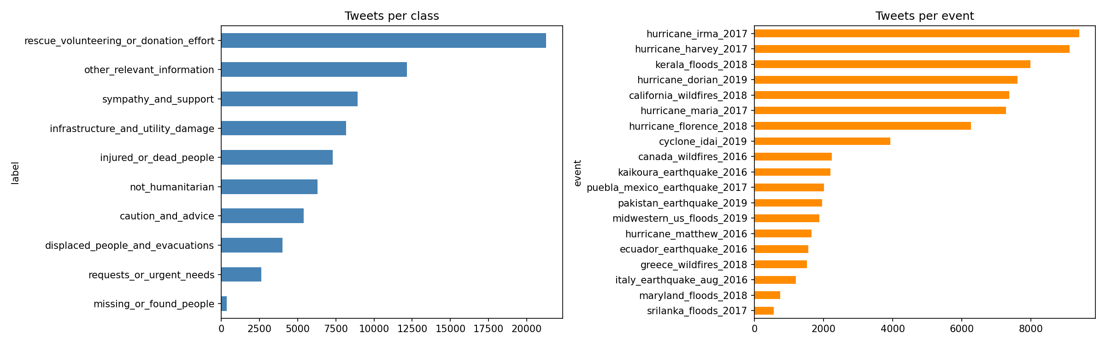
Figure 1. Number of tweets in each category (left) and from each disaster event (right).
We also checked how the mix of categories changes from one disaster type to another, because this is what causes domain shift:
- In earthquakes, 28.2% of tweets are sympathy and support; in the other three types this is around 9 to 10%.
- In floods, 49.0% of tweets are about rescue, volunteering or donations; in the others, about 23 to 24%.
- In wildfires, 21.9% of tweets report injured or dead people; in floods only 4.2%.
- Displaced people and evacuations make up about 7% of hurricane and wildfire tweets but 1% or less of earthquake and flood tweets.
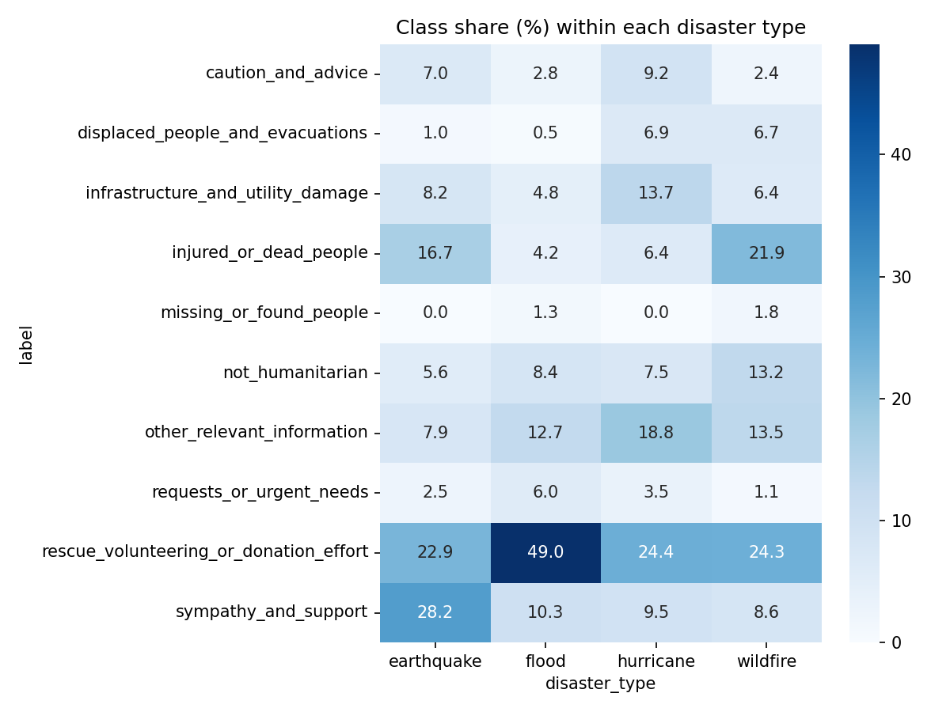
Figure 2. Share of each category (in %) within each disaster type. Each column adds up to 100.

7.2 Preparing the text
We apply only light cleaning: web links are replaced by a placeholder, user mentions (@name) are replaced by a generic "@user", the "RT" retweet marker is removed, and extra spaces are collapsed. We deliberately keep hashtag words, emojis and punctuation, since modern language models can use them.

7.3 Baseline 1: TF-IDF with Logistic Regression
This is the classical approach and our simplest reference point. TF-IDF turns each tweet into a list of numbers by counting its words and short character sequences, giving more weight to terms that are distinctive. Logistic Regression then learns which terms point to which category. The model looks only at which words are present; it has no understanding of word order beyond pairs of adjacent words, and no understanding of meaning.
Settings: single words and word pairs, plus character sequences of length 3 to 5; categories weighted inversely to their size so that rare ones are not ignored. It runs on an ordinary processor without a GPU.

7.4 Baselines 2 and 3: BERT and Twitter-RoBERTa
These are transformer models: large neural networks that have already been trained on huge amounts of text to learn general language patterns, and which read a whole sentence in context. BERT was pretrained on books and Wikipedia. Twitter-RoBERTa has a similar design but was pretrained on tweets, so it is already familiar with informal language. "Fine-tuning" means continuing the training of such a model on our labelled tweets so that it learns our ten categories.
Both were fine-tuned with identical settings so that the comparison is fair:
Setting | Value
Passes over the training data (epochs) | 3
Tweets per training step (batch size) | 32
Learning rate | 0.00002, with warm-up then linear decrease
Maximum input length | 96 tokens
Handling imbalance | Class-weighted loss (weights dampened by a square root)
Model selection | Version with the best development-set macro-F1
Hardware and time | One Tesla T4 GPU; 12.5 min (BERT) and 13.7 min (Twitter-RoBERTa)
Table 5. Training settings for the two transformer baselines.

7.5 How we measure performance
- Accuracy is the fraction of tweets labelled correctly. With imbalanced data it can be misleading, because a model can score well by doing well only on the large categories.
- F1 score for a category combines two things: precision (of the tweets the model put in this category, how many belong there) and recall (of the tweets that belong in this category, how many the model found). It ranges from 0 to 1.
- Macro-F1 is the plain average of the F1 scores of all ten categories. Every category counts equally, however small. This is our primary metric, because rare categories such as urgent requests matter most in practice.
- Weighted-F1 averages the F1 scores in proportion to category size.
- Confusion matrix is a table showing, for each true category, where the model’s predictions went. It reveals which categories get mixed up.

8. Results

8.1 Overall performance on the official test set
Model | Accuracy | Macro-F1 | Weighted-F1
TF-IDF + Logistic Regression | 0.746 | 0.730 | 0.748
BERT-base | 0.782 | 0.766 | 0.779
Twitter-RoBERTa-base | 0.776 | 0.761 | 0.771
Table 6. Results on the 15,160 test tweets. Higher is better; the maximum is 1.
Two things stand out. First, the two transformers are effectively tied: the difference of 0.005 is too small to be meaningful from a single training run. The Twitter-specific pretraining gave no clear advantage here. Second, the gain from a transformer over simple word counting is modest, about 3.5 points of macro-F1. This suggests that much of the task is decided by vocabulary.

8.2 Performance for each category
Category | TF-IDF + LR | BERT | Twitter-RoBERTa
Injured or dead people | 0.906 | 0.926 | 0.925
Displaced people and evacuations | 0.875 | 0.891 | 0.884
Rescue, volunteering or donation | 0.838 | 0.874 | 0.867
Sympathy and support | 0.807 | 0.834 | 0.839
Infrastructure and utility damage | 0.798 | 0.820 | 0.822
Missing or found people | 0.737 | 0.786 | 0.789
Caution and advice | 0.664 | 0.717 | 0.708
Not humanitarian | 0.584 | 0.627 | 0.637
Requests or urgent needs | 0.550 | 0.619 | 0.615
Other relevant information | 0.538 | 0.562 | 0.522
Table 7. F1 score for each category on the test set, ordered from easiest to hardest.
All three models find the same categories easy and the same ones hard. Categories with a clear topic (casualties, evacuations) score around 0.9. The three weakest are "other relevant information", "requests or urgent needs" and "not humanitarian".
The confusion matrix for BERT (Figure 3) shows where the errors go:
- 21% of "not humanitarian" tweets are labelled "other relevant information". The boundary between "unrelated" and "related but unclassifiable" is hard for the model to find.
- "Other relevant information" is recognised only 51% of the time, with its errors spread over several categories. It is a catch-all category with no clear topic of its own.
- 16% of "requests or urgent needs" are labelled "rescue, volunteering or donation". A request for help and an offer of help use much the same words. This confusion matters in practice, because requests are the most actionable tweets.
- 11% of "missing or found people" are labelled "injured or dead people".
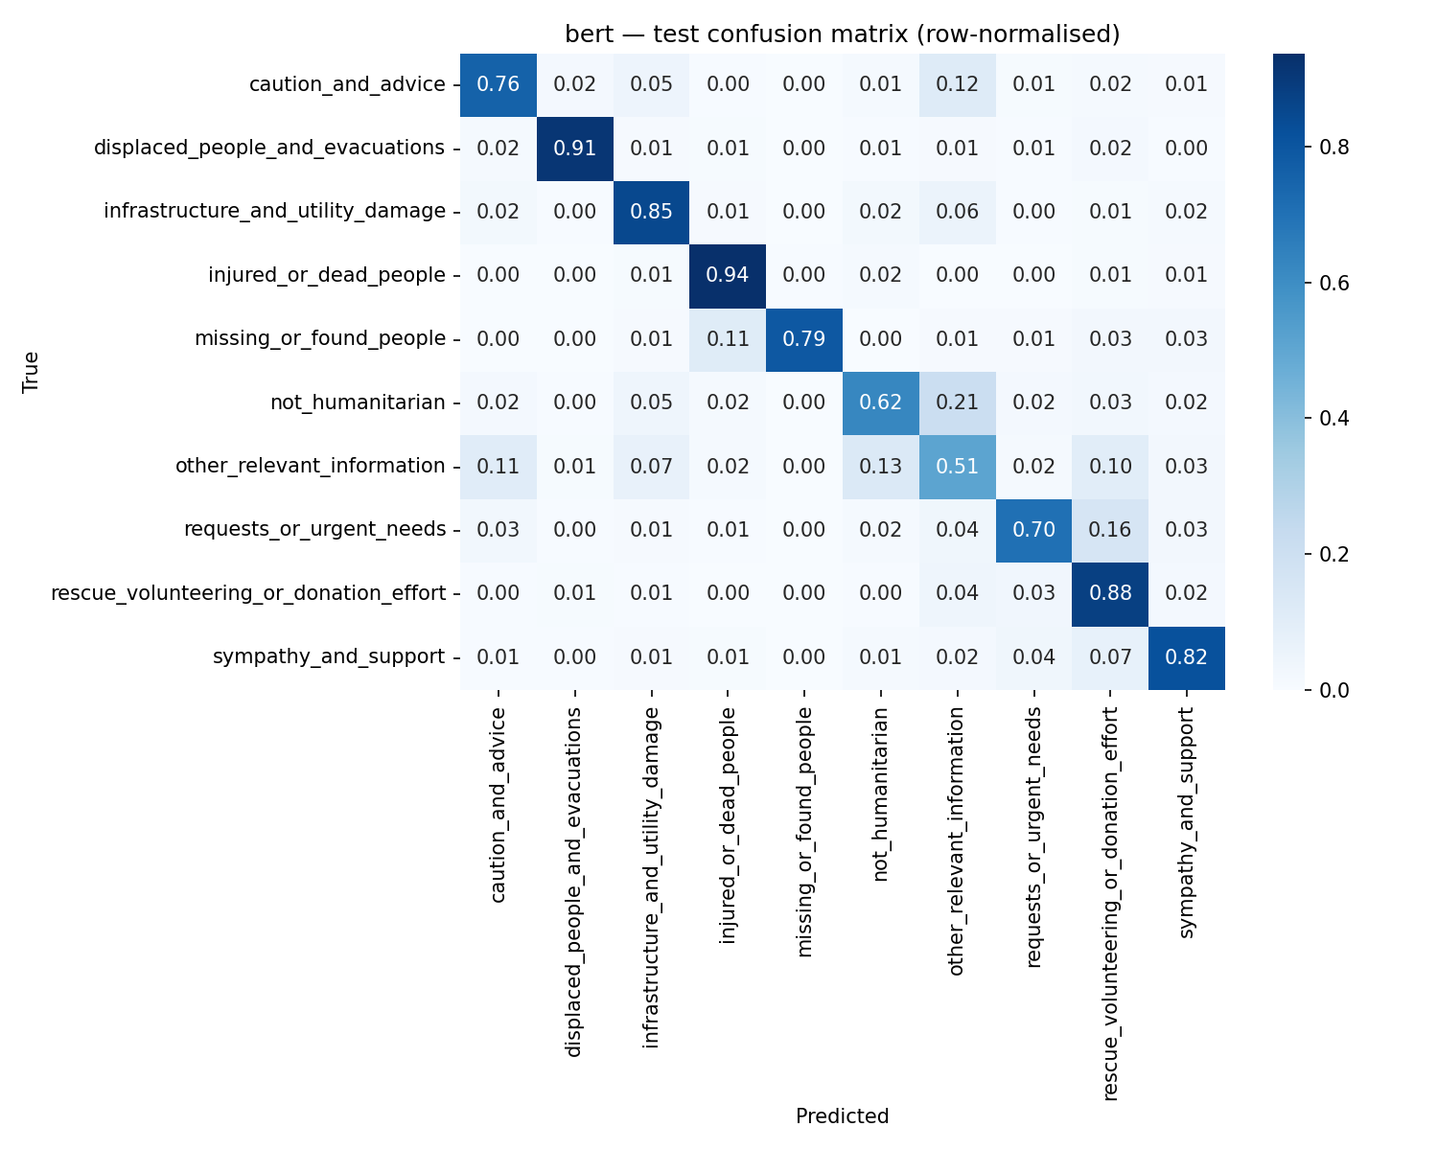
Figure 3. Confusion matrix for BERT on the test set. Each row shows how the tweets of one true category were labelled; the diagonal is the share labelled correctly.

8.3 Performance on an unseen type of disaster
To measure domain shift we trained the TF-IDF model on three disaster types and tested it on the fourth, which it had never seen. We compare this with its score on the same test tweets when that disaster type was included in training.
Disaster type held out | Macro-F1 when seen | Macro-F1 when unseen | Drop
Earthquake | 0.746 | 0.608 | 0.138
Flood | 0.654 | 0.577 | 0.077
Hurricane | 0.719 | 0.659 | 0.060
Wildfire | 0.679 | 0.619 | 0.060
Table 8. Cross-disaster results for the TF-IDF + Logistic Regression baseline.
The score falls for every disaster type, by 6 to 14 points. The largest fall is for earthquakes, where sympathy messages are far more common than in the other types (Figure 2). This confirms that domain shift is a real problem in this dataset.
Not yet done. This experiment has so far been run only for the TF-IDF baseline. Running it for BERT and Twitter-RoBERTa needs four further training runs per model and is planned.

8.4 The context test (first version)
To get an early look at the "bridge" problem, we wrote ten sentences: four real disaster reports, four routine construction or maintenance messages using similar words, and two figurative uses of disaster words. For the six non-disaster sentences the appropriate label is "not humanitarian". We then asked each trained baseline to label them.
Sentence | Type | TF-IDF + LR | BERT | Twitter-RoBERTa
Bridge collapsed after the flood, vehicles stranded on both sides | Real | Infrastructure damage | Infrastructure damage | Infrastructure damage
Bridge closed for repair work till Monday, please use the alternate route | Routine | Rescue / donation | Other relevant info | Caution and advice
Road blocked due to landslide, several houses damaged | Real | Infrastructure damage | Infrastructure damage | Infrastructure damage
Road blocked due to metro construction work near the station | Routine | Infrastructure damage | Infrastructure damage | Infrastructure damage
Power lines down across the town after the cyclone | Real | Infrastructure damage | Infrastructure damage | Infrastructure damage
Scheduled power cut tomorrow for maintenance of power lines | Routine | Other relevant info | Infrastructure damage | Infrastructure damage
Building collapsed in the earthquake, people trapped inside | Real | Infrastructure damage | Infrastructure damage | Infrastructure damage
Old building being demolished today to make way for a new mall | Routine | Not humanitarian | Infrastructure damage | Infrastructure damage
My exam today was a complete disaster | Figurative | Not humanitarian | Not humanitarian | Not humanitarian
That concert was fire, the crowd was flooding in | Figurative | Other relevant info | Not humanitarian | Not humanitarian
Table 9. Labels given by each baseline. For routine and figurative sentences, bold marks a correct answer.
What this shows:
- All three models label the four real disaster sentences correctly.
- Each model gets only two of the six non-disaster sentences right.
- BERT and Twitter-RoBERTa handle figurative language (both figurative sentences correct) but fail on every routine construction or maintenance sentence. Three of the four are labelled infrastructure damage, which in a real system would be a false alarm.
- Moving from word counting to a transformer did not help on the routine sentences.
How much weight to give this. Ten sentences written by us are a demonstration, not a measurement. The result is consistent with the concern raised by our faculty and with our explanation in Section 4.1, but a proper conclusion needs the full confounder set of several hundred verified pairs, which is the next piece of work.

9. Limitations of the work so far
- Each transformer was trained once, with one random seed. Small differences between models (such as BERT against Twitter-RoBERTa) should not be read as real. Final results will be averaged over three runs.
- The context test has only ten sentences.
- Cross-disaster evaluation has been done only for the TF-IDF baseline.
- No part of the proposed model (Section 4) has been built yet.
- The dataset is in English and covers disasters from 2016 to 2019; conclusions may not carry over to other languages or to newer social-media usage.

10. Plan for the remaining work
Step | Task | Status
1 | Environment, repository and Kaggle workflow | Done
2 | Data download and exploratory analysis | Done
3 | Baseline 1: TF-IDF + Logistic Regression, standard and cross-disaster | Done
4 | Baselines 2 and 3: BERT and Twitter-RoBERTa, standard test | Done
5 | Cross-disaster evaluation for BERT and Twitter-RoBERTa | Planned
6 | Confounder set: write and hand-verify several hundred sentence pairs | Next (manual work by the team)
7 | Newer base model (ModernBERT or DeBERTa-v3) with LoRA | Next
8 | Add the two outputs and contrastive training | Planned
9 | Add event masking | Planned
10 | Ablation study: remove one component at a time | Planned
11 | Final evaluation on all three test beds, three runs each | Planned
12 | Error analysis on real misclassified tweets | Planned
13 | Demonstration application and final report | Planned
Table 10. Project plan and current status.
We would welcome guidance on two points in particular: whether the confounder-set approach described in Section 4 is the kind of novelty expected, and whether the types of look-alike sentences we plan to include (routine construction and maintenance, figurative language, past events, drills) cover the cases you had in mind.

11. Glossary
Term | Meaning
Ablation study | Removing one part of a system at a time to see how much each part contributes.
Baseline | A simple or standard model used as a reference point that a new method must beat.
BERT | A widely used pretrained language model (2018) that reads a sentence in full context.
Class / category / label | One of the fixed answers the model can give for a tweet.
Class imbalance | Some categories having far more examples than others.
Confounder | A message that uses disaster vocabulary but does not report a disaster.
Confusion matrix | A table of true categories against predicted categories.
Contrastive training | Training that pushes the model to represent chosen pairs of inputs as far apart (or as close together) as possible.
Domain shift | A drop in performance when test data differs in kind from training data, such as a new disaster type.
Epoch | One complete pass over the training data.
Fine-tuning | Continuing the training of a pretrained model on a specific task.
GPU | Graphics processor; hardware that makes neural-network training fast.
LoRA | A method that fine-tunes a small number of added parameters instead of the whole model.
Macro-F1 | The plain average of per-category F1 scores; our primary metric.
NLP | Natural Language Processing: computer processing of human language.
Precision / recall | Precision: how many of the model’s picks for a category are right. Recall: how many of the true members it found.
TF-IDF | A way of turning text into numbers based on word counts, weighted by how distinctive each word is.
Train / development / test | Parts of the data used respectively to learn, to choose settings, and to report final scores.
Transformer | The neural-network design behind BERT and similar models.
Twitter-RoBERTa | A BERT-like model pretrained on tweets.

