I233099
SE-A
Hasham Munawar

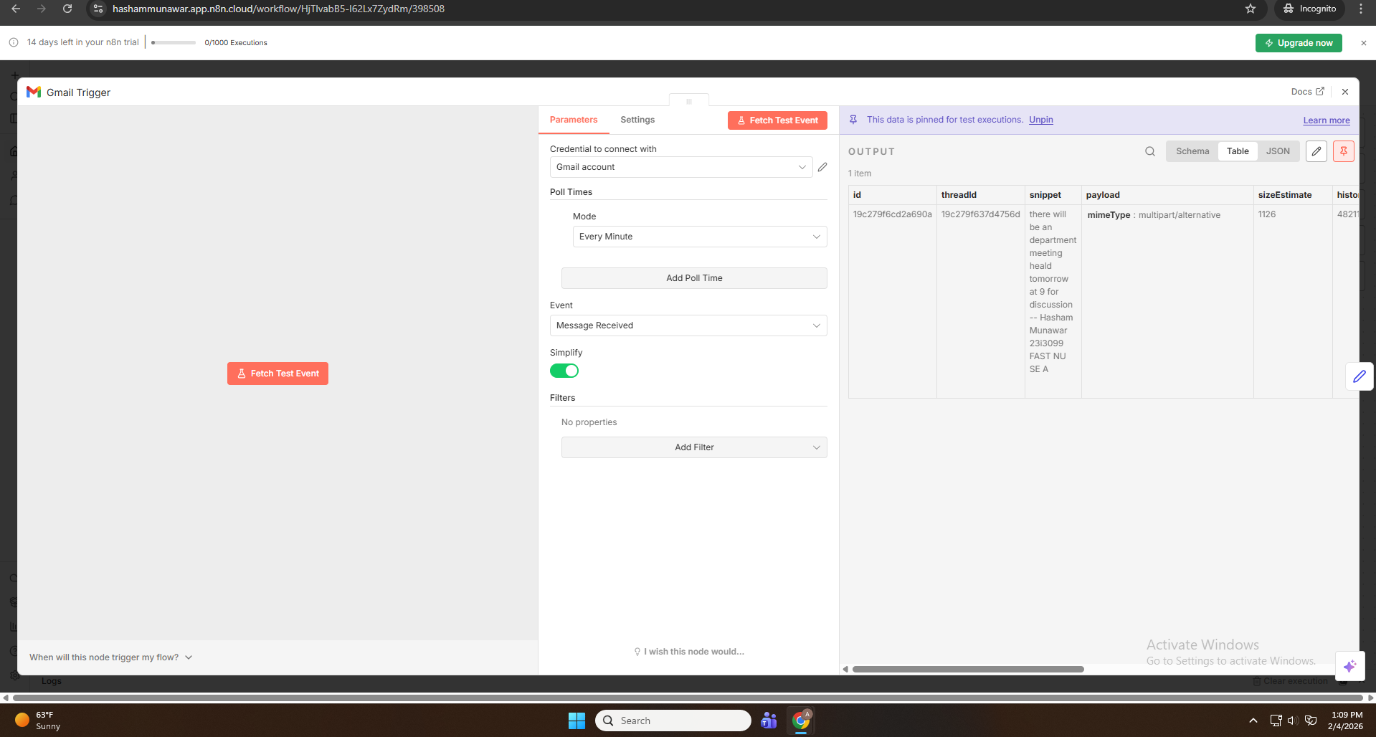
Added Gmail Trigger node
Connected instructor’s Gmail account
Configured trigger to watch new inbox messages only

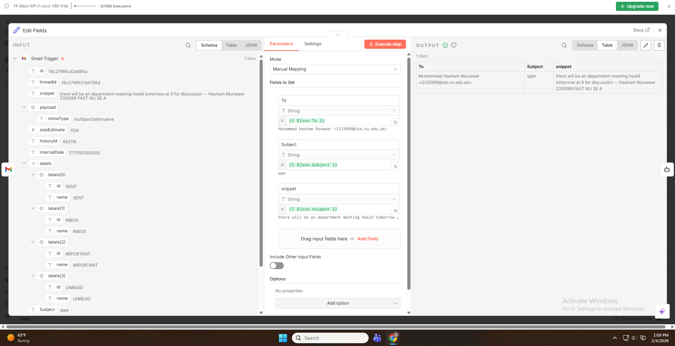

Subject
Email snippet (used as body)
Sender address

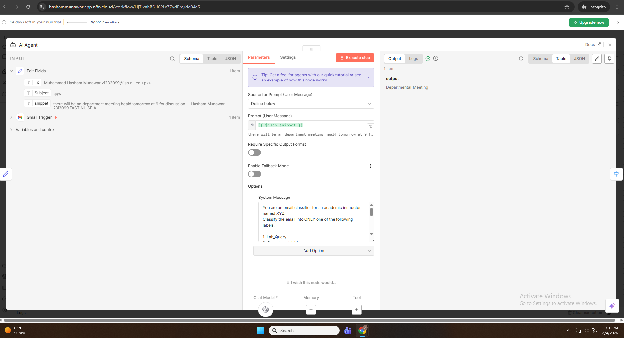

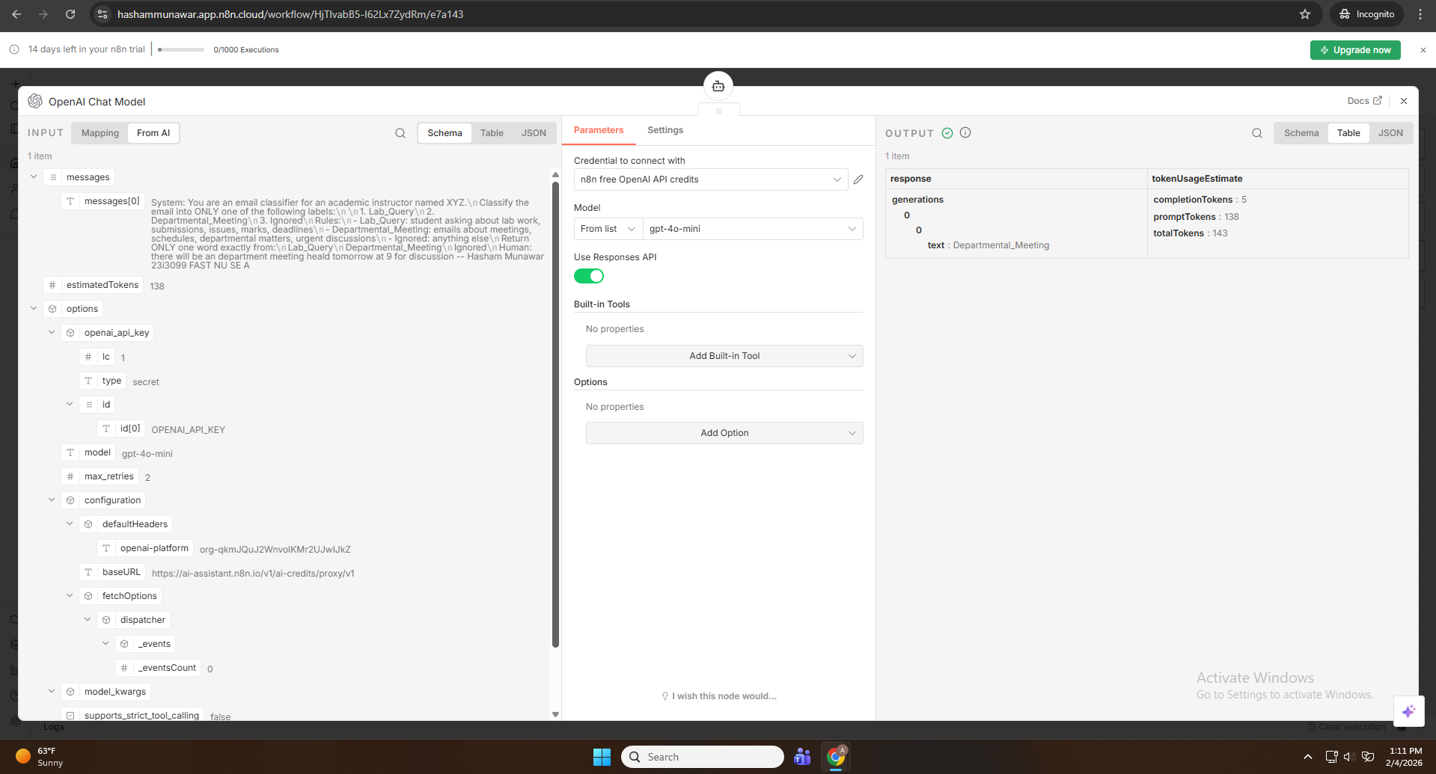
Gave given prompt in manual top open ai mini 4.0 model.

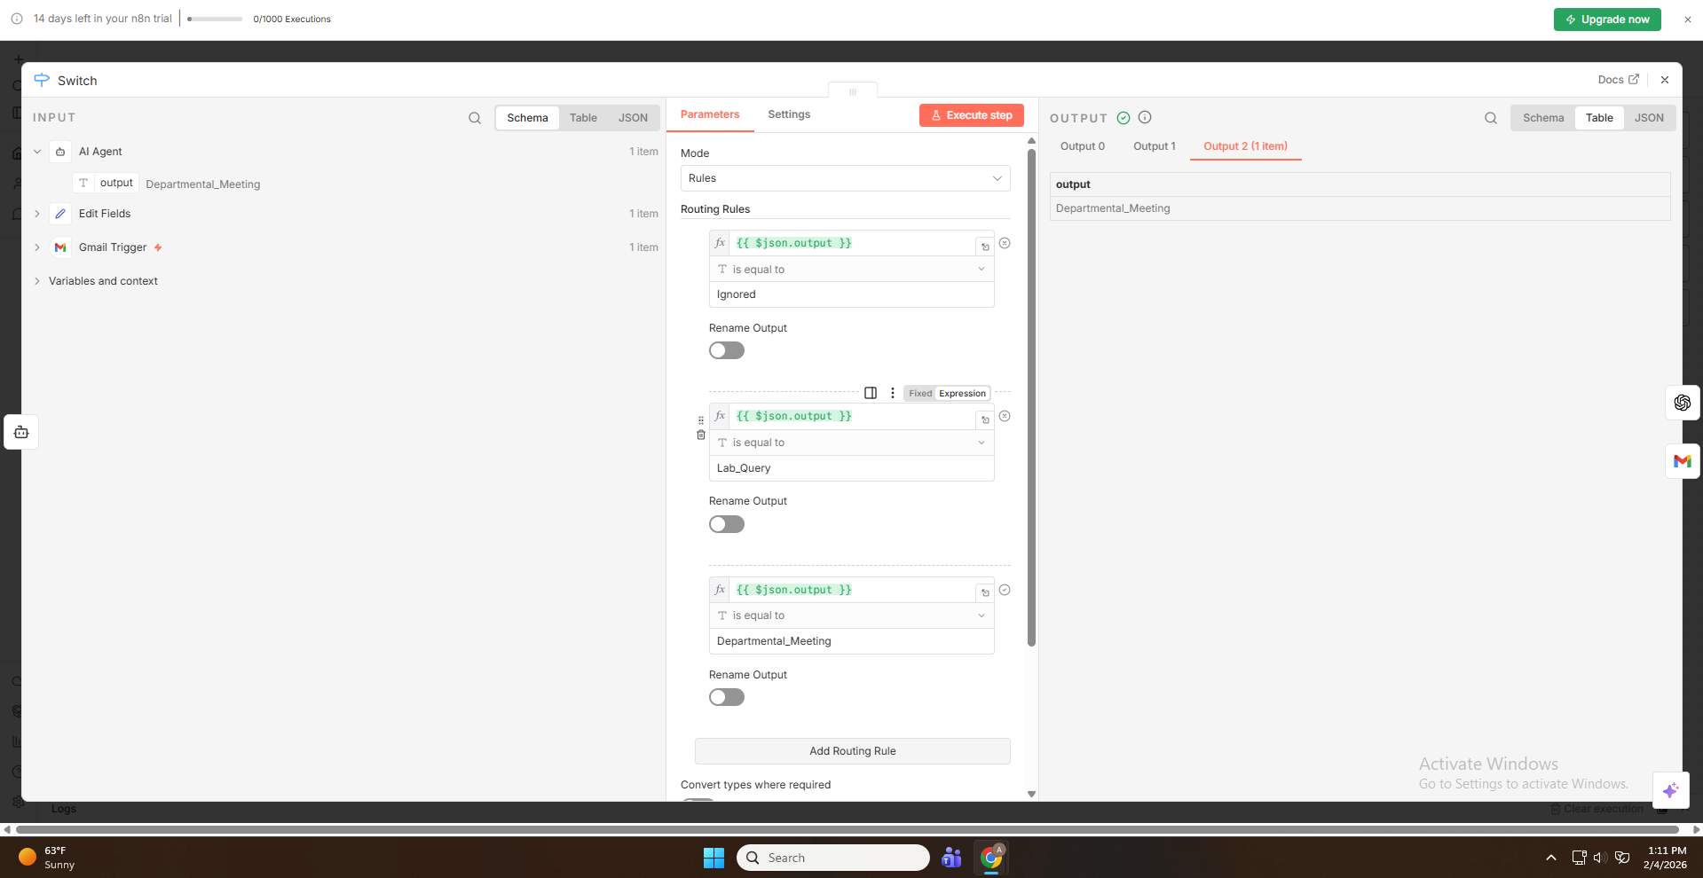
Classification Labels:
- Lab_Query
- Departmental_Meeting
- Ignored
Actions Performed:
- Added OpenAI “Message a Model” node
- Provided strict system prompt for classification
- Passed subject and body as user input
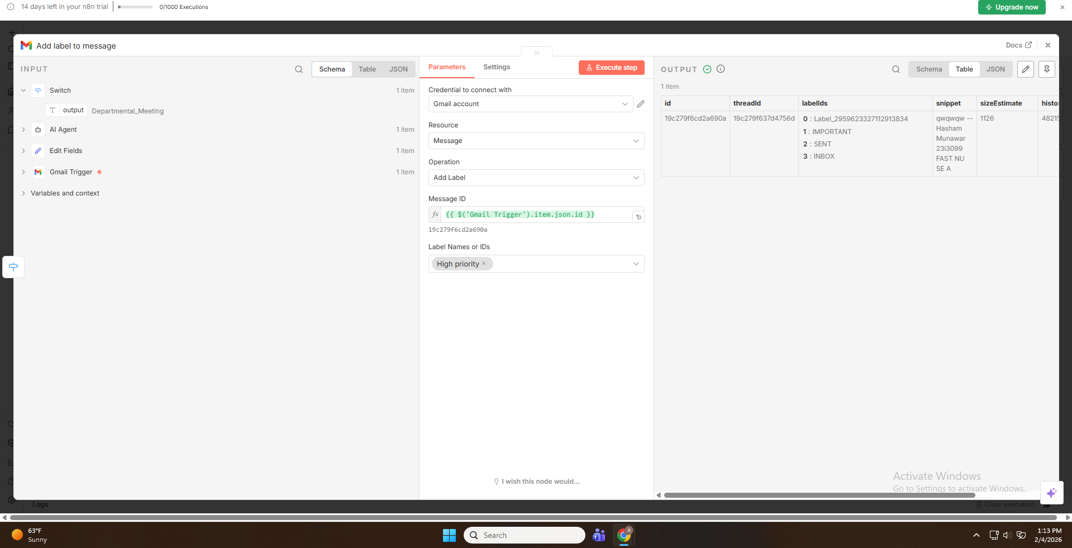

Added label “High Priority” to departmental meetings emails.

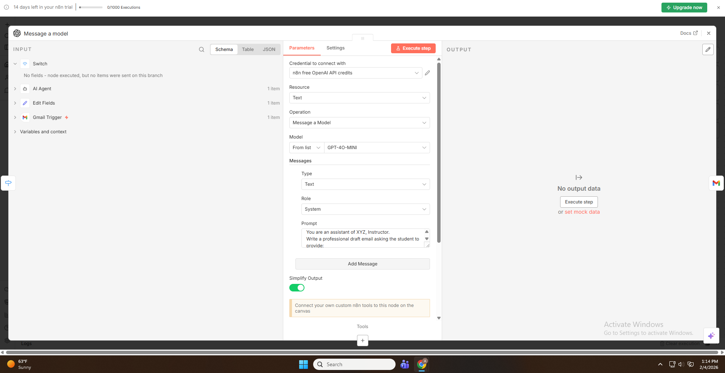
Lab Query emails are connected to openAI and given prompt from manual to provide required information.

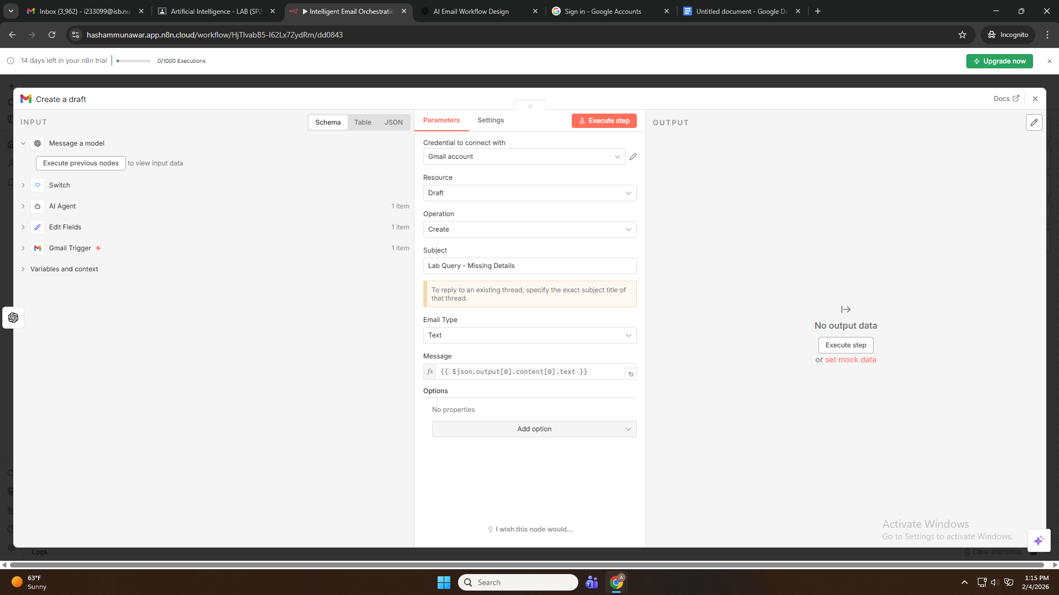
Draft created in response to result from openAI

