

Faculty 1

MINT – Mathematics, Computer Science, Physics, Electrical and Information Engineering

Degree program: Artificial Intelligence

Master-Thesis

Comparing AI Narratives of Tragedy: Semantic Similarity Analysis and Prompt Engineering in Large Language Models

Submitted by

Hassan Raza

(Matriculation No.: 5004946)

Supervisor: Prof. Dr.-Ing. Stefan Glasauer

Cottbus, Date: 31 August 2026

Declaration of Integrity
This declaration applies to term papers, student research projects, essays, including bachelor's and master's theses (cf. § 12 (9) and § 20 (4) RahmenO-BA/MA).

I hereby declare Hassan Raza, Matriculation No.: 5004946, that I have completed this work: Comparing AI Narratives of Tragedy: Semantic Similarity Analysis and Prompt Engineering in Large Language Models, Master-Thesis, Sommersemester 2026, independently, without outside help and without using any resources other than those specified.
All the ideas taken directly or indirectly from external sources (including electronic sources) have been identified and cited as such without exception. Sources used verbatim and in terms of content have been cited in accordance with the recognised rules of scientific work. In particular, all applications of generative AI methods have been explicitly identified and documented. This written work has not been submitted in the same or a comparable form, not even in excerpts, as part of another examination at any university before. It has also not been published to date.
I agree that my work can be checked for plagiarism using plagiarism detection services.
I also hereby confirm that I comply with the “Statutes for Ensuring Good Scientific Practice and Dealing with Suspected Cases of Scientific Misconduct at the Brandenburg University of Technology Cottbus–Senftenberg of 20 July 2023” (https://opus4.kobv.de/opus4-btu/frontdoor/deliver/index/docId/6774/file/31_Satzung.pdf).

Germany, 31-08-2026
Place, Date Signature

Declaration of use of AI

The author declares that generative AI tools (ChatGPT by OpenAI and Claude by Anthropic) were used during the preparation of this thesis for language editing and for drafting and restructuring passages of text. The author has reviewed and corrected all text and takes full responsibility for its content. ChatGPT and Mistral 7B are additionally the objects of study in Chapters 3 to 5; their outputs are documented in Appendices A and B.

Germany, 31-08-2026
________________________________

(Place, Date) (Signature of the author)

Abstract

In this thesis, I examine how Large Language Models (LLMs) create narratives about traumatic historical events, using the 2020 Vienna terror attack as a case study. On the evening of 2 November 2020, a single gunman fired shots at several locations in Vienna's city centre, killing four civilians and injuring 23 others, before police shot him dead nine minutes later (Saal & Lippe, 2021). The so-called Islamic State claimed responsibility for the attack, which prompted a review of counterterrorism intelligence and deradicalisation policy in Austria. The study compares ChatGPT (GPT-4) with Mistral 7B in terms of narrative structure, factual accuracy and emotional tone. Drawing on theories of collective memory and the digital humanities, the thesis treats AI systems as emerging agents of historical representation rather than as mere tools for information retrieval.
A mixed-methods design was used, combining qualitative thematic analysis with quantitative semantic similarity scoring and emotion analysis. Each model responded to 80 prompts in five categories (role-based personas, temporal framing, causality and motivation, media comparison, and ethics, trauma and collective memory), and all responses were compared with a factually verified baseline text. Semantic drift was measured as the cosine similarity between Sentence-BERT embeddings (Reimers & Gurevych, 2019). Sentiment polarity was measured with VADER (Hutto & Gilbert, 2014) and discrete emotions with NRCLex (Mohammad & Turney, 2013; Bailey, 2019).
The results show systematic differences between the two models. ChatGPT generated institutionally contextualised and semantically consistent narratives, albeit with some minor factual inaccuracies. Under the "survivor" persona, Mistral 7B generated more emotionally charged and stylistically elaborate responses, but with more hallucinated detail. Persona prompting also changed how the events were framed in both models: in the manually coded core prompts, survivor prompts led to more negative and fear-related narratives in both models. The lexicon-based measures, however, rated ChatGPT's texts as more negative overall than Mistral's, which shows that a vivid, first-person emotional style and negative vocabulary are different things.
These results indicate that prompt design is not a neutral input but a framing device, and that model architecture influences not only factual accuracy but also emotional expression. LLMs thus act as active agents in the creation of digitally mediated collective memory. The main risks identified are the homogenisation of narratives, an emphasis on emotion without factual support, and the prioritisation of institutional or victim perspectives. The thesis offers a reproducible method for measuring narrative drift and emotional modulation in AI-generated historical texts and calls for transparency, rigorous testing and version documentation when generative systems are used in memory-related settings.

Table of Contents
Abstract 4
List of Figures 8
List of Tables 9
List of Abbreviations: 10
1 Chapter 1: Introduction 11
1.1 Background of the Study 11
1.2 Statement of the Problem 12
1.3 Research Questions 12
1.4 Research Objectives 13
1.5 Hypotheses 13
1.6 Scope and Delimitations 13
1.7 Significance of the Study 14
1.8 Definition of Key Terms 14
1.9 Structure of the Thesis 14
2 Chapter 2: Literature Review 16
2.1 Collective Memory: Foundations and Theoretical Evolution 16
2.2 The Algorithmic Turn in Memory Studies 17
2.3 AI, Archives, and Memory Preservation 17
2.4 AI, Trauma, and Narrative Ethics 18
2.5 Prompt Engineering and Narrative Framing 18
2.6 Semantic Similarity and Narrative Comparison 19
2.7 Collective Memory in the Age of Big Data 19
2.8 Memory Bias and Erasure in AI Systems 19
2.9 Summary and Synthesis 20
2.10 Research Gap 20
3 Chapter 3: Methodology 22
3.1 Research Philosophy and Approach 22
3.2 Research Design 23
3.3 Data Collection 24
3.3.1 Data Sources 24
3.3.2 Data Generation 25
3.3.3 Tools and Technologies 25
3.4 Data Analysis 26
3.5 Baseline Text for Semantic Similarity 27
3.6 Importance of Emotion Analysis 27
3.7 Ethical Considerations 28
3.8 Limitations 28
3.9 Summary 28
4 Chapter 4: Results 30
4.1 Comparative Analysis of Model Outputs 30
4.2 Neutral Prompt (P1) 30
4.3 Role-Based Prompting Effects 32
4.3.1 Journalist Persona (P2) 32
4.3.2 Survivor Persona (P3) 34
4.3.3 Government Response (P5) 36
4.4 Semantic Similarity and Narrative Drift 37
4.5 Factual Accuracy and Hallucinations 39
4.6 Emotional Valence Analysis 39
4.7 Summary of Results 42
5 Chapter 5: Discussion 44
5.1 Narrative Coherence and Factuality 44
5.2 Emotional Valence and Trauma Representation 44
5.3 Persona and Narrative Framing 45
5.4 AI and the Construction of Collective Memory 46
6 Chapter 6: Conclusion and Recommendations 46
6.1 Recommendations 47
6.2 Directions of Future Research 48
6.3 Concluding Remarks 48
7 References 50
8 Appendices 54
8.1 Appendix A: Responses 54
8.1.1 Chat of Mistral Model: 54
8.2 Appendix B: Example of full prompt-response exchanges: 54
8.3 Appendix C: Code Snippets 58
8.3.1 C.1: Semantic Similarity Code 58
8.3.2 C.2: Sentiment and Emotion Analysis Code 59
8.3.3 C.3: Aggregation of Results 60
8.4 Appendix D Full List of Prompts 60
8.4.1 Role-Based Prompts (Persona Simulation) — 20 prompts 60
8.4.2 Temporal Framing Prompts — 15 prompts 61
8.4.3 Causality & Motivation Prompts — 15 prompts 62
8.4.4 Media Comparison & Reporting Style Prompts — 10 prompts 62
8.4.5 Ethics, Trauma & Collective Memory Prompts — 20 prompts 63

List of Figures

Figure 3.1: Models 24
Figure 4.1: Comparison of Neutral Prompt Outputs by Model 31
Figure 4.2: Distribution of Semantic Similarity Scores 32
Figure 4.3: Semantic Similarity Scores for Journalist Persona Prompt (P2) Across ChatGPT and Mistral 33
Figure 4.4: ChatGPT vs. Mistral Semantic Similarity Compared to Baseline 34
Figure 4.5: Lexical Emotion Analysis in Survivor Narratives from ChatGPT and Mistral 7B 35
Figure 4.6: Persona-Based Topical Focus Distribution in Government Response Narratives 36
Figure 4.7: Semantic Similarity Trends Across Prompts 37
Figure 4.8: Cosine Similarity Across Prompts: Semantic Drift in ChatGPT and Mistral 7B Responses 38
Figure 4.9: Factual Accuracy Matrix: Comparative Model Errors in Government and Survivor Narratives 39
Figure 4.10: Comparing Emotional Valence Across Prompts for ChatGPT and Mistral 7B 40

List of Tables

Table 3.1: Overview of Models and Tools Used in the Study 25
Table 4.1: Model Responses to the Neutral Prompt (P1) 30
Table 4.2: Framing and Similarity in Journalist Responses (P2) 33
Table 4.3: Emotional Tone and Narrative Style in Survivor Persona Responses (Prompt P3) 35
Table 4.4: Focus Areas and Evident Biases in Government Response Outputs (Prompt P5) 36
Table 4.5: Semantic Similarity and Narrative Drift 37
Table 4.6: Average Cosine Similarity Scores by Category 38
Table 4.7: Emotional Valence Comparison by Prompt and Model Perspective 40
Table 4.8: Average VADER Compound Scores by Prompt Category 41
Table 4.9: Average NRCLex Emotion Proportions by Prompt Category (Fear and Sadness) 41
Table 4.10: Summary of Results 42

List of Abbreviations:

AI Artificial Intelligence
API Application Programming Interface
BBC British Broadcasting Corporation
EU European Union
GPT Generative Pre-trained Transformer
IS Islamic State
ISIS Islamic State of Iraq and Syria
LLM Large Language Model
MiniLM Miniature Language Model
NLTK Natural Language Toolkit
NRCLex National Research Council Lexicon
P1, P2, etc. Prompt 1, Prompt 2, etc.
VADER Valence Aware Dictionary and sEntiment Reasoner

Chapter 1: Introduction

Background of the Study
Collective memory refers to the socially constructed, shared memory of past events held by a group of people. Sociology, psychology, and cultural studies have centred on the concept, especially after the groundwork of Maurice Halbwachs (1992) and the subsequent developments by Sarah Gensburger (2016). Halbwachs insisted that memory is determined not only by what is remembered, but also by who remembers and by the way remembrance is passed on to succeeding generations.
Oral tradition, archives, literature, journalism, and, most recently, digital media have traditionally mediated collective memory. The emergence of large language models (LLMs) such as ChatGPT and Mistral 7B represents a paradigm shift in how memory is produced, shared, and potentially re-modified. Unlike traditional media, LLMs are trained on vast amounts of text data (books, web pages, and forums) and generate responses through probabilistic language modelling. They do not merely store or summarise information; rather, they reconstruct narrative according to learned linguistic patterns.
This process can be described as algorithmic memory: a form of memory production in which AI systems and users act as co-authors, but which is epistemologically opaque with regard to its source materials and narrative bias (Schuh, 2024). As such systems become embedded in education, journalism and policymaking, they have a growing impact on how societies interpret and remember the past, including traumatic events.
The emergence of LLMs raises serious questions. How do they recreate sensitive history, including terrorist attacks? Do they offer pluralistic representations, or hegemonic representations ingrained in their training data? And what impact does prompt engineering (for example, "narrate as a survivor" as opposed to "narrate as a journalist") have on the framing, tone and construction of AI-generated accounts?
The terror attack in Vienna in 2020 makes this a timely case for investigating how memory is formed through artificial intelligence. On the evening of 2 November 2020, a 20-year-old gunman attacked pedestrians and bystanders at several locations in Vienna's inner city, killing four civilians and injuring 23 others, before police shot him dead about nine minutes after the attack began (Saal & Lippe, 2021). The Islamic State (IS) claimed responsibility two days later (BBC News, 2020). The attack received wide publicity, led to an official inquiry into intelligence failures and sparked a new debate about the success of Austria's deradicalisation programmes (Saal & Lippe, 2021). Because the attack is documented in court records, an official inquiry and investigative journalism, it provides a factual baseline against which the accuracy of AI-generated narratives of a real, controversial and emotionally charged event can be measured.
To address these questions, this study examines the new epistemological role of AI in the construction of collective memory by analysing how ChatGPT and Mistral 7B reconstruct the Vienna attack in response to a range of prompts.

Statement of the Problem
AI has quickly become embedded in communication, education, and narrative production, yet little research has examined the sociocultural consequences of AI-mediated memory creation. Conventional scholarship on collective memory, particularly the foundational work of Maurice Halbwachs (1992), has focused on human actors such as historians, journalists and communities. Because this work predates algorithmic systems, it could not address them, even though such systems are now becoming mediators of historical accounts in their own right.
Recent comparative studies have begun to document bias, stylistic patterning, and factual inconsistency in AI-generated content (Makhortykh, 2021b; Jaillant, 2022). However, systematic investigation into how different large language model architectures form or distort shared recollections, particularly in the context of traumatic events, remains limited. This gap is compounded by the ethical risks inherent in the data infrastructures that underpin these systems (Crawford, 2021), which makes closer scrutiny increasingly urgent.
This gives rise to three gaps. First, there is limited comparative work on the reconstruction of the same historical event by various LLMs. Second, it is not known how persona-based prompt engineering, such as posing a question as a journalist instead of a survivor, affects the generation of narratives. Third, the wider ethical concerns of AI-assisted historical storytelling, such as homogenising narratives, marginalising other viewpoints and boosting dominant narratives, have been under-researched. To fill these gaps, this thesis takes an interdisciplinary stance that combines media theory, memory studies, computational linguistics and trauma research to explore how two widely used LLMs construct and mediate collective memory when humans prompt them to adopt roles.

Research Questions
This study is guided by four interrelated research questions. First, how do ChatGPT and Mistral 7B differ in their descriptions of the 2020 Vienna terror attack? Second, what effect does prompt engineering, specifically role-based framing, have on the structure and tone of AI-generated narratives? Third, what factual errors, inaccuracies, or omissions appear in the AI-generated accounts? Fourth, what do the observed differences between AI-generated narratives suggest about the potential implications of AI-mediated historical narration for collective memory and public understanding of traumatic events? Taken together, these questions address both the technical differences between the two models and the cultural and ethical implications of their use.

Research Objectives
In this study, ChatGPT and Mistral 7B were used to generate narratives of the 2020 Vienna terror attack in response to a variety of prompts. The study compares factual accuracy and emotional tone between the outputs; examines the impact of persona-based prompts, such as a request from a survivor's rather than a journalist's perspective; quantifies semantic differences between outputs using sentence embeddings and cosine similarity; and examines what the outputs of the two systems mean for the shared memory and public image of the event.

Hypotheses
The study tests the following hypotheses. Hypothesis 1 (H1): ChatGPT will produce more detailed and more institutionally framed narratives, because it was trained on an extensive and diverse dataset. Hypothesis 2 (H2): Mistral 7B, with its smaller parameter set and more restricted training data, will produce shorter and more situational narratives. Hypothesis 3 (H3): The narratives generated by both models will show higher emotional valence when the prompt asks them to write as a survivor or journalist than when the prompt is a neutral question.
Qualitative thematic analysis, semantic similarity measures and sentiment analysis were used to test these hypotheses.

Scope and Delimitations
The research was deliberately designed to allow a focused and precise analysis. As a case study, it is limited to the 2020 terror attack in Vienna, which was selected because it is recent, well documented and was extensively covered in the media. Two LLMs are compared: ChatGPT (GPT-4 architecture), representing large commercial models, and Mistral 7B, representing open-weight models. The research includes only English-language, text-based outputs and excludes multimodal and non-English responses. Events before 2020 are treated only as background to the attack (for example, the attacker's earlier attempt to join IS) and are not analysed in their own right.

Significance of the Study
The study contributes at three levels: academic, practical and societal. Academically, it adds to interdisciplinary research on AI ethics, trauma communication and digital memory through an empirical comparison of how different large language models and prompts produce different narratives of the same event (Schuh, 2024). Practically, the results are useful for developers, designers and policymakers who want to reduce the risk of bias when AI-based tools are used in journalism, education and historical documentation, where accuracy and balance matter. For society, the research shows how AI can contribute to the formation of social memory and historical consciousness. It thereby encourages a more critical attitude and greater media literacy in dealing with AI, because it reveals the risks of trusting algorithmically generated accounts uncritically (Crawford, 2021). As LLMs become part of the systems that produce and distribute knowledge, the study also develops a method for assessing the accuracy and inclusiveness of AI-generated versions of history, together with the ethical questions they raise.

Definition of Key Terms
Collective Memory: The shared, socially constructed remembrance of historical events by a community or group (Halbwachs, 1992).
Cultural Trauma: A disruptive, collective event that fundamentally alters a group’s identity and memory structure (Alexander, 2004).
Prompt Engineering: The practice of designing and structuring inputs to large language models in order to guide the style, content, and framing of their outputs (Reynolds & McDonell, 2021).
Semantic Similarity: A computational score of the similarity in meaning between two texts, typically obtained using vector-based embedding models such as Sentence-BERT (Reimers & Gurevych, 2019).

Structure of the Thesis
The thesis has six chapters:
Chapter 1 – Introduction: Presents the background, problem statement, research questions, objectives, hypotheses and significance of the study.
Chapter 2 – Literature Review: Surveys the relevant literature on collective memory theory, trauma and AI narrative generation.
Chapter 3 – Methodology: Describes the research design, prompts, baseline text and analysis tools (embedding models, sentiment and emotion analysis).
Chapter 4 – Results: Presents the comparative analysis of the narratives generated by the two models and the effects of the prompts.
Chapter 5 – Discussion: Interprets the findings with regard to the hypotheses and their theoretical and societal implications.
Chapter 6 – Conclusion and Recommendations: Summarises the contributions and limitations of the study and gives recommendations and directions for future research.

Chapter 2: Literature Review
The advent of artificial intelligence (AI) and large language models (LLMs) has started to influence the ways in which societies are formed, preserved, and passed on. At the heart of concepts of collective memory lies the idea of the social, linked to shared experiences, collective institutions and public debate (Halbwachs, 1992; Gensburger, 2016). The rise of generative AI models that can generate believable narratives raises new ontological and ethical questions about machine-mediated memory. This chapter addresses the interdisciplinary field that has emerged in the past few decades at the nexus of memory studies, digital archiving, narrative ethics, and artificial intelligence (AI), focusing on the role of LLMs in culture and trauma memory, automated narrative generation, and algorithmic indexing and interpretation of archives. The core idea is that AI is not just a tool for memory work, but it is a factor in the creation of the frames themselves, in which past events are understood.

Collective Memory: Foundations and Theoretical Evolution

Maurice Halbwachs' seminal theory states that memory is not entirely an individual memory, but rather always shaped by the social groups, families and institutions in which the person lives (Halbwachs, 1992). Gensburger (2016) builds on this and maintains that collective memory is not the passive and unproblematic product of history but is created through political power, national identity, and institutional authority. This picture has become more complicated with the advent of the "digital" era. Hoskins (2018) outlines “digital memory ecologies”, which are complex and occasionally confusing systems of digital platforms, algorithms and networked publics that are influencing the practice of memory, turning it fluid, iterative and open to non-human agents. Going further, Kansteiner (2022) suggests that the use of AI technologies does not just impact the shape and flow of memory but can even create new ways of historical knowledge, as AI can act as an epistemic agent, creating and sharing its own interpretations of the past.
Memory studies must therefore address a fundamental question: what does collective memory mean in an age of AI systems that create and perpetuate interpretations of the past? This thesis argues that collective memory can no longer be understood as a purely human phenomenon. It is increasingly co-produced with algorithmic systems, whose epistemic logic differs from human intentionality because it is tied to training data, design choices and systemic bias. It is therefore important to examine closely which perspectives these systems include, which they exclude, and which narrative choices they make when humans use them.

The Algorithmic Turn in Memory Studies
The algorithmic turn in memory studies marks an ontological shift: memory is no longer solely mediated by humans but is increasingly co-produced with machine intelligence. Makhortykh (2021a) frames this as a collaborative process in which users and algorithms interact to shape the visibility and longevity of cultural narratives, for example through search engine ranking, recommendation systems, and digital curation tools, all of which affect what is remembered or forgotten. Shur-Ofry and Pessach (2020) introduce the concept of “robotic collective memory”, in which AI systems internalise forms of collective memory, processing, organising, and disseminating narratives without human supervision. Makhortykh (2021b) demonstrates this dynamic in the context of Holocaust remembrance, showing how algorithmic bias in search engines affects the accessibility and prominence of historical narratives: such mechanisms do not only determine what information is available, but also authorise which histories are treated as legitimate and are reproduced. With generative models such as GPT-3 and GPT-4, concerns about authenticity, authority, and truth in narrative construction have become more pronounced. Floridi and Chiriatti (2020) note that although LLMs do not understand or possess consciousness in any traditional sense, they can simulate coherent discourse convincingly enough to create an illusion of expertise. As a result, the credibility traditionally accorded to historians or journalists risks being gradually displaced by probabilistic systems that imitate coherence without engaging historical method. This is particularly consequential when such models are applied to the recreation of historical events. Jaillant (2022) cautions that combining LLMs with archival access and narrative generation risks producing accounts that are narratively compelling yet historically unreliable, since the resulting text can appear authoritative while still containing misinformation, invented detail, or historiographical distortion.

AI, Archives, and Memory Preservation
The use of AI in digital archiving is expanding rapidly, promising faster and more scalable archiving, transcription, and indexing of historical records. However, scholars caution that this automation trades interpretive richness for emotional distance. Rolan et al. (2019) pose the question of whether AI archiving can ever be more than a mechanical process, since machines can store information but may lack the contextual sensitivity required for meaningful remembrance. Barlindhaug (2022) shows that AI-assisted digital preservation is valuable for preventing the loss of fragile or deteriorating records, but warns against conflating the digital fidelity of a record with the truthfulness of the story it tells: memories carry an emotive and subjective dimension that a machine can hardly reproduce. Similarly, Pessanha and Salah (2021) find that while AI-assisted oral history transcription can index large volumes of data efficiently, it may fail to capture subtleties such as tone, accent, and emotional inflection. These are critical omissions for trauma-sensitive memory work, particularly in post-conflict contexts. Bultmann et al. (2022) demonstrate this risk directly, showing how uncurated training data can flatten or misrepresent accounts of mass atrocities when processed by LLMs: outputs generated from biased, partial, or decontextualised training data can perpetuate historical inaccuracies or silence marginalised voices.

AI, Trauma, and Narrative Ethics
One of the most contested questions in this field is whether artificial intelligence can ethically represent trauma. Lothe, Suleiman, and Phelan (2012) highlight the aesthetic and ethical complexity of narrating Holocaust testimony, noting that every narrative choice carries interpretive weight. This complexity is heightened further when the narrator is not a human witness but an artificial system.
Presner (2016) shows how algorithmic approaches to the Shoah Foundation archive can produce ethical missteps through even minor programming decisions in the handling of survivor testimony. Walden (2021) and Walden and Marrison (2023) similarly argue that mass trauma requires careful mediation, and that AI systems used in this context need to be audited for factual accuracy, empathetic framing, and cultural sensitivity. Tangermann (2023) demonstrates a related risk: AI image-generation tools have been used to produce fabricated scenes of violence in sensitive geopolitical contexts, in one documented case images of the Israel-Palestine conflict sold through a commercial stock-image platform. This example demonstrates how uncritical trust in generative AI can produce emotionally charged but misleading memory artefacts.
Ultimately, interpretive and ethical responsibility for trauma narration cannot be delegated to the system generating it. Because AI lacks lived experience, its attempts to simulate survivor perspectives create a persistent tension between narrative coherence and moral authenticity.

Prompt Engineering and Narrative Framing
Prompt engineering, the practice of designing inputs to steer a model’s output (Reynolds & McDonell, 2021), is central to this thesis because persona-based prompting is the primary mechanism through which narrative framing is tested. When a user instructs ChatGPT or Mistral 7B to “act as a survivor” or “report as a journalist”, the model does not draw on lived experience but on patterns learned from its training data, which often reflect dominant and frequently Western-centric versions of history and trauma. Reynolds and McDonell (2021) show that even small changes in prompt phrasing can substantially alter a model’s output. This has direct implications for historical narration: if persona framing alone can shift tone, emphasis, and factual content, the apparent objectivity of an AI-generated account is itself a product of prompt design rather than a neutral report of events. This is the mechanism examined empirically in Chapters 4 and 5.

Semantic Similarity and Narrative Comparison
In computational linguistics, the literature on quantifying variation between texts has grown substantially in recent years. Sentence embeddings (Reimers & Gurevych, 2019) make it possible to compare the meaning of whole texts through the cosine similarity of their vector representations, which is the approach used in this thesis. In memory research, Clavert (2021) and Clavert, Mahroug, and Schafer (2022) examine the impact of massive digital data on historical research and on the preservation and distortion of social memory. Such metrics capture semantic overlap but not interpretive nuance, so they need to be paired with qualitative interpretation. Guo et al. (2024) further show that training on synthetic data can erode linguistic diversity, which is an important condition for memory plurality. This is directly relevant when comparing LLM outputs in order to analyse differences in model architecture or prompting strategy.

Collective Memory in the Age of Big Data
Manning (2013) discusses how big data is changing historical methodology, and Schuh (2024) describes AI as a form of artificial memory that reconfigures collective memory practices globally. In an AI context, this suggests that memory is increasingly produced, at growing scale, not by witnesses, historians or their successors, but by probabilistic algorithms designed to imitate them. Mandolessi (2023) reflects this shift, arguing that memory studies needs to adapt to its digital turn by incorporating critical and computational literacy. Fridman and Gensburger (2024) point to ways in which crises such as the Covid-19 pandemic have driven new forms of memorialisation, in which automated data visualisation creates a form of algorithmic remembrance (for example, Korostoff’s (n.d.) data visualisation mapping Covid-19 deaths in the United States), an immediate and immersive but often dislocated form of storytelling.

Memory Bias and Erasure in AI Systems
Memory consists as much in forgetting as in remembering. Jaillant (2022) and Makhortykh (2021a) argue that, because AI technologies are built on training corpora, their outputs can unintentionally erase marginalised voices. Which narratives are preserved and promoted, and which are forgotten, is shaped by cultural and institutional logics, so AI memory cannot be regarded as politically neutral. This is a reminder that algorithmic tools operate faster than humans can deliberate about what ought to be remembered, and without the capacity for the moral reasoning that such deliberation requires.

Summary and Synthesis
The literature examined in this chapter supports three interrelated conclusions. First, AI systems are already part of digital memory ecologies, influencing what is remembered and how content is framed and recalled. Second, both the design of the model and the way it is prompted directly determine the content and character of the AI-generated narrative: no output is neutral, because every output results from the model's design and training conditions. Third, large-scale generative systems built on large corpora show persistent bias, exclusion and erasure of narratives, because they tend to represent dominant cultural and institutional perspectives while marginalised voices are absent.

Research Gap
While the academic research community has been focusing on AI and collective memory, there is still a lack of understanding around the increasing importance of large language models (LLMs) in this field. Critically, while individual systems have been studied from a variety of angles such as GPT-3 (Floridi & Chiriatti, 2020), there is little research that looks at a selection of LLM models and compares their ability to remember a historical event with different prompts under comparable conditions. This restricts the current knowledge of the interaction of architecture, training data and prompt design in creating historical accounts. Furthermore, much of the existing literature focuses either on search engine bias (Makhortykh, 2021b) or on access to digital archives, leaving the more nuanced consequences of persona-based prompt engineering, for example simulating the perspective of a survivor or a journalist, underexplored in terms of narrative tone, factual integrity, and semantic coherence. A further methodological gap is the limited use of quantitative tools, particularly semantic similarity analysis, in memory research; such methods offer a substantial opportunity to identify narrative drift, coherence, and distortion across AI-generated texts.
Insufficient integration of quantitative and qualitative methods has, until now, limited systematic evaluation of narrative distortion across models, making it difficult to objectively assess how LLMs reframe traumatic or historically sensitive events. This thesis addresses these gaps by comparing two widely used LLMs, ChatGPT and Mistral 7B, in their reconstruction of a single, well-documented traumatic event, the 2020 Vienna terror attack. It examines both the informative and affective dimensions of AI-generated storytelling through persona-based prompting, assessing how different role assumptions (survivor, journalist) shape narrative generation, and combines semantic similarity and emotional valence analysis to map how trauma and collective memory are represented across the two models. In doing so, the study makes both a theoretical and an empirical contribution to the literature on the mnemonic role of artificial intelligence, offering a reproducible framework for measuring narrative change and bias in LLM-generated historical accounts, and new insight into how artificial agents may reinforce or reshape collective remembering.

Chapter 3: Methodology
This chapter describes the methodology used to assess how LLMs contribute to the creation of collective memories of the 2020 terror attack in Vienna. A mixed-methods approach was applied, combining qualitative thematic analysis with computational analysis. To ensure transparency and replicability, sentiment analysis was carried out with VADER (Hutto & Gilbert, 2014; NLTK v3.8, Bird, Klein, & Loper, 2009) and emotion analysis with the NRCLex library and the NRC emotion lexicon (Mohammad & Turney, 2013; Bailey, 2019).
A total of 80 prompts were systematically generated and tested across both ChatGPT and Mistral 7B. This chapter also addresses transparency and analytical rigour through a discussion of ethical considerations and methodological limitations.
This thesis develops a qualitative-computational hybrid design to examine the emotional, factual, and semantic qualities of AI-generated narratives across different prompting conditions and persona-based instructions. This design supports not only descriptive comparison but also critical analysis of how LLMs mediate traumatic historical events and potentially shape digitally constructed collective memory.

Research Philosophy and Approach
The study follows an interpretivist perspective, which seeks to understand how knowledge is socially constructed and context-specific (Schwandt, 2015). The aim is to explore how LLMs build and tell stories that interact with human collective memory as a function of the prompts used.
This position is consistent with the memory studies literature, which treats the past as a discursive object that is culturally and politically constructed (Halbwachs, 1992; Gensburger, 2016). Because memory is essentially social, AI systems trained on massive textual corpora are likely to reproduce the dominant, mainstream memory of a society rather than a neutral or comprehensive one. The theoretical framework of the study builds on this premise.
The study is primarily qualitative but is supplemented by computational methods, including semantic similarity scoring and emotion measurement. This interdisciplinary positioning situates the research at the intersection of AI ethics, digital humanities, and trauma studies (Jaillant, 2022; Makhortykh, 2021a).
Combining qualitative thematic analysis with quantitative semantic and affective measurement provides both interpretive depth and comparative quantifiability. Cosine similarity scoring measures narrative drift between prompts and models; sentiment and emotion analysis captures changes in affective framing; and manual factual verification against a pre-established baseline narrative enhances validity by detecting hallucinations and inaccuracies. Together, these methodological choices enable a systematic assessment of how LLMs mediate traumatic history, exposing how narrative authority, tone, and emotional intensity are constructed, rather than treating AI output as a neutral account of events.

Research Design
This research uses a comparative, experimental case study design. ChatGPT (GPT-4 architecture; OpenAI, 2023) and Mistral 7B (Jiang et al., 2023) were selected for comparison because they differ in transparency (proprietary versus open-weight) and architectural design.
A mixed-methods experimental framework was applied, using a total of 80 prompts grouped into five categories: role-based personas (20 prompts), temporal framing (15 prompts), causality and motivation (15 prompts), media comparison (10 prompts), and ethics, trauma, and collective memory (20 prompts). The full prompt set is provided in Appendix D.
The prompts instructed the models to narrate the Vienna attack under different interpretive roles (e.g. journalist, survivor). This design allowed the effect of persona-based prompting on narrative framing, emotional construction and factual representation to be observed systematically.
The research design is cross-sectional and exploratory: it varies prompt context systematically in order to observe resulting variation in model behaviour. This framework enables both intra-model and inter-model comparison, supporting analysis of tone, coherence, factuality, and memory framing across outputs.
Most importantly, this design treats persona variation as an experimental intervention. Where a persona change produces a measurable shift in emotional intensity or semantic drift, this demonstrates that LLM output is not a fixed, absolute representation of memory but a context-dependent reconstruction.
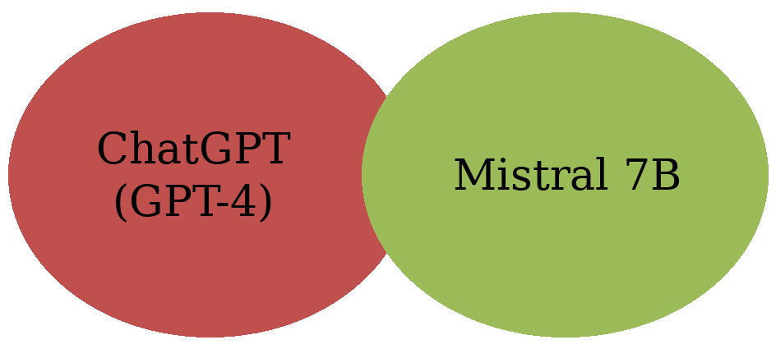
Figure 3.1: Models

Data Collection
Data were collected by systematically prompting both LLMs and by constructing a factual baseline narrative. Prompts were submitted through each model’s API using consistent parameters (temperature = 0.7, chosen to balance creativity and control).
Results were stored as .txt files in organised directories to ensure reproducibility and traceability.

Data Sources
The main data are the textual outputs produced by ChatGPT and Mistral 7B in response to structured prompts about the Vienna attack.
Five core prompts included:
P1: Describe what occurred in the attack that happened in Vienna in 2020.
P2: Report on the Vienna attack as a journalist.
P3: Describe the Vienna attack from a survivor's point of view.
P4: Compare the Vienna attack to other similar past attacks.
P5: Describe how the government reacted to the Vienna attack.
These prompts assign different interpretive roles to the models and allow the impact of persona-based frames on narrative construction to be examined. Because memory can be constructed discursively, prompting conditions act as frames and show how AI systems construct historical events. To establish a factual reference, verified information was collected from academic research, governmental sources and reputable journalism (Saal & Lippe, 2021; Mehra & Coleman, 2020; BBC News, 2020). These materials were used to write a baseline narrative (Section 3.5) against which semantic similarity was calculated. Comparing the AI-generated narratives with this baseline makes it possible to examine alignment, distortion and changes in framing across prompt types.

Data Generation
All of the prompts were entered into ChatGPT through the OpenAI API and Mistral through the Hugging Face or home inference systems. Common token limits, temperature settings and generation instructions were used to ensure consistency across the models. The responses were generated in May 2025 and saved in text form for analysis.

Tools and Technologies
Table 3.1 summarises the models and tools used in the study.
Table 3.1: Overview of Models and Tools Used in the Study
Tool/Model | Description
ChatGPT (GPT-4) | A proprietary language model developed by OpenAI, widely recognised for its fluent and contextually accurate outputs. However, it operates as a black-box system with limited transparency regarding its training data and  architectural parameters (OpenAI, 2023).
Mistral 7B | An open-weight LLM with seven billion parameters (Jiang et al., 2023). Open-weight models offer greater control, transparency and reproducibility, which makes them well suited to academic research on model behaviour and bias.
Sentence-BERT (all-MiniLM-  L6-v2) | A transformer-based semantic similarity model that embeds text and calculates cosine similarity between responses. It enables systematic comparison of semantic drift across different prompts and models (Reimers & Gurevych, 2019).
VADER (NLTK) | Sentiment polarity tool providing positive, negative, neutral and compound scores (Hutto & Gilbert, 2014).
NRCLex | Emotion detection library identifying and normalising categories such as fear, anger and sadness (Mohammad & Turney, 2013; Bailey, 2019).
Python (Pandas, NLTK, etc.) | For data processing and averaging (Python Software Foundation, 2023; McKinney, 2010) and for the analysis scripts in Appendix C.

All models were accessed through Python-based libraries and inference APIs. Responses were embedded and compared in terms of semantic content using the sentence-transformers package.

Data Analysis
The analysis was conducted across five stages. First, a qualitative thematic analysis was carried out by close reading in order to identify differences in the structure, tone and factual orientation of the model outputs (Braun & Clarke, 2006). Second, semantic similarity scoring was used to assess narrative drift by computing the cosine similarity between each response and the factual baseline narrative; a low similarity score indicates reinterpretation rather than reproduction. Third, sentiment and emotion analysis was performed: VADER was used to determine the affective polarity of each output (positive, negative or neutral), and NRCLex was used to analyse discrete emotion categories such as fear, sadness and anger. Differences between the models indicate systematic patterns in affective framing. Fourth, factual accuracy was checked by manually comparing the model outputs with known sources in order to detect hallucinations and distortions. Fifth, a comparative interpretation integrated the quantitative results with the qualitative analysis to explain how technical variation between models translates into different mnemonic constructions. This combined methodology meets the interdisciplinary requirements of research on AI systems (Jaillant, 2022) and supports interpretations that are grounded in the data.

Baseline Text for Semantic Similarity
A neutral, factual background account was compiled from verified sources (Saal & Lippe, 2021; Mehra & Coleman, 2020; BBC News, 2020). It deliberately avoids emotional or narrative embellishment so that it can serve as a semantic anchor. All model outputs were compared with this baseline using Sentence Transformers. Quantifying the deviation from a controlled factual anchor makes it possible to distinguish narrative enrichment from factual distortion, which is critical when studying how AI mediates the formation of memory.
Baseline Text:
On November 2, 2020, at the evening a shooter fired in Vienna at the center near the Seitenstettengasse synagogue. The attacker, Kujtim Fejzulai, a 20-year-old Austrian of North Macedonian origin, had tried to join ISIS before, and had been released early after deradicalisation therapy. He was armed with some kind of AK, a pistol, and a belt of explosives at his will. The incident took a total of nine minutes and had killed four civilians and injured twenty three civilians. The police gunmen killed Fejzulai. The failures were implied in the investigation of the Austrian intelligence agencies. The tip off was not followed up because the attacker had arrived in Slovakia to make ammunition purchases. The deradicalisation efforts also failed to notice his still being an extremist. The Austrian government, in its turn, created more stringent surveillance measures, increased the severity of punishment in case of terrorism, and reforms regarding intelligence sharing. It led to the boost of security, formal grieving and a debate about the counterterrorism strategy, extremism and integration. The social and political outcomes of the attack were significant to the Austrian society, which started discussing security, extremism and social cohesion in the society.

Importance of Emotion Analysis
Emotion analysis is important because emotions are not secondary to communication: they organise perception, memory encoding and group response. Semantic similarity measures alignment in content but does not capture affective intensity. In the case of trauma, affective framing influences collective memory and social interpretation in the long run.
If an AI system instils fear or blurs grief, it does not only tell history, it also alters its emotional context. The consequences can be seen in digital memory preservation, education and public discourse. This thesis uses VADER and NRCLex to determine differences in emotional tone between the AI models, for example in terms of fear, sadness or neutrality.
Emotion analysis is therefore more than a descriptive measure: it allows the possible effects of LLMs on collective memory to be assessed through the way they regulate affective intensity.

Ethical Considerations
Several ethical issues were carefully considered during the execution of this research:
Narrative Accuracy: The outputs were cross-verified manually to ensure that there was no propagation of hallucinated information.
Trauma Sensitivity: Descriptions of the attack and its victims were written with care, avoiding sensationalised or gratuitous detail.
AI Transparency: The differences between proprietary and open-weight models were acknowledged.
Data Privacy: No personal or identifying data was used; all inputs were derived from publicly available information about the attack.

Limitations
Although this approach allows for detailed comparative analysis, it also carries several limitations:
Model Opacity: The internal training data and reasoning processes of GPT-4 are not fully disclosed, which makes it difficult to causally explain its output behaviour.
Prompt Sensitivity: Small changes in prompt wording can substantially change an LLM’s output, which complicates reproducibility.
Emotion Detection: Emotional valence was partly assessed through interpretation rather than formal sentiment scores alone, which may introduce a degree of subjectivity.
Similarity Measure: Cosine similarity of sentence embeddings captures semantic overlap, not factual correctness. In addition, the all-MiniLM-L6-v2 model truncates long inputs at 256 word pieces by default, so longer responses are represented mainly by their opening passages.
However, combining semantic scoring with triangulation across models helps mitigate some of these limitations.

Summary
This chapter has outlined an interpretive, qualitative-computational approach for examining how AI models reconstruct the collective memory of a traumatic historical event. Combining persona-based prompting, semantic analysis, and pairwise comparison provides a rigorous method for investigating how LLMs shape narrative identity, emotional framing, and the distortion of memory. The next chapter presents the results of this analysis, focusing on the narrative patterns and divergences in how ChatGPT and Mistral interpreted the Vienna attack.

Chapter 4: Results
This chapter presents the empirical findings comparing ChatGPT (GPT-4) and Mistral 7B in their reconstruction of the 2020 Vienna terror attack under varying prompt conditions. The results are organised across five analytical domains: inter-model comparison, intra-model variation across personas, semantic similarity and narrative drift, factual reliability, and emotional valence. The aim is not only to record variation but also to identify systematic effects of model architecture and persona-based prompting on narrative framing, factual accuracy and emotional intensity in descriptions of historically traumatic events. Because collective memory is mediated by narrative form and emotional colour, quantifiable differences between the models point to the different ways in which AI systems can become involved in the construction of memory.

Comparative Analysis of Model Outputs
ChatGPT and Mistral 7B differ markedly in the narrative strategies they use to reconstruct the same historical event. A plausible expectation is that a large, heavily aligned commercial model prioritises coherence and institutional framing, while a smaller open-weight model allows greater stylistic flexibility. This difference is visible across all prompting conditions examined in this chapter, particularly in semantic stability, emotional intensity, and factual reliability.
ChatGPT consistently produced institutionally framed narratives that adhered to predictable patterns of information. Mistral 7B, by contrast, showed greater stylistic variation and sensitivity to persona, producing accounts that were more immersive but less consistent. These differences are unlikely to be incidental: they reflect how the telling of historical trauma is shaped by model architecture and training regime. This means AI-generated narratives are not neutral descriptions of events, but highly structured products shaped by the underlying model’s design, in the context of collective memory formation.

Neutral Prompt (P1)
Prompt: “Describe what occurred in the attack that happened in Vienna in 2020.”

Table 4.1: Model Responses to the Neutral Prompt (P1)
Model | Key Characteristics | Similarity Score (vs. Baseline)
ChatGPT | Academic tone, systemic focus (policy failures, intelligence gaps). | 0.931 (high consistency)
Mistral 7B | Journalistic style, vivid victim details, chronological sequencing. | 0.6–0.8 (moderate  variation)

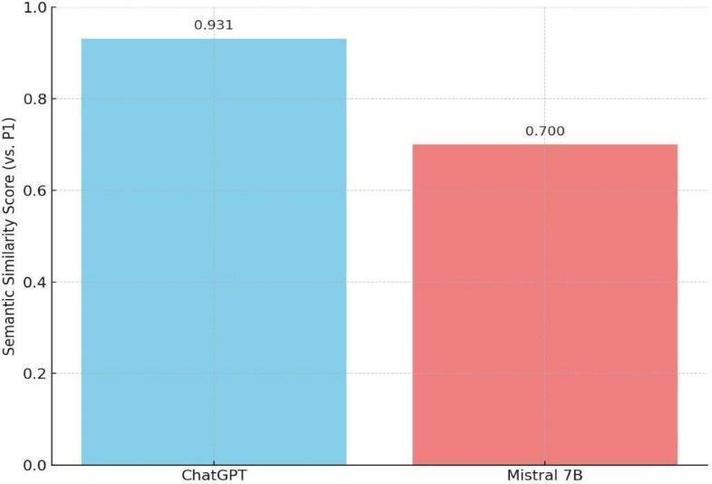
Figure 4.1: Comparison of Neutral Prompt Outputs by Model

As Figure 4.1 shows, ChatGPT produced more consistent narratives under neutral prompting than Mistral 7B, which fits the expectation that a heavily aligned commercial model favours coherence and systemic framing over expressive variation. ChatGPT was more semantically similar to the baseline narrative (0.931) than Mistral (0.60–0.80), while Mistral added more colourful narrative and journalistic detail. This finding matters because it shows that even ostensibly neutral AI-generated narratives can carry model-specific biases that shape how historical events are stabilised and recalled.
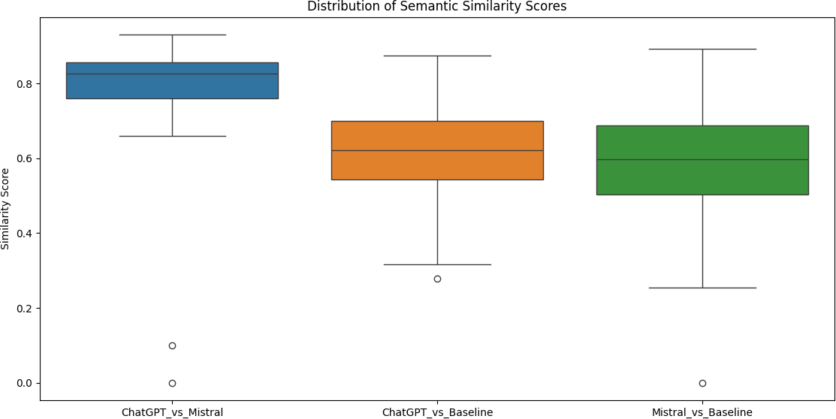
Figure 4.2: Distribution of Semantic Similarity Scores
Figure 4.2 shows boxplots (median, quartiles and outliers) of the similarity scores across all 80 prompts. The responses of ChatGPT and Mistral resemble each other (overall mean similarity 0.807) more than either model's responses resemble the factual baseline (0.610 for ChatGPT and 0.586 for Mistral; see Table 4.6). In other words, even where the two models differ from each other, they differ from the baseline to a greater extent.

Role-Based Prompting Effects

Journalist Persona (P2)
Prompt: “Report on the Vienna attack as a journalist.” Journalistic prompting produced an immediate shift in narrative orientation. ChatGPT adopted an institutional voice, anticipating official statements on security and government communication, and followed conventional news-reporting norms with a clear ordering of facts and process. Mistral, by contrast, incorporated more human-focused description, including sensory detail and emotional framing; although still written in journalistic form, its account read as more immediate and narrative-driven.
Persona framing therefore did not standardise outputs; rather, it amplified each model’s existing tendencies. ChatGPT further strengthened its institutional framing, while Mistral became more narratively expressive. This suggests that prompt-based role simulation does not override architectural bias but interacts with it, producing patterned variation in how collective memory is reconstructed.

Table 4.2: Framing and Similarity in Journalist Responses (P2)
Model | Framing Style | Notable Features | Semantic Similarity Score (vs.  Baseline)
ChatGPT | Formal, policy oriented | Referenced government statements; discussed European counterterrorism efforts. | 0.868
Mistral 7B | Immersive, narrative-driven | It included fictional survivor testimonies and detailed tactical police responses. | 0.45–0.60
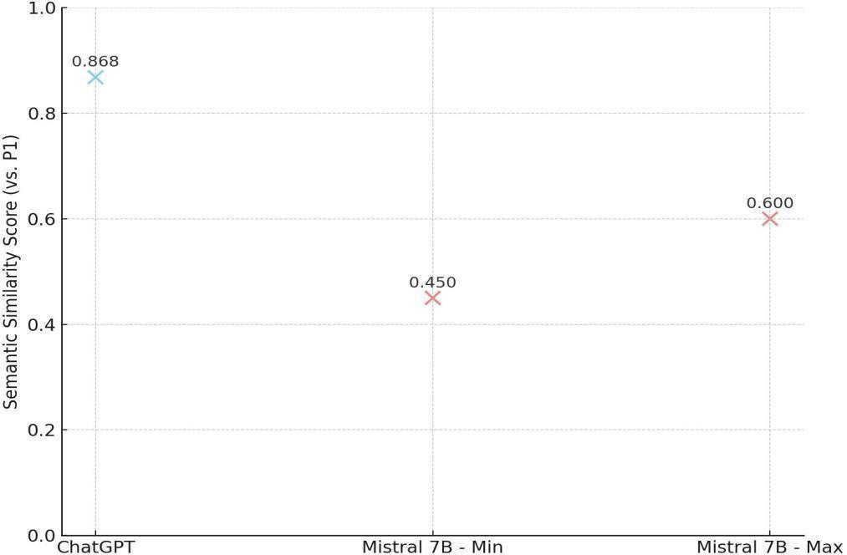
Figure 4.3: Semantic Similarity Scores for Journalist Persona Prompt (P2) Across ChatGPT and Mistral
Figure 4.3 shows that ChatGPT's output was written in an editorial tone and referred to European counterterrorism policy and to statements by Austrian officials. It framed the event as a failure of multinational security cooperation, which is consistent with a tendency towards structured coherence.
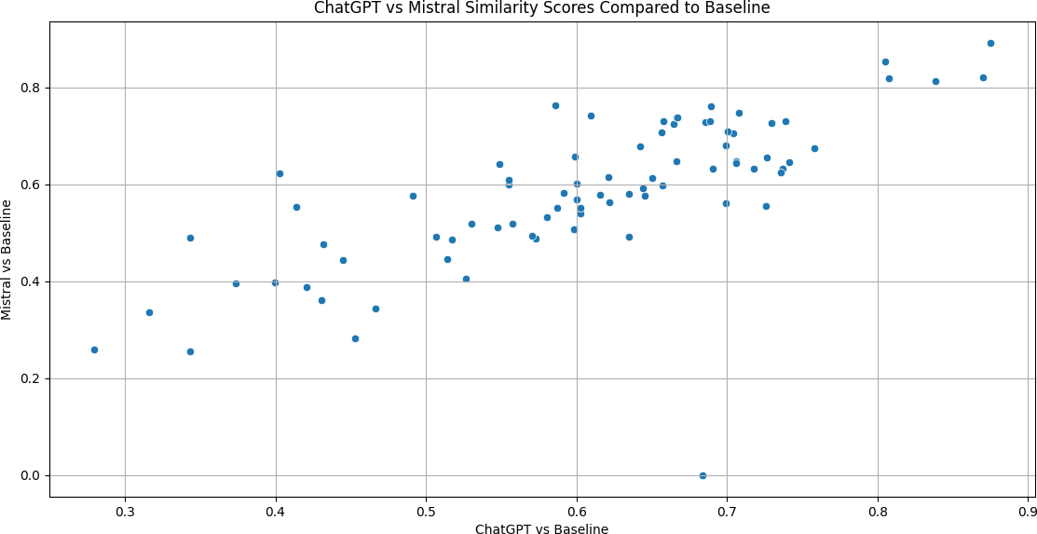
Figure 4.4: ChatGPT vs. Mistral Semantic Similarity Compared to Baseline
Figure 4.4 is a scatter plot that compares the semantic similarity of ChatGPT to the baseline (x-axis) with that of Mistral to the baseline (y-axis) for each prompt. Each point represents one prompt. Points near the diagonal line (bottom left to top right) indicate prompts for which both models are similarly close to the baseline; points far from the diagonal indicate prompts for which one model has strayed much further from the baseline than the other.
For the journalist prompt (P2), Mistral produced detailed, ground-level, event-oriented news reporting with invented interviews with victims and responders, and tactical information such as the timing of police action and the weapons became prominent. The semantic similarity to the baseline was:
- ChatGPT: 0.868
- Mistral: 0.45–0.60
Mistral thus diverged much more from the baseline than ChatGPT, because it added emotional and situational information.

Survivor Persona (P3)
Prompt: “Describe the Vienna attack from a survivor’s point of view.”
Because first-person narration tends to intensify affective engagement, survivor-based prompting produced the strongest emotional divergence between the models. Mistral generated highly sensory and emotionally charged narratives, frequently using vivid imagery and direct emotional expression. ChatGPT, in turn, was relatively restrained and produced generalised rather than immersive descriptions. This difference has interpretive significance. Emotionally enhanced artificial stories may aestheticise trauma and thereby misrepresent lived experience by dramatising it. Conversely, excessively subdued stories can sterilise or proceduralise trauma and make it less complex in its affective dimension. Persona-based prompting therefore reveals not only differences in style but also different ways of depicting traumatic memory.
Table 4.3: Emotional Tone and Narrative Style in Survivor Persona Responses (Prompt P3)
Model | Emotional Tone | Narrative Style | Semantic Similarity Score (vs.  Baseline)
ChatGPT | Subdued trauma | Generalised descriptions (e.g., “people screamed, chaos ensued”). | 0.753
Mistral 7B | High emotionality | Rich sensory detail (e.g., “smell of gunpowder,” “blood on cobblestones”). | 0.40–0.55

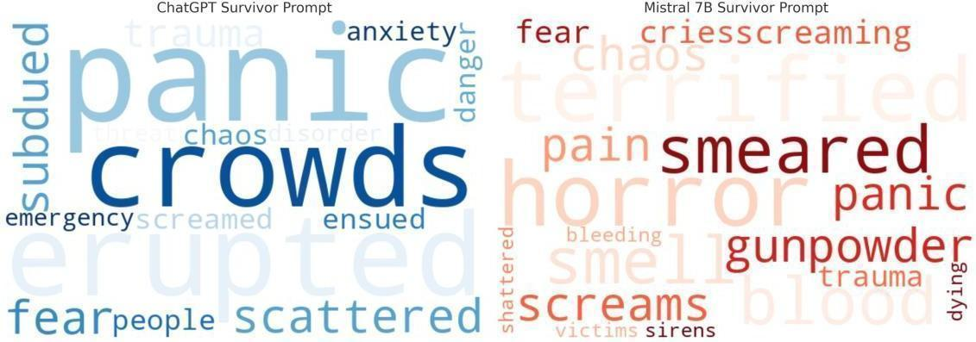
Figure 4.5: Lexical Emotion Analysis in Survivor Narratives from ChatGPT and Mistral 7B
Figure 4.5 shows that Mistral paid more attention to sensory words and personal experience. It included vivid descriptions such as the smell of gunpowder in the air and blood on the cobblestones. This may reflect the greater stylistic flexibility of a smaller open-weight model with less restrictive output filtering.
ChatGPT produced a subdued version of the story, generalising traumatic detail into phrases such as “panic erupted” or “crowds scattered in fear”, plausibly reflecting content guardrails designed to limit graphic detail (OpenAI, 2023). ChatGPT had a semantic similarity score of 0.753, compared with 0.40–0.55 for Mistral.

Government Response (P5)

Prompt: “Describe how the government reacted to the Vienna attack.” Government-focused prompting produced clearly differentiated institutional emphases. ChatGPT foregrounded legislative reform, security reorganisation, and EU-level cooperation, while Mistral focused more on intelligence failures and support for victims.
A government-response narrative can easily emphasise legitimacy at the expense of accountability. Neither model was neutral in this case: each selectively foregrounded different aspects of governance.
This selective emphasis indicates that AI technologies may indeed influence how the public perceives state responsibility in the aftermath of a traumatic event. Narrative framing has an effect on collective memory since it gives certain causations more weight than others and makes some causes seem important and others unimportant.
Table 4.4: Focus Areas and Evident Biases in Government Response Outputs (Prompt P5)
Model | Primary Focus Areas | Bias Detection
ChatGPT | Legislative reforms; EU-level  Cooperation | Downplayed intelligence failures and  oversight.
Mistral 7B | Victim support; emphasis on police heroism | Highlighted Slovak intelligence warning oversight.
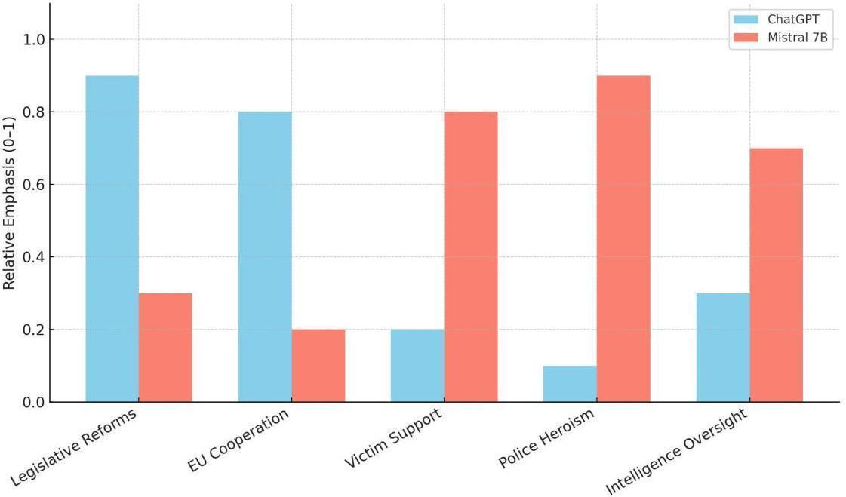
Figure 4.6: Persona-Based Topical Focus Distribution in Government Response Narratives
Figure 4.6 shows that ChatGPT foregrounded action at the national level: new legislation, increased surveillance and cooperation within the EU. It did not explicitly point out shortcomings of the intelligence services, which suggests a bias towards the credibility of institutions. Mistral, in contrast, emphasised community healing and the courage of the police and, in particular, referred to the warning from the Slovak intelligence agencies. The difference between the two models shows that both are selective, in ways that reflect the identity and priorities shaped by their training.
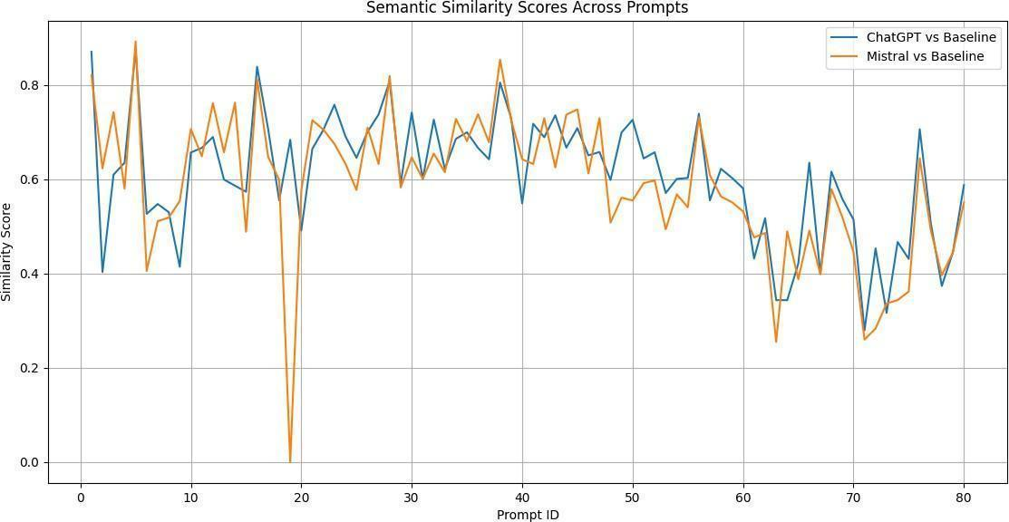
Figure 4.7: Semantic Similarity Trends Across Prompts
Figure 4.7 shows the semantic similarity scores across all 80 prompts. The blue line shows ChatGPT's similarity to the baseline and the orange line shows Mistral's similarity to the baseline. The trends are often similar, but some prompts lead to large differences between the two models. Peaks and drops mark prompts whose responses were highly congruent with, or far from, the baseline narrative.

Semantic Similarity and Narrative Drift
Narrative drift caused by persona-based prompting was measured using semantic similarity analysis. The cosine similarity scores express how closely the responses to each prompt match the factual baseline narrative (Section 3.5).
Table 4.5: Semantic Similarity and Narrative Drift
Prompt | ChatGPT Similarity (vs.  Baseline) | Mistral Similarity (vs. Baseline)
P2 | 0.868 | 0.55
P3 | 0.753 | 0.4–0.55
P4 | 0.72 | 0.42
P5 | 0.89 | 0.58

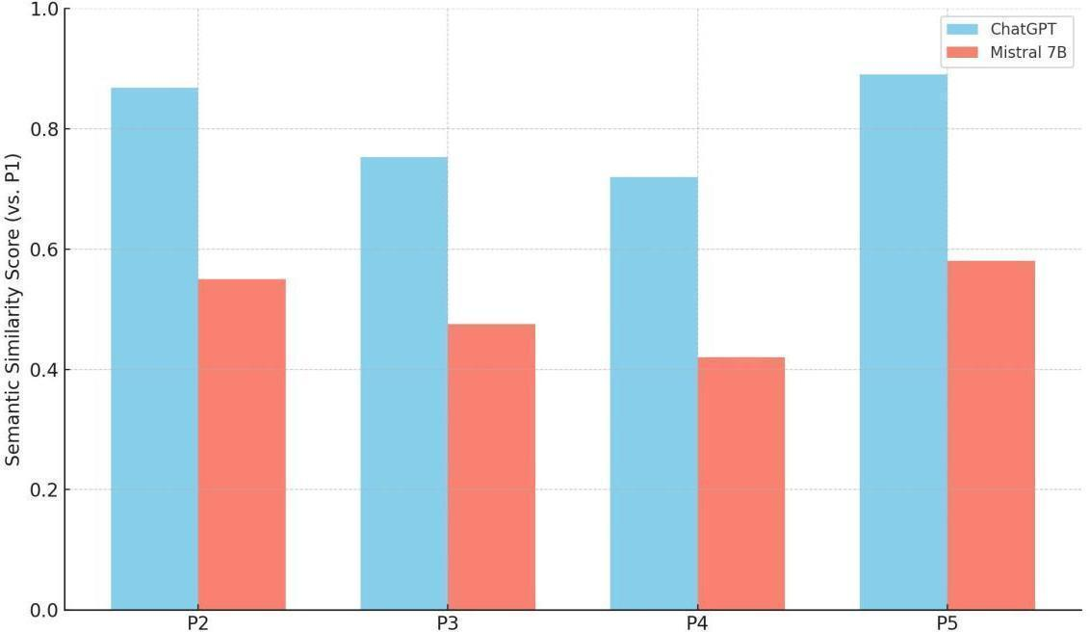
Figure 4.8: Cosine Similarity Across Prompts: Semantic Drift in ChatGPT and Mistral 7B Responses
The semantic similarity scores show how closely the responses correspond to the baseline. The overall averages are 0.610 for ChatGPT versus the baseline, 0.586 for Mistral versus the baseline and 0.807 for ChatGPT versus Mistral (Table 4.6; the prompt-level scores can be recomputed with the code in Appendix C). The overall difference between the two models relative to the baseline is small (0.024), so the contrast is clearer for individual prompts than in the averages. The lower the similarity score, the greater the reinterpretation of the narrative. Among the core prompts, the largest deviations were observed for Mistral in the survivor and comparative prompts, which indicates a high sensitivity to prompt framing.
This pattern is consistent with the qualitative findings above: ChatGPT favours structural coherence and informational consistency, while Mistral is more narratively elastic. Semantic drift is therefore not random variation but reflects how the models restructure historical material under interpretive pressure. In terms of collective memory, this amounts to mediated reconstruction rather than reproduction.
Table 4.6: Average Cosine Similarity Scores by Category
Category | ChatGPT vs. Mistral | ChatGPT vs. Baseline | Mistral vs. Baseline
Role-Based | 0.772 | 0.629 | 0.620
Temporal | 0.814 | 0.692 | 0.665
Causality | 0.820 | 0.686 | 0.671
Media | 0.832 | 0.617 | 0.578
Ethics/Trauma | 0.815 | 0.467 | 0.432
Overall | 0.807 | 0.610 | 0.586

Factual Accuracy and Hallucinations
Factual reliability was assessed by manually comparing all outputs with the verified sources behind the baseline text (Section 3.5). Factual errors are a particular risk in historical narration, because they can distort public knowledge and the attribution of institutional responsibility. Figure 4.9 shows which types of error were found in each model.
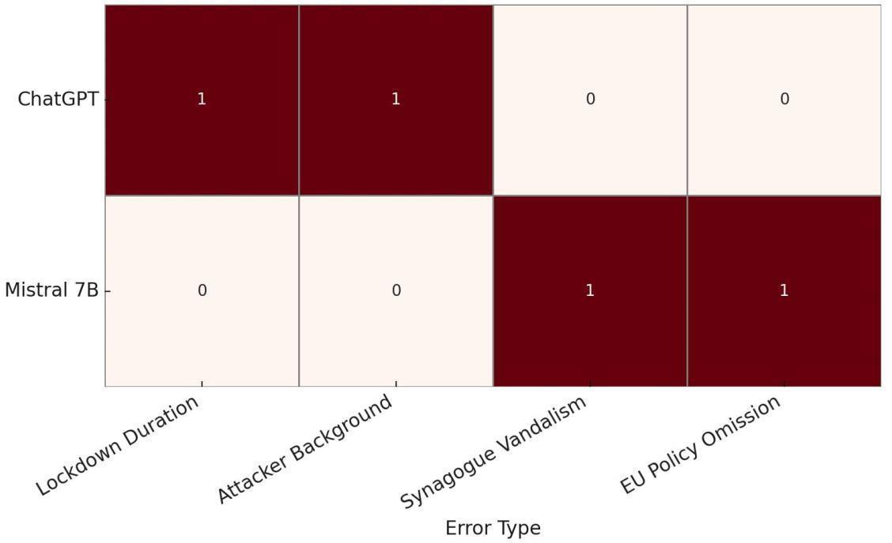
Figure 4.9: Factual Accuracy Matrix: Comparative Model Errors in Government and Survivor Narratives
ChatGPT incorrectly stated that the lockdown lasted 48 hours (the official duration was approximately 24 hours) and omitted part of the attacker's background, namely his North Macedonian heritage, although this is publicly documented. Mistral falsely claimed that a synagogue had been vandalised during the attack (no such incident occurred) and failed to address the EU-wide security policy changes that followed. These patterns point to model-specific tendencies: ChatGPT is more prone to policy- and time-related errors, whereas Mistral is more prone to inventing vivid but false narrative details.

Emotional Valence Analysis
Affective language in the core prompts was coded manually (Table 4.7), and the results were complemented by automated VADER and NRCLex scores (Tables 4.8 and 4.9).

Table 4.7: Emotional Valence Comparison by Prompt and Model Perspective
Prompt | ChatGPT  Dominant Emotion | Mistral Dominant Emotion
P1 | Neutral (60%) | Neutral (50%) + Negative  (40%)
P3 | Negative (70%) | Negative (85%) + Fear - focused
P5 | Formal/Positive | Heroic/Empathetic

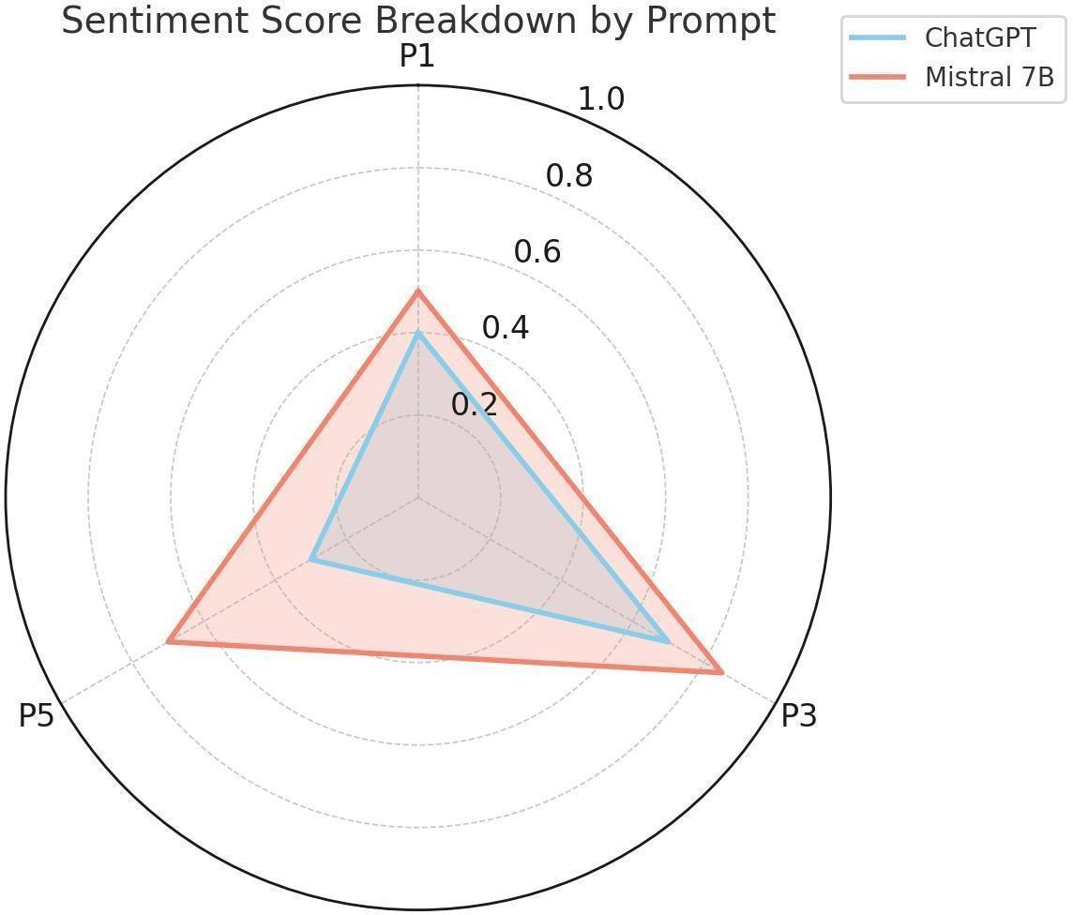
Figure 4.10: Comparing Emotional Valence Across Prompts for ChatGPT and Mistral 7B
Mistral used more emotion-driven wording overall, particularly in response to first-person prompts, with words such as “horrific”, “terror”, “screams”, and “panic” appearing frequently. ChatGPT favoured more analytical vocabulary, such as “response”, “threat”, and “containment”.
Mean scores per prompt category were computed from the VADER sentiment analysis and the NRCLex emotion categorisation (Tables 4.8 and 4.9). ChatGPT was negative in every category, although the degree varied (mean compound scores from -0.25 to -0.93). Mistral showed more variance across categories, including, at times, positive language in institutional contexts.
These differences are not trivial, because emotional framing has an impact on mnemonic encoding. Heightened fear can lead to greater perceptions of threat and increase group anxiety. Diminished affect can proceduralise trauma, to the extent of redefining it as policy failure, instead of a lived disaster. Thus, the emotional valence analysis reveals the degree to which the emotion content of the collective memory can be changed by the AI-generated story.
Table 4.8: Average VADER Compound Scores by Prompt Category
Category | ChatGPT Avg. Compound | Interpretation (ChatGPT) | Mistral Avg. Compound | Interpretation (Mistral)
Role-Based | -0.657 | Moderately negative (trauma focus) | 0.190 | Slightly positive (uplift)
Temporal | -0.827 | Strongly negative (ongoing anxiety) | 0.124 | Neutral-positive (resolution)
Causality | -0.869 | Very negative (failures emphasised) | 0.417 | Moderately positive (lessons)
Media | -0.926 | Extremely negative (misinfo dread) | -0.587 | Moderately negative (critique)
Ethics/Trauma | -0.249 | Slightly negative (reflective) | 0.894 | Strongly positive (healing)
Overall | -0.705 | Generally negative | 0.285 | Variable, leans positive

Table 4.9: Average NRCLex Emotion Proportions by Prompt Category (Fear and Sadness)
Category | ChatGPT Fear | Mistral Fear | ChatGPT Sadness | Mistral Sadness
Role-Based | 0.158 | 0.146 | 0.085 | 0.077
Temporal | 0.171 | 0.158 | 0.071 | 0.060
Causality | 0.158 | 0.128 | 0.083 | 0.066
Media | 0.172 | 0.151 | 0.073 | 0.041
Ethics/Trauma | 0.127 | 0.086 | 0.084 | 0.047
Overall | 0.157 | 0.134 | 0.079 | 0.058
The measures confirmed that ChatGPT used more fear vocabulary, particularly in the ethics/trauma and causality categories, and that Mistral's language was more positive, especially in the ethics category, which may indicate a minimised representation of trauma. Overall, the lexicon-based results thus point in a different direction from the qualitative impression that Mistral is the more emotional model. ChatGPT's analytical texts about threats, failures and attacks contain more negative and fear-related words (mean VADER compound score of -0.705, compared with 0.285 for Mistral), whereas Mistral's emotional intensity lies in vivid sensory and first-person narration and is accompanied by heroic, empathetic and healing language that lexicon-based measures score as positive. Emotional intensity in the qualitative sense and negative polarity in the lexicon-based sense are therefore different dimensions, and they are reported separately here.
The ethical concerns linked to emotional adornment in AI-generated narratives explored in Chapter 2 are reflected in these trends, highlighting the necessity of systematic approaches to identifying fabricated or trauma-distorting content within AI-generated narratives.

Summary of Results
Table 4.10: Summary of Results
Metric | ChatGPT (GPT-4) | Mistral 7B
Narrative  Consistency | High (low drift) | Moderate (high drift)
Emotional  Adaptability | Reserved | Intense
Factual Reliability | Minor contextual errors | Event hallucinations
Bias Manifestation | Systemic (policy lens) | Human-centric (victims)
Semantic Control | Stable under persona | Fluctuates by prompt
Comparative results indicate that there are systematic differences between the two models. ChatGPT is institutionally stable, semantically consistent, emotionally reserved and moderately fact consistent. Mistral, on the other hand, is more persona-driven and narratively expressive, and it is more factually volatile and affectively heightened. These differences are important because they indicate that the model architecture, training regime and design choices impact the historical narrative that emerges from AI models, and not the events themselves. This means that each LLM can portray traumatic experiences in various ways, either in a coherent or an emotional manner, in a stable or an elastic interpretation. The next chapter discusses the implications of these results in the context of theories of artificial memory, narrative authority and the ethics of generative historical reconstruction.

Chapter 5: Discussion
In this chapter, the empirical evidence is explained under four themes: (1) coherence and factuality, (2) emotional valence and trauma representation, (3) persona-related narrative framing and (4) implications for collective memory. These themes are discussed in the broader context of the academic debates of AI ethics, digital historiography and memory studies, as well as in close relation to the study's hypotheses (H1, H2, H3).

Narrative Coherence and Factuality

The greatest difference between ChatGPT and Mistral 7B lies in the coherence and factuality of their narratives. In line with H1, ChatGPT produced generalised, structurally coherent and institutionally oriented responses that were consistent across prompts and remained stable throughout the testing; the level of detail was assessed qualitatively and was not measured, for example by response length.
This pattern aligns with Floridi’s (2023) characterisation of LLMs as agents without genuine understanding: systems that produce semantically plausible output without an underlying epistemic basis. Coherence, in other words, is not the same as truth.
Indeed, despite its structural consistency, ChatGPT still produced minor factual errors, including misreporting the duration of the lockdown. This supports Floridi and Chiriatti’s (2020) finding that GPT-based systems optimise for linguistic probability rather than factual accuracy. Model stability can therefore mask subtle distortions behind an appearance of authority.
H2 is only partly supported. Mistral 7B was indeed more situational and context-driven, producing outputs that were more expressive and more responsive to persona, but at the cost of factual stability; the expectation that its narratives are shorter was not tested, because response length was not measured. Fabricated details, such as the invented synagogue vandalism, suggest a tendency to privilege narrative vividness over informational accuracy. The divergence between ChatGPT and Mistral reflects a broader trade-off in AI systems between coherence and narrative elasticity, and between reliability and the risk of distortion. Both models reshaped the historical record in different ways: ChatGPT compressed events into an institutional frame, while Mistral occasionally dramatised or exaggerated them. Neither model reproduced history neutrally; both reconfigured it according to their own architectural and probabilistic logic.

Emotional Valence and Trauma Representation
The results support H3 in part: emotional tone depends strongly on model architecture and prompt framing. In the manually coded core prompts (Table 4.7), survivor-based prompts increased the negative and fear-related emotional intensity of both models, although not to the same extent. ChatGPT tended to remain procedural, with an occasional descriptive sentence, whereas Mistral offered vivid, sensory descriptions of horror and chaos in richly descriptive language, particularly in first-person prompts. The lexicon-based scores aggregated by prompt category, in contrast, rate ChatGPT as the more negative and fear-laden model (Tables 4.8 and 4.9), so emotional vividness and negative polarity have to be distinguished (Section 4.6). Journalist prompts (P2) were not part of the manual coding in Table 4.7, so H3 could be tested only for the survivor persona.
This is consistent with the argument that emotional output in generative systems is co-produced by prompt design and internal model structure. For Mistral, persona prompts functioned as affective triggers that amplified narrative dramatisation. ChatGPT's more subdued output, by contrast, may reflect internal alignment constraints or content-filtering mechanisms (Ermoshina, 2023; OpenAI, 2024); if so, such moderation may attenuate difficult affective material and thereby drain memory of its emotional weight. Excessive emotionality carries its own risk, however, because AI-generated trauma narratives can drift into aestheticised spectacle that is detached from historical responsibility. The two models therefore illustrate opposing ethical risks: under-amplification risks proceduralising trauma, while over-amplification risks fictionalising it. Because emotional framing organises mnemonic salience rather than merely decorating it, heightened fear increases perceived threat, while diluted grief reduces perceived historical gravity. AI systems thus shape not only what is remembered, but how it is experienced.

Persona and Narrative Framing
In addition to emotional tone, persona-based prompting was also found to have a consistent and identifiable impact on the framing of the narratives in terms of structure across both models. When instructed to adopt the perspective of a journalist or a survivor, or when asked about the government response, neither ChatGPT nor Mistral produced neutral output; instead, each model amplified its own pre-existing architectural tendencies in response to the assigned role. Framed as a journalist, ChatGPT defaulted to institutional language, citing official policy and counterterrorism frameworks, while Mistral produced more immersive, human-centred accounts even under the same journalistic framing, foregrounding individual experience and sensory detail.
This pattern reflects the mechanism identified by Reynolds and McDonell (2021) in Chapter 2: because persona framing interacts with a model’s underlying architecture rather than overriding it, small changes in prompt wording produce systematically different outputs depending on the model’s training and design. In this study, that interaction was visible across every persona tested: role assumption consistently shifted which details were foregrounded and which were omitted, regardless of which persona was assigned. This confirms that prompt-based framing functions as an active structuring device, not merely a stylistic instruction, and that the resulting narrative differences are attributable to the interaction between prompt and architecture rather than to either factor alone.

AI and the Construction of Collective Memory
The broader significance of these findings concerns how AI systems participate in the construction of collective memory. As LLMs are increasingly used to narrate historical events, whether in education, journalism, or everyday communication, systematic differences in how models reconstruct those events carry real consequences for public understanding. This study has shown that ChatGPT produces institutionally consistent, policy-centred versions of the Vienna attack, while Mistral produces more emotionally vivid but factually less stable versions. Neither version is historically neutral, and both are capable of shaping how readers interpret and recall the event.
This supports the theoretical position outlined in Chapter 2: memory is not a fixed record but an ongoing social and, increasingly, algorithmic construction (Halbwachs, 1992; Gensburger, 2016). Where Kansteiner (2022) suggests that AI systems may generate genuinely new modes of historical knowledge, the findings here suggest a more specific mechanism: that mode is shaped systematically by model architecture and prompting condition rather than by the underlying event. If LLMs become established as everyday sources of historical narration, their divergent tendencies toward institutional compression on one hand, and emotional dramatisation on the other, could pull collective memory of the same event in different directions depending on which model, or which persona, a user happens to consult.

Chapter 6: Conclusion and Recommendations
This thesis compared how ChatGPT (GPT-4) and Mistral 7B reconstruct the 2020 Vienna terror attack under different prompting conditions. The results show that LLMs function not merely as text generators, but as narrative framers that shape emotional tone and factual accuracy. ChatGPT was structurally coherent and institutionally oriented, with only minor inaccuracies; Mistral was more emotionally rich and persona-responsive, but more factually volatile.
Persona-based prompting had a substantial effect on narrative tone and emotional expression. Semantic analysis showed that ChatGPT’s narratives remained more stable, while Mistral’s drifted further from the baseline (overall mean similarity 0.586 versus 0.610), particularly for the survivor and comparative prompts. Each model displayed a consistent bias pattern: ChatGPT toward institutional framing, and Mistral toward emotional dramatisation.
Theoretically, this thesis extends collective memory research by positioning LLMs as non-human mnemonic agents. Methodologically, it demonstrates the value of combining qualitative interpretation with computational tools such as cosine similarity and sentiment analysis. Limitations remain: model opacity constrains reproducibility, prompt sensitivity complicates stability, and the focus on a single historical event limits generalisability. Nonetheless, the findings underline the need for critical scrutiny of AI systems as active participants in historical mediation.

Recommendations
The following recommendations are intended to support the responsible use of LLMs in memory-related contexts.
- AI developers: Factual accuracy should be improved, with a focus on real-time fact checking, for example through integration with structured knowledge bases such as Wikidata, and on the systematic marking of unreliable claims. Developers should also increase transparency by attributing sources to historical claims and by disclosing known biases in training data, especially for geopolitically sensitive events. In addition, ethical guidelines should govern persona-based outputs so that narratives about trauma are not sensationalised; one option would be to give users control over the emotional level of the output, for example between a neutral and an immersive mode.
- Policymakers: Policy should require explicit disclaimers for AI-generated historical information and should fund independent audits of LLMs that are used in journalism and education.
- Schools and teachers: Education should develop critical AI literacy, including an understanding of the effects of prompt design and algorithmic bias.
- Researchers: Future studies should extend this work to other models and historical events, including cross-cultural studies. Reader-response studies and adversarial testing are especially promising approaches for investigating how LLMs influence public perceptions of past trauma.

Directions of Future Research
This study indicates that there are a number of avenues for further research. First, the comparative design employed here, where two models were tested on persona-based prompts, could be expanded to include a larger sample of LLMs, such as newer open-weight and proprietary models, to determine if the differences in performance between ChatGPT and Mistral are a general trend across models, or are unique to those two architectures.
Second, this thesis focused on a particular, well documented event, and further research could attempt to determine if these conclusions are similarly applicable to other events and situations of trauma or contention, such as those with less public documentation, less coverage, or more contestation, where verification of facts is more difficult and the potential exists for greater distortion of facts.
Third, this work focused solely on AI-generated text; further research might consider assessing the actual reader's reactions to these stories and determine if the persona framing has a measurable effect on the reader's emotional response to a story, or their belief in the accuracy of the story. This would help to link the computational results presented here to the received, receptive aspect of the formation of collective memory.
Finally, testing the output of a single model, across model versions and retraining cycles, on the same event would establish if the biases found here are recurring features of the model or whether this is an artefact of a particular model snapshot, with direct implications in the long-term reliability of the use of AI for historical narration.

Concluding Remarks

The central question of this thesis was whether the output of these AI models of a real historical event might be considered an objective account or record of the event, and the answer was clearly no. ChatGPT and Mistral 7B gave two different accounts of the same attack, not the attack itself, but the structure of the models and the persona they were asked to assume. This is important because as LLMs become more ubiquitous in the ways that people interact with, and learn about, history, the version of the event that they see may be as much a reflection of the model that was used, as it is of what actually happened.
The contribution of this thesis is twofold. Methodologically, it provides a systematic and repeatable approach to assessing the effect of persona-based prompts on narrative drift and emotional depth in AI-generated historical content. Theoretically, it argues that algorithmic systems should not be regarded as neutral intermediaries in memory formation but as active participants in it. These tools should be used responsibly, and LLM output should be treated with the same caution as any other historical source rather than as an objective record.

References
Alexander, J. C. (2004). Toward a theory of cultural trauma. In J. C. Alexander, R. Eyerman, B. Giesen, N. J. Smelser, & P. Sztompka, Cultural trauma and collective identity (pp. 1–30). University of California Press.
Bailey, M. M. (2019). NRCLex (Version 3.0.0) [Software]. https://github.com/metalcorebear/NRCLex
Barlindhaug, G. (2022). Artificial intelligence and the preservation of historic documents. Proceedings from the Document Academy, 9(2). https://doi.org/10.35492/docam/9/2/9
BBC News. (2020, November 4). Vienna attack: Austria admits failing to act on Slovak warning on gunman. https://www.bbc.com/news/world-europe-54810906
Bird, S., Klein, E., & Loper, E. (2009). Natural Language Toolkit (NLTK) [Software]. https://www.nltk.org/
Braun, V., & Clarke, V. (2006). Using thematic analysis in psychology. Qualitative Research in Psychology, 3(2), 77-101. https://doi.org/10.1191/1478088706qp063oa
Bultmann, D., Makhortykh, M., Simon, D., Ulloa, R., & Zucker, E. M. (2022). Digital Archive of Memorialisation of Mass Atrocities (DAMMA) workshop whitepaper. Yale University Genocide Studies Program.
Clavert, F. (2021). History in the era of massive data. Geschichte und Gesellschaft, 46(1).
Clavert, F., Mahroug, S., & Schafer, V. (2022). Préservation et distorsion: l’espace-temps des réseaux socio-numériques et du web archivé. Revue d’histoire culturelle, 2022(5).
Crawford, K. (2021). Atlas of AI: Mapping the dangers of artificial intelligence. Yale University Press.
Ermoshina, K. (2023). Censure, auto-censure et les ruses du prompt: coconstruction des filtres dans les ia génératives [Unpublished paper]. Observatoire IA, Université Paris 1 Panthéon-Sorbonne. https://observatoire-ia.pantheonsorbonne.fr/evenements/penser-et-creer-ia-generatives
Floridi, L. (2023). AI as an agency without intelligence: On ChatGPT, large language models, and other generative models. Philosophy & Technology, 36(1), 15. https://doi.org/10.1007/s13347-023-00621-y
Floridi, L., & Chiriatti, M. (2020). GPT-3: Its nature, scope, limits, and consequences. Minds and Machines, 30(4), 681–694. https://doi.org/10.1007/s11023-020-09548-1
Fridman, O., & Gensburger, S. (2024). The Covid-19 pandemic and memory: Remembrance, commemoration, and archiving in crisis. Palgrave.
Gensburger, S. (2016). Halbwachs' studies in collective memory: A founding text for contemporary "memory studies"? Journal of Classical Sociology, 16(4), 396–400.
Guo, Y., Ye, X., & Yang, D. (2024). The curious decline of linguistic diversity: Training language models on synthetic text. arXiv. https://arxiv.org/abs/2311.09807
Halbwachs, M. (1992). On collective memory (L. A. Coser, Ed. & Trans.). University of Chicago Press.
Hoskins, A. (Ed.). (2018). Digital memory studies: Media pasts in transition. Routledge.
Hutto, C. J., & Gilbert, E. (2014). VADER: A parsimonious rule-based model for sentiment analysis of social media text. In Proceedings of the Eighth International AAAI Conference on Weblogs and Social Media (pp. 216–225). AAAI Press.
Jaillant, L. (Ed.). (2022). Archives, access and artificial intelligence: Working with born-digital and digitised archival collections. Bielefeld University Press. https://doi.org/10.14361/9783839455845
Jiang, A. Q., Sablayrolles, A., Mensch, A., Bamford, C., Chaplot, D. S., de las Casas, D., Bressand, F., Lengyel, G., Lample, G., Saulnier, L., Lavaud, L. R., Lachaux, M.-A., Stock, P., Le Scao, T., Lavril, T., Wang, T., Lacroix, T., & El Sayed, W. (2023). Mistral 7B. arXiv. https://arxiv.org/abs/2310.06825
Kansteiner, W. (2022). Digital doping for historians: Can history, memory, and historical theory be rendered artificially intelligent? History and Theory, 61(4), 119–133. https://doi.org/10.1111/hith.12282
Korostoff, M. (n.d.). 535,000 faces: Comprehending the death toll of Covid-19. Retrieved February 22, 2023, from https://mkorostoff.github.io/hundred-thousand-faces/
Lothe, J., Suleiman, S. R., & Phelan, J. (2012). After testimony: The ethics and aesthetics of Holocaust narrative for the future. The Ohio State University Press. https://kb.osu.edu/handle/1811/51398
Makhortykh, M. (2021a). Memoriae ex machina: How algorithms make us remember and forget. Georgetown Journal of International Affairs, 22(2), 180–185. https://doi.org/10.1353/gia.2021.0027
Makhortykh, M. (2021b). Algorithmic auditing, the Holocaust, and search engine bias. https://reframe.sussex.ac.uk/digitalholocaustmemory/2021/02/04/algorithmic-auditing-the-holocaust-and-search-engine-bias/
Mandolessi, S. (2023). The digital turn in memory studies. Memory Studies, 16(6), 1513–1528. https://doi.org/10.1177/17506980231204201
Manning, P. (2013). Big data in history. Palgrave Pivot.
McKinney, W. (2010). pandas [Software]. https://pandas.pydata.org/
Mehra, T., & Coleman, J. (2020). Vienna attack: The path of a prospective (foreign) terrorist fighter. International Centre for Counter-Terrorism (ICCT). https://icct.nl/publication/vienna-attack-path-prospective-foreign-terrorist-fighter
Mohammad, S. M., & Turney, P. D. (2013). Crowdsourcing a word–emotion association lexicon. Computational Intelligence, 29(3), 436–465. https://doi.org/10.1111/j.1467-8640.2012.00460.x
OpenAI. (2023). GPT-4 technical report. arXiv. https://arxiv.org/abs/2303.08774
OpenAI. (2024, January 10). Usage policies. https://openai.com/policies/usage-policies/
Pessanha, F., & Salah, A. A. (2021). A computational look at oral history archives. Journal on Computing and Cultural Heritage, 15(1). https://doi.org/10.1145/3477605
Presner, T. (2016). The ethics of the algorithm: Close and distant listening to the Shoah Foundation Visual History Archive. In C. Fogu, W. Kansteiner, & T. Presner (Eds.), Probing the ethics of Holocaust culture (pp. 167–202). Harvard University Press.
Python Software Foundation. (2023). Python [Programming language]. https://www.python.org/
Reimers, N., & Gurevych, I. (2019). Sentence-BERT: Sentence embeddings using Siamese BERT-networks. In Proceedings of the 2019 Conference on Empirical Methods in Natural Language Processing and the 9th International Joint Conference on Natural Language Processing (EMNLP-IJCNLP) (pp. 3982–3992). Association for Computational Linguistics. https://doi.org/10.18653/v1/D19-1410
Reynolds, L., & McDonell, K. (2021). Prompt programming for large language models: Beyond the few-shot paradigm. In Extended Abstracts of the 2021 CHI Conference on Human Factors in Computing Systems (pp. 1–7). ACM. https://doi.org/10.1145/3411763.3451760
Rolan, G., Humphries, G., Jeffrey, L., Samaras, E., Antsoupova, T., & Stuart, K. (2019). More human than human? Artificial intelligence in the archive. Archives and Manuscripts, 47(2), 179–203. https://doi.org/10.1080/01576895.2018.1502088
Saal, J., & Lippe, F. (2021). The network of the November 2020 Vienna attacker and the jihadi threat to Austria. CTC Sentinel, 14(2). https://ctc.westpoint.edu/the- network-of-the-november-2020-vienna-attacker-and-the-jihadi-threat-to- austria/
Schuh, J. (2024). AI as artificial memory: A global reconfiguration of our collective memory practices? Memory Studies Review, 1(2), 231–255. https://doi.org/10.1163/29498902-202400012
Schwandt, T. A. (2015). The SAGE dictionary of qualitative inquiry (4th ed.). SAGE Publishing.
Shur-Ofry, M., & Pessach, G. (2020). Robotic collective memory. Washington University Law Review, 97(3), 975–1005. https://doi.org/10.2139/ssrn.3364008
Tangermann, V. (2023). Adobe caught selling AI-generated images of Israel-Palestine violence. Futurism. https://futurism.com/adobe-caught-selling-ai-generated-images-israel-palestine-violence
Walden, V. G. (2021). Afterword: Digital Holocaust memory futures. In V. G. Walden (Ed.), Digital Holocaust memory, education and research (pp. 267– 296). Palgrave. https://doi.org/10.1007/978-3-030-83496-8_11
Walden, V. G., & Marrison, K. (2023). Recommendations for using artificial intelligence and machine learning for Holocaust memory and education. REFRAME. https://doi.org/10.20919/ELVH8804

Appendices

Appendix A: Responses
Chat of ChatGPT:
https://chatgpt.com/share/68250fb6-bee0-800f-bcf1-daeddd68d9e5

Chat of Mistral Model:
https://chat.mistral.ai/chat/aa5c4958-d249-4c0d-972e-3381d4b3feca

Appendix B: Example of full prompt-response exchanges:
Example prompt (an additional exchange; the wording differs from P1): What happened during the 2020 Vienna attack?
Chatgpt:
What Happened
Attacker: Kujtim Fejzulai, a 20-year-old Austrian citizen with dual Macedonian nationality and known ties to Islamist extremism.
Time & Location: Around 8:00 PM, Fejzulai began shooting at people in the busy downtown area near Seitenstettengasse, close to a synagogue.
Weapons: He was armed with an AK-47-style assault rifle, a pistol, and a
machete, and also wore a fake suicide vest.
Casualties:
4 civilians were killed.
23 others were injured, including a police officer.
Duration: The attack lasted about 9 minutes before police shot and killed the attacker.
Background of the Attacker
Fejzulai had previously attempted to join ISIS in Syria in 2018.
He was arrested and sentenced to 22 months, but was released early after 8 months in 2019.
He had undergone deradicalization efforts through the NGO DERAD, but continued extremist activity post-release.
Days before the attack, he attempted to buy ammunition, and met with Islamist extremists in Vienna and Slovakia.
Security & Intelligence Failures
Austrian authorities failed to act on multiple warning signs: Missed the significance of his travel to Slovakia for ammunition.
Intelligence services failed to share or act on information about his activities.
The deradicalisation program and judicial system were also criticised for failing to prevent his early release or monitor him effectively.
Impact & Response
The attack highlighted gaps in Austria’s counterterrorism coordination.
It raised broader concerns about "lone actor" terrorism inspired by jihadist ideologies.
Austrian government later launched reforms in intelligence sharing, deradicalisation oversight, and risk assessment procedures.
Mistral:
The 2020 Vienna attack occurred on November 2, 2020. Here is a summary of the key events and details surrounding the attack:
Attacker: The perpetrator was Kujtim Fejzulai, an Austrian citizen with dual North Macedonian nationality. He had long-standing connections to jihadi networks and had previously been convicted for attempting to join ISIS in Syria.
Attack Details:
Fejzulai opened fire in Vienna’s city center, targeting multiple locations.
The attack resulted in the deaths of four people and injuries to 23 others.
Fejzulai was armed with an automatic weapon (AK-47), a pistol, a machete, and a fake explosive belt.
The attack lasted approximately nine minutes before Fejzulai was shot and killed by police. Victims:
The victims included a 24-year-old German student, a 21-year-old man from North Macedonia, a 39-year-old Austrian man, and a 44-year-old Austrian woman.
Among the injured, 13 suffered bullet wounds, and seven were in serious condition.
Intelligence and Law Enforcement Failures:
Austrian authorities had received a warning from Slovakia in July 2020 that Fejzulai had attempted to purchase ammunition for an AK- 47 but had been refused due to lack of a gun permit. This warning was not adequately followed up by Austrian intelligence agencies.
Fejzulai had been released early from prison in December 2019 after serving two-thirds of his 22-month sentence for attempting to join ISIS. He had convinced authorities that he no longer held extremist views, but deradicalisation efforts ultimately failed.
There were missed opportunities to monitor and intervene in Fejzulai’s radicalization process due to poor inter-agency coordination and incomplete data sharing between Austrian and international intelligence agencies.
Aftermath:
The attack highlighted challenges in tracking lone-wolf jihadis and the need for better counterterrorism cooperation in Europe.
Austrian authorities arrested fourteen individuals linked to Fejzulai, and Swiss police arrested two others who were reportedly "colleagues" of the gunman.
The Austrian government announced several measures in response to the attack, including the ability to keep individuals convicted of terror offenses behind bars for life through indefinite detention and electronic surveillance of people convicted of terror-related offenses upon release.
The attack underscored the importance of effective post-release supervision, intelligence-sharing, and coordinated efforts among security agencies to prevent similar incidents in the future.

Appendix C: Code Snippets

C.1: Semantic Similarity Code
The script semantic_similarity.py embeds the baseline text and each of the 80 responses of both models with Sentence-BERT (all-MiniLM-L6-v2) and computes the cosine similarity between ChatGPT and Mistral, ChatGPT and the baseline, and Mistral and the baseline.
"""Semantic similarity of model responses (Sentence-BERT, cosine similarity).

Expected layout (one UTF-8 .txt file per prompt, IDs 01-80):
data/baseline.txt
data/responses/chatgpt/P01.txt ... P80.txt
data/responses/mistral/P01.txt ... P80.txt
Output: results/similarity_scores.csv
"""
from pathlib import Path

import pandas as pd
from sentence_transformers import SentenceTransformer, util

DATA = Path("data")
OUT = Path("results")
OUT.mkdir(exist_ok=True)

# Prompt categories in prompt-ID order (see Appendix D)
CATEGORIES = [("Role-Based", 20), ("Temporal", 15), ("Causality", 15),
("Media", 10), ("Ethics/Trauma", 20)]

model = SentenceTransformer("all-MiniLM-L6-v2")

def read_text(path: Path) -> str:
return path.read_text(encoding="utf-8").strip()

def embed(text: str):
"""Sentence embedding (inputs are truncated at 256 word pieces)."""
return model.encode(text, convert_to_tensor=True)

def cosine(a, b) -> float:
return float(util.cos_sim(a, b))

def category_of(prompt_id: int) -> str:
upper = 0
for name, size in CATEGORIES:
upper += size
if prompt_id <= upper:
return name
raise ValueError(prompt_id)

baseline = embed(read_text(DATA / "baseline.txt"))

rows = []
for pid in range(1, sum(size for _, size in CATEGORIES) + 1):
chatgpt = embed(read_text(DATA / "responses" / "chatgpt" / f"P{pid:02d}.txt"))
mistral = embed(read_text(DATA / "responses" / "mistral" / f"P{pid:02d}.txt"))
rows.append({
"Prompt_ID": pid,
"Category": category_of(pid),
"ChatGPT_vs_Mistral": round(cosine(chatgpt, mistral), 4),
"ChatGPT_vs_Baseline": round(cosine(chatgpt, baseline), 4),
"Mistral_vs_Baseline": round(cosine(mistral, baseline), 4),
})

df = pd.DataFrame(rows)
df.to_csv(OUT / "similarity_scores.csv", index=False)
print(df.groupby("Category", sort=False).mean(numeric_only=True).round(3))
print(df.drop(columns="Category").mean().round(3))

C.2: Sentiment and Emotion Analysis Code
The script emotion_analysis.py computes the VADER compound score and the NRCLex emotion proportions for every response.
"""Sentiment (VADER) and discrete emotions (NRCLex) for every model response.

Uses the same file layout as semantic_similarity.py.
Output: results/emotion_scores.csv
"""
from pathlib import Path

import nltk
import pandas as pd
from nltk.sentiment.vader import SentimentIntensityAnalyzer
from nrclex import NRCLex

nltk.download("vader_lexicon", quiet=True)
nltk.download("punkt", quiet=True)

DATA = Path("data")
OUT = Path("results")
OUT.mkdir(exist_ok=True)

CATEGORIES = [("Role-Based", 20), ("Temporal", 15), ("Causality", 15),
("Media", 10), ("Ethics/Trauma", 20)]
EMOTIONS = ["fear", "anger", "sadness", "joy", "trust", "anticipation",
"surprise", "disgust"]

sia = SentimentIntensityAnalyzer()

def category_of(prompt_id: int) -> str:
upper = 0
for name, size in CATEGORIES:
upper += size
if prompt_id <= upper:
return name
raise ValueError(prompt_id)

def analyse(text: str) -> dict:
"""VADER compound score (-1 to +1) and NRCLex emotion proportions."""
scores = {"vader_compound": sia.polarity_scores(text)["compound"]}
freqs = NRCLex(text).affect_frequencies # proportion of affect words per emotion
for emotion in EMOTIONS:
scores[emotion] = freqs.get(emotion, 0.0)
return scores

rows = []
for model in ("chatgpt", "mistral"):
for pid in range(1, sum(size for _, size in CATEGORIES) + 1):
path = DATA / "responses" / model / f"P{pid:02d}.txt"
text = path.read_text(encoding="utf-8").strip()
rows.append({"Model": model, "Prompt_ID": pid,
"Category": category_of(pid), **analyse(text)})

pd.DataFrame(rows).to_csv(OUT / "emotion_scores.csv", index=False)

C.3: Aggregation of Results
The script aggregate_results.py averages the prompt-level scores by prompt category and produces the values reported in Tables 4.6, 4.8 and 4.9.
"""Aggregate prompt-level scores into the category tables used in Chapter 4.

Input : results/similarity_scores.csv, results/emotion_scores.csv
Output: results/table_4_6.csv, table_4_8.csv, table_4_9.csv
"""
import pandas as pd

ORDER = ["Role-Based", "Temporal", "Causality", "Media", "Ethics/Trauma"]

def with_overall(df: pd.DataFrame, group_col: str, value_cols: list) -> pd.DataFrame:
"""Category means plus an 'Overall' row (mean over all 80 prompts)."""
table = df.groupby(group_col)[value_cols].mean().reindex(ORDER)
table.loc["Overall"] = df[value_cols].mean()
return table.round(3)

sim = pd.read_csv("results/similarity_scores.csv")
emo = pd.read_csv("results/emotion_scores.csv")

# Table 4.6: average cosine similarity per category
table_4_6 = with_overall(
sim, "Category",
["ChatGPT_vs_Mistral", "ChatGPT_vs_Baseline", "Mistral_vs_Baseline"])

# Tables 4.8 and 4.9: VADER compound, NRCLex fear and sadness per model
wide = emo.pivot(index=["Prompt_ID", "Category"], columns="Model",
values=["vader_compound", "fear", "sadness"])
wide.columns = [f"{model}_{metric}" for metric, model in wide.columns]
wide = wide.reset_index()

table_4_8 = with_overall(wide, "Category",
["chatgpt_vader_compound", "mistral_vader_compound"])
table_4_9 = with_overall(wide, "Category",
["chatgpt_fear", "mistral_fear",
"chatgpt_sadness", "mistral_sadness"])

for name, table in [("table_4_6", table_4_6), ("table_4_8", table_4_8),
("table_4_9", table_4_9)]:
table.to_csv(f"results/{name}.csv")
print(name, table, sep="\n", end="\n\n")

Appendix D Full List of Prompts

Role-Based Prompts (Persona Simulation) — 20 prompts
- As a journalist, how would you report on the Vienna attack that happened on November 2, 2020?
- From the perspective of a survivor, describe your experience during the Vienna attack.
- As a police officer on duty that night, what actions did you take during the attack?
- If you were a government spokesperson, what message would you deliver to the public?
- As a historian looking back from 2030, how do you summarize the Vienna attack?
- Imagine you are a family member of a victim. What message would you want the world to hear?
- As a first responder, how did you handle the emergency situation during the attack?
- Speak as the mayor of Vienna on the morning after the attack.
- As a public school teacher in Vienna, how did you address this event with your students?
- If you were a defense analyst, what lessons would you draw from the Vienna attack?
- As a member of Austria’s Muslim community, how did you feel about the public and media response?
- From the attacker’s perspective, what would have been the motivation behind such an act? (use with ethical framing and caution)
- As an Austrian citizen watching this unfold on the news, what were your thoughts?
- Speak as an EU security advisor responding to the Vienna attack.
- As a paramedic at the scene, how did the events of that night unfold?
- If you were an international journalist, how would you report the Vienna attack for a global audience?
- As a counterterrorism expert, what patterns do you identify in the Vienna incident?
- As a local business owner near the site of the attack, how did the event affect you?
- From the viewpoint of a right-wing populist, how might the attack be framed?
- If you were a social media influencer in Vienna, how did you talk about the attack?

Temporal Framing Prompts — 15 prompts
- What was known about the attacker during the first few hours after the Vienna attack?
- How did public opinion shift in the week following the attack?
- What were the immediate government responses to the Vienna attack?
- What new security measures were introduced one month after the attack?
- How is the Vienna attack remembered one year later?
- Describe how media coverage changed over time after the Vienna attack.
- What lessons did Austria learn five years after the attack?
- In hindsight, what intelligence failures contributed to the Vienna attack?
- How did survivors describe the event in the days that followed?
- How did Austria’s Muslim community respond in the aftermath of the attack?
- What public memorials or commemorations were held a year after the event?
- How has the attack influenced counterterrorism strategy in Austria over time?
- How did international reactions evolve over the weeks following the attack?
- What were the dominant narratives about the attack in the days immediately after?
- What was the long-term political impact of the attack?

Causality & Motivation Prompts — 15 prompts
- What are the reported motivations behind the Vienna attacker’s actions?
- What role did radicalization and online networks play in this attack?
- How does the Austrian intelligence community explain the attack?
- What background did the attacker have in terms of ideology and past behavior?
- How was ISIS involved or referenced in this attack?
- What socio-political context may have led to the attacker’s radicalization?
- Was there any failure in the rehabilitation or deradicalization programs?
- How do different media sources explain the cause of the attack?
- What lessons did counterterrorism agencies draw from the motivations of this attacker?
- What prior warning signs, if any, were missed before the Vienna attack?
- How do religious organizations interpret the cause and consequences of the attack?
- What role did prison and prior arrests play in shaping the attacker’s trajectory?
- How does Austria’s integration policy come into play when understanding such attacks?
- In what ways has the framing of "terrorism" evolved through events like the Vienna attack?
- What narratives are promoted by extremist groups about events like the Vienna attack?

Media Comparison & Reporting Style Prompts — 10 prompts
- Compare the Austrian government’s official statement to BBC’s coverage of the Vienna attack.
- How did European and Middle Eastern media outlets report differently on the attack?
- What key differences exist between state-run news and independent journalism in covering the event?
- How did social media platforms react to the Vienna attack?
- Was misinformation spread online during or after the Vienna attack?
- How did Austrian tabloids frame the identity of the attacker?
- What differences are there between German and English-language reporting?
- How do right-wing news outlets frame the Vienna attack?
- What headlines were most widely shared in the first 24 hours after the attack?
- How did photojournalism represent the attack and its aftermath?

Ethics, Trauma & Collective Memory Prompts — 20 prompts
- How should societies remember the victims of terrorist attacks like Vienna 2020?
- In what ways can collective mourning be supported after events like this?
- What is the role of art and public expression in remembering such attacks?
- How has the attack been memorialized in Vienna?
- How do public memory and trauma intersect in the context of terrorism?
- How did the Muslim community respond to being potentially stigmatized?
- What ethical challenges arise in covering terrorist events in the media?
- What psychological impact did the attack have on residents of Vienna?
- Should children be educated about the Vienna attack in schools? Why or why not?
- What responsibility do governments have in preserving the dignity of victims?
- What role do memorial days or commemorations play in shaping public memory?
- How did trauma therapists and hospitals deal with survivors and witnesses?
- Can AI models ethically simulate the perspectives of victims or attackers?
- How should language be used to avoid sensationalizing terrorism?
- What is the difference between remembering and exploiting such tragedies?
- What impact did the attack have on Austrian identity and unity?
- What long-term social effects can terrorist events like this have on cities?
- In what ways can community healing take place after such violence?
- How does public space reclaim safety after an attack like this?
- Should the story of the Vienna attack be part of national history education?

