

CONTENTS

1. **Introduction ………………………………………………………………………………………………………………….03**
   1. Domain description …………………………………………………………………………………….……….03
   2. Competitor Analysis ……………………………………………………………………………….……………06
   3. Objectives & Goals ……………………………………………………………………….….………….………12
   4. Assumptions, Constraints & Limitations …………………………….………….….…….……………12
2. **Feasibility Study ……………………………………………………………………………………………………………16**
3. **Requirements ……………………………………………………………………………………………………….………16**
   1. Stakeholders ……………………………………………………………………………………….……………….16
   2. Use case diagrams ………………………………………………………………………….…………………….17
   3. Functional requirements ……………………………………………………………………………………….21
   4. Quality Attributes ……………………………………………………………………………….………………….35
4. **System requirements …………………………………………………………………………………………………….49**
   1. Components ……………………………………………………………………………….………….…………….35
   2. Component interactions…………………………………………………………………….………………….35
5. **System design ………………………………………………………………………………………………………….…….49**
   1. Class diagrams ……………………………………………………………………………….………..…………….35
   2. ER diagram…………………………………………………………………….……………………………………….35
   3. Sequence diagrams..……………………………………………………………………….….………………….35
   4. Activity diagram…………………………………………………………………….……………………………….35
   5. State transition diagram…………………………………………………………………….….……………….35
6. **User interface flow diagram…………………………………………………………………………………………….49**



* 1. Domain Description

“Making learning more fun and interesting”

Today’s students around the world benefit from the powerful new ways of technology and e-learning websites take away a major chunk of it. E-learning websites are taking education outside the classroom and bringing it into the fingertips of the students. In Sri Lanka e-learning websites are very famous among A/L students and the undergraduate

students. But when we consider the O/L students, they do not use these e-learning websites much. The reason behind this is, it is really hard to find a good website which supports the local syllabus and still the education system of O/L students prefers the same book-warming style. The impact of this problem has led the students to lose their interest on studies and they have almost given up on so many subjects because of the lateness of finding solutions for their sudden questions and the hardness of finding resources. Furthermore, if we consider about a situation that the government has to close schools for a long period of time because of an unavoidable reason, for instance, a situation which is similar to the COVID-19 virus pandemic, the O/L students in Sri Lanka will be stuck somewhere alone with their studies due to the less number of self-learning resources they have been provided.

In order to provide some practical solutions for the existing environment of this problem, we are to introduce a self-learning website which comes with the local syllabus of O/L students in Sri Lanka. Through this e-learning resource, we expect to provide a better way to let the students find soon solutions for their sudden questions through an online Question and answer forum, to get online help or lessons from a teacher and to increase their interest on studies and self-motivation from a subject-related quiz series and some interesting challenges.

Moreover, we are expecting to lead the students to use the technology in a useful way, so then they will not hesitate to use the technology for their studies in the future and we expect that this website will be a good first-step for their higher studies. Furthermore, as we know that in every subject there are topics which are so difficult to understand alone and because of this difficulty, the students are used to skip those parts saying they are so ‘boring’. But, through our website, we are expecting to deliver the ‘boring’ parts of the subject more creatively and clear the difficulties through Question and answer forums and online help.

Even though our main concern is making learning fun for the users, we can find this website as a good solution for studies in situations where the students are not able to go to school. As few instances, consider a situation that schools are closed for a long period of time because of a virus pandemic in the country, but still the students can finish the syllabus by using this self-learning website, consider a situation that the student is not able to go to school because of a broken leg, but still the student can cover the exact same syllabus which is taught in the school by self-learning with a lot of help, using this website. As you can see, there is a necessity of a self-learning website for O/L students in Sri Lanka. If we can come across with our expectations, this website can be a better solution for the O/L students to increase their self-motivation and this will be a very useful resource to get answered their questions and get help sooner than they expect.

* 1. Competitor Analysis

In the aim of searching for the solutions that already exist we searched for some applications and selected 5 most relatable ones. Then did some research on those applications as follows.

|  |  |  |  |  |  |  |
| --- | --- | --- | --- | --- | --- | --- |
|  | Functionalities | Actors | Problem Solved | Pros | Cons | Important Features |
| Kahoot | Create quizzes.  Challenge others (live games)  Default quizzes.  Homework app.  Remote training.  Image library.  Host for commercial purposes.  Rewards/ level ups. | Teachers  Students  Businessmen | Making test  papers.  Avoid paper assignments/ homework. | Fun to use.  Colorful.  Large database. | Paid  Only English medium. | Creating quizzes.  Libraries. |
| Stack Overflow | Ask questions.  Vote on everything.  Answer questions.  Tag your question.  Accept an answer.  Get recognized.  Hire your technical talents.  Reach developers worldwide.  Find jobs. | Developers  Self-learners  Businessmen | Find answers for computer programming and other IT based questions.  A job market for developers and for businessmen. | Easy to use.  Available in many languages.  Registration is optional. | Harsh  Abrasive  Unfriendly  (According to several Stack Overflow employees) | Creating teams (Basic, Business and Enterprises) |
| Physics Forum | Articles, tutorials, guides  Mathematica and science quizzes. | Science and education advisors.  Students  Homework helpers  Insights others. | Find answers for Physics, Mathematics, Science and other available subject relatable questions. | No need to pay.  Registration is optional.  Fun to use. | Only English medium is available. | Can apply to join the insight writing team.  Contain the interviews they have done with scientists, mathematicians and mentors. |
| Solo Learn | Courses  Tutorials  Quizzes  Challenges (Play with Friends)  Discuss Panel | Solo Learners  Content Creators (Courses, Quizzes, Tutorials)  Content Approval Panel | Any kind of programming language freely available to learn  Users can ask any related questions and experts answer the questions | User can make a free profile  Challenge with friends make fun  Attractive design  User friendliness | Profile create is required  Pro version is available with payment methods | User can earn badges with complete tasks/objectives  When user started to follow a course, progress is saved  After complete the course, user get a certificate  User can use codes, what other users published  When user win challenges, do quizzes, complete courses, they can collect points  Finally display their world rank, region rank and weekly, monthly, yearly contribution using their points |
| Encyclopedia Britannica | Reference source  Search & browse  Photos, charts…  Make connections (link map) | Developers  Users | Browsing Internet | Large database  Free to download articles. | Paid  Long descriptions | Searching a topic  Related topic network |

According to the details we have found, it is clear that there is no application that is up to the standard we are expecting to develop, or the applications are very expensive as well. Some applications are only available on IOS.

* 1. Objectives and Goals

## Project Objectives and Goals

Since we are planning to develop an e-learning website, our main objective is to come up with a better technical learning resource for O/L students in Sri Lanka and make learning fun for the students who have almost given up on studies because of the boring book-warming education system in Sri Lanka.

As the first stage of development on this website, we are going to create it only for one subject or for one grade, but our goal is to develop it for all students from grade 6 to 11 and for all the subjects in their syllabus. Furthermore, we are planning to add only English medium syllabus first, but our goal is to develop it more, as other students who do their studies in Sinhala medium and in other languages are capable of using this website.

* 1. Assumptions, Constraints & Limitations

## Constrains

* The main actors of this system are the admin, the content manager, teachers and students. The users of the website will be teachers and students.
* First of all the user must create an account using his e-mail address and log in to the system.
* The same person can’t register as both teacher and student.
* The user who is willing to sign in as a teacher, first should send a request to the admin and only after the request is accepted the user can log in to the system as a teacher.
* Choosing a subject and a grade is the user's choice but after choosing a grade it cannot be changed.
* Once the user chose his grade he can access only the topics related to his grade, one grade lower his grade and one grade upper his grade.
* But he will not be given any point or coins for completing the challenges or the lessons in lower grades.

## Assumptions

* For the first phase of the work we assumed that this website will be more useful if we create it based on grade 10 and 11. With the collected information by conducting a survey, we could be clearer on our assumption.

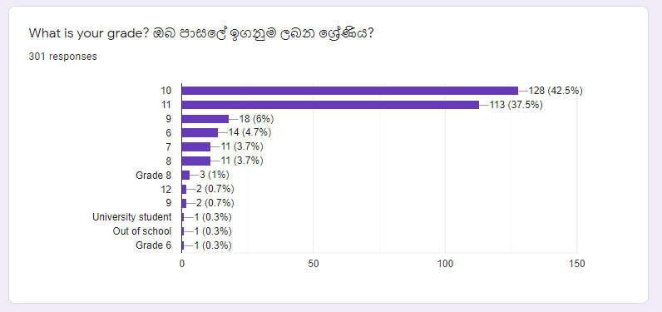

*Figure* ***Error! No text of specified style in document.****-1*

* We assumed that we would be able to fix the problems students have while doing their studies during O/L using technology. To be clear on our assumption we got the information about their problems they have during studies and we asked them if they think that those problems can be solved using technology by conducting the survey. The result could clear our assumption on this.

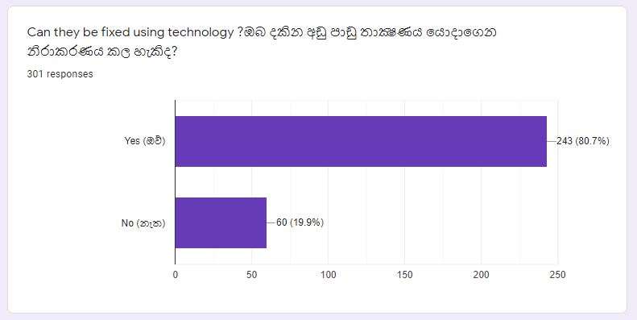

*Figure 2*

* We assumed that the O/L students in Sri Lanka, who are used to study in the typical book-warming system, would like to study under a web-platform and by conducting the survey we could be clear on our assumption.

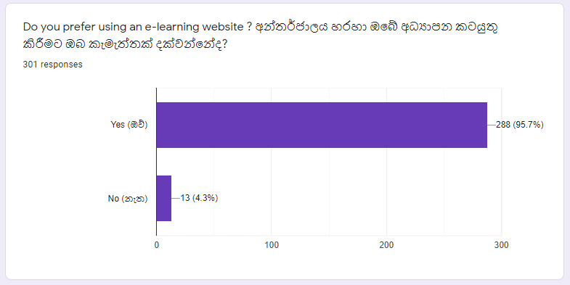

*Figure 3*

* We assumed that most of the students are able to access online to refer to these online resources and our assumption was cleared by the details we got from the survey.

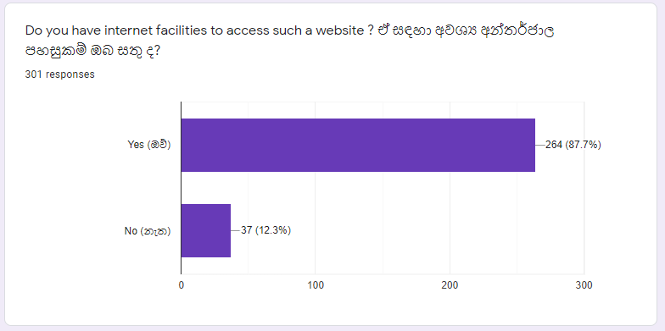

*Figure 4*

* We assume that as the first stage, we would develop the website for ‘Science’ subject

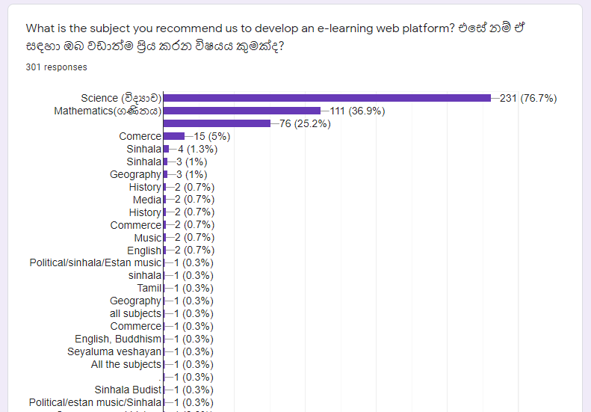

*Figure 5*



**Technical Feasibility**

Technical feasibility is a measure of the practically of a specific technical solution and the availability of technical resources and expertise to implement our project and maintain it.

The main technologies and tools that are associated with system are,

* HTML
* CSS
* Java Script
* J query
* MySQL
* Java EE
* php
* Lucid chart and Draw.io (Diagram drawing tools)

All of these technologies are free to use and technical skills required are manageable. Since all the technologies are readily available for development and that the team is willing to enhance their expertise on the areas that we are not that experienced in, the feasibility of the development of the system in technical terms seems to be in order.

**Economic feasibility**

This project is non-profit oriented; thus we do not expect a financial benefit of any sort. Our goal is to bring benefits to our end user, the student.

In order to assess the economic feasibility of the proposed project a cost-benefit analysis was conducted. Here we have listed the benefits in the user’s point of view.

### Cost-Benefit Analysis

This can help us determine whether benefits received from doing the project are worth compared to the total costs incurred.

### Project Costs:

As explained below there are no significant project costs identified.

#### Hardware/Software costs

* Laptops needed for development of the application are already available.
* All software needed for development are freely available.
* Since this is a web-based application, no purchase of hardware will be required from the user to access the system. According to the survey done by the team all respondents had the facilities needed to access the internet. However, internet costs should be undertaken by each user and we estimate it to be Rs.300 per month (1.5 GB per month)

#### Personnel Costs

* The entire project will be handled by the group (system development, maintenance, etc) and therefore no wages or other costs will be generated under personnel costs.

#### Operational Costs

* The web-application will be hosted using freely available hosting services. Therefore, no cost will be related to hosting.
* Maintenance and content creation will be done by the team and no costs will be generated.

### Project Benefits:

The project's main goal is to produce a solution that is beneficial to the end user. Financial benefits are not expected since we cater to students and are providing our service for free. However, after the initial deployment we would like to explore possible strategies that could make the web-app generate profits.

#### Benefits to the users

**Benefits for students:**

* Students will have a good technical resource to find answers for their subject-related problems.
* Since we are using the local syllabus, which was published by the Ministry of Education Sri Lanka, it will be trustworthy.
* The Q&A forum will be a new experience for students, where they can quickly find the solutions for their sudden questions.
* Since students are allowed to access the lower grades and higher grades, if the user has any doubt with the past topics he is able to learn them easily or if the user could finish the current grade early he is able to study the higher grades and gain his knowledge fast.
* Students are provided with online help, so then if there is anything that he is unable to understand just by self-learning he has another option and it will be way better than waiting for hours until school starts tomorrow.
* The quiz series will come up with new and creative questions that do not make students feel bored and lose their interest in studies.
* And also the quiz series and the challenges will increase their self-motivation.
* When it comes to boring topics, this website will provide a very creative way to not to feel them boring to study those topics and the quizzes will also be nice and easy to answer.
* If we think about a situation where it is unable to have schools, for instance a virus pandemic in the country(COVID-19) students are still able to cover the syllabus.
* If the student is not able to go to school because of an unavoidable reason, for example if the student is having a broken leg or anything similar to that, still he is able to cover the syllabus parallel with the school or faster than school using this website.
* Most of the students in Sri Lanka have almost lost their interest in doing studies because of the boring education system in Sri Lanka where the technical involvement is too low, but this web application can be a very good reason to rebuild their interest in studying in a different way.

**Benefits for teachers:**

* It is not only the students in Sri Lanka but also the teachers are not so happy about the education system in Sri Lanka. This web application will be a good starting point for them to let the technology support be used to do the teachings in a different but a creative way.
* Since teachers are also allowed to access the Q&A forum this web application provides, they will be able to see and study the type of questions that students have about the subject or the particular topic.
* This can be used as a good resource to recommend for the students who are seeking a different way of studying things and for teachers this will be a good homework exercise in their career.
* Since the teachers are able to answer the questions in the Q&A forum and join to give online help for the students who need help, this can become a good leisure time activity for teachers.
* They are able to see other’s answers for the questions on the Q&A forum and by then they will be able to find new, different and more creative ways to do their teachings and come up with new ideas.

### Comment on Economic Feasibility of the Project

The development costs are at a very minimum level to the point that they can be neglected. However, there is a considerable amount of benefits to be received to both developers and users, given the successful completion of the project. Thus, it is an economic gain and therefore the project can be declared economically feasible.

**Legal and Ethical Feasibility Study**

## *Intellectual Property Rights:*

As used in law, intellectual property refers to inventions, creative works, discoveries, know-how, show-how, or artistic works that have value, produced through human activities by individuals or entities. In the field of education, intellectual property can be patentable, trademark able, copyrightable, or licensable, encompassing any faculty work such as books, scholarly publications, syllabi, presentation files, lecture notes, and the like. Any course or instructional materials, such as readings, assignments, tools, simulations, student contributions, discussions, or exams, can be considered intellectual property.

In the website we are to build, the content manager and the teachers will be the people who add their intellectual property to the website for students to refer. So they will have their property rights through a work-for-hire agreement.

### *Work-for-Hire Agreement*

A work-made-for-hire is an exception to intellectual property rights principles; when work is made for hire, the employer or other person for whom the work was prepared becomes the author.

## *Copyright Law:*

Copyright law is the protection of an original work fixed in a tangible form; the work has to be embodied in a material object of some kind, such as the pages of a book, a canvas, or a computer storage device.

In an academic setting, copyrightable works include books, presentation files, Web-based course materials, and scholarly publications.

To avoid copyright breach, users must properly acknowledge original authorship.

### *Fair use*

To use copyright laws as a mechanism for encouraging the dissemination of knowledge while protecting the rights of the creator of that knowledge, content managers and the teachers involved with the website should work collaboratively and creatively. The concept of fair use can be applied to copyright laws, setting certain limitations on the rights of copyright holders

## *Privacy and Trust:*

Our responsibility as ethical web developers, is to inform our site users as to how the information they give us will be used. For instance, we would be taking the students email address and the password as the login information and they must be informed that we will take care of their privacy and their trust. Same goes with the teachers and the other actors who will be giving their information.

### *Privacy statement*

For this reason, we are thinking of posting a privacy disclaimer statement on our Website, and to collect information beyond normal log files. Privacy policies detail the ways that information is gathered and whether it is transferred to third parties. If information is transferred to third parties, the privacy statement will describe how the information is transferred.

**Operational Feasibility**

Here, we measure how well iskole.lk solves the problem of not having a self-learning web site for O/L students. Further, we decided to create a web site without creating an app, because most O/L students do not have smart phones but they have opportunities to access the internet.

* We have surveyed over 100 students from students studying in schools in different districts about the idea of this system and whether they think it would be useful for their educational purposes. Over 80% of the participants of this survey gave positive feedback saying they were interested in such an idea and it would certainly help them in their education.
* O/L students do not have access to such self-learning web sites, they have to spend more time on extra classes. In addition to that It is advisable for children to use this type of web site to improve their self-learning skills and this reduces the chance of visiting a library and searching for the data. Students can learn at their pace and take their time at understanding things.
* By providing opportunities to resolve issues on subjects at the same time and taking action to minimize the undue fear and anxiety of the subjects

**Schedule feasibility**

The website, iscole should finish development by the end of this year. As the team has decided to use an agile methodology for development, requirement gathering is done throughout the development process. With the current understanding of the timeline of development, features have been adjusted. By the time of development more features can be added as well.

|  |  |  |  |  |  |  |  |  |  |  |  |  |  |  |  |  |  |  |  |  |  |  |  |  |  |  |  |  |  |  |  |  |  |  |  |  |  |  |  |  |  |  |  |  |
| --- | --- | --- | --- | --- | --- | --- | --- | --- | --- | --- | --- | --- | --- | --- | --- | --- | --- | --- | --- | --- | --- | --- | --- | --- | --- | --- | --- | --- | --- | --- | --- | --- | --- | --- | --- | --- | --- | --- | --- | --- | --- | --- | --- | --- |
|  | April | | | | May | | | | June | | | | July | | | | August | | | | September | | | | October | | | | November | | | | December | | | | January | | | | February | | | |
|  |  |  |  |  |  |  |  |  |  |  |  |  |  |  |  |  |  |  |  |  |  |  |  |  |  |  |  |  |  |  |  |  |  |  |  |  |  |  |  |  |  |  |  |
| Choose project |  |  |  |  |  |  |  |  |  |  |  |  |  |  |  |  |  |  |  |  |  |  |  |  |  |  |  |  |  |  |  |  |  |  |  |  |  |  |  |  |  |  |  |  |
| Discussing scope |  |  |  |  |  |  |  |  |  |  |  |  |  |  |  |  |  |  |  |  |  |  |  |  |  |  |  |  |  |  |  |  |  |  |  |  |  |  |  |  |  |  |  |  |
| Requirement analysis |  |  |  |  |  |  |  |  |  |  |  |  |  |  |  |  |  |  |  |  |  |  |  |  |  |  |  |  |  |  |  |  |  |  |  |  |  |  |  |  |  |  |  |  |
| Feasibility study |  |  |  |  |  |  |  |  |  |  |  |  |  |  |  |  |  |  |  |  |  |  |  |  |  |  |  |  |  |  |  |  |  |  |  |  |  |  |  |  |  |  |  |  |
| Drawing diagrams |  |  |  |  |  |  |  |  |  |  |  |  |  |  |  |  |  |  |  |  |  |  |  |  |  |  |  |  |  |  |  |  |  |  |  |  |  |  |  |  |  |  |  |  |
| Studying technologies |  |  |  |  |  |  |  |  |  |  |  |  |  |  |  |  |  |  |  |  |  |  |  |  |  |  |  |  |  |  |  |  |  |  |  |  |  |  |  |  |  |  |  |  |
| Project proposal |  |  |  |  |  |  |  |  |  |  |  |  |  |  |  |  |  |  |  |  |  |  |  |  |  |  |  |  |  |  |  |  |  |  |  |  |  |  |  |  |  |  |  |  |
| Database design |  |  |  |  |  |  |  |  |  |  |  |  |  |  |  |  |  |  |  |  |  |  |  |  |  |  |  |  |  |  |  |  |  |  |  |  |  |  |  |  |  |  |  |  |
| UI design |  |  |  |  |  |  |  |  |  |  |  |  |  |  |  |  |  |  |  |  |  |  |  |  |  |  |  |  |  |  |  |  |  |  |  |  |  |  |  |  |  |  |  |  |
| Front end design |  |  |  |  |  |  |  |  |  |  |  |  |  |  |  |  |  |  |  |  |  |  |  |  |  |  |  |  |  |  |  |  |  |  |  |  |  |  |  |  |  |  |  |  |
| Backend design |  |  |  |  |  |  |  |  |  |  |  |  |  |  |  |  |  |  |  |  |  |  |  |  |  |  |  |  |  |  |  |  |  |  |  |  |  |  |  |  |  |  |  |  |
| Database Implementation |  |  |  |  |  |  |  |  |  |  |  |  |  |  |  |  |  |  |  |  |  |  |  |  |  |  |  |  |  |  |  |  |  |  |  |  |  |  |  |  |  |  |  |  |
| System Implementation |  |  |  |  |  |  |  |  |  |  |  |  |  |  |  |  |  |  |  |  |  |  |  |  |  |  |  |  |  |  |  |  |  |  |  |  |  |  |  |  |  |  |  |  |
| Unit testing |  |  |  |  |  |  |  |  |  |  |  |  |  |  |  |  |  |  |  |  |  |  |  |  |  |  |  |  |  |  |  |  |  |  |  |  |  |  |  |  |  |  |  |  |
| Integrated testing |  |  |  |  |  |  |  |  |  |  |  |  |  |  |  |  |  |  |  |  |  |  |  |  |  |  |  |  |  |  |  |  |  |  |  |  |  |  |  |  |  |  |  |  |
| System testing & bug fixing |  |  |  |  |  |  |  |  |  |  |  |  |  |  |  |  |  |  |  |  |  |  |  |  |  |  |  |  |  |  |  |  |  |  |  |  |  |  |  |  |  |  |  |  |
| Deployment & maintenance |  |  |  |  |  |  |  |  |  |  |  |  |  |  |  |  |  |  |  |  |  |  |  |  |  |  |  |  |  |  |  |  |  |  |  |  |  |  |  |  |  |  |  |  |
| Final presentation |  |  |  |  |  |  |  |  |  |  |  |  |  |  |  |  |  |  |  |  |  |  |  |  |  |  |  |  |  |  |  |  |  |  |  |  |  |  |  |  |  |  |  |  |

Project delivery timeline

* 1. Stakeholders

3.2 Use case Diagrams

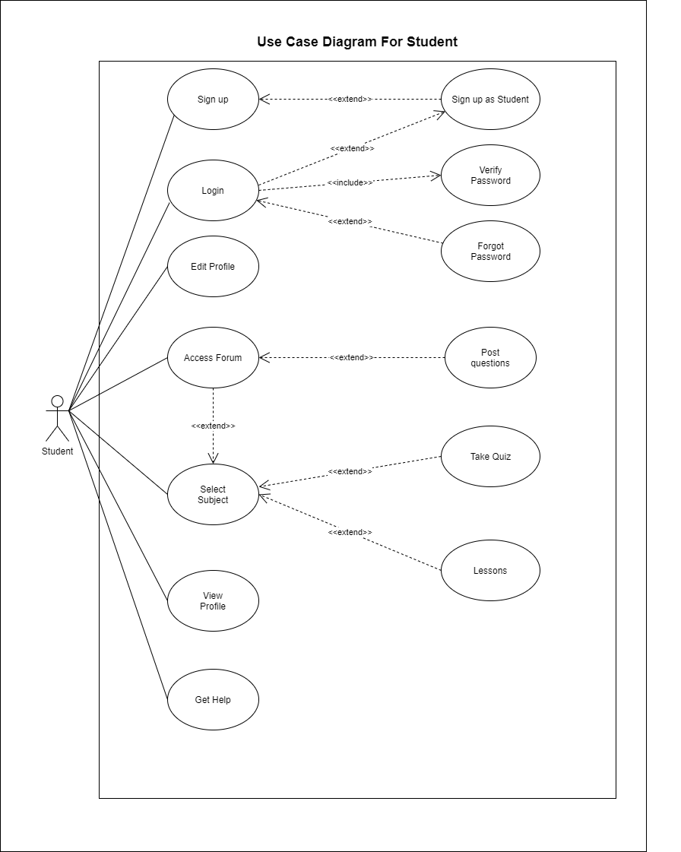

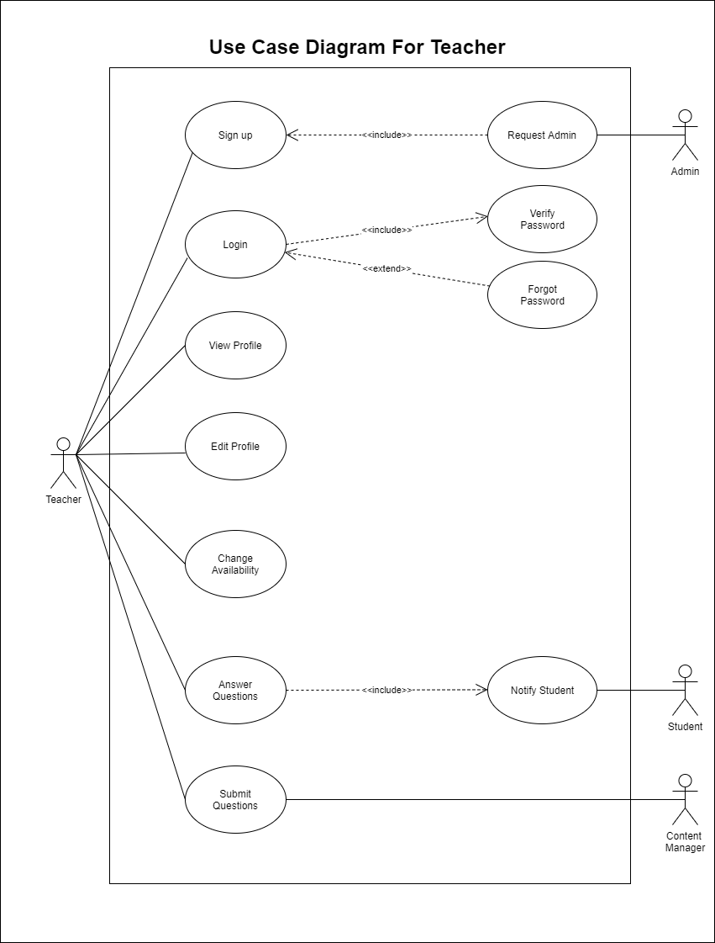

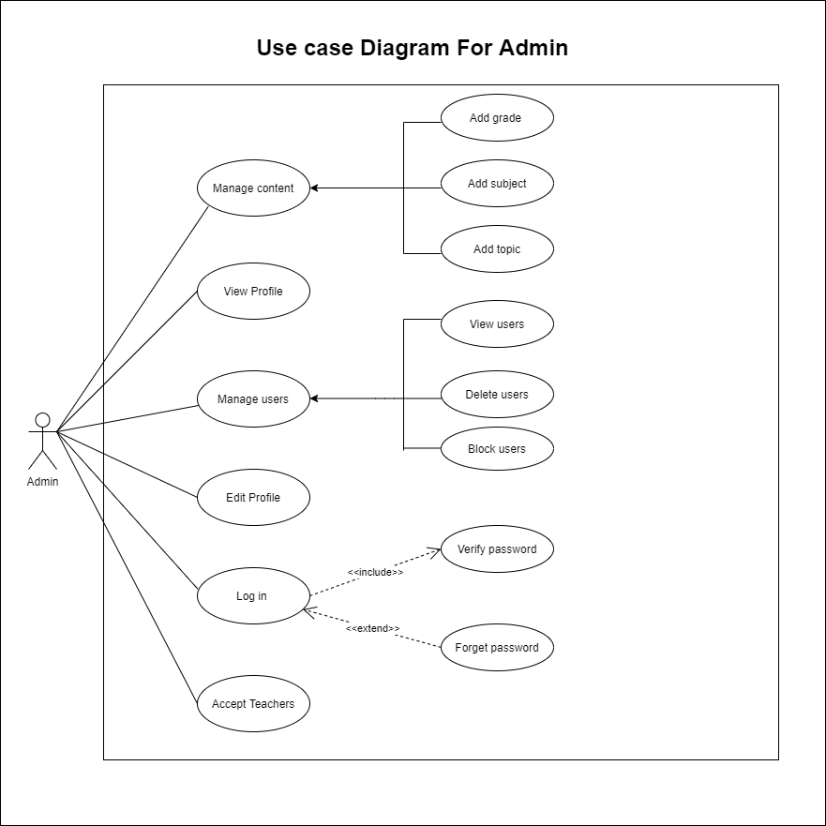

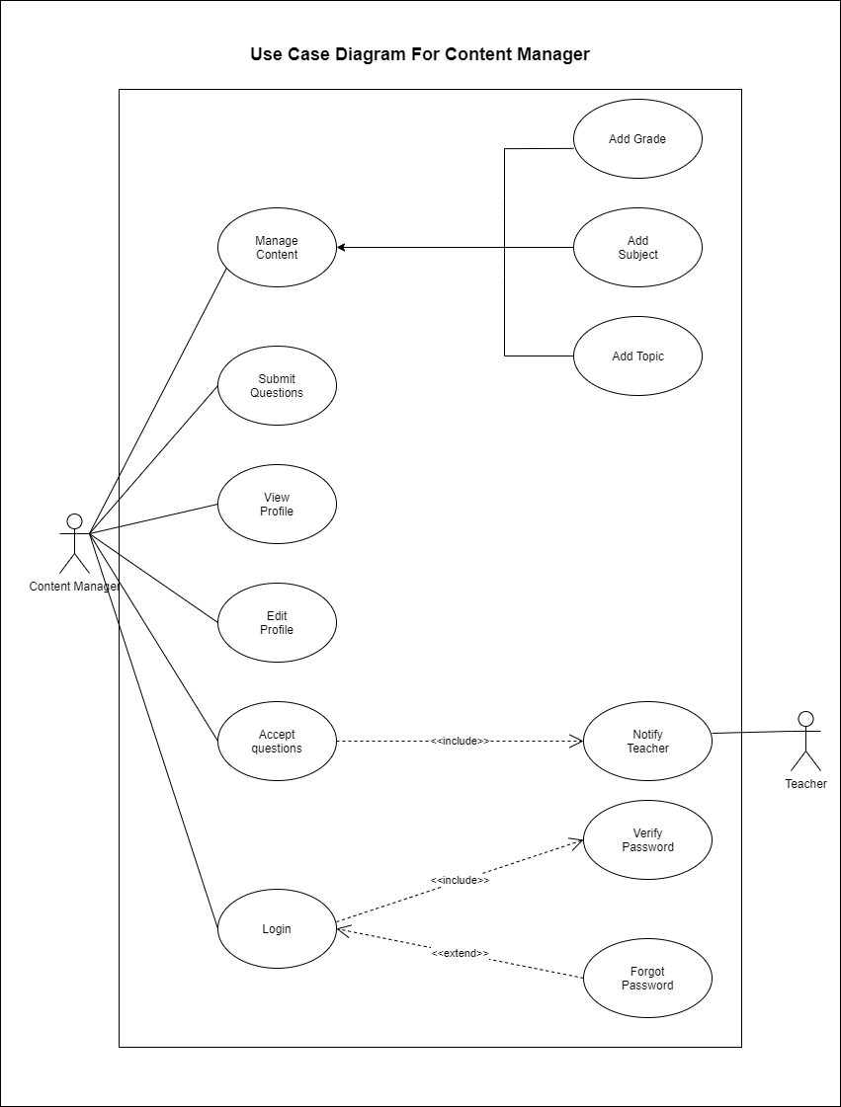



* 1. Use case Narratives

|  |  |
| --- | --- |
| **Use case** | Sign Up |
| **Summary** | Any kind of a user has to be registered in to the system. |
| **Actors** | Teacher  Student |
| **Preconditions** | None |
| **Descriptions** | Before log in to the system, the user has to register to the system by creating an account in the system.  First the user has to select if you are signing up as a student or a teacher.  Teacher sign up: give a valid email and password and the other details the system asks and then the request will be sent to the admin.  Student sign up: give a valid email address and a password. |
| **Exceptions** | The given email address or the password is incorrect. |
| **Post conditions** | Teacher sign up: if the admin accepts the request, an account will be created under the given email address and the user can log into the system using the given email address and password.  Student sign up: an account will be created under the given email address and the user can log into the system using the given email address and password. |

|  |  |
| --- | --- |
| **Use case** | Log In |
| **Summary** | The user use his account to log in to the system. |
| **Actors** | Admin  Content Manager  Teacher  Student |
| **Preconditions** | The user should have his account details to access the system. |
| **Descriptions** | After visiting the log in page user has to enter his email address and the password. |
| **Exceptions** | The given email address or the password is incorrect.  User account has not been created. |
| **Post conditions** | User can access the system. |

|  |  |
| --- | --- |
| **Use case** | Accept Teachers |
| **Summary** | The admin gets the requests from the new teachers who are willing to join the system and the admin can accept them or ignore the requests. |
| **Actors** | Admin |
| **Preconditions** | Admin has logged in to the system by using his login information. |
| **Descriptions** | There is a notification panel in the home page of the admin and in there admin can see the request messages of the teachers. |
| **Exceptions** | None |
| **Post conditions** | If the admin accept a particular request, the sender will be notified and the system will be updated.  If the request is not accepted by the admin, it will be deleted from the notifications and the sender will be notified. |

|  |  |
| --- | --- |
| **Use case** | View Profile |
| **Summary** | The user can see his profile details. |
| **Actors** | Admin  Content Manager  Teacher  Student |
| **Preconditions** | User has logged in to the system by using his login information. |
| **Descriptions** | By clicking on the icon ‘view profile’ he can see his profile details.  Example: points he has earned. |
| **Exceptions** | None |
| **Post conditions** | None |

|  |  |
| --- | --- |
| **Use case** | Edit Profile |
| **Summary** | The user can change his profile details. |
| **Actors** | Admin  Content Manager  Teacher  Student |
| **Preconditions** | User has logged in to the system by using his login information. |
| **Descriptions** | By clicking on the icon ‘edit profile’ he can change his profile details.  Example: change username |
| **Exceptions** | None |
| **Post conditions** | The profile will be updated. |

|  |  |
| --- | --- |
| **Use case** | Manage Users |
| **Summary** | The admin is able to manage the users of the system. Whoever that has an account in the system can be managed by the admin of the system. |
| **Actors** | Admin |
| **Preconditions** | Admin has logged in to the system by using his login information. |
| **Descriptions** | There is an option called ‘Manage users’ in the settings of admin’s home page and by clicking on that admin can come to this stage. |
| **Exceptions** | None |
| **Post conditions** | Admin can either view users, delete users or block users. |

|  |  |
| --- | --- |
| **Use case** | View users |
| **Summary** | The admin can see the current users of the system (everyone who has created an account in the system) |
| **Actors** | Admin |
| **Preconditions** | Admin has logged in to the system by using his login information and come through ‘Settings’ -> ‘Manage users’ from his home page. |
| **Descriptions** | There is an option after coming to the ‘Manage user’ stage, called ‘view users’. By clicking on that the admin can come to this stage. |
| **Exceptions** | None |
| **Post conditions** | Admin can get a list of users who has created accounts in the system with their details. |

|  |  |
| --- | --- |
| **Use case** | Delete Users |
| **Summary** | The admin is able to delete any user who has an account in the system under any circumstances. |
| **Actors** | Admin |
| **Preconditions** | Admin has logged in to the system by using his login information and come through ‘Settings’ -> ‘Manage users’ from his home page. |
| **Descriptions** | There is an option after coming to the ‘Manage user’ stage, called ‘delete users’. By clicking on that, the admin can come to this stage.  And also admin has to enter the details of a particular user to delete him, by giving the user name or the email address of the user and confirm deleting the user from the system or not confirm the deletion. |
| **Exceptions** | The user who has been mentioned by the admin does not exist in the system. |
| **Post conditions** | If the admin confirms the deletion the particular user will be notified as he can’t no longer use the system and the system will be updated.  If the admin does not confirm the deletion, his request will be canceled. |

|  |  |
| --- | --- |
| **Use case** | Block Users |
| **Summary** | The admin is able to block any user who has an account in the system under any circumstances. |
| **Actors** | Admin |
| **Preconditions** | Admin has logged in to the system by using his login information and come through ‘Settings’ -> ‘Manage users’ from his home page. |
| **Descriptions** | There is an option after coming to the ‘Manage user’ stage, called ‘block users’. By clicking on that, the admin can come to this stage.  And also admin has to enter the details of a particular user to block him, by giving the user name or the email address of the user and confirm blocking the user for a period of time or not confirm the blocking. |
| **Exceptions** | The user who has been mentioned by the admin does not exist in the system. |
| **Post conditions** | If the admin confirm the blocking the particular user will be notified as he can’t use the system for a period of time since he has been blocked by the admin and the system will be updated.  If the admin does not confirm the blocking, his request will be canceled. |

|  |  |
| --- | --- |
| **Use case** | Manage Content |
| **Summary** | The admin and the content manager of the system are able to manage the content of the system (Grades, Subjects and topics) |
| **Actors** | Admin, Content Manager |
| **Preconditions** | Admin has logged in to the system by using his login information.  Content Manager has logged in to the system by using his login information. |
| **Descriptions** | There is an option called ‘Manage content’ in the settings of admin’s and content manager’s home page and by clicking on that admin can come to this stage. |
| **Exceptions** | None |
| **Post conditions** | Admin or content manager can either add a new grade, add a new subject or add a new topic of a subject. |

|  |  |
| --- | --- |
| **Use case** | Add grade |
| **Summary** | The admin and the content manager are add a new grade to the system. |
| **Actors** | Admin, Content Manager |
| **Preconditions** | Admin or content manager has logged in to the system by using his login information and come through ‘Settings’ -> ‘Manage content’ from his home page. |
| **Descriptions** | There is an option after coming to the ‘Manage content’ stage, called ‘Add grade’. By clicking on that, the admin or the content manager can come to this stage.  Enter a new grade.  Example: Grade 10 |
| **Exceptions** | The entered grade has been already added to the system. |
| **Post conditions** | The system will be updated and the users will be notified about the new update. |

|  |  |
| --- | --- |
| **Use case** | Add subject |
| **Summary** | The admin and the content manager are able to add a new subject to the system. |
| **Actors** | Admin, Content Manager |
| **Preconditions** | Admin or content manager has logged in to the system by using his login information and come through ‘Settings’ -> ‘Manage content’ from his home page. |
| **Descriptions** | There is an option after coming to the ‘Manage content’ stage, called ‘Add subject’. By clicking on that, the admin or the content manager can come to this stage.  Enter the name of the new subject.  Example: Mathematics |
| **Exceptions** | The entered subject has been already added to the system. |
| **Post conditions** | The system will be updated and the users will be notified about the new update. |

|  |  |
| --- | --- |
| **Use case** | Add topic |
| **Summary** | The admin and the content manager are able to add a new topics to the existing subjects in the system. |
| **Actors** | Admin, Content Manager |
| **Preconditions** | Admin or content manager has logged in to the system by using his login information and come through ‘Settings’ -> ‘Manage content’ from his home page. |
| **Descriptions** | There is an option after coming to the ‘Manage content’ stage, called ‘Add topic’. By clicking on that, the admin or the content manager can come to this stage.  Enter the name of the subject.  Example: Mathematics  Enter the grade which should be updated.  Example: Grade 10  Enter the name of the new topic  Example: perimeter |
| **Exceptions** | The entered topic has been already added to the system. |
| **Post conditions** | The system will be updated and the users will be notified about the new update. |

|  |  |
| --- | --- |
| **Use case** | Accept Questions |
| **Summary** | The content manager is sent the made up quizzes by the teachers who have accounts in the system.  Before uploading them to the system the content manager has to look into them and accept them. |
| **Actors** | Content Manager |
| **Preconditions** | Content manager has logged in to the system by using his login information. |
| **Descriptions** | There is a notification panel in the home screen of the content manager and in that field he can see the quizzes which are sent by the teachers. |
| **Exceptions** | None |
| **Post conditions** | If the content manager accepts the questions, the sender will be notified about the acceptance.  If the content manager does not accept the questions, the sender will be notified about that and the notification will be deleted from the notification panel. |

|  |  |
| --- | --- |
| **Use case** | Submit questions |
| **Summary** | The content manager is able to submit quizzes to the system |
| **Actors** | Content manager, teacher |
| **Preconditions** | Content manager or teacher has logged in to the system by using his login information. |
| **Descriptions** | 1. Select grade 2. Select subject   (Content manager can submit common quizzes here)   1. Select topic   (Content manager can submit topic related quizzes here)   1. Confirm submission or not   (If a teacher submits a quiz it should be accepted by the content manager before updating the system) |
| **Exceptions** | None |
| **Post conditions** | None |

|  |  |
| --- | --- |
| **Use case** | Change Availability |
| **Summary** | Teachers can change their online or offline status for students to see if they can get help from this particular teacher. |
| **Actors** | Teacher |
| **Preconditions** | Teacher has logged in to the system by using his login information. |
| **Descriptions** | By clicking on the icon which shows online or offline status teacher can change his availability to help students. |
| **Exceptions** | None |
| **Post conditions** | Student can see the name of the teacher on the available list of teachers when they seek for a help. |

|  |  |
| --- | --- |
| **Use case** | Answer questions |
| **Summary** | Teachers are able to answer the questions on the Q&A forum where students have submitted their questions. |
| **Actors** | Teacher |
| **Preconditions** | Teacher has logged in to the system by using his login information. |
| **Descriptions** | Teacher can access the forum by clicking on a particular icon on his home page and answer the questions. |
| **Exceptions** | None |
| **Post conditions** | After publishing an answer on a question, the student who published the particular question will be notified. |

|  |  |
| --- | --- |
| **Use case** | Select Subject |
| **Summary** | The student can select a subject |
| **Actors** | Student |
| **Preconditions** | Student has logged in to the system by using his login information. |
| **Descriptions** | By selecting a particular subject, student can access the Q&A forum of the subject, take the quizzes which are common for the subject and go through the lessons under the related topics. |
| **Exceptions** | None |
| **Post conditions** | Students will be given points and badges once they take quizzes and finish the lessons. |

|  |  |
| --- | --- |
| **Use case** | Select Grade |
| **Summary** | The student can select a grade |
| **Actors** | Student |
| **Preconditions** | Student has logged in to the system by using his login information. |
| **Descriptions** | After giving the grade of the student during the signing up process, student is able to access his grade, one grade lower to his grade and one grade upper to his grade.  So then he is able to do the lessons, quizzes and challenges related to any subject in the selected grade. |
| **Exceptions** | The student is not allowed to access the selected grade. |
| **Post conditions** | None |

|  |  |
| --- | --- |
| **Use case** | Access forum |
| **Summary** | The users who have logged in as students to the system can access the Q&A forum |
| **Actors** | Student |
| **Preconditions** | Student has logged in to the system by using his login information. |
| **Descriptions** | By clicking on a particular icon on the home page of student user or inside any subject or a topic of the system provide, they can access the Q&A forum.  They can see the past questions.  They can publish their questions. |
| **Exceptions** | None |
| **Post conditions** | None |

|  |  |
| --- | --- |
| **Use case** | Get Help |
| **Summary** | The student can ask for online help from the teachers who have accounts in the system. |
| **Actors** | Student |
| **Preconditions** | Student has logged in to the system by using his login information. |
| **Descriptions** | By clicking on a particular icon on the home page of the student which called ‘help’, student is able to ask for a help from a teacher who is shown as available at the moment.  The system will show the list of available teachers on the screen and student is able to select a teacher according to his choice. |
| **Exceptions** | None |
| **Post conditions** | None |

* 1. Functional Requirements
  2. Quality Attributes

**Usability**

As our application is created for school students, usability is mandatory. By making the navigation path and the menu simple, usability can be achieved. In our application we are planning to keep the interfaces simple and clear.

Also when signing up for the first time we are planning to include a navigation guide that make the registration process more simple and easy.

**Reliability**

This application is basically consisting of the syllabus that the government has provided. And as the government update the syllabus we are planning to update our content as well. The information of the users will be protected by the system as well.

**Security**

Depending on the access level, each user will gain functionality of the system. In the matter of security, the password of the accounts can be changed and updated by the user. As we don’t use any payments in the system no such security needed.

**Availability**

When the application is deployed it is available 24 hours. As the learning materials of the registered subject is cashed in the device, they are available even there is no internet. For the other grades it is necessary to have a internet connection to get the learning materials.

**Performance**

When a teacher or a student get registered to a system, a content manager or a teacher submit a question or when a student posts a question in the forum the database of the system should update within 5 seconds.

**Dependability**

Keeps a reinforcement of the information with the affirmation of the framework administrator. So regardless of whether there is a failure in the back end server, information is saved.

**Maintainability**

Detecting bugs and errors, enhancement of functions, introduction of new functions, and advancement of the web application are exceptionally viable since each and every section in the framework is very much organized, after the Agile development methodology.

* 1. Components 

|  |  |
| --- | --- |
| **Component** | **Responsibility** |
| Admin component | * Manage users * View users * Delete users * Block users * Manage content * Add grade * Add subject * Add topic * Accept teachers sign in requests |
| Content manager component | * Manage Content * Add grade * Add subject * Add topic * Submit questions to the forum * Accept questions submitted by teachers |
| Teacher component | * Answer questions in the forum * Submit questions |
| Student component | * Access forums * Get help from teacher * Select subject * Study * Take quiz * Study lessons |
| Login component | * Allow the user to log into the system using his/her account |
| Register component | * Allow any kind of user to register in to the system |
| Authentication component | * Verify the register and login |
| Database component | * Connecting all components |

4.2 Component Diagram

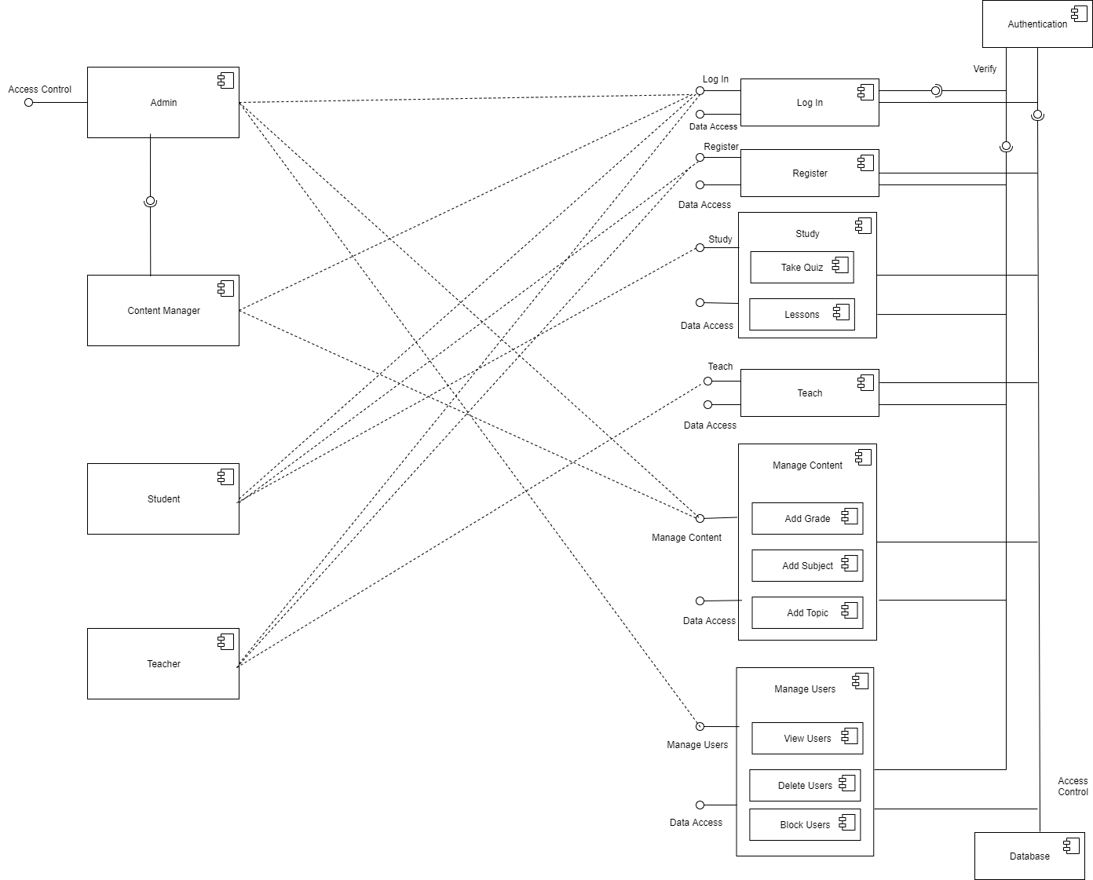

*Figure 6: Component Diagram*



5.1 Class Diagram

5.2 Entity Relationship Diagram

* 1. Sequence Diagram

5.4 Activity Diagrams

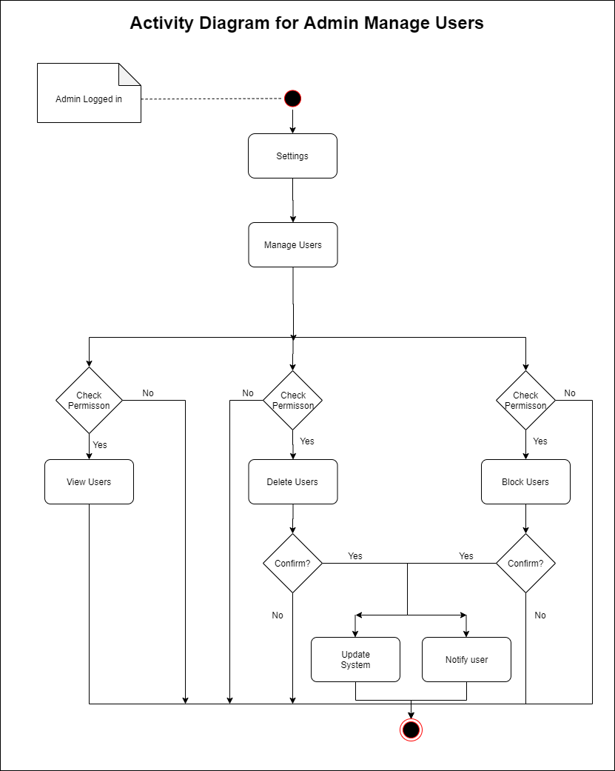

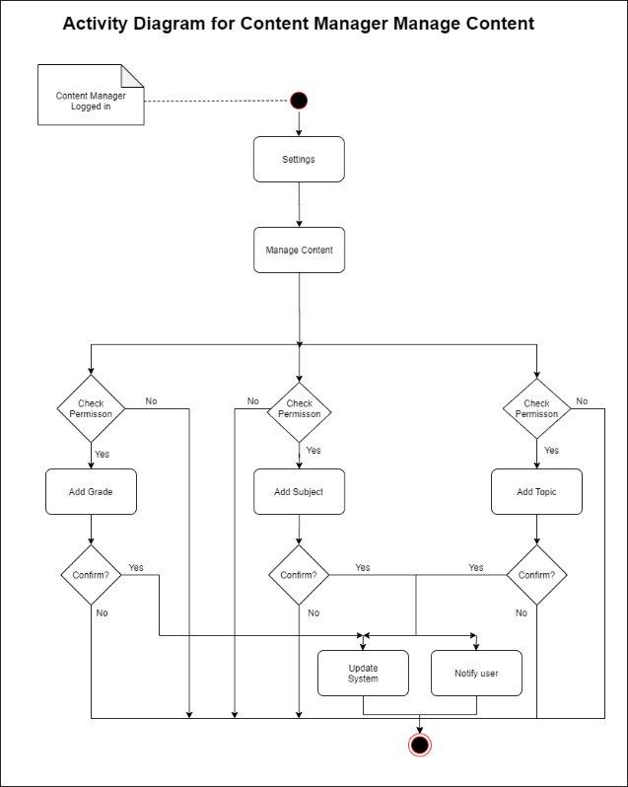

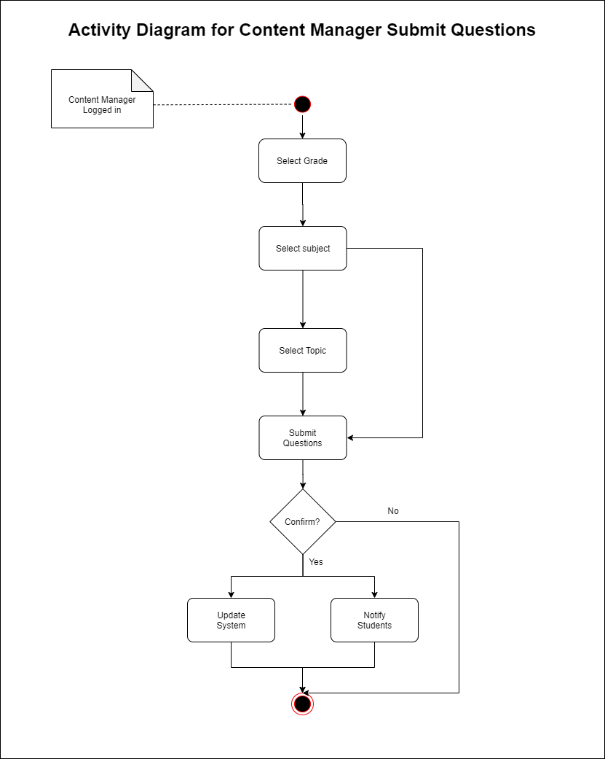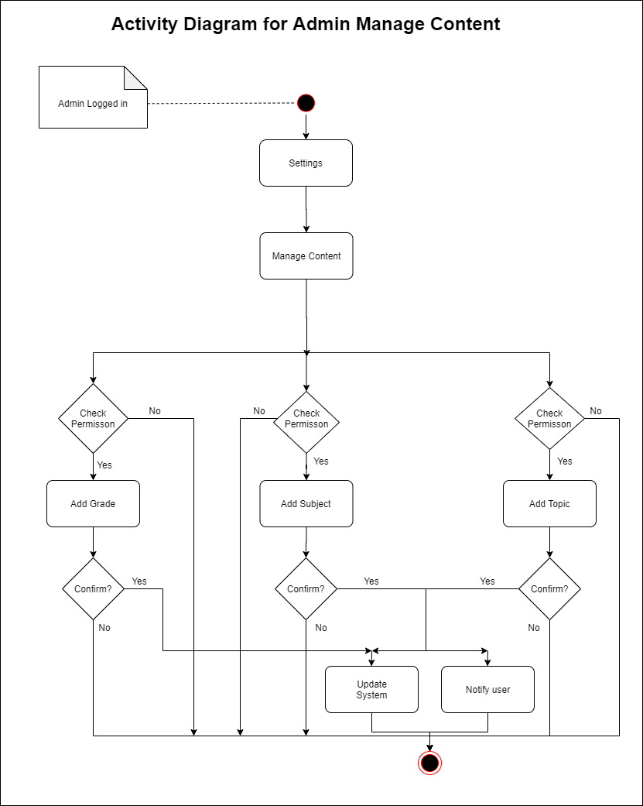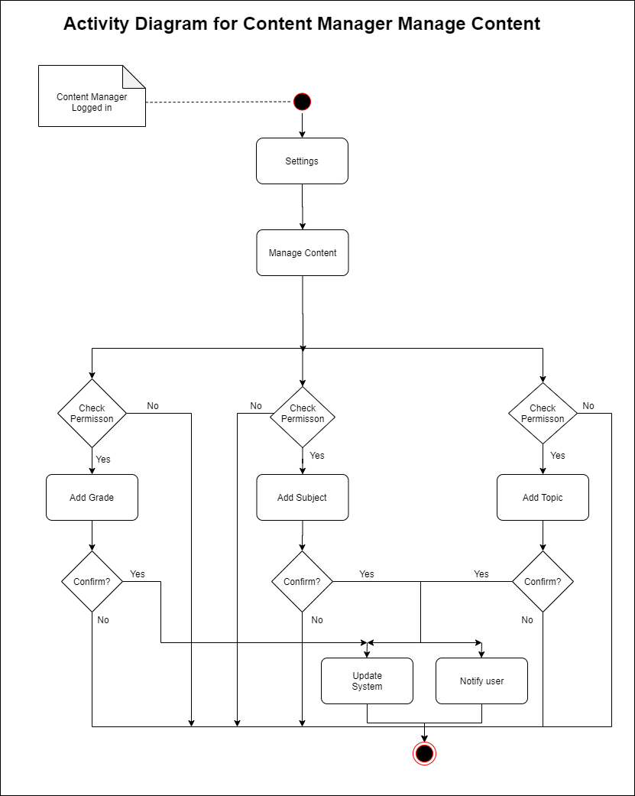

*Figure 13: Activity Diagram- Content manager submit questions*

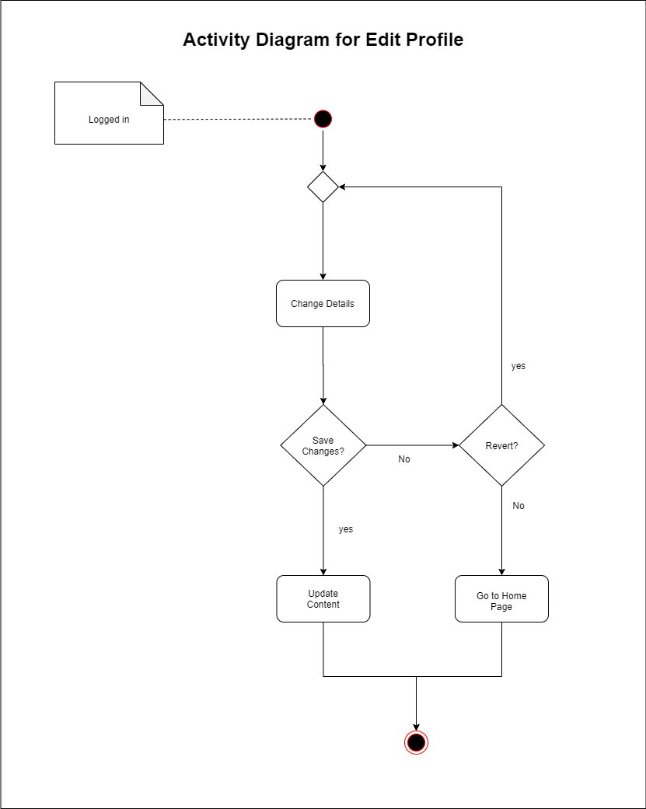

*Figure 14: Activity Diagram- Edit profile*

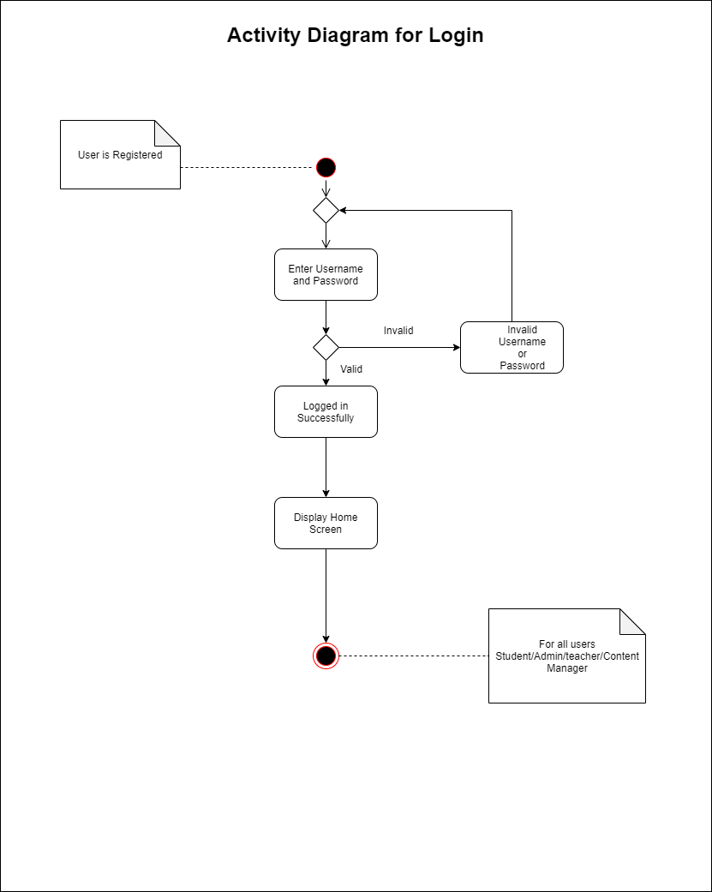

*Figure 15: Activity Diagram - Login*

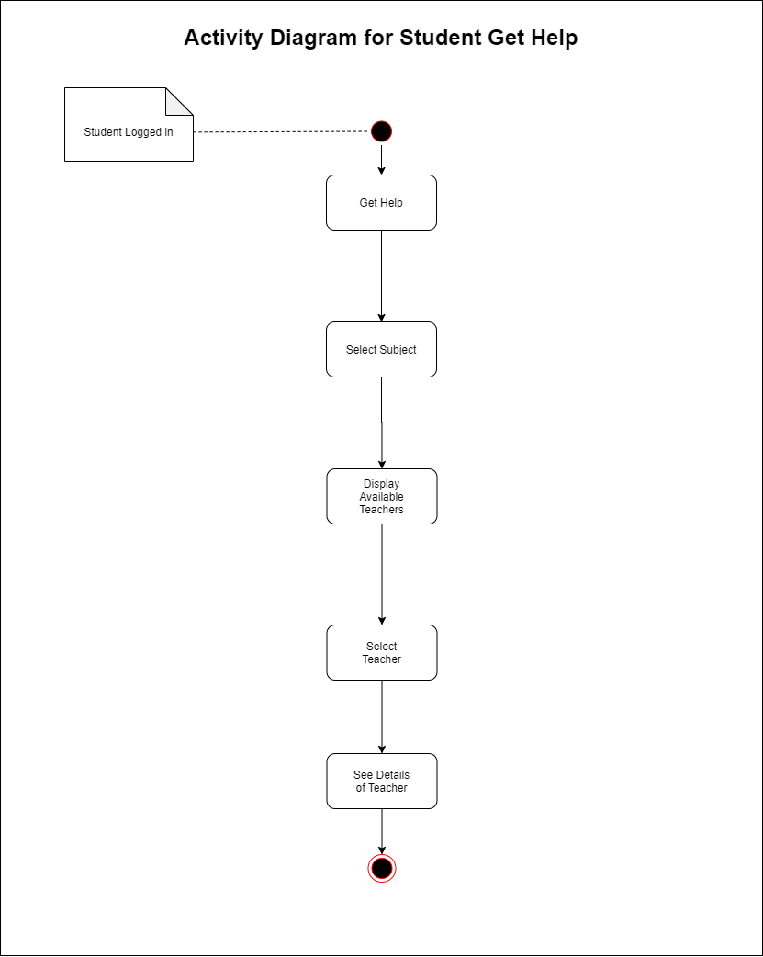

*Figure 16: Activity Diagram - Student get help*

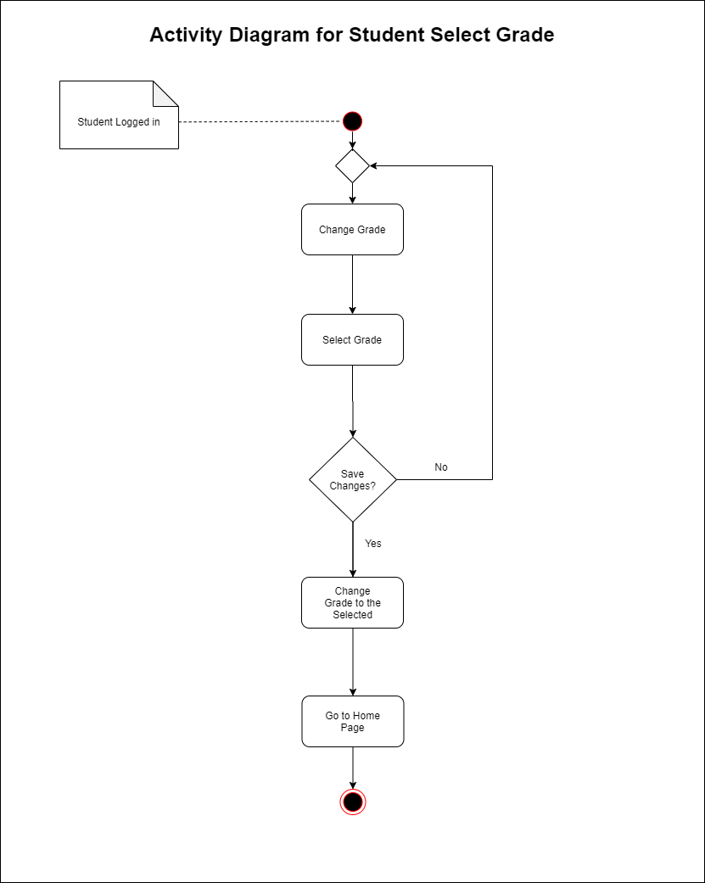

*Figure 17: Activity Diagram - Student select grade*

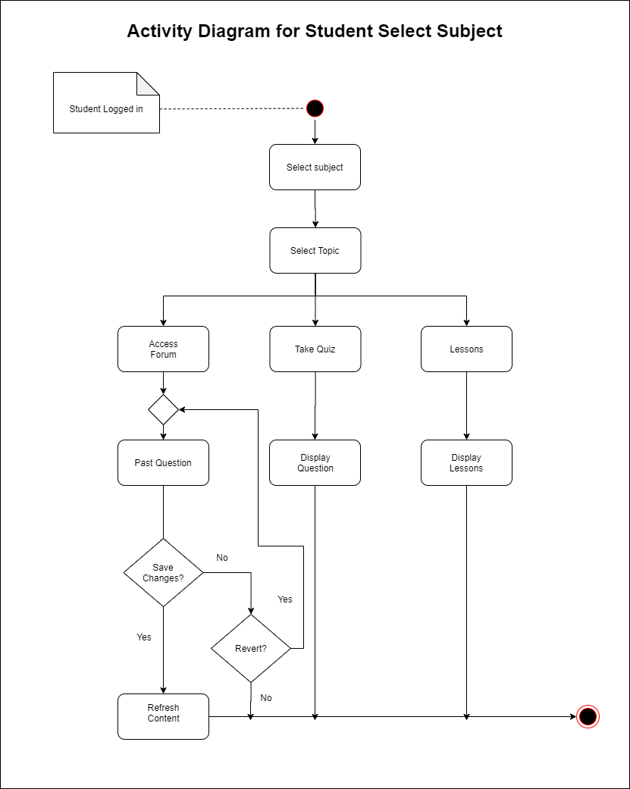

*Figure 18: Activity Diagram - Student select subject*

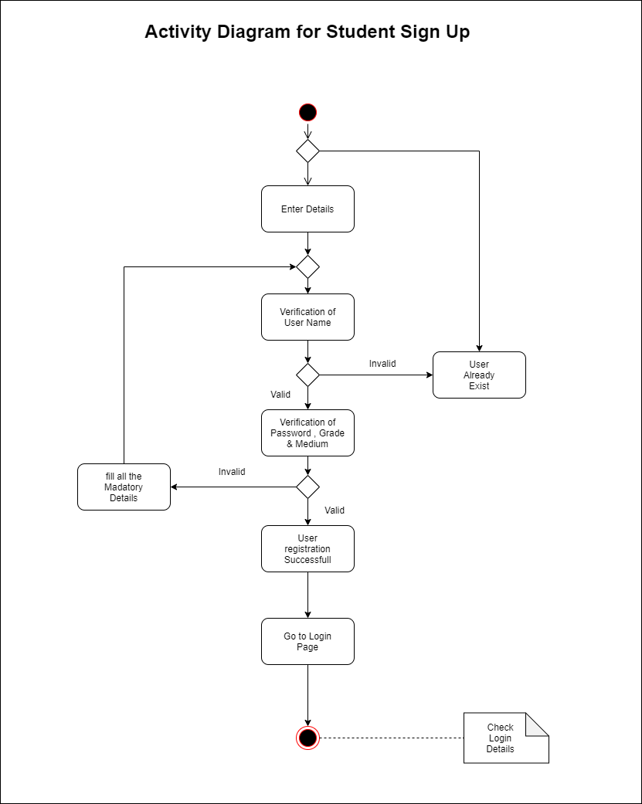

*Figure 19: Activity Diagram - Student sign up*

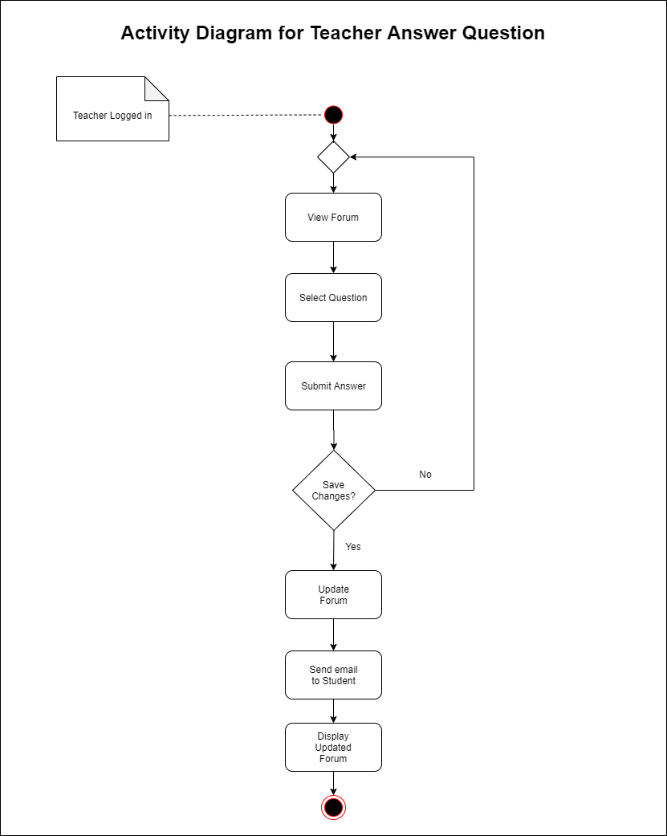

*Figure 20: Activity Diagram - Teacher answer question*

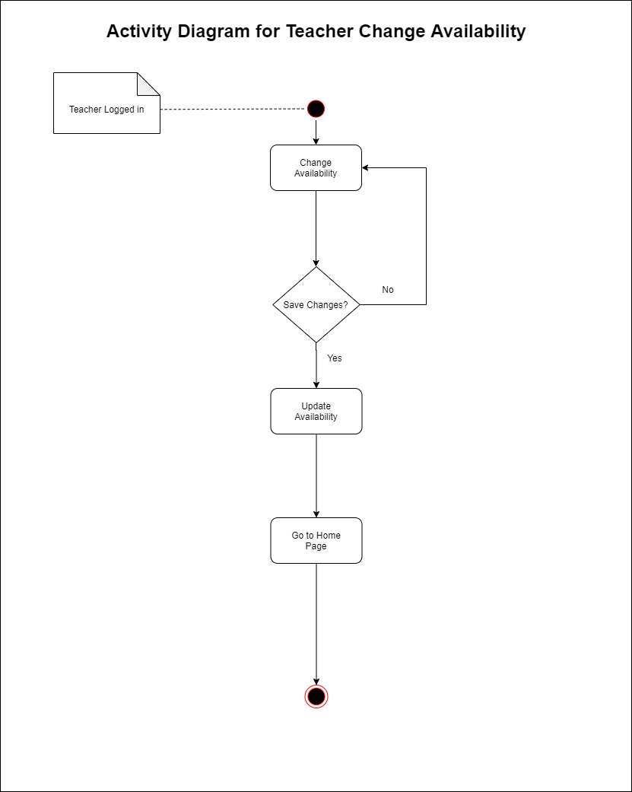

*Figure 21: Activity Diagram - Teacher change availability*

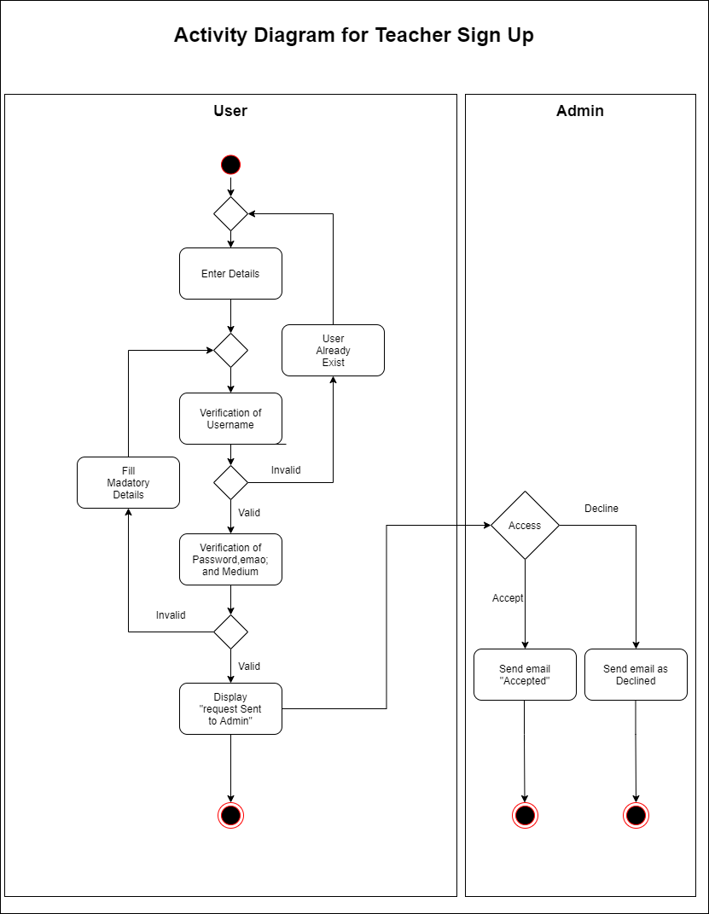

*Figure 22: Activity Diagram - Teacher sign up*

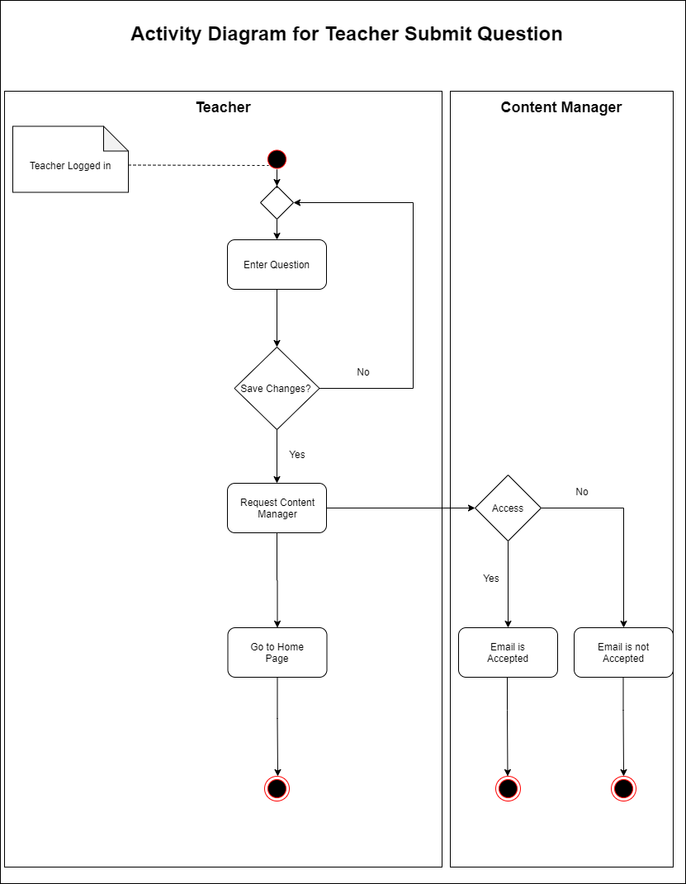

*Figure 23: Activity Diagram - Teacher submit question*

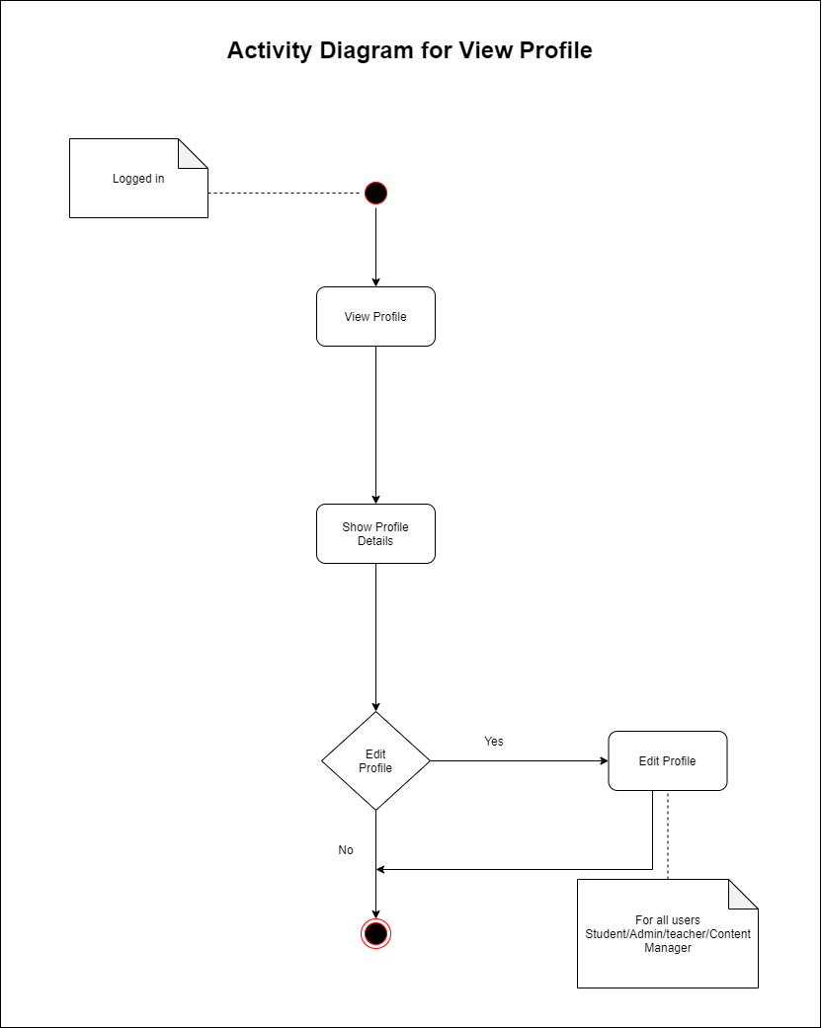

*Figure 24: Activity Diagram - View profile*

* 1. State Transition Diagram

