Chapter I

Introduction

The challenges of struggle encountered by orphaned siblings cause them to suffer from trauma. This trauma makes them overcome obstacles and builds resilience, which continues issues in this society. There is limited research on how this animation effectively demonstrates empathy and understanding among different audiences.

This study examines how a stylized story about two siblings delivers a message of struggle and hope. Using muted colors, a simple art style, and strong sibling dynamics, it conveys emotional impact and has the capacity to connect with viewers.
By looking at the key elements, this study explores how animations can tell stories and help people understand important issues such as family, loss, and hope.

Orphaned siblings face many challenges, including trauma that tests their ability to cope and grow throughout their childhood. Despite their resilience, their struggles remain relevant today, demonstrating significant empathy and understanding among different audiences.
This study examines how to create a story about two siblings delivering a message of struggle and hope. By using muted colors, a simple art style, and strong sibling dynamics, the story delivers an emotional impact and has the capacity to connect with viewers.

Problem statement highlights the key issues:
Poor laptop performance - The team was working on low-spec laptops that would source most of the lag, freeze and slow renditions in the process of animation. The above problems caused it to have difficulties with completing scenes on time and with smoothness that contributed to the general quality of the film.

Poor software functionality - Due to limited animation software, making elaborated effects, flowing motions and quality impressions was rather challenging and this curtailed creativity of the project.

Time lag in production - Numerous setbacks in editing, rendering and exporting of the animation because of the poor functionality of the laptops and the software available. This had an impact to the production time frame and strain in deadlines.

Specific Objective Include:

- To examine how viewers relate to visual components:like character design and soft colors. This helps us understand how these things affect what people think of the story.

- To explore the ways in which animated stories: Looking at stories that show hard times, strength, and hope. This will help us learn what ways of telling stories people like the most.

- To evaluate how the audience's emotional connection:
See how the audience feels about characters when they have siblings. This will help us see how siblings in stories make the audience feel more connected.

- To investigate how straightforward animation techniques: This will help us see how simple styles can create strong feelings in viewers.

- To offer animators insights: These insights can guide animators in making stories that truly resonate with their audience. By understanding what makes a story impactful, animators can create more meaningful work.

Significance of Study

This study highlights the importance of animation in delivering emotional tales, with a special emphasis on themes of grief, resilience, and hope. We provide useful insights for anyone working on animation content creation by looking at important components like color schemes, artistic styles, and character interactions.

For animators/artist: This research offers a better understanding of how various animation techniques can add emotional depth, making stories more engaging and easier for viewers to relate to. It gives practical advice on crafting narratives that resonate on a deeper emotional level.

For researchers and educators: This study adds to the ongoing discussion about the impact of animation in shaping emotions and empathy. It helps deepen the understanding of how animated stories can raise awareness of real-life struggles, especially those experienced by orphaned children.

For viewers: This study demonstrates how animation can carefully address delicate subjects. It promotes a deeper understanding of animated movies that not only amuse viewers but also start important discussions about hope, resilience, and family.

Chapter 2

Related Literature
This chapter reviews significant literature related to the key concepts of emotional storytelling, hope, and resilience. The study aims to explore the connection between animation and these themes, broadening the understanding of storytelling as a powerful form of communication.
Based on the works Orphan Train by Christina Baker and Child Abuse: Towards a Knowledge Base by Brian Corby, these works provide a view about resilience, hope, and struggle that storytelling portrays. These animations serve the purpose of showing how strong the impact of this study is, particularly in exploring how animation can portray similar emotional strength and well-meaning ideas.
Child Abuse: Towards a Knowledge Foundation examines the psychological effects of child abuse and offers information on how complex topics might be handled carefully. Similarly, Orphan Train clearly reflects the hardships and victories of orphaned children, establishing an emotional connection that cuts across time and cultural boundaries, reflecting the objective of animated storytelling, which seeks to inspire empathy through the illustration of challenges faced by characters, such as loss and resilience.

While Rex Bookstore's book on animation, Innovative Training Works, explains the connection to sharing ideas and feelings. It says that cartoon animation helps understand emotions and learn new ideas in an easy way.
It is similarly related to Cartoons, Two Little Orphans. This idea is useful because we are using animation to show the real-life situation of two orphaned siblings. This book supports the idea that animation helps people care about the characters, connect with their feelings, and learn important lessons all through drawings, color, and movement.
In addition, the study of TheSecret of Kells (2009) shows that empathy through film has the power of connection and resilience. The film describes how relationships that started in shared struggle can inspire hope and healing, offering the audience a detailed view of overcoming difficulties together.
By analyzing these works, the study connected traditional literary narratives and modern visual storytelling through animation, highlighting the widespread acceptance of themes that speak to human emotions and experiences.

Chapter 3
Methodology

The chapter outlines the procedures and strategies for exploring emotional storytelling, focusing on how audiences are affected by sibling relationships, animation styles, and emotional stories. The psychological impact of animated stories is enhanced by elements such as character design, color schemes, and animation techniques. By investigating how animation conveys deep emotions and serves as a tool for addressing real-world challenges, the study hopes to help animators to create well-meaningful and engaging stories.
Research Description

In this capstone project, we provide an overview of our research focus and methodology.
Description
Two orphaned children present a compelling story that highlights their struggles and hopes. By examining animation techniques such as muted colors, minimalist art styles, and expressive character relationships, this research seeks to understand how these elements evoke empathy and strengthen audience engagement.

This explores how visual storytelling creates emotional connections, enhances the story’s effect, and helps portray real-life challenges through both qualitative and quantitative analysis. By combining audience feedback with animation techniques, we aim to offer meaningful insights for crafting deeply moving and meaningful content.
Qualitative Research
This study gathers information through interviews and focuses groups, as well as watching how audiences react. We aim to understand how animated stories make viewers feel and how they relate to themes like resilience, hope, and sibling relationships. Looking at what people think and how they react helps us better understand how animation touches emotions and keeps people interested.
Quantitative Research
We use surveys and questionnaires to collect information from animation fans and professionals. This helps us get clear data on how people view animation, how they emotionally respond, and how well visual storytelling works.
Data Analysis
We carefully analyze the data collected, combining qualitative analysis and statistical methods. The qualitative data helps identify persistent emotional themes and assesses the effectiveness of storytelling, while the quantitative data reveals patterns in audience engagement and the impact of the narrative.

Ethical Considerations
Following ethical guidelines is essential for this study. Participants will be told exactly what the study involves and assured that their privacy is respected. They’ll also give their consent before joining, and their information will only be used for studying and kept private.
Conclusion
This study collects data on how animation can create empathy and convey complex emotions like loss, hope, and resilience. The findings will serve as a useful resource for animators and storytellers, providing advice on crafting impact narratives that resonate with audiences from various age groups and cultural backgrounds.
Research Design
This study uses a mixed-method approach to determine how animation conveys emotions such as loss, resilience, and hope. It combines qualitative and quantitative data collection to understand audience engagement and the effectiveness of visual storytelling.

Qualitative Data Collection

We will conduct interviews and focus groups with viewers and animation professionals. These discussions will focus on elements such as character design, color schemes, and narrative techniques to better understand how audiences emotionally connect with animated content. It will be possible to analyze how animation promotes empathy and involvement by observing their responses.
Quantitative Data Collection:

To get quantifiable information from viewers and animation specialists, surveys and questionnaires will be employed. This will make it easier to evaluate how viewers react, how emotionally they are affected, and how well animation styles tell tales.

Data analysis:
Statistical analysis for numerical data and thematic analysis for qualitative insights will be combined in this study to ensure a fair understanding of how animation can effectively tell meaningful stories and engage a diverse audience.

Findings and Interpretation:
The collected data will identify the development in audience emotions and engagement. While quantitative data will offer a statistical perspective into every way that viewers relate to the story, a qualitative analysis will establish the significance of animation methods.

Collection Methods:
As a researcher the methods used to gather data and tools for analyzing digital animation. A well-structured approach to data collection and analysis is essential for understanding the key elements of digital animation.
1. Storyboard: Making a storyboard is the first step to write the scene sequence and visualize how the story will flow.
2. Digital Asset Creation: the production of digital assets like backgrounds, props, and character designs. In our situation, utilizing Krita and CapCut is important to create an appealing visual animation.
3. Animation Techniques: Key-framing and frame-by-frame animation are employed to bring the characters and story to life. Krita is used to create each frame and smooth out the animation, while CapCut is used for final editing, transitions, and adding effects
4. Sound Design and Foley: The sound collection process involves creating essential audio components like sound effects, music, and dialogue. These elements are designed to complement the animation and fit the atmosphere, enhancing the emotional impact and storytelling experience.
Tools for Analysis
- Animation Software: Krita is used to analyze and adjust key-frames, timing, and character movements, helping to refine animation techniques and visual flow.
2. Editing Software: CapCut serves as the primary tool for video editing, allowing for the addition of final effects, transitions, and the overall composting of scenes.

3. User Feedback Tools:
Gathering feedback from test audiences helps analyze how the animation impacts emotions and viewer engagement. Focus groups or surveys can offer valuable insights into how the audience connects with the animation.

Using the appropriate tools and following these organized procedures results in a thorough understanding of the animation process, making sure that the finished output is both emotionally and visually captivating.

Selection Process of Digital Tools

In this capstone project, selecting the right digital tools is essential for creating high-quality animation and compelling storytelling. The choice of Krita, CapCut, and Ibis Paint as primary animation tools was based on their functionality, accessibility, and ability to support the project's visual and narrative goals. These tools work together to contribute to the production process, ensuring smooth work-flow and professional-quality results.

Significance of Krita, CapCut, and Ibis Paint in Animation Production
- Krita :
Artistic and Frame-by-Frame Animation
Krita is an open-source digital painting software widely used for 2D frame-by-frame animation. It provides custom brushes, onion-skinning, and timeline tools, allowing animators to create expressive character movements and detailed scenes. Krita plays a key role in the initial animation process, helping bring characters and environments to life.

- Ibis Paint
Digital Asset Creation and Illustration
Ibis Paint is a powerful mobile-friendly digital drawing app known for its intuitive interface, variety of brushes, and smooth line work. It is particularly useful for background illustrations, and asset creation, ensuring high-quality visual elements that enhance the overall animation.
- CapCut
Editing and Post-Production Enhancements
CapCut is a versatile video editing tool that refines animations through transitions, and audio. It allows for the final composition, and addition of sound elements, ensuring that the animation is polished and emotionally engaging.
- Efficient Workflow and Accessibility
The combination of Krita, Ibis Paint, and CapCut provides a cost-effective yet professional animation. Krita handles frame-by-frame animation, Ibis Paint contributes detailed digital illustrations and assets, and CapCut refines the final product with editing and enhancements. Their accessibility and ease of use ensure an efficient work-flow, making it easier to produce high-quality animations aligned with the project's storytelling and emotional impact.
By integrating these tools, this capstone project ensures a visually appealing, and emotionally engaging animation.

Application of the Cascading Theory in Data Gathering and Animation Development
My goal as a advocate of this capstone project is to investigate how the Cascading Theory is essential to the development of our story about two orphaned children's animation as well as the data collection procedure. According to this theory, we can approach our research and creative process carefully, through step-by-step stage building on one before it, with a smooth and emotionally exciting story.

Illustration of the Cascading Theory.
Tool Used
Visual Elements

Phased 2(Structuring Animation Process)

Phase 1 (Gathering Emotional and Visual Reference)

Application of the Cascading Theory in Data Gathering and Animation Development
Phase | Description
Phase 1: Gathering Emotional and Visual References | Collected real-life stories, psychological insights, and literature to understand themes of loss, hope, and resilience
Phase 2: Structuring the Animation Process | Scene Transitions: Broke down the story into scenes showing gradual emotional change, based on Cascading Theory.
Visual Elements | Used muted colors for sad scenes, warm tones for hopeful moments, and soft transitions between scenes.
Tools Used | Krita for frame-by-frame expressions, CapCut for scene transitions, and Ibis Paint for backgrounds.

Conclusion
This capstone project not only highlights the power of animation in conveying deep emotions but also serves as a testament to how structured methodologies can enhance storytelling, making it meaningful and impact for audiences.

Project Management

The objective of the capstone " Two Little Orphans" is to create an emotionally compelling animated short film that explores themes of resilience, hope, and sibling bonds. The project will involve various stages, including concept development, character design, animation production, and post-production
1. Pre-production Phase (2 weeks) | Days breakdown  Idea Generation And Concept development: Brainstorm and come up with a unique storyline and visual style for the animated short film. (3 days)

1.Pre-production Phase (3 weeks)

- Idea generation and concept development: Brainstorm and come up with a unique storyline and visual style for the animated short film. (3 days)
- Script-writing: Develop a detailed script that outlines the dialogue, actions, and overall structure of the film
(6 days).

- Story-boarding: Create a series of rough sketches that visualize each scene of the film, establishing the composition, camera angles, and character placement. (8 days)
- Character design: Design and finalize the main characters, including their appearances, personalities, and unique traits. (10 days)

- Production Phase (8 weeks)

Background design: Create visually appealing and immersive backgrounds that suit the themed setting of the film (2 weeks).
Asset creation: Develop and create the necessary assets, such as props and objects, that will be used throughout the film (3 weeks).
Animation: Animate the characters and objects using traditional frame-by-frame animation techniques or digital animation software (3 weeks).

- Post-production Phase (2 weeks)

- Editing: Compile and arrange the animated sequences to cohesive final film (3 weeks).

- Final Touches and Presentation (1 weeks)

Visual effects: Add special effects and visual enhancements to elevate the quality and impact of the film (1 week).

Color grading: Adjust the color palette and tones to create a consistent and visually appealing aesthetic (2 week).

Proposed Budget:

It is essential to consider a budget for the "Stylized”: Two Little Orphan" animation project. The proposed budget includes estimated costs for various elements involved in the production process:

- Pre-production Phase:

- Concept development: Php500
- Scriptwriting: Php200
- Storyboarding: Php400
- Character design: Php500

- Production Phase:

- Background design: Php500
- Animation: Php900

3. Post-production Phase:
- Editing: Php500

- Final Touches and Presentation:

- Visual effects: Php900
- Color grading: Php500

Total Proposed Budget: Php4,900

The ROI (Return of Investment)

It is important to create a strategy to reach the audience effectively, implement marketing efforts, and evaluate the return on investment (ROI) for the “Two Little Orphans” animation project.

- Targeting the Audience
To connect with the audience, it is main to identify the background and interest. Considering the project’s emotional and educational themes, the main target audience include:
Students and Young Adults: Individuals who can relate stories of perseverance, emotion, and family struggle.
Educators and Counselors: Teachers, guidance advocates, and professionals interested in educational and moral storytelling tools.
Animation and Artist: People who appreciate emotional animation and creative storytelling.
Families and General Viewers: Audiences looking for meaningful and heartfelt content that promotes empathy and hope.

Strategies to Reach the Target Audience:

Online Communities: Share updates, concept art, and behind-the-scenes content on social media groups, animation forums, and YouTube to build participation.
Educational Collaboration: Partner with schools and organizations that focus on mental health and child development to promote the animation as a learning tool.
Events and Screenings: Engaged in animation exhibits, local film festivals, and school to showcase with the audience.
Influencer and Advocate Collaboration: Work with content creators, mental health advocates, and educators who support emotional storytelling in media.

Marketing Strategy:

To effectively promote “Two Little Orphans,” the marketing. strategy focuses on emotional engagement and accessibility

Teaser and Trailer Campaign: Release short teasers showing emotional scenes and character moments to generate curiosity and expectation.

Social Media Presence: Maintain active pages on Facebook, YouTube, TikTok, and Instagram, sharing updates, time-lapse animations, and character development progress.
Cross-Promotion: Collaborate with animation and art communities, student organizations, and small studios for promotion.
Awareness Campaigns: Use the story to raise awareness on orphan care, hope, and resilience, combining with social causes.
Press Coverage and Outreach: Submit the project to animation blogs, digital art pages, and local publications to increase visibility and credibility.

- Return on Investment (ROI):

Evaluating ROI is essential to measure the project’s creative and financial impact. The following details must be ensure the project’s sustainability and growth.

Monetization Opportunities: Explore potential income sources such as digital platform releases, sponsorship's, merchandise (stickers, posters, key chains), and donations. This supports continued animation production and services.
Engagement Metrics: Analyze viewer statistics like views, shares, reactions, and comments across social media and video platforms. These metrics indicate audience interest, emotional response, and potential for expansion.
Educational and Social Impact: The project’s value is also measured through its emotional and moral impact on audiences. Positive feedback from students, teachers, and animation professionals reflects non-financial ROI in terms of awareness and understanding.

Feedback and Recognition: Monitor audience reviews, awards, or recommendations. Strong positive feedback and participation in animation festivals or online showcases can enhance the project’s trust and attract sponsorship opportunities.

Summary

The ROI of “Two Little Orphans” goes beyond financial returns. It measures emotional impact, audience engagement, and educational contribution. The project’s goal is to inspire empathy, promote resilience, and relate with audiences through heartfelt animation proving that creativity can drive both emotional and meaningful value.

To compare the expenses and estimate the time required to recover from these expenses, we need to consider various factors and categories of expenses. Here's a breakdown:

- Fixed Expenses:

- Groceries: Php200 per month
- Gasoline: Php100 per month
- Eating out: Php150 per month

- Variable Expenses:

- Animation production costs: Php5,000
- Sound design and music expenses: Php1,500
- Software and equipment purchases: Php3,000
- Marketing and promotion expenses: Php2,500

- Accrued Expenses:

- Services rendered: Php1,000
- Goods received: Php500

Fixed Expenses: Php450 per month
Variable Expenses: Php12,950
Accrued Expenses: Php1,500

Total Expenses = Php450 x Number of Months + Variable Expenses + Accrued
Expenses

To estimate the time required to recover from these expenses, it is essential to consider
the revenue generation potential of the animation project. Here are some potential
revenue sources:

1. Licensing and Distribution:
- Licensing fees: Php10,000
- Royalties: 10% of total revenue
2. Merchandise Sales:
- Estimated merchandise sales: Php5,000
3. Crowdfunding:
- Target crowdfunding goal: Php3,000
4. Sponsorships and Partnerships:
- Estimated sponsorship and partnership revenue: Php2,500
Total Revenue:
Licensing and Distribution: Php10,000
Merchandise Sales: Php5,000
Crowdfunding: Php3,000
Sponsorships and Partnerships: Php2,500
Total Revenue = Licensing and Distribution + Merchandise Sales + Crowdfunding +
Sponsorships and Partnerships
To compute the time required to recover the expenses, we need to compare the total
expenses with the total revenue:
Time to Recover = Total Expenses / (Total Revenue - Variable Expenses)

Chapter 4
Animation Content
Presentation of the Story
Title: Two Little Orphans
Synopsis:
In a small, quiet town, two orphaned siblings face life’s hardships together after losing their parents. Despite their struggles, they find comfort in each others presence and continue to believe in brighter days. Through stylized visuals and muted tones, the animation captures their emotional journey from sadness to hope.

Overview:
Act 1: Introduction:
The story begins inside a small orphanage on afternoon.
Two siblings sit quietly by the backyard, missing their parents.
They only have each other for comfort and strength. The older sibling tries to stay strong, hiding the pain to protect the younger one. The younger siblings often cries , asking when their parents will come back. Life in the orphanage is hard, but they find small moments of joy together.

Act 2: Journey:
The sibling brothers hold hands facing the world with courage. They also face hunger, fear, and sadness, but they never give up. The older siblings learn to guide and protect, while the younger learns to trust. Their bond grows stronger as they learn to survive and find happiness in small things.
Act 3: Climax
The siblings feel scared and alone but continue searching for each other. When they finally meet again, they hug tightly, crying with relief. This moment teaches them that love gives them strength to face anything. They realize their parents’ love still lives in their hearts.
Act 4: Resolution:
As the sun rises after the sibling escape under their abusive stepfather, the world looks brighter and full of hope. The siblings smile, walking hand in hand toward a new beginning. They may not have everything. But they have each other.

Script of the “ Two Little Orphans ”
The story of their parents accidental death (Flashback )
Int: day (classroom)

In the quiet classroom, Felix stayed awake, lost in thought, while Eric slept beside him, unaware of the worries that Felix kept inside. The teacher was lectured on math problem-solving. On the blackboard, the teacher has left an activity for the students to complete. Felix and Eric went to the waiting shed to wait for a bus after class.

Int: day (inside the car)
The parent was going home to see their sons Felix and Eric, but there were unexpected things happened. A fox crossed the road, and the father shouted in fear and pulled the brake, but it was too late; they hit the fox, causing them to crash into a big tree, which caused their death.

After their parent passed away ( Present
Ext: day (backyard of orphanage)

Eric and Felix live in an orphanage center after their family died. Eric plays in the park to make himself happy and calm, but every time he sees his brother Felix holding their family picture frame, they cry and comfort each other after the sadness they feel.

Ext: afternoon (Road to Orphanage)

One day,a foster father visited the orphanage center to adopt a child. Anna (the caretaker) watched from the window. Ben (foster father) knocks , and Anna opens the door to welcome Ben inside the orphanage center.

Int: afternoon (Organization Center)

Inside the organization's office, Anna and Ben concluded their discussion. Anna handed Ben the adoption certificate, then introduced him to Eric and Felix, his new foster sons. Overjoyed, the two orphans walked toward Ben and embraced him.

Ext: afternoon (Road)

With the adoption papers signed, the family left the orphanage and got into the car. Ben drove down the road.

Int: afternoon (inside the car)

He glanced in the rear-view mirror, catching Eric and Felix's eyes. He smiled. Seeing his smile, they burst into laughter, their happiness echoing in the car.

Ext: afternoon (Roadside of Ben house)

An hour later, they arrived at their new home and walked through the front door, ready to start their life together.

Int: afternoon (Inside the house)

Ben opened the door, showing his new adopted sons the living room, then closed the door. He started making lunch by heating a pan and cooking eggs. They all ate together at the kitchen table.

Int: evening

That night, they went to bed early; they were tired from the trip.

Int: day

In the morning, Eric and Felix watched TV in the living room. Afterward, Eric wiped the kitchen table, and Felix cleaned the house.

Ext: afternoon (Garden)

Eric and Felix were playing volleyball when they accidentally hit the window with the ball. Felix pulled a container toward the window and then jumped. Eric ran to check on Felix but shouted in fear when he saw something inside the window: a secret room filled with guns and dangerous items. When Ben got home, the first thing he saw was the broken window, and that made his blood boil.

Int: afternoon (Living room)

As Ben entered, Eric and Felix heard footsteps approaching the door. Ben stormed into the living room, shouting in anger, and punched both orphans. He grabbed them by their clothes, dragged them to a locked room, and threw them inside.

Int: (Comfort room)

Eric broke down, crying from the pain and fear of what Ben had done. Felix tried to comfort him, but they both ended up crying and comforting each other.

Int: (Room)

Felix was cleaning the floor while Ben was snoring. All of a sudden, the shelf shook, and the dishes and glasses started crashing down. Felix was so scared and tired that he couldn't move. Ben woke up to the sound of the breaking glass, saw Felix, and kicked him in the head. Eric, who saw everything from the doorway, remembered how their foster father used to beat them and immediately called the police. Then, Felix grabbed a bat, ready to hit Ben . Eric ran to wake Felix up, so happy to see that his brother was still alive.

Ext: day (Roadside of the house)

A police officer arrived to arrest Ben, and Anna came to the house to care for the two orphans. After the incident, the abusive foster father, Ben, was no longer able to keep them.

(ENDING OF THE STORY)
Five years went by. Felix and Eric were teenagers. They went to see their parents' cement memorial. They were happy to see a picture of their family there. They looked up and thought their parents were smiling at them.

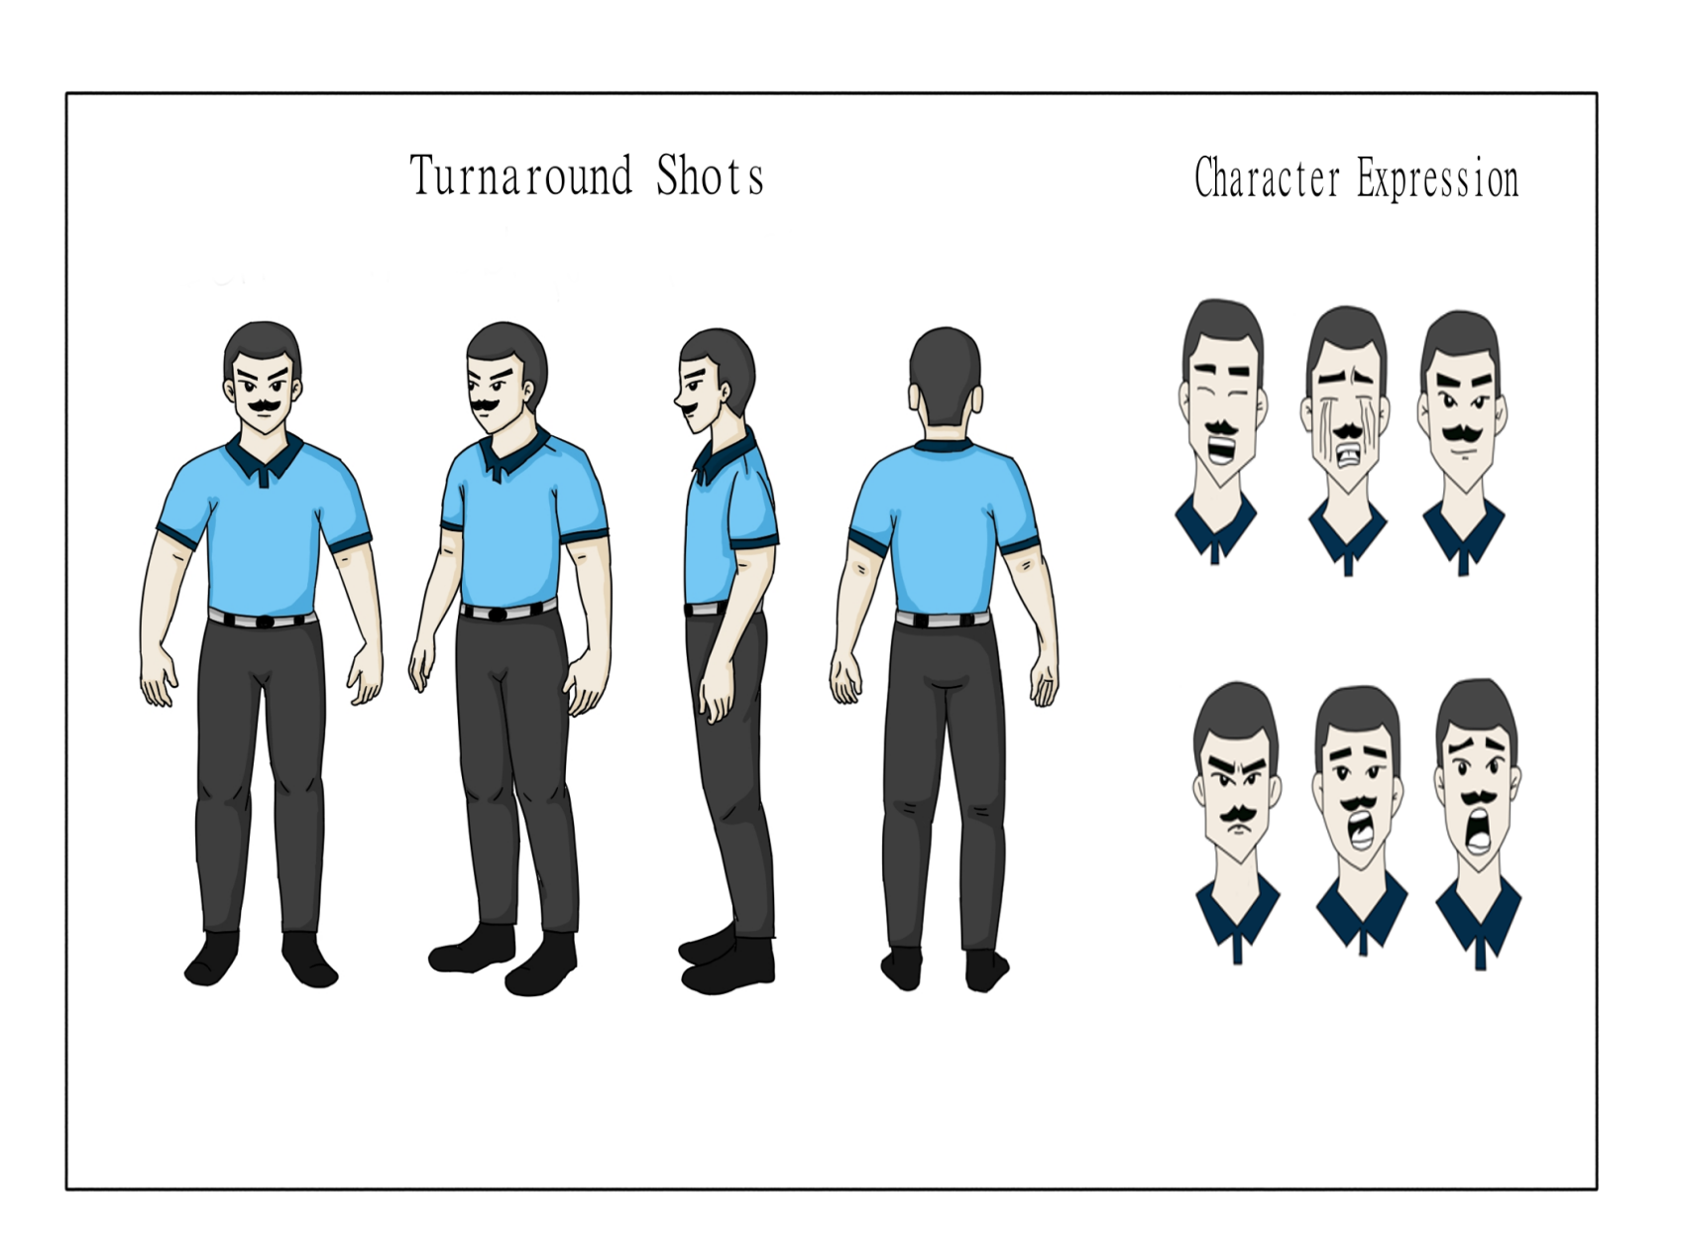
CHARACTER DESIGN

- Ben - The Abusive father (Foster Parent)

- Background:
Once a hardworking man, Ben changed after losing his job. Struggling with failure and alcohol, he became violent toward his former wife and children, letting anger replace love.
- Role in the Story:
Ben is the main source of pain and fear for his adopted sibling. His abusive actions push them to escape and find hope beyond his control.
- Personality Traits:
Short-tempered, controlling, and guilt-ridden. Beneath his anger lies a broken man who never learned to face his pain.

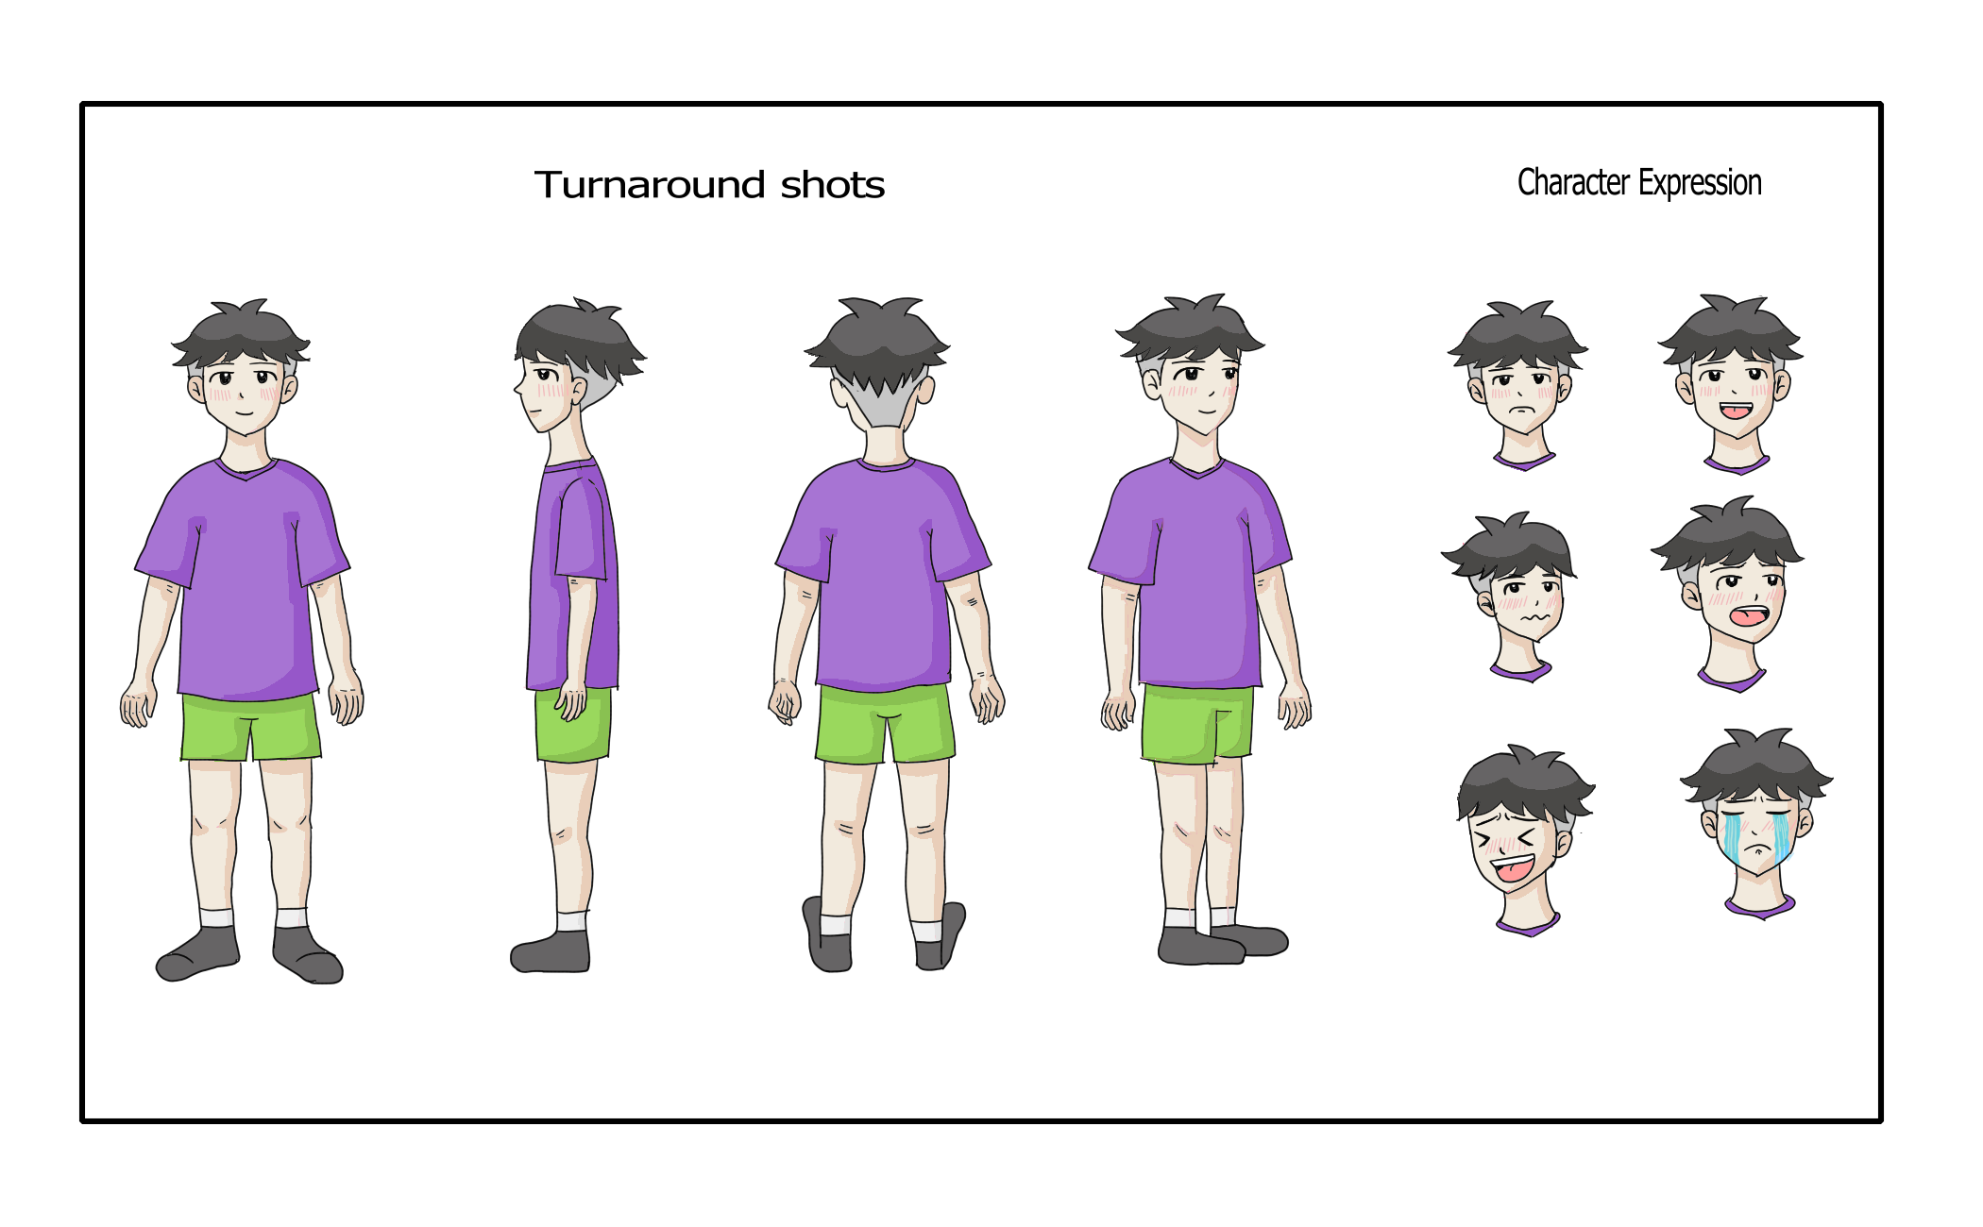

- Eric - The Protective Brother
- Background:
After losing his family in a tragic accident, Eric and his younger brother were left to live in an orphanage. Despite the pain, he remains strong and devoted to protecting his brother from the memory of their abusive father.
- Role in the Story:
Eric plays a vital role as the elder brother who shields and guides his younger sibling. His courage and sense of responsibility drive their survival and hope for a better life.
- Personality Traits:
Brave, caring, and selfless. Eric hides his sadness behind strength, always putting his brother’s safety before his own.

•

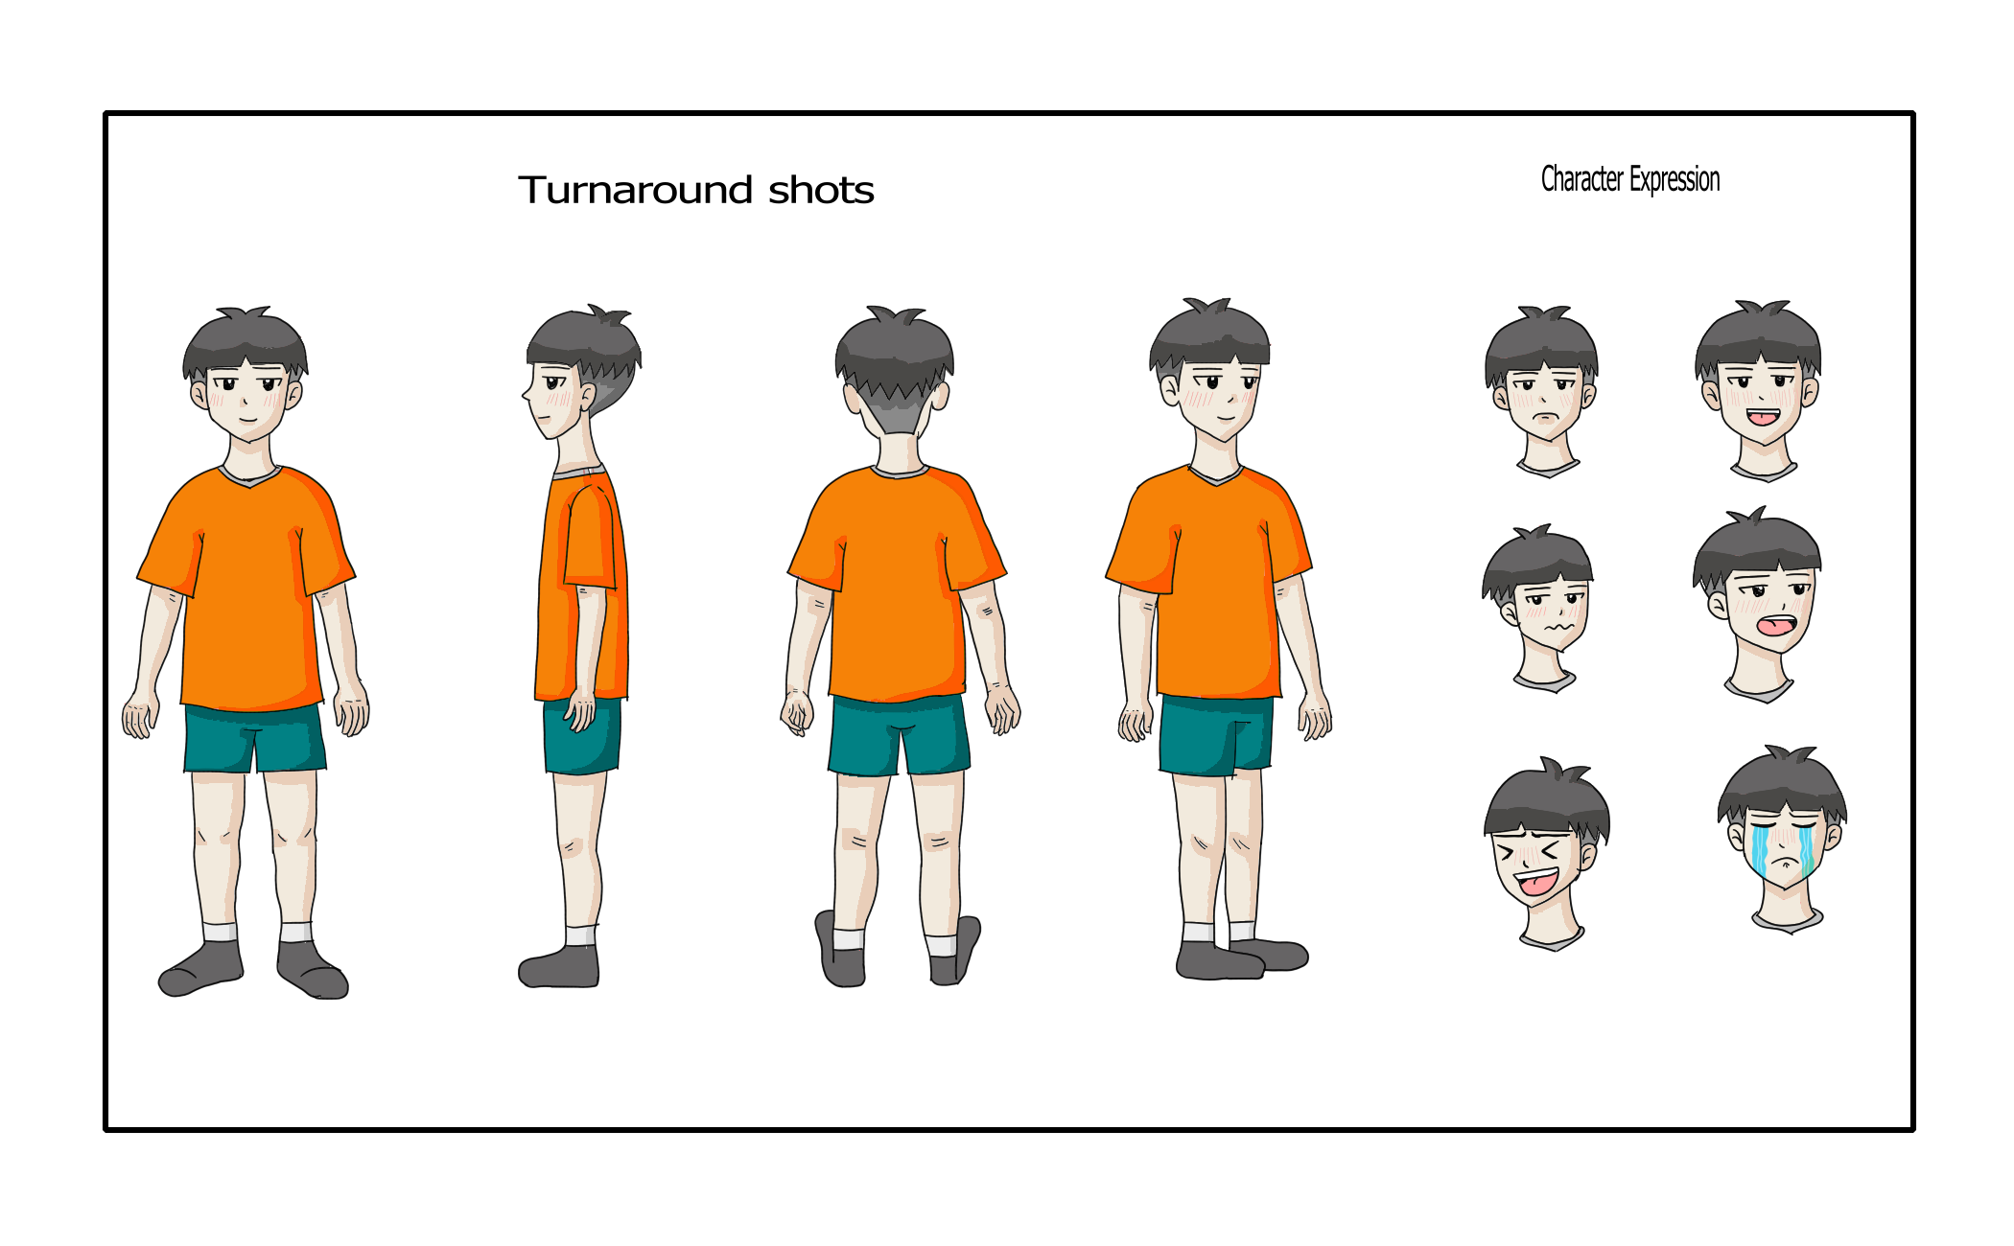

Eric - The Younger Brother
- Background:Like his brother Eric, Felix lost their family in a tragic accident and now lives in an orphanage, haunted by their abusive past but comforted by Eric’s protection.
- Role in the Story:
Felix represents innocence and hope. His bond with Eric gives the story its emotional heart, showing how love between brothers can heal even the deepest wounds.
- Personality Traits:
Gentle, emotional, and hopeful. Though fragile, Felix’s pure heart inspires strength and courage in his older brother.

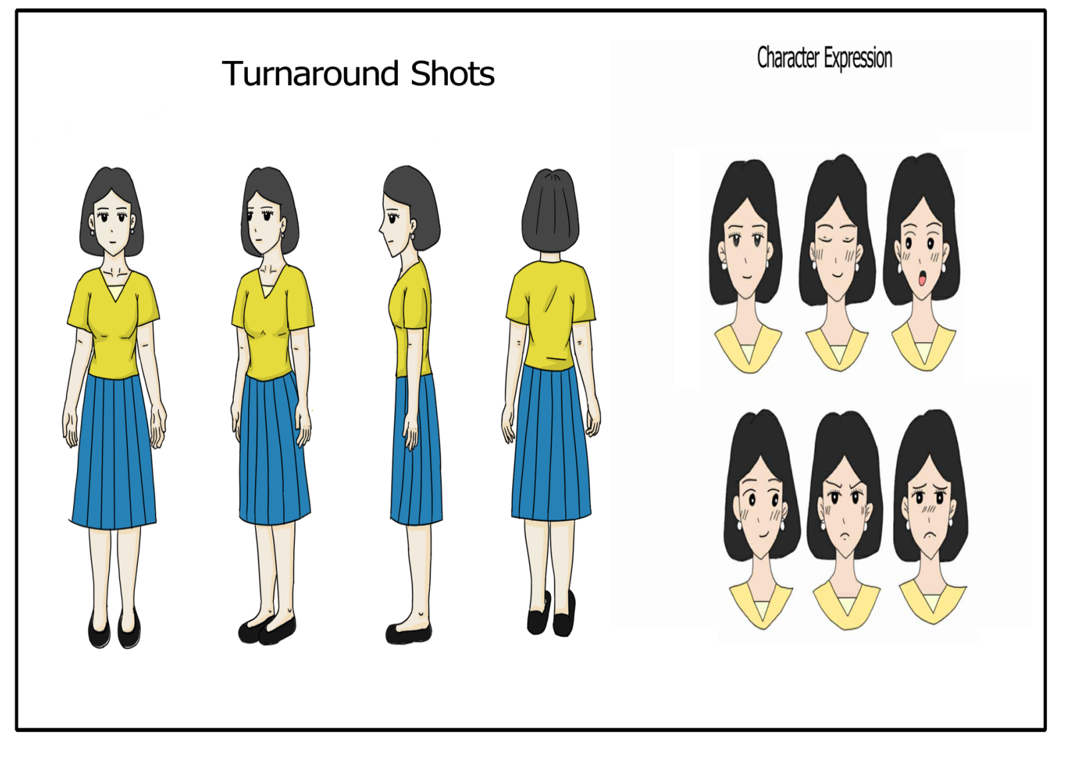

Anna – The Caretaker
- Background:
Anna is a devoted caretaker who manages the orphanage center. She has a loving family of her own but treats every orphan as part of it, giving them the same care and affection she gives her own children.
- Role in the Story:
Anna serves as the caretaker and mother figure to Eric and Felix. She offers them warmth, safety, and guidance, helping them slowly heal from their painful past.
- Personality Traits:
Compassionate, patient, and nurturing. Anna treats every child as her own and believes love can mend even the most broken hearts.

Staging and Layout Themes and Design of the Scenes
In “Two Little Orphans,” the staging and layout of each scene play an important role in making the story emotional and visually touching. Every scene is arranged carefully to help the audience feel the emotions of the two siblings and understand their journey of pain, courage, and hope. Here are the main points considered in designing the scenes:
Staging:
Staging means how the characters, background, and camera are placed in each scene. In this animation, the focus is always on the two siblings, showing their closeness and struggles. The background is kept simple to make sure the viewers pay attention to the characters’ emotions and actions.
Composition:
Composition is how visual elements are arranged in the frame. Scenes use soft colors and balanced space to make them peaceful but emotional. Close-up shots show sadness or love between the brothers, while wide shots show the loneliness of the orphanage or the world around them.
Timing and Rhythm:
Timing gives life to movement. Slow scenes are used when showing sadness or reflection, while faster movements appear in moments of fear or escape. The rhythm helps the audience follow the emotional changes throughout the story.

Exaggeration:
Exaggeration helps show stronger emotions. The brothers’ facial expressions and body movements are slightly exaggerated to help viewers clearly feel their fear, sadness, or relief, even without words.
Solid Drawing:
Each character is drawn with care to look balanced and real. The siblings’ designs show their age difference the older brother looks protective, while the younger one looks small and gentle. This gives a sense of realism and makes their bond more believable.
Appeal:
Appeal makes the characters likable and relatable. Eric and Felix are designed with simple but expressive faces so that audiences can easily connect with their emotions. The caretaker Anna also has a warm look to represent kindness and safety.
By applying these design principles, “Two Little Orphans” delivers a heartfelt and visually engaging story. The staging and layout help the audience understand the characters’ struggles, connect emotionally, and appreciate the message of love and hope.

Chapter 5
Conclusion:
In conclusion, “Two Little Orphans” has been a meaningful and creative capstone project that gave the team valuable experience in emotional storytelling through animation. The project went through many stages, including planning the story, designing the characters, creating animation using digital tools, and editing the final output. It also included marketing ideas, cost planning, and ways to reach viewers. Through hard work and teamwork, this project became proof of the group’s dedication, creativity, and passion for using animation to share messages of hope and love.
Summary:
“Two Little Orphans” is an inspiring capstone project that focuses on the emotional story of two siblings who face pain and hardship but find strength through their bond. The project began with story planning followed by character and background design. Using software like Krita, CapCut, and Ibis Paint, the team brought the story to life with a simple yet expressive art style.
Storyboard helped organize scenes clearly, showing the flow of emotion and action. The post-production phase added sound, effects, and editing to make the animation more powerful and engaging. Marketing and promotion plans were also made to share the animation with schools, social media platforms, and animation communities.

The project helped the creators understand how animation can show real emotions and teach values like courage, empathy, and family love. Overall, “Two Little Orphans” is a touching and educational animation that shows how simple art can tell deep and meaningful stories. It also serves as an inspiration for future animation students to create films that move hearts and spread hope.

