TITLE OF THE INVENTION
CareerMatch: A Smart Job Recommendation System

APPLICANT(S)

Name in Full | Nationality | Country of Residence | Address of Applicants
Anand Sharma | Indian | India | Department of CSE-AIML, KIET Group of Institutions, Delhi  NCR, Ghaziabad, Uttar Pradesh, India-201206
Harsh Vikarm  Singh | Indian | India | Department of CSE-AIML, KIET Group of Institutions, Delhi NCR, Ghaziabad, Uttar Pradesh,  India-201206
Prabal Gupta | Indian | India | Department of CSE-AIML, KIET Group of Institutions, Delhi NCR, Ghaziabad, Uttar Pradesh,  India-201206
Jyoti Kumari | Indian | India | Department of CSE-AIML, KIET Group of Institutions, Delhi NCR, Ghaziabad, Uttar Pradesh,  India-201206



- CLAIM FOR PATENT-
We claim the invention titled “CareerMatch: A Smart Job Recommendation System”, which is a comprehensive web-based solution that leverages Artificial Intelligence (AI) and Natural Language Processing (NLP) to assist learners and fresh graduates in:
- Parsing and analyzing resumes to extract structured information (education, skills, projects, experience, achievements).
- Standardizing extracted data for uniform skill and education representation.
- Mapping skills to job roles using ML models (TfidfVectorizer, LinearSVC).
- Providing personalized job recommendations through direct integration with job postings.
- Enhancing recruitment efficiency by automating resume screening, reducing human error, and enabling fast candidate shortlisting.
We claim the integration of resume parsing, skill categorization, job-role mapping, and AI-driven career recommendation within a unified platform to bridge the gap between graduates’ capabilities and industry requirements.

PREAMBLE TO DESCRIPTION

COMPLETE SPECIFICATION –
The following specification particularly describes the invention and the manner in which it is to be performe.
CareerMatch: A Smart Job Recommendation System

INTRODUCTION
In today’s competitive recruitment landscape, recruiters face the challenge of screening thousands of resumes manually, which is time-consuming and prone to errors. Fresh graduates often struggle to present their skills effectively and match with the right opportunities. CareerMatch addresses this gap by providing an AI-powered resume parser and job matching system that benefits both recruiters and job seekers.

BACKGROUND

Traditional job-matching systems rely heavily on manual processes or simple keyword searches, which lack accuracy and standardization.
Limitations include:

High dependency on human screening.

No standardized representation of skills/education.

Limited ability to match candidates with the best-fit opportunities.

OBJECTIVES
- Automate resume parsing and extraction.
- Standardize and structure candidate information.
• Match candidate skills to suitable job postings using AI/ML.
- Provide a modern web-based platform for easy interaction.
- Reduce recruitment time and effort.

FLOW DIAGRAM

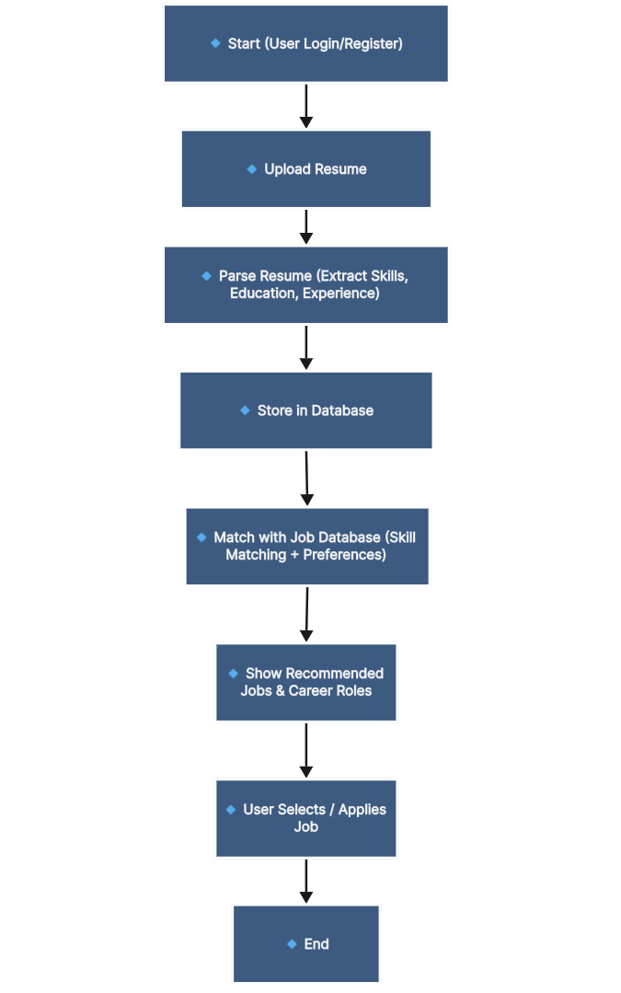

METHODOLOGY OVERVIEW
- Frontend: HTML, CSS, JavaScript, Bootstrap
- Backend: PHP, MySQL
- Machine Learning: TfidfVectorizer, LinearSVC
- NLP: NLTK for text analysis
- Key Modules:
Resume Upload & Parsing (PDF/DOCX support)
Skill Extraction & Standardization
Job Matching Engine (job-matches.php integration)
Candidate Database with search & filter
Error Handling & Validation

ABSTRACT

CareerMatch is a web-based AI-powered system that automates resume parsing, extracts and structures candidate information, analyzes skills, and matches them with relevant job postings. By leveraging ML and NLP, it ensures standardized representation and accurate job recommendations, reducing HR workload while improving employability for fresh graduates.

END USER

End users of our system include:
- Students / Job Seekers: Upload resumes and receive career/job recommendations.
- Recruiters: Automate resume screening and shortlist candidates efficiently.
- Universities: Assist graduates in job placements.
- Employers: Find skill-matched candidates quickly.

CONCLUSION

CareerMatch provides a scalable and intelligent framework to streamline recruitment and empower graduates with AI-driven career opportunities. It transforms manual resume screening into an automated, reliable, and efficient process.

FUTURE SCOPE

- Google Drive resume integration.
- Deep learning for advanced career prediction.
- AI-based interview preparation assistance.

RESULTS :

