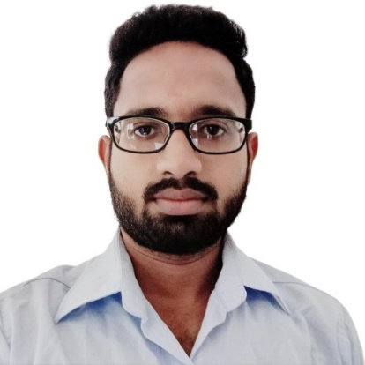

**SUMMARY**

* Member of IEEE club
* Member of Hackathon club

**EXTRA CURRICULAR ACTIVITIES**

 +94768497721

 [hswijemanna@outlook.com](mailto:hswijemanna@outlook.com)

 https://www.linkedin.com/in/hashan-wijemanna-34b8ba27a/

 <https://github.com/hashanwijemanna>

 https://hashanwijemanna.github.io/Portfolio/

 108/24, Munamalgahawatta RD, Honnanthara South, Kesbewa, Sri Lanka

**Hashan Sanjaya Wijemanna**

**Skills**

* Web application Development
* Database Management
* Software Development
* Mobile Application development
* UI/UX Design
* Network Design
* Network Security
* Network Troubleshooting
* Routing and Switching
* Continuous Learning

**Languages**

* English
* Sinhala
* Tamil

**Hobbies**

* Reading
* Listen to music
* Sports
* Self-Learning
* Undergraduate BSc (Hons) Computer Networks, Plymouth University, UK (Final Year - 2025)
* Advanced Certificate Course in NSBM Green University
* Participated in G.C.E. Advanced Level in 2021 at Taxila Central College (Mathematics, Physics, Chemistry)
* G.C.E. Ordinary Level in 2018 at Taxila Central College (A-8, B-1 ‘Tamil’)

**EDUCATION**

I am a self-motivated and problem-solving undergraduate who is currently pursuing a Bachelors degree in Computer Networking offered by Plymouth University, UK. Have expertise in designing and developing web applications, mobile applications and networking systems. Also capable of managing databases. Always concentrates about the work which is doing and have better time planning. Comfortable working independently and always committed to provide a high-quality service.