|  |
| --- |
| Snoggin Development |
| Just Shoot |
| A Scrolling Shooter |
| Version #0.1  All work Copyright © 2012 by Nogbog Games.  All rights reserved. |
| **Colin Capurso** |
|  |



|  |
| --- |
| January 4th 2012 |

**Table of Contents**

[Your Table of Contents should go here. Make sure that your document’s sections are hyperlinked to their corresponding pages.]

**Version History**

[This is where you keep track of the detailed changes made to your document throughout the course of development.]

1. **Game Overview**

“Just Shoot” is a Scrolling Shooter browser game. It will be written in HTML5 / Javascript. The game will follow a control and mechanics style that has been around for a couple of decades. The art style should be retro, with some newish effects like glows and particles.

1. **Game Play Mechanics**

* Controls
  + 8 directional movement
  + Shoot Button
  + Bomb Button
* Player Interactions
  + Player has 3 “lives”
  + Touching an enemy will cause you to lose a life
  + Touching an enemy bullet will cause you to lose a life
  + Player movement is only restricted by the boundaries of the screen
* Objective
  + **Shoot enemies** till they have not more HP and explode
  + At the end of each level, there is a **boss fight**
* Boss Fights
  + Boss is made up of multiple parts that each shoot different things
  + The player must **destroy each** **part** to defeat the boss as a whole
* Other
  + Enemies have different **bullet shooting patterns**
  + Enemies have different **movement paths**
  + Enemies have different **HP**
  + Some enemies drop **power-ups**
* Power-ups
  + Power-ups can change Weapon Type / Add Bombs / Add Rockets
  + Weapon power-ups can change the weapon type
  + Weapon power-ups can enhance the current weapon type
  + Add Rockets add fixed direction rockets to the player’s ship

1. **Camera**

* Top View

1. **Controls**

* Keyboard
  + Movement WASD or Arrow Keys
  + Hold space for shooting
  + Enter for bomb

1. **Saving and Loading**
   * Game State is saved and stored in **local storage**
   * Closing the window and restarting the game should allow you to continue from where you started
   * Losing all lives ends the game
2. **Interface**

* Display Score
* Display how many Lives left
* Display how many Bombs left
* Maybe - Display current weapon type
* Maybe - Display current weapon level
* Maybe - Display rocket levels

1. **Menu and Screen Descriptions**
   * New Game
   * Continue (disabled if no save exists)
   * About Developer
2. **Game World**

* Space
* Alternatives
  + On Earth
  + In the clouds
  + Above floating islands

1. **Levels** 
   * 13 levels
   * Different theme for each level, either by colour or art style
2. **Game Progression**
   * As you complete levels, there are harder enemies
   * As you complete levels there are more opportunities for more powerful weapons
   * Dying causes you to lose all your weapon power-ups
   * Harder enemies fall into categories
     1. More HP – Enemies take more hits to destroy
     2. More Enemies – More enemies on screen making it harder to maneuver around them
     3. More Bullets – Enemies shoot more bullets making it harder to dodge them
3. **Characters**
   * *Storyline to be fleshed out later*
   * Player
4. **Non-player Characters**
   * *Storyline to be fleshed out later*
5. **Enemies**
   * Level 1
     1. Pawns
        1. Ship A: Doesn’t shoot
        2. Ship B: Shoot straight down
        3. Ship C: Shoots 3 Bullets
        4. Ship D: Shoot at player
        5. Ship E: Shoot half circle
     2. Boss
        1. 2 Turrets – Shoots straight, rotates
        2. 1 Main turrets shoots at player
   * Level 2
     1. Pawns
        1. Ship A: Doesn’t shoot
        2. Ship B: Shoot straight down
        3. Ship C: Shoots 3 Bullets
        4. Ship D: Shoot at player
        5. Ship E: Shoot half circle
     2. Boss
        1. 2 Turrets – Shoots straight, rotates
        2. 2 Main turrets shoots at player
   * Level 3
     1. Pawns
        1. Ship A: Doesn’t shoot
        2. Ship B: Shoot straight down
        3. Ship C: Shoots 3 Bullets
        4. Ship D: Shoot at player
        5. Ship E: Shoot half circle
     2. Boss
        1. 4 Turrets – Shoots straight, rotates
        2. 1 Main turrets shoots at player
   * Level 4
     1. Pawns
        1. Ship A: Doesn’t shoot
        2. Ship B: Shoot straight down
        3. Ship C: Shoots 3 Bullets
        4. Ship D: Shoot at player
        5. Ship E: Shoot half circle
     2. Boss
        1. 2 Turrets – Shoots straight, rotates
   * Level 5
     1. Pawns
        1. Ship A: Doesn’t shoot
        2. Ship B: Shoot straight down
        3. Ship C: Shoots 3 Bullets
        4. Ship D: Shoot at player
        5. Ship E: Shoot half circle
     2. Boss
        1. 2 Turrets – Shoots straight, rotates
        2. 2 Main turrets shoots at player
   * Level 6
     1. Pawns
        1. Ship A: Doesn’t shoot
        2. Ship B: Shoot straight down
        3. Ship C: Shoots 3 Bullets
        4. Ship D: Shoot at player
        5. Ship E: Shoot half circle
     2. Boss
        1. 3 Turrets – Shoots straight, rotates
   * Level 7
     1. Pawns
        1. Ship A: Doesn’t shoot
        2. Ship B: Shoot straight down
        3. Ship C: Shoots 3 Bullets
        4. Ship D: Shoot at player
        5. Ship E: Shoot half circle
     2. Boss
        1. 4 Turrets – Shoots straight, rotates
   * Level 8
     1. Pawns
        1. Ship A: Doesn’t shoot
        2. Ship B: Shoot straight down
        3. Ship C: Shoots 3 Bullets
        4. Ship D: Shoot at player
        5. Ship E: Shoot half circle
     2. Boss
        1. 5 Turrets – Shoots straight, rotates
   * Level 9
     1. Pawns
        1. Ship A: Doesn’t shoot
        2. Ship B: Shoot straight down
        3. Ship C: Shoots 3 Bullets
        4. Ship D: Shoot at player
        5. Ship E: Shoot half circle
     2. Boss
        1. 6 Turrets – Shoots straight, rotates
   * Level 10
   * Level 11
   * Level 12
   * Level 13
6. **Weapons**
   * Normal
     1. Shoots bullets straight
     2. Power-ups increase damage and number of bullets
   * Laser
     1. Shoots straight through enemies
     2. Weaker than normal but can hit multiple targets
     3. Power-ups increase damage and width
   * Jumping Beam
     1. Jumps to nearest enemy
     2. Power-ups increase damage and width slightly
   * Bombs
     1. Destroys everything on screen
     2. If the bomb is dropped on boss it does substantial damage.
   * Rockets
     1. These are passive weapons, they shoot out at set angles periodically
     2. Power-ups increase the damage and/or quantity
7. **Items**
   * Power-up: Weapon Change, collect the same colour to increase current powe
   * Power-up: Increase rockets
   * Bomb: Gives player more bombs
8. **Abilities**
   * Flying around
9. **Vehicles**
   * N/A
10. **Script**
11. **Scoring**
    * 10 points per hit * Current Level
    * 1000 per pawn * Current Level
    * 100,000 for boss * Current Level
12. **Puzzles/Mini-games**
    * N/A
13. **Bonuses** 
    * N/A
14. **Cheat Codes** 
    * N/A
15. **Sound Bible**
    * Normal Shooting
    * Laser Shooting
    * Jumping Beam Shooting
    * Normal Hitting
    * Jumping Beam Hitting
    * Enemy exploding
    * Player exploding
    * Collecting power-up
    * Normal Music
    * Boss Music
16. **Story Bible** 
    * N/A
17. **Art Bible** 
    * Damaged enemy – Flash red
    * Player ship – White
    * Weapons full colour, additive if possible
    * Background space
    * Background star field (Parallax Scrolling)
    * Enemies minimal colour
    * All bullets single colour
    * Possible art for: Player   
      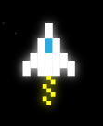
    * Possible art for : Player Weapons  
      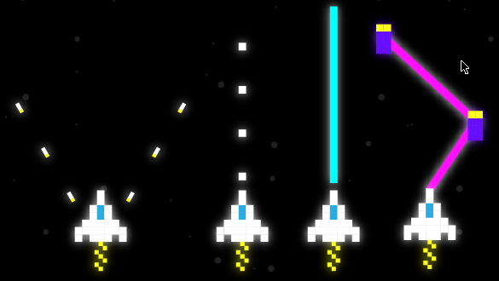
    * Possible art for: Enemies  
      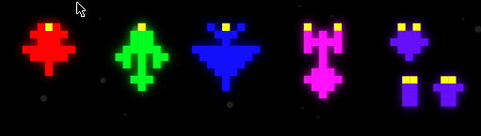
    * Possible art for: Boss  
      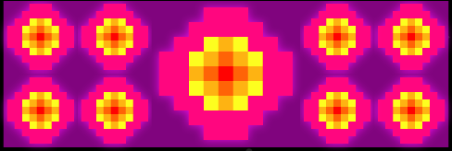
    * Possible art for: Bullets  
      
18. **Design Notes**
    * **Enemy Movements  
      Bullet Movements  
      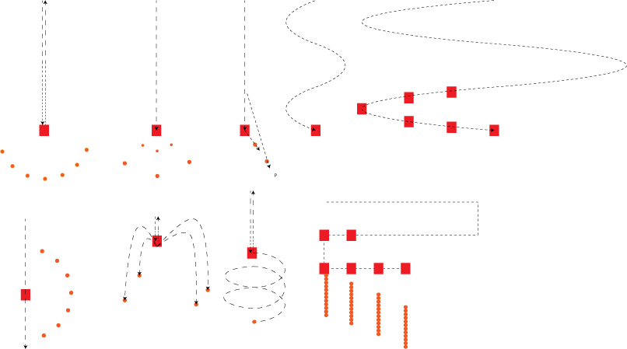**
    * **Boss Designs  
      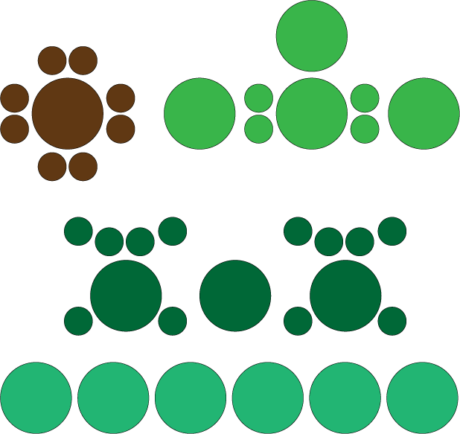**
19. **Future Features**