Description of App:

Growacle is an easy-to-use app in which you can use a wizard to find the plant perfect for you. You will be led through a series of questions that will help narrow down a list of plants to only a few. Ultimately, you will be shown these plants and they will be right for you. Growacle will grow the Earth and improve your habits, one plant at a time!

Questions:

What climate does your area have?

* + Tropical (64 to 95 degrees)
  + Dry (-6 to 127)
  + Temperate (-5 to 95)
  + Continental (-22 to 85)
  + Polar (-60 to 0)

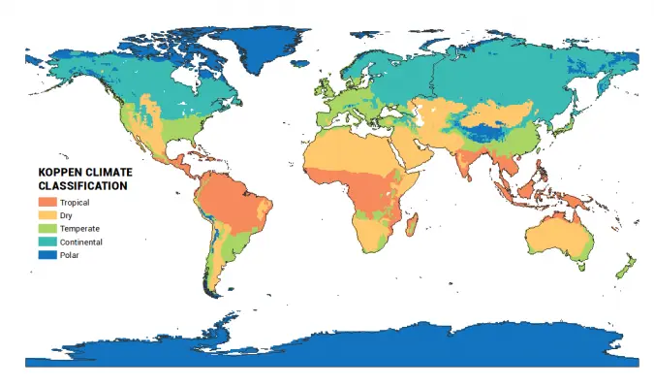

<https://earthhow.com/koppen-climate-classification/>

* How committed and dedicated are you to take care of your plant?
  + A small amount, not much work.
  + A medium amount, relatively
  + A large amount
* Do you want to grow this plant indoors or outdoors?
  + Inside
  + Outside
* What benefits do you want this plant to give?
  + Purifies air
  + Food, spice, or sauce
  + Heal cuts, bruises, burns etc
  + Insect repellent

| Plant Name: **Bunny ear cactus** | | | | |
| --- | --- | --- | --- | --- |
| Temperature | Care frequency | Benefits | Grow location  (house) | Care level difficulty |
| Hot between 70-100 Fahrenheit  [https://www.thespruce.com/bunny-ear-cactus-guide-5190802](https://www.thespruce.com/bunny-ear-cactus-guide-5190802#:~:text=The%20bunny%20ear%20cactus%20requires%20warm%2C%20dry%20conditions%20and%20does,potting%20container%20has%20drainage%20holes) | Water once every month  <https://planterina.com/blogs/indoor-plant-care/bunny-ears-cactus> | Purifies and removes toxins from the air  <https://kadiyamnursery.com/products/bunny-ears-cactus-succulent-plant> | Very direct sunlight  Can be grown in Tropical and Dry regions  <https://www.thespruce.com/bunny-ear-cactus-guide-5190802> | Easy  Description: Bunny ear cactus is a bushy, perennial cactus with oval to round, flattened, small pads.  [Opuntia microdasys (Bunny Ears)](https://www.gardenia.net/plant/opuntia-microdasys-bunny-ears#:~:text=A%20most%20attractive%20cactus%2C%20Opuntia,velvety%20green%20as%20they%20grow.) |

| Plant Name: **Moth Orchid** | | | | |
| --- | --- | --- | --- | --- |
| Temperature | Care frequency | Benefits | Grow location  (house) | Care level difficulty |
| 65-75 Fahrenheit  <https://www.ambius.com/resources/blog/plant-care/cold-weather-orchid-care-tips> | Water once every 3 to 6 days  <https://www.homesandgardens.com/gardens/how-often-should-i-water-my-orchid> | Beautiful flowers. | In Indirect sunlight,not in full sun.  <https://www.nparks.gov.sg/nparksbuzz/issue-40-vol-1-2019/gardening/tips-for-growing-orchids-in-apartments> | Hard  Description: The flowers consist of two lateral petals, a central modified petal known as a labellum (lip), a column that houses the reproductive structures, and three petal-like sepals  <https://www.britannica.com/plant/moth-orchid> |

| Plant Name: **Areca Palm Plant** | | | | |
| --- | --- | --- | --- | --- |
| Temperature | Care frequency | Benefits | Grow location  (Garden) | Care level difficulty |
| 60-75 F  <https://www.thespruce.com/grow-areca-palms-indoors-1902876> | Once every 7-10 days  [How to Grow and Care for Areca Palm | Oxy-PlantsOxy-Plantshttps://oxy-plants.com › care-for-areca-palm](https://oxy-plants.com/care-for-areca-palm/#:~:text=You'll%20need%20to%20water,two%20weeks%20or%20even%20less.) | Purifies air and removes toxins  <https://medium.com/@greenthriveplantservice/areca-palm-16-amazing-uses-and-benefits-of-growing-areca-palm-1f0faf1dd94> | In indirect sunlight  [How to Grow and Care for Areca Palm (Indoors + Outdoors)Planet Naturalhttps://www.planetnatural.com › areca-palm](https://www.planetnatural.com/areca-palm/#:~:text=Quick%20Guide%3A%20Planting%2C%20Growing%20%26%20Caring%20for%20Areca%20Palm,-Areca%20palms%20can&text=Indoors%2C%20they%20require%20bright%20indirect,also%20tolerant%20of%20full%20sun.) | Medium  Description:  The Areca Palm has smooth silver-green trunks, which are topped with arching feather-shaped fronds  [Areca Palm Tree | All You Need To KnowAll About Palm Treeshttps://www.allaboutpalmtrees.com › areca-palm-tree](https://www.allaboutpalmtrees.com/areca-palm-tree) |

| Plant Name: **Snake plant** | | | | |
| --- | --- | --- | --- | --- |
| Temperature | Care frequency | Benefits | Grow location:  (balcony) (Garden) | Care level difficulty |
| 70 and 90 degrees Fahrenheit  [https://www.thespruce.com/snake-plant-care-overview-1902772](https://www.thespruce.com/snake-plant-care-overview-1902772#:~:text=Snake%20plants%20grow%20best%20in,between%2030%20and%2050%20percent.) | Water once every ten days  [https://www.thespruce.com/snake-plant-care-overview-1902772](https://www.thespruce.com/snake-plant-care-overview-1902772#:~:text=Snake%20plants%20grow%20best%20in,between%2030%20and%2050%20percent.) | remove toxins and pollutants from the air.  [7 Benefits of Keeping Snake Plants In Your Home - Garden Caregarden-care.org.ukhttps://garden-care.org.uk › health-wellbeing › 7-benefit...](https://garden-care.org.uk/health-wellbeing/7-benefits-of-keeping-snake-plants-in-your-home/) | Sunlight, with some shade.  <https://www.hgtv.com/outdoors/flowers-and-plants/houseplants/2019/how-often-water-snake-plant> | Easy  Description:  It has web-like underground roots and thick, sword-shaped leaves with a unique banded pattern.  [Snake plant - Kew GardensKew Gardens Https://www.kew.org › plants › snake-plant](https://www.kew.org/plants/snake-plant#:~:text=Plant%20description,-Dracaena%20trifasciata%20is&text=It%20has%20web%2Dlike%20underground,develop%20into%20small%20orange%20fruits.) |

| Plant Name: **Aloe Vera** | | | | |
| --- | --- | --- | --- | --- |
| Temperature | Care frequency | Benefits | Grow location  (house) (garden) | Care level difficulty |
| Warm between 55-85 Fahrenheit  [https://www.architecturaldigest.com/reviews/home-products/how-to-take-care-of-an-aloe-plant](https://www.architecturaldigest.com/reviews/home-products/how-to-take-care-of-an-aloe-plant#:~:text=pot%20with%20gravel.-,Temperature,is%20constantly%20opening%20and%20closing.) | Water once every week or two  [How To Grow And Take Care Of An Aloe Plant (2023 Guide)Architectural Digesthttps://www.architecturaldigest.com › ... › Home Products](https://www.architecturaldigest.com/reviews/home-products/how-to-take-care-of-an-aloe-plant#:~:text=Once%20per%20week%20should%20be,give%20it%20plenty%20of%20liquid.) | Can be used to heal cuts and sunburns | Anywhere in bright indirect sunlight  [How To Grow And Take Care Of An Aloe Plant (2023 Guide)Architectural Digesthttps://www.architecturaldigest.com › ... › Home Products](https://www.architecturaldigest.com/reviews/home-products/how-to-take-care-of-an-aloe-plant#:~:text=To%20stay%20healthy%2C%20aloe%20plants,can%2C%20ironically%2C%20get%20sunburn.) | Easy  Description:  Aloe vera is a herb with succulent leaves that are arranged in a rosette |

| Plant Name: **Laceleaf/Anthrium** | | | | |
| --- | --- | --- | --- | --- |
| Temperature | Care frequency | Benefits | Grow location  (house) | Care level difficulty |
| Warm between 70-90 but can go down to 55 Fahrenheit  (will put 90-55 in the app, we should adjust this for climate)  [Care Instructions Anthurium - Jackson & Perkinsjacksonandperkins.comhttps://www.jacksonandperkins.com › anthurium-care](https://www.jacksonandperkins.com/anthurium-care/a/care-instructions-anthurium/#:~:text=Place%20your%20Anthurium%20near%20a,%C2%B0F%20can%20be%20tolerated.) | Water once a week  [https://www.justaddiceorchids.com/orchid-care-blog/6-biggest-anthurium-care-mistakes](https://www.justaddiceorchids.com/orchid-care-blog/6-biggest-anthurium-care-mistakes#:~:text=Your%20anthurium%20will%20do%20best,of%20water%20once%20a%20week.) | Can purify indoor air and looks pretty, good for a gift to someone.  [Anthurium : Perfect Houseplant for Gifting - Rolling Naturerollingnature.comhttps://www.rollingnature.com › blogs › news › anthuriu...](https://www.rollingnature.com/blogs/news/anthurium-perfect-houseplant-for-gifting#:~:text=Anthuriums%20are%20listed%20in%20NASA's,copiers%2C%20printers%20or%20adhesives).) | Abundant sunlight less than 3 feet from a window  [https://greg.app/plant-care/anthurium-schlechtendalii](https://greg.app/plant-care/anthurium-schlechtendalii#:~:text=Laceleaf%20is%20a%20relatively%20rare,time%20it%20doubles%20in%20size.) | Medium  Description:  The Laceleaf is a herbaceous evergreen plant that grows to 40 cm in height. The dark green leaves are heart-shaped and glossy  [Anthurium andraeanum Linden ex André - National Parks Boardnparks.gov.sghttps://www.nparks.gov.sg › florafaunaweb › flora](https://www.nparks.gov.sg/florafaunaweb/flora/1/6/1672#:~:text=Anthurium%20andraeanum%20or%20Flamingo%20Lily,spadix%20and%20waxy%20red%20spathe.) |

| Plant Name: **Basil Demo plant** | | | | |
| --- | --- | --- | --- | --- |
| Temperature | Care frequency | Benefits | Grow location  (house) (balcony) | Care level difficulty |
| Very adaptable 45-80 F  [Basil PDF - UC DavisUniversity of California, Davishttps://www.wifss.ucdavis.edu › uploads › 2016/10](https://www.wifss.ucdavis.edu/wp-content/uploads/2016/10/Basil_PDF.pdf) | Water twice a week  [How Often to Water Basil - The SpruceThe Sprucehttps://www.thespruce.com › Plants & Flowers › Herbs](https://www.thespruce.com/how-often-to-water-basil-7562384#:~:text=As%20a%20rule%20of%20thumb,even%20if%20it%20is%20outside.) | Insect repellent, can make pesto with it for pasta  [Herbs That Repel Bugs - - Wilson's Garden CenterWilson's Garden Centerhttps://gardencenterohio.com › Gardening With Herbs](https://gardencenterohio.com/herbs-2/herbs-repel-bugs/#:~:text=Basil%20also%20acts%20as%20a,leaves%20rubbed%20on%20the%20skin.&text=Eucalyptol.,and%20repelling%20cockroaches%20and%20weevils.) | Abundant sunlight  [5 Tips for Growing Basil in Pots - The SpruceThe Sprucehttps://www.thespruce.com › Plants & Flowers › Herbs](https://www.thespruce.com/growing-basil-in-containers-848215#:~:text=Whether%20you%20are%20growing%20basil,it%20can%20develop%20leaf%20burn.) | Hard  Description:  Basil is an annual herb of the mint family, grown for its aromatic leaves. Basil is likely native to India and is widely grown as a kitchen herb  ​​[Basil | Definition, Plant, Uses, Species, & Facts | BritannicaBritannicahttps://www.britannica.com › ... › Food](https://www.britannica.com/plant/basil#:~:text=basil%2C%20(Ocimum%20basilicum)%2C,grown%20as%20a%20kitchen%20herb.) |

| Plant Name: **Rosemary Demo plant** | | | | |
| --- | --- | --- | --- | --- |
| Temperature | Care frequency | Benefits | Grow location  (house) (Balcony) | Care level difficulty |
| 55-80 F  [How to Grow and Care for Rosemary](https://www.thespruce.com/grow-and-care-for-rosemary-plants-1403406#:~:text=This%20shrub%20likes%20warm%20weather,55%20degrees%20and%2080%20degrees.) | Once every 2-5 days  <https://www.housebeautiful.com/lifestyle/gardening/a41055925/rosemary-plant-care/#> | Insect repellent, herb, and smells good  [12 Mosquito Repellent PlantsGarden Designhttps://www.gardendesign.com › plants › mosquito-re...](https://www.gardendesign.com/plants/mosquito-repellent.html) | Needs direct sunlight  [How to Grow and Care for Rosemary](https://www.thespruce.com/grow-and-care-for-rosemary-plants-1403406#:~:text=This%20shrub%20likes%20warm%20weather,55%20degrees%20and%2080%20degrees.) | Medium  Description:  Rosemary is a fragrant, evergreen shrub with needle-like leaves and two-lipped, purplish-blue and white flowers.  [Rosemary - Salvia rosmarinus | Plants - Kew GardensKew Gardenshttps://www.kew.org › plants › rosemary](https://www.kew.org/plants/rosemary#:~:text=Rosemary%20is%20a%20fragrant%2C%20evergreen,and%20form%20trunks%20with%20time.) |

| Plant Name: **Cherry Tomato** | | | | |
| --- | --- | --- | --- | --- |
| Temperature | Care frequency | Benefits | Grow location  (Balcony) (Garden) | Care level difficulty |
| 55-85 F  <https://www.homedepot.com/c/ah/when-to-plant-tomatoes/9ba683603be9fa5395fab9016646231b> | Water every two or three days  <https://www.goodhousekeeping.com/home/gardening/a20706658/growing-cherry-tomatoes/> | Produces tasty tomatoes. | Warm areas, receiving 6-8 hours of sunlight. Thus, they are grown in places near the equator, like Peru and Ecuador  [https://www.southernliving.com/garden/edible/how-to-grow-cherry-tomatoesurs](https://www.southernliving.com/garden/edible/how-to-grow-cherry-tomatoes#:~:text=Your%20first%20step%20in%20growing,hours%20of%20sun%20each%20day) | Hard  Description:  The Tomato plant can grow up to 9 feet tall with soft and hairy stems. It has 5-9 leaflets and the flowers on the tomato plant are small, yellow and have five pointed lobes on the corolla.  [The Tomato PlantNorth Dakota State Universityhttps://www.ndsu.edu › plsc211 › articles08 › ChrisBeneda](https://www.ndsu.edu/pubweb/chiwonlee/plsc211/student%20papers/articles08/ChrisBeneda/TomatoPlant.htm#:~:text=Description,pointed%20lobes%20on%20the%20corolla.) |

Identification Key (all identifiers are multiple-choice, goes from top to bottom)

[Abstract](https://docs.google.com/document/d/1ZztEDEGLGU2lGzlrpczkc-vUIc8kLO8aLgPQISGtetQ/edit?usp=sharing) abstract work document

[Github Link](https://github.com/hashbrun554/Growacle)

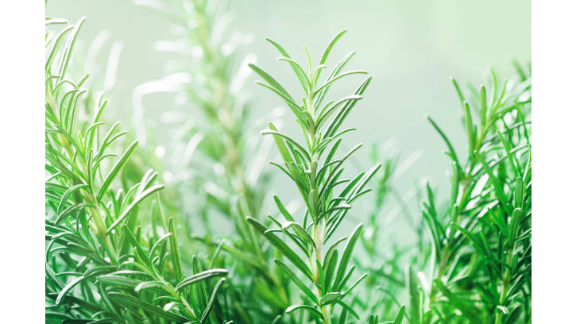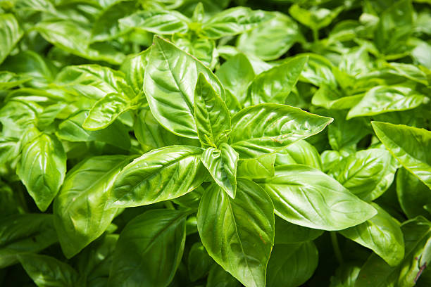  
Rosemary:<https://www.istockphoto.com/photos/rosemary-bush> and Basil:

Works to cite:

<https://thehungryjpeg.com/product/4090057-autumn-leaves-branch-border>  
<https://iconscout.com/free-icon/house-home-building-infrastructure-real-estate-resident-emoj-symbol-1>

<https://www.creativefabrica.com/product/spring-plants-in-garden-flat-icon/>

<https://scijinks.gov/climate-zones/>

<https://thenounproject.com/icon/leaves-46925/>

<https://thegardenersworkshop.com/product/basil-genoveser/>

<https://www.streamlinehq.com/core/core-line-free>