Step:-1 Registration in Git



Step:-2 Create repository in Git 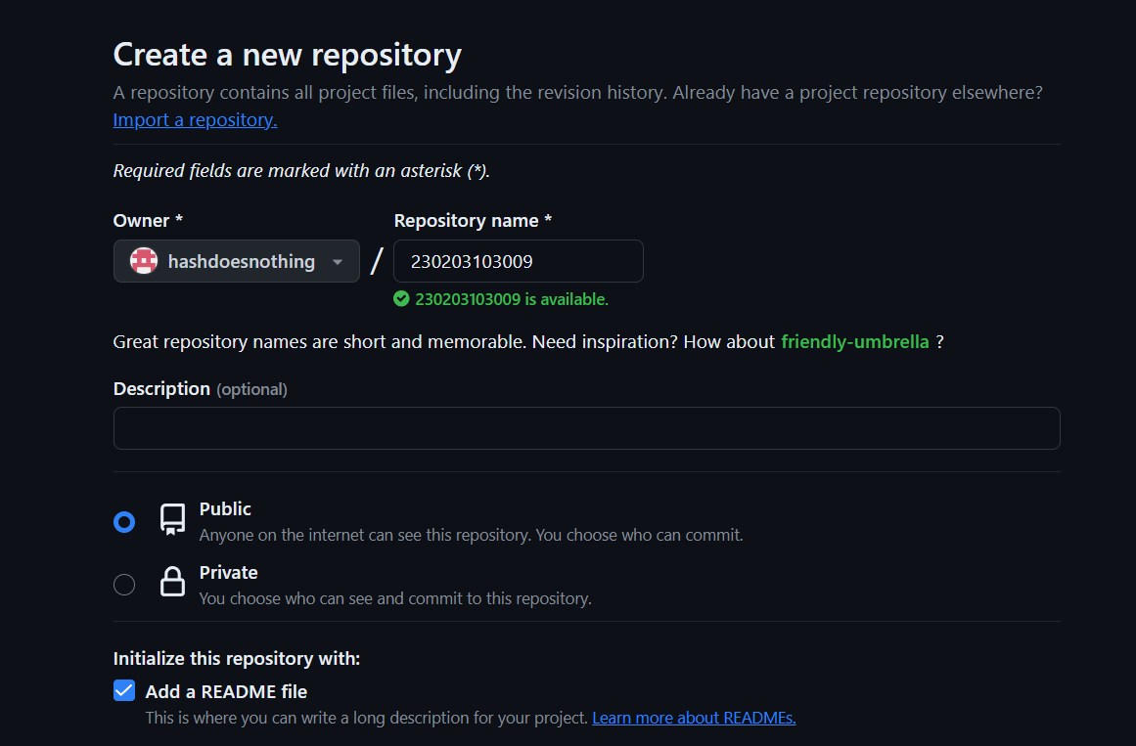

Step:-3 Creating folder Assignment 1 and Assignment 2